HW 04 Report

*Date: 4/13/20*

*Group: Wednesday Group 08*

*Group Members: Alan Joshua, Isaac Krisch, Zaina Qasim*

User Instructions

No special instructions required

RESULTS AND ANALYSIS

Two different hash functions were tested. The first hash function, as recommended by the document, was abs(key) % (maxSize+1 – size) and the second hash function was abs(key) % (maxSize).

The result from the first hash function could be seen below:

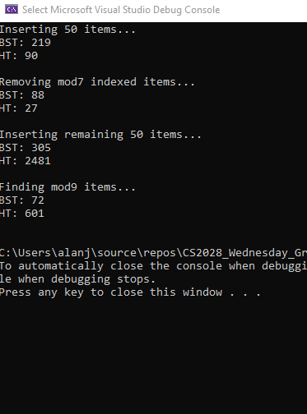

Results using second hash function:

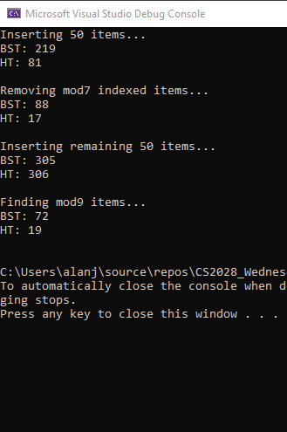

The results clearly show that the second hash function is more efficient. It makes sense because the first function would produce different hash keys for the same key, as the remaining capacity would not remain the same, and so would have to perform extensive linear probing to find the right spot.

From the results, it could be concluded that hash tables are more efficient than binary search trees, given that a good hash function is being used.

Contributions

All members contributed an equal amount.