Lab 8 Report

**Date:** 03/19/2020

**Group:** Wednesday Group 08

**Group Members:** Alan Joshua, Isaac Kirsch, Zaina Qasim

# Objectives/Concepts explored and their Importance in Computer Science

The objective of this lab was to create an ordered double linked list. We explored the concept of LinkedLists which is not only useful for creating various data structures in class, but also is also used widely in the Computer Science industry. For example, Linked Lists are used to construct a number of predefined libraries, web-browser history, and low-level memory management in programming languages.

# TESTING

## Task 3: SCREENSHOT

Test your program. Include a screen shot of some of this testing in your lab report

## Task 4: SCREENSHOT

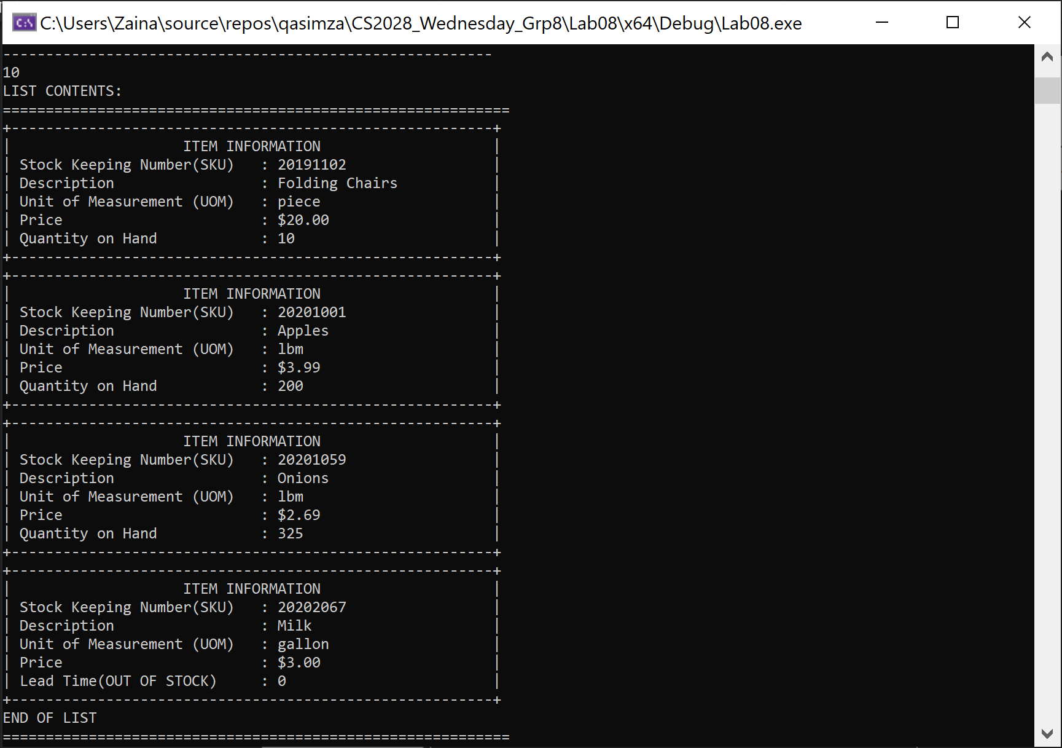

Results of New Display Method (with 4 items in list)

# DISCUSSION

Task 4 required creating an ASCII art visualization of the list. As shown in the screenshot above, we created a display method for the Item class which can directly write the key members of the Item to the screen. SKU, Description, Price and UOM were selected as the key members (displayed for every item in the list). Depending on whether the item is in stock or not, Item::display() prints the Quantity on Hand or the Lead Time. The display method in the ODLinkedList class calls the Item::display() for each item in the list.

Most of the code in the Item class was reused. In particular, the getPartInfo(), getPrice(), and inStock() functions were used for various parts of the display function. Item::getPartInfo() returns string containing the SKU, Description and UOM (delimited by !) while Item::getPrice() returns the price of each item. The only part that needed editing in the code was the delimiter used in the getPartInfo() which was switched to ‘!’ from ‘-’.

# Contributions

All members contributed an equal amount.