Lab 10 Report

Date: 4/13/20

Group: Wednesday Group 08

Group Members: Alan Joshua, Isaac Krisch, Zaina Qasim

# Objectives/Concepts explored and their Importance in Computer Science

The objective of this lab was to explore hashing and create Hash Tables. The topic explored is important in Computer Science because it is a data structure that is widely used in the industry for mapping and maintaining data sets.

# Task 3: Screenshots (TESTING HASH TABLE)

## ScreenSHOT 1: Creating a new List and adding an Item

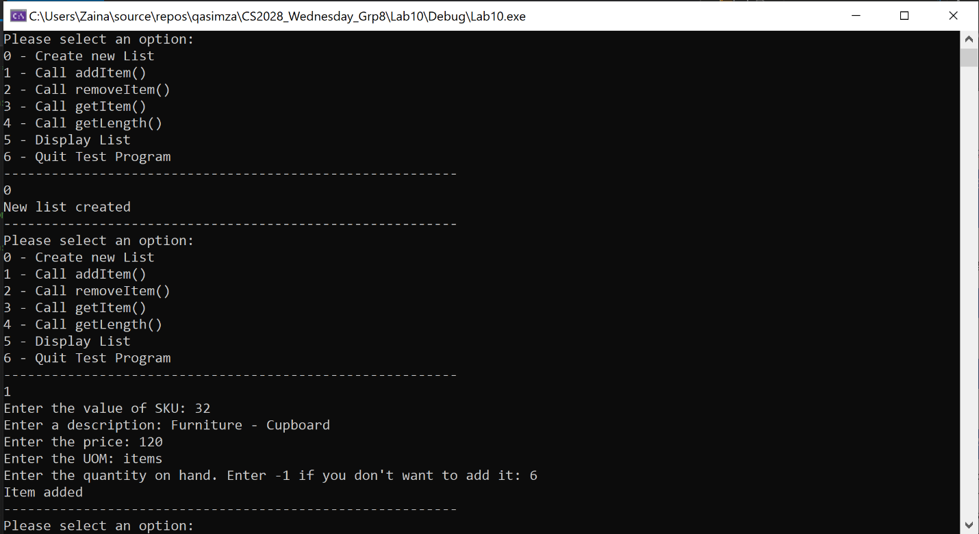

## ScreenSHOT 2: GET LENGTH AFTER ADDING THREE ITEMS

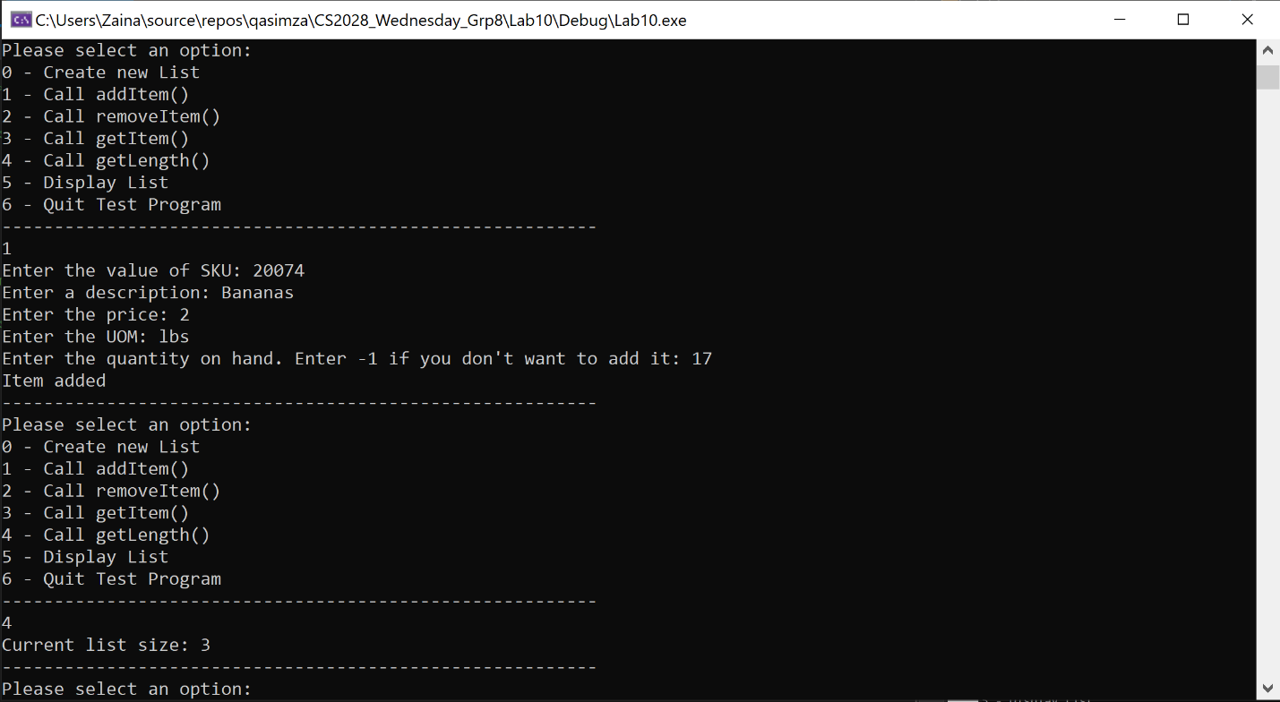

## ScreenSHOT 3: Removing an item (WHICH EXISTS)

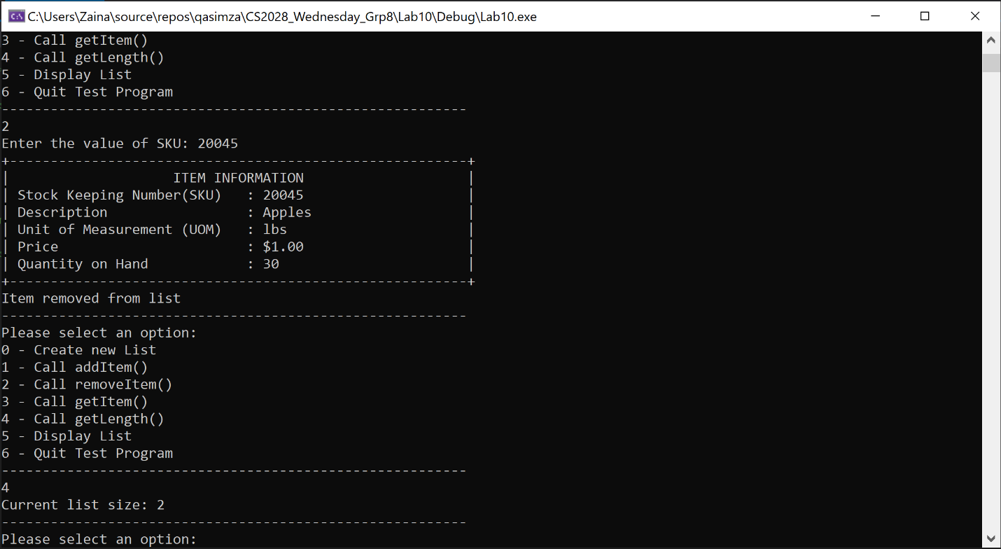

## SCREENSHOT 5: REMOVING AN ITEM (WHICH DOES NOT EXISt)

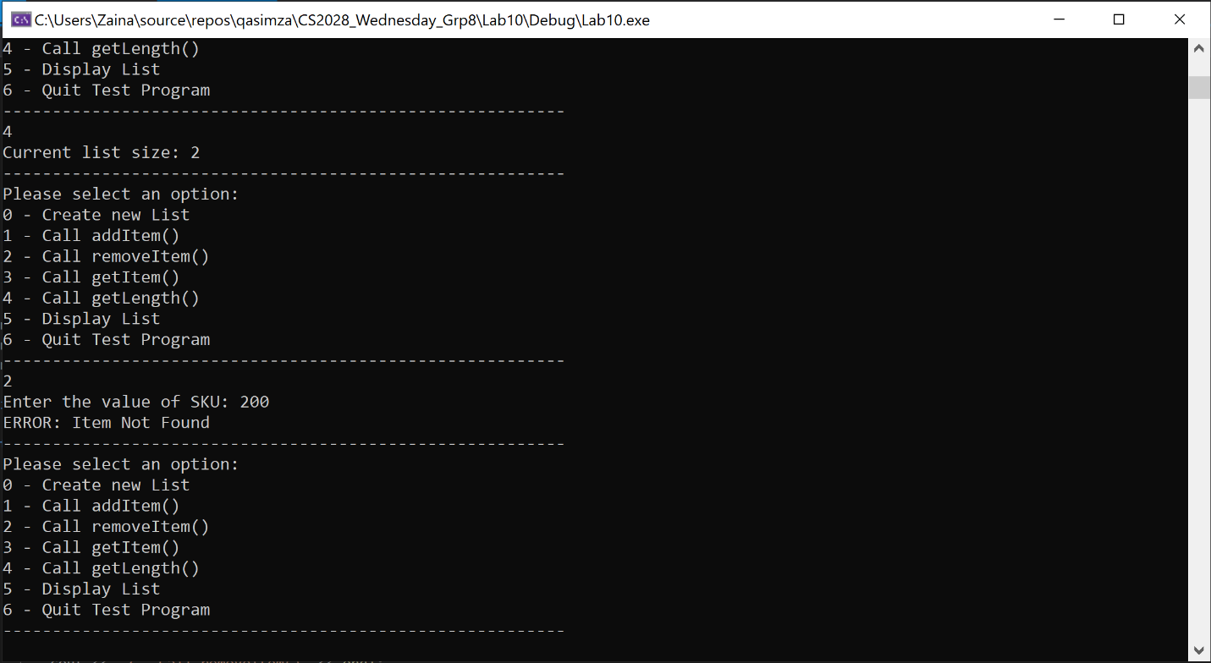

## ScreenSHOT 6: GET item

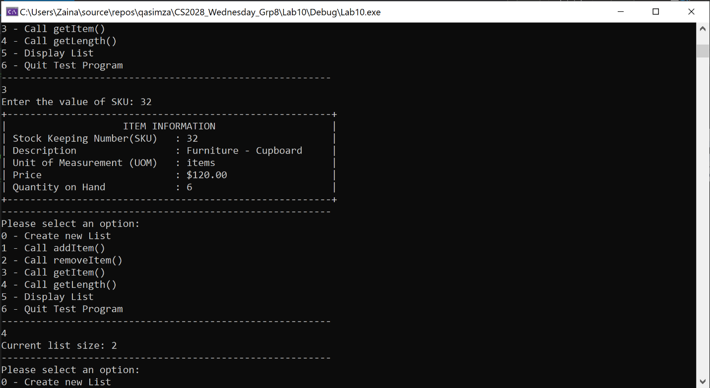

# Task 4: Screenshots (Testing Chained Hash Table)

## ScreenSHOT 1: Creating a new List and adding an Item

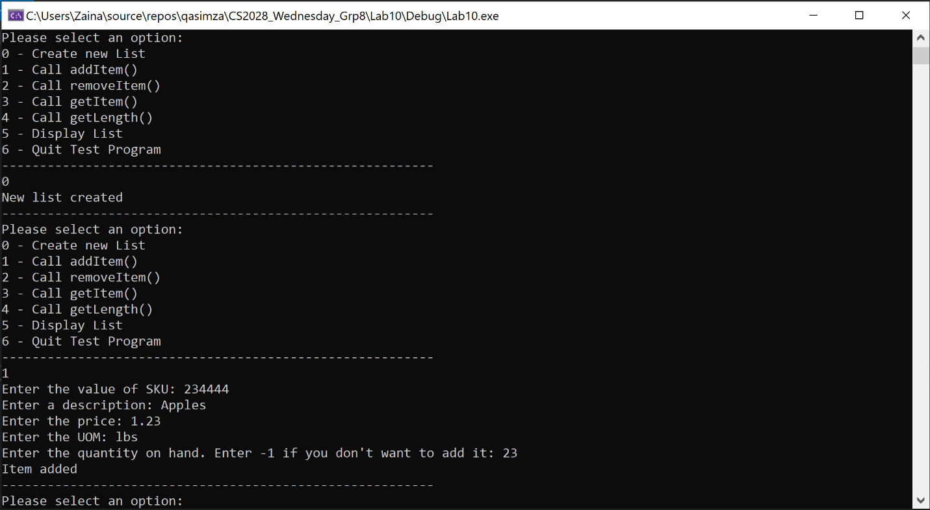

## ScreenSHOT 2: GET LENGTH AFTER ADDING THREE ITEMS

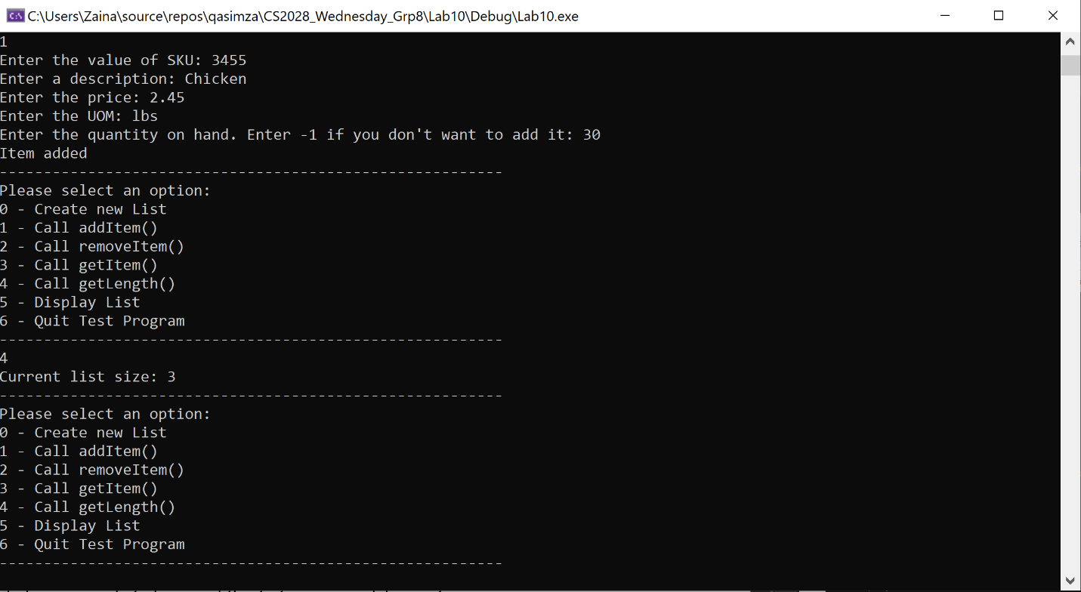

## ScreenSHOT 3: Removing an item (WHICH EXISTS)

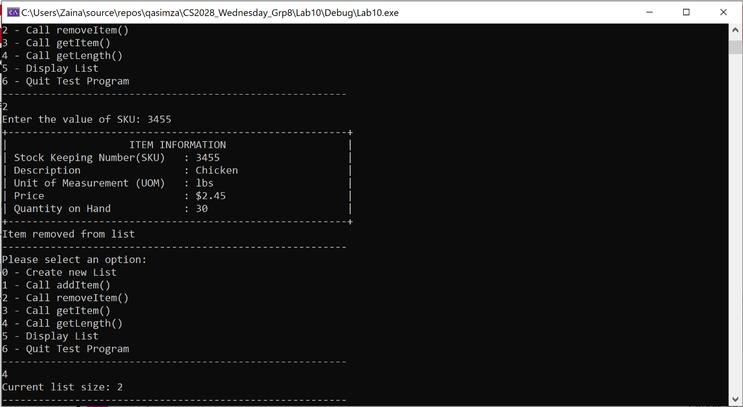

## SCREENSHOT 5: REMOVING AN ITEM (WHICH DOES NOT EXISt)

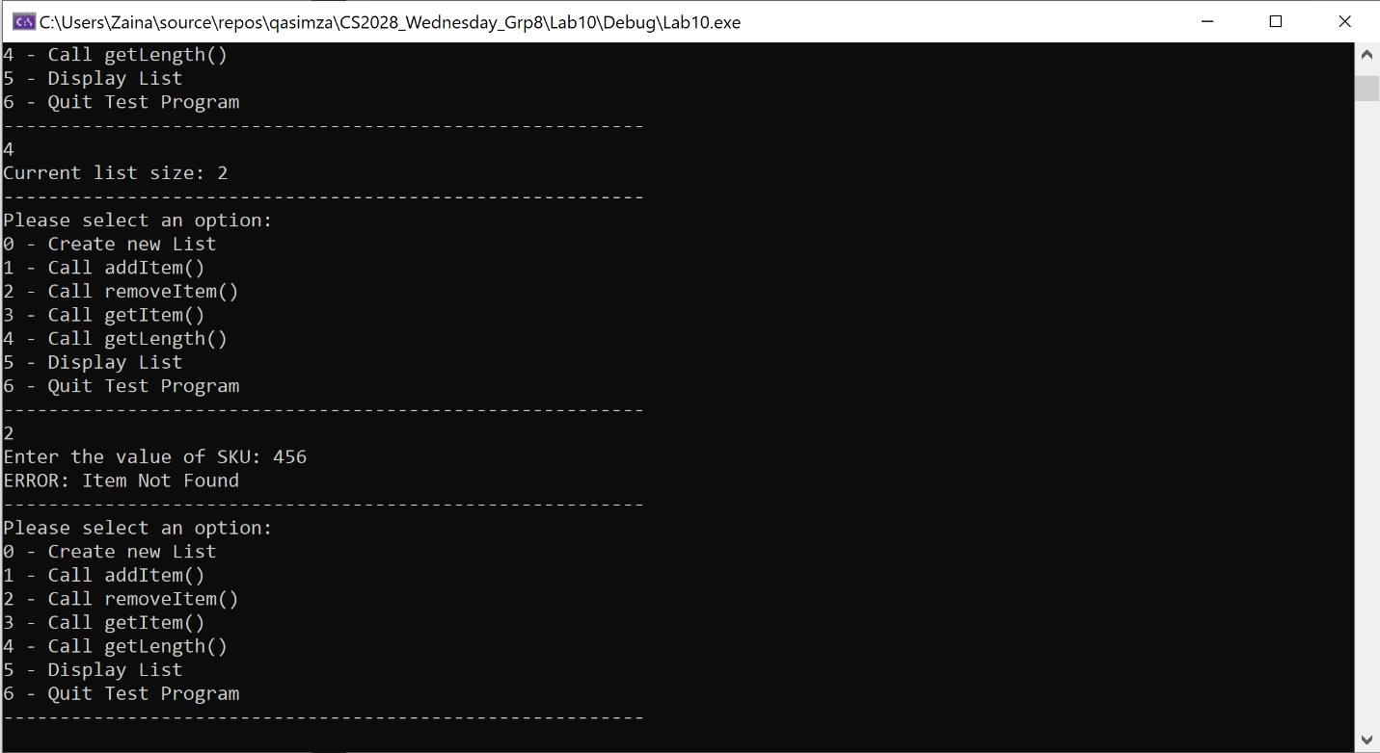

## ScreenSHOT 6: GET item

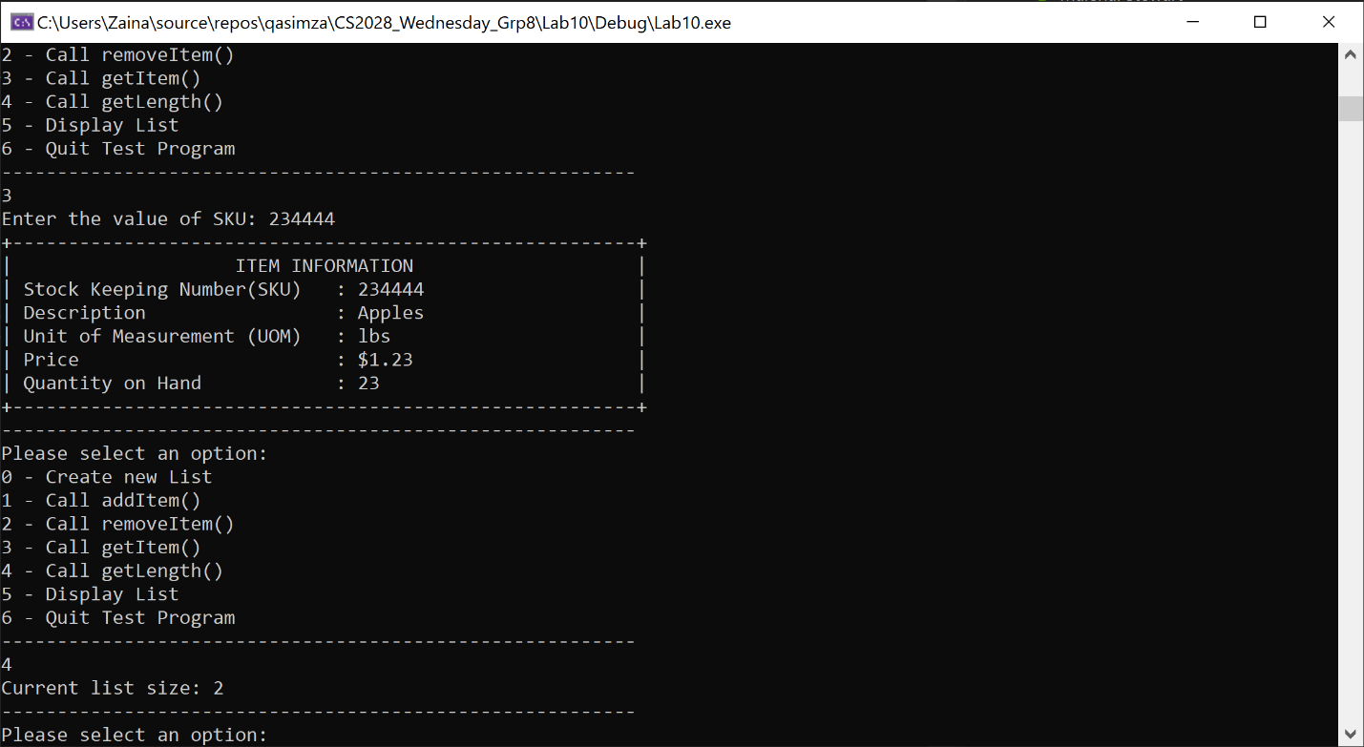

# Task 5: Table (Results of trials)

Table below shows the time taken to add and remove the given number of items from a Hash Table and Chained Hash Table respectively.

|  |  |  |
| --- | --- | --- |
| Array Size | Hash Table | Chained Hash Table |
| 50 | 11ms | 2ms |
| 150 | 47ms | 7ms |
| 200 | 77ms | 9ms |
| 250 | 134ms | 13ms |

## Screenshot for the table is given as under:

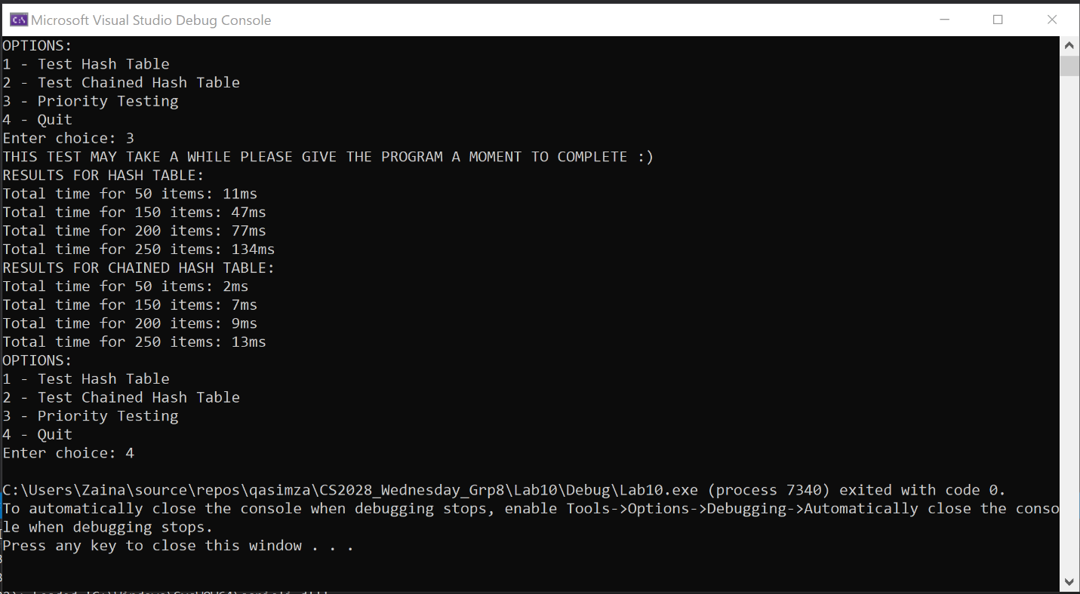

# User Instructions

Display List (HashTable.display() and ChainedHashTable.display()) is for internal testing ONLY.

Priority testing take upto 2 minutes. Please let the program run.

# Discussion: Modifications made for Task 2 and Task 3

For Task 2, we provided an overload for the string operator. As for Task 3, we wrapped up the relevant code from the main in the previous assignment into a function and switched out the ODLinkedList for Hash Table. Most of the code was reused, except for instances where we needed to explicitly declare/initialize a HashTable. Task 4 was done in the same manner.

# Discussion: Results for Task 5 and ideas for further investigation

As we can see in the screenshot above, HashTable takes nearly 10x as much time as Chained Hash Table to perform the same number of operations. We can say that Chained Hash Table is a more efficient data structure using the given hash function. We can try using different hash functions to compare the efficiency of these classes.

# Contributions

All members contributed an equal amount.