Step by step guide for eurocamp test:

1. **Run instructions**
2. **Screen shots**
3. **Technical details**
4. **Proposed improvements**

1- **Run instructions**

* API Bug fixed in PR: <https://github.com/qasirdev/engineering-test/pull/1>
* Clone repo from: <https://github.com/qasirdev/eurocamp-fe-test>
* `**npm install**` run command for the installation of dependencies
* `**npm run dev**` to run project
* `**npm run test**` to run tests
* 2- **Screen shots**:  
  **ERD of database with foreign keys:**  
  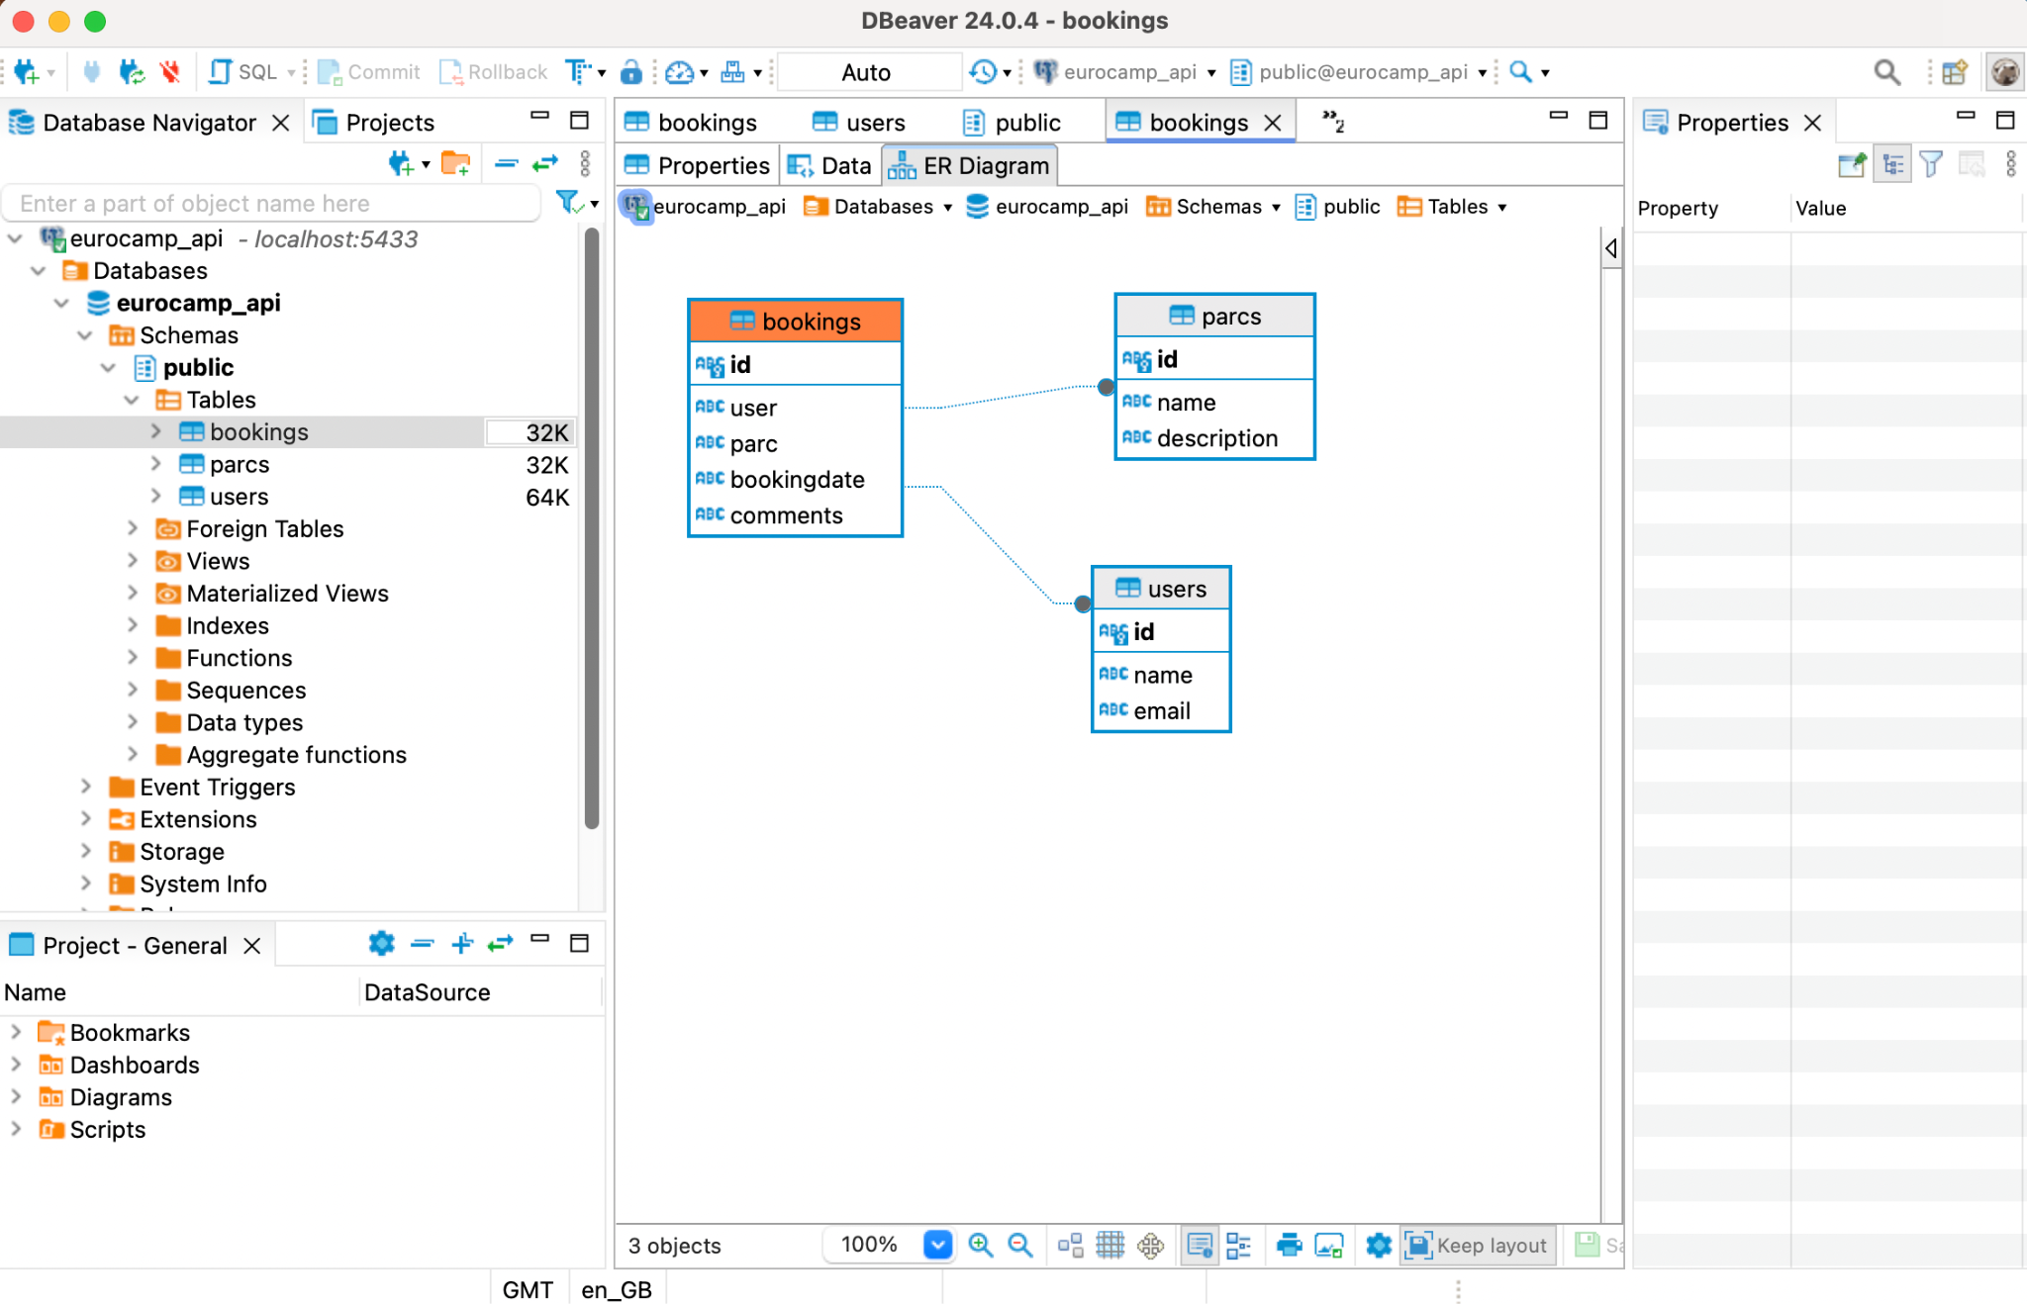
* **A- All Users Page:**  
   Add new user button  
   Displayed all users in [material ui data table](https://mui.com/material-ui/react-table/#customization) with Delete option and pagination  
  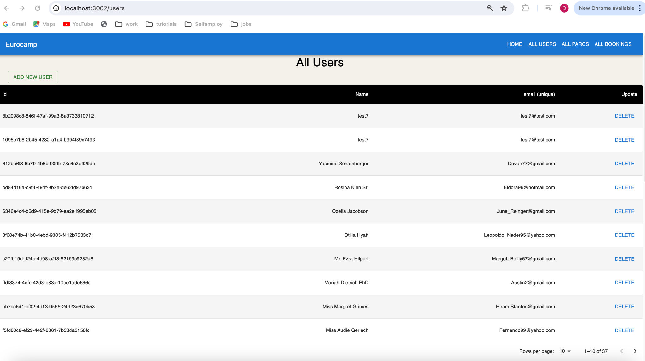

**B- Onclick of any user, navigation to booking page is provided:**  
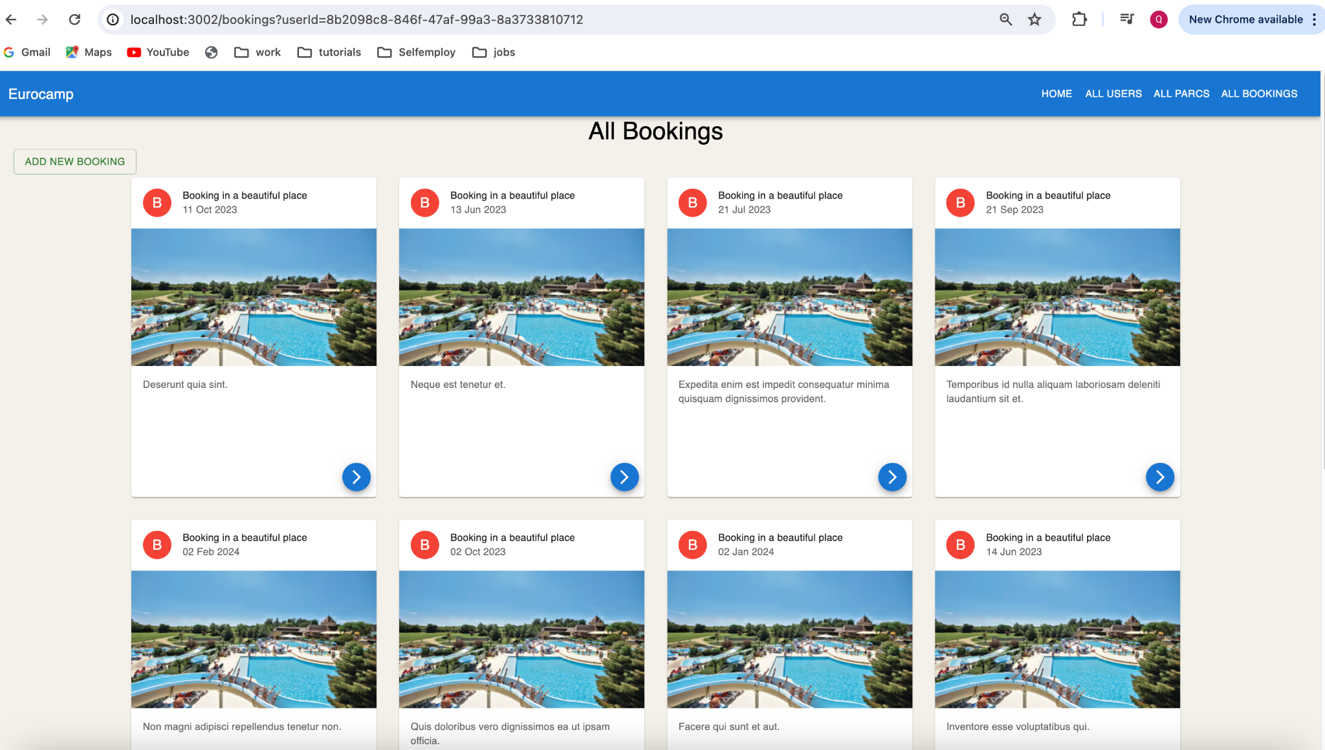

C- Add new user screen:  
 After successfully creating a new user, the system redirects to the **All Users** page.  
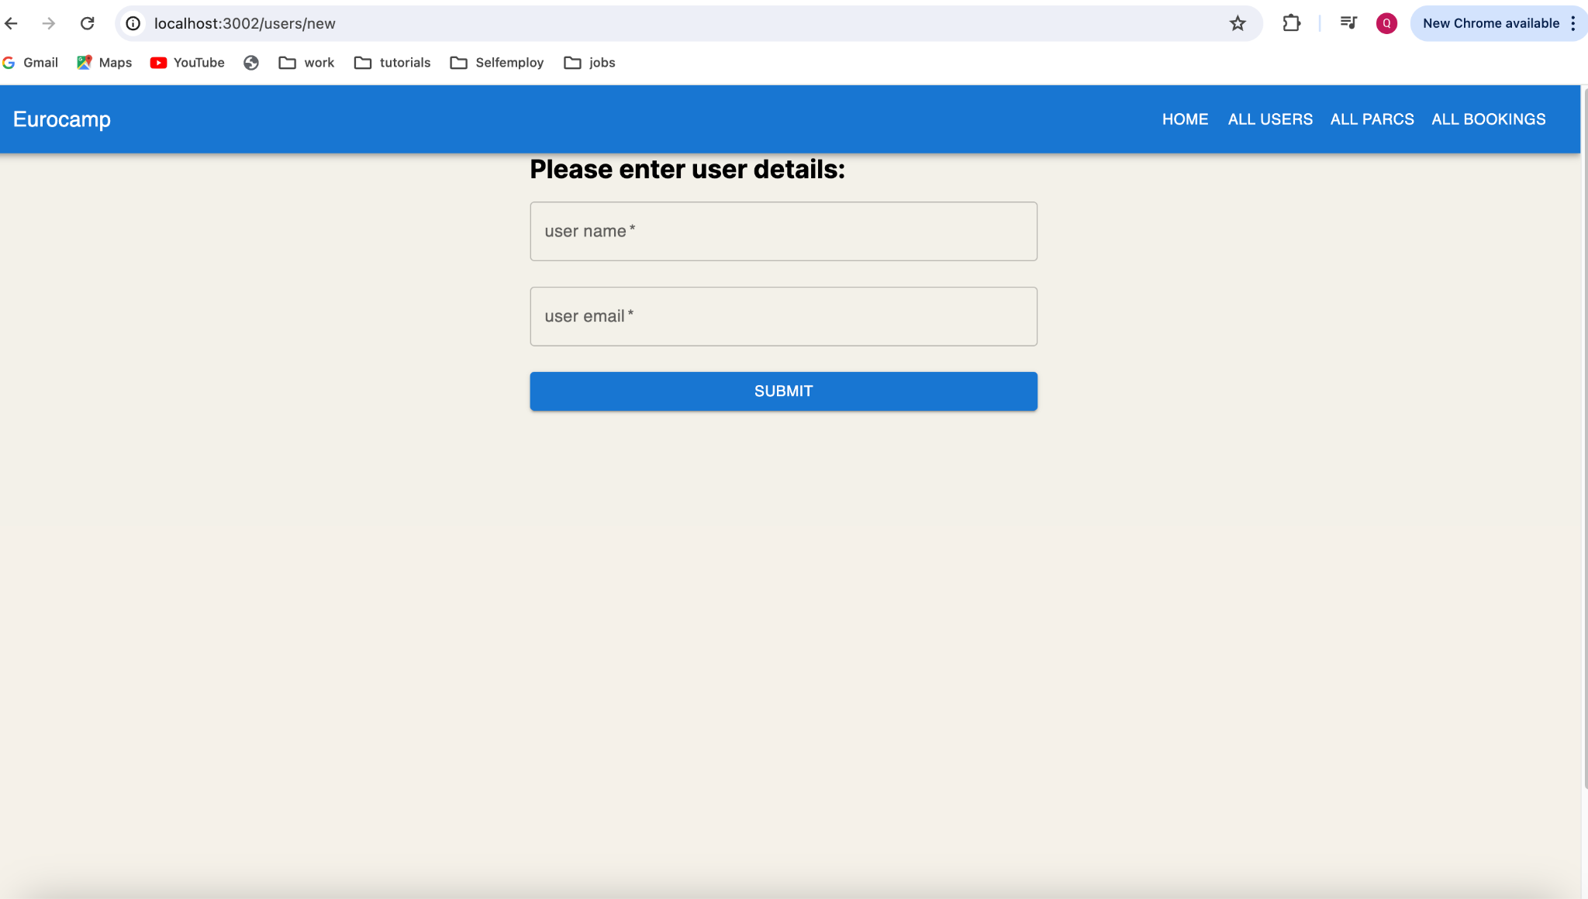

D- Deleter user screen:  
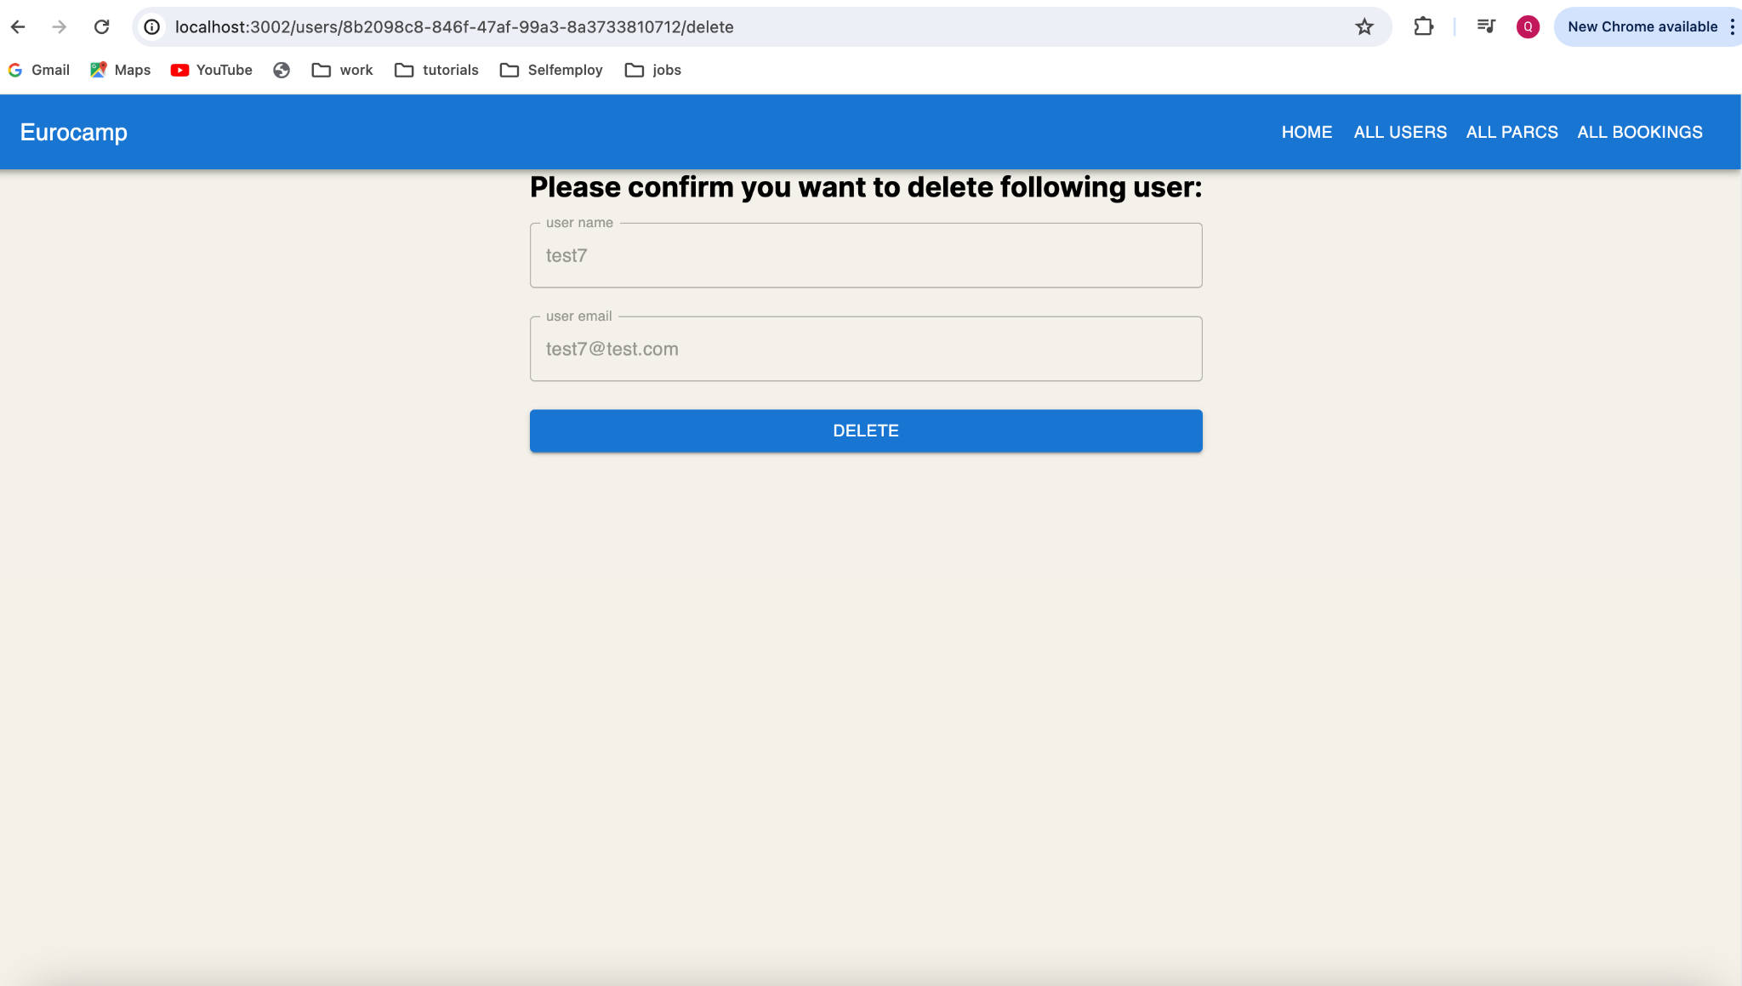

3- **Technical Details:**  
During this project used technologies:

* Created client application with Nextjs by using app router approach
* Used Redux to store all users in store for future use
* Used functional components based approach
* Used jest for unit testing

4- **Proposed improvements**

* We can use **msw** for mocking for testing (<https://mswjs.io/>)
* We can add more unit / integration with **jest** (<https://jestjs.io/>)
* We can add end to end testing with **Cypress** ( <https://www.cypress.io/> ) and **Cucumberjs** (<https://cucumber.io/docs/installation/javascript/>)