**Technical:**

* System build in Nextjs 14
* Redux is used with redux-persist
* Database is in a JSON file ./db.json
* If JSON file need to update , please copy data from ./db-original.json
* Avoid to use any database to avoid db login issue
* Used the “fs” library to update JSON file.
* Used tailwind, api for all meter readings, server actions for initial data
* Jest for testing

**Step by step flow:**  
Please select an account to proceed (mimic login scenario):  
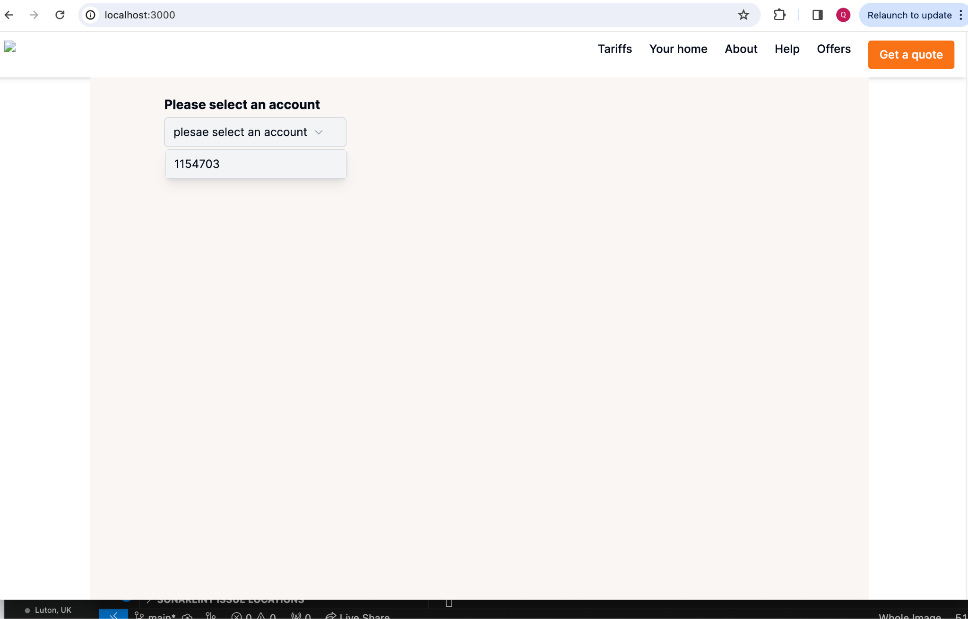  
  
After selection, system will redirect to accounts information(desktop) page:  
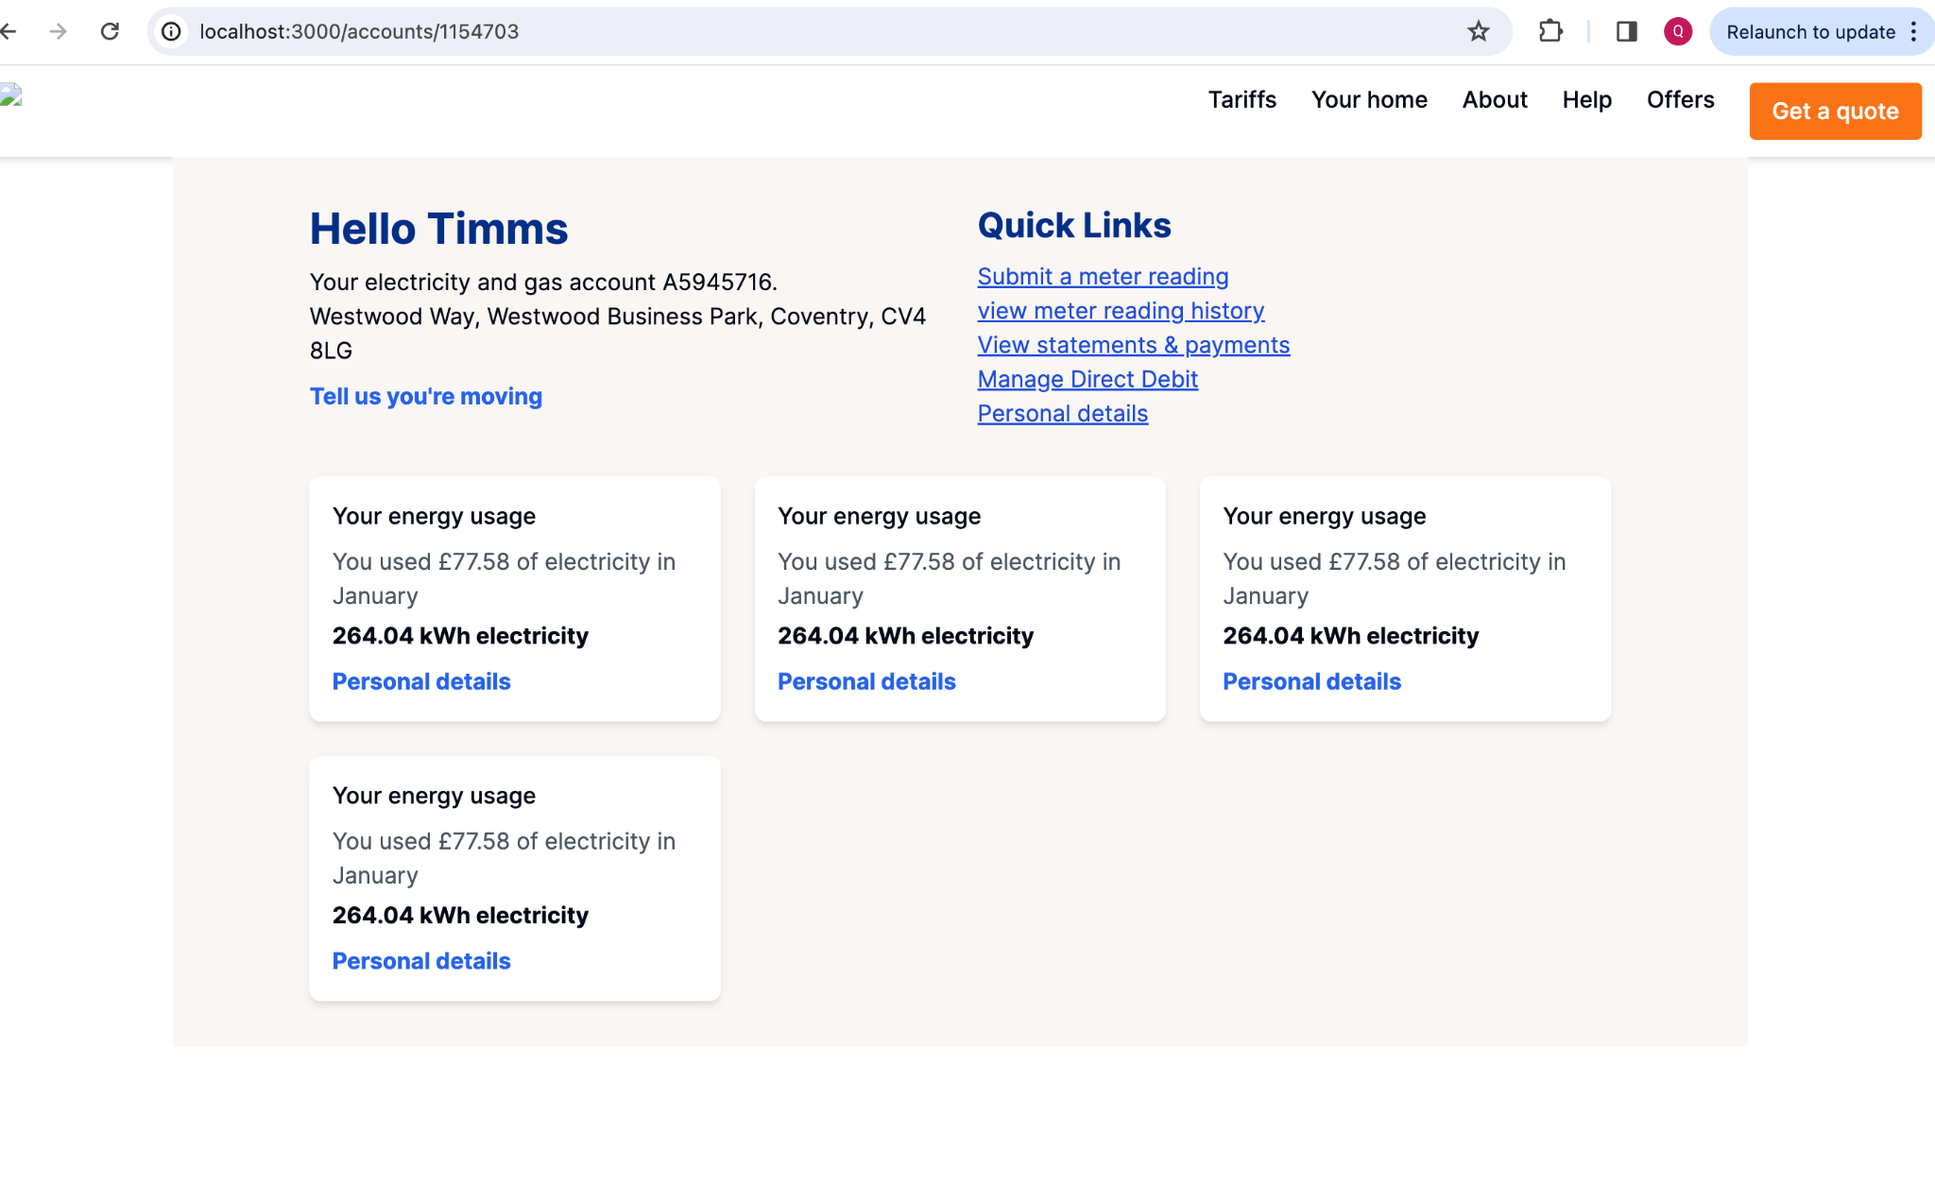

Customer can select top right side two links:

* Submit a meter reading (click on this link)
* View meter reading history  
  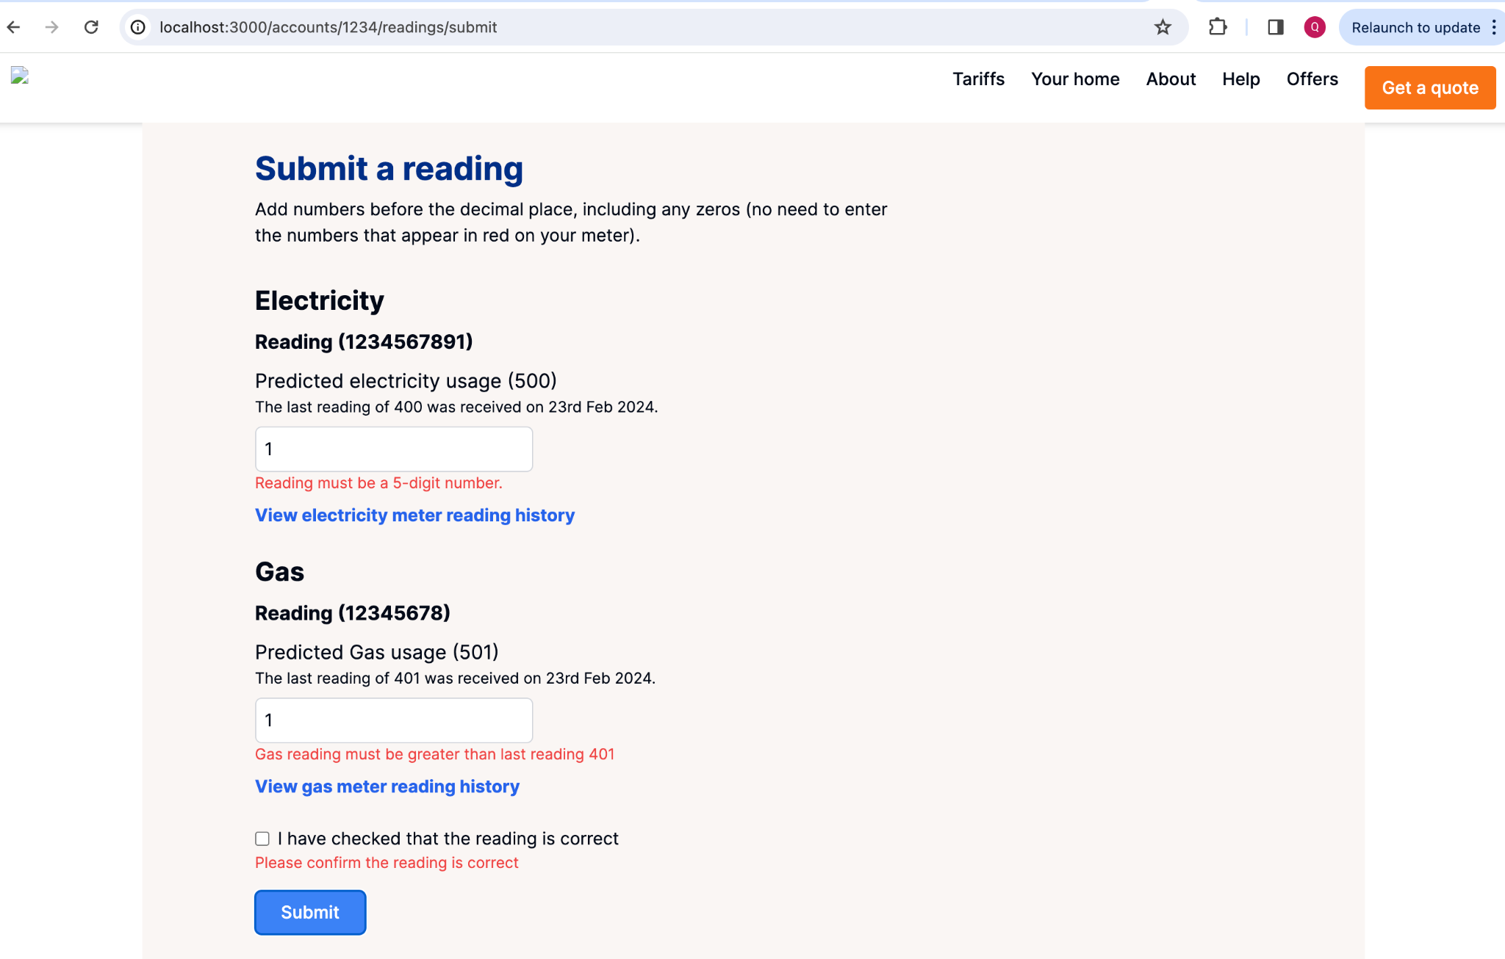

**Note**: above screen shot displaying both meter scenarios with meter id, predicted usage and last reading with data and time. If there is error it also displayed

Successful submitting values:  
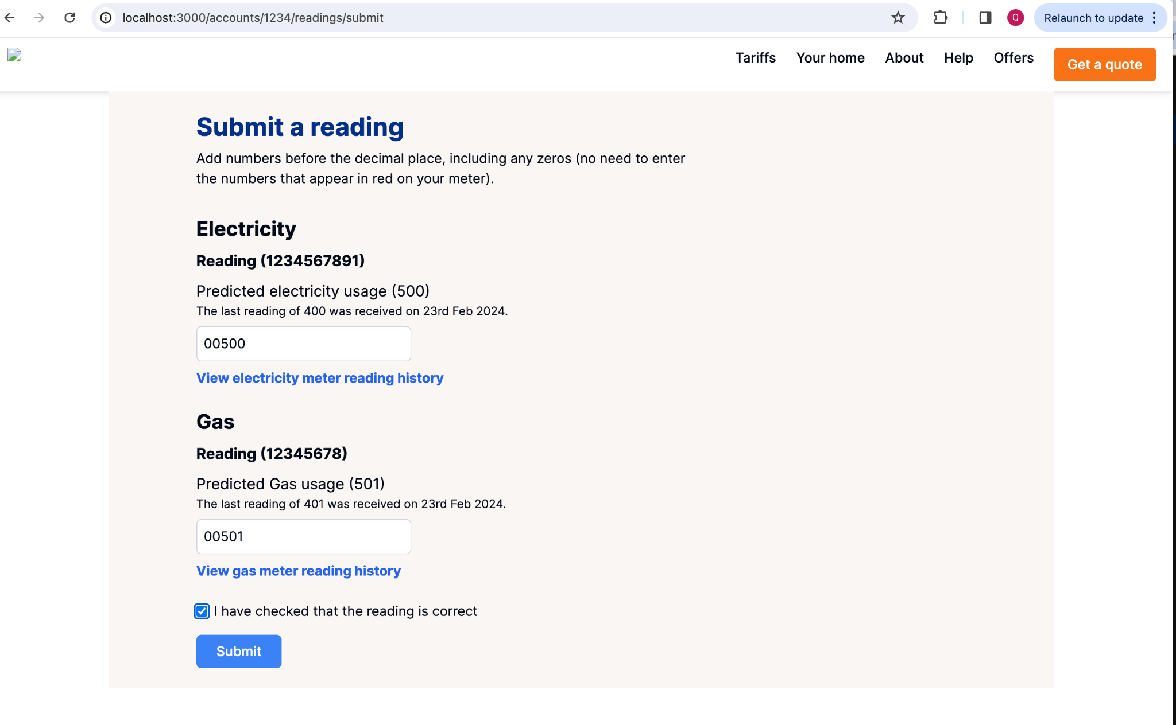

Thankyou page:  
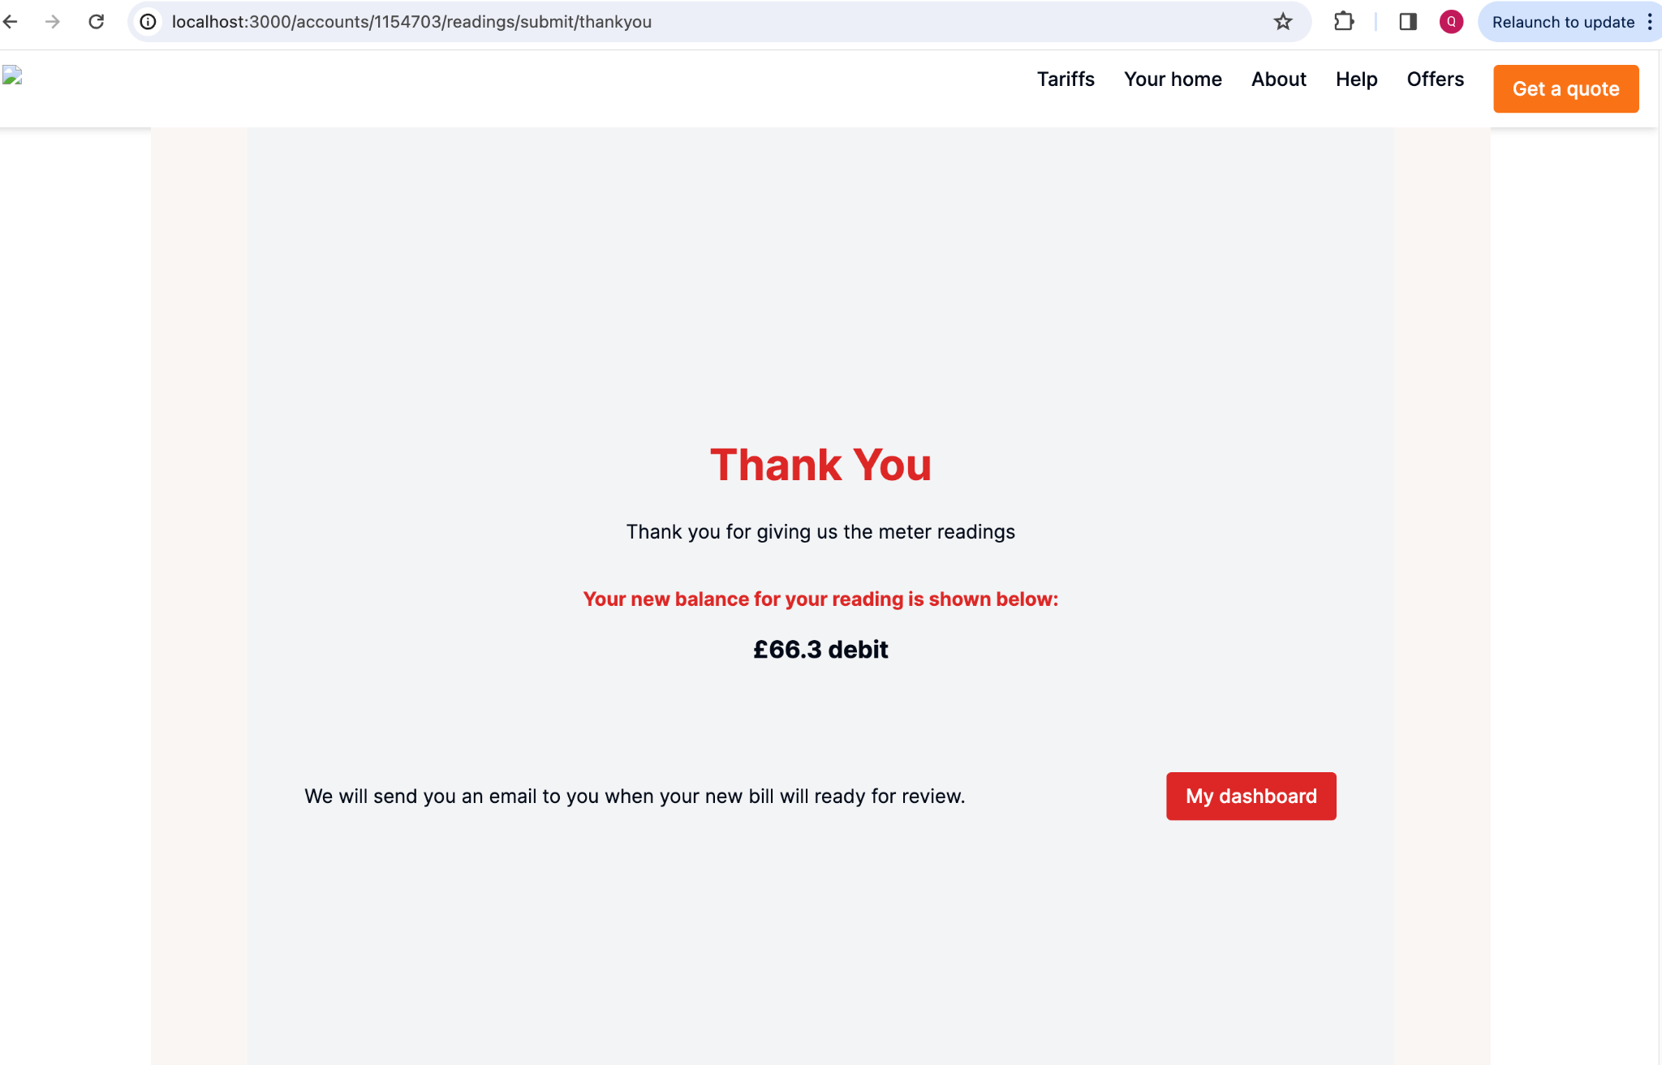

On dashboard, click on “View meter reading history”:  
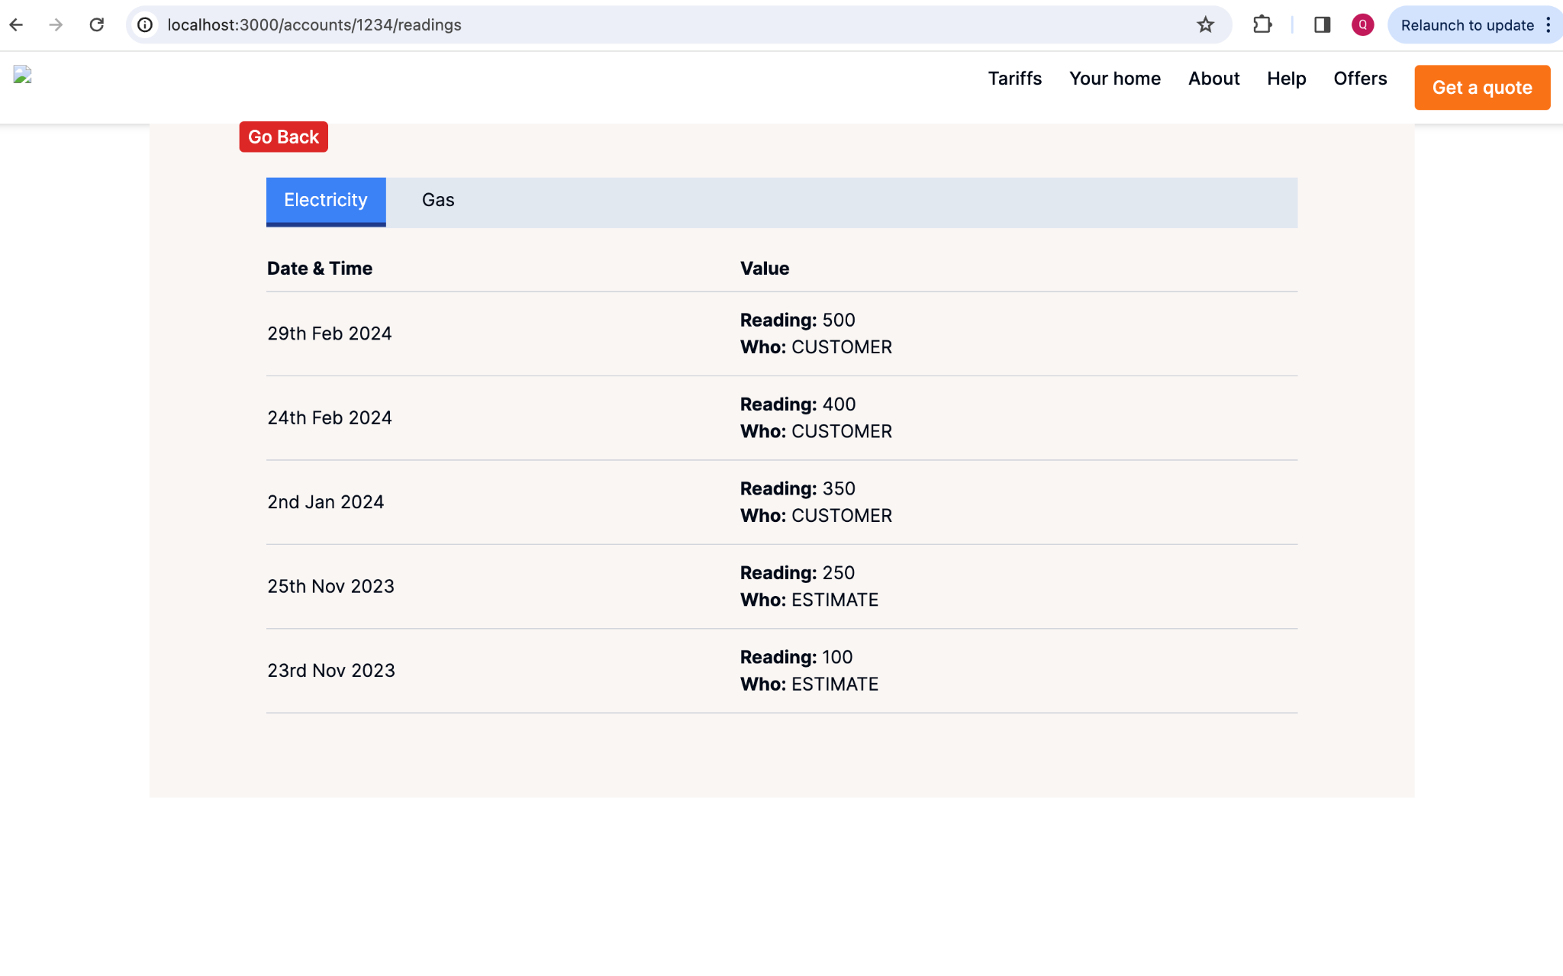  
  
**Please note**:

* There are some needs for further improvements like changing this system for a single fuel energy account.
* More test cases for the stability of the system.