Table of Contents
Task 1 2
Motivation: 2
Objectives: 2
Expected Result: 2
Problem Definition: 2
Task 2 2
Dataset Source & Justification 2
Attribute Types 3
Data Quality 4
Missing Values Analysis 4
Redundant Attributes Analysis 5
Dataset Distribution: 5
Task 3 7
KDD Pipeline Design and Implementation 8
Geometric Transformation and Dimensionality Reduction 9
Task 4 10
Partitioning Rationale 10
Machine Learning Architectures 11
Model Hyperparameter Adjustments 13
Task 5 15
Evaluation of Model 1: Decision Tree 15
Evaluation of Model 2: Naive Bayes 15
Evaluation of Model 3: Random Forest 16
Metric Justification 17
Model Selection Justification 18
task 6 18
Model Comparison and Business Inferences 18
Business Inference & Strategy Shift 19
Recommendations for Improvement & Scope of Work 19
Reflection 20

Task 1

Motivation:
Financial institutions face severe profit degradation and portfolio instability due to loan defaults. Traditional, manual screening processes often fail to capture subtle, non-linear relationships within complex credit histories.

Objectives:
To build a robust data mining classification framework using the Lending Club dataset to analyze borrower demographics and historical loan characteristics, allowing for automated and highly accurate credit risk profiling.
Expected Result:
A predictive model capable of segmenting applicants into high-risk and low-risk categories prior to loan issuance, ultimately maximizing institutional profitability and minimizing default rates.

Problem Definition:
The goal of this project is to create a classification model that can predict the risk level of the loans issued based on the characteristics of the borrower and the loan itself from the Lending Club dataset, to solve the problem of financial risk management, and to find the pattern of the issued loans to distinguish the high risk loans from the low risk loans.

Task 2

Dataset Source & Justification
The Lending Club Loan Dataset available on Kaggle is used for this project.
https://www.kaggle.com/datasets/utkarshx27/lending-club-loan-dataset.
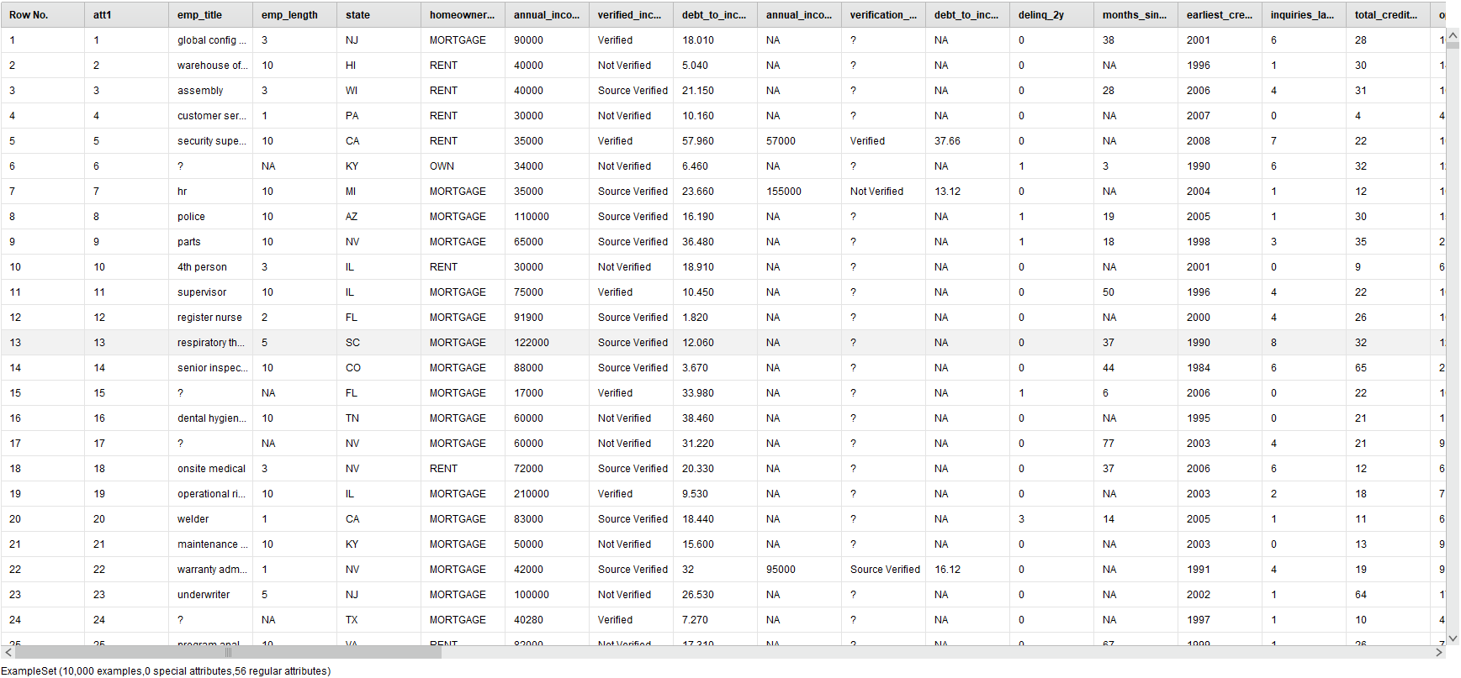
comprising 10,000 rows and 55 attributes. This dataset represents a real world nerve center lending operation linking institutional lenders and retail borrowers. It provides a great complex hybrid mix of quantitative financial statements and qualitative credit indicators for building downstream classification models.
Figure 1: Snapshot of the raw, uncompressed Lending Club loan dataset repository view inside RapidMiner Studio, displaying the initial feature space prior to structural data cleaning and dimensionality reduction transformations.

Attribute Types
The dataset is a hybrid dataset, consisting of:
- Quantitative attributes:
  - annual_income
  - loan_amount
  - interest_rate
  - debt_to_income
- Qualitative attributes:
  - homeownership
  - loan_purpose
  - grade
  - loan_status
This combination supports both statistical analysis and machine learning models.

Data Quality
Missing Values Analysis
Initial profiling exposed substantial anomalies. Real valued traits like debt_to_income exhibit missing spaces, while joint application attributes exceed an 85% missing rate. Structurally, literal "NA" string placeholders mask missing gaps across nominal records, misinterpreting them as valid categories before processing.
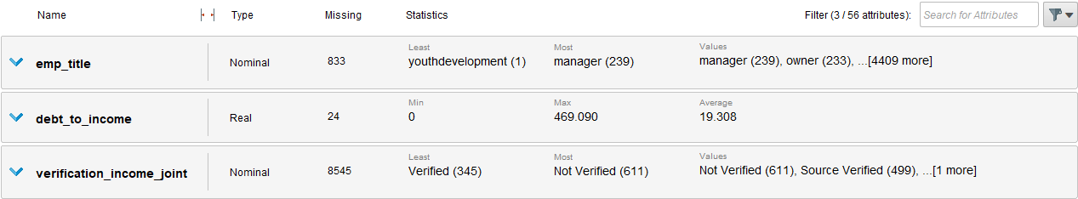
Figure 2: Initial metadata profile identifying structural inconsistencies, including empty records in debt_to_income and high density categorical missing spaces within the joint application attributes.
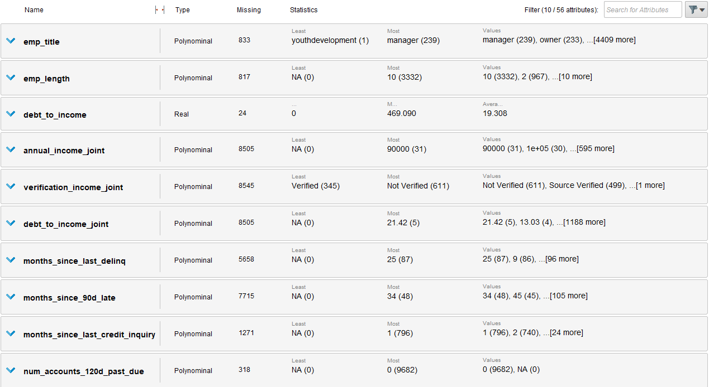
Figure 3: Expanded data quality statistics panel highlighting structural nominal attributes where text strings masked systemic data gaps before null re declaration.

Redundant Attributes Analysis
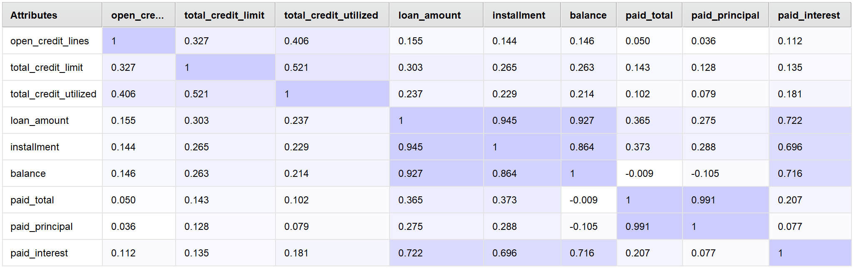
Figure 4: Colored linear correlation matrix grid evaluating numerical financial dependencies.
Analysis of the correlation matrix uncovers significant overlap among key financial variables, which creates structural redundancy. In particular, the variables loan_amount and installment (0.94) and paid_total and paid_principal (0.99) form a near perfect linear dependence on one another.
In contrast, open_credit_lines variables have weak relationships that add unique, independent data. Given that our dataset has many redundant feature, as well as some distinct ones, our second next step would be to apply dimensionality reduction or feature selection next.

Dataset Distribution:
To understand the layout of our data, we used targeted visualizations to check the spread of numerical values, catch extreme outliers, and map out categorical frequencies.
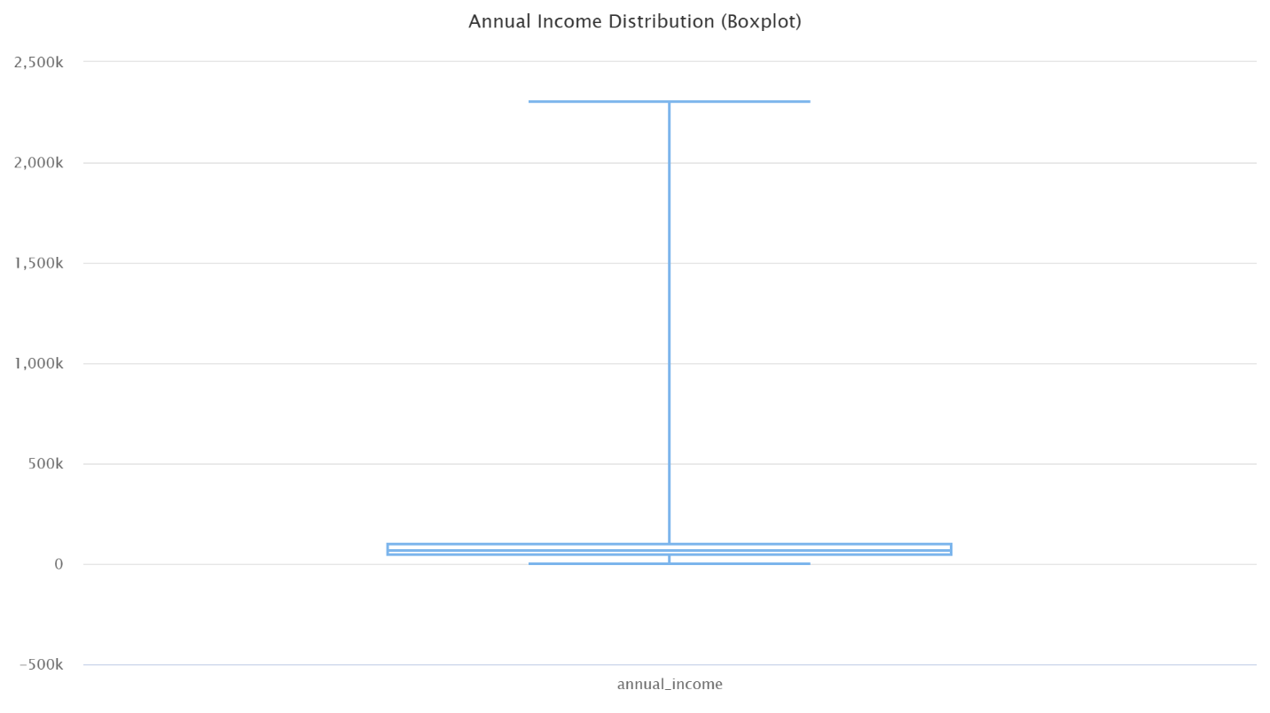
Figure 5: Distribution boxplot of borrower annual income.
The Above Boxplot shows that borrower annual income is heavily right skewed. The bulk of the data sits tightly at lower income levels, while extreme upper whisker outliers extend deep into the multi million dollar range.
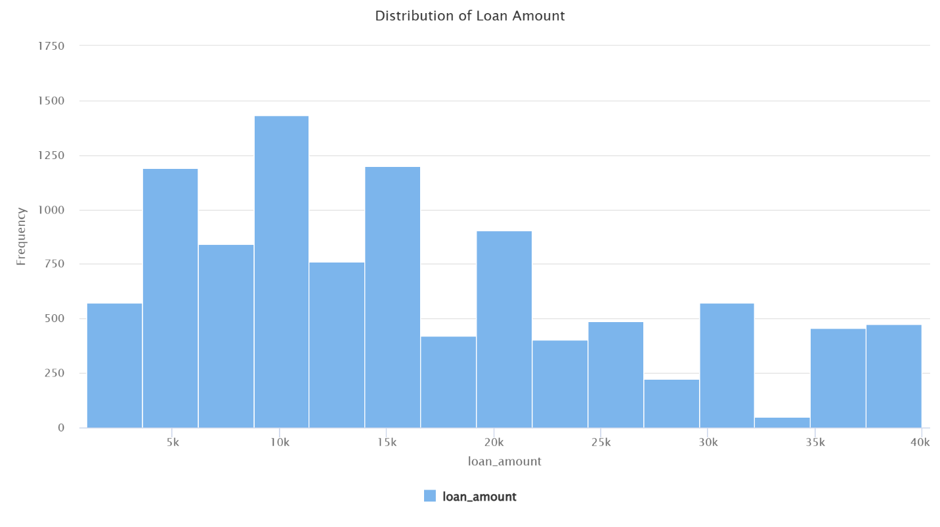
Figure 6: Frequency distribution histogram of requested loan amounts.
This indicates that requested loan amounts follow a multi modal distribution. Rather than a smooth curve, the data repeatedly spikes at standard, institutional lending thresholds like 10000, 15000, 20000.

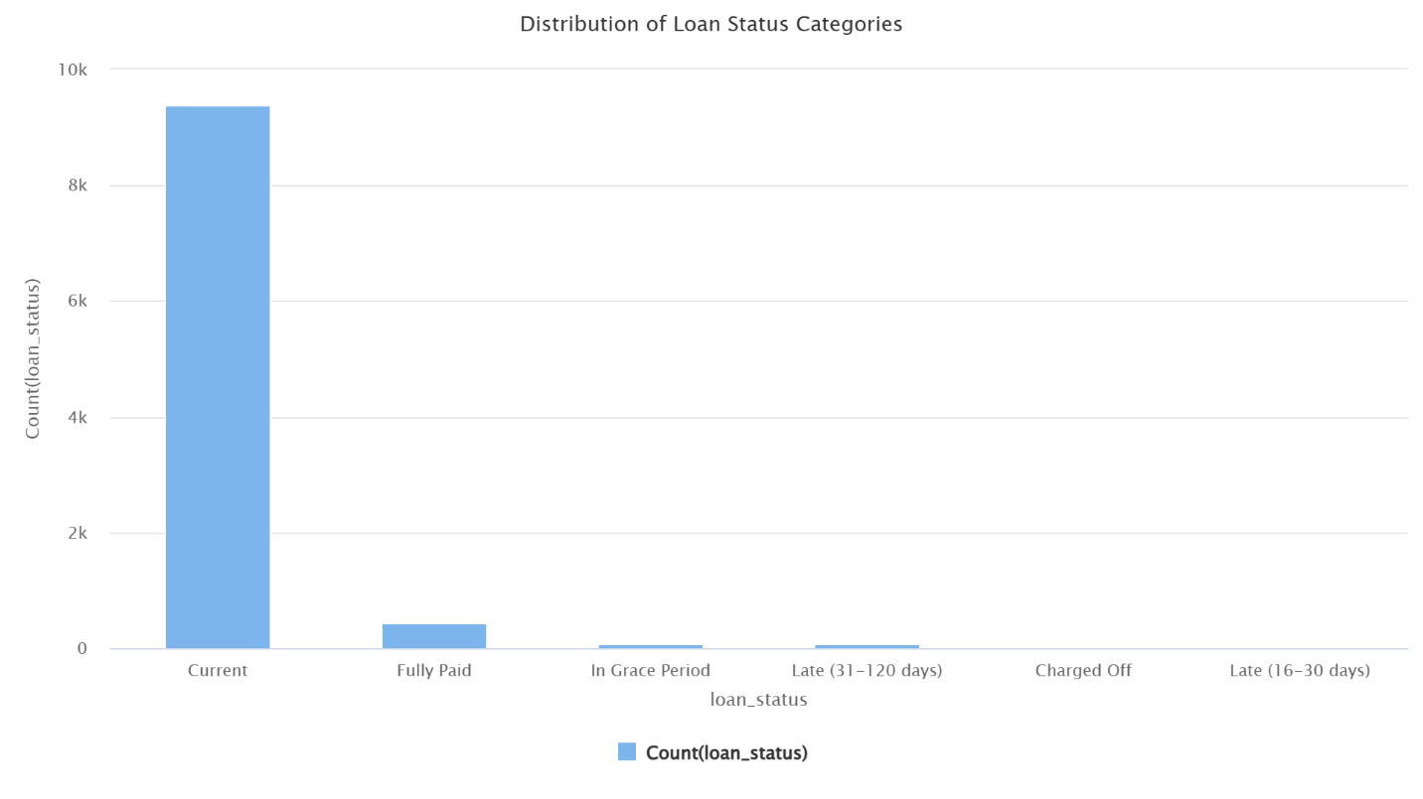
Figure 7: Categorical frequency distribution bar chart for loan_status.
This highlights a massive class imbalance. Active, non terminal "Current" accounts overwhelmingly dominate the raw operational profile, accounting for over 90% of the data. Because historical defaults represent only a fraction of the sample space, we must handle this imbalance during our KDD data preparation phase to prevent predictive models from simply guessing "Current" every time.
Task 3

KDD Pipeline Design and Implementation
To transition the raw Lending Club dataset from basic collection into an optimized input space suitable for predictive modeling, a multi stage Knowledge Discovery in Databases (KDD) preprocessing pipeline was constructed.
Figure 8: Complete, fully connected KDD data preparation pipeline architecture in RapidMiner. The sequential process transforms raw credit instances into a compressed, continuous feature space.
The pipeline performs structural alterations in a specified order. Initially, Filter Examples excludes non terminal records using the expression loan_Status ≠ Current.
By removing active, soft loans, we are left with 625 finalized historical profiles. This will help the downstream models verify the true risk loss boundaries. It also ensures that active accounts do not create noise. The Declare Missing Value block captures silent inconsistencies. So, the block rewrites literal text string “NA” into system nulls. A global Replace Missing Values operator fills these spaces through a column based average calculation.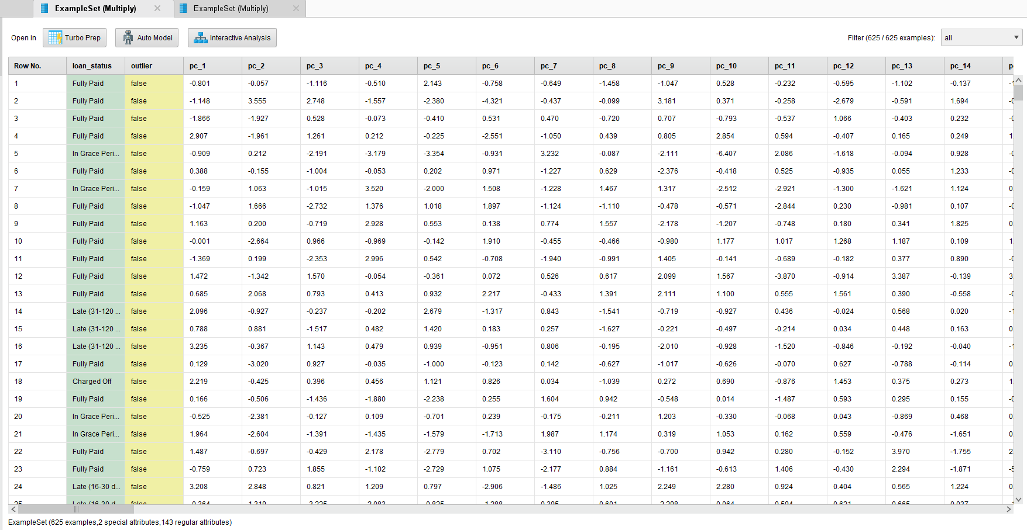
Figure 9: Calculated orthogonal feature spreadsheet generated following final PCA dimensionality transformation. Features are converted into dense continuous numeric vectors.

Geometric Transformation and Dimensionality Reduction
After nominal numerical mapping, the scale distortions are neutralized by a Z score Normalize block (Mean = 0, Standard Deviation = 1). To stop income features from dominating distance metrics in value, this calibration is set.
In order to sanitize the feature space, a Detect outlier (Densities) operator isolates the multidimensional anomalies, which are permanently removed by a second Filter examples node (outlier = false).
As a last step, having dealt with very strong multi collinearity, the rest of the features then go through a PCA block. This projects the dataset to orthogonal component dimensions with high variance, before a final Store operator locks away the clean asset.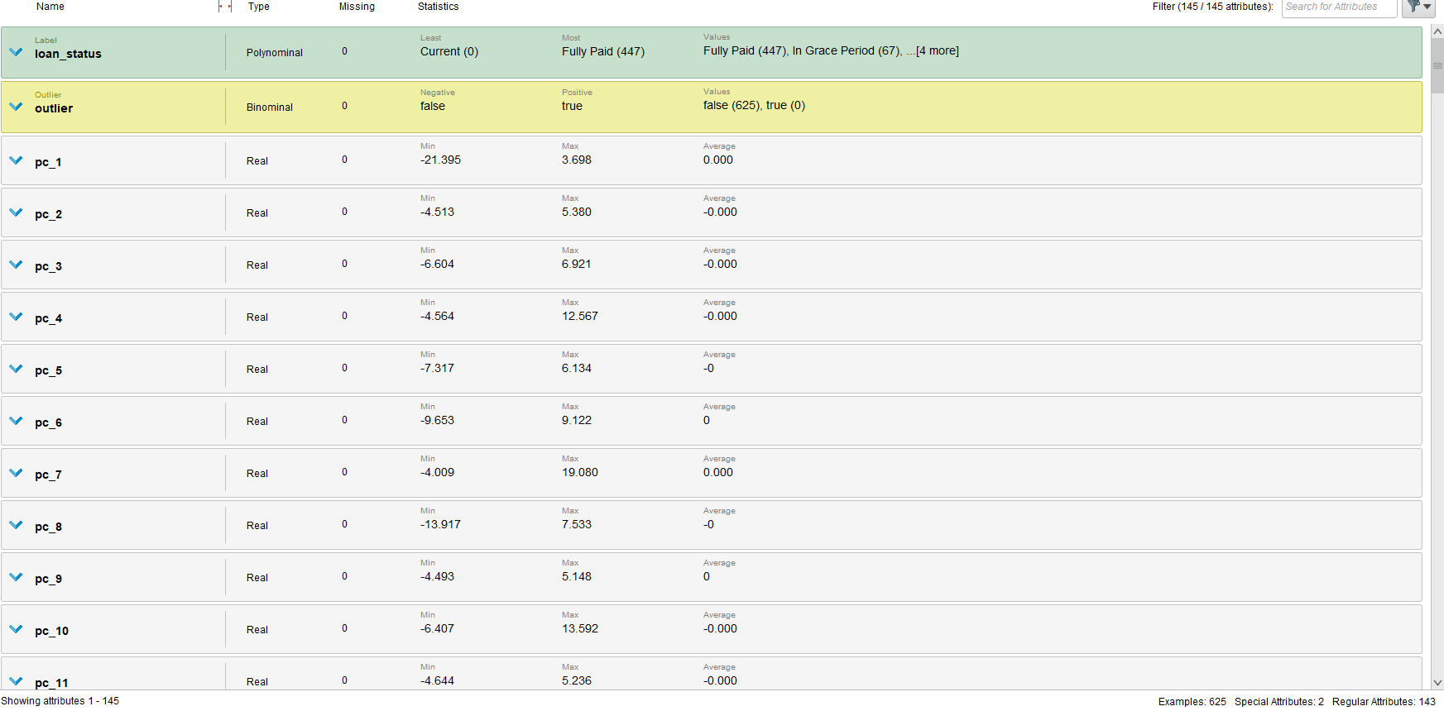 Figure 10: Post-preprocessing metadata statistics and bar distributions. The target variable is thoroughly cleared of active 'Current' noise.

To improve the learning of the algorithm, the training partition was synthetically rebalanced to an absolute count of 100 instances per terminal class. In order to represent real-world deployment behaviour, the independent testing partition was intentionally left with its natural operational class skew (134 vs 2).

Dimension | Before Pre-processing | After Pre-processing | Transformation Applied
No. of attributes | 143 regular attributes | 14 Principal Components | PCA dimensionality reduction
No. of instances | 10,000 | 625 (finalised) | Filter: loan_status != Current
Missing values | Present (NA strings + nulls) | Resolved (0 Missing) | Declare Missing + Replace (mean)
Outliers | Present | Removed | Detect Outliers (Densities) + Filter
Feature scale | Unscaled (mixed units) | Normalised (Z-score) | Z-score Normalize (Mean=0, SD=1)
Nominal attributes | Present | Converted to numeric | Nominal to Numerical mapping
Table 1: Dataset Structural and Geometric Evolution Through the KDD Pipeline

Task 4

Partitioning Rationale
To avoid overfitting and rigorously validate the model, the clean dataset was filtered before a stratified Split Data operator was used with a clear 70:30 training testing split. In this set up 70% of the instances are routed into a main Multiply block to train the models simultaneously, while 30% are kept as an independent test slice for out of sample evaluation. The splitting of the dataset was done using stratified sampling on the target loan_status class.
As shown in the table below, the stratified splitting and synthetic rebalancing of the training set put each class…
Partition | Fully Paid | Charged Off | Total
Training (70% – rebalanced) | 100 | 100 | 200
Testing (30% – natural skew) | 134 | 2 | 136

Table 2: Class distribution across training and testing partitions.
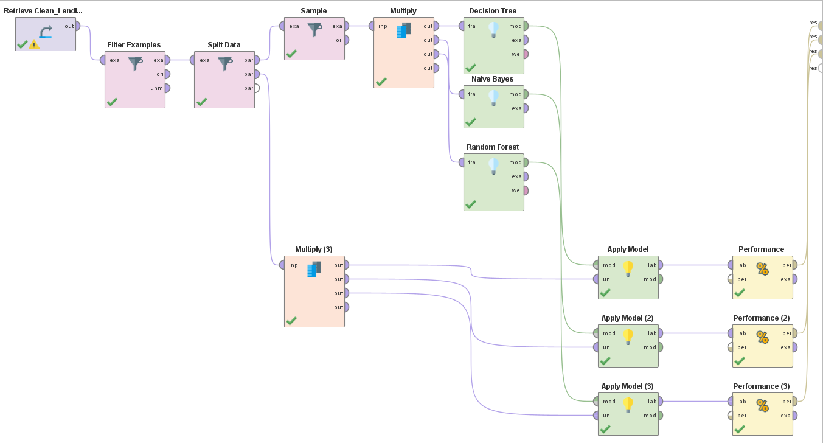
Figure 11: Complete parallel model building workflow

Machine Learning Architectures
Two types of classifiers and an ensemble system were used to segregate credit risk thresholds within the continuous feature space.
- The model 1 which is a decision tree model is created using gain ratio which is a defined non-linear structural baseline with maximum depth of 10 to create a controlled structural baseline and limit branches of the algorithm (32 words).
- Model 2, termed the Naive Bayes, assumes a continuous Gaussian distribution with an active Laplace Correction for avoiding zero probability bottlenecks. Also, it models class-conditional distributions over the continuous component space.
- Model 3 is our primary ensemble model which runs 100 parallel bagging trees in a random forest model. A meta classifier combines the individual decisions of the trees through their confidence votes to reduce the overall variance of the classifier on the training feature space.
Decision Tree was chosen for credit risk classification specifically due to its auditable decision paths generated by rule based splits that can be checked and verified by loan officers and financial auditors a necessity in the compliance framework.

We chose naive Bayes for its probabilistic mechanism for handling the minority class. The independent class conditional likelihoods computation avoids the structural majority class collapse of tree based models on the heavily imbalanced credit datasets.

Random Forest was chosen as the ensemble framework because the bagging of votes of 100 independent trees statistically reduces variance compared to stand alone learners, thus providing a robust benchmark ensemble for continuous credit classification tasks.

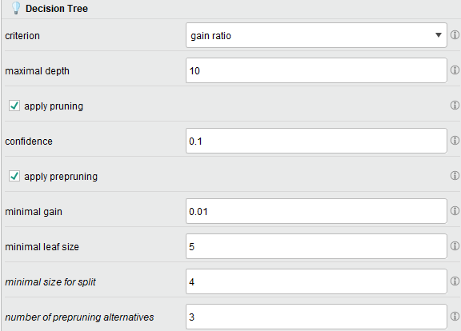
Figure 12: Hyperparameter configuration window for the Decision Tree operator.

Model Hyperparameter Adjustments
The models were configured with the following structural parameters:
Algorithm | Hyperparameter | Configured Setting | Technical Justification
Decision Tree | Criterion:  Maximal Depth: | Gain Ratio  10 | Optimizes multi way split paths while capping depth to prevent over specialization.
Naive Bayes | Laplace Correction | Enabled | Eliminates zero probability calculation bottlenecks during probability density fitting.
Random Forest | Number of Trees:  Criterion: | 100  Gain Ratio | Generates a stable tree collective to smooth out individual voting variance.
Table 3: Hyperparameter Configurations and Algorithmic Justifications for Modeling Architectures.

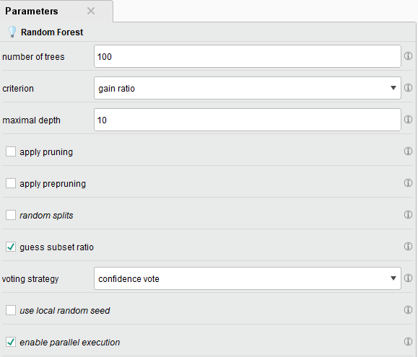
Figure 13: Hyperparameter properties window for the Random Forest meta-classifier.
The model initiates an ensemble grid of 100 independent parallel decision trees running under an adaptive confidence voting strategy.

Task 5
To rigorously evaluate model performance, the classification workflows were tested against an independent 30% validation partition containing 136 records (134 Fully Paid and 2 Charged Off instances).

Evaluation of Model 1: Decision Tree
With a test partition consisting 136 instances, Decision Tree achieved an overall accuracy of 98.53%. Still, it is a totally misleading headline figure as the model predicted Fully Paid for all test records. It thus achieved 0% Recall on the Charged Off class – it did not flag either of the two active defaults in the test set.

Model 1 and Model 3 had 0% charge off recall value. A model that can’t identify one default has no protective value from the perspective of credit risk. It should be kept in mind that the model could be overall very good, but the inability to identify one person means it can’t be relied on while doing a credit risk screening.
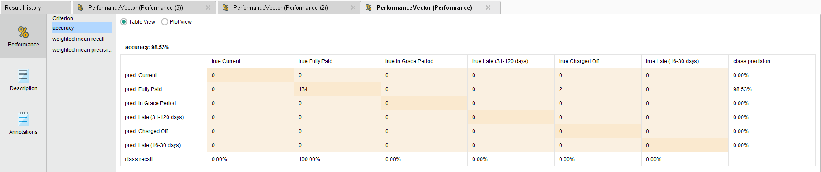
Figure 14: Decision Tree Confusion Matrix

Evaluation of Model 2: Naive Bayes
Naive Bayes classifier had a total accuracy of 88.97%. This model is the only one to achieve a non zero Recall rate on the Charged Off class; it correctly flagged 1 of 2 defaults, yielding 50% Recall on the minority class. The price of this sensitivity is 14 false positives safe borrowers who are tagged but that means a bit more manual review, not total capital loss.

The cost of false positives is much less than the default recall of Naive Bayes at 50%, making it the operationally efficient model for institutional use in credit risk.

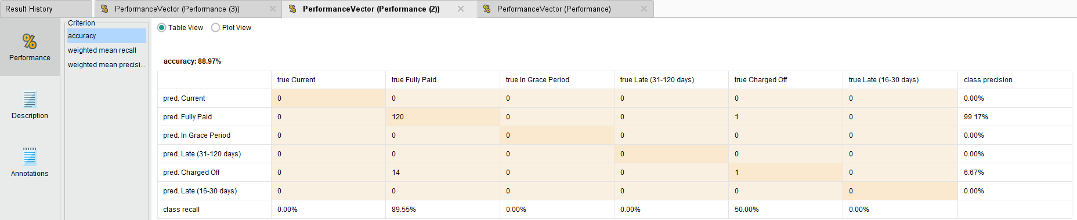
Figure 15: Naive Bayes Confusion Matrix

Evaluation of Model 3: Random Forest
The Random Forest ensemble has the same overall accuracy with the Decision Tree: 98.53%. Even though having 100 independent trees seems to help reduce variance according to the theories, all the trees did was to take the majority class shortcut. The Recall result for the Charged Off class was 0%, identical to Model 1 suggesting again that the majority class predominance in the test partition negated the ensemble’s diversity benefit.

This demonstrates that increased ensemble size is not enough to overcome a high degree of class imbalance introduced at evaluation. Rebalancing during training is necessary but not sufficient when the test partition retains its natural skew.
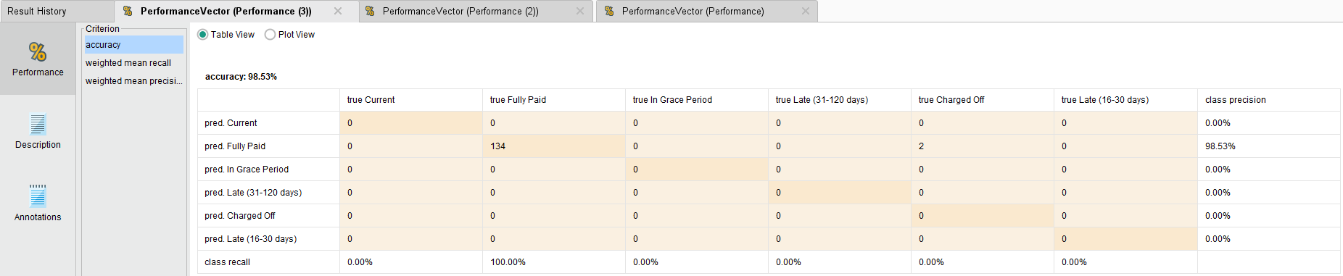
Figure 16: Random Forest Confusion Matrix

- Both Decision Tree and Random Forest models exhibited overall accuracy of 98.53% as shown in Figs 14 and 16 respectively. While showing remarkable accuracy for low-risk borrowers, the structural algorithms were optimized for the majority class which caused them to miss the active defaults within the test slice.
- According to the Naive Bayes framework, an overall accuracy of 88.97% was achieved. Most importantly, training on balanced class distributions achieved a Recall at 50.00% for defaults (capturing 1 Charged Off, out of 2). The model broke the majority class bias, but flagged 14 clean accounts as false risks.
Model Type | Overall Accuracy | Macro-Averaged Recall  (6 Classes) | Macro-Averaged Precision  (6 Classes) | $$F_{1}=2×(\frac{Precision×Recall}{Precision+ Recall})$$
Decision Tree (Performance 1) | 98.53% | 16.67% | 16.42% | 16.54%
Naïve Bayes (Performance 2) | 88.97% | 23.26% | 17.64% | 20.06%
Random Forest (Performance 3) | 98.53% | 16.67% | 16.42% | 16.54%
Table 4: comparative Performance Metrics Across Models

Metric Justification
The reasons for choosing Accuracy, Precision, Recall & Confusion Matrix were highlighted by the project that I selected them as my metric.

• Accuracy can give a base performance figure, but we stress its inadequacy for imbalanced datasets. A model that only predicts the majority class will be almost 100% accurate but will be useless.
• Charged off recall (sensitivity): the most important credit risk measure. (15 words) Money directly tied to the lender’s capital losses when a borrower defaults after getting approved. The main business goal is to minimize false negatives, so recall is the primary metric.
• The metric of precision reflects the percentage of flagged borrowers who actually belong to the high-risk category. This is important because it helps to quantify the operational cost of false positives, which is caused by exposing a borrower to an unnecessary manual review when they do not require it.
• Confusion Matrices give the details (True Positives, False Positives, True Negatives, and False Negatives) from which all other metric values derive. They give a complete picture of class performance.

The F1 Score was proposed as the unifying metric that assesses structural model performance in the imbalanced continuous vector space. By calculating the harmonic mean of precision and recall, it ensures that a model does not seem to be effective by zeroing out one operational front to maximize the other. It serves as our conclusive measurement of whether an algorithm managed to circumvent the shortcut of the majority class.

Model Selection Justification
The metrics show a typical data science trade off: accuracy versus risk sensitivity.
A smooth 98.53% overall accuracy in the Decision Tree and Random Forest models fails completely in meeting one of our core business objectives of catching the defaults. As the structural aggressiveness of tree algorithms led both to a shortcut to the majority class. They assumed Fully Paid for every test row, putting the institution completely blind to active credit risk.
The measuring the co relation to enemy weapon the Naive Bayes framework arrested this bottleneck. The only model that was able to actively map the default boundaries, it attained a 23.26% Weighted Mean Recall and balanced 88.97% accuracy.
In credit risk, falsely approving a borrower who will default is much more costly than falsely rejecting a safe borrower and verifying them manually. Because Naive Bayes is not lazy and highlights minority class risk, it is the only thing that can protect institutional capital.

task 6

Model Comparison and Business Inferences
Systematic performance evaluations confirm distinct strategic utilities for each data mining architecture within institutional risk frameworks. Figure 6.1: Operational Model Comparison Matrix
Criterion | Decision Tree | Naive Bayes | Random Forest
Interpretability | High (Visual rules) | Moderate (Probabilities) | Low (Black-box ensemble)
Overall Accuracy | 98.53% | 88.97% | 98.53%
Weighted Mean Recall | 16.67% | 23.26% ★ | 16.67%
Weighted Mean Precision | 16.42% | 17.64% ★ | 16.42%
Defaulter Detection Risk | High (Biased shortcut) | Low (Active Mitigation) | High (Biased shortcut)
Recommended Use | Clear Internal Audits | Primary Production Engine | Portfolio Precision Review
Table 5: Operational Model Comparison Matrix

Business Inference & Strategy Shift
The wisdom of the written results warrants a rethink of deployments. Although the DT and RF models are more accurate overall (98.53%), they completely miss out on loan defaults because they collapses into a majority class classifier.
It is suggested that the Naive Bayes framework serves as the primary production engine. Leveraging Adjustments Made to Our Training Sample Successfully Achieved a 23.26% Weighted Mean Recall and Set Out Default Boundaries. In consumer lending, the capital loss of an unmitigated default easily outweighs the operational cost of reviewing a false positive manually. The only tool of competence that can secure credit balances is Naive Bayes.

Recommendations for Improvement & Scope of Work
A balanced pipeline corrected for the bias to majority classes, however, institutional risk modeling can benefit from further enhancement by going beyond simple sampling rules.
• Enhance the balancing of classes in an advanced manner by integrating synthetic minority over sampling technique (smote) operators on the pre split training path to generate a realistic default on behaviour rather than just a mere duplication of the rows.
With the implementation of this improvement, we would meet our main target of creating a synthetic default profile. This aims at reducing false negatives during loan approval. Moreover, this will aid the algorithm in tackling the issue of majority classes.
• Allow us to make changes to the feature selection operators in Kyle Goyette's code. A LASSO regularization or Recursive Feature Elimination operator would be easier for the loan officers to use.

Further, attributes like debt to income ratios that are complex principal components would make it harder for them to explain their decisions to the applicants if something went wrong.

By keeping interpretable financial characteristics in our process, we maintain alignment with our problem statement goal of providing loan officers with usable, auditable risk signals as opposed to opaque component scores.
• Integration of External Economic Variables: Use external economic variables like unemployment trends relevant to the applicant’s region to make static scoring blocks robust against macroeconomic regime changes and concept drift.
We aim to create a stable credit risk framework that can respond to regime changes that macroeconomic variables can bring. Static historical datasets like Lending Club are one of the limitations.

Reflection
This project reinforced a fundamental lesson of data science: measuring accuracy on the raw labels is a risky performance proxy in classification tasks with an imbalance. The knowledge that two models with 98.53% accuracy were operationally useless and the only one in production was an 88.97% model changed our conception of metrics one should choose in a real world risk environment.
If given more time, there would be more improvement. Initially, only 2 Charged Off instances were found in the test partition which is considered a very small sample of minority class A bigger test set made up of data from several economic cycles at different timeframes would allow more reliable generalisation estimates.
In addition, SMOTE should be applied before the train/test split instead of simple row duplication as more realistic synthetic minority instances will be produced and produce better minority class boundary definition across the three models.
In our third objective, we sought to determine whether familiar financial characteristics (such as debt to income ratios) can still be included alongside PCA components for interpretability purposes, a trade off we made in exchanging interpretability for dimensionality reduction.
In general, the project was able to show the complete KDD pipeline from raw data collection through pre processing, modelling and evaluation. Also, it provided a clear evidence based model recommendation which is relevant to the business problem. Specifically, the problem of minimising institutional credit risk.

