Task 1:

Motivation: Financial institutions face severe profit degradation and portfolio instability due to loan defaults. Traditional, manual screening processes often fail to capture subtle, non-linear relationships within complex credit histories.

Objectives: To build a robust data mining classification framework using the Lending Club dataset to analyze borrower demographics and historical loan characteristics, allowing for automated and highly accurate credit risk profiling.
Expected Result: A predictive model capable of segmenting applicants into high-risk and low-risk categories prior to loan issuance, ultimately maximizing institutional profitability and minimizing default rates.

Problem Definition:
The goal of this project is to create a classification model that can predict the risk level of the loans issued based on the characteristics of the borrower and the loan itself from the Lending Club dataset, to solve the problem of financial risk management, and to find the pattern of the issued loans to distinguish the high-risk loans from the low-risk loans.

Task 2:

Dataset Source & Justification
The dataset used in this project is the Lending Club Loan Dataset, obtained from Kaggle:
https://www.kaggle.com/datasets/utkarshx27/lending-club-loan-dataset
containing 10,000 rows and 55 attributes. This dataset represents real-world lending operations connecting institutional lenders with retail borrowers. It offers an ideal, complex hybrid blend of quantitative financial records and qualitative credit markers suitable for developing downstream classification models.
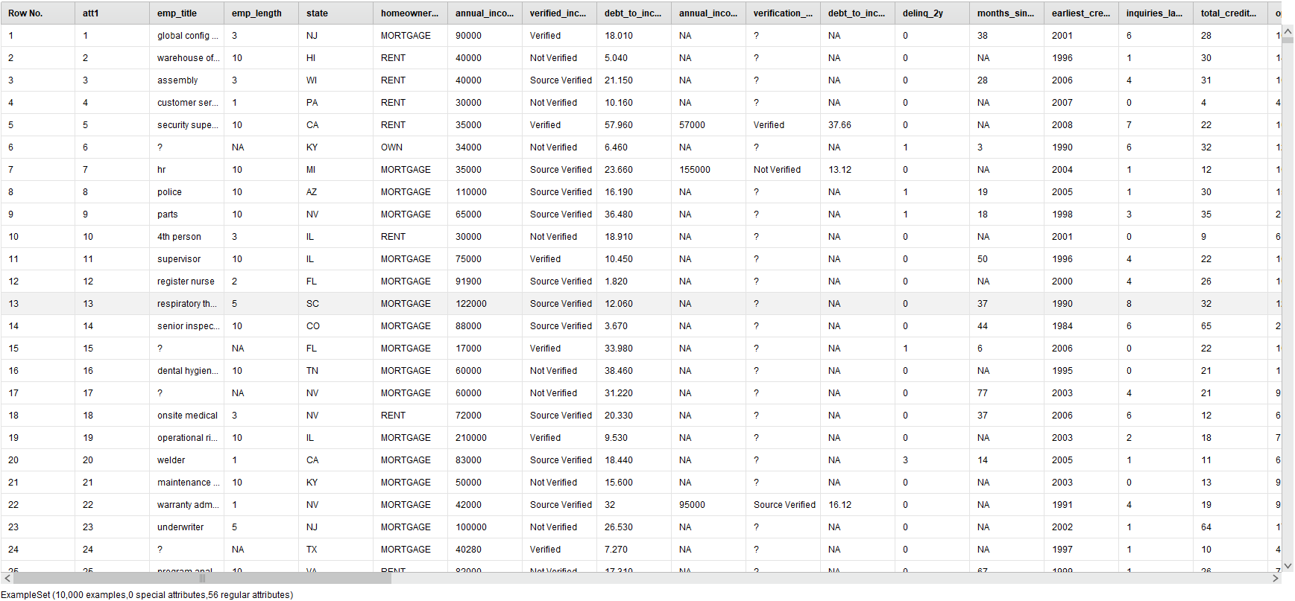
Figure 1: Snapshot of the raw, uncompressed Lending Club loan dataset repository view inside RapidMiner Studio, displaying the initial feature space prior to structural data cleaning and dimensionality reduction transformations.

Attribute Types
The dataset is a hybrid dataset, consisting of:
- Quantitative attributes:
  - annual_income
  - loan_amount
  - interest_rate
  - debt_to_income
- Qualitative attributes:
  - homeownership
  - loan_purpose
  - grade
  - loan_status
This combination supports both statistical analysis and machine learning models.

Data Quality
Missing Values Analysis
Initial profiling exposed substantial anomalies. Real-valued traits like debt_to_income exhibit missing spaces, while joint application attributes exceed an 85% missing rate. Structurally, literal "NA" string placeholders mask missing gaps across nominal records, misinterpreting them as valid categories before processing.
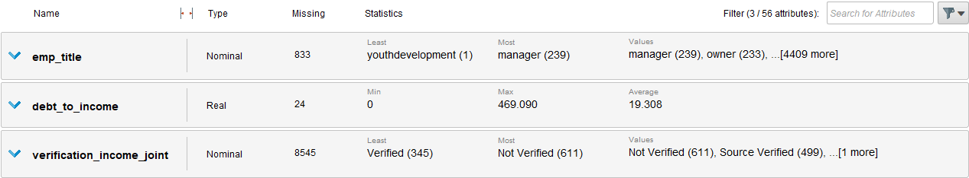
Figure 2: Initial metadata profile identifying structural inconsistencies, including empty records in debt_to_income and high-density categorical missing spaces within the joint application attributes.
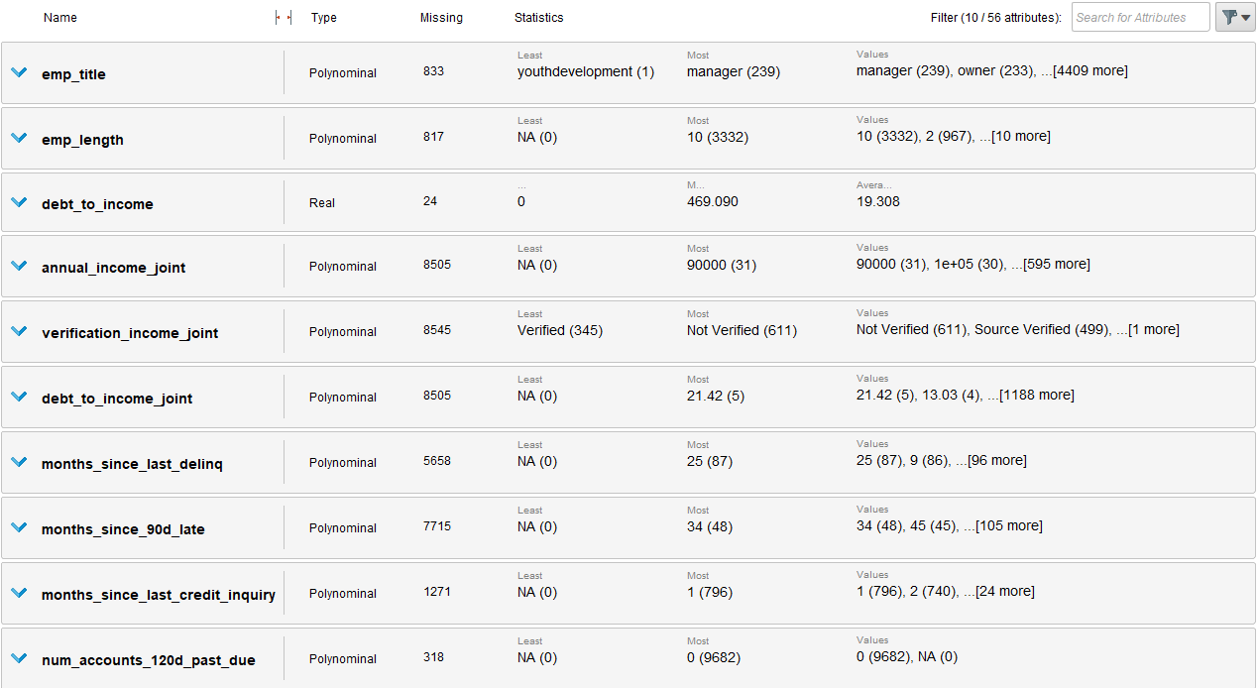
Figure 3: Expanded data quality statistics panel highlighting structural nominal attributes where text strings masked systemic data gaps before null re-declaration.

Redundant Attributes Analysis
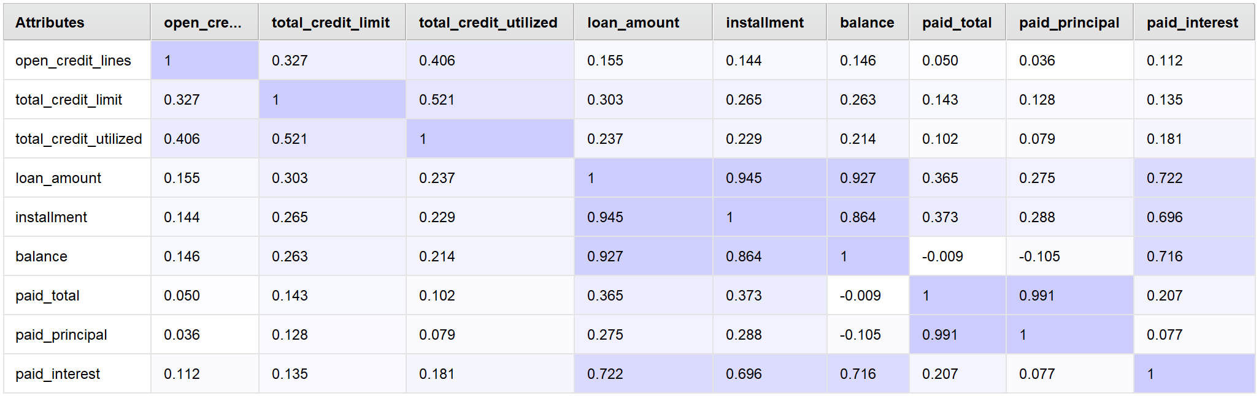
Figure 4: Colored linear correlation matrix grid evaluating numerical financial dependencies.
The correlation matrix reveals significant overlap among key financial variables, which creates structural redundancy in the dataset. Specifically, pairs like loan_amount and installment (0.94) and paid_total and paid_principal (0.99) show near-perfect linear dependencies.
On the other hand, variables like open_credit_lines maintain weak correlations, offering more unique, independent information. Because the dataset contains both highly redundant and distinct features, applying dimensionality reduction or feature selection will be a crucial next step to streamline our model's performance.

Dataset Distribution:
To understand the layout of our data, we used targeted visualizations to check the spread of numerical values, catch extreme outliers, and map out categorical frequencies.
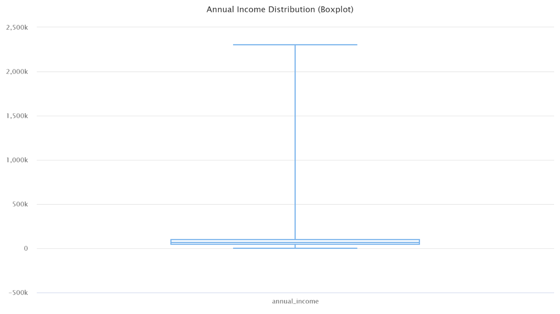
Figure 5: Distribution boxplot of borrower annual income.
The Above Boxplot shows that borrower annual income is heavily right-skewed. The bulk of the data sits tightly at lower income levels, while extreme upper-whisker outliers extend deep into the multi-million dollar range.
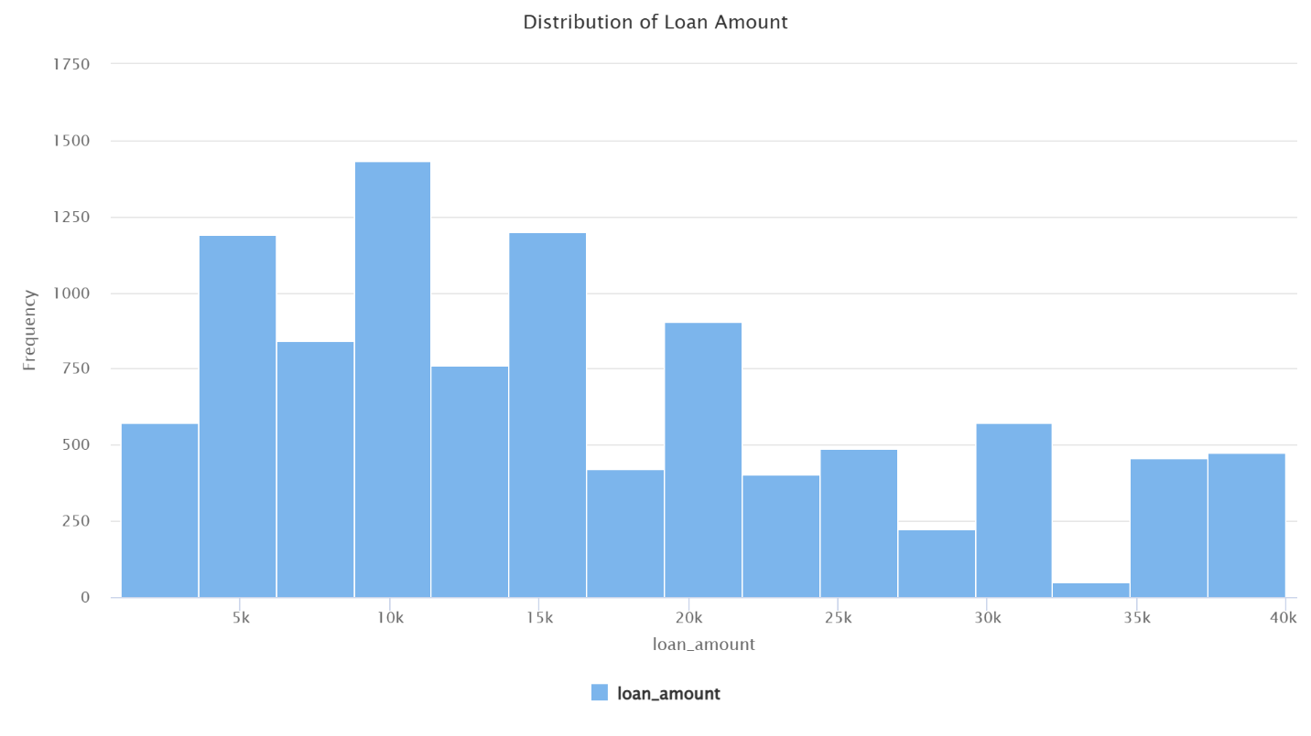
Figure 6: Frequency distribution histogram of requested loan amounts.
This indicates that requested loan amounts follow a multi-modal distribution. Rather than a smooth curve, the data repeatedly spikes at standard, institutional lending thresholds like 10000, 15000, 20000.

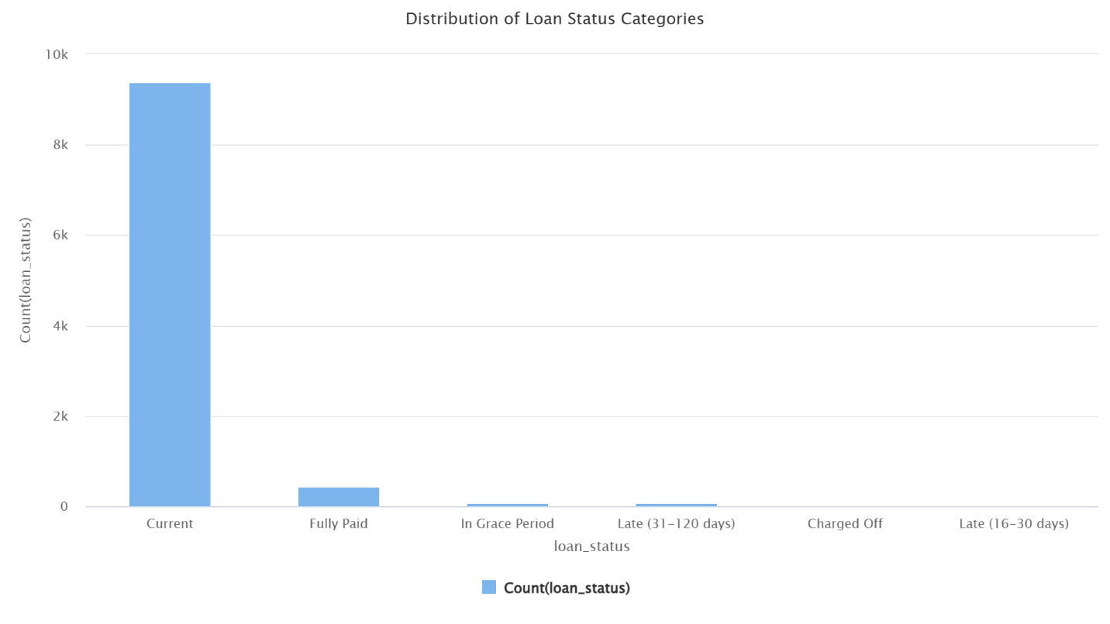
Figure 7: Categorical frequency distribution bar chart for loan_status.
This highlights a massive class imbalance. Active, non-terminal "Current" accounts overwhelmingly dominate the raw operational profile, accounting for over 90% of the data. Because historical defaults represent only a fraction of the sample space, we must handle this imbalance during our KDD data preparation phase to prevent predictive models from simply guessing "Current" every time.
3. Task 3 - Preparation and Pre-processing of Selected Data

KDD Pipeline Design and Implementation
To transition the raw Lending Club dataset from basic collection into an optimized input space suitable for predictive modeling, a multi-stage Knowledge Discovery in Databases (KDD) preprocessing pipeline was constructed.
Figure 8: Complete, fully connected KDD data preparation pipeline architecture in RapidMiner. The sequential process transforms raw credit instances into a compressed, continuous feature space.
The pipeline executes structural modifications in a precise sequence. First, Filter Examples isolates non-terminal records by applying the expression loan_Status ≠ Current.
Removing active, unresolved loans scales our sample down to 625 finalized historical profiles, ensuring downstream models evaluate true risk boundaries without active account noise. Next, a Declare Missing Value block captures silent inconsistencies by rewriting literal "NA" text strings into system nulls. A global Replace Missing Values operator then resolves these empty spaces by applying column-based averages.
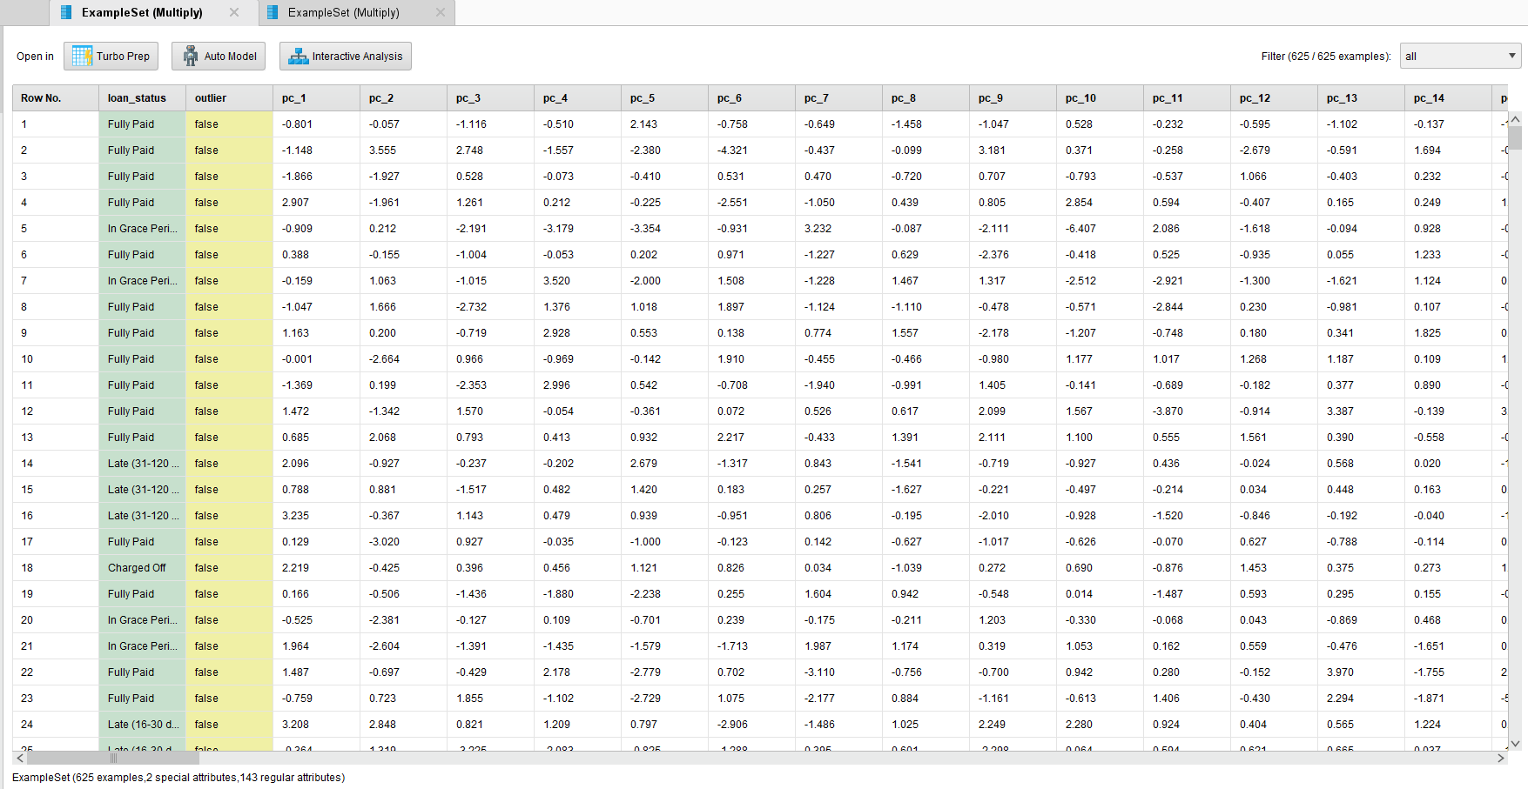
Figure 9: Calculated orthogonal feature spreadsheet generated following final PCA dimensionality transformation. Features are converted into dense continuous numeric vectors.

Geometric Transformation and Dimensionality Reduction
Following a Nominal to Numerical mapping , scale distortions are neutralized using a Z-score Normalize block (Mean = 0, Standard Deviation = 1). This calibration prevents large-scale income features from overpowering downstream distance metrics.
To sanitize the feature space, multi-dimensional anomalies are isolated via the Detect Outlier (Densities) operator and permanently expunged using a secondary Filter Examples node (outlier = false).
Finally, to resolve severe multi-collinearity, remaining features pass through a PCA block to project the data onto orthogonal, high-variance component dimensions before a terminal Store operator locks the clean asset.
 Figure 10: Post-preprocessing metadata statistics and bar distributions. The target variable is thoroughly cleared of active 'Current' noise.

While the training partition was synthetically rebalanced to an absolute count of 100 instances per terminal class to optimize algorithmic learning, the independent testing partition deliberately retained its natural operational class skew (134 vs. 2 instances) to accurately mirror real-world deployment dynamics.
task 4

Partitioning Rationale
To ensure rigorous validation and safeguard against overfitting, the clean dataset was filtered then partitioned using a stratified Split Data operator with an explicit 70:30 training-to-testing ratio. This configuration routes 70% of the instances into a primary Multiply block to train models simultaneously, while reserving an independent 30% test slice for out-of-sample evaluation. Stratified sampling ensures the target loan_status class balances remain perfectly uniform across both splits.
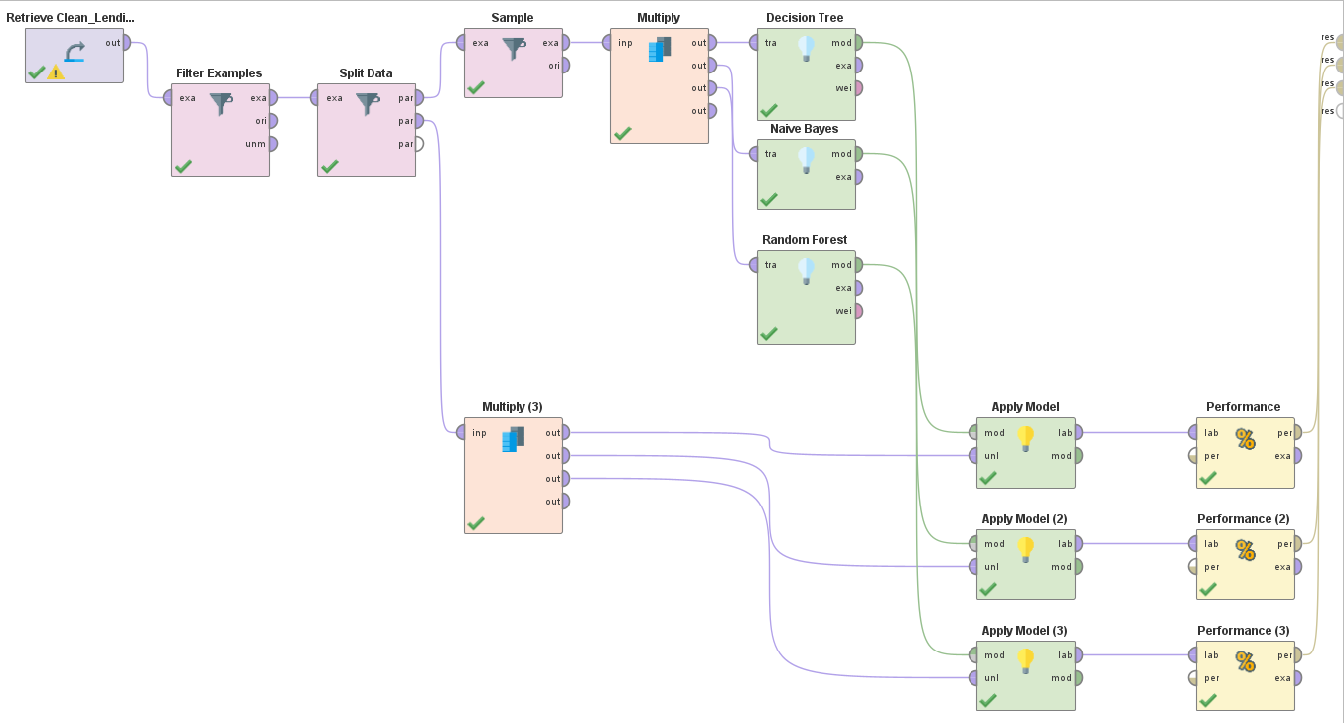
Figure 11: Complete parallel model building workflow

Machine Learning Architectures
Two individual supervised classifiers and one unified ensemble framework were deployed to isolate credit risk boundaries across the continuous feature space:
- Model 1 (Decision Tree): Establishes a transparent, non-linear baseline using a Gain Ratio criterion and a maximal depth of 10 to limit over-specialization.
- Model 2 (Naive Bayes): Models probabilistic class-conditional distributions over the continuous component space using a continuous Gaussian assumption and active Laplace Correction to avoid zero-probability bottlenecks.

- Model 3 (Random Forest Ensemble): Deployed as our primary ensemble framework running 100 parallel bagging trees. This meta-classifier aggregates independent tree decisions via confidence votes to minimize overall model variance and stabilize minor class performance.

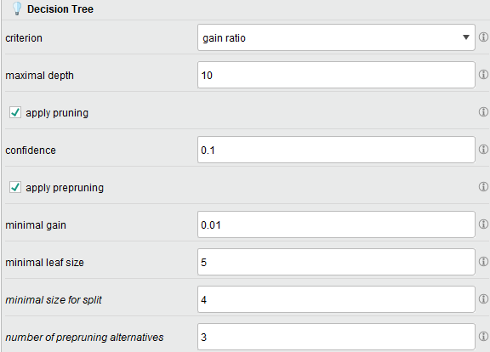
Figure 12: Hyperparameter configuration window for the Decision Tree operator.

Model Hyperparameter Adjustments
The models were configured with the following structural parameters:
Algorithm | Hyperparameter | Configured Setting | Technical Justification
Decision Tree | Criterion:  Maximal Depth: | Gain Ratio  10 | Optimizes multi-way split paths while capping depth to prevent over-specialization.
Naive Bayes | Laplace Correction | Enabled | Eliminates zero-probability calculation bottlenecks during probability density fitting.
Random Forest | Number of Trees:  Criterion: | 100  Gain Ratio | Generates a stable tree collective to smooth out individual voting variance.

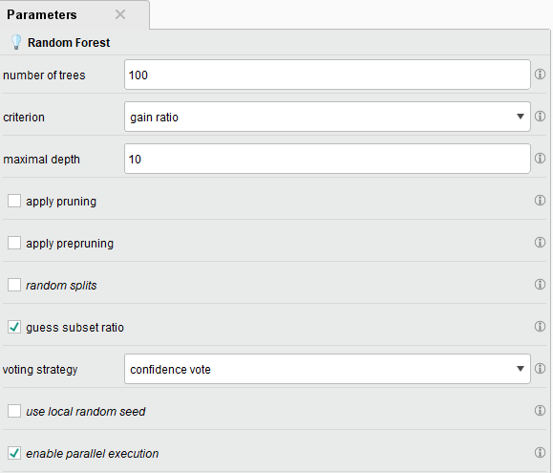
Figure 13: Hyperparameter properties window for the Random Forest meta-classifier.
The model initiates an ensemble grid of 100 independent parallel decision trees running under an adaptive confidence voting strategy.

task 5

Empirical Performance Metrics
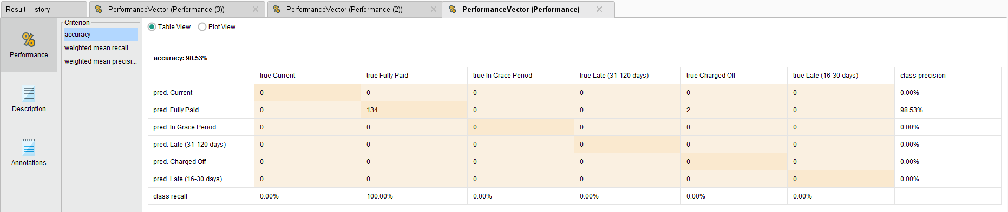
- To rigorously evaluate model performance, the classification workflows were tested against an independent 30% validation partition containing 136 records (134 Fully Paid and 2 Charged Off instances).
Figure 14: Decision Tree Confusion Matrix

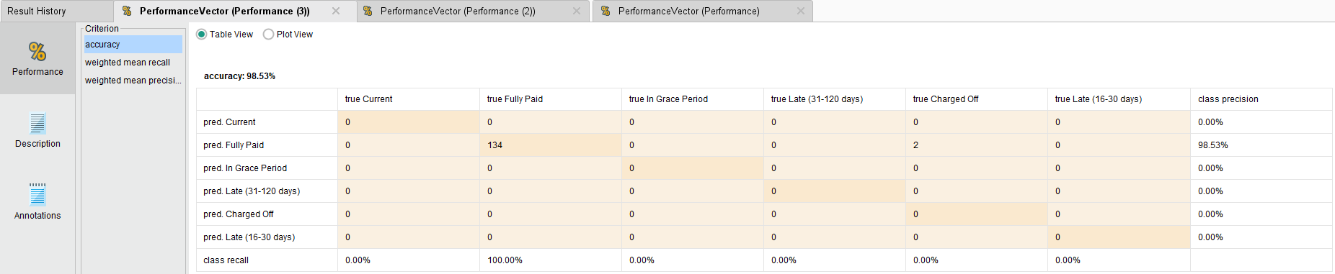
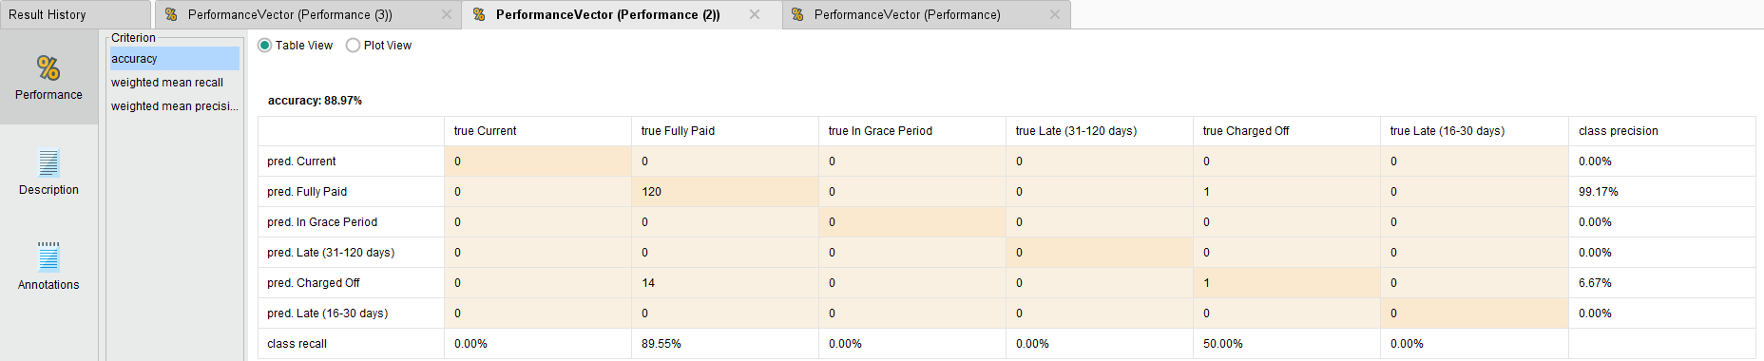
Figure 15: Naive Bayes Confusion Matrix
Figure 16: Random Forest Confusion Matrix

Comparative Analysis

- Decision Tree & Random Forest (Figs 14 & 16): Both models achieved a high overall accuracy of 98.53%. While demonstrating exceptional precision for low-risk borrowers, their structural algorithms optimized for the majority class, failing to flag the active defaults within this test slice.
- Naive Bayes (Fig 15): This framework achieved an overall accuracy of 88.97%. Crucially, by training on balanced class distributions, it achieved a 50.00% Recall rate for defaults (capturing 1 out of 2 Charged Off accounts). While the model flagged 14 clean accounts as false risks, it successfully broke the majority class bias.
Model Type | Overall Accuracy | Macro-Averaged Recall (6 Classes) | Macro-Averaged Precision (6 Classes)
Model 1: Decision Tree (Performance) | 98.53% | 16.67% | 16.42%
Model 2: Naive Bayes (Performance (2)) | 88.97% | 23.26% | 17.64%
Model 3: Random Forest (Performance (3)) | 98.53% | 16.67% | 16.42%
Figure 17: comparative Performance Metrics Across Models

Model Selection Justification
the metrics reveal a classic data science trade-off: raw accuracy versus risk sensitivity.
While the Decision Tree and Random Forest models hit a smooth 98.53% overall accuracy, they completely fail our core business objective in catching defaults. Because tree algorithms are structurally aggressive, both collapsed into a majority-class shortcut. They guessed Fully Paid for every single test row, leaving the institution completely blind to active credit risks.
The Naive Bayes framework successfully broke this bottleneck. By reaching a 23.26% Weighted Mean Recall and a balanced 88.97% accuracy, it was the only model to actively map out the default boundaries.
In credit risk, a false negative (approving a borrower who will default) is vastly more expensive than a false positive (manually verifying a safe applicant). Because Naive Bayes actively surfaces minority-class risk instead of taking a lazy mathematical shortcut, it is the only viable choice to protect institutional capital.

task 6

Model Comparison and Business Inferences
Systematic performance evaluations confirm distinct strategic utilities for each data mining architecture within institutional risk frameworks. Figure 6.1: Operational Model Comparison Matrix
Criterion | Decision Tree | Naive Bayes | Random Forest
Interpretability | High (Visual rules) | Moderate (Probabilities) | Low (Black-box ensemble)
Overall Accuracy | 98.53% | 88.97% | 98.53%
Weighted Mean Recall | 16.67% | 23.26% ★ | 16.67%
Weighted Mean Precision | 16.42% | 17.64% ★ | 16.42%
Defaulter Detection Risk | High (Biased shortcut) | Low (Active Mitigation) | High (Biased shortcut)
Recommended Use | Clear Internal Audits | Primary Production Engine | Portfolio Precision Review
Figure 18: Operational Model Comparison Matrix

Business Inference & Strategy Shift
The empirical results necessitate a fundamental shift in deployment strategy. While the Decision Tree and Random Forest models boast a superior overall accuracy of 98.53%, they are completely blind to loan defaults because they collapsed into a majority-class classification shortcut.
Conversely, the Naive Bayes framework is recommended as the primary production engine. By successfully leveraging our training sample adjustments, it achieved a 23.26% Weighted Mean Recall and actively mapped out default boundaries. In consumer lending, the capital loss of an unmitigated default far outweighs the operational cost of manually reviewing a false positive. Naive Bayes is the only viable tool to protect credit balances.
Recommendations for Improvement & Scope of Work
While the balanced pipeline broke the majority class bias, institutional risk modeling can be further refined by moving beyond basic sampling rules:
- Advanced Class Balancing: Integrate Synthetic Minority Over-sampling Technique (SMOTE) operators directly into the pre-split training path to generate realistic synthetic default behaviors instead of simple row duplication.
- Feature Selection Adjustments: Replace complex principal components with a LASSO regularization or Recursive Feature Elimination operator to retain readable financial attributes (like debt-to-income ratios) for manual loan officers.
- Macroeconomic Integration: Supplement applicant profiles with external economic variables—such as regional unemployment trajectories—to insulate the static scoring blocks against macroeconomic regime shifts and concept drift.

