⚡ ELECTRA SKILL ACADEMY
Platform Edukasi Elektrikal Indonesia

BANK SOAL EVALUASI
Modul 1.19
Saklar, Stop Kontak, Fitting, Terminal & IP Rating:
Komponen Instalasi & Standar Pemasangan
Track | Pondasi Wajib L1 (Essential)
Kategori | Komponen Instalasi Tegangan Rendah
Level Belajar | L1 — Essential Foundation
JP (Jam Pelajaran) | 4 jam
Mode | Teori + Praktik (T+P)
Jumlah Soal | 50 butir
Tipe Soal | Teori, Hitungan, Studi Kasus, Visualisasi
Format | Pilihan Ganda (A/B/C/D)

© Electra Skill Academy
Disusun untuk membentuk tenaga elektrikal profesional Indonesia

Petunjuk Pengerjaan
Sebelum mengerjakan soal-soal pada modul ini, perhatikan petunjuk berikut:
1. Bacalah setiap soal dengan teliti sebelum memilih jawaban.
2. Pilih satu jawaban yang paling tepat dari empat pilihan (A, B, C, atau D).
3. Soal terdiri dari 4 bagian:
• Bagian A (Soal 1–20): Teori dasar
• Bagian B (Soal 21–30): Hitungan/perhitungan numerik
• Bagian C (Soal 31–40): Studi kasus aplikasi industri & PLN
• Bagian D (Soal 41–50): Visualisasi/diagram
4. Untuk soal hitungan, gunakan konstanta berikut:
• Saklar: 1-way, 2-way, dimmer, PIR motion, smart Wi-Fi
• Stop kontak: Type C (2-pin), Type F Schuko (grounded), Industrial CEE
• IP Rating IEC 60529: 1st digit dust (0-6), 2nd digit water (0-8)
• Bathroom zoning: Zone 1 IP65, Zone 2 IP44, Zone 3 IP20
• Tinggi PUIL: saklar 150cm, outlet 125cm/30cm, smoke detector plafon
• Fitting: E27 standar Indonesia, E14 chandelier, GU10 spotlight, G13 tube
5. Kunci jawaban dengan penjelasan detail tersedia di bagian akhir dokumen.
6. Skor kelulusan minimum: 70% (35 dari 50 soal benar).
Selamat mengerjakan! Pahami konsepnya, jangan hanya menghafal jawaban.

BAGIAN A — Teori Dasar
Soal 1–20: Konsep, definisi, hukum dan prinsip dasar.
Soal 1 [Teori]
Saklar 1-way (tunggal) digunakan untuk…
A. Lorong panjang
B. Switching SATU lampu dari SATU posisi (kamar tidur, ruang tunggu)
C. 3 posisi
D. Random

Soal 2 [Teori]
Saklar 2-way (3-way US) digunakan untuk…
A. Tidak feasible
B. Switching SATU lampu dari DUA posisi — lorong panjang, tangga (control dari atas+bawah)
C. Random
D. Tidak ada

Soal 3 [Teori]
Stop kontak Type C (rumah Indonesia umum) berbeda dari Type F (Schuko)…
A. Sama
B. Type C: 2-pin TANPA earth pin (untuk peralatan dengan double insulation); Type F (Schuko): 2-pin + side earth contact (peralatan dengan grounding)
C. Random
D. Type C lebih besar

Soal 4 [Teori]
IP Rating adalah…
A. Internet Protocol
B. Ingress Protection (IEC 60529) — proteksi dari MASUKNYA solid object (1st digit) + water (2nd digit)
C. Insulation Power
D. Random

Soal 5 [Teori]
IP65 berarti…
A. Cuma untuk indoor
B. Dust-tight (1st digit 6) + water jets (2nd digit 5) — outdoor cover, industri dust+occasional water
C. Underwater
D. Random

Soal 6 [Teori]
Stop kontak di bathroom shower zone perlu IP rating minimum…
A. IP20
B. IP65 (dust-tight + water jets) — direct water exposure shower
C. IP00
D. Tidak perlu

Soal 7 [Teori]
Saklar dimmer berfungsi untuk…
A. ON/OFF saja
B. Atur INTENSITAS cahaya lampu (mood lighting, energy saving) — typical untuk lampu pijar/halogen, LED dimmable khusus
C. Random
D. Tidak ada

Soal 8 [Teori]
Fitting lampu E27 adalah…
A. Bayonet 22mm
B. Edison Screw 27mm — screw-in standar lampu rumah Indonesia
C. Bi-pin tube
D. GU10

Soal 9 [Teori]
Lasdop (twist-on wire connector) adalah…
A. Saklar
B. Twist-on connector untuk SPLICE 2-4 wires (junction) — alternatif terminal block
C. Stop kontak
D. Random

Soal 10 [Teori]
Terminal block DIN-rail digunakan untuk…
A. Random
B. Connection multiple wires di panel — screw atau spring terminal, rapi + reliable, bisa label
C. Stop kontak
D. Tidak ada

Soal 11 [Teori]
Konektor WAGO (push-in lever) advantage vs lasdop…
A. Lebih murah
B. (1) TOOL-FREE installation, (2) RELIABLE consistent (force calibrated), (3) REUSABLE (bisa dibuka tanpa rusak), (4) RATING TINGGI (32A typical)
C. Sama saja
D. Tidak ada

Soal 12 [Teori]
Conduit pipa pelindung kabel berfungsi untuk…
A. Estetika
B. Mechanical protection + cable management + future replacement (kabel baru bisa di-pull through), plus EMI shielding (jika metal)
C. Random
D. Tidak perlu

Soal 13 [Teori]
Cable tray vs cable ladder…
A. Sama
B. CABLE TRAY: solid/perforated bottom, cable supported continuous; CABLE LADDER: rung structure, ventilation lebih baik, untuk cable berat & banyak
C. Random
D. Tidak ada

Soal 14 [Teori]
Tinggi pemasangan saklar lampu rekomendasi PUIL…
A. 30 cm
B. ~150 cm dari lantai (eye level standing adult, easy reach)
C. 250 cm
D. Bebas

Soal 15 [Teori]
Stop kontak dengan SHUTTER (anti-tamper) berfungsi untuk…
A. Estetika
B. Cegah anak balita masukan obyek metal ke socket — shutter open hanya saat 2-pole plug insertion simultan
C. Random
D. Tidak ada

Soal 16 [Teori]
Stop kontak USB integrated (built-in USB charger)…
A. Tidak ada
B. Combination: 2-pin AC outlet + USB-A/USB-C charger built-in (typical 2,1A USB-A, 18W+ USB-C PD) — convenience untuk gadget charging
C. Random
D. Hanya US

Soal 17 [Teori]
Saklar PIR (Passive Infrared) motion sensor digunakan untuk…
A. Random
B. AUTO-ON saat detect motion (occupancy), AUTO-OFF setelah delay tanpa motion — energy saving, security, convenience
C. Estetika
D. Tidak ada

Soal 18 [Teori]
Saklar smart Wi-Fi (smart switch) advantage…
A. Tidak ada
B. (1) Remote control via app, (2) Schedule/automation, (3) Voice control (Alexa/Google), (4) Energy monitoring, (5) Integration smart home ecosystem
C. Lebih murah
D. Random

Soal 19 [Teori]
PUIL 2020 mensyaratkan stop kontak di rumah HARUS punya…
A. Tidak ada syarat
B. EARTH PIN (3-pin) untuk peralatan grounded; tinggi minimum 30cm dari lantai (cegah water ingress lantai); RCD upstream (proteksi shock)
C. Hanya 2-pin
D. Bebas

Soal 20 [Teori]
Komponen yang AMAN dipakai outdoor terbuka rain exposure…
A. Stop kontak indoor IP20
B. Stop kontak outdoor IP65/IP44 dengan COVER, plus RCD upstream 30 mA
C. Random
D. Tidak boleh outdoor

BAGIAN B — Hitungan
Soal 21–30: Perhitungan numerik dengan rumus dan formula relevan.
Soal 21 [Hitungan]
Stop kontak rated 16A pada V=220V. Power max yang bisa di-draw…
A. 1.000W
B. 3.520W (16 × 220 = 3.520 VA, ~3.500W resistive)
C. 100W
D. 10kW

Soal 22 [Hitungan]
Cost upgrade 1 panel rumah dari Type C ke Type F (Schuko grounded): 10 outlets × Rp 50rb + grounding wire + labor Rp 500rb. Total?
A. Rp 50rb
B. Rp 1 juta (500rb outlet + 500rb labor + ~100rb wire+misc)
C. Rp 10jt
D. Tidak ada cost

Soal 23 [Hitungan]
Stop kontak dengan IP20 di outdoor exposed: kemungkinan failure dalam 1 tahun?
A. 0% (OK)
B. ~70-90% (water ingress → korosi terminal → short circuit / no contact)
C. 0,1%
D. 50 tahun lifetime

Soal 24 [Hitungan]
Energy saving dari saklar PIR di corridor (lampu 36W LED, occupancy 20% of time tanpa PIR jadi continuous 24/7):
A. 0%
B. ~80% saving (off saat empty 80% time = 0,8 × 24 jam × 36W × 365 = ~252 kWh/year saved)
C. 1%
D. 100%

Soal 25 [Hitungan]
Conduit PVC 20mm bisa fit berapa kabel NYM 3×2,5mm² (diameter 9mm)?
A. 100
B. ~3 kabel (per fill ratio 40% rule untuk 3+ konduktor)
C. 1
D. Bebas

Soal 26 [Hitungan]
10 stop kontak Anti-Tamper Shutter premium @ Rp 60rb vs basic @ Rp 25rb. Cost premium for child safety?
A. Tidak ada premium
B. Rp 350rb extra (10 × Rp 35rb) — small investment untuk family safety
C. Rp 10jt
D. Bebas

Soal 27 [Hitungan]
Saklar smart Wi-Fi 10 unit @ Rp 200rb. Total invest + setup Rp 500rb. Annual energy saving 15% × Rp 1jt/bulan rumah?
A. Rp 0
B. Rp 1,8jt/year saving — payback 1,4 tahun
C. Rp 100jt
D. Tidak ada

Soal 28 [Hitungan]
Cost upgrade IP rating panel pelanggan industri: dari IP20 ke IP65 (waterproof). 5 panel × Rp 5jt enclosure premium + Rp 2jt sealing kit per panel.
A. Rp 5jt total
B. Rp 35 juta total (5 × Rp 7jt)
C. Rp 1M
D. Bebas

Soal 29 [Hitungan]
PLN UP3 acceptance test pelanggan baru: per outlet test (visual + polarity + ground continuity + tightness): 2 menit. 50 outlet pelanggan ruko, total?
A. 2 menit
B. 100 menit (~1,5 jam) per pelanggan ruko 50 outlet
C. 1 hari
D. Tidak perlu test

Soal 30 [Hitungan]
Industri factory dengan 200 outlet IP65 + 50 saklar IP65 + 100 fitting IP65. Cost vs IP20 standar?
A. Same
B. ~Rp 100 juta premium (2-3× cost vs IP20) untuk dust+water protection
C. Rp 1M
D. Tidak relevan

BAGIAN C — Studi Kasus
Soal 31–40: Aplikasi konsep pada situasi nyata di PLN, industri dan lapangan.
Soal 31 [Studi Kasus]
Kontraktor renovasi pasang stop kontak Type C tanpa earth di kamar mandi pelanggan rumah. PLN UP3 acceptance test?
A. Lulus saja
B. REJECT — bathroom WAJIB Type F earthed + IP44 minimum + RCD 30mA upstream. Mandatory replace dengan Type F IP44+, plus RCD installation jika belum ada
C. Borderline
D. Tidak relevan

Soal 32 [Studi Kasus]
Pelanggan industri food processing — IP rating yang DIPERLUKAN untuk panel electrical di production area dengan cleaning hose daily?
A. IP20
B. IP65 minimum (dust-tight + water jets) + corrosion-resistant material (stainless steel 304/316), plus drainage gap behind
C. IP00
D. Tidak perlu

Soal 33 [Studi Kasus]
Pelanggan rumah komplain saklar lampu 'sering rusak' dalam 1-2 tahun. Investigation reveal: saklar high-load (3000W water heater + lampu shared circuit) on/off frequent, saklar rated 6A standar. Diagnosa?
A. Saklar quality buruk
B. UNDER-RATED + OVER-USE — saklar 6A digunakan untuk 14A continuous on/off cycling. WAJIB upgrade saklar rated 16A+ atau split circuit (kontaktor untuk water heater)
C. PLN salah
D. Random

Soal 34 [Studi Kasus]
PLN UP3 inspection panel pelanggan industri 5 tahun lama: terminal terminal banyak kotor, oksidasi. Action?
A. Pakai terus
B. THERMOGRAPHY scan identify hot spots → schedule LOTO maintenance: clean kontak (brush + IPA), retorque dengan torque wrench, replace severely corroded terminal, install Penetrox compound untuk prevent recurrence
C. Tidak relevan
D. Random

Soal 35 [Studi Kasus]
Bathroom rumah pelanggan: stop kontak hair dryer + water heater shared 1 outlet. Risiko?
A. Tidak ada
B. RISIKO TINGGI — overload + water proximity. (1) Overload outlet 16A vs total 20-25A (water heater 3kW + hair dryer 1500W), (2) Water heater near water + hair dryer in wet hand = SHOCK, (3) RCD jika ada akan repeated trip
C. Sepele
D. Tidak relevan

Soal 36 [Studi Kasus]
Konsep modul Envisor 'Smart Home Audit AI' untuk pelanggan PLN. Fitur?
A. Hanya brosur
B. (1) Walkthrough audit dengan camera + AI identify outlets/saklar/peralatan + IP rating estimation, (2) Compliance scoring per area (bathroom, kitchen, bedroom), (3) Recommendation list prioritized + cost, (4) BOM auto-generate, (5) Schedule kontraktor partner, (6) Re-audit verification
C. Tidak feasible
D. Random

Soal 37 [Studi Kasus]
Pelanggan industri minta upgrade panel ke IP65 outdoor. Existing panel IP20 indoor. Effort + considerations?
A. Tinggal swap enclosure
B. (1) New IP65 enclosure (Rp 5-15jt larger panel), (2) Cable gland IP65 untuk semua penetrasi, (3) Ventilation strategy (filtered intake + exhaust untuk component cooling), (4) Mounting sun shade jika exposed direct sun, (5) Re-test acceptance lengkap
C. Tidak feasible
D. Random

Soal 38 [Studi Kasus]
Modul ESA Pak Qastil: Electra Skill Academy — sub-module 'IP Rating Mastery' untuk learner. Curriculum?
A. Cuma teori
B. (1) Theoretical foundation (IEC 60529), (2) Real-world examples 50+ case studies, (3) Interactive simulator (3D environment lecturer place equipment + see consequence), (4) Quiz adaptif, (5) Certification practice exam, (6) AR mobile app untuk identify IP rating dari product label
C. Random
D. Tidak feasible

Soal 39 [Studi Kasus]
PLN UP3 program 'Standard Pemasangan Komponen' untuk kontraktor. Tujuan + impact?
A. Tidak relevan
B. (1) Standardize tinggi pemasangan (saklar 150cm, outlet 125cm/30cm), (2) IP rating per area mandatory, (3) Color coding konsisten, (4) Acceptance test rigorous, (5) Kontraktor certification program, (6) Annual audit + dashboard. Impact: reduce instalasi mismatch, improve safety nationally
C. Tidak feasible
D. Random

Soal 40 [Studi Kasus]
Pelanggan industri import peralatan dari Eropa dengan stop kontak Type F Schuko + UK Type G mixed. Compatibility issue + solusi?
A. Tidak ada masalah
B. INKOMPATIBEL — Type G UK pin lebih besar + earth pin top, tidak fit Type F Schuko outlet. Solusi: (1) Replace plug ke Type C/F lokal, (2) Travel adapter (sementara), (3) Dedicated Type G outlet untuk peralatan UK (rare di Indonesia)
C. Random
D. Tidak relevan

BAGIAN D — Visualisasi & Diagram
Soal 41–50: Interpretasi gambar/diagram rangkaian dan komponen.
Soal 41 [Visualisasi]
Untuk lampu di lorong panjang dengan kontrol di kedua ujung, saklar yang TEPAT…
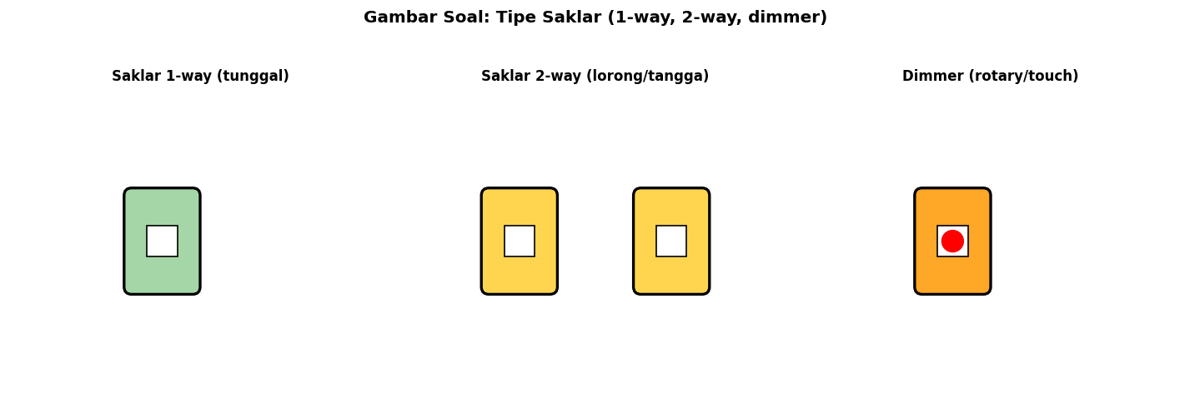
A. 1-way
B. 2-way (3-way US) — dapat switch lampu dari 2 lokasi berbeda
C. Dimmer
D. Random

Soal 42 [Visualisasi]
Untuk peralatan grounded (kulkas, mesin cuci) di rumah Indonesia, stop kontak yang TEPAT…
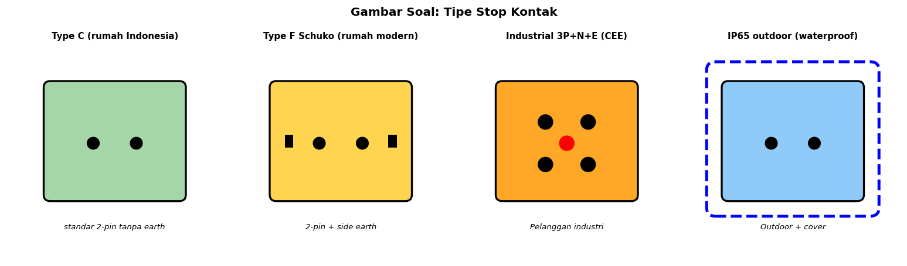
A. Type C (2-pin tanpa earth)
B. Type F Schuko (2-pin + side earth contact)
C. Type G UK
D. Random

Soal 43 [Visualisasi]
IP54 berarti…
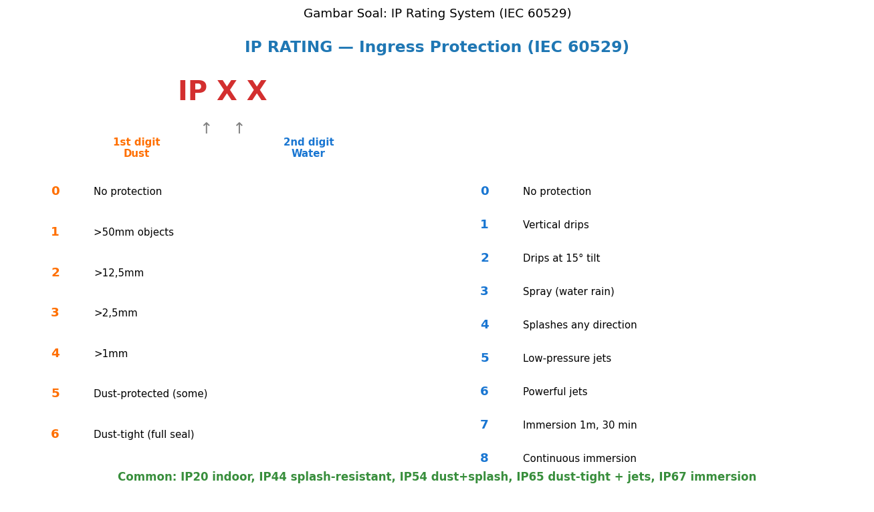
A. Underwater
B. Dust-protected (5) + water splash any direction (4)
C. No protection
D. Random

Soal 44 [Visualisasi]
Untuk shower zone bathroom, IP rating minimum…
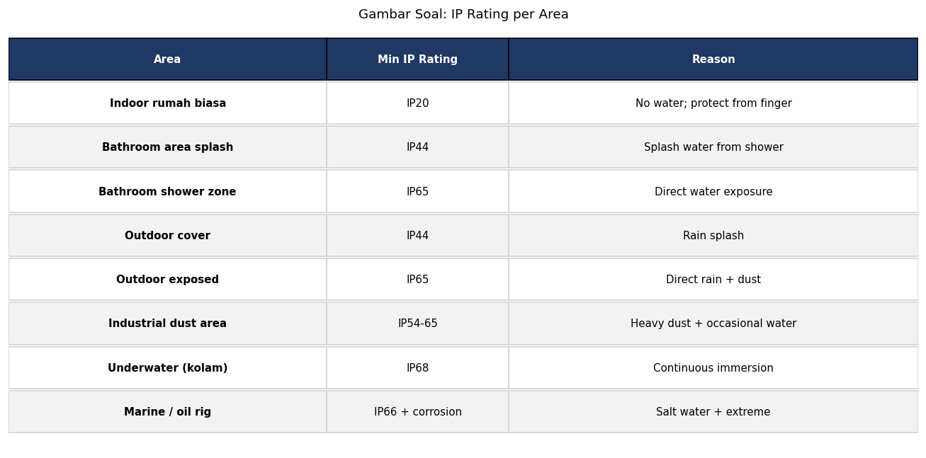
A. IP20
B. IP65 (dust-tight + water jets)
C. IP00
D. Random

Soal 45 [Visualisasi]
Fitting lampu standar untuk lampu rumah Indonesia (LED bulb, CFL)…
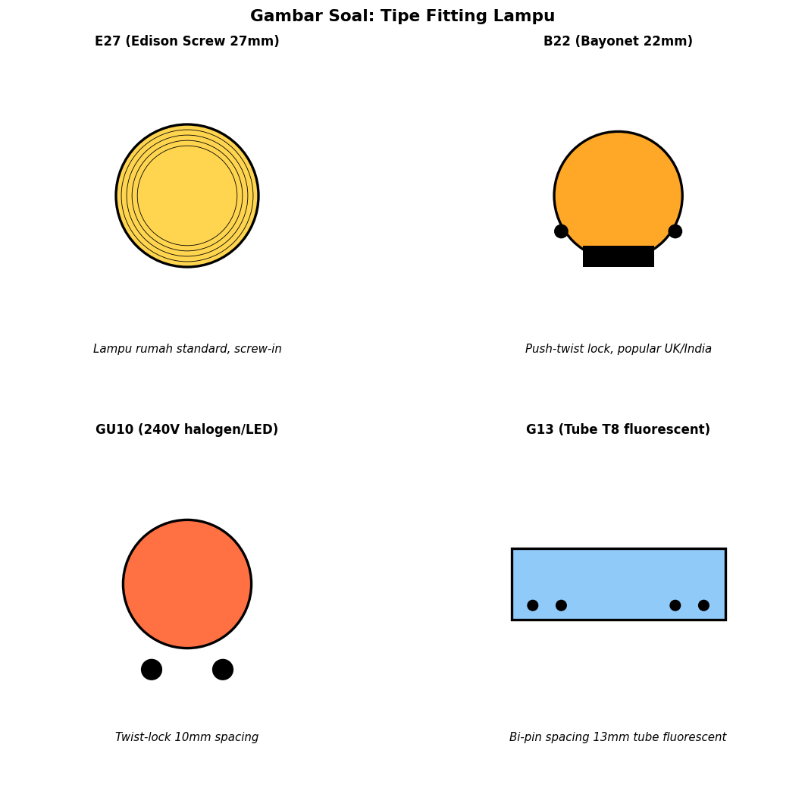
A. B22 (Bayonet)
B. E27 (Edison Screw 27mm)
C. GU10
D. G13

Soal 46 [Visualisasi]
Untuk panel modern dengan banyak konduktor + frequent maintenance, terminal PALING TEPAT…
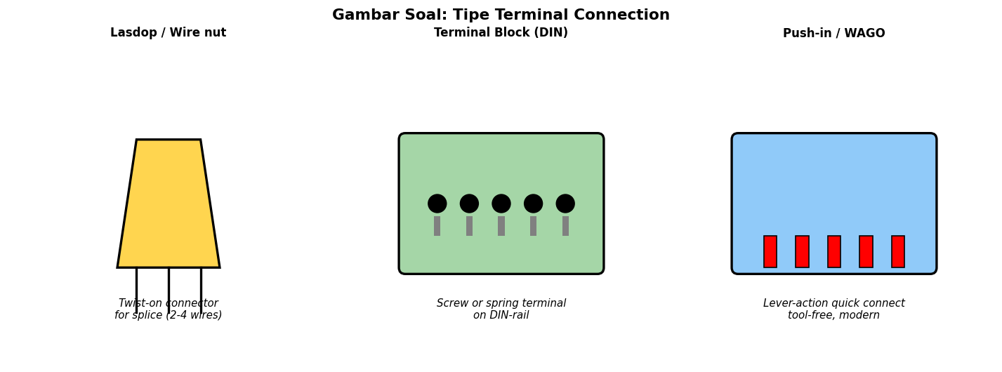
A. Lasdop
B. Push-in / WAGO (lever-action quick connect, tool-free, reusable, consistent force)
C. Twist together
D. Random

Soal 47 [Visualisasi]
Untuk industri heavy-duty dengan banyak kabel paralel, conduit/management TEPAT…
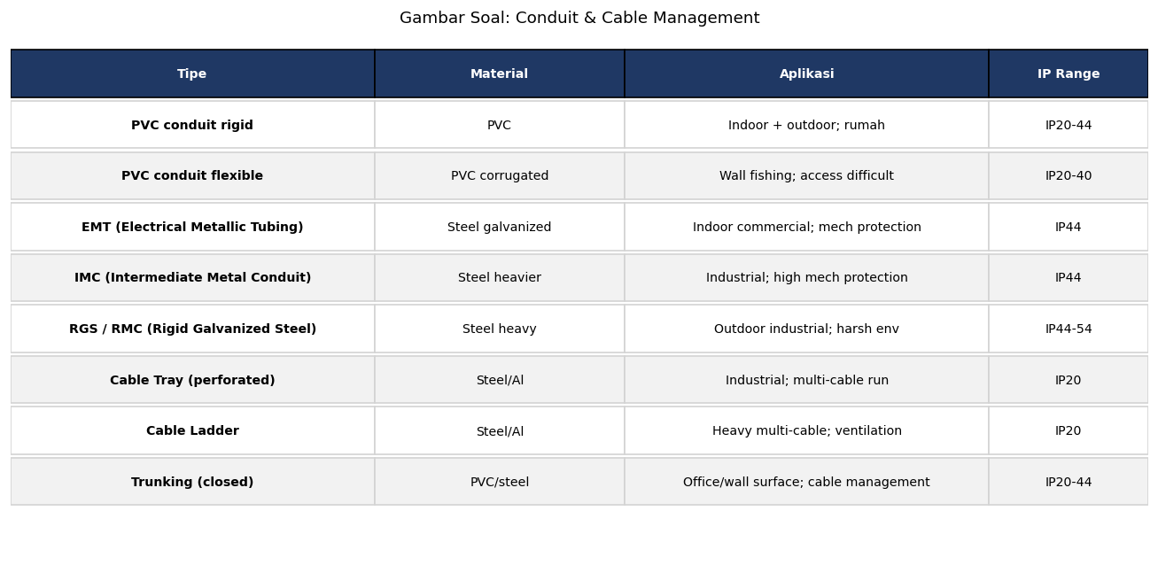
A. PVC flexible kecil
B. Cable Ladder (open rung, ventilation max, support cable berat banyak)
C. Lasdop
D. Random

Soal 48 [Visualisasi]
Tinggi standar pemasangan saklar lampu rekomendasi PUIL…
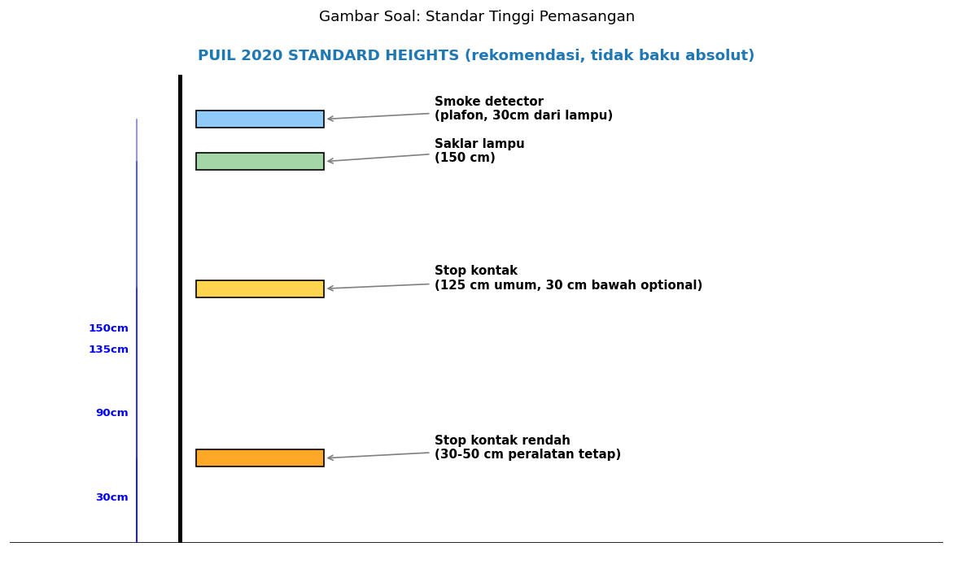
A. 30 cm
B. ~150 cm dari lantai (eye level standing adult)
C. 250 cm
D. Bebas

Soal 49 [Visualisasi]
Untuk peralatan immersi underwater (kolam renang, fountain), IP rating…

A. IP44
B. IP67 (immersion 1m 30 menit) atau IP68 (continuous immersion)
C. IP20
D. Tidak ada

Soal 50 [Visualisasi]
Untuk industri food processing dengan cleaning hose, IP rating panel listrik…

A. IP20
B. IP65 minimum (dust-tight + water jets) + corrosion-resistant material (stainless steel)
C. IP00
D. Random

Kunci Jawaban & Penjelasan Detail
Berikut adalah kunci jawaban beserta penjelasan ilmiah mengapa jawaban tersebut benar. Pelajari penjelasan dengan saksama untuk memahami konsep, bukan sekadar menghafal jawaban.

Ringkasan Jawaban
No. Jwb | No. Jwb | No. Jwb | No. Jwb | No. Jwb
1. B | 2. B | 3. B | 4. B | 5. B
6. B | 7. B | 8. B | 9. B | 10. B
11. B | 12. B | 13. B | 14. B | 15. B
16. B | 17. B | 18. B | 19. B | 20. B
21. B | 22. B | 23. B | 24. B | 25. B
26. B | 27. B | 28. B | 29. B | 30. B
31. B | 32. B | 33. B | 34. B | 35. B
36. B | 37. B | 38. B | 39. B | 40. B
41. B | 42. B | 43. B | 44. B | 45. B
46. B | 47. B | 48. B | 49. B | 50. B

Penjelasan Detail
Soal 1 [Teori] → Jawaban: B
Pertanyaan: Saklar 1-way (tunggal) digunakan untuk…
Saklar 1-way (single pole single throw, SPST): switch ON/OFF lampu dari 1 posisi. Aplikasi: kamar tidur, ruang tunggu, gudang. Wiring: fasa → saklar → lampu, netral langsung ke lampu. PENTING: switch fasa, BUKAN netral, untuk safety.

Soal 2 [Teori] → Jawaban: B
Pertanyaan: Saklar 2-way (3-way US) digunakan untuk…
Saklar 2-way (single pole double throw, SPDT): control SATU lampu dari DUA lokasi berbeda. Aplikasi: lorong panjang, tangga (atas+bawah), pintu kamar+samping ranjang. Wiring: 2 saklar dengan 'traveler' wires antara, lampu di-switch via berbagai kombinasi state. Standar PUIL 2020 + IEC.

Soal 3 [Teori] → Jawaban: B
Pertanyaan: Stop kontak Type C (rumah Indonesia umum) berbeda dari Type F (Schuko)…
Type C (CEE 7/16): 2-pin only, no earth, untuk peralatan double-insulated (Class II) seperti charger HP, lampu LED. Type F Schuko (CEE 7/4): 2-pin + side earth contact, mandatory untuk peralatan Class I (kulkas, mesin cuci, microwave). Indonesia: kombinasi keduanya umum, tapi Type F lebih SAFE untuk peralatan grounded. Standar PUIL 2020: stop kontak ROOM HUMID atau peralatan grounded WAJIB Type F.

Soal 4 [Teori] → Jawaban: B
Pertanyaan: IP Rating adalah…
IP Rating (IEC 60529): standar global untuk classify ENCLOSURE protection level. Format: IP XX. 1st digit (0-6): proteksi dari solid (dust, finger, tools); 2nd digit (0-8): proteksi dari water (drip, splash, jets, immersion). Misalnya IP65 = dust-tight + water jets resistant. Plus huruf optional (M = motion test, W = weather test). Untuk mechanical impact: IK Rating separate (IK01-IK10).

Soal 5 [Teori] → Jawaban: B
Pertanyaan: IP65 berarti…
IP65: 1st digit 6 = DUST-TIGHT (full seal, no dust ingress); 2nd digit 5 = WATER JETS (low-pressure water jets dari any direction, 6,3 mm nozzle, 12,5 L/min, distance 2,5-3m). Aplikasi: outdoor exposed (rain + dust), industri food processing (cleaning hose), kitchen commercial. NOT untuk: continuous immersion (perlu IP67/68).

Soal 6 [Teori] → Jawaban: B
Pertanyaan: Stop kontak di bathroom shower zone perlu IP rating minimum…
Bathroom zoning per IEC 60364:
- Zone 0 (dalam bathtub/shower): IP67+ (immersion risk)
- Zone 1 (di atas bathtub, < 2,25m height): IP65 (water jets)
- Zone 2 (0,6m sekitar Zone 1): IP44 (splash)
- Zone 3 (> 2,4m horizontal dari Zone 1): IP20 (general)
Minimum di shower zone area: IP65. Plus combined dengan RCD 30 mA (atau 10 mA HIGH SENS) untuk personnel protection.

Soal 7 [Teori] → Jawaban: B
Pertanyaan: Saklar dimmer berfungsi untuk…
Dimmer: control intensitas via PHASE CUT (TRIAC/IGBT untuk LED). Aplikasi: ruang tamu, kamar tidur, restoran. PENTING: kompatibilitas — old dimmer untuk pijar/halogen TIDAK BOLEH dipakai untuk LED non-dimmable (flickering, peralatan rusak, dimmer panas). LED DIMMABLE punya driver khusus, kompatibel dengan dimmer modern (leading-edge atau trailing-edge). Cek spec sebelum install.

Soal 8 [Teori] → Jawaban: B
Pertanyaan: Fitting lampu E27 adalah…
Fitting standar lampu:
- E27 (Edison Screw 27mm): paling umum di Indonesia + Eropa, screw-in, untuk LED bulb, CFL, halogen
- E14 (Edison 14mm): chandelier, lampu kecil
- B22 (Bayonet 22mm): UK, India — push-twist lock
- GU10 (240V): twist-lock 10mm, halogen/LED spotlight
- G13 (T8 fluorescent): bi-pin 13mm spacing tube
- B15 (small bayonet): chandelier UK
Kompatibilitas wajib match — bulb E27 hanya pas di socket E27.

Soal 9 [Teori] → Jawaban: B
Pertanyaan: Lasdop (twist-on wire connector) adalah…
Lasdop / Wire nut: connector ulir interior + plastic cone exterior. Cara pakai: strip wire ends, twist together, screw lasdop on. Aplikasi: junction box, splice di rumah/komersial. Pro: cepat, no tools, cheap. Con: less secure than terminal block jika vibrasi atau jumlah wires banyak. Modern: WAGO push-in lever connector lebih reliable + tool-free.

Soal 10 [Teori] → Jawaban: B
Pertanyaan: Terminal block DIN-rail digunakan untuk…
Terminal block DIN-rail: terminal SECARA BARIS pada DIN-rail standard 35mm. Tipe: screw terminal (clamp wire dengan baut, common), spring/cage clamp (insertion tanpa baut, lebih cepat + reliable vibrasi), push-in (modern, tool-free). Aplikasi: panel listrik (junction wires), control panel SCADA, motor control center. Advantage: rapi, reliable, ground per terminal, label/marker, replaceable per unit.

Soal 11 [Teori] → Jawaban: B
Pertanyaan: Konektor WAGO (push-in lever) advantage vs lasdop…
WAGO (Push-in lever connector, 221/2273 series):
(1) TOOL-FREE — lift lever, insert stripped wire, push lever down, done
(2) CONSISTENT FORCE — spring calibrated, same clamping force every connection (no torque wrench required)
(3) REUSABLE — lift lever, remove wire, reuse
(4) HIGH RATING — typical 32A, up to 75A larger version
(5) TRANSPARENT housing — verify wire fully inserted
(6) MODULAR — mix wire size dalam 1 connector
Cost premium ~3-5× vs lasdop, tapi reliable + maintenance-friendly. Adoption increasing di Indonesia industrial + komersial.

Soal 12 [Teori] → Jawaban: B
Pertanyaan: Conduit pipa pelindung kabel berfungsi untuk…
Conduit functions: (1) MECHANICAL — protect kabel dari abrasi, impact, rodent, (2) FIRE BARRIER — limit fire spread, (3) CABLE MANAGEMENT — multiple kabel terorganisir, easier inspection, (4) FUTURE REPLACEMENT — pull old kabel out, pull new in via existing conduit (vs ripping wall), (5) EMI SHIELDING (metallic conduit) — reduce EMI antar kabel & external interference, (6) GROUNDING PATH (metallic). Tipe: PVC rigid, PVC flexible, EMT (steel light), IMC (intermediate steel), RGS (rigid steel heavy).

Soal 13 [Teori] → Jawaban: B
Pertanyaan: Cable tray vs cable ladder…
CABLE TRAY: solid bottom atau perforated, support cable continuous. Pro: protect dari debu/dropping object, organized appearance. Con: less ventilation = derating ampacity higher. Aplikasi: indoor commercial, office.
CABLE LADDER: open rung structure (ladder shape). Pro: maximum ventilation = better cable cooling = less derating, support heavy cable load. Con: dust accumulation, foreign object can fall through. Aplikasi: industrial, outdoor, heavy-cable runs.
Material: galvanized steel (cheap, durable), aluminum (lightweight, corrosion-resistant), stainless steel (food/marine).
Load rating + derating per NEMA VE-1 / IEC 61537 spec.

Soal 14 [Teori] → Jawaban: B
Pertanyaan: Tinggi pemasangan saklar lampu rekomendasi PUIL…
PUIL 2020 rekomendasi tinggi:
- SAKLAR LAMPU: ~150 cm (eye level, easy reach saat masuk ruangan)
- STOP KONTAK UMUM: 125 cm (atas meja kerja) atau 30 cm (di belakang sofa, peralatan tetap)
- STOP KONTAK KAMAR MANDI: 125 cm minimum (di luar zone 0-1)
- SMOKE DETECTOR: plafon, 30cm dari lampu
- TOMBOL DARURAT: 90-120 cm (universal access)
- AKSESIBILITAS DISABLE: 90-120 cm range (wheelchair user reach)
Not baku absolut — adapt per design accessibility.

Soal 15 [Teori] → Jawaban: B
Pertanyaan: Stop kontak dengan SHUTTER (anti-tamper) berfungsi untuk…
Anti-tamper shutter stop kontak: spring-loaded shutter cover socket holes saat tidak ada plug. Open hanya saat 2 pin plug masukan SIMULTAN (push down both shutters). Mencegah: (1) Anak balita masukan obyek metal/finger ke socket → SHOCK FATAL prevention, (2) Object accidental ingress (nail, screw). Standar UL listed (US), banyak negara mandatory di rumah. Indonesia: tidak mandatory tapi recommended untuk family safety. Cost premium ~Rp 20-50rb per outlet, lifesaving investment.

Soal 16 [Teori] → Jawaban: B
Pertanyaan: Stop kontak USB integrated (built-in USB charger)…
Stop kontak USB integrated: 1 device combine outlet AC + USB charger. Spec typical:
- USB-A: 2,1A @ 5V (cukup untuk smartphone, tablet)
- USB-C PD: 18-30W (laptop, tablet fast charging)
- Bersamaan: AC outlet + USB charging
Advantages: (1) Reduce charger brick clutter, (2) Always-available USB charging, (3) Modern aesthetic. Disadvantages: (1) Cost premium ~Rp 100-300rb vs basic outlet, (2) Charger circuitry bisa fail (replace whole device), (3) Older USB-A 2,1A insufficient untuk laptop. Modern install includes 1-2 USB outlets per kamar tidur + ruang tamu.

Soal 17 [Teori] → Jawaban: B
Pertanyaan: Saklar PIR (Passive Infrared) motion sensor digunakan untuk…
PIR Sensor saklar:
(1) DETECT motion via infrared body heat
(2) AUTO-ON lampu saat motion detected
(3) DELAY adjustable (1-30 menit) AUTO-OFF jika no motion
(4) Lux setting — only operate saat dark (energy saving)
Aplikasi: corridor, parkir, garasi, toilet umum, gudang. Energy saving signifikan (lampu tidak menyala saat empty). Safety + security. Modern: Wi-Fi smart sensor terintegrasi smart home. Cost Rp 50-200rb per unit standar, Rp 200-500rb smart Wi-Fi.

Soal 18 [Teori] → Jawaban: B
Pertanyaan: Saklar smart Wi-Fi (smart switch) advantage…
Smart switch Wi-Fi (Sonoff, Tuya, Tasmota custom firmware):
(1) REMOTE CONTROL — turn on/off lampu dari smartphone anywhere (cuti, bisnis trip)
(2) SCHEDULE — auto-on sunset, auto-off bedtime
(3) VOICE — 'Alexa, turn off bedroom lights'
(4) AUTOMATION — trigger based on motion, time, lux, presence
(5) ENERGY MONITORING — track watt+kWh per circuit
(6) ECOSYSTEM — Home Assistant, Apple HomeKit, Google Home integration
(7) GROUP CONTROL — semua lampu turn off dengan 1 tap

Disadvantages: (1) Wi-Fi dependency, (2) Privacy concern (cloud-based brand China), (3) Cost ~3-5× standard switch, (4) Setup complexity. Indonesia adoption growing dengan smart home market. Vendor lokal mulai muncul. Product opportunity Envisor: 'Smart Home Audit & Setup Service'.

Soal 19 [Teori] → Jawaban: B
Pertanyaan: PUIL 2020 mensyaratkan stop kontak di rumah HARUS punya…
PUIL 2020 stop kontak rumah requirements:
(1) EARTH PIN — 3-pin (Type F Schuko atau equivalent) mandatory untuk circuit dengan peralatan grounded (kulkas, mesin cuci). 2-pin masih boleh untuk peralatan double-insulated.
(2) TINGGI MINIMUM 30 cm dari lantai (cegah water ingress saat banjir/cleaning), maximum reach height per accessibility design (~125 cm typical).
(3) RCD UPSTREAM — proteksi shock 30 mA Type A minimum.
(4) MCB matching — kabel ampacity ≥ MCB rating.
(5) COLOR CODING konsisten (L1 merah/hitam, N biru muda, PE hijau-kuning).
(6) ANTI-TAMPER SHUTTER recommended untuk rumah dengan anak.
(7) POLARITAS correct (acceptance test verify L dan N tidak terbalik).
Documented dalam SLD + acceptance test report PLN UP3.

Soal 20 [Teori] → Jawaban: B
Pertanyaan: Komponen yang AMAN dipakai outdoor terbuka rain exposure…
Outdoor stop kontak requirements:
(1) IP RATING — IP44 minimum (splash), IP65 ideal (jets) untuk exposure langsung rain
(2) COVER spring-loaded — close otomatis saat plug removed
(3) ENCLOSURE material — UV-resistant polycarbonate atau die-cast aluminum
(4) RCD UPSTREAM — 30 mA Type A mandatory (shock risk + moisture)
(5) GROUNDING — 3-pin earthed
(6) HEIGHT — 125 cm minimum (avoid water pooling)
(7) MOUNTING — drainage gap behind, ventilation
(8) CABLE GLAND — IP-rated penetration kabel masuk enclosure
Vendor: Schneider, Hager, ABB outdoor series. Cost premium 2-3× indoor. Aplikasi: garden, parkir, market outdoor, site construction.

Soal 21 [Hitungan] → Jawaban: B
Pertanyaan: Stop kontak rated 16A pada V=220V. Power max yang bisa di-draw…
P_max = V × I × cosφ. Untuk resistive load (cosφ=1): 220 × 16 × 1 = 3.520 W. Untuk reactive load (cosφ=0,8 typical motor): 220 × 16 × 0,8 = 2.816 W. Stop kontak 16A standar Indonesia = 3.500W max practical. JANGAN over-load (extension cord daisy chain dengan multiple high-load appliance) — risiko kabel + outlet overheat.

Soal 22 [Hitungan] → Jawaban: B
Pertanyaan: Cost upgrade 1 panel rumah dari Type C ke Type F (Schuko grounded): 10 outlets × Rp 50rb + grounding wire + labor Rp 500rb. Total?
Cost upgrade Type C → Type F: Rp 50rb × 10 outlet = Rp 500rb + grounding wire 30m × Rp 5rb = Rp 150rb + labor Rp 500rb = Rp 1,15 juta total. Worth it untuk safety upgrade peralatan grounded (kulkas, mesin cuci, microwave) — proper earth path saat fault prevent shock.

Soal 23 [Hitungan] → Jawaban: B
Pertanyaan: Stop kontak dengan IP20 di outdoor exposed: kemungkinan failure dalam 1 tahun?
IP20 outdoor exposed = MISMATCH severe. IP20 dust protection minimal (>12,5mm), water protection NOL. Outdoor: rain + UV + temperature cycling + humid air. Within 6-12 bulan: water ingress → corrosion terminal → intermittent contact → arcing → fire/shock hazard. Failure rate 70-90% within 1 tahun. WAJIB IP44 minimum untuk outdoor cover, IP65 untuk exposed.

Soal 24 [Hitungan] → Jawaban: B
Pertanyaan: Energy saving dari saklar PIR di corridor (lampu 36W LED, occupancy 20% of time tanpa PIR jadi continuous 24/7):
Without PIR: lampu always on 24/7 = 36W × 24h × 365 = 315 kWh/year.
With PIR (occupancy 20%): on hanya 20% time = 36W × 24h × 0,2 × 365 = 63 kWh/year.
Saving: 315 - 63 = 252 kWh/year (80% saving).
Cost saving: 252 kWh × Rp 1.500/kWh = Rp 378rb/year.
PIR sensor cost Rp 100-200rb. ROI < 1 tahun. Plus extended lampu lifetime (less burning hours). Strong ROI untuk corridor, parkir, gudang occupancy infrequent.

Soal 25 [Hitungan] → Jawaban: B
Pertanyaan: Conduit PVC 20mm bisa fit berapa kabel NYM 3×2,5mm² (diameter 9mm)?
Conduit fill calculation (NEC 9 / IEC):
- Cross-section conduit 20mm OD ~ 16mm ID = π×8² = 201 mm²
- Cross-section kabel 9mm OD = π×4,5² = 64 mm²
- Fill ratio 40% (3+ konduktor): 201 × 0,4 = 80 mm²
- Number of cables: 80 / 64 = 1,25 → 1 kabel only
Untuk 3 kabel NYM 3×2,5mm²: butuh conduit 25-32mm. Atau pakai NYA single core (lebih kompak per total cross-section). Plus pertimbangkan derating ampacity untuk multi-cable in conduit (mutual heating).

Soal 26 [Hitungan] → Jawaban: B
Pertanyaan: 10 stop kontak Anti-Tamper Shutter premium @ Rp 60rb vs basic @ Rp 25rb. Cost premium for child safety?
Premium 10 outlet anti-tamper: 10 × (60-25) = Rp 350rb extra. Compared dengan: medical bills jika anak masukan finger/object ke socket → SHOCK FATAL (or severe burn). Insurance: $50.000+ medical claim. Family safety: priceless. Investment Rp 350rb obvious. Recommended untuk: rumah dengan anak balita, daycare, sekolah TK/SD, rumah sakit anak.

Soal 27 [Hitungan] → Jawaban: B
Pertanyaan: Saklar smart Wi-Fi 10 unit @ Rp 200rb. Total invest + setup Rp 500rb. Annual energy saving 15% × Rp 1jt/bulan rumah?
Investment: 10 × Rp 200rb + Rp 500rb setup = Rp 2,5 juta.
Annual saving: 15% × (Rp 1jt × 12) = Rp 1,8 juta/tahun (energy efficiency dari schedule/automation/auto-off).
Payback: 2,5 / 1,8 = 1,4 tahun.
Lifetime saving (5 tahun): Rp 9 juta - Rp 2,5 juta = Rp 6,5 juta net.
Plus: convenience, voice control, security (away mode auto-on/off lampu), safety (tidak lupa matikan kompor/peralatan via remote check). ROI strong + lifestyle benefit. Adopsi Indonesia growing dengan smart home awareness.

Soal 28 [Hitungan] → Jawaban: B
Pertanyaan: Cost upgrade IP rating panel pelanggan industri: dari IP20 ke IP65 (waterproof). 5 panel × Rp 5jt enclosure premium + Rp 2jt sealing kit per panel.
Upgrade cost: 5 panel × (Rp 5jt enclosure + Rp 2jt sealing kit) = Rp 35 juta total. Untuk industri food processing / chemical plant / outdoor: justification:
(1) WATER INGRESS prevention (cleaning, condensation) → reduce short circuit
(2) DUST INGRESS — preserve component life, reduce fire risk
(3) COMPLIANCE — hygiene standard, OSHA, food safety
(4) UPTIME — fewer fault-related outage
(5) INSURANCE — premium reduction
Payback via reduced downtime + maintenance + insurance premium typical 2-3 tahun. Worth investment.

Soal 29 [Hitungan] → Jawaban: B
Pertanyaan: PLN UP3 acceptance test pelanggan baru: per outlet test (visual + polarity + ground continuity + tightness): 2 menit. 50 outlet pelanggan ruko, total?
Per outlet test 2 menit. 50 × 2 = 100 menit = 1 jam 40 menit.
Plus setup/teardown: 30 menit.
Plus dokumentasi report: 30 menit.
Total acceptance test pelanggan ruko ~3 jam single teknisi.
Paket dengan acceptance test panel + RCD + grounding: 1 hari penuh untuk pelanggan ruko medium. Reasonable untuk thorough acceptance test. Document hasil dengan PLNlytics digital app untuk archiving + audit trail.

Soal 30 [Hitungan] → Jawaban: B
Pertanyaan: Industri factory dengan 200 outlet IP65 + 50 saklar IP65 + 100 fitting IP65. Cost vs IP20 standar?
Cost premium IP65 vs IP20 typical 2-3×:
- IP20 outlet: Rp 25rb → IP65: Rp 75rb. 200 × Rp 50rb premium = Rp 10jt
- IP20 switch: Rp 15rb → IP65: Rp 50rb. 50 × Rp 35rb = Rp 1,75jt
- IP20 fitting: Rp 30rb → IP65: Rp 100rb. 100 × Rp 70rb = Rp 7jt
Total premium: Rp 18,75 juta untuk semua IP65.
Plus enclosure panel IP65 vs IP20: Rp 80jt premium untuk 5-10 panel.
Grand total premium: ~Rp 100 juta untuk full IP65 factory.
ROI: prevent water/dust ingress damage, reduce downtime, hygiene compliance (food/pharma), insurance reduction. Industri food processing, chemical plant, automotive: WAJIB IP65 minimum di production area.

Soal 31 [Studi Kasus] → Jawaban: B
Pertanyaan: Kontraktor renovasi pasang stop kontak Type C tanpa earth di kamar mandi pelanggan rumah. PLN UP3 acceptance test?
AUDIT VIOLATIONS:
(1) BATHROOM safety — Type C tanpa earth = NO grounding path saat fault peralatan grounded (water heater, hair dryer)
(2) IP RATING tidak adequate — bathroom area dengan splash water → IP44 minimum
(3) RCD MISSING — bathroom mandatory 30mA RCD (atau 10mA HIGH SENS untuk shower zone)

SAFETY HAZARDS:
- Hair dryer drop ke wash basin → no RCD = SHOCK FATAL
- Water splash ke outlet IP20 → ingress → short circuit → fire
- Peralatan grounded fault tanpa earth path → casing energize → shock saat sentuh

ACTION:
(1) REJECT acceptance test, document violations
(2) MANDATORY corrective action plan:
- Replace dengan Type F Schuko 16A IP44 minimum (atau IP65 di shower zone)
- Install RCD 30mA upstream bathroom circuit (dedicated)
- Run grounding wire ke earth bar, R_ground ≤ 5Ω
- Cover outlet dengan spring-loaded splash cover saat unused
(3) RE-INSPECTION setelah corrective action
(4) DOCUMENTED SLO renewal hanya setelah pass
(5) EDUCATION kontraktor — training PUIL 2020 + safety audit dari PLN/Disnaker

Protect pelanggan rumah dari preventable accidents. Critical role PLN UP3 sebagai authority + responsible utility. Product opportunity Envisor: 'Bathroom Electrical Safety Audit'.

Soal 32 [Studi Kasus] → Jawaban: B
Pertanyaan: Pelanggan industri food processing — IP rating yang DIPERLUKAN untuk panel electrical di production area dengan cleaning hose daily?
FOOD PROCESSING ENVIRONMENT requirements:
(1) IP65 MINIMUM — dust-tight (food powder ingress prevent) + water jets (cleaning hose, sanitization)
(2) HYGIENIC DESIGN — smooth surface (no cracks where bacteria accumulate), rounded corners, no horizontal surfaces collect debris
(3) CORROSION RESISTANCE — stainless steel 304 minimum (alkaline cleaning), 316 untuk acidic/salt environment
(4) DRAINAGE GAP — mounting dengan gap behind panel (drain water away)
(5) MOUNTING HEIGHT — minimum 30 cm dari floor (avoid splash dari cleaning floor)
(6) CABLE GLAND — IP65-rated penetrations
(7) IP56-67 di critical zones (washdown intensive)

PLUS SAFETY:
(8) RCD 30 mA Type B (untuk VFD compressor, freezer)
(9) GROUNDING + bonding semua peralatan logam
(10) FOOD-SAFE MATERIALS — no contamination dari plasticizer leaching, certified untuk food contact

STANDARDS:
- IEC 60529 (IP rating)
- BRC food safety
- HACCP
- ISO 22000 food safety management
- FDA/EU/Indonesia food regulation

Cost premium untuk industri food processing: 2-3× standar industri biasa. ROI: hygiene compliance, brand reputation, prevent product recall (cost millions if contamination). Niche market growing dengan FMCG expansion + cold storage Indonesia. Product opportunity Envisor: 'Food-Safe Electrical Audit Service'.

Soal 33 [Studi Kasus] → Jawaban: B
Pertanyaan: Pelanggan rumah komplain saklar lampu 'sering rusak' dalam 1-2 tahun. Investigation reveal: saklar high-load (3000W water heater + lampu shared circuit) on/off frequent, saklar rated 6A standar. Diagnosa?
ROOT CAUSE: water heater 3000W = 13,6A continuous, plus lampu ~5A. Total ~14-19A on/off cycling. Saklar standar 6A WILDLY under-rated:
(1) CONTACT WEAR — frequent on/off + high current = arcing kontak burn → contact resistance increase → I²R heating → contact welding/melting
(2) MECHANICAL WEAR — spring fatigue dari frequent operation
(3) THERMAL — heat build-up degrade plastic body

SOLUSI:
(1) UPGRADE SAKLAR RATING — pilih 16A atau 20A untuk circuit dengan high-load. Vendor: Schneider, Hager, Legrand quality switch rated continuous.
(2) SPLIT CIRCUIT — water heater dedicated circuit dengan kontaktor (relay HEAVY-DUTY 25-32A) controlled by low-current saklar 6A. Separate lampu circuit dengan saklar 6A standar.
(3) PROPER MCB — water heater dedicated MCB 20A + RCD 30mA, lampu MCB 6-10A.
(4) KABEL ADEQUATE — water heater kabel 4mm² Cu (KHA 27A) minimum.

MODERN ALTERNATIVE: saklar SMART dengan kontaktor terintegrasi (Schneider iC60-iSW), atau smart switch Wi-Fi yang internally use solid-state relay (rated current higher).

Customer education penting: don't combine high-load appliance dengan general lighting circuit. PLN-Envisor outreach educational. Product opportunity 'Home Electrical Audit & Upgrade Service'.

Soal 34 [Studi Kasus] → Jawaban: B
Pertanyaan: PLN UP3 inspection panel pelanggan industri 5 tahun lama: terminal terminal banyak kotor, oksidasi. Action?
TERMINAL DEGRADATION 5 TAHUN:
(1) OKSIDASI — Cu/Al exposed to air → oxide layer → high R contact
(2) DUST + MOISTURE → corrosion, especially at junctions
(3) THERMAL CYCLING — expand/contract loosen torque
(4) VIBRATION — equipment vibrasi loosen connection

IMPACT:
- I²R heating chronic at terminal → hot spots, energy loss
- ARCING saat current pulse → degrade insulation nearby
- INTERMITTENT contact → equipment trip nuisance
- FIRE risk thermal runaway

MAINTENANCE PROGRAM:
(1) THERMOGRAPHY SCAN — identify hot spots > 15°C ΔT vs reference (NETA standard). Prioritize repair.
(2) LOTO + ENERGY ISOLATION proper
(3) TERMINAL CLEANING:
- Visible dirt: brush + compressed air
- Oxidation: scotch-brite pad + IPA (isopropyl alcohol)
- Severe corrosion: replace terminal entirely
(4) RETORQUE dengan torque wrench sesuai dataplate spec (typical 30-50 Nm M10 stud, 12-18 Nm M6)
(5) PENETROX COMPOUND (oxide inhibitor) — apply thin layer on Cu-Al joint untuk prevent oxidation recurrence
(6) RE-THERMOGRAPHY — verify post-repair temperatures normal
(7) DOCUMENT — log finding, action, before/after thermography images, schedule next inspection

FREQUENCY:
- THERMOGRAPHY: annual minimum, semester critical area
- TERMINAL RETORQUE + INSPECTION: 5 tahun cycle (full panel maintenance)
- VISUAL EXTERNAL: monthly per operator

Product opportunity PLN/Envisor: 'Predictive Thermography Maintenance Service' SaaS dengan AI analysis hot spot trending + scheduling. Revenue model: subscription per panel atau per project. PLNlytics integration.

Soal 35 [Studi Kasus] → Jawaban: B
Pertanyaan: Bathroom rumah pelanggan: stop kontak hair dryer + water heater shared 1 outlet. Risiko?
MULTIPLE SAFETY VIOLATIONS:

(1) OVERLOAD:
- Water heater 3000W = 13,6A
- Hair dryer 1500W = 6,8A
- Simultan = 20,4A > stop kontak rating 16A
- Kabel 2,5mm² (KHA 20A) borderline overloaded
- MCB 16A trip frequent → user frustrated → BYPASS atau upsize MCB tanpa upgrade kabel = FIRE RISK

(2) WATER PROXIMITY:
- Water heater di bathroom: hot water + steam + condensation
- Hair dryer dipakai dengan tangan basah
- Stop kontak di area splash (zone 2 IEC 60364)
- Hair dryer drop ke wash basin = SHOCK FATAL kecuali RCD 30mA cepat trip

(3) RCD POTENTIAL:
- Jika ada RCD: hair dryer dengan damaged cord + water = leakage current → trip nuisance frequent
- Jika tidak ada RCD: SHOCK pada user, no protection

SOLUSI COMPREHENSIVE:
(1) DEDICATED CIRCUIT untuk water heater — circuit khusus 20A MCB + 4mm² kabel + RCD 30mA, hardwired (TIDAK pakai stop kontak), water heater dipasang TINGGI > zone 1
(2) SEPARATE CIRCUIT untuk hair dryer + grooming peralatan — 16A MCB + 2,5mm² kabel + RCD 10mA HIGH SENS, IP44 stop kontak dengan splash cover
(3) UPGRADE STOP KONTAK ke IP44 minimum (atau IP65 di zone 1) dengan grounding
(4) USER EDUCATION:
- DRY HANDS sebelum touch peralatan listrik
- INSPECT hair dryer cord untuk damage
- DON'T OPERATE peralatan saat di shower
(5) BATHROOM ZONING per IEC 60364 — dokumentasi proper

Cost upgrade: ~Rp 2-3 juta per bathroom (kabel + MCB + RCD + outlet upgrade). Investment vs life safety = obvious. PLN-Envisor education campaign + audit service. Product opportunity bagus.

Soal 36 [Studi Kasus] → Jawaban: B
Pertanyaan: Konsep modul Envisor 'Smart Home Audit AI' untuk pelanggan PLN. Fitur?
SMART HOME AUDIT AI (potensi modul Envisor / OctoAgent agent):

(1) WALKTHROUGH AUDIT — pelanggan record video tour rumah dengan smartphone, AI process:
- Object detection: outlets, saklar, fitting lampu, peralatan grounded (kulkas, mesin cuci, AC, water heater)
- IP rating estimation dari visual cue (waterproof cover? mounting location wet zone?)
- Tinggi pemasangan estimasi
- Color coding kabel visible (untuk verify standar)

(2) COMPLIANCE SCORING — per area:
- Bathroom: zoning compliance, IP rating, RCD presence, grounded outlets
- Kitchen: dedicated circuit, IP44 minimum, kompor circuit dedicated
- Bedroom: anti-tamper outlets (jika anak), proper height
- Outdoor: IP65, dedicated RCD
- Score 0-100 per area + overall

(3) RECOMMENDATION ENGINE — prioritize by safety + cost:
- Critical (safety): RCD missing, ungrounded bathroom outlet, IP rating mismatch
- Important: anti-tamper untuk family with kids, smart switch energy saving
- Optional: USB integrated outlet, smart home upgrade

(4) BOM + COST ESTIMATE — auto-generate:
- Material list dengan vendor SKU + pricing live
- Labor estimate based on complexity
- Total project budget A/B/C tier (basic, recommended, premium)

(5) KONTRAKTOR MARKETPLACE — partner network:
- Verified electrician kontraktor di area
- Rating + review system
- Schedule appointment via app
- Pricing transparent

(6) RE-AUDIT VERIFICATION:
- Post-installation audit by kontraktor + AI
- Sertifikat 'Rumah Aman Listrik' issued (5 tahun validity)
- Database tracking untuk re-audit reminder

(7) GAMIFICATION + EDUCATION:
- Safety quiz per area
- 'Tips of the day' notification
- Family-friendly explainer videos
- Reward poin untuk regular self-test (RCD button, etc.)

MARKET OPPORTUNITY:
- Indonesia 70 juta+ rumah, banyak instalasi lama tidak compliant
- Growing middle class with safety + smart home awareness
- PLN partnership untuk credibility + customer access
- Insurance partnership — premium reduction untuk audited+certified rumah

MONETIZATION:
- Free basic audit + upgrade plan freemium
- Premium audit Rp 200-500rb (deeper analysis + personalized consultation)
- Marketplace commission 10-15% per kontraktor job
- Annual subscription Rp 100rb untuk continuous monitoring + reminder
- Insurance partnership revenue share

PRODUCT FIT dengan Envisor + PLNlytics + Electra Skill Academy ecosystem. Synergistic: data insight inform Electra curriculum, Envisor audit service, kontraktor sourcing dari Academy graduates. National impact opportunity.

Soal 37 [Studi Kasus] → Jawaban: B
Pertanyaan: Pelanggan industri minta upgrade panel ke IP65 outdoor. Existing panel IP20 indoor. Effort + considerations?
PANEL IP20 → IP65 OUTDOOR upgrade COMPREHENSIVE:

(1) ENCLOSURE BARU IP65:
- Larger size (allow ventilation strategy)
- Material: powder-coated steel, fiberglass, atau stainless steel (corrosion environment)
- Cost Rp 5-15 juta untuk panel medium
- Plus shipping, mounting hardware

(2) CABLE GLAND IP65 — semua penetrasi enclosure:
- Brass nickel-plated atau plastic gland
- Sized untuk kabel diameter
- Strain relief built-in
- Sealing ring grommet untuk IP rating maintain
- Cost Rp 50-200rb per gland × 20-50 penetrasi = Rp 1-10 juta

(3) VENTILATION STRATEGY — IP65 sealed = component heat trapped:
- FILTERED INTAKE + EXHAUST FAN (Pfannenberg, Stego) dengan IP54 louver
- AIR-TO-AIR HEAT EXCHANGER untuk extreme environment
- AIR CONDITIONER mini-split untuk panel critical
- Calculate heat dissipation: P_loss component × derating factor → required CFM ventilation
- Cost ventilation Rp 5-20 juta per panel

(4) SUN SHADE + ENVIRONMENTAL PROTECTION:
- Direct sun exposure → enclosure interior > 60°C, derating component
- Sun shade (shed structure) reduce ambient inside enclosure
- White color enclosure (high albedo)
- Insulation (jika ekstrim — vacuum panel)

(5) DEW POINT MANAGEMENT:
- Outdoor enclosure cycling temperature → condensation interior
- Anti-condensation heater (10-50W resistive) keep interior > dew point
- Vapor barrier seal

(6) GROUNDING:
- Outdoor environment → lightning protection
- Surge arrester upstream
- Bonding enclosure ke ground rod

(7) RE-TEST ACCEPTANCE:
- Full re-commissioning test
- IP65 verification (water spray test sesuai IEC 60529)
- Thermal test (component running, measure enclosure interior temp)
- Insulation resistance per circuit
- Polarity, phase rotation, ground continuity

TOTAL UPGRADE COST: Rp 30-80 juta per panel medium tergantung complexity. Long-term ROI dari reliability + uptime + safety di outdoor environment.

CONTRACTOR EXPERTISE penting — outdoor panel design tidak trivial. Vendor specialized: Rittal, Eldon (Schneider), Hammond. Engineering consultancy opportunity Envisor untuk professional design + project management. Industri segment growing dengan renewable energy installation (solar farm, wind), oil & gas remote, infrastructure proyek.

Soal 38 [Studi Kasus] → Jawaban: B
Pertanyaan: Modul ESA Pak Qastil: Electra Skill Academy — sub-module 'IP Rating Mastery' untuk learner. Curriculum?
IP RATING MASTERY MODULE for Electra Skill Academy:

(1) THEORETICAL FOUNDATION:
- IEC 60529 standard deep dive
- 1st digit (solid) + 2nd digit (water) detail per level
- IK rating untuk mechanical impact (separate)
- Plus suffixes (M, S, W) optional designations
- Equivalent NEMA rating (US standard)

(2) REAL-WORLD CASE STUDIES (50+):
- Indonesian context: bathroom design, kitchen, factory food processing, outdoor garden, marine/boat, mining
- Vendor catalog walkthrough: Schneider, Hager, ABB, Legrand IP rating per product
- Failure mode case studies: what happens with mismatched IP rating (real photos + lessons learned)
- Cost-benefit analysis: when to upgrade IP, when overengineering

(3) INTERACTIVE SIMULATOR:
- 3D virtual environment (room, factory, outdoor, bathroom)
- Drag-and-drop electrical components dengan their IP rating
- Inject scenarios: rain, dust storm, water splash, mechanical impact
- Visualize consequence: ingress simulation, component failure, safety hazard
- Score-based feedback dengan recommendations

(4) ADAPTIVE QUIZ:
- IRT (Item Response Theory) algorithm
- Focus weak topics individu
- Real exam-style questions dengan tricky scenarios
- Spaced repetition untuk long-term retention

(5) CERTIFICATION PRACTICE:
- Mock exam timed (60 menit, 50 questions)
- Simulate certification exam (IEC, BNSP electrical industry)
- Post-exam analysis: weak areas, study recommendations

(6) AR MOBILE APP:
- Point smartphone camera ke product label
- AI text recognition + IP rating extract
- Cross-check dengan vendor database — verify genuine vs counterfeit
- Recommend whether suitable for intended environment
- Educational pop-up explaining what each digit means

(7) GAMIFICATION:
- Badge per case study completed
- Leaderboard antar learner
- Real-world challenge: 'Audit your home and document IP rating per area' assignment
- Community forum untuk discussion

(8) INSTRUCTOR DASHBOARD:
- Track student progress
- Identify struggling concepts (heatmap quiz performance)
- Customize learning path per student
- Export gradebook + completion certificate

CURRICULUM INTEGRATION:
- Module L1 foundation (1.19 — current module)
- Cross-reference dengan modul kabel (1.18), MCB/MCCB (1.16), ELCB (1.17), saklar/stop kontak (1.19)
- Specialization track later: Industrial Hygiene & Safety (S2 Public Sector or S5 Industrial)

DIFFERENTIATION:
- Indonesia-specific (PUIL 2020, vendor catalog Indonesia)
- AI-powered (vs static text + photos LMS competitor)
- AR mobile app — innovative teknologi
- Industry validation (PLN UP3, Envisor real cases)

MARKET:
- Vocational electrical engineering students (SMK + politeknik) — ratusan ribu Indonesia
- PLN training programs untuk kontraktor + UP3 staff
- BNSP certification candidates
- Continuing education engineer professional

Revenue model: per-module subscription Rp 100-300rb + premium tier Rp 500rb-1jt dengan AR app + certification practice. Aligned with vision Electra Skill Academy + Envisor + Pak Qastil portfolio. National impact: raise standar safety knowledge electrical industry Indonesia.

Soal 39 [Studi Kasus] → Jawaban: B
Pertanyaan: PLN UP3 program 'Standard Pemasangan Komponen' untuk kontraktor. Tujuan + impact?
PROGRAM 'STANDAR PEMASANGAN' untuk meng-uniform-kan kualitas instalasi listrik di Indonesia:

(1) STANDARDIZE PEMASANGAN per PUIL 2020 + best practice:
- TINGGI: saklar 150cm, outlet umum 125cm, outlet rendah 30-50cm, smoke detector plafon, panel utama 160-180cm tombol akses
- IP RATING per area: indoor IP20, kitchen IP44, bathroom IP44+ (zone 2), shower IP65 (zone 1), outdoor IP44/65, industrial IP54-65
- COLOR CODING konsisten: L1 merah/hitam, L2 kuning/hitam, L3 biru/hitam, N biru muda, PE hijau-kuning stripe
- DEDIKASI CIRCUIT: AC dedicated, kompor dedicated, water heater dedicated, EV charger dedicated
- RCD + MCB matching: kabel KHA ≥ MCB rating
- EARTHING: R_ground ≤ 5Ω, bonding semua peralatan logam

(2) ACCEPTANCE TEST RIGOROUS:
- PLN UP3 supervisor + kontraktor + pelanggan join inspection
- Checklist standar: visual + measurement (Megger, RCD tester, loop impedance, R_ground, polarity, phase rotation)
- Pass/fail per criteria, comprehensive test report
- Sertifikat ISO 17025-style untuk traceability
- Mandatory pass sebelum energize / SLO renewal

(3) KONTRAKTOR CERTIFICATION PROGRAM:
- Training: PUIL 2020 + practical hands-on + safety culture
- Examination: tertulis + praktek + audit lapangan portfolio
- Sertifikat berkelanjutan dengan annual continuing education
- 3 tier: Basic (rumah), Intermediate (komersial), Advanced (industri MV)
- Public registry searchable di PLN/Envisor app

(4) ANNUAL AUDIT + DASHBOARD:
- Random audit kontraktor work portfolio per UP3
- Performance scoring: compliance rate, customer satisfaction, repair rate post-installation
- Public dashboard ranking kontraktor untuk transparency
- Sanksi untuk non-compliance: warning, suspension, decertification

(5) CUSTOMER PROTECTION:
- Standardized contract template
- Warranty mandatory (1-2 tahun untuk instalasi)
- Dispute resolution mechanism via PLN

(6) DIGITAL ENABLEMENT — PLNlytics integration:
- Mobile app untuk acceptance test (digital checklist + photo + GPS metadata)
- Database centralized — per pelanggan installation history, kontraktor portfolio
- Predictive analytics: identify high-risk instalasi untuk proactive intervention
- AI-assisted inspection: pattern recognition dari photo upload (e.g., detect ungrounded outlet)

IMPACT:
(a) NATIONAL SAFETY — reduce electrical fatalities (currently ~500/year Indonesia), reduce fire incidents from instalasi listrik (~30% kebakaran rumah disebabkan listrik per data Damkar)
(b) INDUSTRY UPLIFT — kontraktor profesional, customer trust, market quality
(c) PLN REPUTATION — proactive utility, customer care
(d) ECONOMIC — reduce insurance claim, reduce lost productivity dari outage, healthier electrical infrastructure
(e) EDUCATION — Electra Skill Academy graduates equipped with high-standard skill
(f) COMPLIANCE — alignment dengan PUIL 2020, IEC, international best practice

IMPLEMENTATION TIMELINE:
- YEAR 1: pilot 10 UP3 (Jakarta, Surabaya, Bandung major cities) — 1.000 kontraktor certified
- YEAR 2-3: scale 50% UP3 nationally — 10.000+ kontraktor
- YEAR 5: full national coverage — 50.000+ kontraktor

FUNDING:
- PLN capex (sebagai investasi reliability + safety + compliance)
- Government subsidy (national safety priority)
- Kontraktor certification fee (sustainable model)
- Insurance industry partnership (premium discount untuk certified kontraktor work)
- International donor (World Bank, ADB infrastructure funding)

FIT DENGAN PORTOFOLIO PAK QASTIL: PLN role + PLNlytics platform + Envisor consulting + Electra Skill Academy education + Esri Fellowship (GIS dashboard) + RACE for 2030 (Grid Transformation alignment) + Australia Awards (Just Energy Transition modernization). National impact + research publication + replicable methodology untuk negara berkembang lain. Career-defining project.

Soal 40 [Studi Kasus] → Jawaban: B
Pertanyaan: Pelanggan industri import peralatan dari Eropa dengan stop kontak Type F Schuko + UK Type G mixed. Compatibility issue + solusi?
INDONESIA STANDARD: Type C (CEE 7/16) + Type F Schuko (CEE 7/4) compatible. UK Type G (BS 1363) different dimension + earth top pin. INKOMPATIBEL physically + safety.

SAFETY ISSUE jika force-plug:
- Bend pin → loose contact → arcing
- Earth pin not connected → no grounding path
- User damage / fire risk

SOLUSI:

(1) REPLACE PLUG ke Type C/F (RECOMMENDED untuk permanent installation):
- Cut UK plug, install Type F Schuko plug
- WARRANTY peralatan biasanya void jika modify cord — check vendor terms
- Use proper Type F Schuko plug rated equal to peralatan power
- Strain relief proper, color coding correct (live brown, neutral blue, earth green-yellow)
- Cost: Rp 50-150rb per plug + 30 menit teknisi

(2) TRAVEL ADAPTER (TEMPORARY solution):
- UK to Schuko adapter (universal)
- COST Rp 50-200rb
- WARNING: only untuk LOW POWER < 5A; high current potentially overload adapter pin contact
- NOT untuk permanent — cause fire jika long-term

(3) DEDICATED TYPE G OUTLET (untuk specific peralatan UK):
- Install Type G outlet di lokasi peralatan
- IMPORT outlet UK dari supplier
- Wiring per UK standard (live brown, neutral blue, earth green-yellow) — but voltage same 230V/50Hz
- COST Rp 200-500rb per outlet + labor
- Tidak common di Indonesia, special case

(4) ALTERNATIF: TRANSFORMER untuk peralatan UK 230V:
- UK + Indonesia same voltage 230V/50Hz — TIDAK perlu transformer
- Berbeda dari US 110V/60Hz yang perlu step-down

(5) ALWAYS CHECK SAFETY:
- Voltage rating peralatan kompatibel (230V most UK peralatan)
- Frekuensi (50Hz UK = 50Hz Indonesia)
- Power consumption ≤ outlet rating
- Proper grounding (kontak tidak terbalik)

INDUSTRY IMPORT SCENARIO:
- Peralatan industri import: design kontraktor menyediakan local outlet matching atau modify equipment
- Document dalam project specifications: outlet type per peralatan
- Acceptance test: verify each peralatan plug fit + grounded properly
- Certification: equipment harus SNI / TKDN compliant untuk operasi komersial Indonesia

GLOBAL TREND: USB-C universal port becoming common standar untuk konsumen elektronik (laptop, phone, tablet). Eliminate plug confusion. Tapi industrial peralatan masih AC mains diverse. Universal adapter solution kombinasi standard + travel adapter untuk transition period.

Pak Qastil scenario: Pelanggan industri import peralatan dari berbagai negara. Standard practice: kontraktor instalasi survey peralatan + provide outlet matching. Dokumentasi proper. Acceptance test bertingkat per peralatan.

Soal 41 [Visualisasi] → Jawaban: B
Pertanyaan: Untuk lampu di lorong panjang dengan kontrol di kedua ujung, saklar yang TEPAT…
Saklar 2-way (single pole double throw, SPDT) untuk control SATU lampu dari DUA lokasi. Wiring: 2 saklar dengan 'traveler' wires antara, lampu di-switch via berbagai kombinasi state. Aplikasi: lorong panjang, tangga, pintu kamar+samping ranjang. Standar PUIL 2020 + IEC.

Soal 42 [Visualisasi] → Jawaban: B
Pertanyaan: Untuk peralatan grounded (kulkas, mesin cuci) di rumah Indonesia, stop kontak yang TEPAT…
Type F Schuko (CEE 7/4): 2-pin + side earth contact, mandatory untuk peralatan Class I (grounded — kulkas, mesin cuci, microwave). Type C (2-pin tanpa earth): hanya untuk peralatan Class II double-insulated. PUIL 2020 mensyaratkan grounded outlet untuk peralatan grounded. Plus RCD upstream untuk shock protection.

Soal 43 [Visualisasi] → Jawaban: B
Pertanyaan: IP54 berarti…
IP54: 1st digit 5 = dust-protected (some ingress allowed but not enough to interfere); 2nd digit 4 = water splashes from any direction (no harmful effects). Aplikasi: industri light dust, outdoor cover, kitchen commercial splash. Common rating untuk panel listrik komersial standar.

Soal 44 [Visualisasi] → Jawaban: B
Pertanyaan: Untuk shower zone bathroom, IP rating minimum…
Bathroom zoning per IEC 60364 — zone 1 (di atas bathtub/shower < 2,25m): IP65 minimum. Direct water exposure dari shower head. Plus combined dengan RCD 30 mA (atau 10 mA HIGH SENS untuk shower zone). Outlet zona ini dianjurkan minimal jumlahnya, pakai water-resistant cover.

Soal 45 [Visualisasi] → Jawaban: B
Pertanyaan: Fitting lampu standar untuk lampu rumah Indonesia (LED bulb, CFL)…
E27 (Edison Screw 27mm): paling umum di Indonesia + Eropa, screw-in. Untuk LED bulb, CFL, halogen, lampu pijar. Available di setiap toko peralatan listrik. Plus E14 (Edison 14mm) untuk lampu kecil/chandelier. Compatibility wajib match — bulb E27 hanya pas socket E27.

Soal 46 [Visualisasi] → Jawaban: B
Pertanyaan: Untuk panel modern dengan banyak konduktor + frequent maintenance, terminal PALING TEPAT…
WAGO push-in lever connector advantages: tool-free, consistent clamping force (spring calibrated), reusable (lift lever to remove wire), high rating (32A typical), transparent housing untuk verify wire fully inserted. Modern preferred untuk panel komersial/industri. Cost premium ~3-5× lasdop tapi reliability + maintenance friendly.

Soal 47 [Visualisasi] → Jawaban: B
Pertanyaan: Untuk industri heavy-duty dengan banyak kabel paralel, conduit/management TEPAT…
Cable Ladder: rung structure open. Pro: maximum ventilation (better cable cooling = less derating ampacity), support heavy cable load + multi-cable run, dust accumulation manageable dengan cleaning. Aplikasi: industri, outdoor, heavy-cable runs. Material: galvanized steel cheap+durable, aluminum lightweight+corrosion resistant. Vs cable tray (solid): better untuk indoor commercial dengan sealed protection.

Soal 48 [Visualisasi] → Jawaban: B
Pertanyaan: Tinggi standar pemasangan saklar lampu rekomendasi PUIL…
PUIL 2020 rekomendasi: saklar lampu ~150 cm dari lantai (eye level adult, easy reach saat masuk ruangan). Stop kontak 125 cm umum atau 30 cm untuk peralatan tetap. Smoke detector di plafon. Tombol darurat 90-120 cm untuk universal access. Bukan baku absolut — adapt per accessibility design (ADA / inclusive design).

Soal 49 [Visualisasi] → Jawaban: B
Pertanyaan: Untuk peralatan immersi underwater (kolam renang, fountain), IP rating…
IP67: immersion 1m for 30 menit (temporary). IP68: continuous immersion (depth specified by manufacturer, typical 1-3m). Aplikasi: lampu kolam renang (LED submersible), fountain underwater pump, marine peralatan submerged. Plus combined dengan RCD 10 mA HIGH SENS untuk kolam renang (high human exposure risk). Vendor: special submersible-rated peralatan, cost premium 3-5× standar.

Soal 50 [Visualisasi] → Jawaban: B
Pertanyaan: Untuk industri food processing dengan cleaning hose, IP rating panel listrik…
Food processing area dengan cleaning hose harian: IP65 minimum (dust-tight + water jets). Plus corrosion resistance (stainless steel 304/316), hygienic design (smooth surface, rounded corners), drainage gap behind, mounting tinggi 30 cm dari lantai. Plus food-safe materials (no contamination), compliance HACCP/ISO 22000. Cost premium 2-3× industri biasa, tapi essential untuk hygiene + product safety + brand reputation.

