⚡ ELECTRA SKILL ACADEMY
Platform Edukasi Elektrikal Indonesia

BANK SOAL EVALUASI
Modul 1.20
Simbol Standar IEC/SNI & Konvensi Gambar Kelistrikan:
Drawing Engineering & Documentation Best Practice
Track | Pondasi Wajib L1 (Essential)
Kategori | Engineering Drawing & Standards
Level Belajar | L1 — Essential Foundation
JP (Jam Pelajaran) | 4 jam
Mode | Teori (T)
Jumlah Soal | 50 butir
Tipe Soal | Teori, Hitungan, Studi Kasus, Visualisasi
Format | Pilihan Ganda (A/B/C/D)

© Electra Skill Academy
Disusun untuk membentuk tenaga elektrikal profesional Indonesia

Petunjuk Pengerjaan
Sebelum mengerjakan soal-soal pada modul ini, perhatikan petunjuk berikut:
1. Bacalah setiap soal dengan teliti sebelum memilih jawaban.
2. Pilih satu jawaban yang paling tepat dari empat pilihan (A, B, C, atau D).
3. Soal terdiri dari 4 bagian:
• Bagian A (Soal 1–20): Teori dasar
• Bagian B (Soal 21–30): Hitungan/perhitungan numerik
• Bagian C (Soal 31–40): Studi kasus aplikasi industri & PLN
• Bagian D (Soal 41–50): Visualisasi/diagram
4. Untuk soal hitungan, gunakan konstanta berikut:
• Standar: IEC 60617 (international), SNI 04-IEC 60617, PUIL 2020, SPLN
• Diagram types: Block, Schematic, Wiring, SLD
• Title block: lower-right corner (ISO 5457)
• Skala: 1:100 floor plan, 1:50 panel, 1:500 site plan, NTS schematic
• Reference designator: R, C, L, Q, D, U, M, F, KM (IEEE 200)
• Software: AutoCAD Electrical, EPLAN, ETAP, KiCad open source
5. Kunci jawaban dengan penjelasan detail tersedia di bagian akhir dokumen.
6. Skor kelulusan minimum: 70% (35 dari 50 soal benar).
Selamat mengerjakan! Pahami konsepnya, jangan hanya menghafal jawaban.

BAGIAN A — Teori Dasar
Soal 1–20: Konsep, definisi, hukum dan prinsip dasar.
Soal 1 [Teori]
IEC 60617 adalah standar untuk…
A. Tegangan
B. GRAPHICAL SYMBOLS untuk diagram listrik (international standard, foundation untuk SNI 04-IEC 60617 Indonesia)
C. Kabel
D. Random

Soal 2 [Teori]
Simbol resistor versi IEC adalah…
A. Zigzag (US standard)
B. RECTANGLE (kotak panjang) — IEC 60617 standar Eropa/internasional
C. Lingkaran
D. Triangle

Soal 3 [Teori]
Simbol DIODA…
A. Lingkaran
B. TRIANGLE pointing ke arah aliran arus + bar (anode → cathode), allow current 1 arah saja
C. Random
D. Square

Soal 4 [Teori]
Simbol GROUND/EARTH adalah…
A. Triangle
B. Garis horizontal makin pendek ke bawah (3-4 tingkat) — represent earth tanah
C. Lingkaran
D. Random

Soal 5 [Teori]
Simbol LAMPU adalah…
A. Triangle
B. LINGKARAN dengan TANDA × didalam (atau garis silang) — represent filament
C. Square
D. Random

Soal 6 [Teori]
Simbol VOLTMETER vs AMMETER…
A. Sama
B. Lingkaran dengan huruf di dalam: V untuk Voltmeter, A untuk Ammeter, kHz untuk Frekuensi meter, dll
C. Random
D. Tidak ada

Soal 7 [Teori]
Simbol MCB/MCCB adalah…
A. Tidak ada
B. RECTANGLE dengan switch contact internal — variasi 1P/2P/3P/4P sesuai pole count, plus rating annotation (e.g., 'C16A')
C. Lingkaran
D. Random

Soal 8 [Teori]
Simbol RCD/ELCB adalah…
A. Random
B. Rectangle dengan toroidal core symbol + 'I∆n' annotation (sensitifitas), variasi 2P/4P
C. Triangle
D. Lingkaran

Soal 9 [Teori]
Block diagram berbeda dari schematic diagram dalam hal…
A. Sama
B. BLOCK: high-level system view dengan input/process/output box; SCHEMATIC: detail electrical circuit dengan SEMUA komponen + wiring
C. Random
D. Tidak ada beda

Soal 10 [Teori]
Single Line Diagram (SLD) berfungsi untuk…
A. Random
B. POWER SYSTEM summary 3-fasa = 1 line, untuk substation/distribusi/panel — clear overview tanpa cluttered detail
C. Tidak ada
D. Hanya rumah

Soal 11 [Teori]
Title block pada drawing engineering diletakkan di…
A. Center
B. Pojok BAWAH-KANAN (lower-right corner) — standar global
C. Random
D. Top-left

Soal 12 [Teori]
Skala drawing 1:100 berarti…
A. Real size
B. 1 cm di drawing = 100 cm (1m) di reality. Common untuk floor plan rumah
C. Skala random
D. Tidak ada

Soal 13 [Teori]
North arrow di floor plan/site plan berfungsi untuk…
A. Estetika
B. Indicate ARAH UTARA — untuk orientasi ruangan, sun path, ventilation, satellite alignment
C. Random
D. Tidak penting

Soal 14 [Teori]
Notasi 'NTS' di drawing berarti…
A. Random
B. Not To Scale — drawing tidak proporsional dengan real dimension; pakai untuk schematic/concept
C. New Type Symbol
D. North Track Standard

Soal 15 [Teori]
Konvensi penamaan komponen di schematic…
A. Random
B. Standard prefix: R (resistor), C (capacitor), L (inductor), Q (transistor), D (diode), U/IC (integrated circuit), M (motor), F (fuse), CB/Q (circuit breaker)
C. Bebas
D. Tidak ada konvensi

Soal 16 [Teori]
Standar SNI yang relevan untuk simbol electrical engineering Indonesia…
A. Tidak ada
B. SNI 04-IEC 60617 (adopsi IEC 60617 graphical symbols), plus SPLN dan PUIL 2020 untuk konteks Indonesia
C. Random
D. Bebas

Soal 17 [Teori]
Layer dalam CAD drawing (AutoCAD, EPLAN) berfungsi untuk…
A. Estetika
B. Organize elements (electrical, mechanical, dimension, hidden, text) untuk easier editing + selective display + plotting
C. Random
D. Tidak relevan

Soal 18 [Teori]
Software industry-standard untuk electrical drawing…
A. Hanya Excel
B. AutoCAD Electrical, EPLAN, ETAP, SolidWorks Electrical — vendor commercial; alternative: KiCad (open source untuk PCB), QElectroTech (free SLD)
C. Random
D. Tidak ada

Soal 19 [Teori]
Revision control pada drawing engineering…
A. Tidak perlu
B. WAJIB — revision number/letter di title block, revision history table, change description, date, approver. Audit trail untuk compliance + quality
C. Random
D. Hanya optional

Soal 20 [Teori]
Best practice consistency drawing dalam project…
A. Tiap engineer style sendiri
B. STANDARDIZE: simbol library (IEC), title block format, layer naming, line weight, font, dimension style — TEMPLATE drawing, automated quality check
C. Random
D. Tidak penting

BAGIAN B — Hitungan
Soal 21–30: Perhitungan numerik dengan rumus dan formula relevan.
Soal 21 [Hitungan]
Drawing skala 1:50 menampilkan kabel sepanjang 4 cm. Length real?
A. 4 cm
B. 200 cm (2 meter, dari 4 × 50)
C. 50 cm
D. 4 km

Soal 22 [Hitungan]
Floor plan rumah 100m² (10×10m) di-draw skala 1:100. Ukuran kertas yang BUTUH?
A. A4 (21×30 cm)
B. A4 cukup (10×10 cm di drawing) tapi A3 (30×42 cm) untuk margin + title block + dimensions
C. A0 (84×119 cm)
D. Random

Soal 23 [Hitungan]
Site plan factory 200×300m, butuh skala 1:500 atau 1:1000. Drawing size?
A. 1cm
B. 1:500 = 40×60 cm (A1); 1:1000 = 20×30 cm (A4-A3)
C. Random
D. Tidak feasible

Soal 24 [Hitungan]
Drawing dengan 50 simbol. Time untuk hand-draw vs CAD?
A. Sama
B. Hand-draw ~2-3 jam (5 menit per simbol + drawing); CAD dengan symbol library ~30 menit (insert + connect)
C. Random
D. Tidak ada bedanya

Soal 25 [Hitungan]
AutoCAD subscription Rp 30jt/year. Engineer save 2 jam/hari × 20 hari kerja × Rp 100rb/jam = Rp 4jt/bulan?
A. Tidak ada saving
B. Saving Rp 48 juta/year (2×20×Rp100rb×12). ROI vs Rp 30jt subscription = 60% gain
C. Random
D. Loss

Soal 26 [Hitungan]
Drawing pelanggan industri 50 sheets revisi 5×. Total dokumentasi?
A. 50 sheets
B. 250 sheets total over 5 revisions (50 × 5), plus revision history table per sheet
C. 1 sheet
D. Bebas

Soal 27 [Hitungan]
Symbol library standard berisi ~500 simbol (IEC 60617). Time untuk learn vs custom symbol?
A. Tidak ada bedanya
B. Standard library: instant productive (semua engineer familiar). Custom symbol: weeks training + risk inconsistency + onboarding effort
C. Random
D. Bebas

Soal 28 [Hitungan]
Drawing ISO A4 portrait standar margin (top 25mm, bottom 25mm, left 25mm, right 25mm). Drawable area?
A. Full page
B. 160×247 mm (210-50 × 297-50), kira-kira 40 cm² lost dari total 624 cm², 7% margin
C. Random
D. Bebas

Soal 29 [Hitungan]
Cost development internal symbol library 500 symbols × Rp 50rb desain = Rp 25 juta. ROI dibandingkan beli library Rp 5 juta + customization Rp 5 juta?
A. Internal library lebih murah
B. BUY LIBRARY MUCH cheaper (Rp 10 juta total) vs Rp 25 juta develop. Plus librarian-maintained = ongoing updates. Buy > develop
C. Sama
D. Random

Soal 30 [Hitungan]
Engineer junior take 8 jam draw 1 SLD; senior 2 jam (kombinasi skill + library familiar). Productivity ratio?
A. 1×
B. 4× (senior 4× lebih produktif = saving 6 jam per drawing × project value)
C. Random
D. Tidak ada

BAGIAN C — Studi Kasus
Soal 31–40: Aplikasi konsep pada situasi nyata di PLN, industri dan lapangan.
Soal 31 [Studi Kasus]
Kontraktor instalasi rumah submit drawing dengan simbol mixing IEC + ANSI dalam 1 sheet. Acceptance test PLN?
A. Lulus saja
B. REJECT — inconsistency cause confusion + safety risk. Mandatory CONSISTENT IEC standard (Indonesia preferred). Resubmit dengan unified standard
C. Tidak relevan
D. Random

Soal 32 [Studi Kasus]
Pelanggan industri request retrofit panel old (1990s drawing hand-drawn outdated). Modernization process?
A. Skip drawing
B. (1) DIGITIZE existing drawing (scan + trace), (2) AS-BUILT survey actual installation (mungkin diverge dari original drawing), (3) Update drawing dengan CAD + standar modern (IEC), (4) Full retrofit design dengan up-to-date standar (PUIL 2020), (5) Acceptance test post-retrofit
C. Random
D. Tidak feasible

Soal 33 [Studi Kasus]
Engineer baru di PLN UP3 confused dengan beragam simbol di SLD, schematic, wiring diagram pelanggan. Onboarding strategy?
A. Trial-error
B. (1) Structured training: IEC 60617 fundamentals, (2) Symbol library workshop with hands-on, (3) Project shadowing senior, (4) Reference document desk (cheat sheet), (5) Mentorship + feedback, (6) Continuing education annual
C. Self-study
D. Tidak penting

Soal 34 [Studi Kasus]
Konsep modul Envisor 'AutoSLD AI' — generate SLD otomatis dari spec pelanggan?
A. Tidak feasible
B. (1) Input load list + spec (P, V, type, location), (2) AI generate SLD layout (panel + breaker + kabel sizing), (3) Compliance check PUIL, (4) Render IEC-compliant drawing, (5) Edit + refine GUI, (6) Export PDF/DWG
C. Manual
D. Random

Soal 35 [Studi Kasus]
PLN UP3 program 'Standard Drawing Library Indonesia' untuk kontraktor instalasi listrik. Konten + impact?
A. Tidak relevan
B. (1) IEC 60617 + PUIL adaptasi simbol, (2) Template drawing per skenario rumah/komersial/industri, (3) PLN-spesifik panel standard (gardu trafo, kabel SR, grounding), (4) Compliance check tools, (5) Tutorial + e-learning, (6) Kontraktor certification. Impact: uniform quality, reduce instalasi mismatch, professional industry
C. Random
D. Tidak feasible

Soal 36 [Studi Kasus]
Audit drawing pelanggan industri reveal: 50% sheets tidak punya title block proper, 30% mixing standard. Implikasi + remediation?
A. Tidak masalah
B. PROFESSIONAL DEFICIENCY — affect documentation quality, audit trail, maintainability. Action: corporate drawing standard, mandatory training, drawing review checkpoint, periodic audit
C. Random
D. Tidak relevan

Soal 37 [Studi Kasus]
Esri Fellowship project Pak Qastil: 'GIS Drawing Repository' untuk PLN UP3 Indramayu — apa value-add?
A. Tidak relevan
B. (1) Geospatial drawing storage (drawing terkait location), (2) Search by area/asset/customer, (3) Visualize drawing density per kelurahan, (4) Predictive maintenance via age + complexity, (5) Audit trail history per asset
C. Random
D. Tidak feasible

Soal 38 [Studi Kasus]
Modul ESA Pak Qastil: Electra Skill Academy course 'CAD Electrical Mastery' — curriculum + uniqueness?
A. Generic CAD course
B. (1) IEC 60617 fundamentals + Indonesia adaptation (PUIL/SPLN), (2) AutoCAD Electrical hands-on, (3) EPLAN intro, (4) ETAP power system simulation, (5) Real PLN/industri case studies, (6) Project portfolio building, (7) BNSP certification preparation
C. Random
D. Tidak relevan

Soal 39 [Studi Kasus]
Industri pelanggan PLN UP3 dengan project complex (50+ drawings, multi-discipline, multiple revisions) — bagaimana manage drawing lifecycle?
A. Email + Excel manual
B. PROFESSIONAL drawing management: PDM/PLM system (Bentley ProjectWise, Autodesk Vault, EPLAN Cloud), version control, approval workflow, integration BIM
C. Random
D. Tidak penting

Soal 40 [Studi Kasus]
Pak Qastil ASPP Seoul application — proyek I-SEDT (Digital Twin + EV + AI smart lighting) — peran SLD/drawing dalam project deliverable?
A. Tidak relevan
B. ESSENTIAL — (1) Solar PV + EV charger SLD (Type B RCD, dedicated circuit), (2) Smart lighting controller SLD (PIR, Wi-Fi gateway), (3) Digital twin model lift drawings ke 3D BIM, (4) Documentation comprehensive untuk replication
C. Random
D. Tidak feasible

BAGIAN D — Visualisasi & Diagram
Soal 41–50: Interpretasi gambar/diagram rangkaian dan komponen.
Soal 41 [Visualisasi]
Simbol resistor versi IEC adalah…
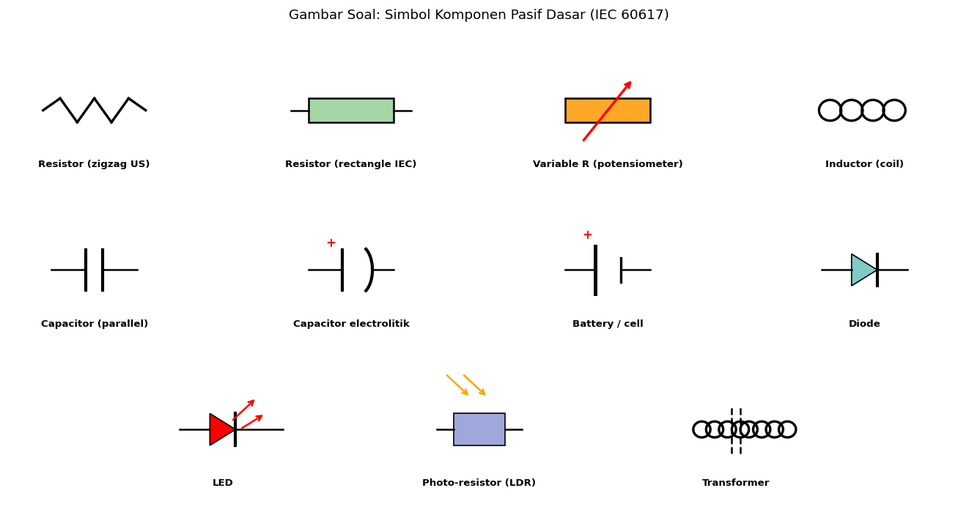
A. Zigzag
B. Rectangle (kotak panjang)
C. Lingkaran
D. Triangle

Soal 42 [Visualisasi]
Simbol Voltmeter…
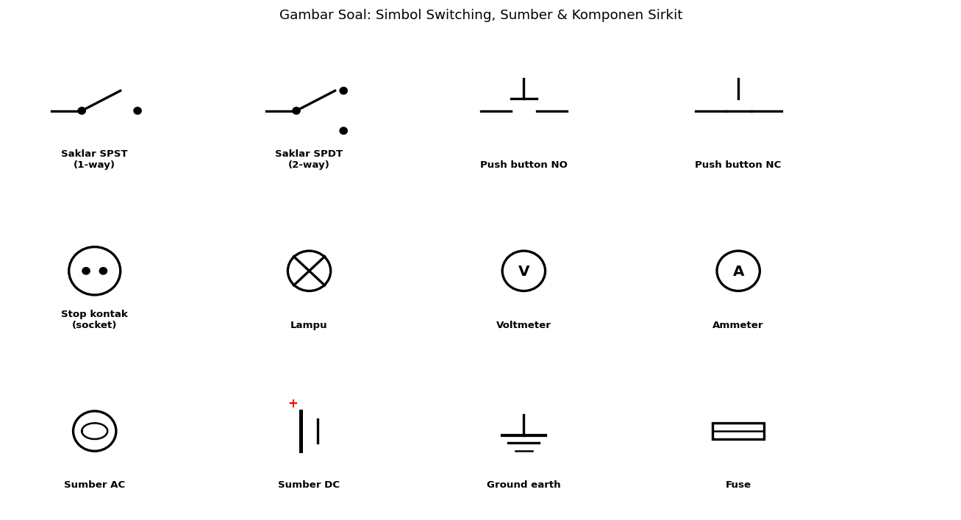
A. Lingkaran dengan A
B. Lingkaran dengan V (Voltmeter, parallel connection)
C. Triangle
D. Square

Soal 43 [Visualisasi]
Simbol RCD/RCCB ditunjukkan dengan…
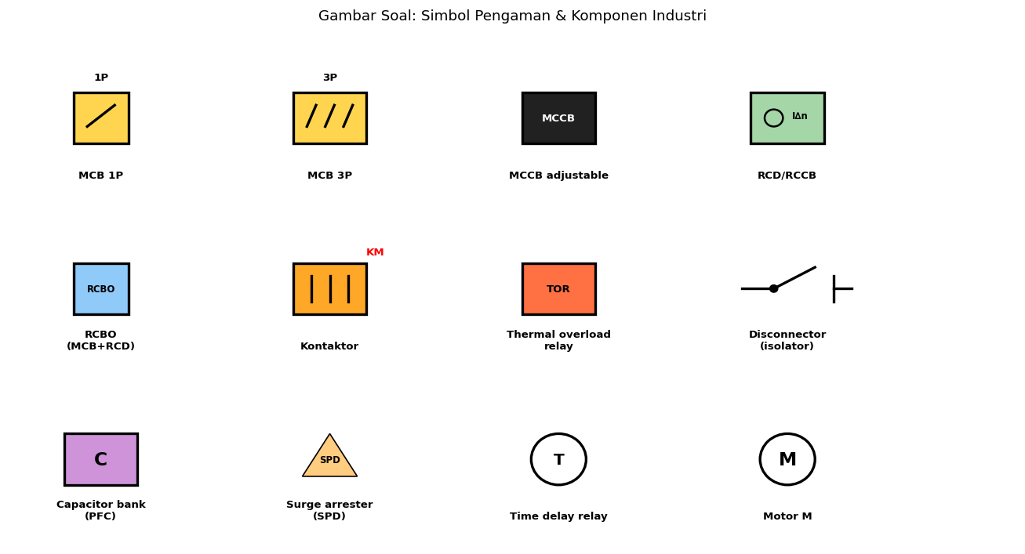
A. Random
B. Rectangle dengan toroidal core symbol + I∆n annotation (sensitifitas)
C. Triangle
D. Lingkaran

Soal 44 [Visualisasi]
Untuk power system summary substation/distribusi, diagram yang TEPAT…
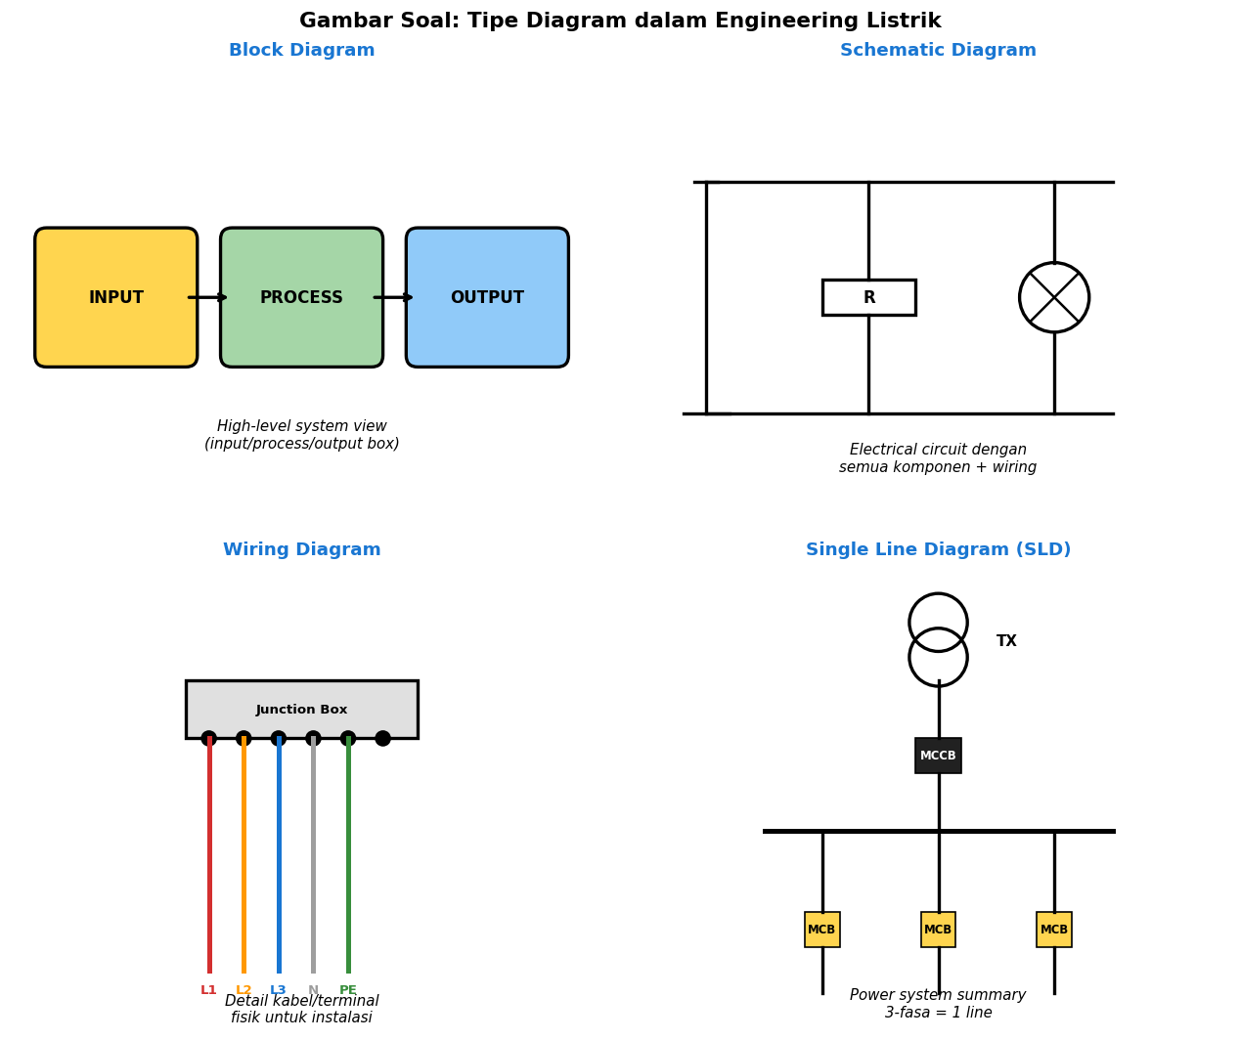
A. Wiring diagram
B. Single Line Diagram (SLD) — power system 3-fasa = 1 line, clear overview
C. Block diagram
D. Schematic

Soal 45 [Visualisasi]
Title block drawing engineering diletakkan di…
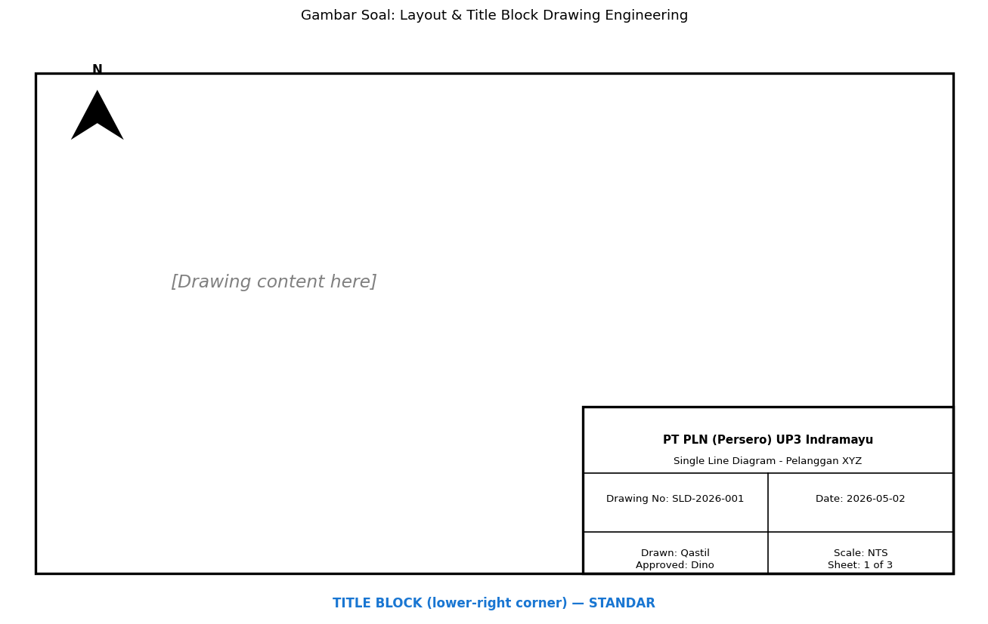
A. Center
B. Pojok BAWAH-KANAN (lower-right corner) — standar global ISO 5457
C. Top-left
D. Random

Soal 46 [Visualisasi]
Untuk floor plan rumah biasa, skala yang TEPAT…
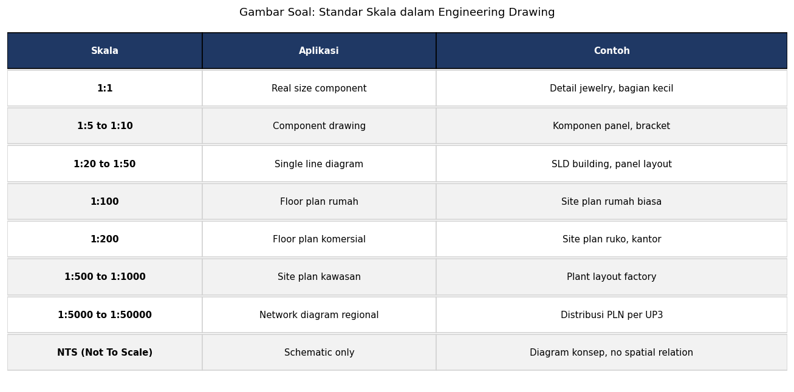
A. 1:1
B. 1:100 (10×10m rumah → 10×10 cm di drawing, fits A3-A4)
C. 1:10000
D. NTS

Soal 47 [Visualisasi]
Notasi 'cos φ' dalam engineering listrik berarti…
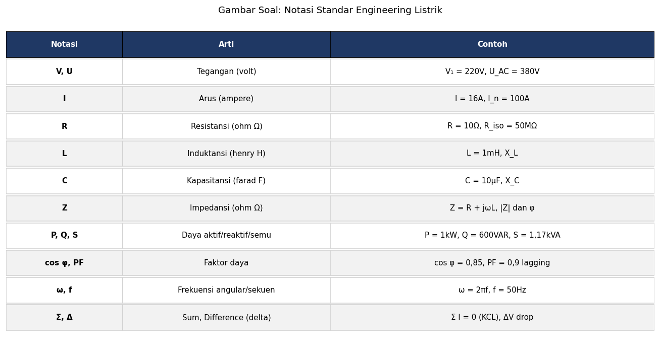
A. Frekuensi
B. Faktor Daya (Power Factor) — cos sudut antara V dan I
C. Random
D. Tidak ada

Soal 48 [Visualisasi]
Standar Indonesia untuk simbol electrical engineering…
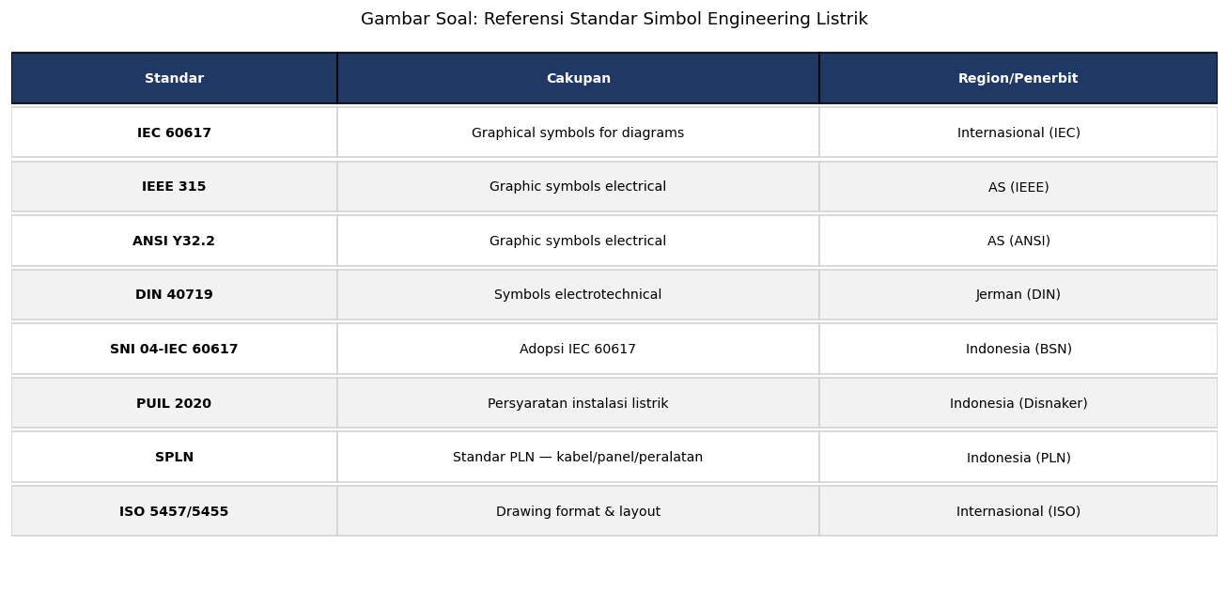
A. Tidak ada
B. SNI 04-IEC 60617 (adopsi IEC 60617) — ditambah PUIL 2020 + SPLN konteks Indonesia
C. Random
D. Hanya IEC

Soal 49 [Visualisasi]
Simbol kapasitor electrolitik (polarized) berbeda dari kapasitor biasa karena…

A. Sama
B. Salah satu plate CURVED (bukan straight line) + tanda + untuk anode — indicate polarized DC
C. Random
D. Lebih besar

Soal 50 [Visualisasi]
Untuk system architecture overview pada presentation, diagram yang TEPAT…

A. Wiring diagram
B. Block Diagram — high-level dengan input/process/output box, signal flow arrow
C. Schematic detail
D. SLD

Kunci Jawaban & Penjelasan Detail
Berikut adalah kunci jawaban beserta penjelasan ilmiah mengapa jawaban tersebut benar. Pelajari penjelasan dengan saksama untuk memahami konsep, bukan sekadar menghafal jawaban.

Ringkasan Jawaban
No. Jwb | No. Jwb | No. Jwb | No. Jwb | No. Jwb
1. B | 2. B | 3. B | 4. B | 5. B
6. B | 7. B | 8. B | 9. B | 10. B
11. B | 12. B | 13. B | 14. B | 15. B
16. B | 17. B | 18. B | 19. B | 20. B
21. B | 22. B | 23. B | 24. B | 25. B
26. B | 27. B | 28. B | 29. B | 30. B
31. B | 32. B | 33. B | 34. B | 35. B
36. B | 37. B | 38. B | 39. B | 40. B
41. B | 42. B | 43. B | 44. B | 45. B
46. B | 47. B | 48. B | 49. B | 50. B

Penjelasan Detail
Soal 1 [Teori] → Jawaban: B
Pertanyaan: IEC 60617 adalah standar untuk…
IEC 60617 = International Electrotechnical Commission Graphical Symbols for Diagrams. Standar internasional untuk simbol-simbol komponen listrik dalam diagram (resistor, kapasitor, saklar, MCB, dll). Indonesia adopsi sebagai SNI 04-IEC 60617. Plus standar lain: IEEE 315 (AS), ANSI Y32.2 (AS), DIN 40719 (Jerman). Konsistensi simbol = clear communication antar engineer global.

Soal 2 [Teori] → Jawaban: B
Pertanyaan: Simbol resistor versi IEC adalah…
Simbol Resistor: IEC 60617 = RECTANGLE (kotak panjang horizontal). IEEE/ANSI (US) = ZIGZAG. Indonesia + Eropa + Asia umumnya pakai IEC rectangle. Pilih ONE STANDARD per project, konsisten throughout. Mixing standards di 1 drawing = confusion.

Soal 3 [Teori] → Jawaban: B
Pertanyaan: Simbol DIODA…
DIODA: triangle (anode side) pointing ke arah ALIRAN ARUS + bar (cathode side). Arus mengalir hanya dari anode ke cathode (forward bias). Reverse bias: high resistance, no flow (until breakdown voltage). Aplikasi: rectifier (AC→DC), protection (anti-back-EMF), zener (regulator). LED = dioda + light emission arrow.

Soal 4 [Teori] → Jawaban: B
Pertanyaan: Simbol GROUND/EARTH adalah…
Simbol Ground/Earth: garis horizontal makin pendek menurun (3-4 tingkat seperti tangga). Variations: PE (Protective Earth) dengan label, signal ground (different connection), chassis ground. PUIL 2020 menggunakan IEC standard. Dalam SLD: ground bus connected ke ground rod symbol, R_ground spec ≤ 5Ω.

Soal 5 [Teori] → Jawaban: B
Pertanyaan: Simbol LAMPU adalah…
LAMPU: lingkaran dengan tanda × (silang) di dalam — represent filament tradisional. Untuk lampu LED modern, simbol sama digunakan (universal lighting symbol). Variations: signal lamp (lingkaran kecil), pilot lamp (R/G/Y indicator panel), strobe (lingkaran dengan zigzag). Notation 'L1, L2' untuk identifier multiple lampu.

Soal 6 [Teori] → Jawaban: B
Pertanyaan: Simbol VOLTMETER vs AMMETER…
Meter: lingkaran dengan huruf identifier dalam:
- V = Voltmeter (parallel connection)
- A = Ammeter (series connection)
- W = Wattmeter (4-terminal V+I)
- kWh = Energy meter (PLN meter)
- Hz = Frequency meter
- Var = Reactive power meter
- cos φ = Power factor meter
- M = Motor (rotating machine)
- G = Generator
Konvensi konsisten — 1 letter per parameter.

Soal 7 [Teori] → Jawaban: B
Pertanyaan: Simbol MCB/MCCB adalah…
MCB/MCCB: rectangle dengan switch contact internal. Variations:
- 1-pole: 1 switch line
- 2-pole: 2 switch line linked
- 3-pole: 3 switch line linked (3-fasa)
- 4-pole: 4 switch line linked (3-fasa + N)
Annotations: type (curve B/C/D for MCB), rating (16A, 32A, dll), brand (e.g., 'Schneider Acti9'). MCCB usually shown larger rectangle (industrial appearance) dengan label 'MCCB' inside. SLD: include short-circuit breaking capacity (Icu).

Soal 8 [Teori] → Jawaban: B
Pertanyaan: Simbol RCD/ELCB adalah…
RCD/ELCB/RCCB: rectangle dengan internal indication detection coil (toroidal core simbol kecil) + I∆n notation (sensitivity 30 mA, 100 mA, etc.). Type designation (AC, A, F, B) tertulis kecil. SLD include trip time spec + selectivity tier (S = Selective). RCBO = combination MCB+RCD dalam 1 simbol (rectangle dengan kedua features).

Soal 9 [Teori] → Jawaban: B
Pertanyaan: Block diagram berbeda dari schematic diagram dalam hal…
BLOCK DIAGRAM: high-level system overview, kotak fungsional (input/process/output) dengan arrow signal flow. Pakai untuk: system architecture, conceptual design, presentation.
SCHEMATIC DIAGRAM: detail electrical circuit, SEMUA komponen (R, C, IC, transistor, dll) dengan wiring lengkap. Pakai untuk: design verification, manufacturing PCB, troubleshooting.
WIRING DIAGRAM: detail kabel/terminal physical untuk instalasi. Pakai untuk: panel building, wiring crew, maintenance.
SINGLE LINE DIAGRAM (SLD): power system summary, 3-fasa = 1 line untuk simplicity. Pakai untuk: power distribution, substation, plant electrical.

Soal 10 [Teori] → Jawaban: B
Pertanyaan: Single Line Diagram (SLD) berfungsi untuk…
SLD (Single Line Diagram): represent 3-fasa power system sebagai SATU GARIS (atau 1 set garis) untuk simplification. Show: trafo, breakers, busbar, branch circuits, major loads. Annotate dengan rating + protection settings. Tujuan: overview clear power distribution, fault analysis, load flow study, koordinasi proteksi.
Untuk WIRING DETAIL (3 wires fasa + neutral + earth): pakai 3-LINE DIAGRAM atau wiring diagram terpisah. SLD essential output dari electrical engineering project — required PUIL 2020 + PLN acceptance.

Soal 11 [Teori] → Jawaban: B
Pertanyaan: Title block pada drawing engineering diletakkan di…
TITLE BLOCK standar global: lower-right corner. Berisi: company name + logo, drawing title, drawing number, date, revision, scale, drawn by, checked by, approved by, sheet number (1 of 3, dll). Format dapat custom per company tapi position konsisten. Standar ISO 5457 / DIN 6771 / ANSI Y14.1 mengatur layout. Plus border + margin standardized.

Soal 12 [Teori] → Jawaban: B
Pertanyaan: Skala drawing 1:100 berarti…
Skala drawing:
- 1:1 = real size (jewelry, detail bagian kecil)
- 1:5 to 1:10 = component (panel, bracket)
- 1:20 to 1:50 = SLD, panel layout
- 1:100 = floor plan rumah
- 1:200 = floor plan komersial (ruko, kantor)
- 1:500 to 1:1000 = site plan kawasan
- 1:5000 to 1:50000 = network regional (PLN UP3)
- NTS (Not To Scale) = schematic/concept saja
Konsisten + clearly mentioned di title block atau dimension label.

Soal 13 [Teori] → Jawaban: B
Pertanyaan: North arrow di floor plan/site plan berfungsi untuk…
NORTH ARROW: indicate arah utara real world. Tujuan: (1) ORIENTASI ruangan (window menghadap mana), (2) SUN PATH analysis (energy efficiency, lighting natural), (3) VENTILATION (prevailing wind direction), (4) SATELLITE/SOLAR PANEL alignment, (5) SAFETY (fire escape direction marking), (6) NAVIGATION & wayfinding. Standar simbol: arrow dengan 'N' label, atau triangle pointing up dengan 'N'. Biasanya di pojok drawing area.

Soal 14 [Teori] → Jawaban: B
Pertanyaan: Notasi 'NTS' di drawing berarti…
NTS (Not To Scale): drawing TIDAK PROPORTIONAL dengan dimensi real. Pakai untuk: schematic, single line diagram, conceptual drawing. Reason: clarity of relationship lebih penting dari spatial accuracy. Kebalikan: TO SCALE drawing dengan ratio specified (e.g., 1:100). Floor plan + site plan WAJIB to scale untuk construction; SLD/schematic biasanya NTS.

Soal 15 [Teori] → Jawaban: B
Pertanyaan: Konvensi penamaan komponen di schematic…
REFERENCE DESIGNATOR per IEEE 200 / IEC 81346:
- R: Resistor (R1, R2, ...)
- C: Capacitor (C1, C2, ...)
- L: Inductor (L1, L2, ...)
- Q: Transistor (Q1, Q2)
- D: Diode (D1, D2)
- U atau IC: Integrated Circuit
- M: Motor
- F: Fuse
- CB atau Q: Circuit Breaker (kadang Q untuk EU style)
- KM atau K: Contactor relay (industrial)
- TX: Transformer
- T: Time relay
- HMI: Human Machine Interface
Konsisten throughout drawing. Naming sequential (left-to-right, top-to-bottom) atau by signal flow.

Soal 16 [Teori] → Jawaban: B
Pertanyaan: Standar SNI yang relevan untuk simbol electrical engineering Indonesia…
STANDAR INDONESIA untuk electrical drawing:
- SNI 04-IEC 60617 (adopsi IEC 60617 graphical symbols)
- PUIL 2020 (Persyaratan Umum Instalasi Listrik) — instalasi requirements
- SPLN (Standar PLN) — spec untuk integrasi jaringan PLN
- ISO 5457 / SNI ISO 5457 — drawing format
- SNI ISO 9001 — quality management (project documentation)

Reference standar internasional juga umum digunakan: IEC, IEEE, NEC (untuk industri global). Engineer Indonesia harus familiar dengan kedua sistem (Indonesia + international) untuk cross-border project.

Soal 17 [Teori] → Jawaban: B
Pertanyaan: Layer dalam CAD drawing (AutoCAD, EPLAN) berfungsi untuk…
LAYER di CAD: organize drawing elements per category. Common layers untuk electrical:
- POWER (heavy lines, tegangan tinggi)
- LIGHTING (medium lines, lampu + saklar)
- COMMUNICATION (data, telecom, fire alarm)
- DIMENSION (text + dimension annotation)
- TEXT (notes, labels)
- HIDDEN (komponen behind panel/wall)
- VIEWPORT (plotting setup)
- CENTERLINE (axis, symmetry)

Benefits: (1) SELECTIVE DISPLAY — show/hide layers untuk clarity, (2) BATCH editing — change all line color/weight per layer, (3) PRINTING control — different layers different plot setting, (4) COLLABORATION — multi-discipline (electrical + mechanical + plumbing) merged via layers, (5) STANDARDIZATION — company-wide naming convention. Modern: BIM (Building Information Modeling) extend ini ke 3D objects + metadata.

Soal 18 [Teori] → Jawaban: B
Pertanyaan: Software industry-standard untuk electrical drawing…
Software EDA / Electrical CAD:
- COMMERCIAL: AutoCAD Electrical (Autodesk, popular), EPLAN (Germany, industrial standard), ETAP (Operation Technology, power systems analysis), SolidWorks Electrical (3D integration)
- OPEN SOURCE / FREE: KiCad (PCB + schematic), QElectroTech (SLD + symbols), FreeCAD
- POWER SYSTEM SPECIFIC: ETAP, DIgSILENT PowerFactory, PSS®E, Siemens PSCAD
- BIM INTEGRATION: Revit MEP, Bentley OpenBuildings

Indonesia: AutoCAD dominant (cost commercial license tinggi), tapi bertahap shift ke EPLAN untuk industrial + ETAP untuk power. PLN: ETAP common untuk planning + relay coordination. Open source growing untuk SME + freelancer.

Product opportunity: Electra Skill Academy CAD curriculum integrate dengan tools modern + Indonesia-specific symbols library. Differentiation.

Soal 19 [Teori] → Jawaban: B
Pertanyaan: Revision control pada drawing engineering…
REVISION CONTROL essential untuk:
(1) AUDIT TRAIL — siapa yang mengubah apa kapan
(2) COMPLIANCE — quality management ISO 9001, project regulatory submission
(3) CONFIGURATION MANAGEMENT — multiple project teams synchronize
(4) LIABILITY — legal record dalam case dispute

Standard practice:
- Revision NUMBER (0, 1, 2, ...) atau LETTER (A, B, C, ...) di title block
- REVISION HISTORY TABLE: Rev | Date | Description | Drawn | Checked | Approved
- CLOUD SHAPE markup pada drawing (bubble around changed area)
- TRIANGLE callout (Δ) dengan revision number
- ELECTRONIC version control: PDM/PLM systems (Vault, Teamcenter, EPLAN)

For PLN UP3 + Pelanggan industri project: revision history mandatory dalam acceptance documentation. SLO renewal request comparison antara as-built vs original design.

Product opportunity Envisor: 'Drawing Management System' SaaS untuk kontraktor + engineering firm Indonesia.

Soal 20 [Teori] → Jawaban: B
Pertanyaan: Best practice consistency drawing dalam project…
BEST PRACTICE consistency:
(1) SYMBOL LIBRARY — pakai library standar (IEC 60617-based), avoid custom symbols
(2) TITLE BLOCK TEMPLATE — company-wide format, populate via attribute fields
(3) LAYER NAMING — convention konsisten (e.g., E-POWER, E-LIGHTING, E-CONTROL, M-MECHANICAL)
(4) LINE WEIGHT — heavier untuk power (0,5mm), lighter untuk control/data (0,25mm), dimensions (0,18mm)
(5) FONT — single font (e.g., Arial, RomanS in CAD), text size hierarchy
(6) DIMENSION STYLE — preset (decimal places, units, arrowhead size)
(7) PLOT STYLE — color-to-line-weight mapping, B&W output untuk print
(8) CHECKLIST/QUALITY CHECK — automated tools verify drawings before submit
(9) TEMPLATE FILES — starter file dengan all setup pre-configured
(10) STYLE GUIDE document — written reference untuk team

Benefit: clear communication, reduced errors, faster onboarding new engineer, professional image, easier maintenance. Investment dalam standardization = ROI multiplier project quality + team productivity.

Soal 21 [Hitungan] → Jawaban: B
Pertanyaan: Drawing skala 1:50 menampilkan kabel sepanjang 4 cm. Length real?
Skala 1:50 berarti 1 cm drawing = 50 cm real. Length real = 4 cm × 50 = 200 cm = 2 meter. Konversi penting saat reading drawing untuk material take-off (BOM) atau site verification.

Soal 22 [Hitungan] → Jawaban: B
Pertanyaan: Floor plan rumah 100m² (10×10m) di-draw skala 1:100. Ukuran kertas yang BUTUH?
Skala 1:100, 10×10m real = 10×10 cm di drawing. Plus margin (1cm), title block (10×3cm), dimensions (additional 5-10 cm tiap sisi). Total butuh ~30×30 cm minimum. A4 (21×30 cm) borderline, A3 (30×42 cm) recommended untuk komfort dan readability. Untuk floor plan komersial besar (e.g., kantor 1000m²): A2 (42×60 cm) atau A1 (60×84 cm) standar.

Soal 23 [Hitungan] → Jawaban: B
Pertanyaan: Site plan factory 200×300m, butuh skala 1:500 atau 1:1000. Drawing size?
Konversi:
- 1:500: 200m=40cm, 300m=60cm → drawing 40×60 cm + margins → A1 (60×84 cm)
- 1:1000: 200m=20cm, 300m=30cm → drawing 20×30 cm + margins → A3 (30×42 cm)
Pilih skala based on detail level needed. Plus consider readability print (text size minimum 2-3mm) — too small skala = text tidak terbaca.

Soal 24 [Hitungan] → Jawaban: B
Pertanyaan: Drawing dengan 50 simbol. Time untuk hand-draw vs CAD?
Productivity comparison:
- HAND-DRAW: 5 menit per simbol (ruler + template + careful drawing) × 50 = 250 menit ~4 jam. Plus erasing + corrections.
- CAD with symbol library: Insert simbol from library (10-20 detik per simbol), connect dengan polyline tool. ~30 menit total untuk 50 simbol drawing. Plus ~30 menit untuk dimension + text + title block.
- Total CAD: ~1 jam vs hand-draw ~4-5 jam.

Productivity gain CAD: 4-5×. Plus quality (consistent, scalable, editable, version-controlled). Investment CAD software: AutoCAD ~Rp 25 juta/year subscription, EPLAN higher. Open source alternatives: KiCad, QElectroTech (free).

For Indonesian electrical industry: CAD adoption growing, especially untuk kontraktor menengah-besar. SME + freelancer: still use hand-draw or basic Excel/Word. Educational opportunity Electra Skill Academy: CAD electrical curriculum bridge gap.

Soal 25 [Hitungan] → Jawaban: B
Pertanyaan: AutoCAD subscription Rp 30jt/year. Engineer save 2 jam/hari × 20 hari kerja × Rp 100rb/jam = Rp 4jt/bulan?
ROI ANALYSIS:
Saving: 2 jam/hari × 20 hari × Rp 100rb/jam (loaded labor cost engineer) × 12 bulan = Rp 48 juta/year
Cost: Rp 30 juta/year subscription
NET: Rp 18 juta/year benefit (60% ROI)
PLUS:
- Quality improvement (less error, professional output)
- Scalability (handle larger projects with same headcount)
- Career growth (CAD-skilled engineer earn premium)
- Integration (BIM, project management, ERP)
Investment justified untuk firm dengan dedicated electrical engineering work. SME freelancer: open source alternative (KiCad, QElectroTech free).

Soal 26 [Hitungan] → Jawaban: B
Pertanyaan: Drawing pelanggan industri 50 sheets revisi 5×. Total dokumentasi?
Untuk project pelanggan industri 50 sheets dengan 5 revisi:
- Total drawings dokumentasi: 50 × 5 = 250 sheets
- Revision history table per sheet: 5 entries
- Markup cloud + triangle callout pada changed area
- Approval workflow per revision
Document management: electronic via PLM/PDM (Bentley ProjectWise, Autodesk Vault, EPLAN ePulse) atau cloud (Bluebeam, BIM 360, manual SharePoint).
For PLN UP3 acceptance: deliverable as-built drawings final revision (the latest 'AS-BUILT' tag) plus revision history. Maintain dalam pelanggan project archive.

Cost dokumentasi management: ~5-10% project budget. Investment penting untuk compliance + future maintenance reference.

Soal 27 [Hitungan] → Jawaban: B
Pertanyaan: Symbol library standard berisi ~500 simbol (IEC 60617). Time untuk learn vs custom symbol?
STANDARD LIBRARY (IEC 60617 ~500 simbol) advantages:
(1) PRE-EXISTING knowledge — engineering grad + experienced engineer udah familiar
(2) TOOL-AGNOSTIC — symbol consistent antar AutoCAD/EPLAN/QElectroTech/SolidWorks
(3) GLOBAL COMMUNICATION — international team can read same drawing
(4) NO ONBOARDING — new hire productive day-1
(5) UPDATES — IEC committee maintain + extend library, automatic via tool updates

CUSTOM SYMBOL disadvantages:
(1) INCONSISTENCY — 10 engineers, 10 styles
(2) TRAINING — weeks untuk new hire understand
(3) MAINTENANCE BURDEN — internal team maintain library, document, update
(4) TOOL LOCK-IN — custom symbol tied to specific tool, migration painful
(5) COMMUNICATION — outside party (vendor, contractor, audit) confused

Best practice: 99% pakai standard library, 1% custom hanya untuk truly proprietary component (e.g., specific machine OEM symbol). Document custom dalam style guide.

Product opportunity Electra Skill Academy: course 'Symbol Library Mastery' covering IEC standard + Indonesia adaptation + tool-specific tricks. Career advantage.

Soal 28 [Hitungan] → Jawaban: B
Pertanyaan: Drawing ISO A4 portrait standar margin (top 25mm, bottom 25mm, left 25mm, right 25mm). Drawable area?
ISO A4 portrait: 210 × 297 mm.
Margin 25mm semua sisi: drawable area = (210-50) × (297-50) = 160 × 247 mm = 39.520 mm² ≈ 396 cm².
Total A4: 210 × 297 = 62.370 mm² ≈ 624 cm².
Lost area: 624 - 396 = 228 cm² (37% loss).
Untuk drawing dengan dense content: gunakan A3 (297×420) atau A2 (420×594) instead. Margin standar ISO 5457:
- Top: 10mm (drawing register/folder)
- Bottom: 10mm
- Left: 20-25mm (binding margin)
- Right: 10mm
Plus title block typically lower-right corner, ukuran ~190×60mm untuk A4.

Soal 29 [Hitungan] → Jawaban: B
Pertanyaan: Cost development internal symbol library 500 symbols × Rp 50rb desain = Rp 25 juta. ROI dibandingkan beli library Rp 5 juta + customization Rp 5 juta?
BUILD vs BUY ANALYSIS:

BUILD (internal development):
- 500 symbols × Rp 50rb = Rp 25 juta (initial)
- Plus testing + validation: Rp 5-10 juta
- Plus maintenance ongoing: Rp 5 juta/year (updates, bug fix, new request)
- TOTAL 1-tahun: Rp 30-40 juta. 5-tahun: Rp 50-65 juta

BUY (commercial library):
- Library purchase: Rp 5-10 juta one-time
- Customization (Indonesia-specific PLN/PUIL): Rp 5 juta
- Annual updates subscription: Rp 1-2 juta/year
- TOTAL 1-tahun: Rp 12 juta. 5-tahun: Rp 17-20 juta

Verdict: BUY 50-70% cheaper than BUILD untuk standard project. Plus:
- TIME-TO-PRODUCTIVITY faster (instant vs months)
- QUALITY higher (vendor specialized, professional)
- SUPPORT (vendor help desk)
- COMMUNITY (forum, examples)

WHEN to BUILD:
- TRULY proprietary component (e.g., custom machine OEM)
- LARGE ENTERPRISE with dedicated CAD admin team + 100+ engineers
- COMPETITIVE ADVANTAGE dari unique IP

For most cases: BUY commercial library + customize 5-10% for company-specific. Open source alternative untuk SME: KiCad library (free), QElectroTech (free), IEC standard library bundled.

Product opportunity Envisor: 'Indonesia Electrical Symbol Library' commercial + customization service untuk PLN/PUIL/SPLN compliance. Niche market.

Soal 30 [Hitungan] → Jawaban: B
Pertanyaan: Engineer junior take 8 jam draw 1 SLD; senior 2 jam (kombinasi skill + library familiar). Productivity ratio?
Productivity gap junior vs senior: 4×.
For project dengan 50 SLD drawings:
- JUNIOR: 50 × 8 = 400 jam = 50 hari (1 engineer)
- SENIOR: 50 × 2 = 100 jam = 12,5 hari (1 engineer)
Saving: 37,5 hari (sekitar 7,5 weeks) per project untuk 1 engineer.
Cost saving (engineer Rp 100rb-200rb/jam loaded): 300 × Rp 150rb = Rp 45 juta saved per project.

IMPLIKASI MANAGEMENT:
(1) HIRE/PROMOTE senior — premium pay (1,5-2× junior) tapi 4× productivity = 2× ROI
(2) TRAIN junior — speed up curve via mentorship + structured curriculum
(3) STANDARDIZE templates + library — junior bisa achieve senior productivity dengan tooling
(4) AUTOMATION — script repetitive task (e.g., panel design auto-generate dari spec input)
(5) AI ASSISTANCE — modern AI tools generate draft drawing dari description, engineer review + refine

Electra Skill Academy product opportunity: structured curriculum 'CAD Electrical Mastery' bridging junior → senior dalam 6-12 bulan vs natural curve 3-5 tahun. Strong career value untuk learner. Industry value untuk firm (faster productivity ramp). Win-win.

Soal 31 [Studi Kasus] → Jawaban: B
Pertanyaan: Kontraktor instalasi rumah submit drawing dengan simbol mixing IEC + ANSI dalam 1 sheet. Acceptance test PLN?
MIXING STANDARD inconsistency = drawing readability + interpretation risk:
(1) RESISTOR: zigzag (US) vs rectangle (IEC) — confusion saat 1 drawing pakai keduanya
(2) SCHEMATIC vs SLD ambiguity
(3) DIMENSION units (mm vs inch) — Indonesia metric, US imperial
(4) PAPER SIZE convention (A-series ISO vs ANSI) — drawing scale interpretation

PLN UP3 ACCEPTANCE PROCEDURE:
(1) REVIEW DRAWING — flag inconsistency
(2) FORMAL FEEDBACK — written review notes ke kontraktor (specific issues)
(3) MANDATORY RESUBMIT — kontraktor clean up dengan unified standard (preferred IEC + Indonesia notation)
(4) RE-REVIEW — verify consistency, approve
(5) DOCUMENT — quality control record

STANDARDIZATION PROGRAM:
- PLN UP3 publish 'Drawing Submission Guidelines' untuk kontraktor (Indonesia-specific)
- Kontraktor certification program include drawing standard
- Mentorship + training untuk SME kontraktor
- Online resources (templates, examples, video tutorials)

Long-term: raise standar nasional Indonesia electrical drawing quality. Reduce error, ambiguity, dispute. Improve safety + reliability instalasi.

Product opportunity Envisor: 'Drawing Quality Audit Service' + 'Electrical CAD Training' untuk kontraktor. Plus Electra Skill Academy curriculum module 'Drawing Standards Mastery'. Synergistic ecosystem.

Soal 32 [Studi Kasus] → Jawaban: B
Pertanyaan: Pelanggan industri request retrofit panel old (1990s drawing hand-drawn outdated). Modernization process?
RETROFIT PANEL OLD comprehensive process:

(1) DIGITIZE EXISTING DRAWING:
- High-res scan original hand-drawn drawing
- TRACE manually di CAD (raster-to-vector tools available, but manual cleanup needed)
- Cleanup dengan modern standard (replace zigzag → rectangle, update simbol modern)

(2) AS-BUILT SURVEY:
- Field walk panel + verify aktual instalasi
- Photograph + measure
- Often: actual installation diverge dari original drawing (modifications over years tidak documented)
- Document discrepancies — "as-found" vs "as-drawn"

(3) UPDATE DRAWING:
- CAD digitization dengan standar modern
- Layer organization
- Title block update with current revision
- Annotation lengkap (rating, settings, vendor info)

(4) RETROFIT DESIGN:
- Identify obsolete components — fuse → MCB, hand-pull switch → MCCB, etc.
- Add proteksi modern — RCD/RCBO mandatory PUIL 2020
- Compliance check — color coding, IP rating, grounding
- Cable replacement jika ageing severe
- Future capacity expansion provision

(5) ACCEPTANCE TEST POST-RETROFIT:
- Megger insulation, polarity, phase rotation, ground continuity, RCD test, loop impedance
- Comprehensive test report ISO 17025-style
- SLO renewal pelanggan

(6) DOCUMENTATION:
- Updated drawings dalam company archive
- Maintenance manual update
- Training operator staff dengan changes

COST: Project retrofit + drawing modernization typical Rp 50-200 juta untuk pelanggan industri medium. ROI dari reliability + safety + compliance + reduced maintenance.

Product opportunity: Envisor 'Industrial Electrical Modernization Service' untuk pelanggan industri. PLN partnership untuk acceptance test + SLO. PLNlytics dashboard untuk asset management ongoing.

Fit dengan tema Pak Qastil: Just Energy Transition (modernization narrative), Esri Fellowship (GIS asset management dashboard), RACE for 2030 (Grid Transformation). Strong project portfolio addition.

Soal 33 [Studi Kasus] → Jawaban: B
Pertanyaan: Engineer baru di PLN UP3 confused dengan beragam simbol di SLD, schematic, wiring diagram pelanggan. Onboarding strategy?
ONBOARDING ENGINEER BARU comprehensive (Pak Qastil's role di PLN UP3 + Electra Skill Academy):

(1) STRUCTURED TRAINING (week 1-2):
- IEC 60617 fundamentals (graphical symbols)
- PUIL 2020 + SPLN context Indonesia
- Drawing types: SLD, schematic, wiring, block diagram
- Title block, scale, dimension convention
- Software tools (AutoCAD basic, ETAP intro)

(2) SYMBOL LIBRARY WORKSHOP (week 3-4):
- Hands-on practice draw simple SLD
- Decode existing pelanggan drawings
- Quiz adaptive (Electra Skill Academy module)
- Common pitfalls + best practice

(3) PROJECT SHADOWING (month 2-3):
- Pair junior dengan senior engineer
- Real pelanggan project — observe + assist
- Site visit untuk context (drawing → real installation correlation)
- Q&A sessions, debrief

(4) REFERENCE DESK:
- Physical cheat sheet — IEC simbol popular, PUIL kunci, common formula
- Digital wiki — searchable, contextual, links to standards
- FAQ database — questions accumulated dari past juniors

(5) MENTORSHIP:
- Assigned senior mentor — bi-weekly 1:1
- Career development plan
- Skills progression milestones

(6) CONTINUING EDUCATION:
- Annual training new standard updates
- Conference + workshop attendance
- Internal lunch-and-learn series
- Certification track (BNSP, vendor-specific)

(7) ROTATION PROGRAM:
- 6-12 bulan rotate across PLN UP3 functions (planning, operations, customer service, P2TL, regulatory)
- Comprehensive understanding business
- Cross-functional networks

METRICS untuk onboarding success:
- TIME-TO-PRODUCTIVITY — junior bisa handle independent project after X months
- QUALITY — error rate drawings (review feedback)
- RETENTION — first-year turnover
- ENGAGEMENT — survey scores
- KARIR PROGRESS — promotion timeline

RESOURCES:
- Electra Skill Academy curriculum integrated dengan PLN onboarding
- AI-powered tutoring (OctoAgent module 'EngineeringMentor AI')
- Mobile app untuk just-in-time learning

Pak Qastil's positioning: PLN UP3 Energy Transaction Manager + Electra Skill Academy founder = uniquely placed untuk bridge industry training gap. Knowledge transfer multiplier — train trainer + scale via Academy. National impact: raise standar engineering quality di Indonesia electrical sector.

Soal 34 [Studi Kasus] → Jawaban: B
Pertanyaan: Konsep modul Envisor 'AutoSLD AI' — generate SLD otomatis dari spec pelanggan?
AUTOSLD AI MODULE (potensi produk Envisor / OctoAgent agent):

(1) INPUT WIZARD:
- LOAD LIST: peralatan + spec (P kW, V, single/3-fasa, type lighting/motor/AC/VFD)
- TRAFO SOURCE: kVA, voltage, impedance
- LOCATION: ruangan/area + dimensi
- SPECIAL REQUIREMENTS: redundancy, RCD type, harmonic mitigation

(2) AI GENERATION:
- LOAD CALCULATION — diversity factor, total demand
- TRAFO + MAIN BREAKER sizing
- SUB-MAIN distribution panel design
- BRANCH CIRCUIT per peralatan dengan dedicated MCB/RCBO sizing
- CABLE sizing per circuit (KHA + V_drop check + harmonic if applicable)
- GROUNDING + bonding plan
- PROTECTION coordination (selectivity tier)

(3) COMPLIANCE CHECK:
- PUIL 2020 — kabel ampacity, V_drop limit, RCD requirement
- SPLN — vendor spec compliance
- IEC — international best practice
- LOCAL CODE — Disnaker, fire safety

(4) AUTO-RENDER DRAWING:
- IEC 60617 simbol
- Layout intelligent (avoid overlapping, minimize crossings)
- Title block auto-populate (project info, date, revision)
- Dimension annotation
- Notes + legend

(5) EDIT + REFINE:
- GUI editor untuk tweak layout, swap component, update annotation
- Real-time validation (warning jika tweak break compliance)
- Version control integrated

(6) EXPORT:
- PDF untuk presentation
- DWG untuk AutoCAD compatibility
- DXF untuk other CAD tools
- Excel BOM (Bill of Materials) auto-generate dengan vendor SKU + pricing

(7) BACK-OFFICE INTELLIGENCE:
- LEARNING — AI improve based on engineer feedback per drawing
- LIBRARY — accumulated symbol + pattern dari past projects
- REUSE — similar project clone + adapt

(8) COLLABORATION:
- TEAM editing — multiple engineer + reviewer simultaneous
- COMMENT + APPROVAL workflow
- AUDIT trail dengan revision history

MARKET:
- Kontraktor instalasi (10.000+ Indonesia)
- Konsultan electrical engineering
- PLN UP3 (untuk pelanggan industri review + design)
- Building MEP design firm
- Industrial facility manager (in-house design)

PRICING:
- Free tier (1 SLD/month, watermarked PDF)
- Pro Rp 200rb/bulan unlimited
- Enterprise Rp 1-5 jt/bulan multi-user + custom branding + API

DIFFERENTIATION:
- Indonesia-specific (PUIL, SPLN, vendor catalog Indonesia)
- AI-powered (vs hard-coded rule engine)
- Integrated dengan portfolio Envisor (audit, optimization, training) — full electrical lifecycle
- API + mobile app — accessible anywhere

FIT DENGAN PORTFOLIO PAK QASTIL: PLN domain expertise + Envisor consulting brand + OctoAgent AI platform + Electra Skill Academy training (graduate kontraktor pakai tool ini). Synergistic ecosystem. Potential national impact: democratize quality electrical design, raise Indonesia industry standard.

Soal 35 [Studi Kasus] → Jawaban: B
Pertanyaan: PLN UP3 program 'Standard Drawing Library Indonesia' untuk kontraktor instalasi listrik. Konten + impact?
PROGRAM 'STANDARD DRAWING LIBRARY INDONESIA' comprehensive:

(1) IEC 60617 SYMBOL ADAPTASI:
- Translate IEC simbol ke konteks Indonesia (notation Bahasa, vendor spec local)
- Add SPLN-spesifik simbol (PLN-unique components)
- Mobile-friendly format untuk handphone field reference

(2) TEMPLATE DRAWING per SKENARIO:
- RUMAH BIASA — single fasa 1300/2200/3500 VA
- KOMERSIAL — single fasa 5500/7700 VA, 3-fasa 11/22/41 kVA
- INDUSTRI — 3-fasa 53/82/105/131/197 kVA
- TRAFO DISTRIBUSI — 25/50/100/160/250/400 kVA dengan Standard SLD
- KABEL SR — overhead/underground configurations
- GROUNDING — single rod/multi rod/mesh
- RENEWABLE — solar PV grid-tie, EV charger

(3) PLN-SPESIFIK PANEL STANDARDS:
- Panel TR gardu trafo distribusi (incoming + outgoing feeder)
- KWh meter pelanggan + sealing protocol
- P2TL detection panel
- Substation low voltage panel
- Modular component standard

(4) COMPLIANCE CHECK TOOLS:
- AutoCAD plugin/script — automated check IEC + PUIL compliance
- Excel template — load calculation + cable sizing
- Mobile app — quick reference + verification

(5) TUTORIAL + E-LEARNING:
- Video series — drawing fundamentals, software tutorial, case studies
- Electra Skill Academy module: 'Drawing Standards Mastery'
- Webinar + workshop reguler
- Certification practice exam

(6) KONTRAKTOR CERTIFICATION:
- Pre-requisite: Electra Skill Academy course completion
- Examination: tertulis + praktek + portfolio review
- Tier: Basic (rumah), Intermediate (komersial), Advanced (industri)
- Public registry searchable di PLN/Envisor app
- Annual continuing education + recertification

(7) DIGITAL PLATFORM (PLNlytics + Envisor integration):
- Centralized library accessible via web + mobile
- Subscription model (free tier + premium)
- Community features — forum, examples, peer review
- Cloud-based storage drawing pelanggan

IMPACT:
(a) UNIFORM QUALITY — drawings di seluruh Indonesia mengikuti standard sama
(b) REDUCE ERROR — mismatch instalasi, ambiguity, kontradiksi standar
(c) PROFESSIONAL IMAGE — industri kontraktor naik kelas
(d) FASTER ACCEPTANCE TEST — PLN UP3 evaluator familiar dengan format standar
(e) CUSTOMER PROTECTION — kontraktor non-compliance tertangkap early
(f) DATA INSIGHTS — PLN gather data design pattern + identify common issues
(g) NATIONAL CAPACITY BUILDING — engineering pool Indonesia stronger

IMPLEMENTATION TIMELINE:
- YEAR 1: pilot 5 UP3 (Indramayu, Surabaya, Bandung, Medan, Makassar) + 1.000 kontraktor enrolled
- YEAR 2-3: scale 30 UP3 + 10.000 kontraktor
- YEAR 5: full national + 50.000+ kontraktor certified

FUNDING:
- PLN capex (capacity building + safety priority)
- Government partnership (Disnaker, BNSP)
- Kontraktor membership fee (sustainable)
- Vendor sponsorship (Schneider, ABB, Hager, Siemens — premium placement di standard library)
- International donor (USAID, ADB technical assistance)

FIT DENGAN PORTOFOLIO PAK QASTIL:
- PLN role (authority + reach)
- PLNlytics (technical platform)
- Envisor (consulting + commercial offering)
- Electra Skill Academy (education + certification)
- OctoAgent (AI tooling)
- Esri Fellowship (GIS dashboard adoption tracking)
- Australia Awards Just Energy Transition (modernization)
- ASPP Seoul (international platform)

Potential national impact + research publication + replicable for other developing countries. Career-defining initiative.

Soal 36 [Studi Kasus] → Jawaban: B
Pertanyaan: Audit drawing pelanggan industri reveal: 50% sheets tidak punya title block proper, 30% mixing standard. Implikasi + remediation?
DRAWING QUALITY ISSUES audit reveal:

IMPLICATIONS:
(1) AUDIT TRAIL — title block missing = no traceability (siapa author, kapan, revisi keberapa)
(2) MAINTAINABILITY — future engineer susah modify
(3) COMPLIANCE — fail ISO 9001 quality audit, fail PLN UP3 acceptance test
(4) LEGAL EXPOSURE — disputes legal lacking proper documentation
(5) PROFESSIONAL IMAGE — perception sebagai company yang tidak detail-oriented
(6) ERROR RATE — high (mixing standard = ambiguity = misinterpretation)

REMEDIATION COMPREHENSIVE:

(1) CORPORATE DRAWING STANDARD:
- Documented style guide (IEC 60617 + PUIL Indonesia adaptation)
- Title block template (mandatory fields)
- Layer convention
- Symbol library curated
- Distribution: every engineer + kontraktor receive copy + training

(2) MANDATORY TRAINING:
- Onboarding new engineer/kontraktor
- Refresher annual untuk existing staff
- Practice exercises + assessment
- Electra Skill Academy module integration

(3) DRAWING REVIEW CHECKPOINT:
- Pre-submit checklist (title block ✓, standard ✓, scale ✓, etc.)
- Peer review oleh senior engineer (draft) sebelum submit ke client/PLN
- AUTOMATED LINT TOOL — script check drawing compliance (e.g., title block fields populated, layer naming correct)
- Stage-gate approval — drawing tidak release tanpa review pass

(4) PERIODIC AUDIT:
- Quarterly random sample drawings audit per project team
- Score quality scorecard
- Trend analytics — improvement over time?
- Recognition program (best team) + corrective action (struggling team)

(5) DOCUMENT MANAGEMENT SYSTEM:
- Centralized repository (Bentley ProjectWise, Autodesk Vault, atau cloud)
- Version control automatic
- Permission management (who can edit/view/approve)
- Search + retrieve efficient

(6) METRICS:
- COMPLIANCE RATE — % drawings dengan complete title block + correct standard
- ERROR RATE — review feedback per drawing
- TIME-TO-APPROVAL — efficient review cycle
- CUSTOMER SATISFACTION — feedback dari pelanggan yang menerima drawing
- RE-WORK RATE — drawings need redo karena inconsistency

(7) CULTURE CHANGE:
- Leadership emphasize quality + standardization
- Reward team yang excel
- Continuous improvement mindset (Kaizen)
- Communication open about issues + solutions

INVESTMENT:
- Training: Rp 10-50 juta/year untuk corporate program
- Software tools (lint, document management): Rp 50-200 juta/year
- Audit + governance: 0,5-1 FTE dedicated quality engineer
- TOTAL: Rp 100-300 juta/year for medium-size firm

ROI:
- ERROR REDUCTION saves rework: 5-10× investment
- COMPLIANCE — avoid audit failure penalty
- PROFESSIONAL IMAGE — win more projects via quality reputation
- TALENT ATTRACTION — engineers want work in well-organized firm

Product opportunity Envisor: 'Drawing Quality Audit & Improvement Service' untuk pelanggan industri + kontraktor. PLNlytics dashboard tracking compliance kontraktor. Electra Skill Academy module 'Drawing Standards Mastery'. Synergistic ecosystem.

Soal 37 [Studi Kasus] → Jawaban: B
Pertanyaan: Esri Fellowship project Pak Qastil: 'GIS Drawing Repository' untuk PLN UP3 Indramayu — apa value-add?
GIS DRAWING REPOSITORY (Esri Fellowship project + PLNlytics integration):

CONCEPT: Centralize PLN UP3 drawings dalam GIS-enabled platform — drawings GEOREFERENCED to physical asset/location.

(1) GEOSPATIAL DRAWING STORAGE:
- ArcGIS Online / Enterprise hosted
- Drawings (PDF, DWG) attached to GIS feature (asset, customer, kabel route)
- Metadata: customer ID, asset type, kategori (rumah/komersial/industri), date, revision, kontraktor
- GeoJSON format untuk spatial query

(2) SEARCH CAPABILITY:
- BY AREA — "semua drawing pelanggan di kelurahan X"
- BY ASSET — "drawing trafo distribusi GD-001"
- BY CUSTOMER — "drawing pelanggan dengan ID 1234567890"
- BY KONTRAKTOR — "drawings yang dikerjakan kontraktor PT XYZ"
- BY DATE RANGE — "drawing yang dibuat 2020-2025"
- BY COMPLIANCE STATUS — "drawings flagged untuk re-audit"

(3) DRAWING DENSITY VISUALIZATION:
- Heat map per kelurahan/kecamatan — banyak drawing = high activity
- Clustering kontraktor — area dengan banyak drawing dari kontraktor X
- Trend over time — growth area
- Gap analysis — area dengan minim drawing (potential outdated installation)

(4) PREDICTIVE MAINTENANCE:
- Drawing AGE + COMPLEXITY — older + complex = likely candidate untuk audit/upgrade
- CORRELATION dengan outage data — frequent outage di asset dengan drawing lama outdated
- ML model predict probability fault per asset
- DASHBOARD — prioritized list assets need attention

(5) AUDIT TRAIL HISTORY:
- Per asset — drawing revision history (Rev 0 original → Rev 1 modification 2018 → Rev 2 retrofit 2024)
- Modifications tracked dengan reason (load expansion, equipment upgrade, fault repair)
- Compliance checkpoints — last acceptance test date, next due date

(6) COLLABORATION FEATURES:
- Field engineer — view drawing on tablet via ArcGIS Field Maps
- Office engineer — review + edit centralized
- Customer portal — view their installation drawings (transparency)
- Kontraktor portal — submit + check status

(7) ANALYTICS DASHBOARD:
- COMPLIANCE RATE — % drawings dengan title block + standard correct
- KONTRAKTOR PERFORMANCE — quality scoreboard
- GEOGRAPHIC PATTERNS — area dengan banyak issue
- TREND — improvement over time
- EXEC SUMMARY — high-level KPI untuk leadership

(8) INTEGRATION:
- PLN BMC (Business Management System) — customer data
- PLNlytics — IoT + smart meter data
- Esri ArcGIS — GIS platform foundation
- Envisor — audit + consulting services
- Electra Skill Academy — kontraktor certification + training data

VALUE-ADD:
(a) DECISION-MAKING — data-driven prioritization untuk replacement, upgrade, audit
(b) EFFICIENCY — find drawing instant (vs paper file rummage)
(c) RELIABILITY — predict + prevent fault
(d) CUSTOMER EXPERIENCE — transparency, faster service
(e) ASSET MANAGEMENT — comprehensive asset registry digital
(f) RESEARCH OUTPUT — Pak Qastil publish methodology + result
(g) NATIONAL IMPACT — replicable methodology untuk PLN UP3 lain di Indonesia

FIT DENGAN PORTFOLIO PAK QASTIL:
- Esri Fellowship Program 2026 deliverable
- PLN UP3 Indramayu data + access
- PLNlytics platform integration
- Envisor consulting model
- Electra Skill Academy curriculum
- RACE for 2030 Grid Transformation alignment
- Australia Awards Just Energy Transition theme
- ASPP Seoul international showcase
- Monash PhD research output

PUBLICATION + IMPACT:
- Journal: 'GIS-Enabled Electrical Drawing Repository for Distribution Utility' — IEEE Power Systems, Energy Policy, Esri ArcGIS Blog
- Conference: Esri User Conference, IEEE PES, CIRED international distribution
- National: PLN UID Jawa Barat → roll-out other regions Indonesia
- International: replicable for ASEAN + other developing countries

Project worthy of multi-year effort + significant research + commercial impact. Career-defining.

Soal 38 [Studi Kasus] → Jawaban: B
Pertanyaan: Modul ESA Pak Qastil: Electra Skill Academy course 'CAD Electrical Mastery' — curriculum + uniqueness?
CAD ELECTRICAL MASTERY COURSE for Electra Skill Academy:

CURRICULUM (12 weeks intensive atau 6 bulan part-time):

MODULE 1 — FUNDAMENTALS (Week 1-2):
- IEC 60617 graphical symbols (deep dive 500+ symbols)
- ANSI/IEEE comparison + when to use which
- PUIL 2020 + SPLN Indonesia context
- Drawing types: SLD, schematic, wiring, block diagram
- Title block, scale, dimension convention
- Software ecosystem overview

MODULE 2 — AutoCAD ELECTRICAL HANDS-ON (Week 3-5):
- AutoCAD Electrical specialized tools (vs vanilla AutoCAD)
- Symbol library navigation + customization
- Wire numbering + cross-reference automation
- Catalog database integration (Schneider, ABB, Siemens lib)
- Reports generation (BOM, wire list, cable list)
- Hands-on: complete pelanggan rumah project SLD + schematic
- Practice: 5 small projects + 1 medium project

MODULE 3 — EPLAN INTRO (Week 6-7):
- EPLAN Electric P8 platform (industrial standard)
- Comparison with AutoCAD Electrical
- Project structure + macro library
- Multi-discipline integration (mechanical, fluid, control)
- Industrial automation use case
- Hands-on: motor control center project

MODULE 4 — ETAP POWER SYSTEM (Week 8-9):
- Power systems analysis fundamentals
- ETAP modeling — bus, branch, generator, transformer
- Load flow simulation
- Short circuit analysis
- Protection coordination study
- Hands-on: PLN distribution feeder model

MODULE 5 — REAL CASE STUDIES (Week 10-11):
- 3 PLN UP3 cases — pelanggan rumah, komersial, industri
- 2 industrial cases — factory, food processing plant
- 1 commercial — high-rise office MEP design
- Critique published designs + identify improvements
- Group project — design + presentation

MODULE 6 — PROJECT PORTFOLIO + CERTIFICATION (Week 12):
- Build personal portfolio — 5 sample projects with multiple drawings each
- BNSP certification preparation — examination practice
- Mock interviews — common technical questions
- Career advice — resume tips, networking, salary negotiation
- Final assessment — comprehensive project review

UNIQUENESS / DIFFERENTIATION:

(1) INDONESIA-SPECIFIC:
- IEC adaptation untuk PUIL + SPLN context
- Vendor catalog Indonesia (Schneider Acti9, ABB SH200, Hager popular di Indonesia)
- PLN-specific case studies (real data anonimized)
- Bahasa Indonesia priority

(2) HANDS-ON HEAVY:
- 70% practical, 30% theoretical
- Real software (subscription provided dalam course)
- Mentorship dari industry practitioner (Pak Qastil + senior PLN engineers + kontraktor partners)

(3) AI-POWERED LEARNING:
- IRT adaptive quiz
- AI tutor (OctoAgent module 'CADTutor AI') — answer questions 24/7
- AR mobile app — point camera ke real panel, identify komponen + matching simbol
- Virtual classroom dengan recording

(4) INDUSTRY VALIDATION:
- Curriculum reviewed oleh PLN engineers + senior kontraktor
- Endorsed oleh BNSP (national certification body)
- Partnership dengan vendor (Autodesk, EPLAN, ETAP Indonesia)
- Internship placement opportunity dengan partner companies

(5) CAREER PATH:
- Entry-level: kontraktor instalasi (junior engineer)
- Mid-level: konsultan electrical (engineer)
- Senior: PLN UP3 engineer, plant engineer, lead designer
- Career progression mapped — earnings range + responsibilities

(6) COMMUNITY:
- Alumni network — ongoing peer support + job leads
- LinkedIn group, Discord/Telegram channel
- Annual reunion + tech talks
- Mentorship — alumni mentor new students

MARKET:
- VOCATIONAL ELECTRICAL ENGINEERING STUDENTS (SMK + politeknik) — primary target
- WORKING ENGINEER career upskill
- KONTRAKTOR INSTALASI staff — improvement
- PLN UP3 engineer — internal training
- FREELANCER + ENTREPRENEUR — start own design firm

PRICING:
- BASIC tier Rp 1,5 juta (8 weeks online self-paced + assignment graded)
- INTERMEDIATE Rp 3 juta (12 weeks blended online + virtual workshop + 1:1 mentor)
- PREMIUM Rp 6 juta (12 weeks intensive + on-site workshop Jakarta/Bandung + project portfolio review + BNSP exam preparation + job placement support)
- CORPORATE Rp 100-500 juta — for company training cohort 10-50 staff

REVENUE PROJECTION (Year 1):
- 500 students × Rp 3 juta avg = Rp 1,5 milyar
- 5 corporate × Rp 200 juta = Rp 1 milyar
- TOTAL Year 1 Rp 2,5 milyar

Growth Year 2-3: 2-3× scale = Rp 5-7,5 milyar

FIT DENGAN PORTOFOLIO PAK QASTIL:
- PLN domain expertise + industry network
- Electra Skill Academy founding
- Envisor consulting (cross-pollinate insights)
- OctoAgent AI tutor
- BNSP partnership opportunity
- Australia Awards Just Energy Transition (modernization narrative)
- National impact: raise Indonesia electrical engineering quality standard

Product line strong, market validated, business model sustainable, mission-aligned. Strategic flagship offering Electra Skill Academy.

Soal 39 [Studi Kasus] → Jawaban: B
Pertanyaan: Industri pelanggan PLN UP3 dengan project complex (50+ drawings, multi-discipline, multiple revisions) — bagaimana manage drawing lifecycle?
PROFESSIONAL DRAWING LIFECYCLE MANAGEMENT untuk industri pelanggan PLN UP3 complex project:

CHALLENGES:
(1) 50+ DRAWINGS — multi-discipline (electrical, mechanical, civil, instrumentation)
(2) MULTIPLE REVISIONS — design iterations, change requests, corrections
(3) DISTRIBUTED TEAM — engineer di kantor, kontraktor lapangan, vendor luar, owner
(4) APPROVAL WORKFLOW — designer → checker → approver → client → regulator
(5) AUDIT COMPLIANCE — ISO 9001, PLN regulations, project regulatory
(6) ASSET LIFECYCLE — design → construction → commissioning → operation → maintenance

SOLUSI: PDM/PLM SYSTEM (Product Data Management / Product Lifecycle Management):

VENDOR OPTIONS:
- BENTLEY PROJECTWISE — popular untuk infrastructure project (PLN, oil & gas, transportation)
- AUTODESK VAULT — terintegrasi dengan AutoCAD ecosystem
- EPLAN CLOUD — vendor EPLAN platform extension
- TEAMCENTER — enterprise heavy-duty (Siemens)
- SHAREPOINT + custom workflow — budget option Microsoft ecosystem

CAPABILITIES:

(1) VERSION CONTROL:
- AUTOMATIC versioning saat save (no manual rev tracking)
- BRANCH + MERGE — parallel design tracks
- ROLLBACK — revert to previous version safely
- DIFF — compare two versions, see what changed

(2) APPROVAL WORKFLOW:
- DEFINED stages (Draft → Internal Review → Client Review → Approved → Issued for Construction → As-Built)
- ELECTRONIC SIGNATURE per stage
- NOTIFICATION + ESCALATION (overdue alerts)
- PARALLEL APPROVAL (multiple reviewers simultaneous)

(3) ACCESS CONTROL:
- ROLE-BASED permissions (designer, checker, approver, viewer)
- PROJECT-LEVEL access (different team different drawings)
- AUDIT LOG — who accessed/modified when

(4) METADATA + SEARCH:
- DRAWING ATTRIBUTES (project, discipline, system, equipment, tag, revision)
- POWERFUL SEARCH (faceted, full-text, attribute filter)
- TAG SYSTEM untuk cross-discipline relationships

(5) INTEGRATION:
- CAD TOOLS — drawings live-linked dari AutoCAD/EPLAN/Revit
- ERP — integration project management, procurement
- BIM — 3D model + drawing coordinated
- FIELD MOBILE — engineer view drawing on tablet di lapangan

(6) AS-BUILT TRACKING:
- DESIGN drawings (planning phase)
- ISSUED FOR CONSTRUCTION (procurement phase)
- MARKED-UP (construction phase, kontraktor annotate changes)
- AS-BUILT (final, reflecting actual installation)
- HANDOVER package to client/operator

(7) MAINTENANCE PHASE:
- LIVING DOCUMENT — drawings updated saat modifications
- LINK ke CMMS (Computerized Maintenance Management System) — work orders reference drawings
- TRAINING DOCUMENTATION — SOP linked

(8) DECOMMISSIONING:
- ARCHIVE drawings sesuai retention policy
- COMPLIANCE — regulatory requirement keep drawings X tahun setelah decommission

FOR PLN UP3 + INDUSTRI PELANGGAN:
- ACCEPTANCE TEST proses — drawings as deliverable formal
- SLO renewal — re-audit drawings setiap 5-10 tahun
- INCIDENT INVESTIGATION — historical drawings critical
- CAPACITY EXPANSION — base off existing drawings

INVESTMENT:
- SMALL (<10 user): SharePoint custom Rp 50-100 juta setup + Rp 20 juta/year operation
- MEDIUM (10-50 user): ProjectWise/Vault subscription Rp 200-500 juta/year
- LARGE (50+ user, multi-project): full PLM Rp 1-3 milyar/year

ROI:
- TIME SAVED finding drawings: 30 menit/engineer/hari × 50 engineer × 250 hari = 6.250 jam/year saved
- Loaded labor Rp 200rb/jam × 6.250 = Rp 1,25 milyar/year saved
- ERROR REDUCTION (correct version used): cost incident avoided, prioritized fix
- COMPLIANCE — avoid audit penalty
- TYPICAL ROI: 2-3 years payback, 10× lifetime benefit

Product opportunity: Envisor 'Drawing Management Implementation' service untuk pelanggan industri. Partnership dengan Bentley/Autodesk/EPLAN. SaaS reseller atau system integrator. Niche but high-value market di Indonesia.

FIT dengan PLN UP3 modernization theme: digital transformation, asset management excellence, operational efficiency. Pak Qastil portfolio addition: 'Industrial Customer Drawing Management' competence.

Soal 40 [Studi Kasus] → Jawaban: B
Pertanyaan: Pak Qastil ASPP Seoul application — proyek I-SEDT (Digital Twin + EV + AI smart lighting) — peran SLD/drawing dalam project deliverable?
I-SEDT (Digital Twin + EV + AI Smart Lighting) — comprehensive integrated project untuk ASPP Seoul. SLD/Drawing ESSENTIAL deliverable:

PROJECT COMPONENTS:

(1) SOLAR PV SYSTEM:
- 10-50 kWp grid-tie inverter
- DC string combiner box dengan fuse + isolator
- AC output dengan dedicated MCCB + Type B RCD (DC injection consideration)
- Net metering interface dengan PLN
- Lightning protection + grounding

DELIVERABLE:
- SOLAR SLD comprehensive
- DC schematic (string layout)
- AC interconnection diagram
- Site plan dengan panel layout
- Mechanical drawings (mounting structure)

(2) EV CHARGER:
- Mode 3 charger (AC) atau Mode 4 (DC fast charge)
- Dedicated circuit dari panel utama dengan Type B RCD 30 mA + MCB sized untuk charger rating
- Cable sized untuk continuous max load + V_drop
- Network connectivity (Wi-Fi/Ethernet) untuk monitoring

DELIVERABLE:
- EV CHARGER SLD
- Wiring diagram detail dengan protection devices
- Site plan dengan charger location + cable route
- Compliance documentation (IEC 61851)

(3) AI SMART LIGHTING:
- LED fixtures dengan dimming capability (DALI, 0-10V, atau Wi-Fi)
- PIR/microwave occupancy sensor
- Wi-Fi gateway (Sonoff, Tuya, atau industrial)
- AI controller (edge computing — Raspberry Pi atau dedicated controller)
- Cloud dashboard

DELIVERABLE:
- LIGHTING SLD
- Wiring diagram dengan sensor + controller
- Network diagram (Wi-Fi, communication path)
- Lighting design (lux level per area, fixture placement)
- AI model schematic (data flow, control logic)

(4) DIGITAL TWIN INTEGRATION:
- 3D BIM model gedung
- IoT sensor placement diintegrasikan ke 3D
- Real-time data stream (PV generation, EV charge state, lighting status, energy metering)
- Web dashboard + mobile app
- Predictive analytics (ML untuk failure prediction, optimization)

DELIVERABLE:
- DATA ARCHITECTURE diagram
- Network topology
- Sensor + IoT inventory
- Cloud integration architecture
- API specification

(5) SYSTEM INTEGRATION:
- Energy flow optimization (solar PV charge EV during day, lighting auto-adjust based on PV availability)
- Grid interaction smart (sell back to grid jika excess)
- Demand response (PLN signal untuk load reduction during peak)
- Maintenance scheduling automated

DELIVERABLE:
- INTEGRATION DIAGRAM showing data flow + control logic
- USE CASE diagrams
- SEQUENCE diagrams
- STATE machine diagrams

WHY DRAWING/SLD CRITICAL:

(a) DESIGN VALIDATION — verify electrical compliance + safety + performance
(b) PROCUREMENT — exact spec untuk vendor procurement
(c) CONSTRUCTION — kontraktor build dari drawing
(d) ACCEPTANCE TEST — PLN UP3 verify against drawing
(e) HANDOVER — operator manual + maintenance reference
(f) REPLICATION — other organization adopt + scale (key untuk ASPP Seoul international audience)
(g) RESEARCH — paper publication need detailed drawings as evidence + reproducibility

DRAWING STANDARDS:
- IEC 60617 simbol
- IEEE 315 (untuk komunikasi internasional di ASPP Seoul context)
- BIM (Building Information Modeling) integration via Revit / Bentley OpenBuildings
- Documentation comprehensive sebagai 'best practice pilot'

FOR ASPP SEOUL PRESENTATION:
- HIGH-QUALITY drawings sebagai visual aid untuk slide presentation
- DETAIL sufficient untuk technical credibility
- ARCHITECTURE diagram untuk system overview
- USE CASE STORY dengan annotated drawing untuk relatable narrative
- DEMO video (3D BIM walkthrough + dashboard)

FIT dengan PORTOFOLIO PAK QASTIL:
- ASPP Seoul application strong
- Australia Awards Just Energy Transition (smart grid + renewable + EV theme)
- Esri Fellowship (GIS integration of project location)
- RACE for 2030 Grid Transformation (modernization)
- Monash PhD research output
- Electra Skill Academy curriculum case study
- Envisor commercial offering replication
- PLN UP3 + UID Jawa Barat real-world deployment

Project worthy of significant investment + multi-stakeholder collaboration. Career-defining international showcase opportunity. Drawing/SLD is FOUNDATION untuk technical credibility + reproducibility + impact.

Soal 41 [Visualisasi] → Jawaban: B
Pertanyaan: Simbol resistor versi IEC adalah…
IEC 60617 = rectangle (Eropa/internasional). IEEE/ANSI (US) = zigzag. Indonesia + Eropa + Asia umumnya pakai IEC standard. Konsistensi penting — pilih ONE standard per project.

Soal 42 [Visualisasi] → Jawaban: B
Pertanyaan: Simbol Voltmeter…
Meter: lingkaran dengan huruf di dalam. V = Voltmeter (parallel ke load), A = Ammeter (series ke load), W = Wattmeter, kWh = Energy meter, Hz = Frekuensi meter. Konvensi konsisten untuk readability.

Soal 43 [Visualisasi] → Jawaban: B
Pertanyaan: Simbol RCD/RCCB ditunjukkan dengan…
RCD/ELCB/RCCB: rectangle dengan internal indication detection coil (toroidal core simbol kecil) + I∆n notation (30 mA, 100 mA, dll). Type designation (AC, A, F, B). Variations 2P/4P. RCBO = combination MCB+RCD.

Soal 44 [Visualisasi] → Jawaban: B
Pertanyaan: Untuk power system summary substation/distribusi, diagram yang TEPAT…
SLD: simplification 3-fasa = 1 line untuk overview clear power distribution. Show major components: trafo, breaker, busbar, branch. Annotate rating + protection. Untuk wiring detail (3 wires + N + PE): pakai 3-line diagram terpisah. Standar PLN dan industri.

Soal 45 [Visualisasi] → Jawaban: B
Pertanyaan: Title block drawing engineering diletakkan di…
TITLE BLOCK lower-right corner. Berisi: company name+logo, drawing title, drawing number, date, revision, scale, drawn by, checked by, approved by, sheet number. Standar ISO 5457 / DIN 6771 / ANSI Y14.1. Position konsisten globally.

Soal 46 [Visualisasi] → Jawaban: B
Pertanyaan: Untuk floor plan rumah biasa, skala yang TEPAT…
1:100 untuk floor plan rumah biasa. 1:200 untuk komersial (ruko, kantor). 1:50 untuk panel layout detail. 1:500-1000 untuk site plan kawasan. NTS hanya untuk schematic/concept tanpa spatial relation. Pilih skala based on detail level + readability.

Soal 47 [Visualisasi] → Jawaban: B
Pertanyaan: Notasi 'cos φ' dalam engineering listrik berarti…
cos φ = Power Factor = cos sudut antara V dan I. PF = P / S (daya aktif / daya semu). Range 0-1. PF = 1 (resistive load), PF < 1 (reactive load — motor, inverter). Target industri: PF > 0,85 (PLN penalty kVARh jika PF rendah). Improvement via kapasitor bank (PFC). Aplikasi audit Envisor reduce kVARh penalty.

Soal 48 [Visualisasi] → Jawaban: B
Pertanyaan: Standar Indonesia untuk simbol electrical engineering…
Standar Indonesia: SNI 04-IEC 60617 (graphical symbols), PUIL 2020 (instalasi requirement), SPLN (PLN spec). International reference: IEC, IEEE, NEC. Engineer Indonesia harus familiar dengan kedua sistem (Indonesia + international).

Soal 49 [Visualisasi] → Jawaban: B
Pertanyaan: Simbol kapasitor electrolitik (polarized) berbeda dari kapasitor biasa karena…
Kapasitor biasa (non-polarized): 2 straight parallel plates. Kapasitor electrolitik (polarized): 1 plate straight + 1 plate CURVED (mewakili anode), dengan + sign untuk identify polarity. ESSENTIAL untuk DC circuit — reverse polarity dapat damage kapasitor (heat, leak, explode).

Soal 50 [Visualisasi] → Jawaban: B
Pertanyaan: Untuk system architecture overview pada presentation, diagram yang TEPAT…
BLOCK DIAGRAM: high-level system overview, kotak fungsional dengan signal flow. Pakai untuk: system architecture, conceptual design, presentation. Tidak detail komponen. Mudah understand non-technical audience. Schematic + SLD + wiring diagram untuk progressively more detail level.

