⚡ ELECTRA SKILL ACADEMY
Platform Edukasi Elektrikal Indonesia

BANK SOAL EVALUASI
Modul 1.21
Single Line Diagram (SLD) & Diagram Pengawatan:
Power System Documentation untuk Pelanggan PLN
Track | Pondasi Wajib L1 (Essential)
Kategori | Engineering Drawing & Standards
Level Belajar | L1 — Essential Foundation
JP (Jam Pelajaran) | 6 jam
Mode | Teori + Praktik (T+P)
Jumlah Soal | 50 butir
Tipe Soal | Teori, Hitungan, Studi Kasus, Visualisasi
Format | Pilihan Ganda (A/B/C/D)

© Electra Skill Academy
Disusun untuk membentuk tenaga elektrikal profesional Indonesia

Petunjuk Pengerjaan
Sebelum mengerjakan soal-soal pada modul ini, perhatikan petunjuk berikut:
1. Bacalah setiap soal dengan teliti sebelum memilih jawaban.
2. Pilih satu jawaban yang paling tepat dari empat pilihan (A, B, C, atau D).
3. Soal terdiri dari 4 bagian:
• Bagian A (Soal 1–20): Teori dasar
• Bagian B (Soal 21–30): Hitungan/perhitungan numerik
• Bagian C (Soal 31–40): Studi kasus aplikasi industri & PLN
• Bagian D (Soal 41–50): Visualisasi/diagram
4. Untuk soal hitungan, gunakan konstanta berikut:
• SLD pelanggan rumah: PLN → kWh → MCB main → RCD → Busbar → MCB cabang → beban
• SLD pelanggan industri 3-fasa: TX → CT/PT → MCCB main → busbar → sub-feeders + PFC
• Wiring 2-way: 2 travel wires antara saklar; stop kontak grounded: L+N+PE
• Motor 3-fasa: Star (V_L=√3×V_ph) vs Delta (I_L=√3×I_ph)
• Star-Delta starter: reduce inrush 1/3; VFD: soft start + variable speed + saving 30%
• DOL: simple cheap (motor <5kW); Star-Delta: motor 22-100kW; VFD: variable load motor
• Gardu PLN: SUTM 20kV → cut-out fuse → trafo Dyn5 → kWh → NH Fuse → JTR feeders + grounding R≤2Ω
5. Kunci jawaban dengan penjelasan detail tersedia di bagian akhir dokumen.
6. Skor kelulusan minimum: 70% (35 dari 50 soal benar).
Selamat mengerjakan! Pahami konsepnya, jangan hanya menghafal jawaban.

BAGIAN A — Teori Dasar
Soal 1–20: Konsep, definisi, hukum dan prinsip dasar.
Soal 1 [Teori]
SLD pelanggan rumah lengkap minimum berisi…
A. Hanya kabel
B. Sumber PLN → kWh meter → MCB main → RCD → Busbar → MCB cabang per circuit → Beban + grounding
C. Random
D. Tidak ada

Soal 2 [Teori]
SLD pelanggan industri 3-fasa berbeda dari rumah karena…
A. Sama
B. Trafo dedicated, MCCB main + sub-feeders, CT/PT untuk metering, PFC kapasitor bank, motor circuit dengan VFD/starter, grounding lebih ketat
C. Random
D. Tidak relevan

Soal 3 [Teori]
Saklar tukar (2-way) wiring memerlukan…
A. 1 wire
B. 2 'TRAVEL WIRES' antara 2 saklar — allow lampu di-switch dari kedua lokasi independen
C. Random
D. Tidak ada

Soal 4 [Teori]
Stop kontak Type F Schuko (grounded) memerlukan wiring…
A. 2-wire
B. 3-WIRE: L (fasa merah/hitam) + N (netral biru muda) + PE (hijau-kuning) — earth path saat fault
C. Random
D. 4-wire

Soal 5 [Teori]
Motor 3-fasa Star (Y) connection berarti…
A. Random
B. 3 winding bertemu di NEUTRAL center; Line V = √3 × Phase V; Line I = Phase I — starting torque rendah, current rendah
C. Triangle
D. Tidak ada

Soal 6 [Teori]
Motor 3-fasa Delta (Δ) connection berarti…
A. Random
B. 3 winding membentuk TRIANGLE (U1-V2, V1-W2, W1-U2); Line V = Phase V; Line I = √3 × Phase I — starting torque tinggi, current tinggi
C. Star
D. Tidak ada

Soal 7 [Teori]
Star-Delta starter motor 3-fasa berfungsi untuk…
A. Estetika
B. Reduce STARTING CURRENT — start di Star (1/3 inrush), setelah motor accelerate switch ke Delta (full power) → reduce stress jaringan + breaker
C. Random
D. Tidak ada

Soal 8 [Teori]
DOL (Direct-On-Line) starter motor adalah…
A. Random
B. Motor di-start LANGSUNG dengan full voltage — simple + cheap untuk motor kecil <5 kW, tapi inrush current 6× FL
C. Star
D. Delta

Soal 9 [Teori]
Power circuit vs control circuit motor starter…
A. Sama
B. POWER: 3-fasa V tinggi current besar untuk motor; CONTROL: 1-fasa V rendah current kecil untuk push button + kontaktor coil
C. Random
D. Tidak ada

Soal 10 [Teori]
3-fasa balanced load berarti…
A. Random
B. I_L1 = I_L2 = I_L3 (equal magnitude, 120° phase apart); I_neutral = 0 (vector sum nol)
C. Tidak ada
D. Selalu imbalance

Soal 11 [Teori]
3-fasa imbalance load consequences…
A. Tidak ada
B. (1) I_neutral ≠ 0 (kabel netral carry current, bisa overload), (2) Voltage imbalance di terminal motor (overheating winding), (3) Energy loss extra, (4) Trip nuisance proteksi
C. Lebih efisien
D. Tidak relevan

Soal 12 [Teori]
SLD gardu trafo distribusi PLN typical components…
A. Hanya trafo
B. SUTM 20kV → cut-out fuse → trafo 20/0,4kV → kWh meter → NH Fuse main → busbar TR → multiple JTR feeders + grounding
C. Random
D. Tidak ada

Soal 13 [Teori]
Cut-out fuse pada SUTM 20 kV gardu adalah…
A. Random
B. PROTEKSI MV side trafo — drop-out type fuse, melt + drop saat fault MV → isolasi visual + safety
C. Hanya estetika
D. Tidak ada

Soal 14 [Teori]
NH Fuse pada LV side trafo distribusi adalah…
A. Random
B. Knife-blade fuse high breaking capacity untuk PROTEKSI LV outgoing feeders. Size NH00/1/2/3/4 sesuai current rating (40A-1000A)
C. Estetika
D. Tidak ada

Soal 15 [Teori]
Vector group trafo 'Dyn5' berarti…
A. Random
B. D = HV Delta, y = LV Wye/Star, n = neutral exposed, 5 = phase shift 5×30° = 150° lagging
C. Tidak ada
D. Lebih murah

Soal 16 [Teori]
Grounding system trafo distribusi PLN…
A. Tidak perlu
B. (1) Casing/tank trafo grounded, (2) Neutral LV side grounded (TT system Indonesia), (3) Multi-rod system R ≤ 2Ω, (4) Equipotential bonding
C. Random
D. Hanya 1 rod

Soal 17 [Teori]
VFD (Variable Frequency Drive) untuk motor mengganti starter konvensional karena…
A. Lebih murah
B. (1) SOFT START (no inrush), (2) VARIABLE SPEED control (efisiensi pump/fan), (3) ENERGY SAVING 20-50%, (4) PROTECTION built-in (overload, over-V, etc.), (5) NETWORK communication (Modbus, Profibus)
C. Random
D. Tidak ada bedanya

Soal 18 [Teori]
Wiring diagram berbeda dari schematic dalam hal…
A. Sama
B. WIRING: detail FISIK kabel + terminal layout untuk instalasi (kontraktor follow); SCHEMATIC: logical electrical relationship (engineer design)
C. Random
D. Tidak ada beda

Soal 19 [Teori]
Single Line Diagram dengan 'as-built' notation berarti…
A. Random
B. Drawing UPDATED untuk reflect ACTUAL installation post-construction (mungkin diverge dari original design due to field changes)
C. Sama dengan original
D. Tidak ada

Soal 20 [Teori]
Standar SPLN untuk SLD pelanggan baru PLN…
A. Tidak ada
B. SPLN 41 (LV cable), SPLN 56 (single-fasa), SPLN 64 (MV cable), plus PUIL 2020 + PLN UP3 acceptance procedure
C. Bebas
D. Random

BAGIAN B — Hitungan
Soal 21–30: Perhitungan numerik dengan rumus dan formula relevan.
Soal 21 [Hitungan]
Pelanggan rumah 1300 VA, 220V. I_main yang harus didukung MCB main?
A. 1 A
B. 5,9 A → MCB main 6A (rating sedikit di atas continuous load)
C. 100 A
D. 1.000 A

Soal 22 [Hitungan]
Pelanggan industri 250 kVA 3-fasa 380V. I_main MCCB?
A. 100 A
B. 380 A → MCCB main 400A (rating standar)
C. 1.000 A
D. 10 A

Soal 23 [Hitungan]
Motor 3-fasa 22 kW 380V cos φ 0,85. I_FL?
A. 1 A
B. 39,3 A (I_FL = P / (√3 × V × cos φ × η))
C. 100 A
D. 1.000 A

Soal 24 [Hitungan]
Star-Delta starter motor 22kW: starting current saat Star vs Delta?
A. Sama
B. Star ~85 A (1/3 dari Delta inrush 260A) — significant reduction
C. Random
D. Tidak ada

Soal 25 [Hitungan]
3-fasa balanced load: I_L1 = I_L2 = I_L3 = 100A. I_neutral?
A. 100 A
B. 0 A (vector sum equal-magnitude 120° phasor = 0)
C. 300 A
D. 173 A

Soal 26 [Hitungan]
3-fasa imbalance: I_L1 = 100A, I_L2 = 70A, I_L3 = 80A. I_neutral approximate?
A. 0 A
B. ~26 A (vector sum phasor calculation)
C. 250 A
D. Random

Soal 27 [Hitungan]
Cost SLD design pelanggan industri 250 kVA: engineer 40 jam × Rp 200rb/jam + revisi 2× × 5 jam = ?
A. Rp 1jt
B. Rp 10 juta total (40 jam + 10 jam revisi × Rp 200rb)
C. Rp 100jt
D. Bebas

Soal 28 [Hitungan]
Trafo distribusi 100 kVA 20/0,4 kV: kapasitas LV side?
A. 100 A
B. 144 A (S_LV / (√3 × V_LV) = 100.000 / (√3 × 400) = 144)
C. 1.000 A
D. 10 A

Soal 29 [Hitungan]
VFD untuk motor 22 kW: cost vs Star-Delta starter. ROI dari energy saving 30%?
A. VFD lebih mahal
B. VFD Rp 25-40 juta vs Star-Delta Rp 5-8 juta. Energy saving 30% pada motor running 8h/day = ROI 1-2 tahun
C. Tidak ada saving
D. Random

Soal 30 [Hitungan]
Acceptance test SLD pelanggan industri durasi: review document (4 jam) + field verification (8 jam) + test electrical (4 jam) + dokumentasi (4 jam) = ?
A. 1 jam
B. 20 jam (~2,5 hari kerja per pelanggan industri)
C. 1 minggu
D. Bebas

BAGIAN C — Studi Kasus
Soal 31–40: Aplikasi konsep pada situasi nyata di PLN, industri dan lapangan.
Soal 31 [Studi Kasus]
Pelanggan rumah 1300 VA submit SLD tanpa RCD. PLN UP3 acceptance test?
A. Lulus
B. REJECT — PUIL 2020 mensyaratkan RCD 30mA Type A minimum di stop kontak final circuit. Mandatory revisi SLD + install RCD sebelum re-test
C. Random
D. Tidak relevan

Soal 32 [Studi Kasus]
Pelanggan industri komplain motor 75 kW sering trip MCCB saat starting. SLD reveal: DOL starter. Diagnosa + solusi?
A. MCCB rusak
B. INRUSH CURRENT 6× FL (~700A) trip MCCB. SOLUSI: (1) Upgrade ke Star-Delta starter (reduce inrush 1/3), (2) Better — VFD (soft start + variable speed + energy saving 20-50%)
C. PLN salah
D. Tidak ada

Soal 33 [Studi Kasus]
Pelanggan industri food processing imbalance 3-fasa: I_L1=200A, I_L2=120A, I_L3=180A. Action?
A. Tidak relevan
B. (1) AUDIT load list per fasa identify imbalance source (typical: single-fasa heavy peralatan di fasa terkonsentrasi), (2) REDISTRIBUTE load — move peralatan ke fasa lebih ringan, (3) MONITOR continuous, (4) Pertimbangkan automatic phase balancer untuk dynamic load
C. Bebas
D. Random

Soal 34 [Studi Kasus]
PLN UP3 modernization gardu trafo distribusi 1990s ke smart grid. Komponen upgrade SLD?
A. Tidak feasible
B. (1) IoT sensor (temperature, current, voltage per phasa, oil level), (2) Smart RMU (Ring Main Unit) MV side, (3) Smart NH fuse base dengan monitoring, (4) Communication SCADA ke PLN UID, (5) AI predictive maintenance dashboard
C. Random
D. Tidak ada

Soal 35 [Studi Kasus]
Pelanggan rumah komplain saklar tukar 2-way lampu lorong 'kadang hidup saat semua off, kadang tidak'. Diagnosa?
A. Random
B. WIRING ERROR — kontraktor pasang travel wires terbalik atau mismatch saklar. SOLUSI: re-wire dengan correct topology (L → SW1 common → 2 travel → SW2 common → Lampu → N)
C. PLN salah
D. Tidak ada

Soal 36 [Studi Kasus]
Konsep produk Envisor 'AutoSLD AI' khusus untuk SLD pelanggan PLN. Fitur essential + workflow?
A. Tidak feasible
B. (1) Input pelanggan profile (rumah/komersial/industri, daya kontrak), (2) AI generate SLD compliant PUIL/SPLN, (3) Auto-populate vendor catalog (Schneider, ABB, Hager), (4) Compliance check + warning, (5) Export PDF/DWG ready submit PLN, (6) BOM auto + cost estimate
C. Random
D. Tidak ada

Soal 37 [Studi Kasus]
Pelanggan industri request retrofit motor existing DOL ke VFD untuk energy efficiency. Implementation?
A. Tinggal swap
B. (1) Audit motor + load profile (apakah variable speed beneficial?), (2) Select VFD spec match motor + protection, (3) Update SLD + wiring (harmonics filter, RCD Type B, dedicated cable), (4) Commissioning + tuning, (5) Operator training + documentation
C. Random
D. Bebas

Soal 38 [Studi Kasus]
Pak Qastil ASPP Seoul application — proyek I-SEDT (Digital Twin + EV + AI smart lighting). SLD+wiring components untuk rooftop solar + EV charger?
A. Standard residential SLD
B. (1) Solar PV array (DC string) → DC isolator → grid-tie inverter → AC dedicated circuit → Type B RCD → main panel + net metering, (2) EV charger Mode 3 dedicated circuit dari panel utama → Type B RCD 30 mA → cable sized untuk continuous charge
C. Random
D. Tidak feasible

Soal 39 [Studi Kasus]
PLN UP3 program 'SLD Digital Library' untuk pelanggan + kontraktor. Komponen + impact?
A. Tidak relevan
B. (1) Template SLD per category pelanggan, (2) Vendor catalog integration (Schneider/ABB/Hager), (3) Compliance auto-check, (4) Submit-to-PLN workflow, (5) Tracking dashboard, (6) Training + certification kontraktor. Impact: standardize quality, faster acceptance, reduce error
C. Random
D. Tidak feasible

Soal 40 [Studi Kasus]
Modul Electra Skill Academy 'SLD Mastery' — curriculum + outcome?
A. Generic CAD course
B. (1) Foundational simbol (IEC), (2) SLD typology rumah/komersial/industri/special, (3) Hands-on practice 20+ scenarios, (4) Real PLN/industri case studies, (5) Software tools (AutoCAD/EPLAN/ETAP), (6) Project portfolio + BNSP certification prep, (7) Career placement support
C. Random
D. Tidak feasible

BAGIAN D — Visualisasi & Diagram
Soal 41–50: Interpretasi gambar/diagram rangkaian dan komponen.
Soal 41 [Visualisasi]
Pada SLD rumah lengkap, urutan komponen DARI SUMBER PLN ke beban…
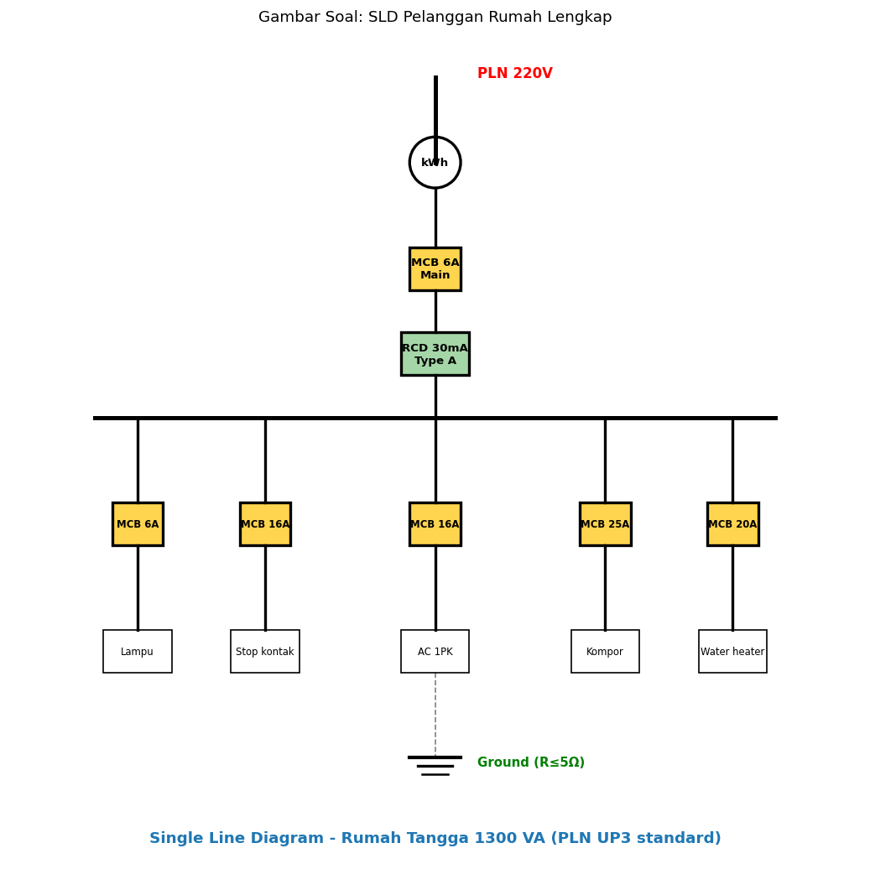
A. Random
B. PLN → kWh meter → MCB main → RCD → Busbar → MCB cabang per circuit → Beban + grounding
C. Hanya kabel
D. Tidak ada urutan

Soal 42 [Visualisasi]
Pada SLD pelanggan industri 250 kVA, fungsi 'CT' dan 'PT' adalah…
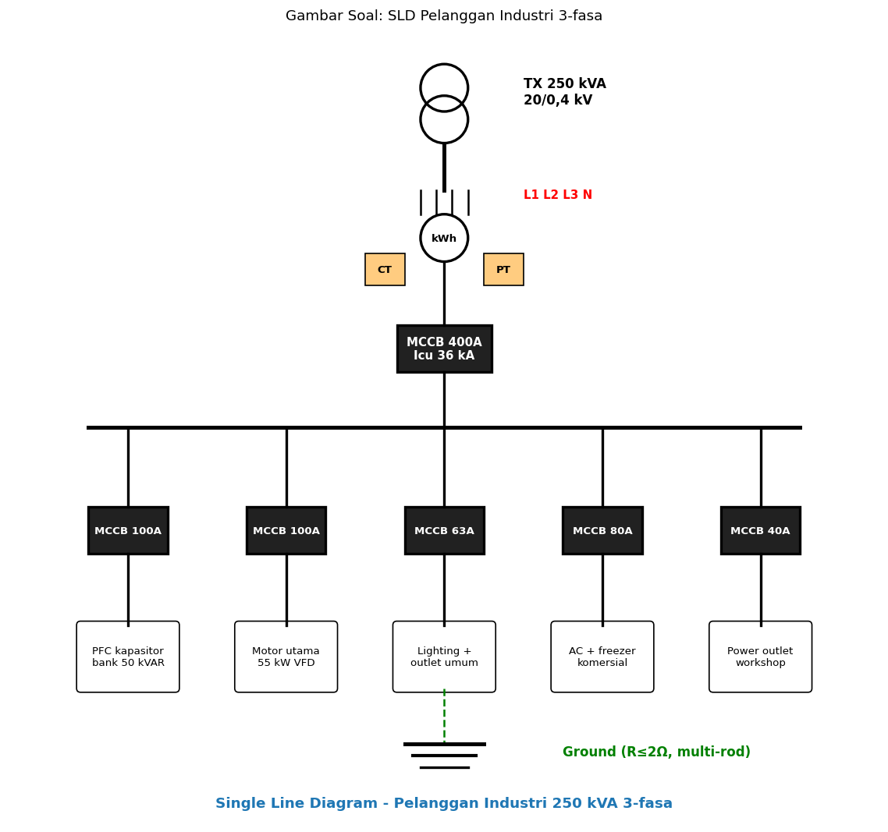
A. Random
B. CT (Current Transformer) + PT (Potential Transformer) untuk METERING ACCURATE arus + tegangan tinggi (PLN tarif industri) — step-down ke level meter standar
C. Tidak ada
D. Kabel

Soal 43 [Visualisasi]
Saklar tukar 2-way wiring memerlukan…
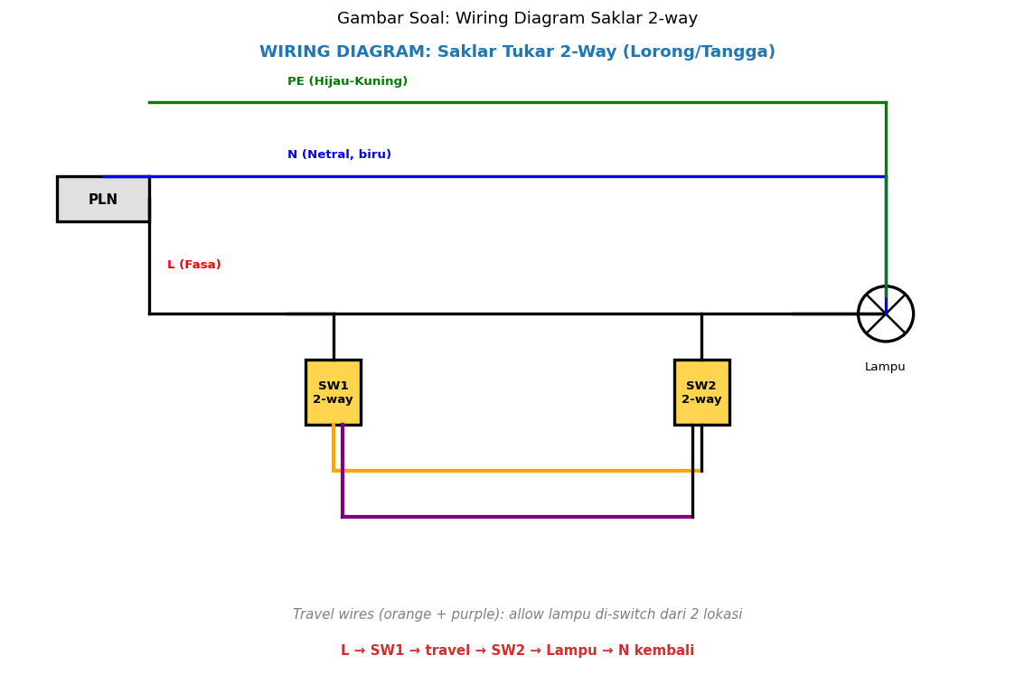
A. 1 wire
B. 2 'TRAVEL WIRES' antara saklar (SW1 dan SW2) — allow toggle dari kedua lokasi
C. Random
D. Tidak ada

Soal 44 [Visualisasi]
Stop kontak Type F Schuko grounded memerlukan wiring…
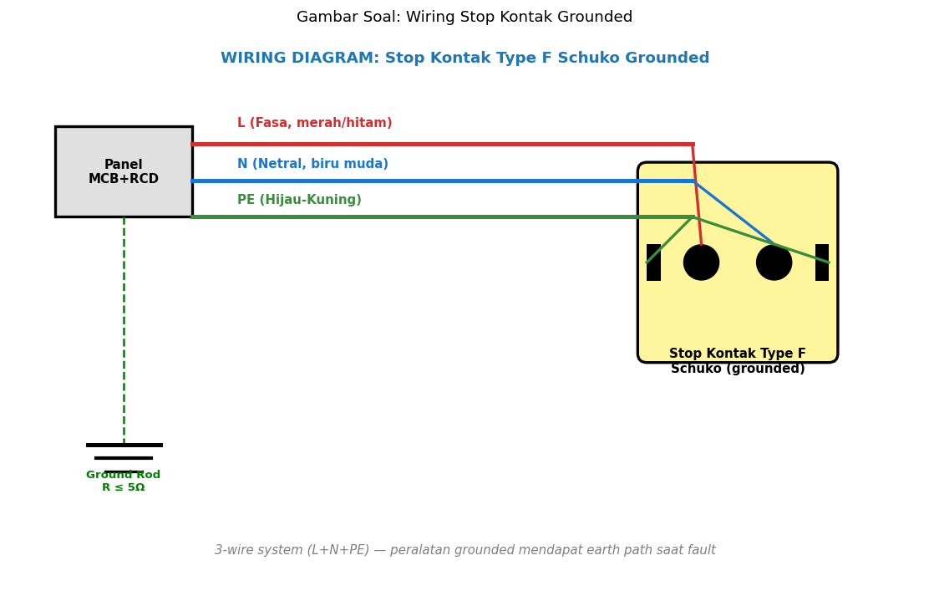
A. 2-wire
B. 3-WIRE: L (fasa merah/hitam) + N (netral biru muda) + PE (hijau-kuning) — earth path saat fault peralatan
C. Random
D. 4-wire

Soal 45 [Visualisasi]
Motor 3-fasa Star (Y) connection: Line V dan Line I relasi dengan Phase V dan Phase I…
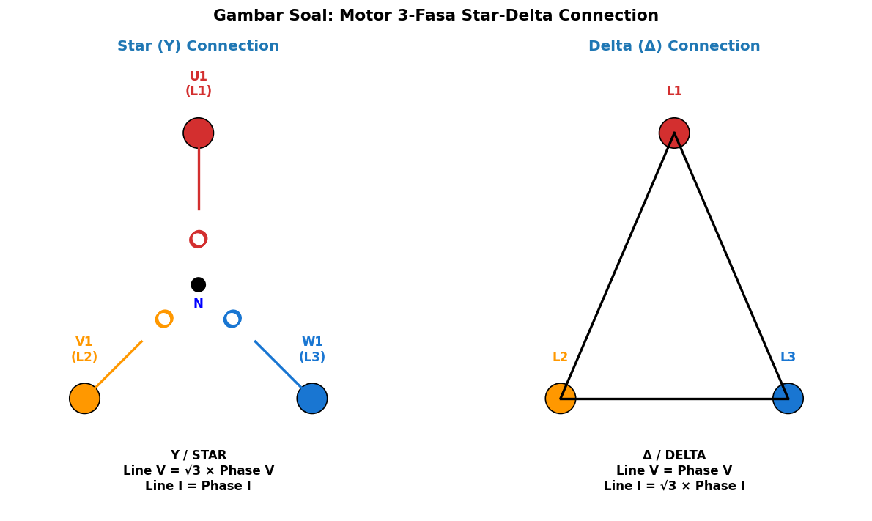
A. Sama
B. Line V = √3 × Phase V; Line I = Phase I
C. Random
D. Tidak ada

Soal 46 [Visualisasi]
Pada DOL motor starter, 'KM hold contact' (NO) berfungsi untuk…
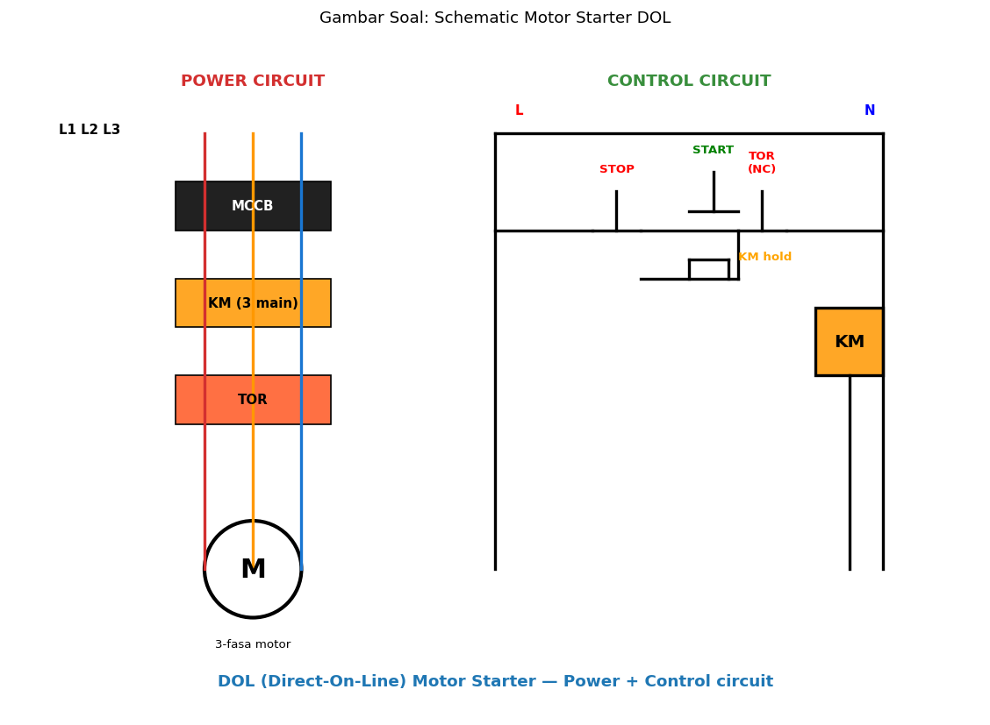
A. Estetika
B. KEEP KM coil energized setelah Start button dilepas — operator tekan Start sekali, motor terus running sampai Stop ditekan
C. Random
D. Tidak ada

Soal 47 [Visualisasi]
Pada balanced 3-fasa load, vector sum I_L1 + I_L2 + I_L3…
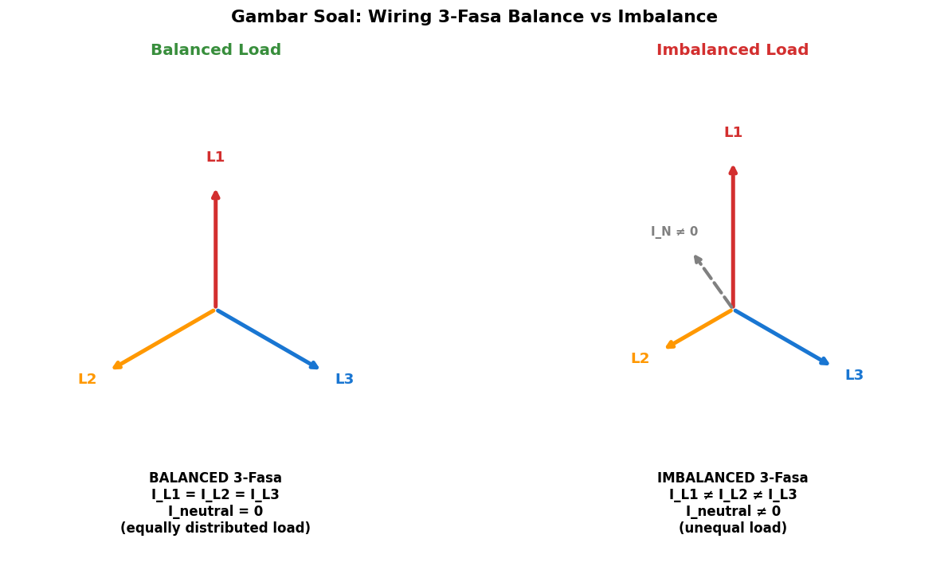
A. Maksimum
B. = 0 (vector cancel) → I_neutral = 0
C. Random
D. Tidak ada

Soal 48 [Visualisasi]
Pada SLD Gardu Trafo Distribusi PLN, fungsi 'NH Fuse' adalah…
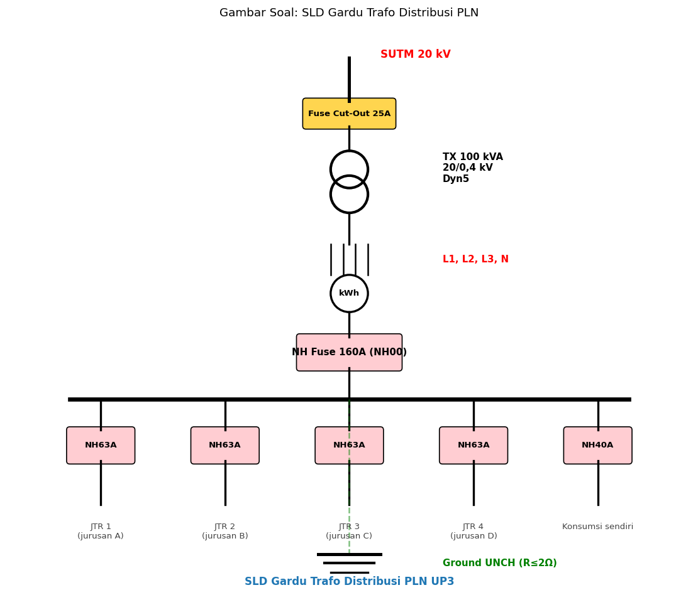
A. Random
B. PROTEKSI LV side outgoing JTR feeders — knife-blade fuse high breaking capacity; replace saat fault, melt action
C. Estetika
D. Tidak ada

Soal 49 [Visualisasi]
Pada SLD rumah, untuk circuit AC 1 PK direkomendasikan MCB rating…

A. 6A
B. 16A (sesuai I_FL AC 1PK ~7-8A continuous + margin starting current)
C. 100A
D. Random

Soal 50 [Visualisasi]
Pada SLD Gardu Trafo Distribusi, vector group 'Dyn5' menunjukkan…

A. Random
B. HV Delta + LV Wye dengan neutral exposed + phase shift 5×30° (150°) — STANDARD untuk distribusi PLN (4-wire LV system)
C. Tidak ada
D. Hanya estetika

Kunci Jawaban & Penjelasan Detail
Berikut adalah kunci jawaban beserta penjelasan ilmiah mengapa jawaban tersebut benar. Pelajari penjelasan dengan saksama untuk memahami konsep, bukan sekadar menghafal jawaban.

Ringkasan Jawaban
No. Jwb | No. Jwb | No. Jwb | No. Jwb | No. Jwb
1. B | 2. B | 3. B | 4. B | 5. B
6. B | 7. B | 8. B | 9. B | 10. B
11. B | 12. B | 13. B | 14. B | 15. B
16. B | 17. B | 18. B | 19. B | 20. B
21. B | 22. B | 23. B | 24. B | 25. B
26. B | 27. B | 28. B | 29. B | 30. B
31. B | 32. B | 33. B | 34. B | 35. B
36. B | 37. B | 38. B | 39. B | 40. B
41. B | 42. B | 43. B | 44. B | 45. B
46. B | 47. B | 48. B | 49. B | 50. B

Penjelasan Detail
Soal 1 [Teori] → Jawaban: B
Pertanyaan: SLD pelanggan rumah lengkap minimum berisi…
SLD rumah lengkap: PLN feeder → kWh meter → MCB main → RCD 30mA → Busbar → MCB cabang dedicated per circuit (lampu, stop kontak, AC, kompor, water heater) → Beban. Plus grounding system R ≤ 5Ω. Standar PUIL 2020 + PLN UP3 acceptance.

Soal 2 [Teori] → Jawaban: B
Pertanyaan: SLD pelanggan industri 3-fasa berbeda dari rumah karena…
Industri 3-fasa SLD: trafo dedicated (50-2500 kVA), MCCB main 200-2000A, CT/PT untuk metering (PLN tarif industri), busbar 3-fasa, sub-feeders MCCB ke motor/lighting/AC/PFC, kapasitor bank untuk PFC, harmonic filter jika VFD significant. Grounding R ≤ 2Ω + bonding equipotential.

Soal 3 [Teori] → Jawaban: B
Pertanyaan: Saklar tukar (2-way) wiring memerlukan…
2-way wiring: L → SW1 (common) → 2 travel wires → SW2 (common) → Lampu → N kembali. Setiap saklar dapat toggle state. Travel wires biasanya orange + purple atau labeled. Aplikasi: lorong panjang, tangga (atas+bawah), pintu kamar+samping ranjang.

Soal 4 [Teori] → Jawaban: B
Pertanyaan: Stop kontak Type F Schuko (grounded) memerlukan wiring…
3-wire system rumah Indonesia: L (fasa) + N (netral) + PE (Protective Earth). PE connect ke earth pin Schuko + grounding rod (R ≤ 5Ω). Saat peralatan fault → casing energize → arus mengalir via PE ke ground → RCD detect → trip → SAFETY. Tanpa PE = peralatan grounded berbahaya saat fault.

Soal 5 [Teori] → Jawaban: B
Pertanyaan: Motor 3-fasa Star (Y) connection berarti…
Star (Y): U2-V2-W2 dihubungkan ke neutral common. U1, V1, W1 ke 3-fasa supply. Karakteristik: V_line = √3 × V_phase, I_line = I_phase, P = √3 × V_line × I_line × cosφ. Starting current LEBIH RENDAH (1/3 dari delta) tapi torque juga lebih rendah. Aplikasi: motor running mode (steady-state), motor kecil low-load.

Soal 6 [Teori] → Jawaban: B
Pertanyaan: Motor 3-fasa Delta (Δ) connection berarti…
Delta (Δ): U1 connect V2, V1 connect W2, W1 connect U2 (triangle loop). Karakteristik: V_line = V_phase, I_line = √3 × I_phase, P = √3 × V_line × I_line × cosφ. Starting current TINGGI (3× dari star) dan torque juga tinggi. Aplikasi: motor full-load mode (running), motor besar high-load. Untuk start: pakai Star → switch ke Delta (Star-Delta starter) untuk reduce inrush current.

Soal 7 [Teori] → Jawaban: B
Pertanyaan: Star-Delta starter motor 3-fasa berfungsi untuk…
Star-Delta starter: motor START di Star connection (current 1/3 inrush, torque 1/3) selama beberapa detik untuk accelerate. Setelah ~70-80% rated speed: switch ke Delta connection (full power). Mengurangi: (1) Inrush current dari 6× FL ke ~2× FL, (2) Stress mechanical drivetrain, (3) Voltage dip jaringan saat starting, (4) Breaker tripping nuisance. Standar untuk motor 5-100 kW. Modern alternative: VFD (variable frequency drive) — soft start + variable speed control + energy efficiency.

Soal 8 [Teori] → Jawaban: B
Pertanyaan: DOL (Direct-On-Line) starter motor adalah…
DOL Starter: motor di-energize directly dengan full voltage via kontaktor + thermal overload relay. Schematic: power circuit (3-fasa via MCCB → KM kontaktor → TOR → motor); control circuit (start NO + stop NC + KM hold contact + TOR contact NC + KM coil). Pro: cheap, simple, reliable. Con: inrush current 6× FL → voltage dip + breaker stress. Aplikasi: motor kecil <5 kW, jaringan kuat, tidak ada concern dengan starting current.

Soal 9 [Teori] → Jawaban: B
Pertanyaan: Power circuit vs control circuit motor starter…
POWER CIRCUIT: 3-fasa supply (380V) → MCCB → kontaktor main contacts → TOR → motor. Carry full motor current (puluhan-ratusan ampere).
CONTROL CIRCUIT: 1-fasa supply (220V atau 24V DC step-down) → STOP push button (NC) → START push button (NO) parallel dengan KM hold contact (NO) → TOR contact (NC) → KM coil → N. Carry small current (~1-2A untuk coil energize).
Separation: safety (operator touch low voltage) + isolation control logic dari high power.

Soal 10 [Teori] → Jawaban: B
Pertanyaan: 3-fasa balanced load berarti…
Balanced 3-fasa: load distributed equally per fasa → I_L1 = I_L2 = I_L3 (magnitude sama, 120° phase apart). Vector sum: Σ I = 0 → I_neutral = 0 → kabel netral tidak carry current. Ideal untuk efficiency + power quality. Sebaliknya imbalance: I_neutral ≠ 0, kabel netral overload, voltage di-imbalance, motor overheating.

Soal 11 [Teori] → Jawaban: B
Pertanyaan: 3-fasa imbalance load consequences…
Imbalance 3-fasa consequences:
(1) NEUTRAL OVERCURRENT — kabel netral designed equal cross-section dengan fasa, jadi imbalance bisa exceed rating; oversize neutral untuk imbalance + 3rd harmonic
(2) MOTOR OVERHEATING — voltage di winding tidak equal → torque tidak balance → vibration + heating; per IEEE std max 1% voltage imbalance untuk motor longevity
(3) ENERGY LOSS — I²R loss di neutral conductor + harmonic current
(4) PROTECTION nuisance trip — RCD detect Σ I > sensitivity threshold
(5) POWER QUALITY — voltage flicker, equipment malfunction
SOLUSI: redistribusi load ke fasa equal, monitoring continuous, automatic phase balancing system.

Soal 12 [Teori] → Jawaban: B
Pertanyaan: SLD gardu trafo distribusi PLN typical components…
Gardu Trafo Distribusi PLN typical:
(1) SUTM 20 kV (Saluran Udara Tegangan Menengah) — incoming
(2) FUSE CUT-OUT 25A — proteksi MV side
(3) TRAFO 20/0,4 kV (typical 100/160/250/400 kVA) — Dyn5 vector group
(4) LV side 3-fasa + N
(5) kWh METER PLN — billing
(6) NH FUSE main 160-630A (NH00, NH1, NH2 size)
(7) BUSBAR TR — distribusi
(8) JTR FEEDERS (Jaringan Tegangan Rendah) — outgoing 4 jurusan typical (NH 63A per feeder)
(9) GROUNDING UNCH (Unconnected) — bonding chassis trafo + neutral

Standar SPLN, dokumentasi PLN UP3 acceptance + maintenance reference.

Soal 13 [Teori] → Jawaban: B
Pertanyaan: Cut-out fuse pada SUTM 20 kV gardu adalah…
FUSE CUT-OUT (FCO) MV: drop-out fuse holder dengan fuse element internal. Saat fault MV (short circuit, overcurrent): fuse element melt → spring mechanism drops fuse holder → visual indication (operator dari ground bisa lihat dropped state) + isolasi physical dari MV line. Rating typical 25-100A continuous untuk trafo 100-400 kVA. Replace fuse element + reset holder via insulated stick + boom truck.

Soal 14 [Teori] → Jawaban: B
Pertanyaan: NH Fuse pada LV side trafo distribusi adalah…
NH Fuse (NIEDERSPANNUNGS HOCHLEISTUNGS — German untuk Low Voltage High Performance): blade-type fuse untuk LV proteksi.
Sizes:
- NH00: 40-160A
- NH1: 100-250A
- NH2: 200-400A
- NH3: 315-630A
- NH4: 500-1250A
Replaceable element, high breaking capacity (50-100 kA), I²t curve untuk proteksi cable. Aplikasi: trafo distribusi LV main, JTR feeder. Inspect periodic — fuse melt = fault, replace + investigate.

Soal 15 [Teori] → Jawaban: B
Pertanyaan: Vector group trafo 'Dyn5' berarti…
Vector group trafo:
- HV side: D (Delta uppercase) atau Y (Wye/Star uppercase)
- LV side: d (delta lowercase), y (wye lowercase)
- n: neutral exposed (accessible, untuk grounding/4-wire system)
- Number: phase shift dalam multiples of 30°

Common configurations:
- Dyn5: D-y dengan 150° lagging, n exposed → STANDARD distribusi PLN (4-wire LV system)
- YNyn0: Y-y dengan 0° (in phase), both n exposed → sub-station HV-MV
- Dyn11: D-y dengan 330° lagging

Dyn5: HV side delta (no neutral) → reduce 3rd harmonic propagation; LV side wye → 4-wire 3-fasa+N untuk distribusi pelanggan rumah/komersial.

Soal 16 [Teori] → Jawaban: B
Pertanyaan: Grounding system trafo distribusi PLN…
Grounding gardu trafo distribusi:
(1) CASING/TANK TRAFO — bonded ke ground (safety personnel touch)
(2) NEUTRAL LV side — grounded di gardu (TT system Indonesia, atau TN-S/TN-C-S variant)
(3) MULTI-ROD GROUNDING — minimum 3-4 rod copper-clad steel 3m, spaced 2-3× depth, parallel + bentonite/conductive backfill
(4) R_GROUND ≤ 2Ω target (kritis)
(5) EQUIPOTENTIAL BONDING — semua peralatan logam (cabinet, fence, door) connected ke ground bus
(6) LIGHTNING PROTECTION — surge arrester di MV side + LV side
(7) DOCUMENTED test report — earth tester R measurement annual
STANDAR: SPLN, IEEE 80 (substation grounding).

Soal 17 [Teori] → Jawaban: B
Pertanyaan: VFD (Variable Frequency Drive) untuk motor mengganti starter konvensional karena…
VFD vs starter konvensional:
(1) SOFT START — gradual ramp up frekuensi dari 0 ke 50/60 Hz, no inrush current (vs DOL 6× FL atau Star-Delta 2× FL)
(2) VARIABLE SPEED — control output frequency 0-100+ Hz, motor speed proportional. Aplikasi: pump (variable flow), fan (variable airflow), conveyor (variable speed). Energy saving 20-50% vs throttle control
(3) PROTECTION BUILT-IN — overload, overvoltage, undervoltage, phase loss, ground fault, thermal
(4) NETWORK — communicate dengan PLC/SCADA via Modbus, Profibus, Profinet
(5) DIAGNOSTICS — fault history, run hours, energy consumption logging
(6) HARMONIC ISSUES — VFD inject harmonics ke supply line (THD bisa 30-50%) → mitigation dengan input filter atau active harmonic filter
(7) RCD compatibility — wajib Type B (DC component dalam fault current)
COST premium 2-5× vs DOL/Star-Delta tapi ROI dari energy saving + reliability.

Soal 18 [Teori] → Jawaban: B
Pertanyaan: Wiring diagram berbeda dari schematic dalam hal…
WIRING DIAGRAM: detail physical (terminal numbers, kabel routing, color, location). Audience: kontraktor instalasi + maintenance.
SCHEMATIC: logical electrical relationship (component, connection, function). Audience: engineer design + troubleshoot.
Untuk panel besar: keduanya provided dalam document set. Schematic untuk understand circuit, wiring untuk physical build. Software (EPLAN, AutoCAD Electrical) auto-generate wiring dari schematic via mapping.

Soal 19 [Teori] → Jawaban: B
Pertanyaan: Single Line Diagram dengan 'as-built' notation berarti…
AS-BUILT DRAWING: drawing yang updated post-construction untuk reflect actual installation. Often diverge dari original design karena: field changes (obstruction, relocation), value engineering (cost reduction), regulatory adjustment, supplier substitution. Process: kontraktor mark-up changes during construction, lalu engineer update master drawing dengan revision 'AS-BUILT'. Critical untuk: future maintenance, modification, troubleshooting. PLN UP3 acceptance test refer ke AS-BUILT drawing, bukan original design. Documented dalam project handover package.

Soal 20 [Teori] → Jawaban: B
Pertanyaan: Standar SPLN untuk SLD pelanggan baru PLN…
Standar Indonesia untuk SLD pelanggan PLN:
- SPLN 41: spec kabel LV (NYA, NYM, NYY, NYFGbY)
- SPLN 42: spec kabel TR overhead (TIC)
- SPLN 56: pelanggan 1-fasa
- SPLN 64: kabel MV (XLPE, NYFGbY 20 kV)
- SPLN 78: standar kWh meter
- PUIL 2020: persyaratan instalasi listrik
- PLN UP3 acceptance procedure: standar testing + dokumentasi

Submit drawing + specification ke PLN UP3 untuk pelanggan baru dengan daya tertentu (typically >450 VA komersial atau >2200 VA rumah). Reviewer PLN evaluate compliance + return feedback. Drawing bagian dari Sertifikat Layak Operasi (SLO).

Soal 21 [Hitungan] → Jawaban: B
Pertanyaan: Pelanggan rumah 1300 VA, 220V. I_main yang harus didukung MCB main?
I_main = P/V = 1.300/220 = 5,91 A. PLN UP3 standar pelanggan 1300 VA: MCB main 6A (rating sesuai daya kontrak). Di-seal oleh PLN. Jika konsumen pakai >6A continuous → MCB trip → upgrade daya kontrak. Plus MCB cabang per circuit (lampu 6A, stop kontak 16A, AC 16A, dll).

Soal 22 [Hitungan] → Jawaban: B
Pertanyaan: Pelanggan industri 250 kVA 3-fasa 380V. I_main MCCB?
I_main = S/(√3×V) = 250.000/(√3×380) = 380 A. MCCB main rating 400A standard (sedikit di atas continuous). Plus Icu (interrupting capacity) >36 kA untuk fault current handling. Plus CT/PT untuk metering PLN tarif industri (akurat measurement P, Q, S, kWh, kVARh).

Soal 23 [Hitungan] → Jawaban: B
Pertanyaan: Motor 3-fasa 22 kW 380V cos φ 0,85. I_FL?
I_FL = P / (√3 × V × cos φ × η). Asumsi η = 0,9 (typical motor 22 kW): I_FL = 22.000 / (√3 × 380 × 0,85 × 0,9) = 43,8 A. Plus consideration efisiensi + tolerance: design current 50-60A. MCCB rating 60-80A. Kabel min 16-25 mm² Cu. Starter Star-Delta atau VFD untuk reduce inrush starting.

Soal 24 [Hitungan] → Jawaban: B
Pertanyaan: Star-Delta starter motor 22kW: starting current saat Star vs Delta?
Inrush motor 22kW di Delta: 6× I_FL = 6 × 44 = 264 A. Di Star: 1/3 dari Delta = 88 A. Significant reduction → less voltage dip, less stress jaringan + breaker. Setelah motor accelerate ~75-80% rated speed: switch ke Delta untuk full power. Transition timer typical 5-10 detik. Modern: VFD better untuk variable speed application + soft start kontinu.

Soal 25 [Hitungan] → Jawaban: B
Pertanyaan: 3-fasa balanced load: I_L1 = I_L2 = I_L3 = 100A. I_neutral?
Balanced 3-fasa: I_L1 = I_L2 = I_L3 = |I| dengan phase 0°, 120°, 240°. Σ I = I × (1 + e^j120° + e^j240°) = I × 0 = 0. Jadi I_neutral = 0 (vector sum). Kabel netral tidak carry current → bisa downsize, tapi standar selalu sama dengan fasa untuk safety + future imbalance.

Soal 26 [Hitungan] → Jawaban: B
Pertanyaan: 3-fasa imbalance: I_L1 = 100A, I_L2 = 70A, I_L3 = 80A. I_neutral approximate?
Vector sum: I_N = I_L1∠0° + I_L2∠120° + I_L3∠240°. Real part: 100 + 70×cos(120°) + 80×cos(240°) = 100 - 35 - 40 = 25. Imaginary: 70×sin(120°) + 80×sin(240°) = 60,6 - 69,3 = -8,7. |I_N| = √(25² + 8,7²) = 26,5 A. Significant — kabel netral perlu carry 26A. Imbalance ratio = (Imax - Imin)/avg = (100-70)/83,3 = 36% (jauh di atas IEEE limit 1% untuk motor longevity). Action: redistribusi load.

Soal 27 [Hitungan] → Jawaban: B
Pertanyaan: Cost SLD design pelanggan industri 250 kVA: engineer 40 jam × Rp 200rb/jam + revisi 2× × 5 jam = ?
Engineering cost: (40 + 10) × Rp 200rb = Rp 10 juta untuk SLD design pelanggan industri 250 kVA. Plus material cost untuk kontraktor build (panel, kabel, breaker, dll Rp 100-300 juta tergantung complexity). Plus PLN acceptance test + SLO renewal cost. Total project pelanggan industri medium typical Rp 200-500 juta termasuk semua aspect. Engineering ~3-5% project cost — low ratio tapi essential untuk quality + compliance.

Soal 28 [Hitungan] → Jawaban: B
Pertanyaan: Trafo distribusi 100 kVA 20/0,4 kV: kapasitas LV side?
I_LV = S/(√3 × V) = 100.000 / (√3 × 400) = 144 A continuous. NH Fuse main: 160A typical (sedikit di atas continuous). Outgoing JTR feeders: 4 jurusan typical, masing-masing NH 63A → total 252A capacity (over-subscribed by design — load diversity). Pelanggan typical 1300-2200 VA per rumah, jadi 1 trafo 100 kVA dapat handle ~30-50 rumah.

Soal 29 [Hitungan] → Jawaban: B
Pertanyaan: VFD untuk motor 22 kW: cost vs Star-Delta starter. ROI dari energy saving 30%?
Cost VFD 22 kW: Rp 25-40 juta (Schneider, ABB, Siemens quality). Cost Star-Delta starter: Rp 5-8 juta (kontaktor 3× + TOR + timer + push button + enclosure).
Energy saving VFD 30% (variable speed pump/fan typical):
- Motor 22 kW running 8h × 250 hari × 30% saving = 13.200 kWh/year saved
- Tariff industri Rp 1.500/kWh = Rp 19,8 juta/year saved
- Premium VFD vs Star-Delta = Rp 20-32 juta
- ROI: 1-1,5 tahun
Plus benefits: protection built-in, network monitoring, soft start. Strong business case untuk industri dengan motor variable load (pump, fan, conveyor). Untuk constant load (e.g., compressor selalu full speed): Star-Delta atau DOL cukup.

Soal 30 [Hitungan] → Jawaban: B
Pertanyaan: Acceptance test SLD pelanggan industri durasi: review document (4 jam) + field verification (8 jam) + test electrical (4 jam) + dokumentasi (4 jam) = ?
Total acceptance test pelanggan industri: 20 jam = 2,5 hari kerja oleh 1 PLN UP3 engineer + 1 teknisi. Plus mungkin tambahan untuk re-test post-correction jika fail initial. Cost labor PLN: ~Rp 5-10 juta per acceptance. Worth it untuk safety + compliance + reliability. Sebanding dengan project pelanggan industri yang Rp 200-500 juta.

Soal 31 [Studi Kasus] → Jawaban: B
Pertanyaan: Pelanggan rumah 1300 VA submit SLD tanpa RCD. PLN UP3 acceptance test?
PUIL 2020 MANDATORY: RCD 30mA minimum di stop kontak final circuit pelanggan rumah. Tanpa RCD = no shock protection saat fault peralatan grounded → safety hazard severe. REJECT acceptance test. Mandatory corrective action: (1) Update SLD untuk include RCD, (2) Install RCD physical (Rp 200-500 juta untuk RCD 4P 30mA Type A), (3) Wiring connect properly (RCD 4P pole untuk fasa+netral), (4) Test sensitivity dengan RCD tester, (5) Re-acceptance test PLN. Setelah pass → SLO issued + energize. Educational opportunity: PLN-Envisor public awareness 'Listrik Aman' campaign untuk educate pelanggan + kontraktor importance RCD.

Soal 32 [Studi Kasus] → Jawaban: B
Pertanyaan: Pelanggan industri komplain motor 75 kW sering trip MCCB saat starting. SLD reveal: DOL starter. Diagnosa + solusi?
DIAGNOSE: Motor 75kW DOL inrush ~6× I_FL = 6 × 120 = 720A. MCCB main rating 200A trip seketika atau MCCB cabang 150A. Stress: jaringan voltage dip, breaker contact wear, mechanical drivetrain shock.

SOLUSI:

OPTION 1 — STAR-DELTA STARTER:
- Cost: Rp 15-25 juta (kontaktor 3× + TOR + timer + push button + enclosure 22kW)
- Inrush reduce ke 1/3 (~240A) — manageable oleh MCCB 250A
- Switching transient (Star-to-Delta) bisa cause trouble
- Suitable: motor 22-100 kW constant speed application

OPTION 2 — VFD (Variable Frequency Drive):
- Cost: Rp 60-100 juta (Schneider Altivar, ABB ACS580 untuk 75 kW)
- SOFT START gradual ramp 0→50Hz tanpa inrush spike
- VARIABLE SPEED control — energy saving 20-50% pada pump/fan variable load
- BUILT-IN PROTECTION (overload, OV, UV, phase loss, ground fault, thermal)
- NETWORK communication (Modbus, Profibus) untuk SCADA
- HARMONIC ISSUES — install input filter (LCL atau DC link reactor)
- RCD compatibility wajib Type B

OPTION 3 — SOFT STARTER (resistor/electronic):
- Cost: Rp 30-50 juta (cheaper than VFD, more than Star-Delta)
- Soft start tapi NO speed control (run di 50Hz fixed)
- Suitable: applications dengan starting issue tapi tidak butuh speed variation

RECOMMENDATION:
- Jika motor pump/fan/conveyor dengan variable load → VFD (best ROI from energy saving)
- Jika motor constant load (compressor, mesin produksi fixed speed) → Star-Delta atau Soft Starter
- Jika motor critical + frequent starting → VFD untuk reliability + monitoring

For Pak Qastil pelanggan industri context: audit motor inventory, identify candidates untuk VFD upgrade, calculate ROI per motor. Product opportunity Envisor: 'Motor Drives Audit & Upgrade Service'.

Soal 33 [Studi Kasus] → Jawaban: B
Pertanyaan: Pelanggan industri food processing imbalance 3-fasa: I_L1=200A, I_L2=120A, I_L3=180A. Action?
IMBALANCE 3-FASA significant:
- L1: 200A, L2: 120A, L3: 180A
- Avg: 167A
- Imbalance ratio: (200-120)/167 = 48% (jauh di atas IEEE 1% limit untuk motor longevity)
- I_neutral approximate: vector sum ~75A (kabel netral overload jika designed equal dengan fasa)

IMPACT:
(1) NEUTRAL OVERCURRENT — kabel netral original untuk 200A capacity, sekarang carry 75A continuous (OK), tapi spike bisa exceed
(2) MOTOR OVERHEATING — voltage dropped di fasa heavily-loaded → motor torque uneven → vibration + winding heat
(3) ENERGY LOSS — I²R extra di neutral conductor + harmonic
(4) PFC ineffective — kapasitor calibrated untuk balanced, imbalance reduce efficiency

ROOT CAUSE INVESTIGATION:
- Audit load list per fasa: peralatan single-fasa terkonsentrasi di fasa apa?
- Common culprits: lighting circuit (banyak fitting di 1 fasa), single-fasa motor pump/fan, peralatan kantor (komputer, AC kantor)
- Industri food processing: motor 3-fasa balanced, tapi peralatan auxiliary (lampu, stop kontak, AC kantor, freezer kompresor 1-fasa) sering imbalance

SOLUSI:

(1) REDISTRIBUTE LOAD MANUAL:
- Identify peralatan single-fasa di fasa heavy (L1)
- Move beberapa ke fasa ringan (L2, L3) via re-wiring panel
- Document changes dalam updated SLD
- Monitor post-redistribution dengan power analyzer

(2) AUTOMATIC PHASE BALANCER (untuk dynamic load):
- Solid-state device monitor I per fasa, automatically transfer load via switching antara fasa
- Cost Rp 100-300 juta untuk industri medium
- Suitable jika load dynamic (peralatan on/off frequent)

(3) MONITORING CONTINUOUS:
- Power quality analyzer (Fluke 1748, Hioki 3197) installed permanent
- Dashboard via SCADA/PLNlytics — alert jika imbalance > threshold
- Periodic review + corrective action

(4) DESIGN FUTURE EXPANSION:
- Plan untuk balance saat design awal (load study + diversity factor)
- Standard: max 1% voltage imbalance per IEEE std 1100

Product opportunity Envisor: 'Power Quality Audit & Optimization Service' — niche but high-value market untuk industri Indonesia. Pak Qastil portfolio addition. Plus academic publication potential.

Soal 34 [Studi Kasus] → Jawaban: B
Pertanyaan: PLN UP3 modernization gardu trafo distribusi 1990s ke smart grid. Komponen upgrade SLD?
GARDU TRAFO DISTRIBUSI MODERNIZATION untuk smart grid:

EXISTING (1990s):
- SUTM 20 kV → cut-out fuse → trafo 100 kVA Dyn5 → kWh meter → NH fuse → busbar → 4 JTR feeders
- Manual operation, manual reading kWh (monthly visit)
- Fault detection reactive (after pelanggan komplain)
- Minimal data, no analytics

UPGRADE COMPONENTS:

(1) IoT SENSOR ARRAY:
- TEMPERATURE — oil temperature sensor + winding hot-spot via fiber optic atau Bluetooth wireless
- CURRENT — clamp-on CT pada masing-masing JTR feeder + main
- VOLTAGE — PT pada busbar + per fasa
- OIL LEVEL + DGA (Dissolved Gas Analysis) — predict trafo health
- VIBRATION — bearing health monitoring
- AMBIENT — temperature + humidity gardu

(2) SMART RMU (Ring Main Unit) MV SIDE:
- Replace cut-out fuse manual dengan smart RMU yang dapat REMOTE CONTROL (via SCADA)
- Auto-reclosing untuk transient fault
- Protection coordination dengan upstream feeder
- Digital metering MV side

(3) SMART NH FUSE BASE:
- LV fuse base dengan voltage detection — alert saat fuse blown (vs manual visual inspection)
- Real-time current monitoring per JTR feeder
- Predict overload trend

(4) COMMUNICATION:
- 4G/LoRa/Fiber connection ke PLN UID master station
- SCADA integration (DNP3, IEC 61850 protocol)
- Real-time data stream

(5) AI DASHBOARD (PLNlytics integration):
- TRAFO HEALTH SCORE — based on sensor data + ML model
- LOAD FORECAST — predict peak demand per gardu
- OUTAGE PREDICTION — anomaly detection
- MAINTENANCE SCHEDULING — optimal timing untuk minimize disruption
- ASSET MANAGEMENT — registry, age, condition, replacement priority

(6) FIELD INTERFACE:
- Mobile app (ArcGIS Field Maps) untuk team lapangan
- View status + history per gardu
- Receive alerts + work orders
- Log inspection + repair action

(7) CUSTOMER INTERFACE:
- Smart meter pelanggan integrated
- Outage notification SMS/app
- Self-service portal untuk billing + complaint

IMPLEMENTATION:
- PILOT 1-2 gardu per UP3 dengan high-priority profile
- LEARN dari pilot, refine
- SCALE 10-20 gardu/year
- 10-tahun program untuk full coverage

COST per gardu modernization: Rp 200-500 juta (sensor + smart breaker + communication + integration). Untuk PLN UP3 Indramayu dengan ~1000 gardu = Rp 200-500 milyar over 10 tahun. Funding via PLN capex + government grid modernization budget + international donor.

ROI:
- RELIABILITY — SAIDI/SAIFI improvement, fewer outage hours
- ASSET LIFE — predictive maintenance prevent catastrophic failure
- ENERGY EFFICIENCY — loss reduction via load balancing + voltage regulation
- CUSTOMER SATISFACTION — fewer outages, faster restoration, transparency
- DATA-DRIVEN PLANNING — capex optimization

FIT dengan PORTFOLIO PAK QASTIL:
- PLN UP3 role + access
- PLNlytics platform integration
- Esri Fellowship (GIS dashboard)
- RACE for 2030 Grid Transformation
- Australia Awards Just Energy Transition
- ASPP Seoul international showcase
- Monash PhD research output

National impact + research publication opportunity. Strategic project.

Soal 35 [Studi Kasus] → Jawaban: B
Pertanyaan: Pelanggan rumah komplain saklar tukar 2-way lampu lorong 'kadang hidup saat semua off, kadang tidak'. Diagnosa?
TROUBLESHOOTING saklar tukar 2-way mis-behave:

ROOT CAUSE: wiring error pada salah satu saklar — typical mistakes:
(1) TRAVEL WIRES terbalik di salah satu saklar (orange ke common, purple ke travel terminal — should be vice versa)
(2) SALAH NEUTRAL — netral di-switch instead of fasa (dangerous + tidak proper functioning)
(3) MIXING saklar 2-way dengan 1-way (terminal mismatch)
(4) BAD CONNECTION — terminal lasdop loose, intermittent contact

DIAGNOSE:
(1) MULTIMETER continuity test:
- Saklar di-toggle, verify terminal common ke travel terminals (alternate)
- Verify kabel L masuk ke common SW1
- Verify kabel ke lampu keluar dari common SW2
(2) NIGHT TEST — observe behavior dengan switch combinations:
- SW1 ON + SW2 ON = ?
- SW1 ON + SW2 OFF = ?
- SW1 OFF + SW2 OFF = ?
Properly wired: 2 of 4 combinations should turn on lampu (alternating).

CORRECT WIRING:
- L (fasa) → COMMON terminal SW1
- COMMON SW1 connects via internal mechanism ke salah satu travel terminal (state 1 atau 2)
- 2 TRAVEL WIRES dari travel terminals SW1 ke travel terminals SW2 (one pair each)
- COMMON terminal SW2 → LAMPU
- LAMPU → N (netral) kembali ke panel
- PE (ground) → fitting lampu (jika fitting metal grounded)

FIX:
- Disconnect kabel
- Re-wire per correct topology
- Use proper 2-way saklar (3-terminal)
- Test setiap combination
- Document dalam updated wiring diagram

PREVENTION:
- Kontraktor training (Electra Skill Academy + PLN UP3 program)
- Kontraktor certification dengan exam termasuk 2-way wiring
- Color-coded travel wires (orange + purple standar)
- Templated wiring diagram untuk reference saat install

Product opportunity Envisor: 'Home Electrical Troubleshooting Service' — niche but commonly needed. Plus Electra Skill Academy module 'Common Wiring Mistakes & Troubleshooting'.

Soal 36 [Studi Kasus] → Jawaban: B
Pertanyaan: Konsep produk Envisor 'AutoSLD AI' khusus untuk SLD pelanggan PLN. Fitur essential + workflow?
AutoSLD AI for PLN customers (Envisor product concept):

WORKFLOW:

(1) INPUT WIZARD (5-10 menit):
- Customer category: rumah / ruko / kantor / pabrik / mall / hospital
- Daya kontrak: 1300/2200/3500/5500/7700 VA (1-fasa) atau 11/16/22/33 kVA (3-fasa) atau >50 kVA industrial
- Building dimensi (m²) + jumlah ruangan/area
- Special needs: AC, kitchen, bathroom, kompor listrik, water heater, EV charger, solar PV, motor industri
- Location: indoor/outdoor portion, environment (humid, dusty, food processing)

(2) AI GENERATION:
- LOAD CALCULATION — diversity factor per category (rumah 0,7; komersial 0,8; industri 0,9)
- CIRCUIT BREAKDOWN — assign peralatan ke dedicated circuits per best practice
- BREAKER SIZING — MCB/MCCB per circuit, RCD/RCBO per requirement
- CABLE SIZING — KHA + V_drop check + harmonic if applicable
- GROUNDING design — rod count + spacing untuk R ≤ 5Ω target
- PROTECTION coordination — selectivity tier
- REDUNDANCY — alternate paths jika critical (e.g., hospital, data center)

(3) VENDOR CATALOG INTEGRATION:
- Schneider Acti9 (popular Indonesia)
- ABB SH200 / S200 series
- Hager Visionplus
- Legrand DX³
- Auto-suggest based on availability + price + spec match
- Pricing live (atau cached weekly update)

(4) COMPLIANCE CHECK:
- PUIL 2020 — RCD requirement, kabel ampacity vs MCB, color coding, IP rating per area
- SPLN — vendor spec compliance untuk PLN integration (kabel SR, kWh meter, dll)
- IEC — international best practice
- LOCAL CODE — Disnaker, fire safety BSN
- WARNING flagged untuk non-compliance + suggested fix

(5) AUTO-RENDER DRAWING:
- IEC 60617 simbol
- SLD layout intelligent
- Title block auto-populate (project info, date, revision)
- Dimensions + annotation
- Notes + legend
- Rev history table

(6) EDITING + REFINE:
- GUI editor untuk tweak
- Real-time validation
- Version control

(7) EXPORT READY-TO-SUBMIT:
- PDF untuk PLN UP3 submission (signed-off oleh certified engineer)
- DWG untuk modification
- Excel BOM dengan vendor SKU + pricing untuk procurement
- Acceptance test checklist (untuk kontraktor + PLN inspector)
- Compliance certificate template

(8) COLLABORATION:
- Multi-user editing
- Approval workflow
- Audit trail
- Customer portal (pelanggan view their SLD)

DIFFERENTIATION:
- Indonesia-specific (PUIL/SPLN/PLN UP3 integration)
- AI-powered (vs hard-coded rule engine)
- VENDOR CATALOG live integration (Indonesia market)
- READY-TO-SUBMIT format (save weeks of back-and-forth dengan PLN)
- Mobile-friendly (review on tablet)

MARKET:
- KONTRAKTOR INSTALASI Indonesia (10.000+) — primary user
- KONSULTAN ELECTRICAL ENGINEERING — secondary
- PLN UP3 reviewer (verify submission consistency)
- BUILDING MEP DESIGN firms (architects sub-consultant)
- CUSTOMER SELF-SERVICE (rumah owner pre-design before kontraktor)

PRICING:
- FREE TIER — 1 SLD/month, watermarked output, basic features
- PRO Rp 200rb/bulan — unlimited SLD, full features, priority support
- ENTERPRISE Rp 1-5 jt/bulan — multi-user team, custom branding, API integration, white-label option
- ONE-TIME PROJECT Rp 500rb-2 jt — for occasional users

REVENUE PROJECTION:
- Year 1: 1.000 paying users avg Rp 200rb/bulan = Rp 200 juta/bulan = Rp 2,4 milyar/year
- Year 2-3: 5.000 users + enterprise contracts = Rp 10 milyar/year
- Year 5: 20.000 users + 100 enterprise = Rp 50 milyar/year

CAC (customer acquisition cost): Rp 200-500rb per user (digital marketing, content, partnerships)
LTV (lifetime value): Rp 5-20 juta per user (5-10 years retention)
LTV/CAC ratio: 10-40× (excellent)

FIT DENGAN PORTFOLIO PAK QASTIL:
- PLN domain expertise + industry network
- Envisor consulting brand
- OctoAgent AI platform foundation
- Electra Skill Academy (kontraktor pakai tool ini setelah training)
- PLNlytics (data insights from usage)
- Innovation Gateway PLN — submission opportunity
- Strategic ecosystem product

PROTOTYPE TIMELINE:
- MONTH 1-3: technical architecture + database schema + AI model training
- MONTH 4-6: core engine + vendor catalog integration + basic GUI
- MONTH 7-9: compliance check engine + drawing rendering + beta testing
- MONTH 10-12: refinement + launch with limited users (50-100 beta)
- YEAR 2: scale to mass market + enterprise sales

Go-to-market: partnership dengan PLN UP3 (endorsement), Asosiasi Kontraktor Listrik Indonesia (AKLI), vendor (Schneider, ABB partnership untuk catalog integration). Beta testing dengan PLN UP3 Indramayu real cases. Iterate based on feedback. National impact: democratize quality electrical design Indonesia, raise standar industry.

Soal 37 [Studi Kasus] → Jawaban: B
Pertanyaan: Pelanggan industri request retrofit motor existing DOL ke VFD untuk energy efficiency. Implementation?
VFD RETROFIT comprehensive process untuk pelanggan industri:

(1) AUDIT (Week 1-2):
- MOTOR INVENTORY — list semua motor dengan rating + actual operation profile
- LOAD CHARACTERIZATION — variable speed beneficial? (pump/fan/conveyor with throttle = strong YES; constant load motor = WEAK)
- ENERGY MEASUREMENT — power analyzer baseline current consumption
- ROI CALCULATION — projected energy saving × VFD cost = payback period
- PRIORITIZE motors with highest ROI (typically 20-40% saving achievable)

(2) VFD SELECTION:
- POWER RATING — match motor (sometimes upsize 1 step untuk reliability)
- VOLTAGE — match supply (380V 3-fasa typical industri Indonesia)
- CURRENT — output ≥ motor I_FL
- ENVIRONMENT — IP54+ untuk industri food processing, IP20 untuk control room
- FEATURES — basic V/F vs vector control vs servo (per application requirement)
- COMMUNICATION — Modbus, Profibus, Profinet untuk SCADA
- BRAND — Schneider Altivar, ABB ACS580, Siemens Sinamics, Yaskawa, Mitsubishi (Indonesia popular)

(3) UPDATE SLD + WIRING:
- POWER CIRCUIT — supply → MCCB (sized for VFD) → input filter (DC link reactor atau LCL) → VFD → motor (dedicated cable, EMC-shielded for long runs)
- HARMONICS FILTER — passive (LC) atau active (AHF) jika THD > 5% (IEEE 519)
- RCD TYPE B — wajib karena DC component
- BRAKING RESISTOR (optional) — untuk regenerative braking jika dibutuhkan
- BYPASS CONTACTOR (optional) — manual switch ke direct supply jika VFD fault

(4) MOTOR CONSIDERATION:
- INSULATION — older motor (>10 years) might fail with VFD high-frequency dV/dt → install dV/dt filter atau upgrade ke inverter-duty motor
- BEARING — circulating current via shaft → install grounding brush atau insulated bearing
- COOLING — VFD low-speed = motor own fan less effective → external blower untuk continuous low-speed operation
- DERATING — motor torque available di low-speed reduced, calculate per application

(5) COMMISSIONING + TUNING:
- INSTALL VFD physical (mounting, cooling clearance, ambient < 40°C)
- WIRE per updated SLD
- INITIAL CONFIG — motor nameplate parameters
- AUTO-TUNE function — VFD measure motor electrical characteristic
- FUNCTIONAL TEST — start/stop, speed up/down, reverse direction
- PROTECTION TEST — overload, ground fault, phase loss
- ENERGY MEASUREMENT post-VFD untuk verify saving
- DOCUMENT actual saving + ROI achieved

(6) OPERATOR TRAINING:
- HMI navigation
- BASIC parameters adjustment
- TROUBLESHOOTING common faults
- SAFETY procedure (LOTO sebelum service VFD — DC link capacitor stored energy)

(7) DOCUMENTATION:
- Updated SLD (revision 'AS-BUILT')
- VFD parameter list (untuk re-config jika rusak)
- Maintenance schedule (filter cleaning, capacitor inspection)
- Spare parts inventory (encoder, fan, capacitor module)
- O&M manual integrated dengan plant master

(8) ONGOING MONITORING:
- DASHBOARD via SCADA — real-time motor status, energy consumption, run hours
- ALERTS untuk fault
- TREND ANALYSIS — predict bearing wear, motor degradation
- SCHEDULED MAINTENANCE based on data

COST + ROI EXAMPLE (motor 22 kW pump):
- VFD 22 kW: Rp 35 juta
- Wiring + filter + RCD upgrade: Rp 10 juta
- Engineering + commissioning: Rp 5 juta
- Total: Rp 50 juta
- Energy saving 30%: 22 × 0,3 × 8h × 250 days = 13.200 kWh/year
- Tariff industri Rp 1.500/kWh: Rp 19,8 juta/year saved
- ROI: 2,5 years payback
- 10-year benefit: Rp 198 juta saving - Rp 50 juta investment = Rp 148 juta net

Product opportunity Envisor: 'Motor Drive Audit & Upgrade Service' untuk industri Indonesia. Plus integration dengan PLNlytics untuk monitoring + advisory. Plus Electra Skill Academy module 'VFD Application & Troubleshooting'. Synergistic offering. National impact: industrial energy efficiency, support 'Just Energy Transition' theme.

Soal 38 [Studi Kasus] → Jawaban: B
Pertanyaan: Pak Qastil ASPP Seoul application — proyek I-SEDT (Digital Twin + EV + AI smart lighting). SLD+wiring components untuk rooftop solar + EV charger?
I-SEDT (Digital Twin + EV + AI Smart Lighting) - SLD + WIRING DETAIL untuk rooftop solar + EV charger integrated dengan home/building electrical system:

SOLAR PV ROOFTOP COMPONENTS:

(1) DC SIDE:
- Panel array (e.g., 10 kWp = 25 panel × 400Wp)
- DC string combiner box dengan DC fuse + isolator
- DC cable UV-resistant (4 mm² typical untuk 10 kWp)
- DC isolator MAIN (visible disconnect untuk maintenance)
- DC surge protection (SPD)

(2) INVERTER:
- Grid-tie inverter (string atau micro-inverter)
- Rating match panel array (10 kWp panel → 10 kVA inverter typical)
- IEC 62109 compliance (safety standar internasional)
- Anti-islanding protection (mandatory, prevent inverter feed grid saat outage)
- MPPT (Maximum Power Point Tracking) untuk efisiensi
- Display + monitoring interface (Wi-Fi to dashboard)

(3) AC SIDE:
- DEDICATED CIRCUIT dari inverter ke main panel
- AC isolator (visible disconnect)
- TYPE B RCD 30 mA (mandatory untuk DC injection from inverter)
- MCCB sized untuk continuous + 25% margin
- KABEL dedicated NYY 4 mm² Cu (10 kVA = 14 A continuous)
- BIDIRECTIONAL kWh METER (PLN net metering — measure import + export)
- INTERCONNECTION POINT — sebelum atau sesudah main breaker (sesuai PLN technical guideline)

(4) GROUNDING + LIGHTNING PROTECTION:
- PV frame + mounting → bonded ke ground rod dedicated
- Inverter casing → bonded ke main panel ground
- LIGHTNING ROD (Class III protection) di rooftop
- DOWN CONDUCTOR ke earth
- SPD multi-level (MV side, LV side, equipment level)

(5) MONITORING + DATA:
- Inverter Wi-Fi to cloud dashboard (vendor app)
- API integration to PLNlytics + I-SEDT Digital Twin
- Real-time generation data, lifetime energy, performance ratio
- Alerts untuk fault (string fault, inverter trip)

EV CHARGER COMPONENTS:

(1) CHARGER UNIT:
- Mode 3 charger (AC, 7-22 kW typical Indonesia rumah)
- IEC 61851 compliance
- Connector Type 2 (Mennekes, Indonesia popular)
- RFID/app authentication
- Display + status indication
- Wi-Fi/Ethernet untuk management

(2) ELECTRICAL SUPPLY:
- DEDICATED CIRCUIT dari main panel
- TYPE B RCD 30 mA mandatory (DC residual current dari EV)
- MCB sized untuk charger rating (e.g., 32A 3-fasa untuk 22 kW charger)
- KABEL Cu min 4-6 mm² 1-fasa atau 3-fasa untuk charger 22 kW
- BERMINAL connection dengan strain relief
- Dedicated circuit — TIDAK shared dengan rumah load lain

(3) SITE PLAN:
- Charger mounted di garage atau driveway
- Cable run dari main panel ke charger location (typical 5-20m)
- Conduit pelindung kabel (PVC atau steel)
- Outdoor enclosure IP44+ untuk charger di luar
- Lighting + safety di area charging

(4) GROUNDING:
- Charger casing + frame grounded
- Vehicle chassis automatic grounded saat plug-in (via charger PE pin)
- R_ground ≤ 5 Ω target

(5) MONITORING + INTEGRATION:
- Charger to cloud — usage data, energy consumption, fault log
- Smart scheduling — charge saat solar excess generation (PV-charged EV ideal)
- Demand response — pause charge saat peak grid demand (PLN signal)
- Integration ke I-SEDT Digital Twin dashboard

SYSTEM INTEGRATION (Energy Flow Optimization):

(a) SOLAR-TO-EV PRIORITY:
- Sun shining + EV plugged in → charge EV from solar (max self-consumption)
- Excess solar setelah EV full → export to grid (net metering credit)

(b) GRID INTERACTION:
- Solar generation < home + EV demand → import from grid
- Solar generation > demand → export to grid
- Battery storage (optional, 5-10 kWh) untuk maximize self-consumption

(c) DEMAND RESPONSE:
- PLN peak signal received → reduce EV charge rate atau pause
- Restore normal saat off-peak
- Earn DR credit dari PLN (program future)

(d) AI SMART LIGHTING SYNC:
- Daylight harvesting — dim lampu saat natural light sufficient (lux sensor)
- Occupancy-based — auto-off saat empty
- Energy budget — coordinate dengan solar generation forecast

SLD INTEGRATION VIEW:

PLN (incoming) → KWh Bidirectional → Main MCCB → Main RCD
→ Branch lighting + outlets standard
→ Branch AC dedicated
→ SOLAR INV interconnection (Type B RCD + MCB)
→ EV CHARGER dedicated (Type B RCD + MCB)
→ Battery storage (optional, dengan inverter+RCD Type B)

WIRING DETAIL:
- Color coding strict (L1 merah, L2 kuning, L3 biru, N biru muda, PE hijau-kuning)
- Cable sizing dengan derating + V_drop check
- Conduit + cable tray organized per circuit
- Junction box accessible untuk inspection
- Label setiap circuit pada main panel + termination

MONITORING INTEGRATION (Digital Twin):
- Solar inverter API → PLNlytics dashboard
- EV charger API → PLNlytics dashboard
- Smart meter API → PLNlytics dashboard
- IoT sensor (temperature inverter, battery state) → cloud
- Aggregated view: real-time energy flow per node, historical trends, predictive analytics

DOCUMENTATION:
- COMPREHENSIVE SLD (this scenario integrate solar + EV + smart lighting)
- SCHEMATIC per subsystem
- WIRING diagram detail
- 3D BIM model untuk visualization
- COMPLIANCE certificate per IEC + PUIL + SPLN
- O&M MANUAL integrated
- WARRANTY + spare parts inventory

FIT DENGAN PROJECT I-SEDT untuk ASPP Seoul:
- Tangible exemplar — implementable design dengan replicable methodology
- ENERGY TRANSITION narrative — solar + EV + efficiency = decarbonization story
- DIGITAL TWIN integration — real-time data + AI optimization
- INDONESIA CONTEXT — PLN integration, vendor catalog Indonesia, PUIL compliance
- SCALABLE — design template untuk replicate ke building lain
- EDUCATIONAL — Electra Skill Academy case study
- COMMERCIAL — Envisor service offering

Pak Qastil ASPP Seoul presentation: detailed SLD + wiring + monitoring dashboard sebagai visual aid. Show technical sophistication + Indonesia relevance + replicable methodology. Strong international audience appeal.

Soal 39 [Studi Kasus] → Jawaban: B
Pertanyaan: PLN UP3 program 'SLD Digital Library' untuk pelanggan + kontraktor. Komponen + impact?
PLN PROGRAM 'SLD DIGITAL LIBRARY' COMPREHENSIVE:

GOAL: Standardize SLD design + submission untuk pelanggan PLN, raise industry quality, accelerate acceptance test, reduce error.

COMPONENTS:

(1) TEMPLATE SLD PER CATEGORY:
- RUMAH 1-FASA: 450/900/1300/2200/3500/5500/7700 VA
- KOMERSIAL 1-FASA: ruko, kantor kecil, warung
- KOMERSIAL 3-FASA: 11/22/33 kVA — restoran, ruko medium, klinik
- INDUSTRI 3-FASA: 50-2.500 kVA — pabrik, food processing, manufacturing
- KHUSUS: hospital, school, mall, hotel, data center
- RENEWABLE: rooftop solar PV + grid-tie + net metering
- EV CHARGER: home + commercial fast charge

Setiap template:
- Pre-designed dengan industry best practice
- IEC 60617 simbol
- PUIL 2020 + SPLN compliance built-in
- Editable parameters untuk customize ke specific project
- Documentation lengkap (notes, legend, BOM template)

(2) VENDOR CATALOG INTEGRATION:
- Schneider Acti9 (popular Indonesia)
- ABB SH200/S200 series
- Hager Visionplus
- Legrand DX³
- Siemens 5SY series
- Vendor Indonesia (Domae, Nordis)

For each vendor:
- SKU code mapping
- Spec sheet linked
- Pricing live (bulk update mingguan)
- Availability status
- Compatibility check (e.g., RCD Type B mandatory untuk EV)

(3) COMPLIANCE AUTO-CHECK:
- PUIL 2020 — RCD requirement, kabel KHA vs MCB rating, color coding, IP rating per area, grounding
- SPLN — kabel SR spec, kWh meter spec, PLN integration
- IEC — international compatibility
- WARNING flagged untuk non-compliance + suggested fix dengan one-click apply

(4) SUBMIT-TO-PLN WORKFLOW:
- Kontraktor draft SLD via library
- Internal review (kontraktor lead engineer)
- SUBMIT ke PLN UP3 reviewer (digital, no print)
- PLN reviewer evaluate via dashboard, mark up annotation
- FEEDBACK loop ke kontraktor untuk revisi
- Multiple iteration sampai approved
- DIGITAL APPROVAL signature
- AUTO-GENERATED acceptance test checklist
- ENERGIZE preparation

(5) TRACKING DASHBOARD:
- Per pelanggan: status SLD (draft/submitted/approved/energized)
- Per kontraktor: portfolio + quality scoreboard
- Per UP3: aggregate stats + trend
- Per PLN UID: regional performance + benchmark
- Per Indonesia (PLN HQ): national metrics + best practices

(6) TRAINING + CERTIFICATION KONTRAKTOR:
- ELECTRA SKILL ACADEMY integration
- Course: 'PLN-Compliant SLD Design'
- Certification exam — practical (design SLD untuk scenario) + theoretical
- 3 tier: Basic (rumah), Intermediate (komersial), Advanced (industri)
- Renewal annual continuing education
- Public registry searchable di PLN/Envisor app

(7) DIGITAL PLATFORM:
- WEB (desktop) — primary design environment
- MOBILE (tablet) — review + lapangan reference
- API — integration dengan vendor system + ERP
- CLOUD-based — accessible anywhere, auto-backup
- COLLABORATION — multi-user team editing
- VERSION CONTROL — track all revisions

(8) AI ENHANCEMENTS:
- AUTO-GENERATE SLD from input wizard (loads, dimensi, location)
- COMPLIANCE PREDICT — flag potential issues before submission
- COST OPTIMIZATION — alternative vendors atau topology untuk lower cost dengan compliance retained
- ANOMALY DETECTION — flag unusual patterns (mungkin error)
- KNOWLEDGE BASE — Q&A from PUIL/SPLN documentation

(9) CUSTOMER PORTAL:
- Pelanggan view their SLD
- Track submission status
- Self-service complaint + request modification
- Educational content tentang electrical safety
- Energy efficiency tips

(10) ANALYTICS + INSIGHTS:
- Trend per region — quality, error rate, common issues
- Vendor performance — quality + reliability
- Kontraktor benchmarking
- Pelanggan satisfaction metrics
- Improvement recommendation untuk PLN policy

IMPLEMENTATION:

- YEAR 1: pilot 3 UP3 (Indramayu, Surabaya, Bandung) — 5.000 kontraktor enrolled
- YEAR 2-3: scale 30 UP3 — 30.000 kontraktor
- YEAR 5: full national — 100.000+ kontraktor active

FUNDING:
- PLN capex (digital transformation budget)
- Government partnership (Disnaker, BNSP)
- Kontraktor membership fee Rp 100rb/bulan (sustainable)
- Vendor sponsorship — premium placement di catalog
- International donor (USAID, ADB, World Bank technical assistance)

IMPACT:

(a) STANDARDIZE QUALITY — uniform SLD throughout Indonesia
(b) FASTER ACCEPTANCE TEST — reviewer familiar dengan format, less back-and-forth
(c) REDUCE ERROR — auto-compliance check catch issues early
(d) PROFESSIONAL INDUSTRY — kontraktor certified + measured
(e) DATA-DRIVEN PLN — insights for policy + investment
(f) CUSTOMER PROTECTION — kontraktor accountable
(g) NATIONAL IMPACT — raise Indonesia electrical industry standar globally
(h) RESEARCH OUTPUT — Pak Qastil + team publish methodology + results

FIT DENGAN PORTOFOLIO PAK QASTIL:
- PLN UP3 Energy Transaction Manager role (data + access)
- PLNlytics platform (technical foundation)
- Envisor consulting (commercial offering, customer-facing)
- Electra Skill Academy (training + certification arm)
- OctoAgent AI (smart features)
- Esri Fellowship (GIS dashboard)
- RACE for 2030 Grid Transformation
- Australia Awards Just Energy Transition
- ASPP Seoul international showcase
- Monash PhD research

National impact + research publication + replicable methodology untuk negara berkembang lain. Career-defining initiative for Pak Qastil — lead Indonesia electrical industry digital transformation.

Soal 40 [Studi Kasus] → Jawaban: B
Pertanyaan: Modul Electra Skill Academy 'SLD Mastery' — curriculum + outcome?
SLD MASTERY MODULE for Electra Skill Academy:

DURATION: 12 weeks intensive atau 6 bulan part-time blended.

CURRICULUM:

MODULE 1 — FOUNDATIONS (Week 1-2):
- IEC 60617 simbol library — 100+ critical simbol untuk SLD
- PUIL 2020 + SPLN context Indonesia
- Drawing types overview — SLD vs schematic vs wiring
- Tools intro (AutoCAD, EPLAN, ETAP, KiCad open source)
- HOMEWORK: identify simbol dari 20 sample SLD existing

MODULE 2 — SLD TYPOLOGY (Week 3-4):
- RUMAH single fasa (450-7700 VA) — 5 case studies
- KOMERSIAL single fasa + 3-fasa kecil — 5 cases
- KOMERSIAL 3-fasa medium (11-100 kVA) — 5 cases
- INDUSTRI 3-fasa (100-2500 kVA) — 5 cases
- SPECIAL (hospital, data center, food processing, EV station, solar PV) — 5 cases
- HOMEWORK: design SLD per category dengan provided spec

MODULE 3 — HANDS-ON PRACTICE (Week 5-7):
- 20+ DESIGN SCENARIOS dari real PLN UP3 + industri pelanggan
- Each scenario: load list, location, special requirements
- Student design SLD + cable + breaker + RCD selection
- Auto-grading via AI compliance check
- Peer review session
- Mentor feedback (Pak Qastil + senior engineers)

MODULE 4 — REAL CASE STUDIES (Week 8-9):
- 5 PLN UP3 CASES anonimized — pelanggan kompleks dengan multiple challenges
- 3 INDUSTRI CASES — manufacturing, food processing, telco data center
- 2 SPECIAL CASES — hospital, mall
- Critique published designs + identify improvements
- Group project — design + presentation

MODULE 5 — SOFTWARE TOOLS (Week 10):
- AutoCAD ELECTRICAL hands-on — SLD specific tools
- EPLAN intro — industrial automation orientation
- ETAP intro — power system simulation (load flow, short circuit)
- KiCad open source untuk SME (free)
- Comparison + when to use each tool

MODULE 6 — PROJECT PORTFOLIO + CERTIFICATION (Week 11-12):
- BUILD personal portfolio — 10 sample SLD (home, commercial, industrial, special)
- BNSP certification preparation — examination practice
- MOCK INTERVIEWS — common technical questions
- CAREER ADVICE — resume tips, networking, salary expectations
- FINAL ASSESSMENT — comprehensive project review by industry panel

UNIQUENESS / DIFFERENTIATION:

(1) INDONESIA-SPECIFIC:
- IEC adaptation untuk PUIL + SPLN context
- Vendor catalog Indonesia (Schneider Acti9, ABB SH200, Hager popular)
- PLN-specific case studies (real data anonimized)
- Bahasa Indonesia priority

(2) HANDS-ON HEAVY:
- 70% practical, 30% theoretical
- Real software (subscription provided dalam course)
- Mentorship dari industry practitioner (Pak Qastil + senior PLN engineers + kontraktor partners)

(3) AI-POWERED LEARNING:
- IRT adaptive quiz (focus weak areas)
- AI tutor (OctoAgent module 'SLDTutor AI') — 24/7 Q&A
- AUTO-GRADER untuk SLD design — instant feedback compliance + best practice
- VIRTUAL CLASSROOM dengan recording untuk asynchronous review

(4) INDUSTRY VALIDATION:
- Curriculum reviewed oleh PLN engineers + senior kontraktor
- BNSP certification body endorsement
- Vendor partnership (Autodesk, EPLAN, ETAP Indonesia)
- Internship placement opportunity dengan partner companies

(5) CAREER SUPPORT:
- LINKEDIN profile review + optimization
- INTERVIEW preparation (technical + behavioral)
- JOB BOARD — partner companies post openings exclusive untuk graduates
- ALUMNI network — peer support + mentorship
- ENTREPRENEURSHIP track — start own consultancy

(6) COMMUNITY:
- LinkedIn group + Discord/Telegram channel
- Annual reunion + tech talks
- Mentorship — alumni mentor new students

MARKET:
- VOCATIONAL ELECTRICAL ENGINEERING STUDENTS (SMK + politeknik) — primary target Indonesia
- WORKING ENGINEER career upskill
- KONTRAKTOR INSTALASI staff — improvement
- PLN UP3 engineer — internal training
- FREELANCER + ENTREPRENEUR — start own design firm

PRICING:
- BASIC tier Rp 1,5 juta (8 weeks online self-paced + assignment graded)
- INTERMEDIATE Rp 3 juta (12 weeks blended online + virtual workshop + 1:1 mentor)
- PREMIUM Rp 6 juta (12 weeks intensive + on-site workshop Jakarta/Bandung + project portfolio review + BNSP exam preparation + job placement support)
- CORPORATE Rp 100-500 juta — for company training cohort 10-50 staff

REVENUE PROJECTION (Year 1):
- 500 students × Rp 3 juta avg = Rp 1,5 milyar
- 5 corporate × Rp 200 juta = Rp 1 milyar
- TOTAL Year 1 Rp 2,5 milyar

GROWTH Year 2-3: 2-3× scale = Rp 5-7,5 milyar

OUTCOME (per student):
- 12-week intensive: junior engineer ready untuk pekerjaan electrical design
- BNSP CERTIFICATE in hand
- 10-piece PORTFOLIO showcasing skills
- LINKEDIN OPTIMIZED untuk recruitment
- ALUMNI NETWORK access untuk continuing support
- CONFIDENCE + COMPETENCE design real-world SLD

FIT DENGAN PORTOFOLIO PAK QASTIL:
- PLN domain expertise + industry network
- Electra Skill Academy founding
- Envisor consulting (cross-pollinate insights)
- OctoAgent AI tutor + auto-grader
- BNSP partnership opportunity
- Australia Awards Just Energy Transition (modernization narrative)
- National impact: raise Indonesia electrical engineering quality standard

Product line strong, market validated, business model sustainable, mission-aligned. Strategic flagship offering Electra Skill Academy. SLD Mastery sebagai gateway course untuk attract students ke broader curriculum (Power System, Industrial Automation, Renewable Energy, etc.).

Soal 41 [Visualisasi] → Jawaban: B
Pertanyaan: Pada SLD rumah lengkap, urutan komponen DARI SUMBER PLN ke beban…
Urutan SLD pelanggan rumah: PLN feeder → kWh meter (PLN proprietary) → MCB main (rating sesuai daya kontrak) → RCD 30mA Type A (proteksi shock) → Busbar distribusi → MCB cabang dedicated per circuit (lampu, stop kontak, AC, kompor, water heater) → Beban. Plus grounding system R ≤ 5Ω + bonding peralatan logam. Standar PUIL 2020 + PLN UP3 acceptance procedure.

Soal 42 [Visualisasi] → Jawaban: B
Pertanyaan: Pada SLD pelanggan industri 250 kVA, fungsi 'CT' dan 'PT' adalah…
CT (Current Transformer) + PT (Potential Transformer): instrument transformer untuk metering AKURAT pelanggan industri PLN. CT step-down arus tinggi (e.g., 400A) ke standar 5A untuk meter. PT step-down tegangan tinggi (jika MV side metering) ke 110V. Output proporsional digunakan oleh kWh meter PLN tarif industri (P, Q, S, kWh, kVARh, peak demand). Mandatory untuk akurasi billing pelanggan industri. Class accuracy 0,5 atau 0,2S untuk billing. Plus protection class CT untuk relay protection.

Soal 43 [Visualisasi] → Jawaban: B
Pertanyaan: Saklar tukar 2-way wiring memerlukan…
2-way wiring topology: L (fasa) → COMMON terminal SW1 → 2 TRAVEL WIRES ke travel terminals SW2 → COMMON terminal SW2 → Lampu → N (netral) kembali ke panel. Travel wires biasanya orange + purple atau labeled. Setiap saklar dapat toggle state (on/off) untuk lampu — kombinasi SW1 + SW2 menentukan apakah ada continuity dari L ke lampu. Aplikasi: lorong panjang, tangga, pintu kamar+samping ranjang.

Soal 44 [Visualisasi] → Jawaban: B
Pertanyaan: Stop kontak Type F Schuko grounded memerlukan wiring…
3-wire system rumah Indonesia modern: L (fasa) + N (netral) + PE (Protective Earth). PE connect ke earth pin Schuko (side contact) + grounding rod (R ≤ 5Ω). Saat peralatan fault (winding short ke casing): casing energize → arus mengalir via PE ke ground → RCD detect Σ I ≠ 0 → trip cepat → SAFETY. Tanpa PE = peralatan grounded berbahaya saat fault. PUIL 2020 mandatory untuk peralatan Class I (grounded — kulkas, mesin cuci, microwave).

Soal 45 [Visualisasi] → Jawaban: B
Pertanyaan: Motor 3-fasa Star (Y) connection: Line V dan Line I relasi dengan Phase V dan Phase I…
Star (Y) connection:
- 3 winding bertemu di neutral center
- V_line = √3 × V_phase (line voltage measured antara 2 fasa, lebih besar dari phase voltage)
- I_line = I_phase (line current sama dengan phase current — single path through winding)
- P_total = √3 × V_line × I_line × cos φ

Delta (Δ) connection:
- 3 winding membentuk triangle
- V_line = V_phase (line voltage = phase voltage langsung)
- I_line = √3 × I_phase (line current lebih besar dari phase current — 2 path parallel)
- P_total = √3 × V_line × I_line × cos φ

KEDUANYA produce same total power, tapi different starting current characteristic. Star starting → 1/3 inrush dari Delta. Aplikasi Star-Delta starter: start di Star (low inrush), running di Delta (full power).

Soal 46 [Visualisasi] → Jawaban: B
Pertanyaan: Pada DOL motor starter, 'KM hold contact' (NO) berfungsi untuk…
KM HOLD CONTACT (NO, parallel dengan Start button): hold function. Saat:
(1) Operator press START button → KM coil energized (via Start NO closure)
(2) KM coil energized → main contacts close (motor running) + KM auxiliary contact (NO) closed (parallel dengan Start)
(3) Operator release Start button — TAPI KM coil tetap energized via auxiliary contact yang masih closed
(4) Motor continues running
(5) Operator press STOP button (NC normally closed → opens) → KM coil de-energized → main contacts open (motor stop) + auxiliary contact open
(6) Sampai Start button ditekan lagi

This 'latching' atau 'hold-in' mechanism = standar untuk motor starter. Without it: operator harus tahan Start button continuously (impractical). Dengan it: pulse Start → continuous run sampai Stop. Plus TOR contact (NC) di series — jika thermal overload trip → coil de-energized → motor stop (safety). Restart manual via Start button.

Soal 47 [Visualisasi] → Jawaban: B
Pertanyaan: Pada balanced 3-fasa load, vector sum I_L1 + I_L2 + I_L3…
Balanced 3-fasa: I_L1, I_L2, I_L3 equal magnitude, 120° phase apart. Vector sum: I_L1 + I_L2 + I_L3 = |I| × (1 + e^j120° + e^j240°) = |I| × 0 = 0. Karena 3 phasor equal-magnitude di 120° intervals saling cancel. Implication: I_neutral = 0 → kabel netral tidak carry current. Ideal untuk efficiency + power quality. Imbalance = nonzero neutral current, cable overload, voltage imbalance, motor heating.

Soal 48 [Visualisasi] → Jawaban: B
Pertanyaan: Pada SLD Gardu Trafo Distribusi PLN, fungsi 'NH Fuse' adalah…
NH FUSE (Niederspannungs Hochleistungs - Low Voltage High Performance): blade-type replaceable fuse untuk LV protection di gardu trafo distribusi. Aplikasi:
- MAIN — fuse besar (NH1/NH2 size, 160-400A) protect main LV side trafo
- OUTGOING JTR FEEDERS — fuse medium (NH00, 40-160A) protect setiap feeder

Function:
- OVERCURRENT — saat fault di feeder, current spike melts fuse element → isolasi feeder tanpa affect feeder lain (selectivity)
- HIGH BREAKING CAPACITY — 50-100 kA, handle severe fault current dari trafo
- REPLACEABLE — fuse element sealed dalam holder, swap saat blown

Maintenance:
- VISUAL inspect blown fuses periodically
- REPLACE element + investigate root cause (overload, short circuit, wrong sizing)
- DOCUMENT each replacement untuk reliability tracking
- INVENTORY spare fuses di gardu untuk fast restoration

Modern alternatives: SMART FUSE BASE dengan voltage detection (alert saat blown — vs visual inspection). Atau MCCB with electronic trip (more flexible but expensive).

Soal 49 [Visualisasi] → Jawaban: B
Pertanyaan: Pada SLD rumah, untuk circuit AC 1 PK direkomendasikan MCB rating…
AC 1 PK (Paard-Kracht / horsepower, ~750W cooling capacity): I_FL ~7-8A continuous (V=220V, factor cos φ + efisiensi). Plus inrush starting current saat compressor cycle ~3-4× FL = 28-32A briefly. MCB sizing: 16A typical (rating handle continuous + tolerate starting transient, sebelum trip). Kabel 2,5mm² Cu (KHA 20A) cukup. Plus dedicated circuit untuk AC (tidak shared dengan stop kontak general). Best practice: dedicated MCB + dedicated kabel + RCD upstream.

Soal 50 [Visualisasi] → Jawaban: B
Pertanyaan: Pada SLD Gardu Trafo Distribusi, vector group 'Dyn5' menunjukkan…
Vector group 'Dyn5':
- D = HV side Delta connection (uppercase, no neutral exposed)
- y = LV side Wye/Star (lowercase)
- n = neutral exposed di LV side (untuk grounding + 4-wire 3-fasa+N distribusi pelanggan)
- 5 = phase shift 5×30° = 150° lagging (LV lag HV by 150°)

Aplikasi: STANDARD untuk trafo distribusi PLN 20/0,4 kV.
- HV Delta — reduce 3rd harmonic propagation (3rd harmonic circulate within Delta winding, tidak escape ke MV grid)
- LV Wye dengan neutral grounded — 4-wire distribusi (3-fasa + N) untuk pelanggan rumah/komersial
- 150° phase shift — compatible dengan parallel operation antar trafo (sama vector group required)

Vector group lain umum:
- YNyn0 — sub-station HV-MV
- Dyn11 — 330° lagging variant

Dokumentasi vector group dalam SLD penting untuk: (1) parallel operation antar trafo, (2) earthing system design, (3) protection coordination, (4) maintenance + replacement.

