CUPUM 2027 — Future Cities in the Era of AI · Book chapter (full manuscript draft)
One Model, Two Cities: The Objective Function as an Unaccountable Planning Decision in Algorithmic EV Charging Deployment
Qashtalani Haramaini — Monash University Indonesia (RACE for 2030 Program) / PT PLN (Persero) UID Jawa Barat, Indonesia — qashtalani.haramaini@monash.edu (corresponding and presenting author)
Alyas Widita — Monash University Indonesia — alyas.widita@monash.edu
Liz Taylor — Monash University, Faculty of Art, Design and Architecture (MADA), Australia — liz.taylor@monash.edu

Abstract
Public electric-vehicle (EV) charging in Indonesia is allocated not by a planning authority but by a siting model inside the vertically integrated state utility. This chapter treats that model as an object of planning inquiry. Using a random forest fitted to 101,020 charging sessions at 330 public sites and a Bayesian exposure model of 3,687 registered EV owners in West Java, we build a reproducible siting pipeline on a 5 km grid and then run it under two objective functions: a commercial lens that maximises predicted energy yield and an equity lens that weights unserved owners, distance to existing chargers and regency income. The same evidence and the same 50-site budget produce two different provinces. The commercial portfolio concentrates in 9 regencies, places 20 per cent of sites in low-income regencies and reaches 577 currently unserved owners; the equity portfolio spreads over 14 regencies, places 54 per cent of sites in low-income regencies and reaches 723 owners, at a cost of 42 per cent of model-predicted energy. Only 21 sites appear in both. A continuous sweep of the equity weight shows the trade-off is smooth and monotonic: a political choice rendered as a parameter. We argue that where no planning authority allocates infrastructure, the objective function is land-use policy, and propose a minimum accountability standard: publish the objective and its weights, publish at least one counterfactual portfolio, name who each objective excludes, and version the model. Disclosure of the objective function is the functional substitute for a planning process.
Keywords: electric vehicle charging; algorithmic accountability; spatial justice; planning support systems; Global South; Indonesia

1. Introduction
Cities are increasingly planned by systems that were never designed as planning instruments. A recommender for where to place a bus stop, a scoring model for which streets receive lighting, a demand forecast that decides which neighbourhood receives the next substation: each encodes a judgement about who deserves what, and each is usually written by engineers, calibrated to data, and never subjected to the procedures that a zoning decision or a transport plan would face. The computational urban planning literature has long argued that planning support systems (PSS) should make such judgements visible and contestable (Geertman and Stillwell, 2020; Pettit et al., 2018). This chapter examines a case in which the PSS has quietly replaced the planning process altogether.
Public EV charging in Indonesia is that case. Presidential Regulation 55/2019 launched the national battery-EV programme and assigned the roll-out of public charging stations (SPKLU) to the state electricity company, PT PLN (Persero). PLN is vertically integrated: it operates the distribution network, sells the electricity, and owns or anchors most public chargers through a partnership scheme. In West Java, Indonesia's most populous province with 49.9 million residents, there is no provincial or municipal instrument that allocates charging capacity across its 27 cities and regencies. Where a charger is built is decided inside the utility, using an internal multi-criteria siting model that ranks candidate locations on predicted demand, points of interest, population and distance to existing stations. No public hearing, no zoning review and no appeal mechanism governs that ranking.
The consequence is that the objective function inside the siting model has become a land-use policy. Its weights decide whether the next tranche of public capital densifies the Jakarta commuter belt or reaches the southern regencies; whether it follows toll corridors or follows households. In Sovacool and Dworkin's (2015) vocabulary, this is a distributive outcome produced by a procedural choice, except that the procedure is four numbers in a configuration file and the choice was never disclosed.
This chapter makes that choice visible. It has three aims. First, it documents a computational siting pipeline that is in operational use in a Global South megaregion, built on operator data that urban researchers rarely obtain: session-level charging transactions, the transformer asset register, and a geocoded register of households that applied for the home-charging tariff. Second, it demonstrates counterfactual portfolio analysis as a technique for making objective functions legible: the same model, the same budget, run under a commercial and an equity objective, with the difference between the two portfolios mapped and quantified. Third, it argues for a minimum accountability standard for algorithmic infrastructure siting, and shows what that standard would have revealed here. The empirical work is fully reproducible from a public repository; every figure below is recomputed from the raw data.
The chapter responds directly to CUPUM 2027's call for work that pairs technical rigour with critical reflection, and to its interest in spatial justice and computational urbanism beyond the usual Northern circuits. The Indonesian structure, one organisation holding both the grid and the chargers, is not an exotic exception. It is the structure of most state utilities in Asia, Africa and Latin America, and it is where the next several hundred thousand public chargers will be sited by models nobody outside the utility can see.

2. Background: siting models as planning instruments

2.1 From optimisation to allocation
The academic literature on charging-station siting is large and overwhelmingly framed as optimisation. Flow-refuelling and set-covering formulations locate stations to intercept traffic or minimise access distance (Kuby and Lim, 2005); GIS multi-criteria overlays rank candidate parcels on weighted layers (Malczewski, 2006; Csiszár et al., 2019); machine-learning models predict utilisation from land use and demographics (Pagany et al., 2019). Pagany et al.'s review of 133 localisation studies finds that almost all take the objective as given and treat the weights as an analyst's choice. That is a reasonable stance in a paper. It is not a reasonable stance in a utility that will build what the model recommends.
A separate literature documents that public charger access is unequally distributed. In California, block groups with below-median income and Black or Hispanic majorities are significantly less likely to contain any public charger (Hsu and Fingerman, 2021); nationally in the United States, the gap persists after controlling for vehicle ownership (Lou et al., 2024); across Europe, access clusters with commercial land use and motorway corridors (Falchetta and Noussan, 2021; Carlton and Sultana, 2022). Roy and Law (2022) use machine learning to show that placement in the United States is predicted by affluence even after accounting for demand. These studies treat the allocation mechanism as a market outcome. In a state-utility setting the mechanism is a model, and the model can be opened.

2.2 Planning support systems and the problem of the black box
The PSS tradition has always been concerned with the legibility of models to planners and publics. Geertman and Stillwell (2020) trace three decades of effort to close the gap between what models can compute and what planning processes can absorb; Pettit et al. (2018) show that scenario-based PSS can be adopted when they make alternative futures comparable rather than prescribing one. Batty (2013) frames the underlying epistemology: a model is a hypothesis about the city, and its value lies in the comparison of hypotheses, not in a single output. The counterfactual method in this chapter is an application of that principle to an operational model.
The algorithmic-accountability literature adds the governance layer. Kroll et al. (2017) argue that accountability for automated decisions requires more than transparency of code; it requires procedures that let affected parties contest outcomes. Ananny and Crawford (2018) caution that 'seeing inside' a system does not by itself produce accountability. Yeung (2018) distinguishes algorithmic regulation that steers behaviour from regulation of algorithms that constrains the steering. Diakopoulos (2016) proposes concrete disclosure elements for public-sector algorithms. What none of these authors addresses is the case where the algorithm is not making a decision within a policy but is the policy, because no other allocation instrument exists. That is the gap this chapter addresses.

2.3 The Indonesian setting
Indonesia's EV programme is young and fast. Battery-EV sales roughly doubled in 2025 to about 107,000 units, and the PLN public-charging network grew 44 per cent in a year to 4,655 units at 3,007 locations (IEA, 2025). EV penetration remains below one per cent of the vehicle stock, so charging is being built ahead of demand: the regime in which the siting objective matters most, because there is no observed usage to discipline it. PLN's dominance means that the model documented here is not one operator's tool among many; it is, for most of the province, the allocation mechanism.

3. Case, data and the deployed model

3.1 Data
Three datasets were assembled from PLN UID Jawa Barat, the distribution unit for West Java, and one from public sources (Table 1). The charging log contains every session at PLN's public chargers in March 2026: 101,020 transactions at 636 charging units across 348 registered sites, of which 330 have valid coordinates, totalling 2.26 GWh. The EV customer register lists 3,687 geocoded households that applied for the home-charging tariff between November 2025 and June 2026; because these households were registered by vehicle ownership rather than by proximity to a public charger, the register is an exposure proxy for latent demand that is independent of where chargers were built. The transformer register provides 53,797 distribution-transformer records with location, rated capacity and loading, of which 41,129 pass plausibility checks; it is used here for a feasibility screen (headroom at the 80 per cent planning limit) and as a density covariate. City and regency population, Human Development Index and income tier come from Statistics Indonesia (BPS) and the provincial Klassen typology.
Table 1. Datasets. All PLN data are internal operator records; aggregated outputs and the analysis code are published in an open repository.
Dataset | Source | Records | Role in this chapter
Charging transaction log, March 2026 | PLN UID Jawa Barat | 101,020 sessions; 330 geocoded sites | Target for the observed-data model; yield concentration
EV home-charging customer register | PLN UID Jawa Barat | 3,687 geocoded households | Latent-demand exposure proxy; owners reached
Distribution transformer register | PLN UID Jawa Barat | 53,797 records (41,129 usable) | Feasibility screen (headroom ≥ 240 kVA); density covariate
Population, HDI, income tier | BPS 2022/2023; Klassen typology | 19 city/regency groups | Equity lens; regency-level outcomes

3.2 The deployed siting tool
The operational tool, built in ArcGIS for the 2026 Esri Indonesia Fellowship, works in three stages. A random forest trained on the transaction log predicts station-level energy sales for candidate locations, with SHAP attribution (Lundberg and Lee, 2017) used to identify the dominant predictors. Predicted demand is then composited with point-of-interest density, population and distance to the nearest existing station through a weighted overlay (weights 0.35, 0.30, 0.25 and 0.20 respectively) on a 2 km hexagonal grid, producing a suitability index over 490 candidate cells. Served area is defined by a 10-minute network drive-time isochrone rather than a Euclidean buffer. The tool's headline output is a ranked build order of 244 locations projected to sell 12.6 GWh a year; in that projection the ten highest-ranked locations carry 46.4 per cent of projected energy and the top fifty carry 92.7 per cent. The weights were set by the analyst. They were reviewed by nobody outside the project.

3.3 A reproducible counterfactual pipeline
To make the objective function contestable, the chapter rebuilds the pipeline in open code on a coarser 0.045° (≈5 km) grid of 1,295 cells, so that every result can be recomputed from the raw data without the proprietary POI layer. The rebuild preserves the logic of the deployed tool while replacing its unpublishable inputs. Its components are as follows.
Observed-data predictor. A random forest (Breiman, 2001) is fitted on the 174 cells that contain at least one charger, with log energy sold in March 2026 as the target and six covariates available for every cell in the province: installed transformer capacity (kVA), transformer count, growth-corrected headroom, latitude, longitude and distance to the nearest existing charger. This is deliberately the model a utility would build from what it already holds: transactions, the grid and geography. Out-of-bag R² is 0.18; the predictor is weak in absolute terms, which is itself informative, and it is used only to rank.
Yield calibration. For the 132 cells that have registered EV owners but no charger (908 owners), an expected monthly energy is also computed as owners multiplied by a regency-specific yield intensity, the observed energy per registered owner in served cells of the same regency, bounded to between one quarter and four times the provincial mean of 812 kWh per owner. This gives a second, register-based yield estimate that does not depend on the random forest.
Feasibility. A cell is eligible only if aggregate transformer headroom at the 80 per cent limit, corrected for load growth to March 2026, is at least 240 kVA, sufficient for one four-charger 60 kW site; 21 of the 132 candidate cells fail this screen.
Two objective functions. The commercial lens ranks eligible cells by the observed-data predictor's expected energy, standardised as a z-score of log predicted kWh. The equity lens is a weighted sum of three standardised terms: log registered owners in the cell (weight 0.4), distance to the nearest existing charger (0.3) and a regency need score set to 1 for low-income, 0.5 for medium-income and 0 for high-income regencies under the provincial Klassen typology (0.3). A blended score with equity weight λ ∈ [0, 1] interpolates between them; λ = 0 is purely commercial and λ = 1 purely equity-oriented. Under each λ the 50 highest-scoring eligible cells are selected.
Outcome metrics. For each portfolio the chapter reports: unserved registered owners newly reached; model-predicted energy; regencies covered; share of sites in low-income regencies; sites in cells with below-median registered demand (a proxy for stranded capital); provincial coverage, defined as the share of registered owners living in a cell with a charger; and the between-regency Gini of coverage, following the Lorenz-curve tradition in transport equity (Delbosc and Currie, 2011). Regency assignment for cells uses a nine-nearest-neighbour vote over labelled EV customer and site points.

4. Results

4.1 The geography of demand and supply
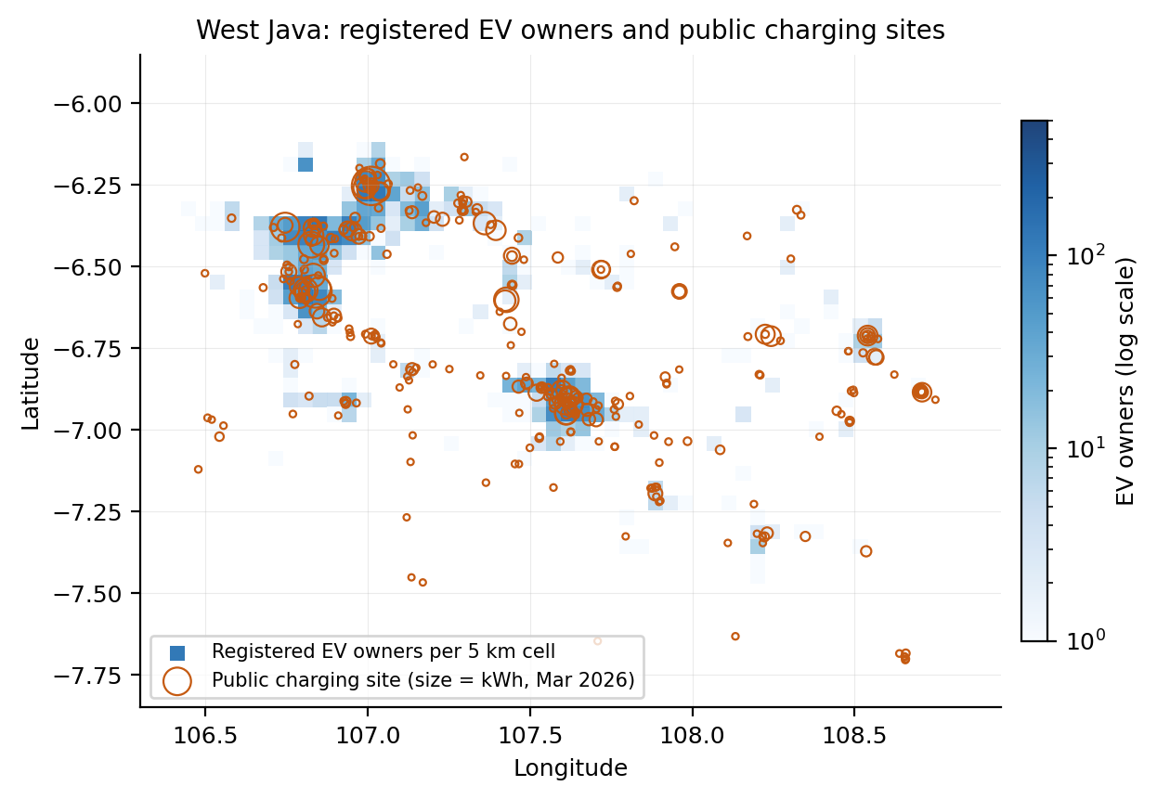
Figure 1. Registered EV owners per 5 km cell (blue, log scale) and public charging sites sized by March 2026 energy sales (orange). Owners cluster in the Jakarta commuter belt (Depok, Bogor, Bekasi) and Greater Bandung; a secondary corridor runs east along the toll road to Cirebon.
Figure 1 sets the stage. Registered EV owners are concentrated in two metropolitan cores and one corridor; public chargers follow the same pattern but with a long tail of low-yield sites at PLN offices across the province. Of 3,687 registered owners, 75 per cent already live in a cell with at least one charger, but the between-regency coverage Gini is 0.24: coverage is near-complete in Bekasi and Depok and fragmentary in the southern regencies.

4.2 Yield is concentrated, and concentration is where the commercial objective lives
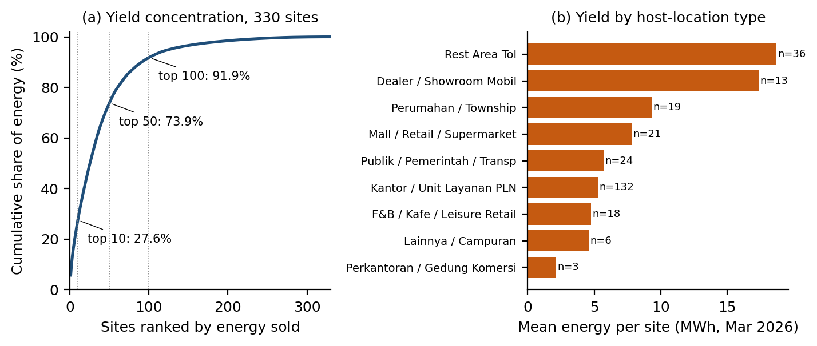
Figure 2. (a) Cumulative share of March 2026 energy across 330 sites ranked by yield. (b) Mean energy per site by host-location type; n is the number of sites of that type.
Figure 2(a) shows why the objective function matters. Across the 330 existing sites, the ten busiest sold 27.6 per cent of all energy, the busiest fifty sold 73.9 per cent and the busiest hundred 91.9 per cent; the site-level Gini of energy is 0.77. Figure 2(b) shows the mechanism: toll-road rest areas average 18.7 MWh a month per site, dealer showrooms 17.3 MWh, while the 132 PLN office sites, 40 per cent of the network, average 5.3 MWh and hotels 1.4 MWh. Any model trained on this record learns that yield lives on the motorway and in the showroom. A commercial objective will send capital there, and it will be right, in its own terms, to do so.

4.3 Two objectives, two provinces
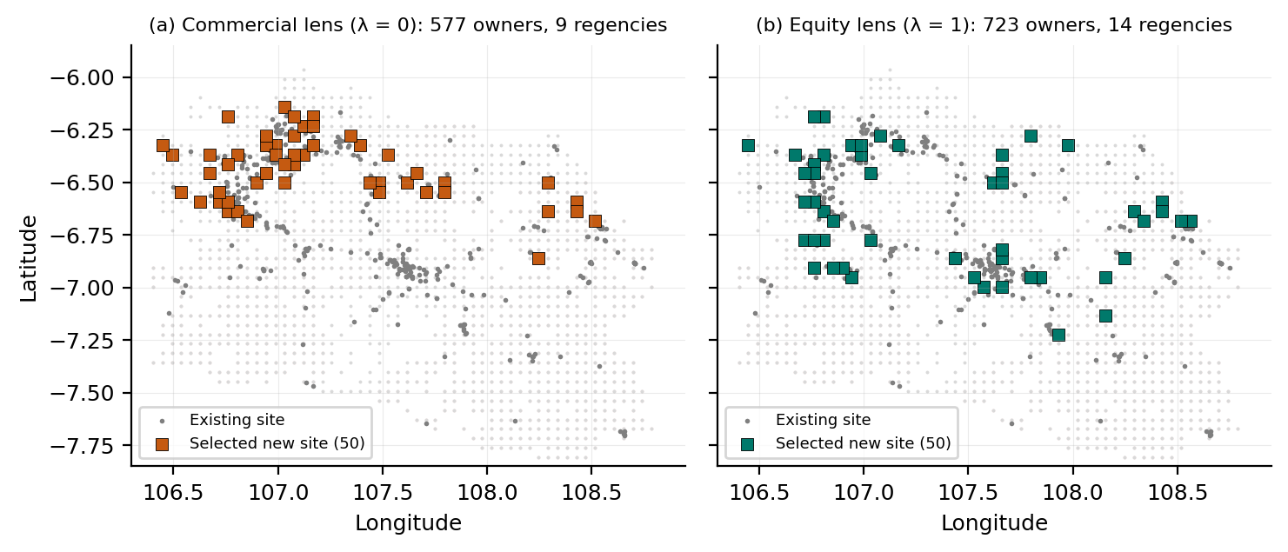
Figure 3. Fifty new sites selected from the same 111 eligible cells under (a) the commercial objective and (b) the equity objective. Grey dots are existing sites; pink shading marks low-income regencies. Only 21 cells appear in both portfolios.
Figure 3 and Table 2 are the core of the chapter. Given the same eligible cells and the same budget of 50 sites, the commercial objective selects a portfolio that hugs the existing network: 18 sites in Bogor, 13 in Bekasi, none in Bandung, Sukabumi, Garut or Tasikmalaya. It reaches 577 of the 908 unserved registered owners, spreads over 9 regencies, places 10 sites in low-income regencies, and puts 18 of its 50 sites in cells with below-median registered demand, because the observed-data predictor rewards grid density and proximity to the metropolitan core regardless of who lives there. The equity objective selects a portfolio that reaches 723 owners, 25 per cent more, over 14 regencies with 27 sites in low-income regencies, including 7 in Sukabumi and 4 in Bandung, and lowers the between-regency coverage Gini from 0.24 today to 0.14, against 0.18 under the commercial objective. Its cost, in the model's own currency, is 42 per cent less predicted energy.
Table 2. Outcomes of 50 new sites under the two objective functions and the current network.
Outcome | Today (no new sites) | Commercial lens (λ = 0) | Equity lens (λ = 1)
Unserved registered owners reached | — | 577 | 723
Model-predicted energy of new sites (MWh/month) | — | 213 | 125
Register-based expected energy (MWh/month) | — | 415 | 511
Regencies receiving a site | — | 9 | 14
Sites in low-income regencies | — | 10 (20%) | 27 (54%)
Sites in below-median-demand cells | — | 18 | 12
Mean distance to nearest existing charger (km) | — | 6.6 | 7.3
Owners living in a served cell (%) | 75.4 | 91.0 | 95.0
Between-regency coverage Gini | 0.242 | 0.177 | 0.136

Two features of Table 2 deserve emphasis. First, neither portfolio is wrong. The commercial portfolio is a defensible optimisation of the utility's revenue; the equity portfolio is a defensible optimisation of the province's access. Both are produced from identical evidence by an identical machine. Second, the two portfolios disagree about most of the map: only 21 of 50 cells are common to both. A regency such as Sukabumi, with 3.2 million residents and a low-income classification, receives 7 sites under one objective and none under the other. That is not a technical detail. It is a decision about whether one of the largest regencies in Java is part of the electric-mobility transition in the next investment cycle.

4.4 A political choice rendered as a parameter
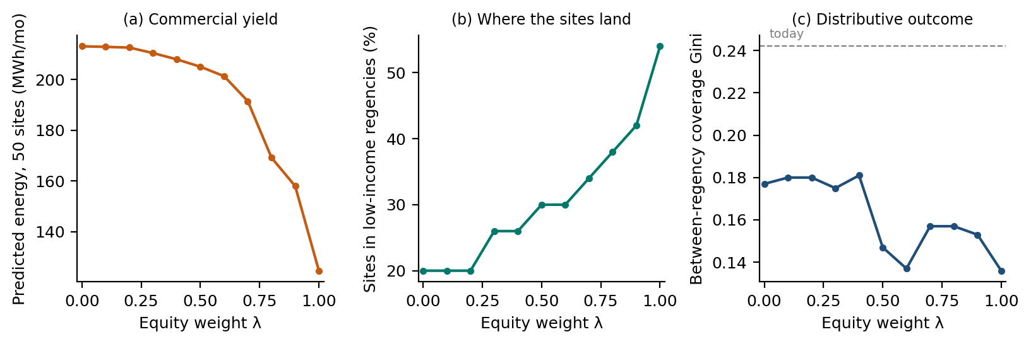
Figure 4. Sweeping the equity weight λ from 0 (commercial) to 1 (equity): (a) model-predicted energy of the 50-site portfolio; (b) share of sites in low-income regencies; (c) between-regency coverage Gini, with today's value as the dashed line.
Figure 4 sweeps λ in steps of 0.1. The trade-off is smooth. Predicted energy falls slowly until λ ≈ 0.6 and then steeply; the share of sites in low-income regencies rises from 20 to 54 per cent; the coverage Gini falls in two steps, at λ ≈ 0.5 and λ ≈ 1. There is no natural breakpoint, no value of λ that the data select. Every point on the curve is a different province, and the choice among them is exactly the kind of choice that planning processes exist to make: how much revenue the utility should forgo to reach households in Sukabumi and Garut. In the deployed tool that choice is made by whoever last edited the weight table. The chapter's claim is not that the current weights are wrong. It is that they are a policy, and that policies are supposed to be visible.

5. Discussion

5.1 What the counterfactual reveals that the model does not
A siting model reports a ranking. A ranking hides its own alternatives. Running the same model under a second objective and mapping the difference is a cheap operation, a few lines of code against a pipeline that already exists, and it converts an opaque recommendation into a legible trade-off. In this case it reveals that the commercial objective would not place a single site in four regencies with a combined population of 14 million; that the equity objective would reach a quarter more currently unserved owners; and that the price of doing so is 42 per cent of predicted energy from 50 sites, or roughly 89 MWh a month, on a network that sells 2,260 MWh a month today. That is a number a provincial government could argue about. It is not a number the current process produces.

5.2 A minimum accountability standard for algorithmic infrastructure siting
The findings translate into four requirements that a public utility, or the regulator that licenses it, could adopt without changing who owns the chargers. First, publish the objective function and its weights, in the same way that EU system operators must now publish the criteria behind hosting-capacity maps. Second, publish at least one counterfactual portfolio under an alternative objective, so that the distributive content of the chosen objective is visible rather than implicit. Third, name the population that each objective excludes: the regencies that receive no site, the owners who remain unserved, the income tiers that lose share. Fourth, version the model and its weights, so that a ranking that misdirected public capital can be traced to the configuration that produced it and corrected rather than trusted. These requirements echo Diakopoulos's (2016) disclosure elements and Kroll et al.'s (2017) insistence on contestability, but they are specific to the situation in which the algorithm is the allocation instrument. They are also cheap: everything in this chapter was produced from data the utility already holds.

5.3 Publication as the substitute for a planning process
Where a planning authority exists, a siting model is an input to it and the authority can be lobbied. Where none exists, the model is the authority. Kitchin (2014) warns that data-driven urbanism tends to present political choices as technical ones; Shelton et al. (2015) show that the actually existing smart city is assembled from precisely such unexamined defaults. The Indonesian charging roll-out is an unusually pure instance, because the organisation running the model also owns the grid, the chargers and the customer data, and because the model is running ahead of any observed demand that could discipline it. In that structure, disclosure of the objective function is not a transparency nicety. It is the functional substitute for a planning process: the only point at which a province, a regency or a civil-society group could see what the utility is optimising for and ask it to optimise for something else.

5.4 Limitations
The counterfactual is built on a 5 km grid and an open-data rebuild of the deployed tool; the operational model uses a 2 km hexagon grid and a proprietary POI layer that cannot be published, so the portfolios shown are illustrative of the deployed tool's logic rather than reproductions of its output. The observed-data predictor is weak (out-of-bag R² of 0.18), which is a finding about the predictability of yield from grid and geography alone, but it means the commercial ranking carries substantial noise. Registered home-charging customers under-represent households without off-street parking, who may depend most on public chargers; the equity lens therefore understates need in dense urban kampung. The equity objective is one of many that could be written, and the chapter does not claim it is the right one; its role is to show that any second objective exposes the first. Finally, the 50-site budget is a device; the deployed tool ranks 244 sites, and the shape of the trade-off at that scale is a matter for the full study.

6. Conclusion
In West Java the question of who gets public EV charging has moved from the planning office, where it never was, to the objective function of a siting model inside the state utility. This chapter has shown that the model, run under two defensible objectives on identical evidence, produces two different provinces: one that densifies the Jakarta commuter belt and one that reaches the southern regencies, differing in 29 of 50 sites, in whether Sukabumi and Bandung receive any site at all, and in 42 per cent of predicted energy. The difference is a parameter. It should be a policy. Publishing the objective function, the counterfactual it suppresses and the population it excludes is the least a utility can do when its model has become the only planning instrument a province has, and it is also, on this evidence, enough to turn a black box into an argument that can be had in public.

References
Ananny, M. and Crawford, K. (2018) 'Seeing without knowing: Limitations of the transparency ideal and its application to algorithmic accountability', New Media & Society, 20(3), pp. 973–989.
Batty, M. (2013) The New Science of Cities. Cambridge, MA: MIT Press.
Breiman, L. (2001) 'Random forests', Machine Learning, 45(1), pp. 5–32.
Carlton, G.C. and Sultana, S. (2022) 'Electric vehicle charging station accessibility and land use clustering: A case study of the Chicago region', Journal of Urban Mobility, 2, 100019.
Csiszár, C., Csonka, B., Földes, D., Wirth, E. and Lovas, T. (2019) 'Urban public charging station locating method for electric vehicles based on land use approach', Journal of Transport Geography, 74, pp. 173–180.
Delbosc, A. and Currie, G. (2011) 'Using Lorenz curves to assess public transport equity', Journal of Transport Geography, 19(6), pp. 1252–1259.
Diakopoulos, N. (2016) 'Accountability in algorithmic decision making', Communications of the ACM, 59(2), pp. 56–62.
Falchetta, G. and Noussan, M. (2021) 'Electric vehicle charging network in Europe: An accessibility and deployment trends analysis', Transportation Research Part D, 94, 102813.
Geertman, S. and Stillwell, J. (2020) 'Planning support science: Developments and challenges', Environment and Planning B: Urban Analytics and City Science, 47(8), pp. 1326–1342.
Hsu, C.-W. and Fingerman, K. (2021) 'Public electric vehicle charger access disparities across race and income in California', Transport Policy, 100, pp. 59–67.
IEA (2025) Global EV Outlook 2025. Paris: International Energy Agency.
Kitchin, R. (2014) 'The real-time city? Big data and smart urbanism', GeoJournal, 79(1), pp. 1–14.
Kroll, J.A., Huey, J., Barocas, S., Felten, E.W., Reidenberg, J.R., Robinson, D.G. and Yu, H. (2017) 'Accountable algorithms', University of Pennsylvania Law Review, 165(3), pp. 633–705.
Kuby, M. and Lim, S. (2005) 'The flow-refueling location problem for alternative-fuel vehicles', Socio-Economic Planning Sciences, 39(2), pp. 125–145.
Lou, J., Shen, X., Niemeier, D.A. and Hultman, N. (2024) 'Income and racial disparity in household publicly available electric vehicle infrastructure accessibility', Nature Communications, 15, 5106.
Lundberg, S.M. and Lee, S.-I. (2017) 'A unified approach to interpreting model predictions', Advances in Neural Information Processing Systems, 30, pp. 4765–4774.
Malczewski, J. (2006) 'GIS-based multicriteria decision analysis: A survey of the literature', International Journal of Geographical Information Science, 20(7), pp. 703–726.
Pagany, R., Ramirez Camargo, L. and Dorner, W. (2019) 'A review of spatial localization methodologies for the electric vehicle charging infrastructure', International Journal of Sustainable Transportation, 13(6), pp. 433–449.
Pettit, C., Bakelmun, A., Lieske, S.N., Glackin, S., Hargroves, K., Thomson, G., Shearer, H., Dia, H. and Newman, P. (2018) 'Planning support systems for smart cities', City, Culture and Society, 12, pp. 13–24.
Roy, A. and Law, M. (2022) 'Examining spatial disparities in electric vehicle charging station placements using machine learning', Sustainable Cities and Society, 83, 103978.
Shelton, T., Zook, M. and Wiig, A. (2015) 'The "actually existing smart city"', Cambridge Journal of Regions, Economy and Society, 8(1), pp. 13–25.
Sovacool, B.K. and Dworkin, M.H. (2015) 'Energy justice: Conceptual insights and practical applications', Applied Energy, 142, pp. 435–444.
Yeung, K. (2018) 'Algorithmic regulation: A critical interrogation', Regulation & Governance, 12(4), pp. 505–523.

Length statement: 3,525 words of text, 4 figures and 2 tables counted at 250 words each (1,500), and 497 words of references — 5,522 words against the 4,000–6,000 word limit. Abbreviated abstract: 249 words.

