CUPUM 2027 — Future Cities in the Era of AI · Book chapter (full manuscript draft)
Training on the Past: Feedback Loops, Latent Demand and the Politics of Sparse Data in Charging Networks
Qashtalani Haramaini — Monash University Indonesia (RACE for 2030 Program) / PT PLN (Persero) UID Jawa Barat, Indonesia — qashtalani.haramaini@monash.edu (corresponding and presenting author)
Alyas Widita — Monash University Indonesia — alyas.widita@monash.edu
Liz Taylor — Monash University, Faculty of Art, Design and Architecture (MADA), Australia — liz.taylor@monash.edu

Abstract
In a network built ahead of demand, the transaction record a siting model learns from is not a sample of demand but a record of previous allocation decisions. This chapter shows, with operator data from West Java, Indonesia, that the conventional data-driven siting pipeline contains a feedback loop with distributive consequences. Observed transactions exist in only 174 of 1295 five-kilometre cells; 132 cells hold 908 registered EV owners and no charger. We compare two models on the same territory: a random forest fitted to observed transactions using grid and geographic covariates, and a Gamma–Poisson hierarchical model of latent demand that partially pools an exposure signal independent of charger placement, 3,687 households registered for the home-charging tariff. The models agree only weakly on where to build next (Spearman ρ = 0.30; 26 of the top 50 cells in common), and posterior uncertainty is widest exactly where no infrastructure and no observation exist. A deployment simulation shows why the difference compounds: demand from unserved cells is credited to the nearest served site, and a model retrained on that record keeps recommending densification. After ten rounds the observed-data rule leaves 19 per cent of latent demand in low-income regencies unserved against 7 per cent for the latent-demand rule. Sparsity is an artefact of an earlier distributive choice; treating missing data as missing demand launders that choice into a forecast. The chapter proposes an inferential design that separates exposure from observation and reports uncertainty as a first-class output of any planning support system.
Keywords: latent demand; Bayesian hierarchical modelling; feedback loops; data sparsity; algorithmic fairness; electric vehicle charging

1. Introduction
Every machine-learning model of urban demand is a model of the past. Charging-station siting models are trained on transaction logs, utilisation records and mobile-app check-ins; they learn where charging happens and recommend more of it. In a mature network, where nearly every plausible location has been tried, this is a reasonable procedure: the record approximates the demand surface. In a young network, built ahead of demand in a country where EVs are still below one per cent of the vehicle stock, the record is something else. It is the set of places where the utility chose to build, and nothing more. Places never served produce no transactions, and a model cannot learn that they should have been served from data that does not contain them.
This chapter argues that the standard data-driven siting pipeline therefore contains a feedback loop, structurally identical to the one Ensign et al. (2018) proved for predictive policing. There, police are dispatched to neighbourhoods where crime was previously discovered, discover more crime there because they are present, and the model that allocates them learns from the discoveries. Here, chargers are built where charging was previously observed, drivers from unserved neighbourhoods travel to those chargers, the sessions are logged at the served location, and the model that allocates the next tranche learns that demand lives where the chargers already are. Performative prediction (Perdomo et al., 2020) gives the general form: a model whose outputs change the distribution it will next be trained on. The novelty of this chapter is to demonstrate the loop with operator data, to quantify what it does to a real siting recommendation, and to show that a different inferential design can break it.
The setting is West Java, Indonesia's most populous province, where the state utility PLN operates both the distribution grid and most public chargers. Three datasets held by one organisation make the analysis possible: the complete charging log for March 2026, 101,020 sessions at 330 geocoded sites; the distribution transformer register, 53,797 records; and, crucially, a register of 3,687 households that applied for PLN's home-charging tariff, geocoded at the service point. The third dataset is the key. Households applied because they bought an EV, not because a public charger was nearby; the register is therefore an exposure proxy for latent demand that is statistically independent of the deployment decisions the transaction log reflects. Few utilities hold such a proxy and fewer researchers have seen one; it allows the feedback loop to be measured rather than merely asserted.
The chapter proceeds as follows. Section 2 positions the argument between the siting literature, which treats sparsity as a data-availability problem, and the algorithmic-fairness literature, which treats it as a source of bias. Section 3 describes the two models: an observed-data random forest and a Gamma–Poisson hierarchical latent-demand model with partial pooling across regencies. Section 4 reports how far they disagree, where the posterior is uncertain, and what happens when each is used to drive deployment over ten rounds. Section 5 draws the implications for planning support systems in data-sparse cities.

2. Background

2.1 Sparsity as a data problem
The siting literature is aware that observed usage is scarce in emerging markets. Pagany et al.'s (2019) review of localisation methods notes that most demand-based approaches rely on traffic counts, parking data or existing usage that are unavailable outside a handful of rich cities, and recommends proxies such as land use and points of interest. Csiszár et al. (2019) build a land-use-based method precisely for cities without usage data. The dominant framing is that sparsity limits what can be estimated, and that better proxies or more data will close the gap. Missing data are treated, in Rubin's (1976) terms, as missing at random: uninformative about the quantity being estimated once covariates are accounted for.

2.2 Sparsity as bias
The algorithmic-fairness literature reads the same situation differently. When the mechanism that generates observations depends on the outcome of earlier predictions, missingness is informative and the resulting estimates are biased in a direction that reinforces the earlier decision. Ensign et al. (2018) formalise this with an urn model and show that even a small initial disparity in discovery rates is amplified without limit. Perdomo et al. (2020) generalise to any predictor that influences its own future training distribution. Barocas et al. (2023) catalogue the selection mechanisms that produce such loops in lending, hiring and public services; Eubanks (2018) documents their human consequences in welfare administration. Applications to urban infrastructure are rare, and none to charging. Yet charging is close to the ideal case: allocation is made by a single actor, the outcome of allocation (sessions) is the training target of the next allocation, and users are mobile, so unserved demand is not lost but displaced onto served locations.

2.3 Exposure, observation and partial pooling
Statistical epidemiology solved a closely related problem decades ago. Disease counts in small areas are sparse and noisy; the raw rate in a district with three cases is uninformative. Clayton and Kaldor (1987) introduced empirical-Bayes smoothing of area rates towards a regional mean, and Besag, York and Mollié (1991) the spatial random-effects formulation that underlies modern disease mapping. The essential move is to separate exposure (population at risk) from observation (cases), and to let areas borrow strength from their neighbours in proportion to how little they have observed (Efron and Morris, 1975; Gelman and Hill, 2007). This chapter applies the same logic to charging demand, with registered EV owners as cases and electrified premises, proxied by transformer count, as exposure. The result is a model whose uncertainty is largest where it has seen least, which is the property a siting model in a sparse network most needs and most often lacks.

3. Data and models

3.1 The grid and the pattern of observation
All data were aggregated to a 0.045° (≈5 km) grid over West Java. Of 1,295 cells that contain at least one distribution transformer, 238 contain registered EV owners and 174 contain a public charger. The overlap is partial: 132 cells hold 908 registered owners, a quarter of the provincial total, and no charger. Classified by median demand and median network headroom, the high-demand/high-headroom quadrant holds 84.2 per cent of owners and 70.3 per cent of chargers; the roll-out is broadly rational. The high-demand/low-headroom quadrant holds 11.6 per cent of owners but 5.6 per cent of chargers, and 20 of its cells, with 230 owners, have no charger at all (Table 1). These are the cells a transaction-trained model has never seen.
Table 1. Cells with registered EV owners classified by median registered demand and median growth-corrected transformer headroom (5 km grid, West Java).
Quadrant | Cells | Share of registered owners (%) | Share of chargers (%)
High demand / high headroom | 89 | 84.2 | 70.3
High demand / low headroom | 30 | 11.6 | 5.6
Low demand / high headroom | 30 | 1.2 | 13.7
Low demand / low headroom | 89 | 3.0 | 10.4

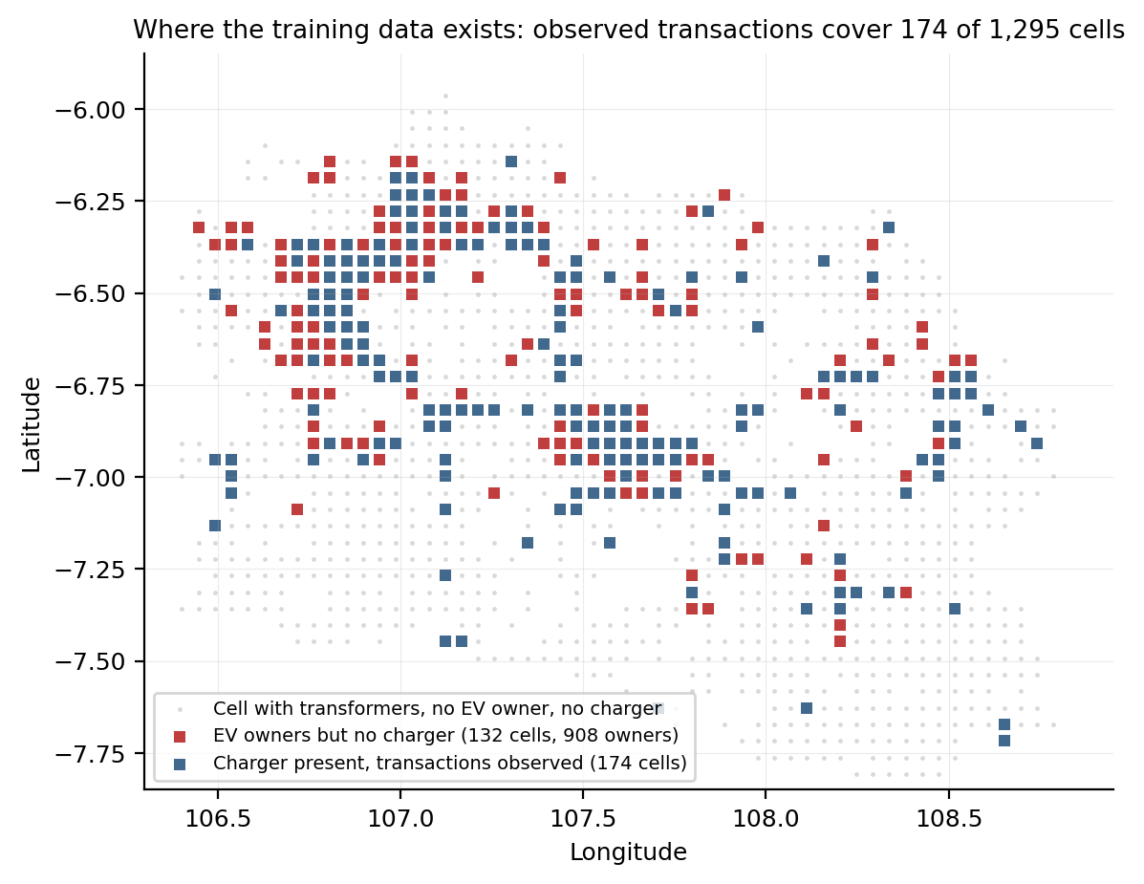
Figure 1. Where the training data exist. Blue cells contain a public charger and therefore observed transactions; red cells contain registered EV owners but no charger; grey cells contain transformers but neither. A transaction-trained model has information about the blue cells only.

3.2 Model A: the observed-data predictor
Model A is the model a utility builds from what it already holds. A random forest (Breiman, 2001; 500 trees, minimum leaf size 3) is fitted on the 174 served cells with log energy sold in March 2026 as the target and six covariates available everywhere: installed transformer capacity, transformer count, growth-corrected headroom, latitude, longitude and distance to the nearest charger. The EV customer register is deliberately excluded, because the purpose is to represent the conventional pipeline that does not have it. Out-of-bag R² is 0.18. The most important covariates are installed capacity (0.26), headroom (0.23) and the two coordinates (0.40 combined): the model has learned that yield is a function of grid density and of where in the province one is. That is an accurate description of the March 2026 record. It is also a description of the geography of previous investment.

3.3 Model B: latent demand with partial pooling
Model B separates exposure from observation. Let n_i be registered EV owners in cell i and E_i the number of distribution transformers, a proxy for electrified premises. We assume n_i ~ Poisson(θ_i E_i), where θ_i is the latent adoption rate per transformer, and θ_i ~ Gamma(α_r, β_r) with hyperparameters specific to regency r. The Gamma prior is conjugate, so the posterior is θ_i | n_i ~ Gamma(α_r + n_i, β_r + E_i), with posterior mean (α_r + n_i)/(β_r + E_i) and closed-form quantiles. Regency hyperparameters are set by the method of moments on the observed cell rates within each regency, shrunk towards the provincial moments with weight k/(k + 10) where k is the number of cells in the regency (Clayton and Kaldor, 1987). Latent demand in cell i is θ_i E_i; its 90 per cent posterior interval is reported as a relative width, (q95 − q05)/mean, so that cells with different exposure are comparable. Three properties matter. First, a cell with owners but no charger has a well-defined posterior, because the model never used chargers. Second, a cell with no owners does not receive a point estimate of zero; it receives the regency prior, with an interval that reflects how little was observed. Third, regencies with few cells borrow strength from the province rather than from their own noise.

3.4 Comparison and simulation
The two models are compared on the 132 candidate cells that have registered owners and no charger, by Spearman rank correlation and by overlap of the top 50. A stylised deployment simulation then runs each model as a siting rule for ten rounds of 15 sites, over all electrified cells with at least 240 kVA of headroom. The simulation needs a ground truth; one realisation is drawn from each cell's posterior and held fixed, so that neither rule knows it exactly. The observed record is regenerated each round: energy at a served cell equals a yield factor times its own true demand plus half the true demand of unserved cells within 12 km whose nearest served cell it is. This spillover term encodes the mobility of drivers; it is what makes the loop close. Rule A retrains Model A on the regenerated record each round and builds where it predicts most energy. Rule B builds where the latent-demand posterior mean is highest and does not retrain, because it does not use the record. Outcomes are the between-regency Gini of demand coverage, the share of latent demand covered in low-income regencies, and the mean distance of new sites to the nearest existing one.

4. Results

4.1 The models disagree about the next fifty sites
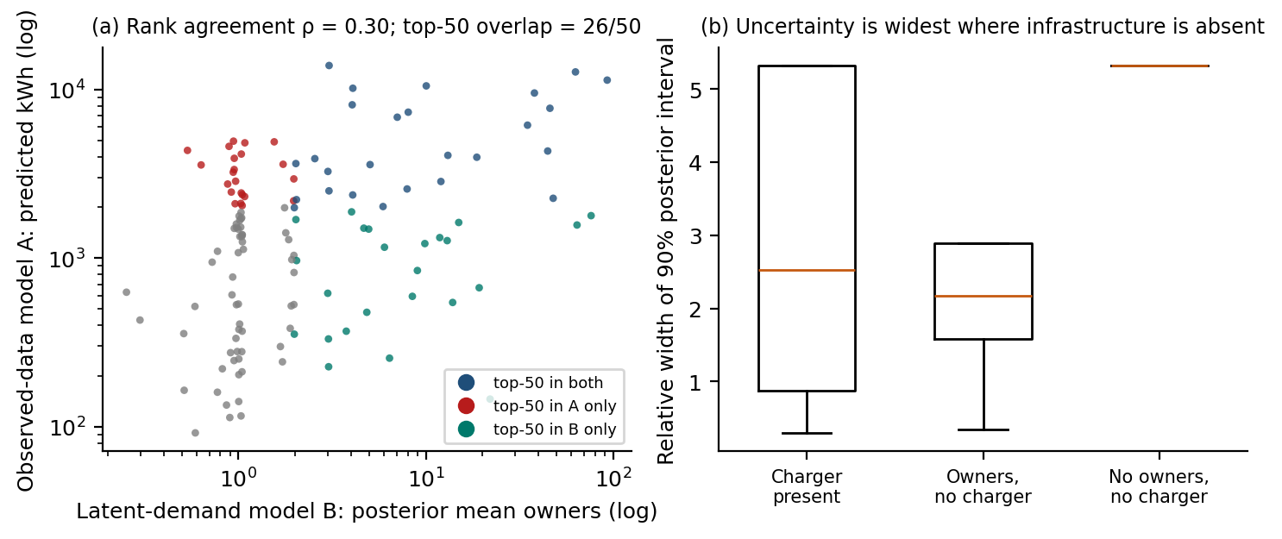
Figure 2. (a) Predicted energy from the observed-data model against posterior mean latent demand, for the 132 candidate cells; colour marks membership of each model's top 50. (b) Relative width of the 90 per cent posterior interval by cell status.
Figure 2(a) shows the core empirical result. Across candidate cells the two rankings correlate at ρ = 0.30, and only 26 of the 50 cells each model would build first are common to both. The disagreement is not random. Model A's exclusive picks lie, on average, 6.7 km from an existing charger; Model B's lie 5.8 km away but in cells with more registered owners. Model A is recommending cells that resemble served cells, dense grid, metropolitan coordinates, whether or not anyone there has bought an EV; Model B is recommending cells where people have bought EVs. Figure 4 maps the disagreement: Model A's exclusive picks ring the Jakarta commuter belt, Model B's include the Bandung basin and Sukabumi.

4.2 Uncertainty is largest where nothing has been observed
Figure 2(b) reports the relative width of the posterior interval. For served cells the median is 2.5; for cells with owners but no charger 2.2; for the 1057 cells with neither, 5.3, which is simply the width of the regency prior. The point is not that unserved cells with owners are more uncertain than served ones; on this measure they are slightly less so, because the register is observed everywhere. The point is that the majority of the province, the cells with no charger and no registered owner, receives from Model A a confident point prediction and from Model B an interval more than five times its mean. A transaction-trained model does not know that it does not know; a hierarchical model does, and says so in the cells where a wrong confident answer would matter most.

4.3 The loop closes
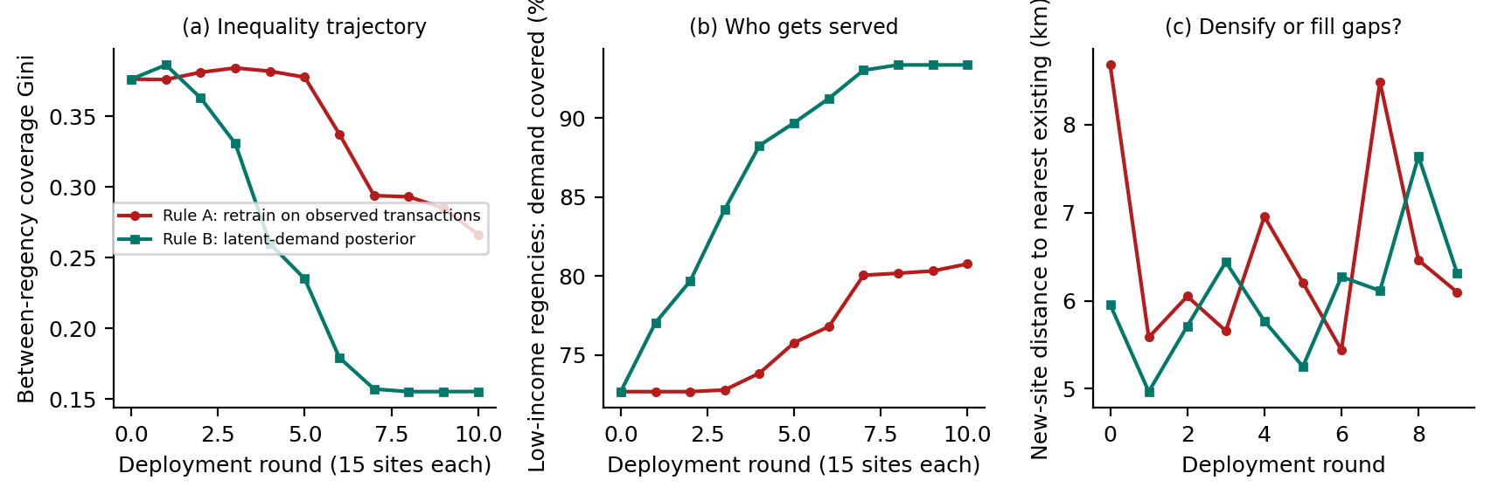
Figure 3. Ten rounds of 15 new sites under Rule A (retrain on the observed record) and Rule B (latent-demand posterior). (a) Between-regency Gini of demand coverage; (b) share of latent demand covered in low-income regencies; (c) mean distance of each round's new sites to the nearest existing site.
Figure 3 shows what happens when each model is allowed to drive deployment. Both rules start from the current network, with 74 per cent of latent demand covered and a between-regency Gini of 0.38. Rule B reaches 98 per cent coverage and a Gini of 0.15 after 150 sites; Rule A reaches 95 per cent and 0.27. The difference is concentrated where it matters. In low-income regencies, Rule B lifts coverage from 73 to 93 per cent; Rule A leaves it at 73 per cent through its first 45 sites and reaches only 81 per cent after 150. Panel (c) shows the mechanism: Rule A's first rounds are placed closer to existing sites than Rule B's, because spillover from unserved neighbours has been credited to those sites and the retrained model reads the credit as local demand. The loop is not dramatic in any single round. It is a steady bias that compounds, exactly as Ensign et al. (2018) predict, and it is invisible from inside the model, whose retrained fit improves each round as the record it created grows.
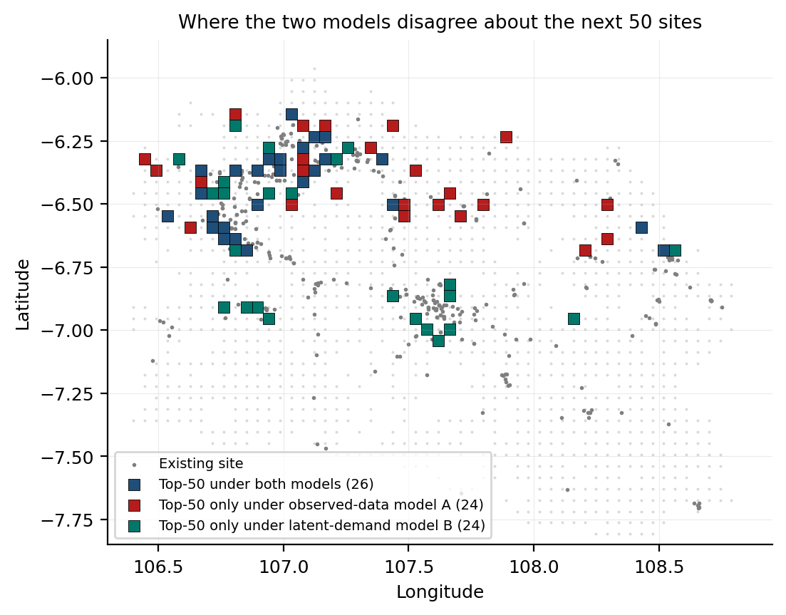
Figure 4. Candidate cells in each model's top 50. Cells chosen by both (blue), by the observed-data model only (red) and by the latent-demand model only (teal). Grey dots are existing sites.

5. Discussion

5.1 Sparsity is an artefact of allocation, not a property of the city
The siting literature's instinct is to treat the empty cells in Figure 1 as a data gap: cities without usage records need better proxies. This chapter's evidence points the other way. The empty cells are empty because the utility did not build there, and the utility did not build there, in part, because earlier decisions had produced no evidence that it should. Sparsity is the shadow of allocation. Treating it as missing-at-random noise, and smoothing it away with covariates that themselves encode the geography of investment, launders a distributive decision into an objective-looking forecast. Selbst et al. (2019) call this the framing trap: solving a sociotechnical problem as if it were a technical one and thereby importing the social structure into the solution. In charging deployment the trap has a map, and Figure 4 is it.

5.2 Design implications for planning support systems
Three implications follow for anyone building a siting model in a sparse network. First, separate exposure from observation. Any signal generated by the population rather than by the infrastructure, vehicle registrations, tariff applications, parking permits, can serve as exposure; the transaction log cannot. Second, pool. Hierarchical estimation with shrinkage towards regional means is standard in disease mapping and almost absent from infrastructure siting; it costs a few lines of code and produces the one thing a sparse-data model most needs, honest uncertainty. Third, publish the uncertainty. A planning support system that returns a ranked list of cells has hidden its own blind spot; one that returns a ranked list with intervals lets a planner see that the top of the list in an unserved regency is a guess and the top of the list in Bekasi is not. Geertman and Stillwell (2020) argue that PSS adoption depends on models that support argument rather than replace it; interval-bearing recommendations are what argument needs.

5.3 The politics of the prior
Partial pooling is not neutral either. Model B's regency hyperparameters encode an assumption that cells within a regency resemble one another, and its shrinkage weight encodes how much to trust a regency's own record against the province's. These are choices, and they have distributive content: a stronger prior lifts unserved regencies further. The chapter does not claim that Model B is right. It claims that Model B's assumptions are visible, in three parameters, whereas Model A's assumption that the future resembles the record is invisible, in five hundred trees. A model whose bias can be seen can be argued with. The argument for hierarchical latent-demand estimation in sparse networks is not that it removes politics from siting but that it puts the politics where a planner can find it.

5.4 Limitations
The simulation is stylised. Its ground truth is a single posterior draw, its spillover rule is a fixed fraction within a fixed radius, and it holds demand constant over ten rounds while a real network would see adoption respond to deployment; the results should be read as a demonstration of mechanism, not a forecast. Transformer count is an imperfect exposure measure that over-weights industrial areas. Registered home-charging customers under-represent households in multi-unit housing without off-street parking, so latent demand in dense urban cores is understated; the same limitation affects any register-based proxy and is the subject of the companion chapter on perceived quality. Model A is one observed-data model; a gradient-boosted or spatially cross-validated alternative would change the numbers but, by construction, not the direction, because no model can learn from transactions that were never generated.

6. Conclusion
A siting model trained on where charging happens will recommend more of where charging happens. In a network built ahead of demand that is not a forecast but a repetition, and the chapter has measured how much of one: two models on identical territory agree on half of their first fifty sites, and over ten rounds of deployment the transaction-trained rule leaves a fifth of latent demand in low-income regencies unserved while the latent-demand rule leaves a fifteenth. The remedy is not more data, which cannot exist until the infrastructure does. It is an inferential design that separates the population's signal from the infrastructure's record, borrows strength across space in proportion to ignorance, and reports what it does not know. For the wider debate about AI in cities, West Java offers a concrete instance of a claim usually made in the abstract: that urban AI reproduces the geography of past investment unless it is explicitly designed not to, and that the design choices which prevent it are neither exotic nor expensive.

References
Barocas, S., Hardt, M. and Narayanan, A. (2023) Fairness and Machine Learning: Limitations and Opportunities. Cambridge, MA: MIT Press.
Besag, J., York, J. and Mollié, A. (1991) 'Bayesian image restoration, with two applications in spatial statistics', Annals of the Institute of Statistical Mathematics, 43(1), pp. 1–20.
Breiman, L. (2001) 'Random forests', Machine Learning, 45(1), pp. 5–32.
Clayton, D. and Kaldor, J. (1987) 'Empirical Bayes estimates of age-standardized relative risks for use in disease mapping', Biometrics, 43(3), pp. 671–681.
Csiszár, C., Csonka, B., Földes, D., Wirth, E. and Lovas, T. (2019) 'Urban public charging station locating method for electric vehicles based on land use approach', Journal of Transport Geography, 74, pp. 173–180.
Efron, B. and Morris, C. (1975) 'Data analysis using Stein's estimator and its generalizations', Journal of the American Statistical Association, 70(350), pp. 311–319.
Ensign, D., Friedler, S.A., Neville, S., Scheidegger, C. and Venkatasubramanian, S. (2018) 'Runaway feedback loops in predictive policing', Proceedings of the 1st Conference on Fairness, Accountability and Transparency, PMLR 81, pp. 160–171.
Eubanks, V. (2018) Automating Inequality: How High-Tech Tools Profile, Police, and Punish the Poor. New York: St. Martin's Press.
Geertman, S. and Stillwell, J. (2020) 'Planning support science: Developments and challenges', Environment and Planning B: Urban Analytics and City Science, 47(8), pp. 1326–1342.
Gelman, A. and Hill, J. (2007) Data Analysis Using Regression and Multilevel/Hierarchical Models. Cambridge: Cambridge University Press.
Pagany, R., Ramirez Camargo, L. and Dorner, W. (2019) 'A review of spatial localization methodologies for the electric vehicle charging infrastructure', International Journal of Sustainable Transportation, 13(6), pp. 433–449.
Perdomo, J.C., Zrnic, T., Mendler-Dünner, C. and Hardt, M. (2020) 'Performative prediction', Proceedings of the 37th International Conference on Machine Learning, PMLR 119, pp. 7599–7609.
Rubin, D.B. (1976) 'Inference and missing data', Biometrika, 63(3), pp. 581–592.
Selbst, A.D., boyd, d., Friedler, S.A., Venkatasubramanian, S. and Vertesi, J. (2019) 'Fairness and abstraction in sociotechnical systems', Proceedings of the Conference on Fairness, Accountability, and Transparency (FAT* '19), pp. 59–68.

Length statement: 3,035 words of text, 4 figures and 1 tables counted at 250 words each (1,250), and 322 words of references — 4,607 words against the 4,000–6,000 word limit. Abbreviated abstract: 249 words.

