CUPUM 2027 — Future Cities in the Era of AI · Book chapter (full manuscript draft)
From Access to Use: Large Language Models as a Participation Surface for Charging Infrastructure, and the Class Filter They Inherit
Qashtalani Haramaini — Monash University Indonesia (RACE for 2030 Program) / PT PLN (Persero) UID Jawa Barat, Indonesia — qashtalani.haramaini@monash.edu (corresponding and presenting author)
Alyas Widita — Monash University Indonesia — alyas.widita@monash.edu
Liz Taylor — Monash University, Faculty of Art, Design and Architecture (MADA), Australia — liz.taylor@monash.edu

Abstract
Counting chargers measures presence, not usability. Where no formal participation channel exists, the only systematic record of how charging is experienced is user-generated review text; this chapter treats it as a participation surface and asks what it reveals and whom it fails to hear. Using aspect-based sentiment analysis with a large language model, we score 584 charging locations in and around West Java, Indonesia, on seven service aspects and aggregate them into a Station Quality Index (SQI). Reliability and availability dominate perceived quality, and the seven aspects explain 63 per cent of SQI variance. Joining SQI to population-weighted concentration indices across 19 cities and regencies ranked by Human Development Index, we find that hardware is distributed almost neutrally (CI = +0.06) while use is strongly pro-rich (energy per capita CI = +0.34; EV ownership CI = +0.45), and that perceived quality is flat across the income gradient (CI = -0.02). The reliability problem is network-wide, not peripheral. But the surface that reports this is skewed: PLN sites in the highest-HDI tercile attract 8.3 reviews each, those in the lowest 4.0, and only 38 per cent of low-HDI sites have enough reviews to score. LLM-mediated feedback reproduces a class filter while wearing the appearance of public voice. We propose a two-dimensional equity framework, access and experience, and a coverage audit as the condition for using scraped sentiment in planning.
Keywords: aspect-based sentiment analysis; large language models; vertical equity; public participation; user-generated content; electric vehicle charging

1. Introduction
The equity of public EV charging is almost always assessed by counting. Chargers per capita, chargers per square kilometre, Gini coefficients of chargers across districts, distance from each household to the nearest charger: the metrics differ but the object is the same, the presence of hardware in space (Hsu and Fingerman, 2021; Lou et al., 2024; Falchetta and Noussan, 2021). Presence is necessary. It is not sufficient. A charger that has been offline for a month, that is permanently occupied by a vehicle that is not charging, that delivers 22 kW when its sign says 60, or whose payment application rejects every card, is counted as access by every one of these metrics and experienced as none by every driver who tries it. The transport-justice literature has long insisted that accessibility is about what people can actually do, not what exists near them (Martens, 2017; Pereira et al., 2017). Charging research has been slow to take the point.
Part of the reason is data. Usability is not in any asset register. Where regulators require operators to report uptime, as in California and under the EU's Alternative Fuels Infrastructure Regulation, some of it can be reconstructed; in most of the world nothing of the kind exists. Indonesia has no uptime reporting, no consultation requirement for charging deployment and no service-quality regulator with a public complaints record. The only systematic account of how charging is experienced is what drivers write about it on mapping platforms, and until recently that account was too unstructured to use.
Large language models change this. Aspect-based sentiment analysis (ABSA) can read thousands of free-text reviews and code each on a fixed set of service dimensions with a consistency no human panel could sustain, and Asensio et al. (2020) have shown, at national scale in the United States, that platform reviews classified by machine learning reveal reliability failures invisible to operators' own data. This chapter applies that approach to West Java and joins it to distributive-equity analysis, producing what we believe is the first two-dimensional equity assessment of a charging network in the Global South: how much hardware people have, and how well the hardware they have works for them.
The chapter is deliberately in two halves. The first treats review text as a participation surface and reports what it shows: which aspects drive experienced quality, and whether quality follows the same income gradient that use does. The second turns the method on itself and asks whom the surface hears. Reviews are written by people who own an EV, a smartphone and a platform account, and who choose to write. In Indonesia that is an affluent, digitally fluent minority, and the chapter shows that it is also a spatially skewed one. As generative models increasingly mediate how residents interact with government, the temptation to treat scraped sentiment as consultation will grow. The second half is a measured argument for resisting it.

2. Background

2.1 Horizontal and vertical equity in charging
Horizontal equity asks whether like areas are treated alike; vertical equity asks whether disadvantaged groups are treated better, worse or the same (Pereira et al., 2017). Charging-equity research has been almost entirely horizontal, using Lorenz curves and Gini coefficients of chargers across spatial units (Delbosc and Currie, 2011, in the transit tradition), or regression of charger presence on neighbourhood income and ethnicity (Hsu and Fingerman, 2021; Roy and Law, 2022). Vertical equity requires ranking areas by socio-economic status and asking whether provision concentrates at the top or the bottom. The concentration index of health economics does exactly this (Wagstaff et al., 1991; O'Donnell et al., 2008): the population-weighted covariance between a measure and the fractional socio-economic rank, scaled so that +1 means the measure is held entirely by the richest, −1 by the poorest, and 0 is neutral. It has rarely been applied to charging, and never, to our knowledge, to a measure of experienced quality.

2.2 Perceived environmental quality and PPGIS
Planning has a long tradition of treating perceived quality as data. Kyttä and colleagues' softGIS work showed that residents' located experiences of their environment could be collected at scale and used to reveal quality gradients that administrative data missed (Kyttä et al., 2011; Kyttä et al., 2013), and public-participation GIS has developed methods for eliciting such data deliberately (Brown and Kyttä, 2014). The distinctive feature of platform reviews is that they are not elicited. They are volunteered, by whoever chooses to volunteer, and the literature on volunteered geographic information has been clear since Haklay (2013) that this democratises the appearance of participation more than the substance: contributors are disproportionately urban, male, affluent and technically fluent (Hecht and Stephens, 2014). Ilieva and McPhearson (2018) argue that social-media data can nonetheless support urban sustainability research if their biases are measured rather than assumed away. That is the stance taken here.

2.3 Machine reading of infrastructure experience
Asensio et al. (2020) classified 127,000 reviews of US charging stations with a convolutional network and found that reliability complaints were concentrated at publicly funded sites; Ha et al. (2021) extended the approach with transformer models for topic classification. Both treat the review corpus as a sensor of infrastructure performance. Neither joins it to distributive equity, and neither examines the corpus's own coverage. The methodological contribution of this chapter is that join, and the critical contribution is the coverage audit.

3. Data and methods

3.1 The review corpus and the Station Quality Index
Public reviews were collected for 894 charging locations in West Java and the adjacent Jakarta metropolitan area, of which 584 had sufficient review volume to be scored (244 in West Java, 340 outside). Each review was passed to a large language model with a fixed prompt that codes seven service aspects on a −1/0/+1 scale, with fractional values where a location's reviews disagree: reliability (does the charger work), availability (is it free when needed), delivered power (does it charge at the advertised rate), payment, facilities, staff service and connector compatibility. Aspect codes were aggregated per location and combined with the Bayesian-shrunk star rating into a Station Quality Index (SQI) on a 0–100 scale; a confidence flag records review volume. The scored set spans seven operators, with PLN accounting for 150 locations and independent operators for the remainder.

3.2 What drives perceived quality
Two analyses identify the aspects that determine SQI. The first compares mean SQI between locations where an aspect is coded positive and locations where it is coded negative; the difference is the aspect's impact. The second is an ordinary-least-squares regression of SQI on the seven aspect codes with unmentioned aspects set to zero, which estimates each aspect's contribution holding the others constant.

3.3 Distributive measures
Population, Human Development Index (HDI) and income tier for 19 city and regency groups were taken from Statistics Indonesia and the provincial Klassen typology; PLN's Master SPKLU register (636 units at 348 sites) and the March 2026 transaction log (101,020 sessions) supplied units per 100,000 residents and energy per capita; the home-charging customer register supplied EV owners per 100,000. Four measures were computed for each group: chargers per 100,000, energy per capita, EV owners per 100,000 and mean SQI of scored locations. For each, a population-weighted concentration index against HDI rank was calculated following Wagstaff et al. (1991), together with the corresponding concentration curve. Horizontal-equity Gini coefficients of units and of energy against population were also computed.

3.4 Coverage audit
To measure whom the review surface hears, scored locations and total review counts were tallied per city and regency and divided by the number of PLN sites in the Master register, giving scored locations per site and reviews per site. Groups were split into HDI terciles. Because independent operators also appear in the review corpus, the ratio can exceed one; it is a measure of review density relative to the public network, not a coverage rate.

4. Results

4.1 The shape of experienced quality
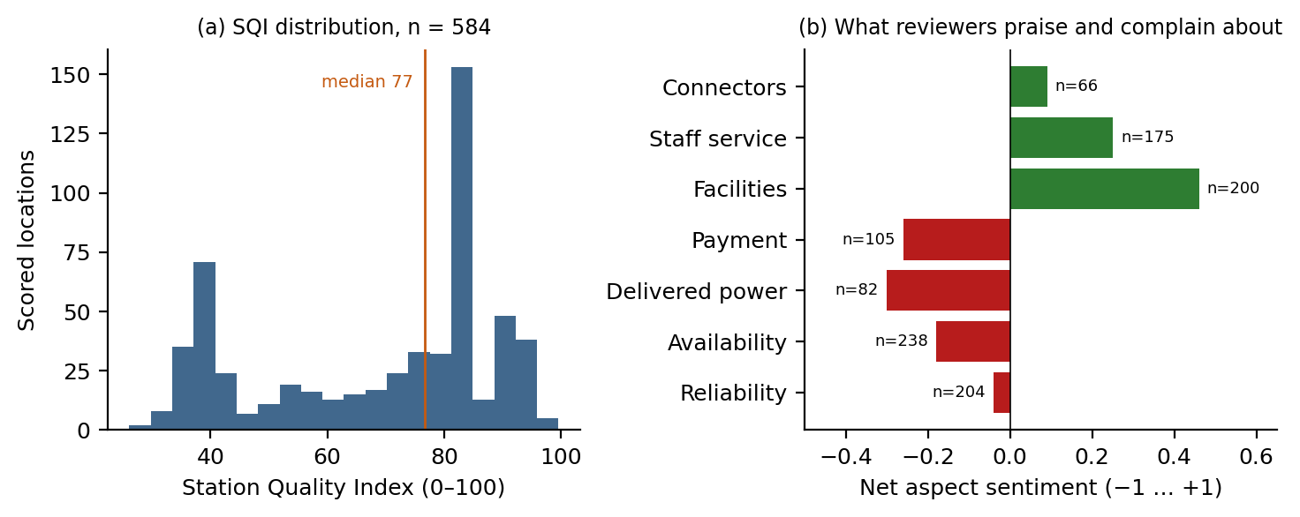
Figure 1. (a) Distribution of the Station Quality Index across 584 scored locations. (b) Net aspect sentiment across all reviews; n is the number of locations at which the aspect was mentioned.
Figure 1(a) shows a bimodal network. The median SQI is 77 and 271 locations score 80 or above, but 100 score below 40: a network in which most stations work well and a large minority are, by their users' account, barely functional. Figure 1(b) shows what users talk about. Facilities and staff service are praised; reliability is neutral on balance; availability, payment and delivered power are net negative, with delivered power the most negative aspect at -0.30. Reviewers are not complaining about amenities. They are complaining that the charger did not work, was occupied, would not take their money or did not deliver what its label promised.
Table 1. Aspect drivers of the Station Quality Index. Impact is mean SQI at locations where the aspect is positive minus mean SQI where it is negative; OLS coefficients from a regression of SQI on all seven aspects (R² = 0.63).
Aspect | Locations mentioning | SQI when positive | SQI when negative | Impact (points) | OLS coefficient
Reliability | 204 | 83.5 | 45.2 | 38.3 | 13.0
Availability | 238 | 83.5 | 49.1 | 34.5 | 14.4
Payment | 105 | 81.5 | 49.7 | 31.9 | 9.3
Delivered power | 82 | 81.5 | 50.1 | 31.4 | 7.8
Connectors | 66 | 81.7 | 50.6 | 31.1 | 1.5 (n.s.)
Staff service | 175 | 79.7 | 48.8 | 30.9 | 7.1
Facilities | 200 | 77.8 | 52.3 | 25.5 | 5.7

Table 1 ranks the aspects by impact. Reliability and availability are decisive: a location praised for reliability scores 84 on average and one criticised for it 45, a gap of 38 points; availability's gap is 34. Holding the other aspects constant, availability contributes 14 points and reliability 13, payment 9 and delivered power 8; facilities, the most praised aspect, contributes 6, and connectors are not significant. The seven aspects explain 63 per cent of the variance in SQI. The implication for a coverage-first roll-out is direct: the marginal review point is bought by keeping existing chargers working and free, not by adding a café.

4.2 Hardware is neutral, use is pro-rich, quality is flat
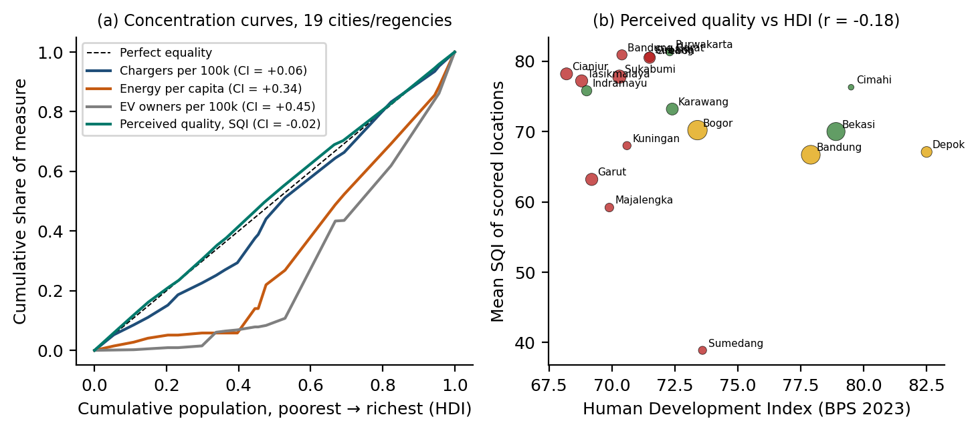
Figure 2. (a) Concentration curves against HDI rank for four measures across 19 city and regency groups, with concentration indices. (b) Mean SQI of scored locations against HDI; bubble size is population, colour is provincial income tier.
Figure 2(a) reports the vertical-equity result. Chargers per 100,000 residents are distributed almost neutrally across the HDI gradient (CI = +0.06): the public network, dominated by PLN office sites in every regency, has put hardware roughly where people are. Use is another matter. Energy per capita concentrates strongly among more affluent areas (CI = +0.34) and EV ownership more strongly still (CI = +0.45). The horizontal Gini tells the same story: units against population 0.19, energy against population 0.45. The network is equal in presence and unequal in use, because the cars are unequal.
The chapter's central hypothesis was that a quality gradient would sit on top of this use gradient: that less advantaged areas would receive not only fewer users but worse-performing chargers, so that deprivation compounds. The data do not support it. The concentration index of SQI is -0.02, indistinguishable from zero, and Figure 2(b) shows no relationship between a regency's HDI and the quality its stations receive (r = -0.18, n = 18). Among West Java's scored locations, mean SQI is 72 in low-income regencies, 68 in medium and 71 in high. Sumedang, at 40, is an outlier on a single location. The reliability and availability problems that dominate Table 1 are not a peripheral problem; they are a network problem, as likely to be reported in Bekasi as in Garut.
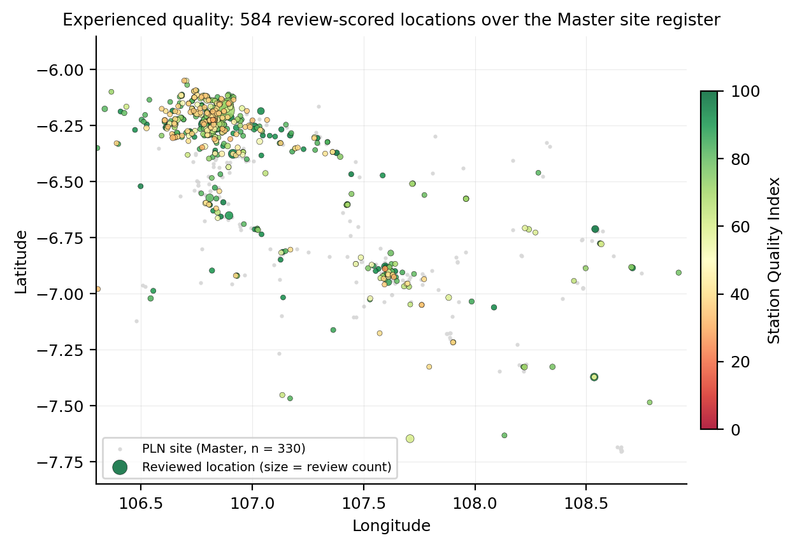
Figure 3. The 584 review-scored locations coloured by SQI and sized by review count, over the PLN Master site register (grey). Low-SQI locations are scattered through the Jakarta belt and Greater Bandung rather than confined to the periphery.
Figure 3 makes the point spatially. Red, low-SQI locations sit inside the Jakarta commuter belt and the Bandung basin among green ones; the periphery has few scored locations of either colour. That last observation is the pivot to the second half of the chapter.

4.3 Whom the surface hears
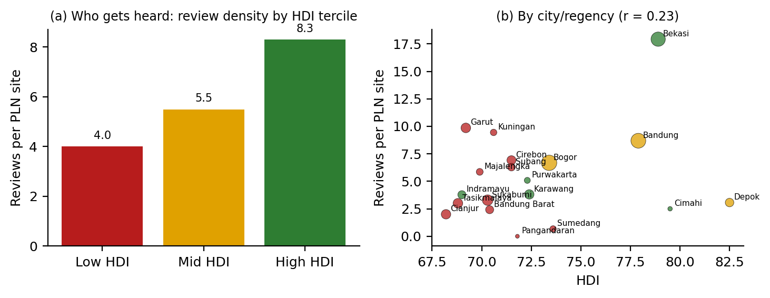
Figure 4. Review density relative to the public network. (a) Reviews per PLN site by HDI tercile of the city or regency. (b) Reviews per PLN site by city and regency against HDI; bubble size is population, colour is income tier.
Figure 4 is the coverage audit. PLN sites in the highest-HDI tercile of cities and regencies attract 8.3 reviews each; sites in the middle tercile 5.5; sites in the lowest 4.0. Scored locations per PLN site are 0.82, 0.77 and 0.38 respectively: in the poorest third of the province fewer than two in five public sites generate enough reviews to be assessed at all. Bekasi, the richest large regency, produces 18 reviews per site; Sumedang produces 0.7 and Pangandaran none. The surface is loudest where the cars are.
This reframes the flat quality gradient of Section 4.2. It is a real finding, but it is measured on 36 scored locations in the low-HDI tercile against 143 in the high tercile, and the low-tercile locations that reach the scoring threshold are, by construction, the ones that attract enough traffic to be reviewed. If the worst charger in a poor regency is one nobody uses because it has never worked, it has no reviews, no SQI and no place in Figure 2. The participation surface cannot see the failure it would most need to report.

5. Discussion

5.1 A two-dimensional equity framework
The results support separating charging equity into two dimensions that behave differently. Access, measured by hardware per capita, is close to neutral in West Java; use, measured by energy and ownership, is strongly pro-rich; experienced quality, measured by review sentiment, shows no gradient. A one-dimensional assessment based on counting would conclude that the network is equitable. A one-dimensional assessment based on energy would conclude that it is not. Both are right about their dimension and wrong about the network. The framework proposed here reports access and experience side by side, because a planning response differs by quadrant: where access is low, build; where access is adequate and experience poor, maintain; where both are adequate and use is low, the constraint is the car, not the charger, and charging policy cannot fix it.

5.2 What the machine can read and what it cannot
LLM-based ABSA is a real advance. It converts an unstructured corpus into a consistent, aspect-level measure of infrastructure performance that no operator in Indonesia currently produces and no regulator requires, and it does so at a marginal cost close to zero. Table 1 is actionable: it tells a utility that its reputation is made by reliability and availability, and that the most-praised aspect, facilities, buys the least. The method should be used. But Figure 4 shows the condition under which it should be used. The corpus is a census of the people who already have EVs, smartphones and accounts, weighted by their propensity to write, and its spatial distribution follows theirs. Haklay's (2013) warning about the delusion of democratisation applies with full force: the platform looks like a public and is a customer base. Treating its sentiment as consultation would let the loudest third of the province set the maintenance priorities of the whole.

5.3 Implications for participation in the era of AI
CUPUM's call notes that large language models increasingly mediate how residents interact with government. This chapter offers a concrete case of what that mediation does when it is passive rather than elicited. Arnstein's (1969) ladder distinguished participation from its appearance; scraped sentiment sits on the lower rungs, informing without conferring any power, and the coverage audit shows that even the informing is partial. Three practices follow. First, publish the coverage audit alongside any sentiment-derived indicator, so that the population it represents is visible. Second, treat gaps in the surface as findings, not as missing data: a public site with no reviews in a low-income regency is a site to inspect, not a site to drop from the sample. Third, use the machine-read corpus to target elicited participation, in the softGIS tradition (Kyttä et al., 2013; Brown and Kyttä, 2014), at precisely the places and populations it cannot hear. The model is a good listener with a bad microphone; the fix is the microphone.

5.4 Limitations
The review corpus is drawn from a single mapping platform and its threshold for scoring excludes low-traffic locations by design. Aspect coding by an LLM was validated on a sample but not against an independent human panel at scale. The socio-economic analysis uses 19 city and regency groups, a coarse spatial unit that hides within-regency inequality, and HDI as a single status ranking. PLN-only site counts in the denominator of the coverage audit understate the private network in affluent areas, which would make the class skew larger, not smaller. The flat quality gradient is a null result on limited low-HDI data and should be read as absence of evidence rather than evidence of absence.

6. Conclusion
Counting chargers measures presence; reading reviews measures experience; neither alone measures equity. In West Java the hardware is spread almost neutrally, the use is strongly pro-rich, and the experienced quality, where it can be measured, is the same poor-to-good mixture everywhere, dominated by whether the charger works and is free. That is worth knowing and could not have been known without a machine that reads. But the machine reads a corpus that the affluent write, at twice the density, and the poorest third of the province's public sites are mostly silent within it. A two-dimensional equity framework that reports access and experience together, and a coverage audit that reports who was heard, are the minimum conditions under which LLM-derived sentiment can inform infrastructure planning without becoming one more way in which those who already have the most also have the loudest say.

References
Arnstein, S.R. (1969) 'A ladder of citizen participation', Journal of the American Institute of Planners, 35(4), pp. 216–224.
Asensio, O.I., Alvarez, K., Dror, A., Wenzel, E., Hollauer, C. and Ha, S. (2020) 'Real-time data from mobile platforms to evaluate sustainable transportation infrastructure', Nature Sustainability, 3(6), pp. 463–471.
Brown, G. and Kyttä, M. (2014) 'Key issues and research priorities for public participation GIS (PPGIS): A synthesis based on empirical research', Applied Geography, 46, pp. 122–136.
Delbosc, A. and Currie, G. (2011) 'Using Lorenz curves to assess public transport equity', Journal of Transport Geography, 19(6), pp. 1252–1259.
Falchetta, G. and Noussan, M. (2021) 'Electric vehicle charging network in Europe: An accessibility and deployment trends analysis', Transportation Research Part D, 94, 102813.
Ha, S., Marchetto, D.J., Dharur, S. and Asensio, O.I. (2021) 'Topic classification of electric vehicle consumer experiences with transformer-based deep learning', Patterns, 2(2), 100195.
Haklay, M. (2013) 'Neogeography and the delusion of democratisation', Environment and Planning A, 45(1), pp. 55–69.
Hecht, B. and Stephens, M. (2014) 'A tale of cities: Urban biases in volunteered geographic information', Proceedings of the 8th International AAAI Conference on Weblogs and Social Media, pp. 197–205.
Hsu, C.-W. and Fingerman, K. (2021) 'Public electric vehicle charger access disparities across race and income in California', Transport Policy, 100, pp. 59–67.
Ilieva, R.T. and McPhearson, T. (2018) 'Social-media data for urban sustainability', Nature Sustainability, 1(10), pp. 553–565.
Kyttä, M., Broberg, A., Tzoulas, T. and Snabb, K. (2013) 'Towards contextually sensitive urban densification: Location-based softGIS knowledge revealing perceived residential environmental quality', Landscape and Urban Planning, 113, pp. 30–46.
Kyttä, M., Kahila, M. and Broberg, A. (2011) 'Perceived environmental quality as an input to urban infill policy-making', Urban Design International, 16(1), pp. 19–35.
Lou, J., Shen, X., Niemeier, D.A. and Hultman, N. (2024) 'Income and racial disparity in household publicly available electric vehicle infrastructure accessibility', Nature Communications, 15, 5106.
Martens, K. (2017) Transport Justice: Designing Fair Transportation Systems. New York: Routledge.
O'Donnell, O., van Doorslaer, E., Wagstaff, A. and Lindelow, M. (2008) Analyzing Health Equity Using Household Survey Data. Washington, DC: World Bank.
Pereira, R.H.M., Schwanen, T. and Banister, D. (2017) 'Distributive justice and equity in transportation', Transport Reviews, 37(2), pp. 170–191.
Roy, A. and Law, M. (2022) 'Examining spatial disparities in electric vehicle charging station placements using machine learning', Sustainable Cities and Society, 83, 103978.
Wagstaff, A., Paci, P. and van Doorslaer, E. (1991) 'On the measurement of inequalities in health', Social Science & Medicine, 33(5), pp. 545–557.

Length statement: 2,854 words of text, 4 figures and 1 tables counted at 250 words each (1,250), and 408 words of references — 4,512 words against the 4,000–6,000 word limit. Abbreviated abstract: 228 words.

