CAPTIVE GENERATION AND THE VERIFICATION-INCENTIVE INVERSION: SPATIALLY DIFFERENTIATED GRID EMISSION FACTORS AND CBAM EXPOSURE OF INDONESIA'S EXPORT INDUSTRY
Haramaini, Q.¹
¹Monash University Indonesia, Jakarta, Indonesia
qashtalani.haramaini@monash.edu
ABSTRACT
The EU Carbon Border Adjustment Mechanism (CBAM) entered its definitive regime on 1 January 2026, pricing the indirect emissions embedded in electricity used to produce imported aluminium, steel, cement and fertilisers. Exporters may either accept a country-level default value or verify an installation-specific actual value. This study shows that where national carbon intensity is spatially bimodal, that binary choice inverts the incentive it was designed to create. We compile a georeferenced inventory of 526 generating units (95.4 GW) and 933 transmission substations across Indonesia's eight interconnected systems, separate grid-connected from captive industrial self-generation using an auditable registry, and estimate zonal emission factors with Monte Carlo uncertainty propagation. Captive units hold 17.7 % of capacity but 27.6 % of generation-side CO2. Including them raises the Sulawesi emission factor by 38 %, Papua by 40 % and Maluku by 27 %, while leaving Java–Bali unchanged; provincial factors span a 3.1-fold range. At EUR 75.36/tCO2 the indirect charge on unwrought aluminium varies by EUR 324 per tonne between zones. Producers in five of eight zones, covering the entire nickel-processing captive belt, would pay more by verifying than by accepting the default.
Keywords: carbon border adjustment mechanism; grid emission factor; captive power; embedded emissions; Indonesia
1. INTRODUCTION
The European Union's Carbon Border Adjustment Mechanism (CBAM) completed its reporting-only transitional phase on 31 December 2025 and entered its definitive regime on 1 January 2026. Importers of cement, iron and steel, aluminium, fertilisers, hydrogen and electricity above a 50-tonne annual threshold must now hold authorised declarant status and surrender certificates against the verified embedded emissions of their goods (European Union, 2023). The European Commission published the first quarterly certificate price on 7 April 2026 at EUR 75.36 per tonne of CO2.
Embedded emissions under CBAM comprise direct process emissions and indirect emissions from electricity consumed in production (European Commission, 2025a). For electro-intensive goods the indirect term dominates: primary aluminium consumes roughly 14 MWh per tonne of metal, so the carbon intensity of the electricity supply, rather than the smelter process, sets the liability. A national inventory statistic has therefore become a determinant of trade competitiveness.
Indonesia is exposed on two fronts. Its CBAM-covered export basket is growing, and the electricity supplying that industry has an unusual structure. A rapidly expanding fleet of captive coal plants, built inside industrial parks and connected to no public grid, now supplies most of the electricity consumed by the metal-processing export sector. Operating captive capacity reached 25.9 GW in 2024, over three quarters coal-fired, with Sulawesi (10.5 GW) and Maluku (4.5 GW) the largest concentrations (JETP Indonesia Secretariat, 2025), emitting an estimated 131 MtCO2, roughly 37 % of power-sector emissions (IESR, 2026). Coal-powered Indonesian nickel producers report 57–70 tCO2 per tonne of nickel against 28.7 for the single producer supplied by its own hydroelectric cascade (Peh, 2024).
Carbon accounting practice does not see this fleet. Indonesian emission factors are published per interconnected system by the Ministry of Energy and Mineral Resources (MEMR, 2021) and derive from the dispatch of utilities and independent power producers serving the public grid; off-grid self-generation lies outside the boundary. The same fleet sits outside the intensity-based emissions trading scheme applied to grid-connected coal plants (Climate Action Tracker, 2026), so no domestic carbon price attaches to it and none can be deducted from a CBAM liability.
Three literatures bear on this problem and none closes it. Work on electricity emission factors is methodologically mature but has been applied to systems with complete metered dispatch and no significant off-grid segment (Ryan et al., 2016; Tranberg et al., 2019). Assessments of border carbon adjustment incidence use computable general equilibrium models resolved at country and sector level, treating national emission intensity as an exogenous scalar (Böhringer et al., 2022; Perdana & Vielle, 2022). Studies of Indonesian captive coal document its growth but stop at description. This study connects them, and asks whether a country-level default value can function as intended when the underlying distribution of carbon intensity is bimodal. The question is regionally relevant: captive industrial power is expanding across several ASEAN member states, and the answer bears directly on how APAEC 2026–2030 should treat sub-national energy data.
2. METHODOLOGY
2.1 Data and Captive Classification
The dataset covers Indonesia's eight interconnected systems (Jamali, Sumatra, Kalimantan, Sulawesi, Maluku, NTB, NTT, Papua) in three georeferenced layers: 933 transmission substations with coordinates, voltage class, transformer count, capacity in MVA and province, extracted from the supply-side tables of the 2025–2034 electricity supply business plan (PLN, 2025) and matched to OpenStreetMap geometry by fuzzy name matching; 526 operating generating units with coordinates, technology class, installed capacity, province and operator, obtained by Overpass extraction from OpenStreetMap and cross-checked against the same plan;. Fifty-six small units lacking a capacity attribute are imputed at the median of their technology class within their system and contribute under 1 % of national capacity.
No source attribute marks self-generation, so units are classified through an explicit registry: a unit is captive if its name or operator tag identifies an industrial host (smelter, alumina refinery, pulp and paper mill, cement plant, chemical works, mine) or a dedicated industrial-estate licensee. The registry is conservative, capturing 17.0 GW against the 25.9 GW reported for 2024, so the biases reported below are lower bounds, and it is technology-neutral, admitting the 365 MW Larona–Balambano–Karebbe hydroelectric cascade operated by a nickel producer.
2.2 Zonal Emission Factor Estimator
For a zone z under accounting boundary b (grid, captive, or system-wide), the emission factor is the generation-weighted mean of technology emission factors, where each unit contributes installed capacity multiplied by its capacity factor, 8760 hours, and its operating emission factor. Capacity factors and emission factors are treated as random variables with triangular distributions, and the estimator is evaluated over 20,000 Monte Carlo draws, giving a mean and a 5th–95th percentile interval for every zone and boundary. Emission factors combine IPCC default fuel factors with representative net thermal efficiencies for the Indonesian fleet (IPCC, 2006). Captive units receive a separate, higher capacity-factor distribution, since a plant sized to a continuous metallurgical load runs at a higher duty cycle than one dispatched against a diurnal demand curve.
2.3 CBAM Exposure and Verification Incentive
The indirect liability for a CBAM good is its specific electricity consumption multiplied by the zonal emission factor and the certificate price, taken as EUR 75.36. An installation reports actual values only if doing so lowers its liability, that is if its specific consumption times its zonal emission factor is below the country default value carrying the applicable mark-up. Default values are set above the producer-country average and carry mark-ups of 10 % in 2026, 20 % in 2027 and 30 % from 2028 (European Commission, 2025b). The mark-up is the instrument by which the Regulation intends to make verification worthwhile. We evaluate the condition with the default set equal to the national system-wide factor estimated here, which is the assumption most favourable to that logic.
3. RESULT AND DISCUSSION
3.1 Spatial Structure of the Fleet
The inventory covers 95.4 GW across 526 units. Figure 1 shows two structural features. Grid generation concentrates along the Java–Bali corridor and the Sumatran spine, co-located with dense substation coverage. Captive units appear as isolated points of very large unit capacity in eastern Indonesia, in locations with almost no surrounding substation infrastructure, which is the spatial signature of an industrial enclave supplying itself. Captive capacity totals 17.0 GW, or 17.7 % of mapped capacity, but 22.2 % of estimated generation and 27.6 % of estimated CO2. Four units, Weda Bay (4.0 GW), Labota (3.4 GW), IMIP Morowali (2.1 GW) and Delong Nickel Phase II (1.8 GW), account for 66 % of captive capacity and all serve nickel processing.
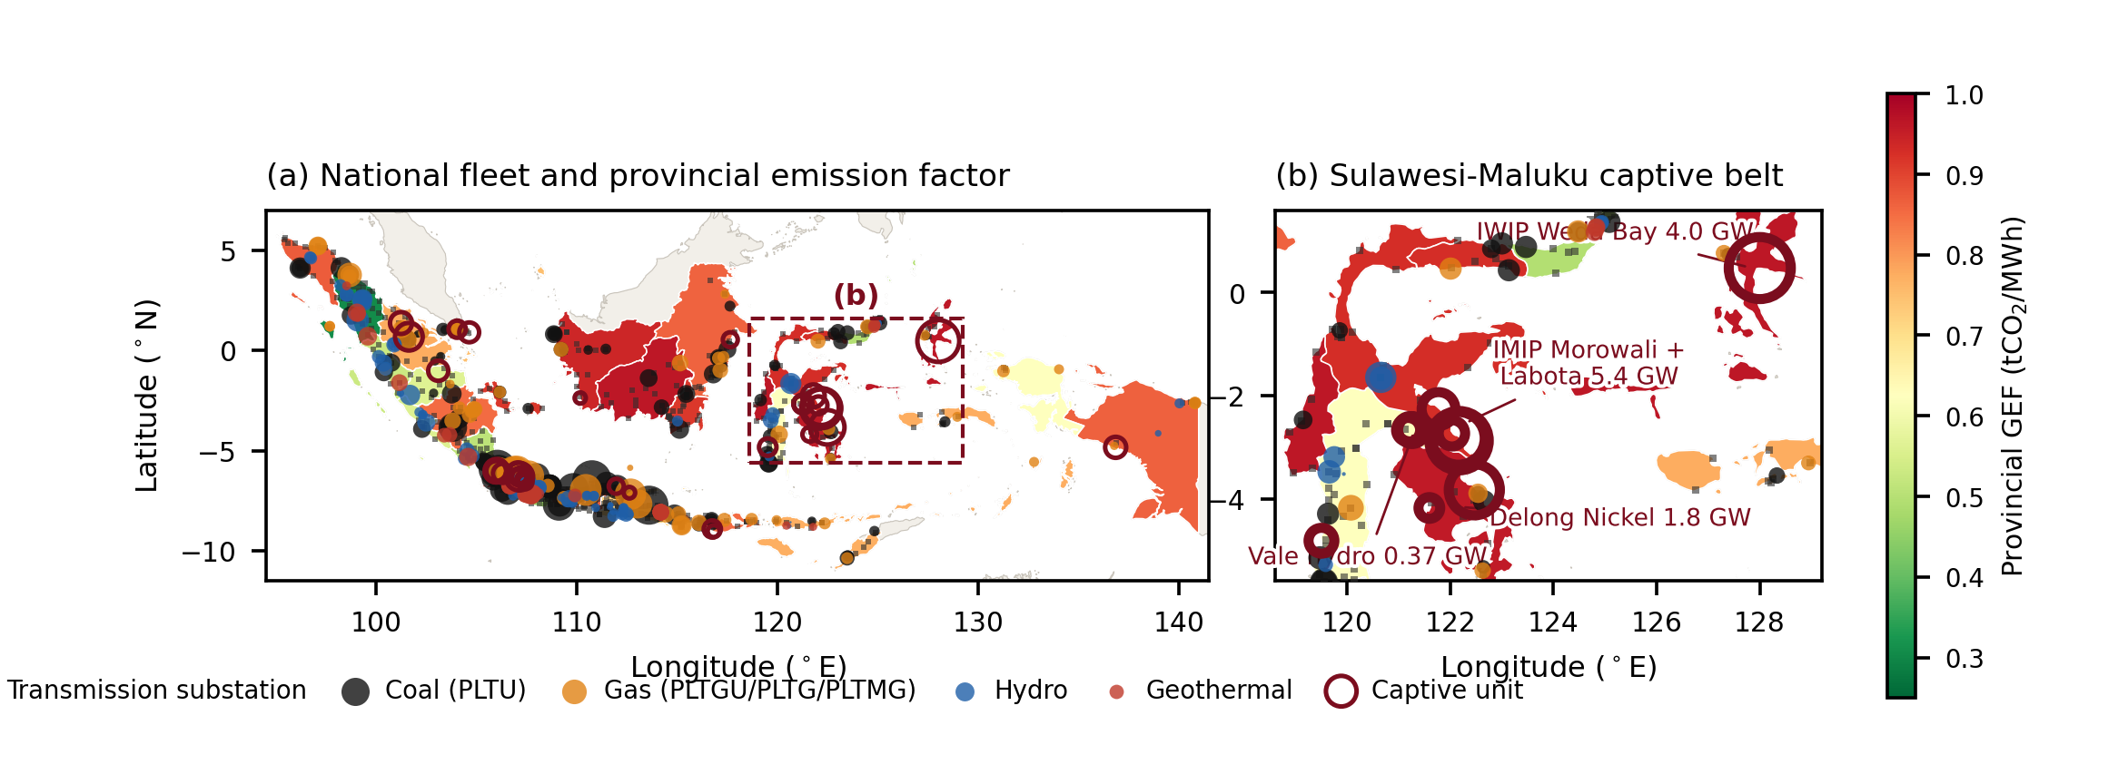
Figure 1. Generation fleet, transmission substations and estimated provincial emission factors. Panel (b) enlarges the Sulawesi–Maluku captive belt.
Source: author's analysis; base layers Natural Earth 1:10 m
3.2 Zonal Emission Factors
Table 1 reports the central result. Under the grid-only boundary the eight systems span 0.60–0.90 tCO2/MWh; under the system-wide boundary they span 0.66–0.96. The change is highly uneven. Jamali, Kalimantan and NTT move by under one percent because their captive fleets are small relative to a large public grid. Sulawesi rises by 38 %, Papua by 40 % and Maluku by 27 %.
Table 1. Zonal Grid Emission Factors by Accounting Boundary (tCO₂/MWh)
System | Grid only | System-wide | 90 % CI | Δ (%) | Captive share of generation (%)
Jamali | 0.693 | 0.694 | 0.679–0.711 | +0.3 | 5.3
Sumatra | 0.618 | 0.656 | 0.641–0.671 | +6.1 | 12.5
Kalimantan | 0.898 | 0.900 | 0.880–0.920 | +0.3 | 3.5
Sulawesi | 0.639 | 0.885 | 0.849–0.923 | +38.4 | 80.2
Maluku | 0.756 | 0.962 | 0.881–1.052 | +27.4 | 98.0
NTB | 0.828 | 0.853 | 0.819–0.887 | +3.0 | 26.0
NTT | 0.775 | 0.775 | 0.739–0.814 | 0.0 | 0.0
Papua | 0.595 | 0.831 | 0.778–0.889 | +39.6 | 63.4
National | 0.688 | 0.738 | 0.726–0.751 | +7.3 | 22.2
Source: author's analysis
The mechanism is visible in the energy shares. In Maluku, captive units supply an estimated 98.0 % of system generation; in Sulawesi 80.2 %; in Papua 63.4 %. In these zones the public grid is not the dominant electricity system, and a factor derived from it describes a minority of the electrons actually consumed. Sulawesi is the sharpest case: its public grid, carrying substantial hydro and geothermal, is among the cleanest in Indonesia at 0.64 tCO2/MWh, while the zone as a whole is among the dirtiest at 0.89. Resolving to province widens the spread to a factor of 3.1, from 0.31 tCO2/MWh in North Sumatra to 0.96 in North Maluku. At national level the boundary choice moves the factor from 0.688 to 0.738, an increase of 7.3 %. That the aggregate effect is modest is precisely why the distributional effect escapes national reporting.
3.3 CBAM Exposure and the Verification-Incentive Inversion
For unwrought aluminium the indirect charge ranges from EUR 692 per tonne in Sumatra to EUR 1015 in Maluku at the central certificate price, a spread of EUR 324 per tonne attributable solely to the location of the electricity supply. Within Sulawesi alone the boundary choice alone is worth EUR 259 per tonne.
Table 2 and Figure 2 evaluate the verification condition. Setting the default equal to the national system-wide factor with the 2026 mark-up gives a default liability of EUR 857 per tonne. Five of eight zones carry actual liabilities above that threshold, so an installation in any of them lowers its CBAM bill by declining to verify: the saving is EUR 158 per tonne in Maluku, EUR 92 in Kalimantan and EUR 76 in Sulawesi. Producers in Sumatra, Jamali and NTT face the opposite position and gain EUR 165, EUR 124 and EUR 40 per tonne respectively by verifying.
Table 2. Verification Incentive for Unwrought Aluminium at EUR 75.36/tCO₂ and the 2026 Mark-up
Zone | Zonal GEF (tCO2/MWh) | Actual liability (EUR/t) | Gain from verifying (EUR/t) | Verification rational?
Sumatra | 0.656 | 692 | +165 | Yes
Jamali | 0.694 | 733 | +124 | Yes
NTT | 0.775 | 817 | +40 | Yes
Papua | 0.831 | 877 | −20 | No
NTB | 0.853 | 900 | −43 | No
Sulawesi | 0.885 | 933 | −76 | No
Kalimantan | 0.900 | 949 | −92 | No
Maluku | 0.962 | 1015 | −158 | No
Source: author's analysis
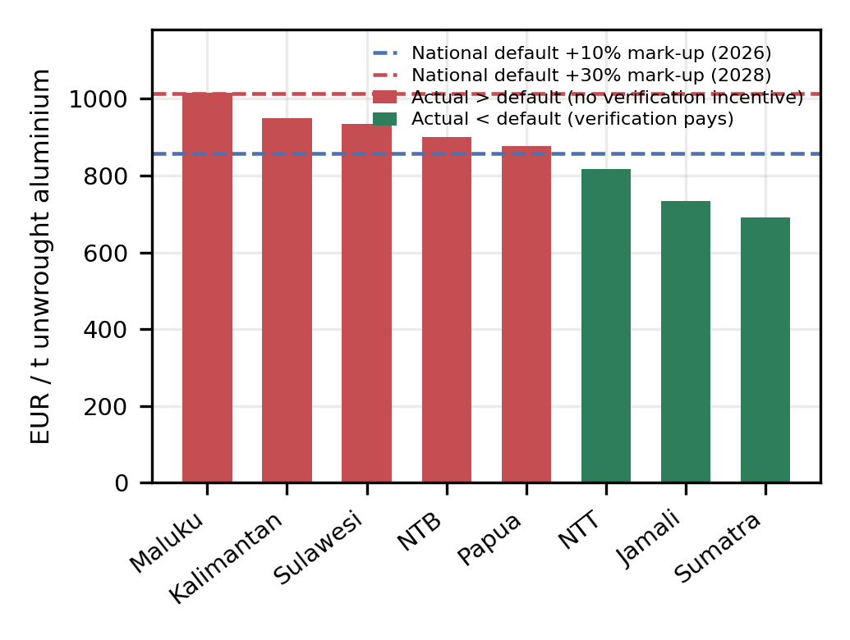
Figure 2. Verification incentive for unwrought aluminium. Bars give actual liability under zonal factors; dashed lines give the national default carrying the 2026 and 2028 mark-ups.
Source: author's analysis
Raising the mark-up to its 2028 level of 30 % moves the threshold to EUR 1015 per tonne, lifting every zone except Maluku above the break-even line. The phase-in therefore does eventually restore the intended incentive, but only after the affected zones have had three compliance years in which the cheapest strategy was opacity.
The result is not an artefact of the modelled default. It follows from the shape of the distribution. A default constructed as a country average plus a mark-up separates cleanly into verifying and non-verifying populations only if the underlying distribution is unimodal and the mark-up exceeds its upper dispersion. The Indonesian distribution is bimodal, with a grid mode near 0.62–0.69 and a captive-coal mode near 0.95, and the gap between the modes is 45 % of the lower one, larger than any mark-up scheduled before 2028. Under those conditions the country default functions as a transfer to the high-intensity mode financed by the low-intensity mode, and the transparency incentive operates in reverse precisely where transparency matters most.
3.4 Policy Implications
Three implications follow. First, aggregation is a trade cost: an exporter in Central Sulawesi asserting the national factor asserts a number 29 % below its own supply, while producers in North Sumatra are penalised by a national average more than twice their actual intensity. Second, emissions excluded from the domestic scheme are undeductible: the 27.6 % of power-sector CO2 attributed to captive units attracts no domestic carbon price and therefore generates no CBAM deduction. Extending allowance allocation to captive plants under the framework introduced by Presidential Regulation 110/2025 would convert part of that flow into domestic revenue while creating the abatement signal the current design lacks. Third, the provincial results suggest a siting strategy: North Sumatra, Jakarta, West Java, North Sulawesi and Lampung all sit below 0.51 tCO2/MWh and are served by dense substation infrastructure, so locating new electro-intensive export capacity on these nodes rather than replicating the captive-coal enclave model would cut CBAM exposure by EUR 300–500 per tonne of aluminium before any abatement investment.
4. CONCLUSION AND OUTLOOK
Indonesia's electricity emission factor is spatially heterogeneous to a degree that national reporting conceals. Including industrial self-generation raises the factor by 38 % in Sulawesi, 40 % in Papua and 27 % in Maluku while leaving Java–Bali unchanged, and provincial factors span a 3.1-fold range. Under the CBAM definitive regime this heterogeneity is priced, varying the indirect liability on unwrought aluminium by EUR 324 per tonne between the cleanest and dirtiest zone.
The central finding concerns incentives rather than levels. Because the distribution is bimodal and the gap between its modes exceeds the scheduled mark-up, a country-level default makes verification unprofitable for producers in the five zones hosting the captive-coal fleet, while penalising the cleanest producers by up to EUR 165 per tonne. Combined with the exclusion of captive plants from the domestic trading scheme, the most carbon-intensive segment of Indonesia's export industry faces the weakest transparency incentive and the smallest relative cost.
Three research questions follow. How closely do capacity-based zonal factors track metered dispatch, and can the estimator be calibrated against officially published system factors? Does the inversion identified here also arise in other ASEAN member states with significant captive industrial power, which would make sub-national emission factors a regional rather than a national priority under APAEC 2026–2030? And at what spatial resolution, substation cluster or province, does an MRV-grade factor become both defensible to a CBAM verifier and administratively feasible for the national registry?
ACKNOWLEDGEMENT
The dataset, the captive classification registry and the analysis code reproducing every table and figure are openly available.
REFERENCES
Böhringer, C., Fischer, C., Rosendahl, K. E., & Rutherford, T. F. (2022). Potential impacts and challenges of border carbon adjustments. Nature Climate Change, 12, 22–29.
Climate Action Tracker. (2026). Indonesia: Policies and action. Climate Analytics & NewClimate Institute.
European Commission. (2025a). Commission Implementing Regulation (EU) 2025/2547 on the methods for the calculation of emissions embedded in goods. Official Journal of the European Union.
European Commission. (2025b). Commission Implementing Regulation (EU) 2025/2621 on default values for the determination of embedded emissions. Official Journal of the European Union. (Corrected by Implementing Regulation (EU) 2026/1740.)
European Union. (2023). Regulation (EU) 2023/956 establishing a carbon border adjustment mechanism. Official Journal of the European Union, L 130, 52–104.
Institute for Essential Services Reform. (2026). Fact sheet: Captive power plants in Indonesia. IESR.
Intergovernmental Panel on Climate Change. (2006). 2006 IPCC guidelines for national greenhouse gas inventories, Volume 2: Energy. IGES.
JETP Indonesia Secretariat. (2025). Indonesia's industrial power landscape and green transition opportunities.
Ministry of Energy and Mineral Resources. (2021). Keputusan Menteri ESDM No. 163.K/HK.02/MEM.S/2021 tentang penetapan faktor emisi gas rumah kaca sistem ketenagalistrikan.
Peh, G. (2024). Indonesia's nickel companies: The need for renewable energy amid increasing production. Institute for Energy Economics and Financial Analysis.
Perdana, S., & Vielle, M. (2022). Making the EU carbon border adjustment mechanism acceptable and climate friendly for least developed countries. Energy Policy, 170, 113245.
PT PLN (Persero). (2025). Rencana Usaha Penyediaan Tenaga Listrik (RUPTL) 2025–2034.
Republic of Indonesia. (2025). Peraturan Presiden No. 110 Tahun 2025 tentang penyelenggaraan instrumen nilai ekonomi karbon dan pengendalian emisi gas rumah kaca nasional.
Ryan, N. A., Johnson, J. X., & Keoleian, G. A. (2016). Comparative assessment of models and methods to calculate grid electricity emissions. Environmental Science & Technology, 50(17), 8937–8953.
Tranberg, B., Corradi, O., Lajoie, B., Gibon, T., Staffell, I., & Andresen, G. B. (2019). Real-time carbon accounting method for the European electricity markets. Energy Strategy Reviews, 26, 100367.

