From Energy Forecast to Network Load: A Demand Modelling Methodology for EV Charging in Distribution Network Development Planning
Qashtalani HARAMAINI — Monash University, Indonesia / PT PLN (Persero) — qashtalani.haramaini@pln.co.id
Paper prepared for CIRED 2027, Session 5 — Planning of Power Distribution Systems (Demand and Generation Forecast)

ABSTRACT
Ex-ante models can now predict how much energy a public electric-vehicle charging site will sell before it is built. A distribution network development plan (DNDP), however, is not denominated in kilowatt-hours per month; it is denominated in kilowatts at a named transformer, at the hour the network peaks. This paper supplies the missing translation layer and demonstrates it on a full-scale utility dataset: 101,020 revenue-grade charging sessions from 328 public stations, joined to the measured loading of 41,128 distribution transformers across West Java, Indonesia.
Three results follow. First, public fast charging is not an off-peak load: reconstructed at 15-minute resolution, the aggregate charging curve retains 88–91% of its daily maximum throughout the 18:00–22:00 evening peak window, and 20.4% of monthly energy is delivered in those four hours against 16.7% under a flat profile. Second, the relationship between forecast energy and design peak is strongly sub-linear, P = 0.133·E^0.695 (R² = 0.810), so the nameplate-times-coincidence rule that dominates connection studies over-estimates 74% of sites and carries 1.7 times the error of an energy-based rule. Third, inverting the transfer function prices network headroom in the same unit as the demand forecast: the 41,128 transformers can host 452 GWh/month of charging in aggregate, roughly twenty times the 2030 provincial requirement, yet under a demand-led rollout 49% of the transformers that host charging today would exceed 100% loading, and the 13% of 2 km cells in deficit contain 46% of the forecast energy. Reallocating half of the increment under the statutory coverage obligation removes the violation entirely. Charging demand in this network is therefore not a capacity problem but an allocation problem, and the coverage mandate is a network-relief instrument rather than a network cost.

1. INTRODUCTION
Electromobility has become the fastest-moving line in most distribution demand forecasts, and Indonesia is a useful extreme case because the rollout is mandated rather than merely projected. Ministerial Decree Kepmen ESDM 24.K/TL.01/MEM.L/2025 raises the national public charging target from 5,810 units in 2025 to 62,918 units by 2030 and attaches a spatial equity obligation to the trajectory: for every five units built in the Jakarta metropolitan area, and for every twelve built elsewhere outside provincial capitals, one must be sited in a non-dense area. For the distribution system operator this is a planning input with an unusual property — the quantity of stations is fixed by statute, while their location, rating and connection point are not.
Two literatures address parts of the resulting problem and neither closes it. Siting studies rank candidate locations by weighted suitability layers or by flow capture, producing an ordinal score [1], [2], [3]. Demand-forecasting studies predict occupancy or load at stations that already exist, over horizons of hours to days [4], [5]. A recent companion study to this paper closes one gap by predicting, ex ante, the monthly energy a site will sell before it is built, calibrated against billed transactions [6]. What none of them produces is the object a DNDP consumes: a kilowatt value, attached to a specific medium- or low-voltage asset, at the hour that asset peaks.
The translation is not arithmetic. Between an energy forecast and a feeder loading forecast sit three quantities that must be measured rather than assumed: the shape of the charging load through the day, and specifically how much of it survives into the network peak window; the ratio between monthly energy and design peak at a single site, which is not constant across site sizes; and the diversity that accrues when several sites share a feeder or a supply substation. Planning practice fills these gaps with rules of thumb — nameplate rating multiplied by an assumed coincidence factor, an assumed load factor, an assumed off-peak profile. Each of these can be tested against measurement, and this paper tests all three.
The contributions are:
- A measured charging load profile at network scale, reconstructed from 101,020 sessions, showing that public charging in this network coincides almost fully with the evening distribution peak rather than avoiding it.
- An energy-to-peak transfer function estimated on 296 stations, with a sub-linear exponent that is inconsistent with constant-load-factor scaling, and a quantified comparison against the nameplate rule it is intended to replace.
- An empirical coincidence curve for aggregations of charging sites, usable directly at feeder and supply-substation level.
- Network headroom expressed in kilowatt-hours per month, obtained by inverting the transfer function over the measured loading of 41,128 distribution transformers. This puts capacity and demand in a common currency and makes the two directly comparable at any spatial resolution.
- A spatial scenario test to 2030 under the statutory trajectory, comparing a demand-led allocation with the coverage-obligated allocation, and reporting the network consequence of each.
Everything reported here is derived from data a vertically integrated utility already holds — a charge-point management system and a distribution transformer load register — with no vehicle trajectory data, no smart-meter feed and no proprietary mobility product.

2. STUDY AREA AND DATA
The study area is the service territory of PLN UID Jawa Barat, the densest electric-vehicle corridor in Indonesia, covering 25 regencies and cities. Three registers are used (Table 1).
The transaction layer comprises 101,020 charging sessions recorded at 330 public stations over 1–31 March 2026 by the charge-point management system, at revenue-grade metering accuracy — the same measurement chain used for billing. Aggregated to the station, the network delivered 2,258 MWh in the window at 22.37 kWh per session and a mean session duration of 53.8 minutes. Two stations lack usable coordinates and are excluded, leaving 328; stations with no transactions are retained at zero.
The network layer is the distribution transformer register for the same territory: 53,797 records, of which 41,128 carry a valid coordinate, a capacity between 5 and 3,000 kVA and a plausible loading measurement. Loading is recorded as the three-phase average current measured twice, once in the daytime off-peak window (LWBP, nominally 10:00–14:00) and once in the evening peak window (WBP, nominally 18:00–22:00), expressed against the transformer’s nominal current. Median measured loading is 28.3% by day and 44.2% at night; 11.8% of transformers exceed 80% at night and 3.0% exceed 100%. Installed distribution capacity totals 7,802 MVA. Each record also carries its feeder and supply substation identity, allowing results to be aggregated upward.
The station register supplies the connector configuration and nameplate rating of each charging site, used as the comparator for the transfer function.
Table 1. Data inputs.
Layer | Size | Role
Charging transactions | 101,020 sessions, 330 stations, 31 days | load profile, calibration target
Distribution transformer register | 41,128 units, 7,802 MVA, day and night loading | network capacity, connection screening
Charging station register | 636 units at 348 locations, rating and connectors | nameplate comparator
Feeder and supply substation identity | 2,574 feeders, 665 supply substations | upward aggregation

3. METHOD

3.1 Reconstructing the charging load
Each session carries a start timestamp, a duration and a delivered energy. Session power is taken as delivered energy over duration, capped at the charger’s nameplate rating to suppress metering and idle-time artefacts, and distributed over 15-minute bins from the start time with the final bin partially filled so that energy is conserved. This produces a 328 × 2,976 station–time matrix of average power for the month. The mean reconstructed session power is 34.5 kW and the median 30.2 kW, consistent with a network dominated by 60–200 kW direct-current equipment.
Two aggregation windows are then defined to match the measurement convention of the transformer register: the daytime window (10:00–14:00) and the evening window (18:00–22:00). For each station i we extract the absolute monthly maximum Pᵢ^own, the maximum within the evening window Pᵢ^WBP, and the mean within the evening window.

3.2 The energy-to-peak transfer function
A DNDP needs to convert a forecast quantity of energy into a design load. We estimate the relation directly in logarithms,
log Pᵢ = log a + b log Eᵢ + εᵢ (1)
where Eᵢ is monthly energy in kWh and Pᵢ is the relevant peak in kW, fitted on the 296 stations with more than 100 kWh in the month. Two variants are reported: P^own, the value a dedicated service transformer must carry, and P^WBP, the value that must be added to the host transformer’s measured evening loading. A third variant using the mean of the evening window gives the expected contribution appropriate for aggregation over many sites.
The competing convention is the nameplate rule, P = CF · Σ rated kW, which is compared on the same data by regressing log P^WBP on log nameplate, and by evaluating the fixed rule CF = 0.6 used in current connection practice.

3.3 Coincidence across sites
The coincidence factor of an aggregation of n sites is estimated empirically rather than assumed. For each n in a geometric ladder, 200 random subsets of stations are drawn, the group maximum within the evening window is divided by the sum of the members’ individual evening maxima, and the mean and standard deviation are recorded. The result is a diversity curve directly usable at feeder level (small n) and supply-substation level (large n).

3.4 Network headroom priced in kilowatt-hours
The transfer function is monotone and therefore invertible. For a transformer with capacity S and measured evening loading λ, the spare capacity to an 80% planning limit is
ΔS = max(0.8·S − λ·S, 0) (2)
and the quantity of monthly charging energy that spare capacity can host is
E^host = (ΔS / a)^(1/b) (3)
with a, b from the P^WBP fit. Equation (3) is the pivot of the paper. It converts every transformer in the register into an energy quantity denominated exactly like the output of the ex-ante demand model, so that supply and demand can be differenced at any spatial unit — transformer, 2 km cell, feeder, supply substation, or service area — without further conversion. The 80% limit is a conservative planning convention rather than a thermal limit; it can be relaxed with a loading-guide assessment where cyclic ratings apply.

3.5 Spatial allocation of the statutory trajectory
The 2030 forecast is anchored on the statutory unit trajectory, a factor of 10.83 between the 2025 and 2030 targets, applied to observed provincial charging energy to give 24.4 GWh/month. Two allocations of the same total are compared.
Demand-led. The increment is distributed in proportion to observed station energy, i.e. growth occurs where charging already happens. This is the allocation that an unconstrained commercial rollout, or a siting model optimised on predicted sales alone, would produce.
Coverage-led. Half the increment is distributed as above and half is spread over transformers in areas with no charging today, weighted by their available headroom. This approximates the spatial effect of the equity clause of the decree.
For each allocation, site energy is converted to evening-window load by (1), added to the host transformer’s measured evening loading, and the resulting loading distribution is reported. Each station is assigned to its nearest transformer as a proxy for the connection point; the median station-to-transformer distance is 121 m and the 90th percentile 828 m, so the proxy is tight in the urban core and looser along corridors.

4. RESULTS

4.1 Public charging is not an off-peak load
Figure 1 (left) gives the aggregate charging curve averaged over the 31 days. It peaks at 15:00, but the more consequential feature is its flatness: the curve holds 87.5–91.1% of its daily maximum right through the 18:00–22:00 evening window, and 20.4% of monthly energy is delivered in those four hours, against 16.7% under a flat profile. At station level the same conclusion holds individually: the median station’s maximum inside the evening window is 0.93 of its absolute monthly maximum (interquartile range 0.79–1.00). The absolute network maximum of 8.26 MW occurred at 17:15 on 22 March.
This matters because the distribution network in this territory is evening-peaking. Figure 1 (right) contrasts the measured daytime and evening loading of the 41,128 transformers: the daytime distribution is concentrated below 40%, the evening distribution is shifted up by roughly 16 percentage points at the median, and the population above the 80% planning limit is almost entirely an evening phenomenon. Public charging therefore lands on the constrained window, not the spare one. A planning assumption that public fast charging is a daytime load — common in studies transferred from residential charging, where the coincidence with the evening peak is the classic concern — inverts the actual risk in this network: here the daytime component is real, but it does not reduce the evening contribution.
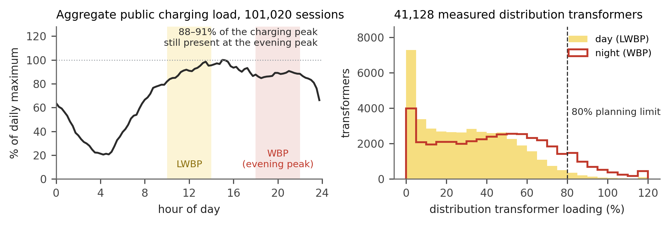
Figure 1. Left: aggregate public charging load over 101,020 sessions, averaged over 31 days and normalised to its daily maximum; the shaded bands are the daytime and evening windows in which distribution transformer loading is measured. The curve retains 88-91% of its maximum through the evening window. Right: measured day and night loading of 41,128 distribution transformers; the population above the 80% planning limit is almost entirely an evening phenomenon.

4.2 The transfer function, and why nameplate rules mis-size connections
Figure 2 shows the fitted relation between monthly energy and evening-window peak across four orders of magnitude of station size. The design-peak fit is
P^WBP = 0.133 · E^0.695 (R² = 0.810)
and the own-peak fit P^own = 0.258 · E^0.633 (R² = 0.829). The expected contribution over the evening window is essentially linear in energy, P = 0.0011 · E^1.041 (R² = 0.956), which is the appropriate quantity when many sites are aggregated.
The exponent is the substantive result. It is far below unity, so peak does not scale with energy: a site selling ten times more energy needs only about five times the connection capacity. The mechanism is legible — high-energy sites are busy for more of the day, so their load factor is better. Median load factor rises from about 0.04 in the lowest-selling quartile to 0.14 at highway rest areas, the highest-energy category. A constant-load-factor assumption, which is implicit whenever a planner scales peak linearly with forecast energy, therefore over-sizes large connections and under-sizes small ones simultaneously.
Table 2 compares the candidate rules on the same 296 stations. The nameplate regression explains 70.8% of variance in evening peak with a root-mean-square error of 64.4 kW; the energy transfer function reaches 81.0% at 38.5 kW, a 40% reduction in error. Using both inputs — the equipment the developer proposes and the energy the demand model forecasts — gives P^WBP = 0.126 · N^0.403 · E^0.484 with R² = 0.855 and RMSE 25.8 kW, and is the form we recommend for connection screening, since both inputs are available at application. The fixed rule CF = 0.6 applied to nameplate over-estimates the evening peak at 74% of sites, with a mean absolute error of 43.6 kW — an error large enough, at typical Indonesian distribution transformer sizes, to trigger unnecessary reinforcement at a majority of connection points.
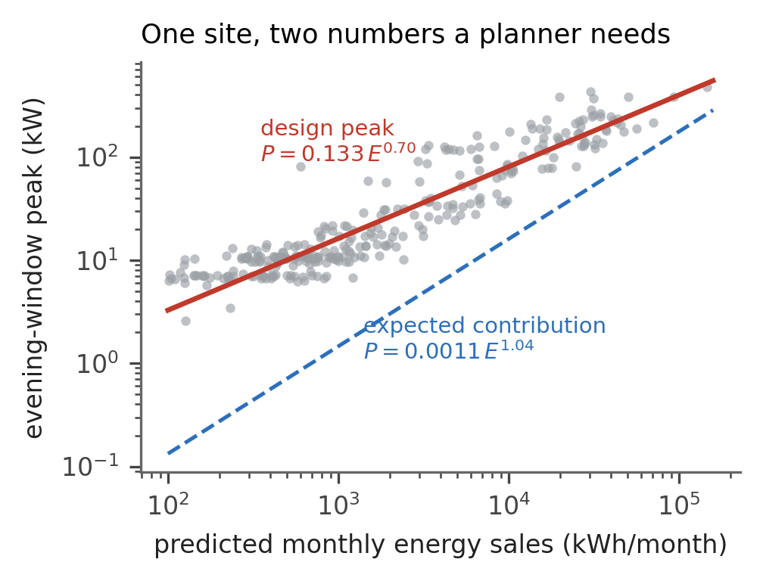
Figure 2. Energy-to-peak transfer function, 296 stations. The solid line is the design peak used to size a connection; the dashed line is the expected contribution used when many sites are aggregated. Both axes are logarithmic.
Table 2. Predicting the evening-window peak of a charging site (n = 296).
Rule | Inputs | R² | RMSE (kW)
Nameplate regression | Σ rated kW | 0.708 | 64.4
Energy transfer function | forecast kWh/month | 0.810 | 38.5
Combined (recommended) | both | 0.855 | 25.8
Fixed rule, CF = 0.6 | Σ rated kW | — | 43.6 (MAE)

4.3 Diversity is exhausted early
Figure 3 gives the measured coincidence curve. Two sites on a common feeder already coincide at 0.84, five at 0.72, twelve at 0.61, and the curve flattens near 0.45 beyond about fifty sites. The planning default of 0.6 is therefore approximately correct only in a narrow band around a dozen aggregated sites; it is optimistic for the two-to-five-site case that dominates real feeders, and pessimistic at supply-substation scale. The flatness is a direct consequence of the profile result in §4.1 — loads that are individually flat and simultaneously present do not diversify. Charging sites behave, for planning purposes, more like industrial process load than like residential load.
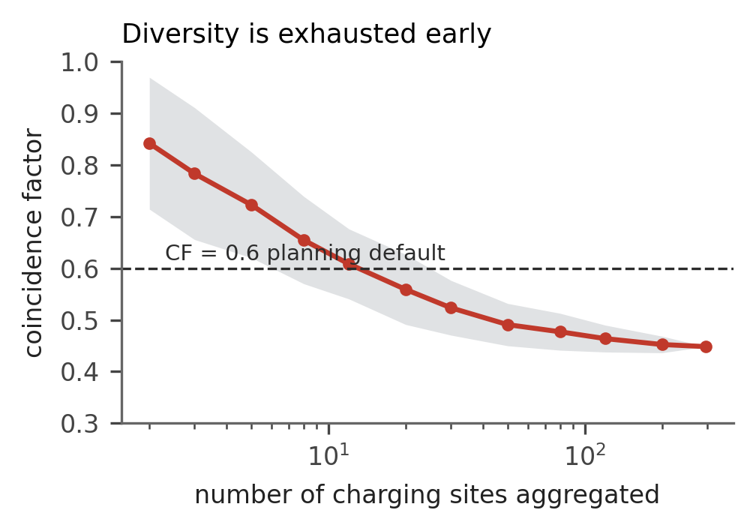
Figure 3. Measured coincidence factor against the number of aggregated charging sites, evening window; shaded band is one standard deviation over 200 random subsets. The 0.6 planning default holds only near a dozen sites.

4.4 Headroom, priced in the same unit as demand
Applying (2) and (3) to the register gives 2,902 MVA of evening headroom to the 80% limit, equivalent to 452 GWh/month of hostable charging energy. Set against the 2030 provincial requirement of 24.4 GWh/month, the aggregate ratio is about twenty to one. The distribution, however, is extremely uneven (Table 3): the median transformer can host only 4,675 kWh/month, roughly the output of a single well-used 60 kW unit, while the 125 best-placed transformers could between them host the entire provincial 2030 demand. Sixty-three per cent of all hosting capacity sits in 2 km cells where no charging takes place today.
Figure 4 (right) makes the consequence explicit at 2 km resolution. Of the 222 cells that host charging, 28 — 13% — would see forecast 2030 charging exceed local hosting capacity, but those 28 cells contain 46% of the forecast energy. This is the characteristic signature of a network whose problem is allocation rather than capacity: an aggregate surplus of twenty to one coexisting with binding local deficits that account for nearly half the load.
The same screening applied to today’s network is already informative. Of the 328 existing stations, the evening-window load implied by their measured energy exceeds the headroom of the nearest transformer at 111 sites, 33.8% of the network, and the median station consumes 26.8% of its host transformer’s headroom. Some of these sites are in fact fed by dedicated transformers not identifiable in the register, which is a limitation of the nearest-asset proxy; but the order of magnitude indicates that charging connections in this territory are already a material driver of low-voltage loading rather than a marginal one.
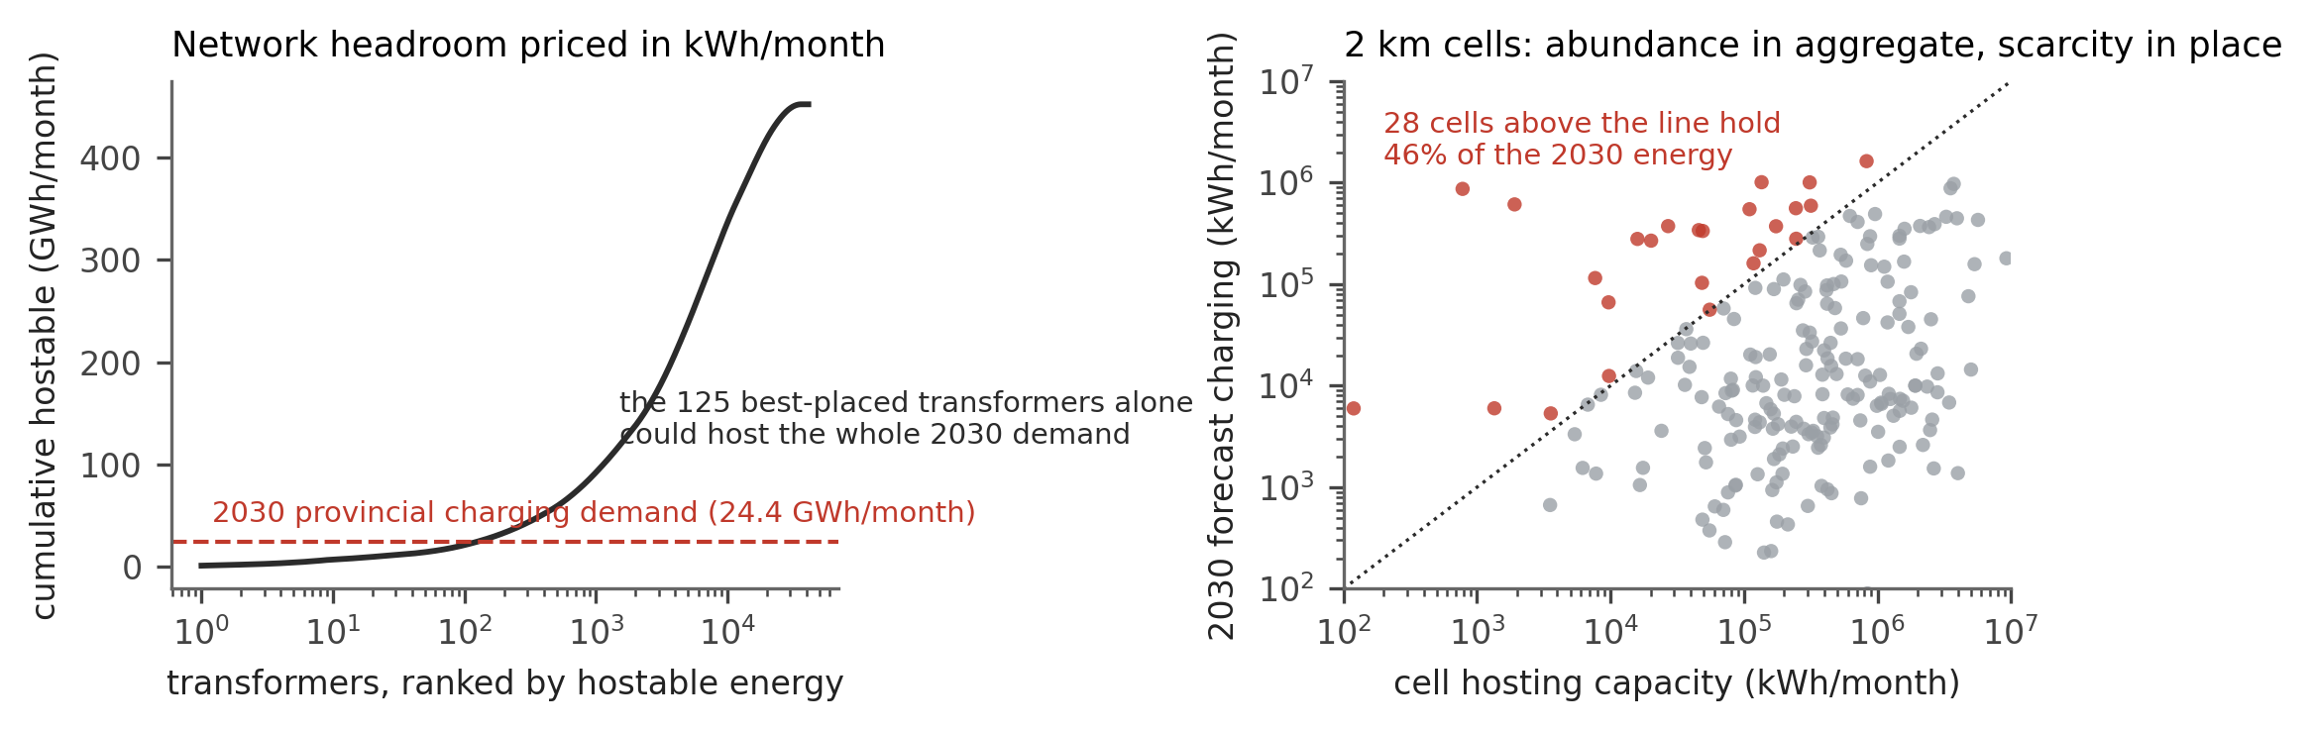
Figure 4. Left: cumulative hostable charging energy of the transformer population, ranked. Right: 2 km cells, forecast 2030 charging against local hosting capacity; cells above the 1:1 line are in deficit.
Table 3. Hostable charging energy of the distribution transformer population.
Metric | Value
Transformers screened | 41,128
Installed capacity | 7,802 MVA
Evening headroom to 80% limit | 2,902 MVA
Aggregate hostable energy | 452 GWh/month
Median per transformer | 4,675 kWh/month
Transformers hosting ≥ 20,000 kWh/month | 7,101 (17.3%)
Transformers hosting ≥ 50,000 kWh/month | 1,301 (3.2%)
Transformers needed to host all 2030 demand | 125

4.5 The 2030 trajectory under two spatial allocations
Figure 5 and Table 4 report the network outcome of the two allocations of the same 24.4 GWh/month.
Under the demand-led allocation, growth concentrates on the 296 transformers that host charging today. Their median evening loading moves from 41.7% to 98.2%; 60% cross the 80% planning limit and 49% cross 100%. In other words, an unconstrained commercial rollout of the statutory number of units would push half of its own host transformers past nameplate at the evening peak, and would do so on assets that are, by construction, in the busiest parts of the network where reinforcement is most expensive and most disruptive.
Under the coverage-led allocation, half the increment is absorbed by 19,740 previously unserved transformers with headroom, at a mean addition of 10.5 kW each. No transformer in that leg crosses the 80% limit. The demand-led half continues to load the existing hosts, but at half the increment the number crossing 100% falls correspondingly.
The policy reading is direct, and it reinforces from the network side a conclusion reached in the companion study on commercial grounds [6], namely that mandated coverage sites are the most productive per site rather than a subsidy to be minimised. Here the same obligation turns out to be a network-relief instrument: it moves load from the transformers least able to accept it onto assets with 2.9 GVA of measured, unused evening headroom. Coverage and capacity are aligned, not opposed.
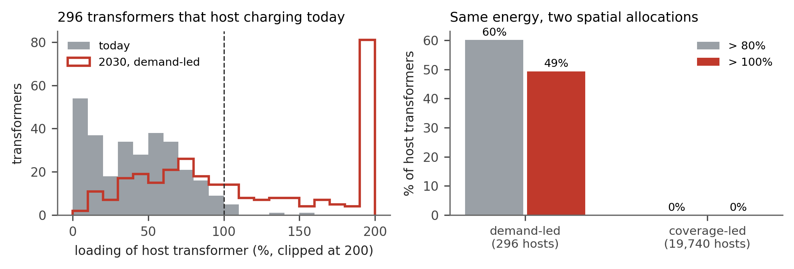
Figure 5. Left: loading of the 296 transformers that host charging today, before and after the demand-led 2030 allocation. Right: share of host transformers exceeding the 80% and 100% thresholds under the two spatial allocations of the same energy.
Table 4. 2030 outcome for host transformers under the two allocations.
 | Demand-led | Coverage-led
Host transformers | 296 | 19,740 (+296)
Mean added evening load per host | 402 kW | 10.5 kW
Median loading after | 98.2% | below 50%
Exceeding 80% | 60% | 0%
Exceeding 100% | 49% | 0%

5. IMPLICATIONS FOR DISTRIBUTION NETWORK DEVELOPMENT PLANS
Four consequences follow for the practice of distribution planning under an electromobility mandate.
Connection screening should be energy-based, not nameplate-based. The combined rule in §4.2 uses only quantities available when a connection is requested and reduces sizing error by 60% against the fixed coincidence rule. Applied across a mandate of tens of thousands of units, the difference between a rule that over-estimates three-quarters of sites and one that does not is a large volume of avoided or deferred reinforcement.
Hosting capacity should be published in the unit the demand forecast uses. Equation (3) allows a DSO to publish, per feeder or per cell, how many kilowatt-hours of monthly charging can be accommodated before reinforcement is triggered. Developers can then self-screen against a public number, and the tender process for mandated sites can be constrained to locations where the network is ready. This is a low-cost intervention: it requires no new measurement, only a transformation of a register the DSO already maintains.
Spatial allocation belongs inside the demand forecast, not after it. The two scenarios differ by no energy at all and by a factor of ten in transformer violations. A DNDP that consumes a provincial energy forecast without a spatial allocation rule cannot see this difference, and will either over-reinforce uniformly or discover the deficits at connection time.
The equity obligation should be planned as a network asset. Because the coverage clause directs sites toward areas with low existing charging density — which are, in this network, the areas with unused evening headroom — compliance and network relief coincide. This should be exploited deliberately: the clause defines a set of eligible locations, and the hosting-capacity map defines which of those locations are cheapest to connect. The intersection is the buildable set.

6. LIMITATIONS
The calibration window is one month, so seasonal variation — particularly the holiday travel peaks that dominate corridor sites — is not resolved, and the transfer function should be re-estimated on a multi-month window before it is used for firm capacity decisions. Transformer loading is a two-point manual measurement rather than a continuous record, so the evening value is a snapshot and the resulting headroom is an estimate with unquantified measurement error. The connection point of each station is proxied by the nearest transformer; sites fed by dedicated transformers or at medium voltage are consequently mis-assigned, which inflates the count of apparently over-loaded hosts in §4.4. The transfer function is estimated on a fleet-to-charger ratio characteristic of an early market; as utilisation rises, load factors will improve and the exponent should be re-estimated, which is itself a testable prediction. Finally, the scenario growth factor is taken from a statutory unit target and assumes constant energy per unit; a demand-side model of fleet growth would replace this with a behavioural projection.

7. CONCLUSION
Ex-ante prediction of charging energy is now feasible from data a distribution utility already owns. This paper supplies the layer that converts such a forecast into a network planning input and demonstrates it on 101,020 metered sessions and 41,128 measured distribution transformers.
Three measured quantities replace three assumptions. Public charging in this network coincides with the evening distribution peak at 0.93 of its own maximum rather than avoiding it. The design peak of a site scales as the 0.70 power of its monthly energy, so nameplate-times-coincidence rules over-estimate three sites in four and carry 1.7 times the error of an energy-based rule. Diversity between charging sites is exhausted by about fifty sites at a coincidence factor of 0.45, well below the planning default over the range that matters at feeder level.
Inverting the transfer function prices the network in the same unit as the forecast. On that basis West Java holds twenty times the hosting capacity its 2030 charging mandate requires, and would still push half of its currently charging-hosting transformers past 100% loading if the mandate were allocated by demand alone. The statutory coverage obligation, allocated instead across transformers with measured spare evening capacity, eliminates the violation. The mandate and the network are not in tension; they are in tension only with a rollout that ignores where the headroom is.

REFERENCES
[1] S. H. Gökler, “Optimal site selection for electric vehicle charging stations: Analysis with hybrid FUCOM and geographic information systems,” Energy, vol. 307, p. 132659, 2024, doi: 10.1016/j.energy.2024.132659.
[2] Ö. Gönül, A. C. Duman, and Ö. Güler, “A comprehensive framework for electric vehicle charging station siting along highways using weighted sum method,” Renew. Sustain. Energy Rev., vol. 199, p. 114455, 2024, doi: 10.1016/j.rser.2024.114455.
[3] M.-O. Metais, O. Jouini, Y. Perez, J. Berrada, and E. Suomalainen, “Too much or not enough? Planning electric vehicle charging infrastructure: A review of modeling options,” Renew. Sustain. Energy Rev., vol. 153, p. 111719, 2022, doi: 10.1016/j.rser.2021.111719.
[4] S. Wang, C. Zhuge, C. Shao, P. Wang, X. Yang, and S. Wang, “Short-term electric vehicle charging demand prediction: A deep learning approach,” Appl. Energy, vol. 340, p. 121032, 2023, doi: 10.1016/j.apenergy.2023.121032.
[5] J. Zheng, J. Zhang, R. Jia, P. Song, and S. Zhao, “Demand prediction of new electric vehicle charging stations: A deep learning approach,” Energies, vol. 19, no. 2, p. 378, 2026, doi: 10.3390/en19020378.
[6] Q. Haramaini, “Ex-ante prediction of station-level energy sales for electric vehicle charging site selection: A transaction-calibrated spatial model for investment ranking and coverage policy,” under review, 2026.
[7] B. Borlaug, S. Salisbury, M. Gerdes, and M. Muratori, “Public electric vehicle charging station utilization in the United States,” Transp. Res. D, vol. 114, p. 103564, 2022, doi: 10.1016/j.trd.2022.103564.
[8] C. Hecht, J. Figgener, and D. U. Sauer, “Analysis of electric vehicle charging station usage and profitability in Germany based on empirical data,” iScience, vol. 25, no. 12, p. 105634, 2022, doi: 10.1016/j.isci.2022.105634.
[9] M. Baresch and S. Moser, “Allocation of e-car charging: Assessing the utilization of charging infrastructures by location,” Transp. Res. A, vol. 124, pp. 388–395, 2019, doi: 10.1016/j.tra.2019.04.009.
[10] S. Ghanbari Motlagh and L. Li, “A review on electric vehicle charging station planning: Infrastructure placement, sizing, upgrades, and uncertainties,” J. Energy Storage, vol. 141, p. 119325, 2026, doi: 10.1016/j.est.2025.119325.
[11] T. Kristiana, L. Pierce, C. Baldino, and J. Schmidt, “Charging Indonesia’s vehicle transition: Infrastructure needs for electric passenger cars in 2030,” International Council on Clean Transportation, Working Paper ID-88, 2024.
[12] N. Damanik, R. C. Octavia, and D. F. Hakam, “Powering Indonesia’s future: Reviewing the road to electric vehicles through infrastructure, policy, and economic growth,” Energies, vol. 17, no. 24, p. 6408, 2024, doi: 10.3390/en17246408.
[13] Ministry of Energy and Mineral Resources of the Republic of Indonesia, Decree 24.K/TL.01/MEM.L/2025 on the national development plan for public electric vehicle charging infrastructure 2025–2030, Jakarta, 2025.
[14] IEC 60076-7, Power transformers — Part 7: Loading guide for mineral-oil-immersed power transformers, International Electrotechnical Commission, 2018.
[15] B. Borlaug, V. Caristo, F. Ouren, F. Yang, E. Wood, and L. Roberson, “Economics of electric vehicle corridor fast charging in the United States,” Advances in Applied Energy, vol. 21, p. 100257, 2026, doi: 10.1016/j.adapen.2025.100257.

