Tailpipe to Smokestack: Marginal Emission Factors and the Illusion of Zero-Emission Mobility on a Coal-Dominated Grid
Qashtalani Haramaini
Monash University Indonesia, Jakarta, Indonesia

Abstract
Electric vehicles are credited with zero tailpipe emissions, and national decarbonisation targets are built on that premise. This paper argues that in a coal-dominated archipelagic power system the result is determined not by the fleet-average grid emission factor but by two distributional tails that conventional accounting removes. The merit-order tail concerns supply: the marginal kilowatt-hour serving new charging load is set by the dispatchable stack, and because public charging is empirically midday-weighted rather than evening-peaked, that margin is mid-merit coal rather than gas peaking plant. The infrastructure tail concerns demand: public charging utilisation is heavy-tailed, so the embodied carbon of a large population of near-idle chargers is amortised over very little delivered energy.
We integrate 528 georeferenced generating units (87.4 GW) across Indonesia’s eight interconnected systems, 3,201 georeferenced public charging stations (4,997 chargers, 121.6 MW), and 101,020 metered charging sessions. Station-level energy is extremely unequal (Gini 0.769; the least-utilised half of stations delivers 2.6% of energy), and the operator’s own national classification places 2,193 stations in the low-utilisation class with none in the medium or high classes. Amortised infrastructure carbon ranges from 4 to 749 g CO2 per delivered kWh between the 10th and 90th percentile station. Combining both tails, a battery electric vehicle charged at a 90th-percentile station emits 281–318 g CO2/km well-to-wheel, 1.56–1.76 times a conventional benchmark.
We introduce two metrics. The carbon-breakeven utilisation A* is the minimum annual throughput at which a charger is carbon-justified against the vehicle it displaces; it is 6,418 kWh/yr in Jamali, 26,439 kWh/yr in Kalimantan, and undefined in Sulawesi and Maluku, where no level of utilisation suffices. The Compound Tail Index ranks systems by the combined penalty. We show the two tails are spatially coincident, so equity-driven deployment and carbon minimisation are, under present conditions, in direct conflict.

1. Introduction
The decarbonisation case for electric vehicles rests on a substitution argument: combustion emissions at the tailpipe are replaced by generation emissions at the power plant, and the latter fall over time as the generation mix cleans up. In systems where that mix is already low-carbon the argument is robust to accounting detail. In systems where it is not, the conclusion becomes acutely sensitive to two choices that are usually made implicitly: which kilowatt-hour is assumed to serve the charging load, and whether the carbon embodied in the charging infrastructure sits inside or outside the boundary.
Indonesia is a demanding test case on both counts. Coal supplies 61.2% of the georeferenced capacity examined here; fossil capacity exceeds 73% in every interconnected system and reaches 100% in Maluku. At the same time the public charging network has expanded rapidly ahead of vehicle uptake, producing a large population of assets with very low throughput. Policy evaluation to date has largely used a national or system-average grid emission factor and has treated charging infrastructure as carbon-free once installed. Both simplifications, we argue, delete precisely the terms that determine the answer.
This paper makes those terms explicit and quantifies them from observed data rather than assumption.

2. Novelty and Contributions
The contribution is not a new emission-factor estimator nor a new siting algorithm. It is the joint treatment of the supply tail and the demand tail at the vehicle level, using measured utilisation, and the two decision metrics that fall out of it. Six specific claims to novelty are made.
- N1 — Integrated supply–demand carbon accounting across all eight Indonesian interconnected systems. Existing work treats generation mix and charging infrastructure in separate literatures. We join a georeferenced generation inventory, a georeferenced national charging asset register, and session-level metering into a single spatial frame, which is what makes the coincidence of the two tails observable at all.
- N2 — The infrastructure tail is measured, not assumed. Charger life-cycle studies conventionally assume a constant utilisation. We derive the full empirical distribution of station throughput from 101,020 metered sessions and carry it through as a distribution. Because infrastructure carbon intensity is a ratio whose denominator is heavy-tailed, its mean is uninformative; the upper percentiles carry the result, and only a measured distribution exposes them.
- N3 — A new decision metric: the carbon-breakeven utilisation A*. We invert the accounting to ask what minimum annual throughput makes a charger carbon-justified against the vehicle it displaces. This converts an abstract life-cycle result into a commissioning threshold a planner can apply to a specific site. Its corollary is stronger still: in systems whose marginal factor already exceeds the displaced-vehicle benchmark, A* is undefined, and no level of utilisation redeems the asset.
- N4 — A new ranking metric: the Compound Tail Index, which expresses the tail-station well-to-wheel intensity relative to the displaced conventional vehicle, allowing systems to be ordered by the combined penalty rather than by grid factor alone.
- N5 — An empirical finding that determines which margin applies. Public direct-current charging in the metered province is midday-weighted and close to flat (37.2% of energy between 09:00 and 15:00 against 30.8% between 17:00 and 22:00), not evening-peaked as residential charging models assume. It therefore sits on the mid-merit coal margin rather than the gas and diesel peaking margin. We report the margin as a band bounded by these two cases and show the choice moves the result by roughly 30 g CO2/km.
- N6 — Spatial evidence of an equity–carbon conflict. We show that the systems with the highest marginal emission factors host the fewest charging assets and therefore the thinnest demand per asset, so equitable geographic deployment moves the network toward both tails simultaneously. This is stated here as a measured spatial relationship rather than a conjecture.
Table 1. Positioning relative to existing strands of work
Strand | Supply representation | Infrastructure representation | Utilisation input
Vehicle life-cycle assessment | Average grid factor | Vehicle and battery only | Assumed
Marginal emission factor studies | Dispatch-derived marginal unit | Not represented | Not applicable
Charging infrastructure siting | Not represented, or average factor | Capital cost only | Modelled demand
Charger life-cycle studies | Average grid factor | Manufacturing and installation | Assumed constant
This work | Margin band, per system, profile-informed | Embodied carbon amortised over delivered energy | Measured, 101,020 sessions

3. Data
Three sources are combined. All are static snapshots. No confidential operational data and no personally identifying attributes are used.

3.1 Generation fleet
A georeferenced inventory of 528 generating units totalling 87,361 MW, assembled from the national electricity supply business plan and cross-matched to open geographic sources. Each record carries coordinates, technology class, nameplate capacity, operating status, and system membership. The inventory also contains 502 transmission substations and 2,357 transmission line segments, used to confirm system membership and to provide the network skeleton in the maps that follow. Coal-fired capacity is 53,452 MW.

3.2 Public charging assets
A national register of 3,212 public charging stations with coordinates, rated power, charger and connector counts, operator category and operational status. Of these, 3,201 fall inside the eight system envelopes and are retained, comprising 4,997 chargers and 121.6 MW of installed charging capacity. Two auxiliary registers are used: an operator utilisation classification covering 2,193 stations, and a register of 1,207 chargers recorded as inactive.

3.3 Metered charging sessions
A complete month of session-level records for one province: 101,020 sessions, 2,259,548 kWh, 329 stations, with timestamp to the second, energy, duration, connector rating and station identifier. Median session energy is 19.8 kWh over a median 0.68 hours. This province is the most mature charging market in the country, a fact exploited in Section 4.5.
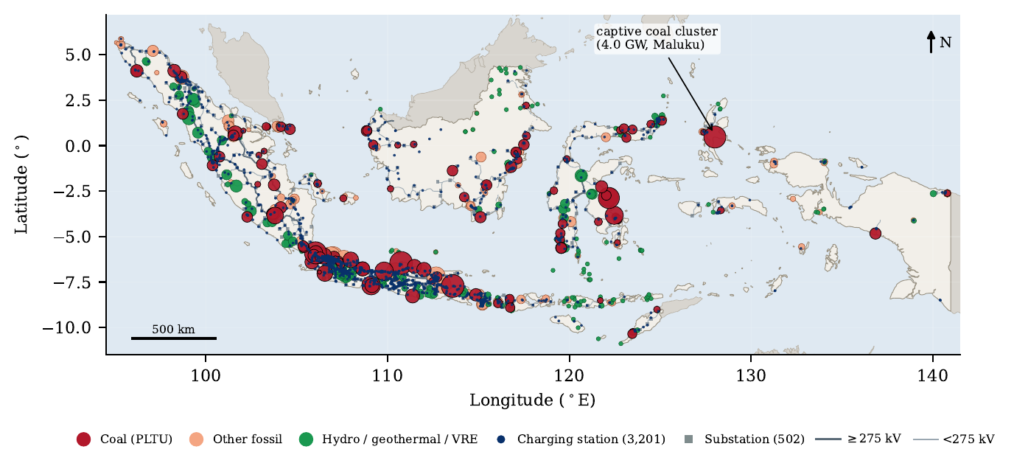
Figure 1. Spatial coincidence of generation and charging assets. Marker area scales with the square root of installed capacity; transmission lines provide the network skeleton. Charging stations concentrate on Java, where coal capacity is also densest; the eastern systems combine near-total fossil dependence with almost no charging demand.

4. Method

4.1 System assignment
Each generating unit and each charging station is assigned to one of the eight interconnected systems by coordinate envelope. Eleven stations fall outside all envelopes and are dropped. Assignment is verified against the operator’s administrative unit coding.

4.2 Emission factors and the margin band
Two factors are computed per system from the capacity inventory. The generation-weighted average factor AEF weights each technology by capacity multiplied by an assumed capacity factor and by its direct emission factor at the busbar. The dispatchable-margin factor MEF restricts the weighting to the thermal set of coal, combined cycle, open cycle gas, diesel and gas engine capacity, reflecting that hydro, geothermal and the very small solar fleet are either baseload-committed or non-dispatchable and therefore do not set the margin.
Because the identity of the marginal unit depends on where in the load duration curve the charging load falls, we report a band rather than a point. The lower bound is a peaking margin, computed over diesel, gas engine and open-cycle capacity only; the upper bound is a coal margin. The measured charging profile determines which end of the band is relevant, and Section 5.2 shows that it is the coal end. Both factors are referred to the vehicle inlet by network losses of 8.5% and charger efficiency of 0.92. Technology parameters are held fixed across systems so that all inter-system variation is driven by observed fleet composition.

4.3 The infrastructure tail
For each station, monthly metered energy is annualised. The empirical Lorenz curve and Gini coefficient of annual station energy characterise the tail. Embodied carbon is modelled as a hardware term proportional to rated power, taken as 40 kg CO2e per kW, plus a fixed site term of 8 t CO2e covering civil works and the medium-voltage connection. Over an assumed asset life of ten years, the infrastructure carbon intensity of delivered energy is the embodied total divided by lifetime delivered energy. The distribution of this quantity, not its mean, is the object of interest.

4.4 Carbon-breakeven utilisation and the Compound Tail Index
Let the displaced vehicle emit a benchmark intensity per kilometre and let specific consumption be 0.17 kWh/km. Setting the electric vehicle’s well-to-wheel intensity equal to that benchmark defines a maximum admissible infrastructure carbon intensity, and inverting the amortisation gives the carbon-breakeven utilisation A*: the minimum annual throughput at which the charger is carbon-justified. Where the marginal factor alone already exceeds the benchmark, the admissible infrastructure intensity is negative and A* is undefined. The Compound Tail Index is the ratio of the well-to-wheel intensity at the 90th-percentile station to the conventional benchmark, so that values above one identify systems in which a tail-station vehicle is worse than the technology it displaces.

4.5 Transfer to systems without metering
Session-level metering exists for one province only. We transfer the shape of the utilisation distribution, not its level, to the remaining systems. This is deliberately conservative: the metered province has the highest vehicle registration density in the country, so applying its distribution elsewhere over-states utilisation and therefore under-states infrastructure carbon intensity in every other system. Compound penalties reported outside that province are consequently lower bounds. The operator’s national tagging supports this direction, placing 2,193 stations in the low-utilisation class and none above it.
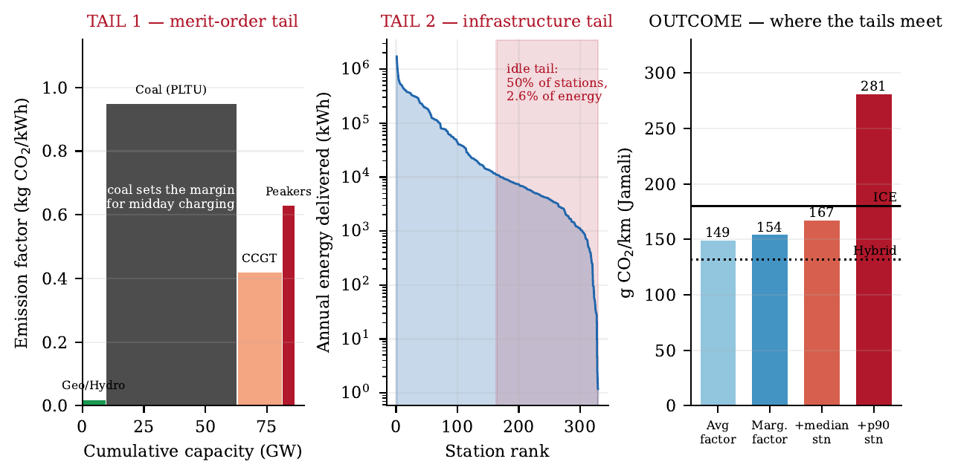
Figure 2. The mechanism. Left: the dispatchable stack, in which coal occupies the mid-merit position that new midday charging load reaches. Centre: the measured station throughput distribution, whose lower half delivers 2.6% of energy. Right: the resulting well-to-wheel intensity as each term is admitted to the accounting boundary.

5. Results

5.1 Both tails are steep
Station-level energy is extremely unequal. The Gini coefficient of annualised station throughput is 0.769; the ten busiest stations deliver 28.3% of energy while the least-utilised half of the network delivers 2.6%. The operator’s own national classification is more striking still: the medium and high utilisation classes are empty, so the infrastructure tail is not a property of a few outliers but the central feature of the deployment. Amortised over delivered energy, embodied carbon contributes 4 g CO2/kWh at the 10th percentile station, 81 g CO2/kWh at the median, and 749 g CO2/kWh at the 90th percentile. The upper-tail figure is of the same order as the generation intensity itself: for a tail station the charger, not the power plant, is the larger emitter per unit of energy delivered.
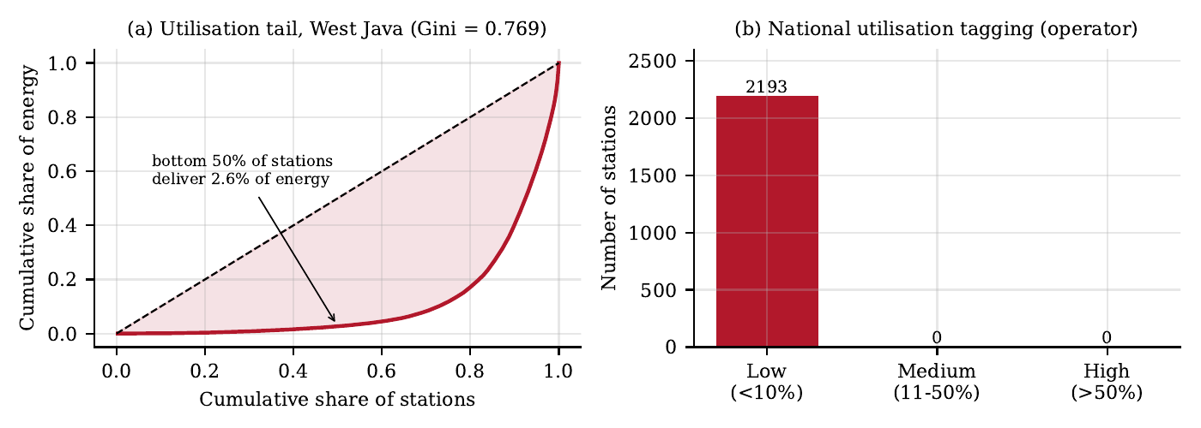
Figure 3. The infrastructure tail. (a) Lorenz curve of annualised station energy from 101,020 metered sessions. (b) Operator utilisation classification of the national network, in which the medium and high classes are empty.

5.2 The charging load does not fall on the evening peak
The diurnal distribution of delivered energy is close to flat, with 37.2% of energy delivered between 09:00 and 15:00 and 30.8% between 17:00 and 22:00. Public direct-current charging therefore behaves quite differently from residential charging, and the common assumption that electric vehicle load aggravates the evening peak does not hold for this segment. The consequence for the accounting is direct: load added in the middle of the day is not served by gas and diesel peaking plant at the top of the stack but by mid-merit coal. The peaking margin computed for these systems lies between 0.57 and 0.67 kg CO2/kWh, below the coal margin of 0.95, so treating the margin as peaking would understate the result by roughly 30 g CO2/km. The measured profile is what rules that case out.
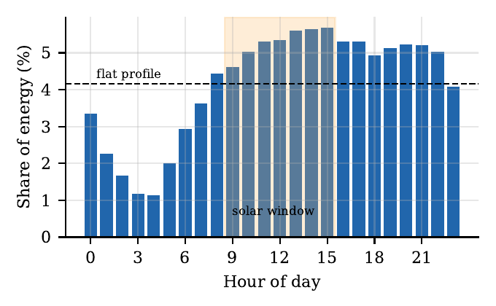
Figure 4. Diurnal distribution of delivered energy across 101,020 sessions. The dashed line is a uniform profile; the shaded band marks the solar generation window.

5.3 System characteristics and spatial coincidence
Fossil capacity exceeds 73% in every system and reaches 100% in Maluku. Charging assets are strongly concentrated: Jamali holds 71.4% of stations and 77.4% of chargers, while the four eastern systems together hold 4.7% of stations. The relationship between marginal emission factor and installed chargers is inverse and steep, so the systems with the dirtiest margin host the thinnest demand per asset. The two tails fall in the same places.
Table 2. Supply and charging infrastructure by interconnected system
System | Capacity (MW) | Coal (%) | Fossil (%) | Peaker (%) | Stations | Chargers | AEF | MEF
Jamali | 51,968 | 57.6 | 91.1 | 2.4 | 2,284 | 3,869 | 0.738 | 0.760
Sumatra | 15,092 | 46.7 | 73.6 | 15.7 | 468 | 577 | 0.651 | 0.797
Kalimantan | 3,199 | 70.8 | 96.8 | 20.4 | 182 | 230 | 0.884 | 0.860
Sulawesi | 11,366 | 82.1 | 86.9 | 3.2 | 116 | 141 | 0.866 | 0.930
Maluku | 4,140 | 97.7 | 100.0 | 2.3 | 51 | 53 | 0.946 | 0.942
NTB | 736 | 49.7 | 93.5 | 43.8 | 41 | 52 | 0.842 | 0.789
NTT | 313 | 54.6 | 89.5 | 34.9 | 32 | 39 | 0.774 | 0.801
Papua | 546 | 51.1 | 95.2 | 44.2 | 27 | 36 | 0.822 | 0.792
Total | 87,361 | 61.2 | 89.9 | 6.1 | 3,201 | 4,997 | — | —
Emission factors in kg CO2 per kWh at the busbar. Peaker denotes diesel, gas engine and open-cycle gas capacity.
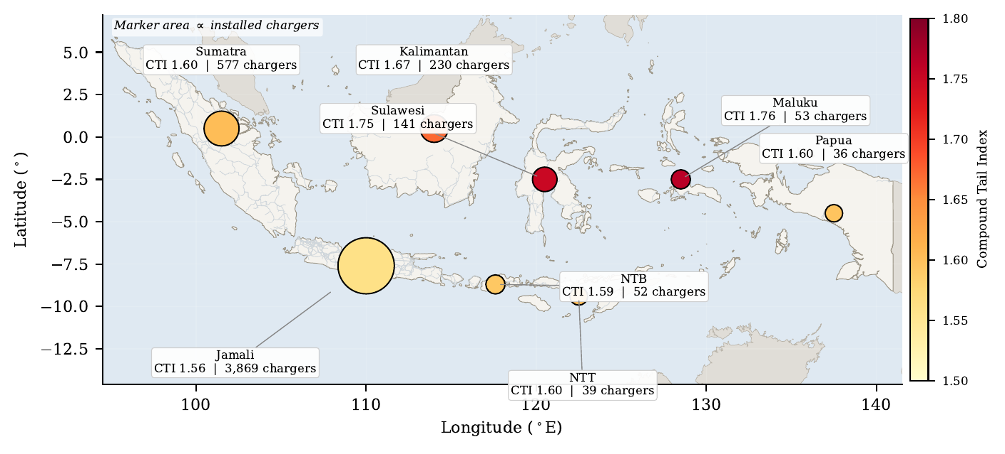
Figure 5. Compound Tail Index by interconnected system. Marker area scales with installed chargers. The index rises toward the east precisely where the charging fleet thins, which is the spatial statement of the equity–carbon conflict.

5.4 Vehicle-level outcome
Evaluated at the average grid factor, an electric vehicle emits 131–191 g CO2/km depending on system. That already places Kalimantan, Sulawesi and Maluku above the hybrid benchmark, and Maluku above the conventional benchmark. Substituting the marginal factor raises the figure in five of eight systems. Adding the infrastructure tail at the 90th percentile raises it to 281–318 g CO2/km everywhere, giving a Compound Tail Index of 1.56 in Jamali and 1.76 in Maluku.
Table 3. Well-to-wheel intensity (g CO2/km), Compound Tail Index and carbon-breakeven utilisation
System | Average factor | Marginal factor | Median station | p90 station | CTI | A* vs ICE (kWh/yr)
Jamali | 149 | 154 | 167 | 281 | 1.56 | 6,418
Sumatra | 131 | 161 | 175 | 288 | 1.60 | 8,943
Kalimantan | 179 | 174 | 187 | 301 | 1.67 | 26,439
Sulawesi | 175 | 188 | 202 | 315 | 1.75 | undefined
Maluku | 191 | 190 | 204 | 318 | 1.76 | undefined
NTB | 170 | 159 | 173 | 287 | 1.59 | 8,209
NTT | 156 | 162 | 176 | 289 | 1.61 | 9,274
Papua | 166 | 160 | 174 | 287 | 1.60 | 8,487
Benchmarks: conventional vehicle 180 g CO2/km, hybrid 132 g CO2/km, both well-to-wheel. A* is computed for a 50 kW unit over a ten-year life. "Undefined" indicates that the marginal factor alone exceeds the benchmark, so no utilisation makes the asset carbon-justified.
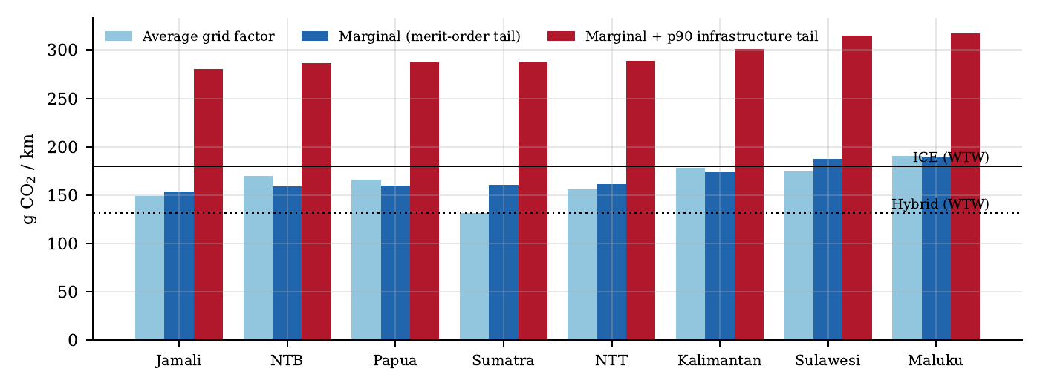
Figure 6. Well-to-wheel intensity by system under three accounting boundaries, against conventional and hybrid benchmarks. Systems are ordered by tail intensity.

5.5 The carbon-breakeven utilisation
The breakeven threshold varies by an order of magnitude across systems and becomes undefined in two of them. In Jamali a 50 kW unit must deliver at least 6,418 kWh per year to be carbon-justified against a conventional vehicle; 63.8% of observed stations meet that threshold. In Kalimantan the threshold rises to 26,439 kWh per year, met by 35.6% of stations. In Sulawesi and Maluku the marginal factor alone exceeds the benchmark, so no throughput suffices and the correct policy response is to decarbonise the margin before, not alongside, expanding the network.
The same inversion applied to the grid rather than the charger yields a second threshold. For an electric vehicle to beat a conventional vehicle the busbar factor must fall below 0.891 kg CO2/kWh; to beat an efficient hybrid it must fall below 0.654 kg CO2/kWh. Only Sumatra, at 0.651, is currently near the latter. This is the sharpest form of the paper’s claim: at present grid intensities the electric vehicle in Indonesia is competitive with the conventional vehicle it usually displaces, but not with the hybrid it could displace instead.
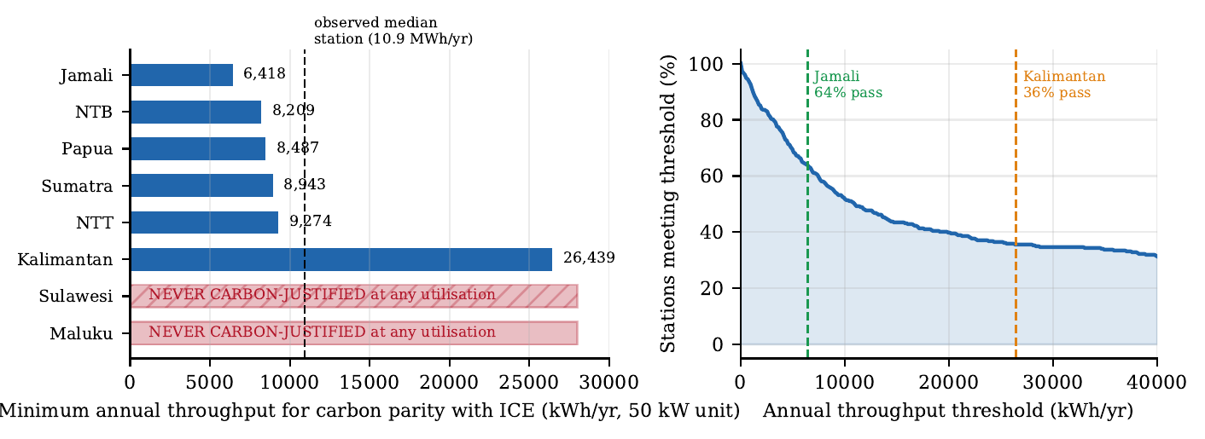
Figure 7. Carbon-breakeven utilisation. Left: minimum annual throughput for carbon parity with a conventional vehicle, by system; two systems admit no solution. Right: the share of observed stations meeting a given throughput threshold, with two system thresholds marked.
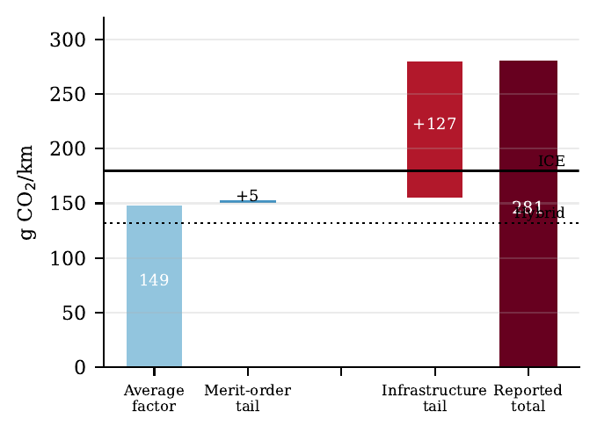
Figure 8. Decomposition of the reported intensity for Jamali by accounting boundary. The infrastructure tail contributes more than the merit-order correction and more than the average factor understates.

6. Discussion

6.1 The equity–carbon conflict
Charging infrastructure is currently concentrated where vehicles are, which is also where the grid is comparatively least carbon-intensive. Spatial equity arguments, and the universal-service obligation that follows from them, push deployment toward the eastern systems. Figure 5 shows that this movement is toward higher marginal emission factors and, because vehicle density there is lower still, toward deeper infrastructure tails. Under present conditions equity-driven deployment and carbon minimisation are in direct conflict. This does not argue against equitable deployment. It argues that the carbon claim should not be attached to it, and that the two objectives require separate instruments and separate reporting.

6.2 Where the binding term is
The decomposition identifies which lever acts on which term. Adding stations acts on neither: it lengthens the infrastructure tail without changing the margin. Raising utilisation acts directly on infrastructure carbon intensity, and the elasticity is largest exactly where the problem is worst, because that intensity is inversely proportional to throughput. Redeploying the 1,207 chargers currently recorded as inactive to demonstrated-demand sites converts stranded embodied carbon into delivered energy at no additional manufacturing burden. Changing the generation margin acts on the other term but on a much longer timescale.

6.3 The midday window
The observed profile is the one constructive finding. Because public fast charging is midday-weighted rather than evening-peaked, a substantial share of it already coincides with the solar generation window. Solar capacity is presently negligible in all eight systems, below 2.3% everywhere and below 0.1% in Sumatra and Maluku, so this coincidence is unexploited. Co-locating distributed solar with high-throughput stations addresses the supply tail at the point where the demand tail is thinnest, and is the only lever identified here that improves both terms simultaneously.

6.4 Policy implications
- Utilisation floors should precede station-count targets. A* provides the threshold in physical units, and it is system-specific rather than national.
- Procurement and reporting should be expressed as carbon per delivered kilowatt-hour rather than stations installed, which makes the infrastructure term visible to the decision-maker.
- Emission reporting for electric mobility should state which factor is used. The difference between the average and tail boundaries in Table 3 is larger than the difference between an electric and a conventional vehicle.
- In systems where A* is undefined, network expansion should be sequenced behind generation replacement rather than run in parallel with it.

7. Limitations
Emission factors are derived from capacity composition with fixed technology parameters rather than from metered dispatch, which is not publicly available; they should be read as structural indicators rather than settled values, and calibration against official system factors is the natural next step. The margin is approximated by capacity-weighted subsets of the dispatchable fleet, which is appropriate for systems with negligible variable renewable capacity but would require unit-commitment data to refine. Embodied carbon coefficients are literature-order estimates and the 90th-percentile result scales linearly in them; the qualitative conclusion holds for any coefficient above roughly one third of the values used. Session metering covers one province and one month, so seasonality is not captured, and the shape transfer of Section 4.5 is an assumption, albeit a conservative one. Finally, 1,013 stations operated by third parties report no telemetry, so measured utilisation reflects the operator-owned subset; if third-party stations are less utilised, the tail is deeper than reported.

8. Conclusion
Evaluating electric mobility in a coal-dominated archipelagic system at a fleet-average grid factor, with charging infrastructure treated as carbon-free, systematically flatters the result. Once the merit-order tail and the infrastructure tail are both admitted, the well-to-wheel intensity of an electric vehicle charged at a 90th-percentile station reaches 281–318 g CO2/km, between 1.56 and 1.76 times a conventional benchmark, and the two tails are shown to fall in the same places. The carbon-breakeven utilisation converts that finding into a commissioning threshold, and shows that in two of the eight systems no threshold exists. The policy consequence is that utilisation, not station count, is the carbon-relevant variable, and that the midday concentration of public charging is an unexploited opportunity to attack both tails at once.

References
[1] International Energy Agency, Global EV Outlook, IEA, Paris, 2024.
[2] J. Hofmann et al., “Life cycle assessment of electric vehicles in a coal-dominated grid,” Applied Energy, vol. 184, pp. 995–1003, 2016.
[3] K. Siler-Evans, I. L. Azevedo and M. G. Morgan, “Marginal emissions factors for the U.S. electricity system,” Environmental Science & Technology, vol. 46, no. 9, pp. 4742–4748, 2012.
[4] J. A. de Chalendar, J. Taggart and S. M. Benson, “Tracking emissions in the US electricity system,” PNAS, vol. 116, no. 51, pp. 25497–25502, 2019.
[5] F. Bohnes and A. Laurent, “Environmental impacts of electric mobility: a review,” Environmental Science & Technology, vol. 53, no. 8, pp. 4194–4211, 2019.
[6] T. Gnann et al., “Fast charging infrastructure for electric vehicles: today’s situation and future needs,” Transportation Research Part D, vol. 62, pp. 314–329, 2018.
[7] M. Nicholas, “Estimating electric vehicle charging infrastructure costs,” ICCT Working Paper 2019-14, 2019.
[8] P. Jochem, S. Babrowski and W. Fichtner, “Assessing CO2 emissions of electric vehicles in Germany in 2030,” Transportation Research Part A, vol. 78, pp. 68–83, 2015.
[9] Z. Yi et al., “Electric vehicle charging station siting under demand uncertainty,” Transportation Research Part D, vol. 91, 102686, 2021.
[10] S. Hardman et al., “A review of consumer preferences of and interactions with electric vehicle charging infrastructure,” Transportation Research Part D, vol. 62, pp. 508–523, 2018.
[11] IPCC, 2019 Refinement to the 2006 IPCC Guidelines for National Greenhouse Gas Inventories, IGES, 2019.

