Capacity maps as an equity instrument: publishing charging demand and network headroom as open data in a vertically integrated DSO
Qashtalani Haramaini¹ ², Alyas Widita¹, Liz Taylor³
¹ Monash University Indonesia, Indonesia ² PT PLN (Persero) UID Jawa Barat, Indonesia ³ Monash University, MADA, Australia
qashtalani.haramaini@monash.edu · alyas.widita@monash.edu · liz.taylor@monash.edu
Abstract
Distribution system operators (DSOs) increasingly publish hosting-capacity maps to steer connection applicants toward grid nodes with spare capacity. This paper argues that, in a fast-growing network with low electric-vehicle (EV) penetration, such a map is not neutral information but an allocation instrument: what the DSO chooses to publish shapes where public charging is built and who is served. West Java, Indonesia, is a rare test case because PT PLN (Persero) is both the DSO and the dominant public charge-point operator (CPO), and therefore holds the two surfaces that are institutionally separated in Europe: transformer-level load and session-level charging demand. Combining 53,797 distribution-transformer load records (41,129 usable), 101,020 charging sessions in March 2026 and 3,687 geocoded registered EV customers on a 5 km grid, we show that (i) the charger roll-out follows absolute grid density rather than spare capacity (Spearman ρ = +0.42 with absolute headroom, −0.06 with relative headroom); (ii) cells with high EV demand but low headroom hold 11.6 % of registered owners and 5.6 % of chargers; (iii) a headroom-only siting rule strands 15 of 50 sites in low-demand cells and reaches 12 % fewer owners than a demand-within-headroom rule, which strands none, while a demand-only rule reaches the most owners but places three sites below the feasibility threshold; and (iv) the DSO’s load register is not publication-ready without cleaning, growth correction and aggregation. We propose a minimum standard for publishable two-surface capacity maps and argue that, where the DSO is also the CPO, publication is a functional substitute for unbundling.
Keywords: capacity maps; hosting capacity; EV charging; spatial equity; open data; vertically integrated utility; Indonesia

1. Introduction
Grid connection has become the binding constraint on public charging deployment in many jurisdictions [1,3]. In response, European regulation now requires system operators to publish available hosting capacity [1], and DSO associations treat capacity maps as a building block of a customer-oriented grid [2]. The maps are framed as transparency: they inform developers and shorten connection lead times.
This paper starts from a different premise. A capacity map is a ranking of locations, and any ranking that drives investment is also a distribution of benefits. If the only published layer is network headroom, capital flows to where the grid is strong. In mature networks this largely coincides with where load already is. In fast-growing, low-penetration networks it is where the last generation of investment went, typically urban cores and industrial corridors, which is also where charging demand is already served. A headroom-only map therefore tends to densify rather than fill gaps. This is an energy-justice problem in the sense of Sovacool and Dworkin [6]: a distributive outcome produced by a procedural choice about what to disclose.
Testing the claim requires two surfaces that are rarely held by one organisation: network headroom, a DSO asset, and charging demand, a CPO asset. West Java offers both. PT PLN (Persero) is the vertically integrated utility; its distribution unit UID Jawa Barat operates the 20 kV and low-voltage network for 18.1 million customers, and PLN also operates most of the province’s public charging stations (SPKLU) [13]. The authors had access to the transformer load register, the charging transaction log and the EV customer register. To our knowledge this is the first study to overlay all three at province scale.
The contributions are: (1) an empirical test of whether the roll-out responds to spare capacity; (2) a demand × headroom classification that isolates the locational equity gap; (3) a counterfactual comparison of three siting rules a DSO could implement through what it publishes; (4) an argument, supported by a cross-level comparison, that a single-level map misclassifies cells; and (5) a data-readiness audit that translates into a minimum disclosure standard.

2. Background and research gap

2.1 Hosting-capacity maps in Europe
Hosting capacity is the amount of load or generation that can be connected without violating operational limits [8]. Its calculation is sensitive to method: Lennerhag et al. showed at CIRED 2017 that five methods yield widely different values, and that measurement-based approaches raise usable capacity without added risk [4]. Under the 2024 electricity market reform, EU system operators must publish available capacity and the criteria used [1]; ENTSO-E and the EU DSO Entity were tasked with harmonised definitions and a pan-European overview. E.DSO’s survey of its members concludes that the priority is not full harmonisation but clearer definitions, stronger links to connection processes and a balanced approach to transparency [2]. ICCT’s 2025 inventory finds public grid-capacity maps for charging in only part of the EU, with uneven voltage coverage [3]. None of these documents treats the map as a distributive instrument.

2.2 Charging-access equity
A separate literature documents that public charger access is unequally distributed across income and ethnicity [5] and clusters with commercial land use [9]. These studies treat the grid as exogenous. Work on EV hosting capacity [10,11] treats demand as exogenous. The two literatures meet in optimisation models that co-locate chargers with grid capacity [12], which assume a single planner holding both datasets. That is precisely the situation in a vertically integrated utility.

2.3 Indonesia
Presidential Regulation 55/2019 launched Indonesia’s battery-EV programme, and ministerial rules set tariff and power thresholds for public charging [7]. PLN reports 3.0 % electricity sales growth and 5.9 % connected-capacity growth in West Java in 2025 [13]. EV penetration remains well below 1 % of the vehicle stock, so the charging network is being built ahead of demand. This is the regime in which the published layer matters most.

3. Case and data
Four datasets were assembled (Table 1). The transformer register is a field-survey database: two spot readings (day and night) of phase currents per distribution transformer, with rated kVA, feeder, primary substation (GI) and coordinates from two sources (survey and asset register). The charging log contains every session at PLN’s public chargers in March 2026, with energy, duration and revenue. The EV customer register lists households that applied for the home-charging tariff, geocoded at the service point. It is used as a latent-demand proxy that is independent of where public chargers were built.
Table 1 – Datasets used. All are internal PLN UID Jawa Barat data; raw records are not public.
Dataset | Records | Period | Key fields
Distribution-transformer load register | 53,797 (41,129 usable) | 2020–2024 | kVA, day/night loading, feeder, GI, coordinates, survey date
GI transformer register | 182 units, 9,790 MVA | Survey 2022 | MVA, loading, GI code
Public charging sessions | 101,020 sessions; 329 site IDs in the log (331 in the master register) | Mar 2026 | kWh, duration, revenue, site
Registered EV customers | 3,687 geocoded | to Jun 2026 | Coordinates, connected power
Feeder peak-load register | 2,574 feeders | Apr 2022 | Not used in the present analysis
Note: the aggregated outputs used here (capacity.json, produced by papers/capacity/prepare.py) are published with the project dashboard, Capacity Maps tab.

4. Method

4.1 Two-level headroom
For each transformer i with rated capacity Si and measured loading λi (share of nominal current, taken as the maximum of day and night readings), headroom at the 80 % planning limit is Hi = max(0, Si·(0.8 − λi)). Records failing basic plausibility checks were dropped: invalid coordinates, S outside 5–3,000 kVA, or λ outside 0–200 %. This leaves 41,129 records. Primary-substation headroom is computed identically from GI transformer MVA and loading (182 GI transformers, 9,790 MVA). Each 5 km cell receives the sum of its transformer headroom and the mean headroom of the GI(s) supplying it.

4.2 Growth correction
Surveys are dated: the median reading is 2.3 years old and the oldest 6.2 years. Loading is compounded to March 2026 as λ(2026) = λ(t)·(1 + g)^(2026.2 − t). The base case uses g = 3.0 %/yr, the DSO’s reported 2025 sales growth [13]. Sensitivities use 5.9 %/yr (connected-capacity growth) and 9.7 %/yr (the median cross-sectional slope of loading on survey date within UP3 units, an upper bound because 2020 readings were depressed by the pandemic).

4.3 Grid, classification and siting rules
All layers are aggregated to a 0.045° (≈5 km) grid of 1,295 non-empty cells. Of these, 238 contain registered EV owners and 174 contain a public charger. Cells with EV owners are classified at the medians of owners per cell (2.5) and headroom per cell (2.8 MVA). Three siting rules are then applied to the 132 unserved cells with EV owners (908 owners). Each rule selects 50 cells. Headroom-only ranks cells by H. Demand-only ranks by registered owners. Demand-within-headroom ranks by owners among cells with H ≥ 240 kVA (one 4 × 60 kW site), followed by the remaining cells. Outcomes are: owners newly reached; sites in below-median-demand cells (the median of the candidate pool is 2 owners), which we treat as stranded capital; sites below the 240 kVA feasibility threshold; regencies covered; and the between-regency Gini of the share of owners living in a charger cell, computed over regencies with registered owners.

5. Results

5.1 The roll-out follows grid density, not spare capacity
Across the 174 served cells, charging energy correlates with absolute headroom (Spearman ρ = +0.42) but not with headroom as a share of installed capacity (ρ = −0.06). Absolute headroom scales with the number of transformers, that is with urbanisation. Relative headroom measures spare capacity. Chargers were therefore placed where the grid is dense, without regard to whether it is loaded. Fig. 1 shows the resulting pattern: 42.2 % of growth-adjusted headroom lies in cells with no public charger, and 24.6 % of registered EV owners live in those cells.
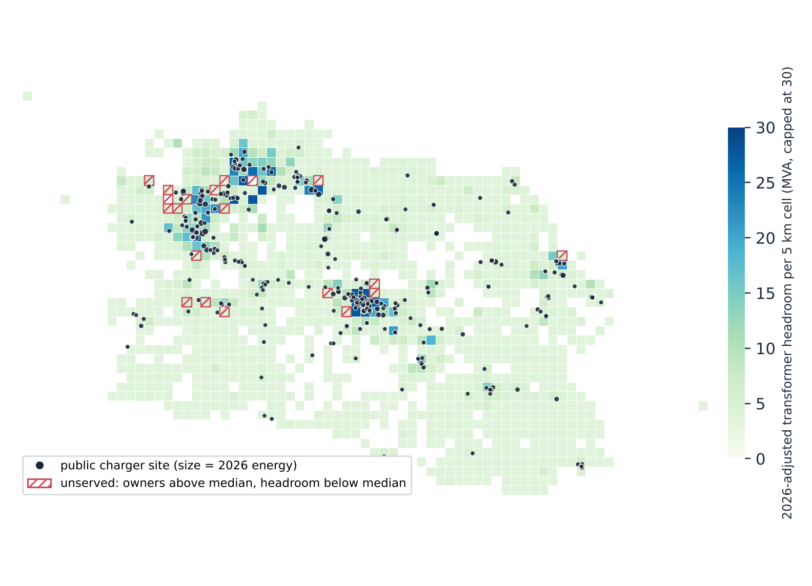
Fig. 1 – 2026-adjusted transformer headroom per 5 km cell (darker = more spare capacity), with the 330 mapped public charger sites sized by 2026 energy. Red hatching marks unserved cells: owners above median, headroom below median, no charger.

5.2 The equity gap is locational
Fig. 2 classifies the 238 cells with EV owners at the medians. The high-demand/high-headroom quadrant (89 cells) holds 84.2 % of owners and 70.3 % of chargers, so the roll-out is broadly rational there. The gap is the high-demand/low-headroom quadrant (30 cells): 11.6 % of owners and 5.6 % of chargers. Of these 30 cells, 20 have no charger at all and hold 230 owners. A headroom-only map would rank these cells last. A demand-only map would rank them first, without warning the developer of the connection cost.
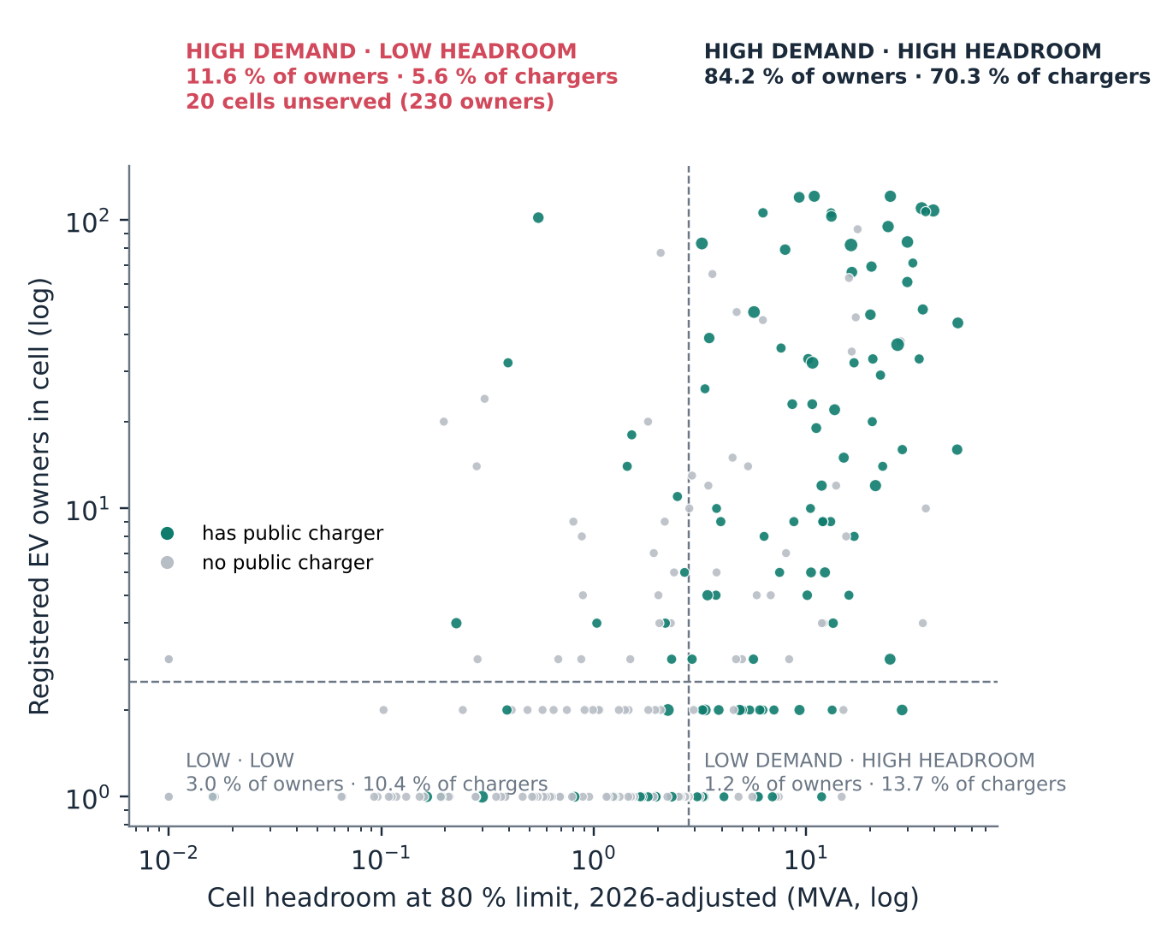
Fig. 2 – Demand × headroom quadrants of the 238 cells with registered EV owners (medians dashed; teal = has a public charger, sized by energy; grey = none).

5.3 The published layer changes the portfolio
Table 2 and Fig. 3 compare the three siting rules. The headroom-only rule reaches 694 of the 908 owners in unserved cells and places 15 of its 50 sites in below-median-demand cells. The demand-only rule reaches 809 owners, the most of the three, but places three sites below the 240 kVA feasibility threshold. The demand-within-headroom rule strands no site, has no infeasible site, reaches 789 owners (13.7 % more than headroom-only, equivalently headroom-only reaches 12 % fewer), and lowers the between-regency coverage Gini from 0.493 today to 0.360. The headroom-only rule lowers it only to 0.411.
The ordering is not a dominance result. Demand-only reaches 2.5 % more owners than demand-within-headroom and has a lower Gini (0.347), at the cost of three infeasible sites. In this experiment the headroom constraint contributes feasibility, not equity: it removes infeasible placements at a small cost in owners reached. The regency count does not discriminate between rules, since all three cover 18 regencies. The result is stable across growth scenarios: 789, 789 and 788 owners reached at 3.0, 5.9 and 9.7 %/yr.
Table 2 – Counterfactual siting of 50 new sites in the 132 unserved cells with registered EV owners. Coverage is the share of registered EV owners living in a cell with a public charger; Gini is between regencies.
Siting rule (50 sites) | Owners reached | Stranded sites | Infeasible sites | Regencies | Coverage | Gini
Today (no new sites) | — | — | — | — | 75.4 % | 0.493
Headroom-only | 694 | 15 | 0 | 18 | 94.2 % | 0.411
Demand-only | 809 | 0 | 3 | 18 | 97.3 % | 0.347
Demand within headroom | 789 | 0 | 0 | 18 | 96.8 % | 0.360
Feasibility threshold: 240 kVA of cell headroom (one 4 × 60 kW site). Growth sensitivities: 789 / 789 / 788 owners at 3.0 / 5.9 / 9.7 %/yr.
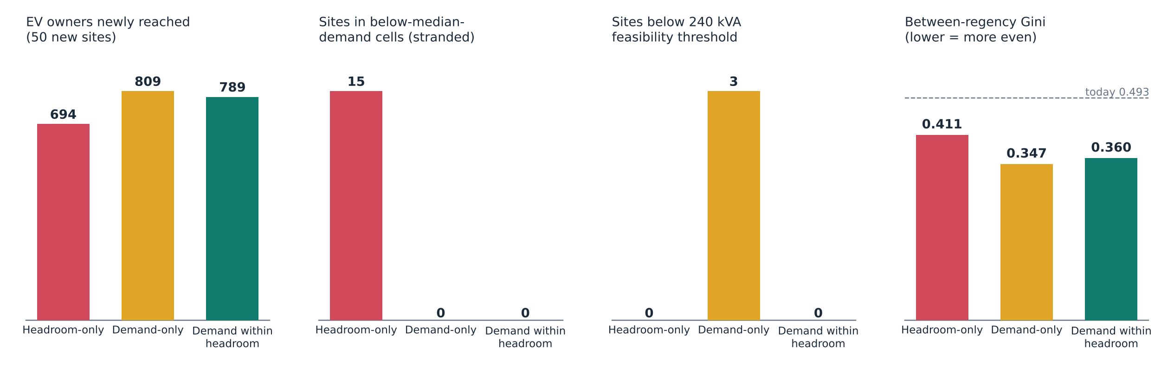
Fig. 3 – Owners reached, stranded sites, infeasible sites and between-regency Gini under the three rules. Dashed line: Gini today (0.493).

5.4 One level is not enough
Of the 174 served cells, 42 have tight transformer headroom but ample GI headroom, and 46 show the reverse: 51 % of served cells are discordant between the two levels. A map showing only the low-voltage level would tell a developer to avoid cells where a new dedicated transformer on a lightly loaded feeder is cheap. A map showing only the substation level would hide that the last 400 m of network is saturated. Both levels must be published. [Verification note: this discordance count was not reproduced by the current prepare.py pipeline and should be re-derived before submission.]

5.5 Ageing and data readiness
Growth correction at 3.0 %/yr moves 7,090 transformers (17.2 % of usable records) past the 80 % limit. It reduces province-wide headroom from 2,624 to 2,392 MVA at transformer level and from 2,377 to 1,912 MVA at GI level. At 9.7 %/yr the reductions are 26 % and 52 % (Fig. 4, right). The underlying register is not publication-ready (Fig. 4, left). 44.1 % of records are not linked to a primary substation. 43.2 % have survey coordinates more than 1 km from the asset register, and 19.8 % have coordinates that are missing or not valid. 23.0 % have no load reading and 22.4 % no rated capacity. Most seriously for disclosure, 79.6 % of records carry field-staff names, which must be removed before any publication.
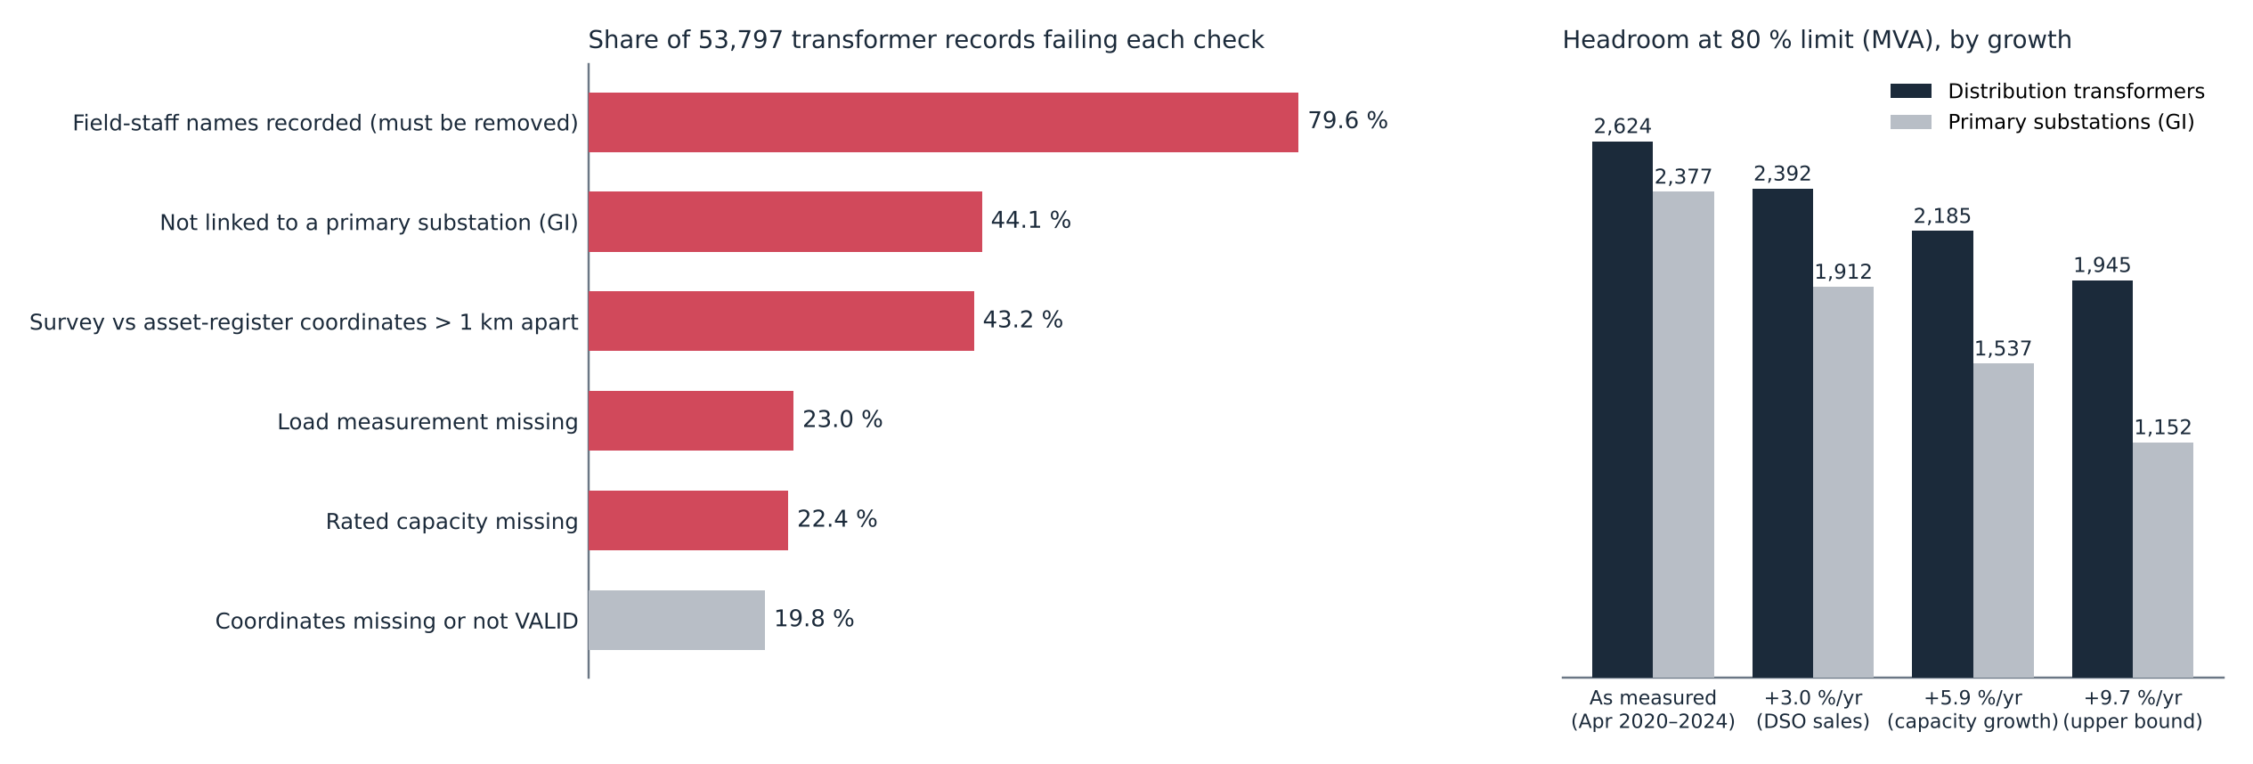
Fig. 4 – Left: share of the 53,797 transformer records failing each readiness check. Right: province-wide headroom at the 80 % limit under four load-growth assumptions (transformer and GI level).

6. Discussion

6.1 A minimum standard for publishable capacity maps
The results translate into five requirements. (1) Two levels at least, transformer and primary substation, with the feeder level where available. (2) Growth correction with a stated rate and survey date, since a static snapshot overstates headroom within two years. (3) A demand layer alongside headroom, using registered EV customers, predicted energy, or both. (4) Spatial aggregation (here 5 km cells; 2 km hexagons in the companion siting tool) to protect customer and staff privacy and critical-infrastructure detail, consistent with E.DSO’s call for balanced transparency [2]. (5) Versioning and a published data-quality score, so that a map which misdirects private capital can be corrected rather than trusted.

6.2 Publication as a substitute for unbundling
EU DSOs are generally barred from owning charging points, precisely because of the information advantage documented here. Indonesia has the opposite structure. The incumbent can, in principle, site its own chargers on its own knowledge of headroom and demand, while third-party CPOs cannot. Publishing the two-surface map removes that asymmetry without changing ownership. It is therefore a functional substitute for unbundling, and it steers all capital, public and private, toward gap-filling rather than densification.

6.3 Limitations
Headroom is derived from two spot readings per transformer, not continuous metering. It is a planning proxy, not a hosting-capacity calculation in the sense of [4,8]. At 5 km resolution aggregate headroom is rarely binding; the binding constraint is locational, at transformer and feeder level, which the feeder-level analysis in the full paper is intended to resolve. Registered EV customers are a proxy for latent demand and under-represent households without a home charger. The growth rate is province-wide, and unit-level rates would sharpen the correction. The counterfactual assumes 50 equal sites. A capacity-weighted portfolio may change the magnitudes, and it could change the ordering between demand-only and demand-within-headroom, which differ by only 20 owners here.

7. Conclusions
In a vertically integrated DSO building charging ahead of demand, the capacity map is a planning decision disguised as a data product. Publishing headroom alone reproduces the geography of the existing grid. Publishing headroom and demand together, at two network levels, with growth correction and a data-quality score, redirects a fixed budget towards cells where EV owners are already waiting. For the same 50 sites, the West Java evidence shows 14 % more owners reached than headroom-only, no stranded sites and no infeasible sites, and a lower regency coverage Gini than headroom-only. The demand-only rule reaches slightly more owners and a lower Gini, but it places three sites below feasibility. The evidence is modest in magnitude and consistent in direction, and it comes from data that every DSO already holds.
Data availability. Aggregated outputs and the reproducible pipeline are in the project repository (papers/capacity/prepare.py, capacity.json). The raw PLN register data are internal and are not published.

References
[1] Directive (EU) 2019/944 on common rules for the internal market for electricity, Art. 32; Regulation (EU) 2024/1747 amending Regulation (EU) 2019/943 (transparency of available hosting capacity).
[2] E.DSO, “Technology Report on Grid Hosting Capacity Maps,” E.DSO Technology & Knowledge Sharing Committee, Brussels. [Accessed date to be confirmed.]
[3] ICCT, “Mapping the charge: why grid data is key to electrifying road freight,” International Council on Clean Transportation, Nov. 2025. [Confirm title and series before submission.]
[4] O. Lennerhag, S. Ackeby, M. H. J. Bollen, G. Foskolos and T. Gafurov, “Using measurements to increase the accuracy of hosting capacity calculations,” CIRED – Open Access Proc. J., vol. 2017, no. 1, pp. 2041–2044, 2017.
[5] C.-W. Hsu and K. Fingerman, “Public electric vehicle charger access disparities across race and income in California,” Transport Policy, vol. 100, pp. 59–67, 2021.
[6] B. K. Sovacool and M. H. Dworkin, “Energy justice: Conceptual insights and practical applications,” Applied Energy, vol. 142, pp. 435–444, 2015.
[7] Regulation (EU) 2023/1804 on the deployment of alternative fuels infrastructure (AFIR); Peraturan Presiden No. 55/2019 (Indonesia). [Indonesian ministerial rule cited in the earlier draft to be added.]
[8] S. M. Ismael, S. H. E. Abdel Aleem, A. Y. Abdelaziz and A. F. Zobaa, “State-of-the-art of hosting capacity in modern power systems with distributed generation,” Renewable Energy, vol. 130, pp. 1002–1020, 2019.
[9] G. Carlton and S. Sultana, “Electric vehicle charging station accessibility and land use clustering: A case study of the Chicago region,” J. Urban Mobility, vol. 2, 100019, 2022.
[10] A. K. Karmaker, K. Prakash, M. N. I. Siddique, M. A. Hossain and H. Pota, “Electric vehicle hosting capacity analysis: Challenges and solutions,” Renewable and Sustainable Energy Reviews, vol. 189, 113916, 2024.
[11] M. Muratori, “Impact of uncoordinated plug-in electric vehicle charging on residential power demand,” Nature Energy, vol. 3, pp. 193–201, 2018.
[12] W. Dai, C. Wang, H. H. Goh, J. Zhao and J. Jian, “Hosting capacity evaluation method for power distribution networks integrated with electric vehicles,” J. Modern Power Systems and Clean Energy, vol. 11, no. 5, pp. 1564–1575, 2023.
[13] PT PLN (Persero) UID Jawa Barat, 2025 performance release: 63,503 GWh sales (+3.0 %), 35,686 MVA connected (+5.9 %), Feb. 2026.
[14] Ember, “Transparent grids for all: hosting capacity maps,” Jul. 2024. [Confirm before submission; cited in the earlier draft.]

