RESEARCH PROPOSAL

Pathways to Advancing Sustainable Transportation
A Focus on Indonesia’s EV Ecosystem
Qashtalani Haramaini

Doctor of Philosophy candidate

Faculty of Art, Design and Architecture, Monash University
Ariel Liebman RACE for 2030 Monash Indonesia PhD Program
Main supervisor: Dr Alyas Widita
Co-supervisor: Dr Elizabeth Taylor
October 2026
Revised draft, 8 October 2026, following supervisor feedback on the 3-month checkpoint submission to the RACE for 2030 consortium.

Abstract
Indonesia’s public electric vehicle (EV) charging network is expanding rapidly, yet the measures used to judge whether this expansion is fair remain crude. The most common indicator, chargers per registered vehicle, makes the least-served provinces look best: Aceh records one charger per vehicle and Jakarta one per 47, because hardly anyone in Aceh owns an EV where there is almost nowhere to charge one. Counting chargers also ignores whether they can be reached, whether they deliver enough power, whether they work, whether they are congested, and whether people can actually use them. Province-level ratios also hide the scale at which charging is actually used: the city and its surrounding metropolitan area.
This project asks: who is really served by Indonesia’s public EV charging network, sufficiently and with a real ability to use it, and are shortfalls concentrated in less-developed regions? It adopts an explicit normative standard that combines sufficientarianism (no one should fall below a threshold of “enough”) with the capability approach (what matters is the real opportunity to use a service). This standard is operationalised as a five-step service ladder: reachable, sufficient power, functioning, uncongested, and positive user experience. Four sequential research questions locate each area on the ladder (RQ1), measure the incidence and depth of insufficiency (RQ2), explain why access does not convert into use in West Java, where transaction data exist (RQ3), and test whether shortfalls concentrate in less-developed regions, and how equality and equity of access differ between metropolitan areas (RQ4).
The study is anchored in a nationwide, multi-city comparison. Because the exact coordinates of every public charging station in the country are available, access is measured not by administrative containment but by road-network travel time from each village (desa/kelurahan) to the nearest stations, computed with the R5 routing engine (r5r) on OpenStreetMap networks. The same pipeline is applied to each major metropolitan area, so that the equality of access (how evenly it is distributed) and its equity (whether it follows need rather than affluence) can be compared across cities on identical terms. The pipeline has been piloted for West Java, Jakarta and mainland Banten.
The study draws on a national master file of 3,233 public chargers, 101,020 charging transactions from West Java, user reviews, and national socio-economic statistics. Its intended contributions are an explicit normative basis for assessing charging equity, a multidimensional sufficiency measure for charging services, a travel-time-based comparison of equality and equity across Indonesian metropolitan areas, and national evidence from a setting in which one state-owned utility funds, plans, and operates the network.
Keywords: electric vehicle charging; distributive justice; sufficientarianism; capability approach; accessibility; travel time; metropolitan comparison; Indonesia

Contents
- Chapter 1. Introduction
- Chapter 2. Literature Review and Research Gap
- Chapter 3. Theoretical and Conceptual Framework
- Chapter 4. Research Questions and Logic of Inquiry
- Chapter 5. Research Design and Methods
- Chapter 6. Ethics and Data Governance
- Chapter 7. Expected Contributions and Thesis Structure
- References

Chapter 1. Introduction

1.1 Background
The transition to electric mobility depends on public charging infrastructure that is available, reliable, and accessible. Where it is not, the benefits of electrification, such as cleaner air and reduced fuel imports, accrue mainly to those who are already well served. This condition is particularly demanding in Indonesia, an archipelago with large and persistent differences in regional development.
Indonesia’s network is distinctive in its governance. The state-owned utility PT PLN (Persero) funds, plans, and operates the public charging stations (Stasiun Pengisian Kendaraan Listrik Umum, SPKLU). Any spatial pattern in the network can therefore be traced directly to a single planning logic, unlike in markets where public subsidies are channelled through private operators. In the United States, where public charging is deployed largely by private operators, access to public chargers has been shown to be uneven across race and income (Hsu & Fingerman, 2021).

1.2 The problem: counting chargers is not measuring service
The most widely reported indicator, chargers per registered vehicle, rewards the absence of demand. Aceh records a ratio of 1 : 1 and Jakarta 1 : 47 (Figure 1).
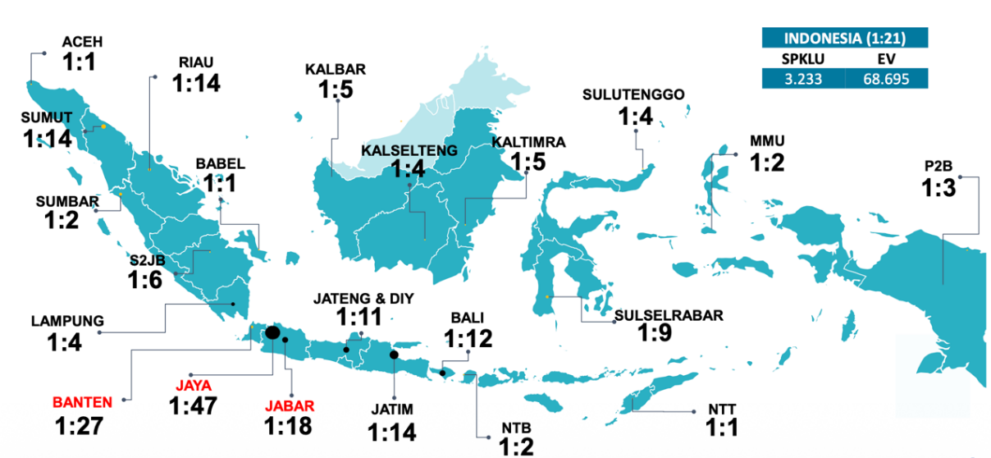
Figure 1. Ratio of public charging stations (SPKLU) to registered EVs by PLN regional unit, end of 2024 (Indonesia 1 : 21; 3,233 SPKLU and 68,695 EVs). Source: PT PLN (Persero).
Read at face value, Aceh is the better-served province. It is not: few people in Aceh own an EV precisely because there is almost nowhere to charge one. Because vehicle registrations rise where chargers are built, a vehicle-based denominator is endogenous to the supply it is meant to evaluate, and the least-served places appear the most served.
Count-based indicators fail in at least four further ways:
- Administrative containment is not reach. A charger inside a district boundary may be far from where people live, and a charger just across a provincial boundary serves residents who are counted against another province. Province-level ratios therefore misstate access in exactly the places where most charging happens: the metropolitan areas that straddle administrative lines, such as Jakarta–Bogor–Depok–Tangerang–Bekasi.
- Counts ignore capacity. A 7 kW unit and a 200 kW unit count equally, although their service capacity differs by more than an order of magnitude.
- Corridor chargers serve through-traffic. Units at toll-road rest areas serve passing travellers rather than local residents.
- Installation is not operation. Chargers may be broken, congested, or difficult to use while still appearing on the map.
The consequence is that equity judgements about Indonesia’s network currently rest on indicators that can invert the truth. A defensible assessment requires an explicit standard of what it means to be served, and measurement that follows that standard all the way from reach to actual use.

1.3 Aim and main research question
The aim of this research is to determine who is really served by Indonesia’s public EV charging network, using an explicit and testable normative standard. The study is organised around a single main question:
Main research question. Who is really served by Indonesia’s public EV charging network, that is, sufficiently and with a real ability to use it, and are shortfalls concentrated in less-developed regions?

The main question has four components that must be answered in order: where each area stands, who falls short and how far, why available access does not become use, and where shortfalls concentrate. Chapter 4 sets out how four research questions answer these components sequentially and how their answers are combined.

1.4 Significance
The research matters for three reasons. First, it supplies the normative clarity that the literature on charging equity currently lacks (Chapter 2). Second, it distinguishes failures that require new sites from failures that require repair, capacity upgrades, or better service, a distinction that is invisible in count-based statistics. Third, it provides evidence from a context, a developing archipelago with an integrated state utility, that is under-represented in a literature dominated by North American, European, and Chinese cases.

1.5 Scope
The study operates at three nested scales. Nationally, all 514 districts and cities of Indonesia are placed on the service ladder. Within the country, the principal unit of comparison is the metropolitan area: villages (desa/kelurahan) in each of the ten national metropolitan areas designated in spatial planning (Jabodetabek, Bandung Raya, Cirebon Raya, Gerbangkertosusila/Surabaya, Kedungsepur/Semarang, Yogyakarta Raya, Mebidangro/Medan, Palembang Raya, Sarbagita/Denpasar and Mamminasata/Makassar), compared on identical travel-time terms. Finally, West Java, the only province with transaction-level usage data, serves for the analysis of actual use; together with Jakarta and mainland Banten it is also the pilot area in which the travel-time pipeline has been built and tested. The study evaluates the current network. It does not prescribe where PLN should build next; that is a decision, not a research question, and it appears only as an implication of the findings.

1.6 Structure of this proposal
Chapter 2 reviews the literature and identifies the research gap. Chapter 3 develops the theoretical and conceptual framework. Chapter 4 states the research questions and the logic by which they answer the main question. Chapter 5 details the design, data, and methods. Chapter 6 sets out the ethics and data-governance arrangements. Chapter 7 summarises the expected contributions and the thesis structure.

Chapter 2. Literature Review and Research Gap
This chapter reviews four bodies of work: the measurement of charging equity, distributive justice in transport, the measurement of accessibility, and evidence from Indonesia. It concludes by identifying four gaps. The review is preliminary; a systematic search will be completed before the claims of novelty in Section 2.5 are finalised.

2.1 Measuring equity in EV charging
Research on charging equity has grown rapidly, but its normative foundations remain thin. A recent review of 91 studies finds that the field relies mainly on geographic information systems, network optimisation, and behavioural modelling, yet lacks consistent normative frameworks for evaluating equity outcomes; it identifies spatial accessibility, cost burdens, reliability and usability, and user awareness and trust as the dimensions most often assessed (Chen et al., 2025). Studies typically compare access across income or racial groups, using ratios, Gini coefficients, or threshold-based comparisons. Examples include threshold equity toolkits applied in Austin, Texas (Jiao et al., 2024) and Gini-based assessments of horizontal and vertical inequity in Hong Kong (Peng et al., 2024). The use of thresholds as such is therefore not new.
Two strands are particularly relevant here. The first concerns reliability. Evidence from the United States shows that charger reliability itself is unevenly distributed (Yu et al., 2025), and user reviews have been shown to be a viable source for evaluating charging performance (Asensio et al., 2020). The second concerns measurement pitfalls. Karner, Pereira and Farber (2025) show how the choice of indicator embeds normative judgements, and Metais et al. (2022) review the planning models that dominate the field. Policy reviews stress that equity outcomes depend on how programmes are designed and delivered (Sheldon, 2022; Center for Law, Energy & the Environment [CLEE], 2024; Soltani Mandolakani & Singleton, 2024).

2.2 Distributive justice in transport
Transport scholarship has established that equity cannot be assessed without stating a principle of justice. Pereira, Schwanen and Banister (2017) review utilitarian, libertarian, intuitionist, Rawlsian and capability-based positions and recommend combining priority for the worst-off with the capability approach. Methods have been proposed to evaluate accessibility under several ethical theories at once (Lucas, van Wee & Maat, 2016). Within accessibility research, sufficientarian thresholds have received growing attention; a recent review notes that few studies involve the public in setting such thresholds (Jasso Chávez et al., 2026). These positions have not yet been operationalised for EV charging services, where availability, reliability and congestion all shape whether access is real.

2.3 Measuring accessibility
Accessibility, the ease of reaching opportunities, is the core variable of transport equity, distinct from mobility or proximity (Geurs & van Wee, 2004). For services with limited capacity, the two-step floating catchment area (2SFCA) family compares supply with competing demand (Luo & Wang, 2003). Its enhanced version (E2SFCA) applies distance decay within catchments (Luo & Qi, 2009). Because total supply is allocated exactly once, scores are comparable across areas. These methods measure potential access; they do not measure whether the service functions or is used.
Two further points from the accessibility literature shape the design. First, the measurement of travel time has become reproducible at scale: open routing engines such as R5, accessible from R through the r5r package, compute door-to-door travel-time matrices on OpenStreetMap road networks for thousands of origins and destinations (Conway, Byrd & van der Linden, 2017; Pereira et al., 2021). Travel-time matrices of this kind, combined with exact facility coordinates, are now the standard foundation for accessibility and equity analysis, and they remove the dependence on administrative boundaries that distorts count-based indicators. Second, equality and equity are distinct questions. The equality of a distribution describes how evenly access is spread across people or places, typically with Lorenz curves and the Gini coefficient; its equity describes whether access follows need, or instead follows income or other advantage, typically with concentration indices that rank people by a socio-economic variable (van Wee & Geurs, 2011; Pereira, Schwanen & Banister, 2017; Karner, Pereira & Farber, 2025). A network can be unequal without being inequitable, and the two can diverge between cities. This study reports both, side by side, for every metropolitan area.

2.4 Evidence from Indonesia
Indonesian studies of public charging have focused predominantly on siting, that is, on where chargers should be built, using location set-covering and optimisation models (for example in Surabaya; Albana et al., 2022; Amilia et al., 2022) and multi-criteria methods such as the analytic hierarchy process. A public geocoded dataset of Indonesian charging stations documents large provincial disparities in per-capita coverage and is offered as a resource for equity research (A Geocoded Dataset of Public EV Charging Stations in Indonesia, 2026). Related Indonesian transport research shows that district-level vehicle ownership responds to new mobility services (Widita & Diwangkari, 2022) and that use of transport infrastructure depends on its surrounding built environment, not on its presence alone (Widita et al., 2025). To the author’s knowledge, no study has evaluated the national network against an explicit standard of justice, compared the equality and equity of charging access across Indonesian metropolitan areas on road-network travel time, nor examined whether available access translates into use.

2.5 Research gap
Five gaps follow from this review:
Gap | Description | How this study responds
G1 Normative | Charging equity studies rarely state which principle of justice defines a fair outcome | Adopts and defends an explicit standard: sufficiency combined with capability
G2 Measurement | Access is measured on single dimensions (distance, counts, ratios), separately from reliability and use | Integrates five service dimensions into one multidimensional sufficiency measure, with depth and decomposition
G3 Access-to-use | Potential access is rarely compared with realised use and the barriers between them | Compares access with use in West Java and identifies conversion factors
G4 Context | Evidence comes mainly from privately operated networks in high-income settings | Provides national evidence from a developing archipelago with an integrated state utility
G5 Scale | Indonesian comparisons are made between provinces, on counts and ratios, although charging is used at the scale of the city and its metropolitan area | Compares metropolitan areas on village-level road-network travel time from exact station coordinates, separating equality from equity

In a preliminary search, no study of EV charging was found that combines sufficientarianism, the capability approach, and a multidimensional deprivation measure such as Alkire–Foster. This is not evidence that none exists. The novelty statement is therefore framed conservatively: to the author’s knowledge, this study is the first to operationalise sufficiency and capability for the national assessment of EV charging services in a developing country.

Chapter 3. Theoretical and Conceptual Framework

3.1 Why an explicit principle is necessary
Different principles of justice deliver different verdicts on the same distribution. A measure of equity is therefore never neutral: choosing an indicator without stating a principle is itself an unstated choice of principle (Pereira et al., 2017). A simple example shows why averages cannot settle questions of fair allocation. When one new charger is added to a network, the population-weighted average access score is the same wherever it is placed, because the capacity is merely redistributed among households. Only principles that attend to who falls below a threshold, or who is worst off, can discriminate between locations.

3.2 Principles considered
Principle | Core idea | Role in this study
Equality and proportionality (Aristotle) | Treat like cases alike; treat unlike cases in proportion to their difference | Diagnostic: horizontal and vertical equity
Utilitarianism | Maximise total benefit | Comparator: shows why averages cannot decide allocation
Priority to the worst-off (Rawls, 1971) | Inequalities are justified only if they benefit the least advantaged | Incorporated through depth-sensitive measures (FGT with α = 2)
Sufficientarianism | What matters is that everyone has enough (Frankfurt, 1987; Crisp, 2003; Casal, 2007) | Core standard of fairness
Capability approach | What matters is the real opportunity to achieve valued functionings (Sen, 1999; Nussbaum, 2011; Robeyns, 2005) | Defines the content of “enough” and the conversion factors
Procedural justice and recognition (Young, 1990; Fraser, 2008) | Who participates in decisions and who is recognised | Discussed as a policy lever; measured only if thresholds are set deliberatively

3.3 Sufficientarianism
Sufficientarianism holds that justice requires everyone to have enough. Following Casal (2007), it combines a positive thesis, that there is special importance in securing enough, with a negative thesis, that once everyone has enough, further inequalities matter less or not at all. This study adopts a weak version: the positive thesis is central, while inequality above the threshold is monitored as a diagnostic rather than ignored.
Sufficientarianism suits the present case for five reasons. The network is young and highly uneven, so the most pressing question is who lacks adequate service. Full equality is neither feasible nor meaningful across an archipelago. Threshold-based verdicts translate directly into action. Thresholds expose shortfalls that averages conceal. And the approach permits explicit, pre-specified standards that can be tested.
Objection | Response in this design
The threshold problem: who decides what is enough? | Thresholds are derived from need, fixed before the data are examined, recorded in a decision log, and tested across a range of values; deliberative setting is considered (Section 6.1)
Indifference to inequality above the threshold | Concentration indices and Theil decomposition are reported as diagnostics
Small gains below the threshold can outweigh large gains above it | Depth and severity (FGT with α = 1, 2) are reported alongside incidence
Capabilities are not directly observable | Observable proxies (transactions and reviews) are used, and the limits of the claims are stated

3.4 The capability approach
The capability approach distinguishes resources (what people have), functionings (what they do or are), and capabilities (what they are really able to do or be) (Sen, 1999; Robeyns, 2005). The same resource yields different capabilities depending on conversion factors: personal, social and environmental conditions that enable or block the use of a resource. Applied to charging, a nearby charger is a resource; the ability to charge reliably when needed is the capability. Conversion factors include the possibility of charging at home, payment systems, physical access, price, and the capacity of the local grid. The approach therefore rejects the view that a charger which appears on a map, but is broken, full or unusable, constitutes service.

3.5 Operational definition of “served”
Definition
A household that depends on public charging is served when it has a real opportunity to charge adequately, that is, when it is above the sufficiency threshold on every step of the service ladder: reachable, sufficient power, functioning, uncongested, and positive user experience.

The definition joins the threshold logic of sufficientarianism with the opportunity logic of the capability approach. It is designed to fail in identifiable places: when an area is not served, the definition reveals at which step and therefore which remedy is implied.

3.6 The five-step service ladder
Service is represented as a ladder of five steps that must be passed in order (Figure 2). An area’s position is the number of consecutive steps passed from the bottom. An area that fails step 3 stops at step 2 even if it would pass steps 4 or 5, because a charger that does not function cannot meaningfully be described as uncongested.
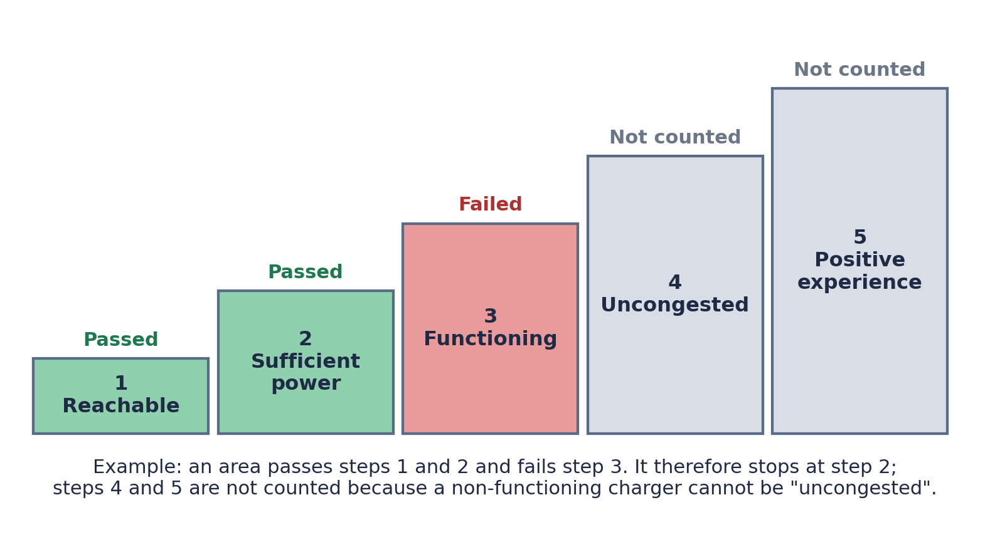
Figure 2. The five-step service ladder and the placement rule.

Step | Question | Indicator | Candidate threshold (fixed ex ante)
1 Reachable | Is a non-corridor charger reachable? | Road-network drive time (r5r/R5) from the village to the nearest charger | ≤ 15 minutes (sensitivity 10 and 30)
2 Sufficient power | Is there enough capacity per competing household? | E2SFCA score (kW per dependent household) | Derived from daily energy need
3 Functioning | Does the charger actually work? | Uptime share | ≥ 90 per cent
4 Uncongested | Can it be used without long waits? | Peak-hour utilisation | ≤ 70–80 per cent
5 Positive experience | Can users use it without other barriers? | Share of reviews reporting problems | ≤ 20 per cent

Where data for steps 3 to 5 are unavailable, an area is recorded as “unobserved”, never as “passed”. Areas with no charger fail every step. Each failure points to a different remedy:

Condition | Fails at step | Implied instrument
No reachable capacity | 1 | New sites
Reachable but insufficient capacity | 2 | Capacity added at existing sites
Reachable but not functioning | 3 | Operations and maintenance, not capital expenditure
Functioning but congested | 4 | Additional plugs at the same site
All passed but poor experience | 5 | Payment, information, physical access, pricing
Four of the five conditions do not require new locations, a distinction invisible in count-based statistics.

3.7 Conceptual framework
Figure 3 summarises the framework. The main question is answered through a standard that joins two principles into one operational definition. That definition is measured on the five-step ladder, for a population of need defined independently of vehicle registrations, and conditioned by conversion factors.

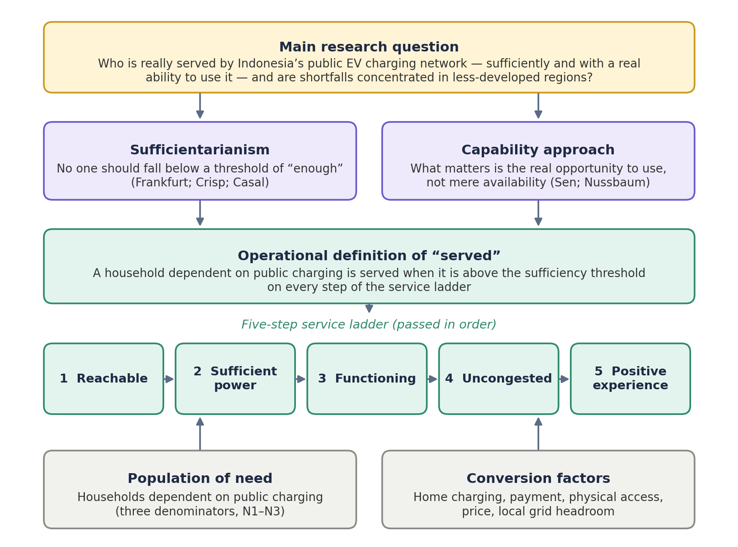
Figure 3. Conceptual framework of the study.

Chapter 4. Research Questions and Logic of Inquiry
This chapter states how the main question is answered. It first sets out the logic of inquiry, then presents each research question with its purpose, method, and output, and finally specifies how the four answers are combined into an objective answer to the main question.

4.1 From the main question to four research questions
The main question cannot be answered in a single step. To know who is really served, one must first know where each area stands on the ladder; only then can one judge who falls below sufficiency and by how much; only then can one ask why available access fails to become use; and only then can one ask whether these shortfalls are concentrated in less-developed regions. The four research questions are therefore sequential: the output of each is the input of the next.
Before any question is answered, the framework is fixed (Stage 0): the definition of “served”, the ladder indicators, thresholds, weights, the cut-off k, and the decision rules are recorded in a decision log before the data are examined. A robustness procedure then tests every verdict across 162 specifications. Figure 4 presents this logic.
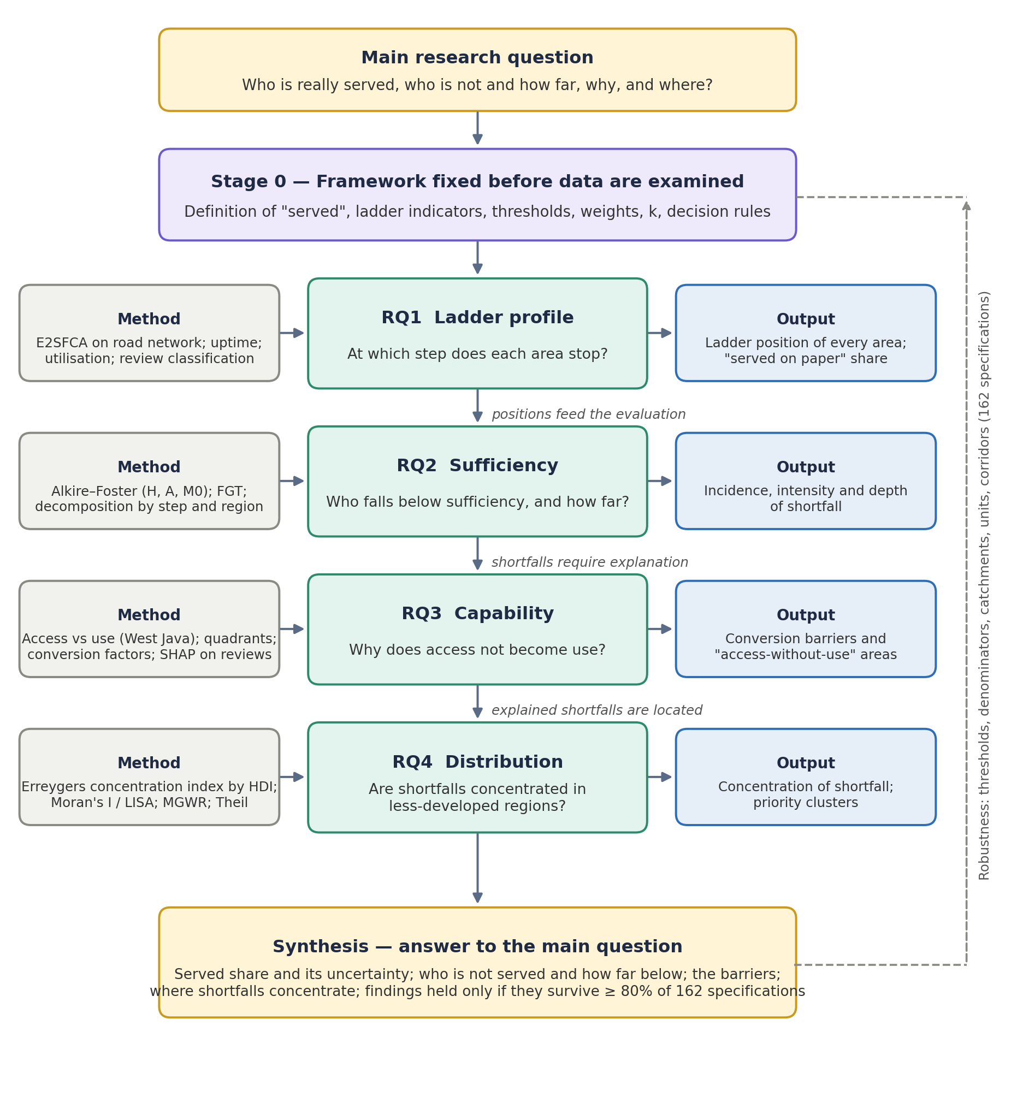
Figure 4. Logic of inquiry: how the four research questions answer the main question.

4.2 RQ1: Ladder profile
RQ1. At which step of the service ladder does each area stop, and how are these stopping points distributed across Indonesia?

Purpose. RQ1 is descriptive. It places every area on the ladder without yet judging whether the distribution is fair. It establishes how much of the network’s apparent coverage is service “on paper” only: areas that pass reach and capacity but fail at reliability, congestion, or experience.
Method. Reach is computed from road-network travel times rather than straight-line buffers. Capacity is measured with the enhanced two-step floating catchment area method (E2SFCA). Reliability is measured from uptime records or, where unavailable, from a service-quality proxy. Congestion is measured from peak-hour utilisation computed from transactions. Experience is measured by classifying user reviews. Each area is then placed using the sequential rule in Section 3.6, at two scales (514 districts and cities nationally; a 5 km grid in West Java).
Output. The distribution of households and areas across ladder positions, maps of ladder positions, and the share of areas served only on paper. These positions are the input to RQ2.

4.3 RQ2: Sufficiency
RQ2. What share of households dependent on public charging falls below the sufficiency threshold on one or more dimensions of service, how deep is the shortfall, and which dimensions and regions contribute most?

Purpose. RQ2 is evaluative. It applies the sufficiency standard to the measurements from RQ1 and converts them into verdicts about who is not served and how far they fall below the standard.
Method. The Alkire–Foster method (Alkire & Foster, 2011) counts, for each area, the weighted number of dimensions in which it falls below threshold, identifies areas as insufficiently served when this count reaches a cut-off k, and reports the incidence (H), the intensity (A), and the adjusted headcount (M0 = H × A). Depth and severity on continuous dimensions are measured with the Foster–Greer–Thorbecke (FGT) indices (Foster et al., 1984). Because M0 is additively decomposable, contributions by dimension and by region are reported. Uncertainty is estimated by cluster bootstrap.
Output. The incidence, intensity, and depth of insufficiency; the dimensions and regions that contribute most; and their sensitivity to k, weights, thresholds, and the definition of need. These verdicts raise the question RQ3 addresses: why do areas with access still fall short?

4.4 RQ3: Capability
RQ3. Does access translate into the real ability to use public charging, and which conversion factors explain the gap between them?

Purpose. RQ3 is explanatory. It tests the capability claim that access is not the same as service, and identifies the barriers that separate them. It is answered in West Java, the only province with transaction-level usage data, which serves as a test bed for the national map.
Method. Potential access (E2SFCA) is compared with realised use (sessions per registered vehicle and utilisation) using rank correlation. Areas are classified into four quadrants: high access and high use (served), high access and low use (served on paper), low access and high use (under-served but functioning), and low access and low use (doubly under-served). Conversion factors are measured from the likelihood of home charging, from labelled user reviews (broken, congested, difficult physical access, failed payment, price), and from local grid headroom. Explainable machine learning (SHAP; Lundberg & Lee, 2017) identifies which factors most strongly shape positive and negative experience.
Output. The areas where access does not convert into use, and the barriers responsible. With shortfalls located (RQ2) and explained (RQ3), RQ4 asks whom they fall upon.

4.5 RQ4: Distribution
RQ4. Are shortfalls in service concentrated in less-developed regions, do insufficiently served areas cluster spatially, and how do the equality and the equity of access differ between Indonesia’s metropolitan areas?

Purpose. RQ4 is distributional and descriptive. It establishes whether the burden of insufficiency falls disproportionately on less-developed regions, which is the final component of the main question, and it compares cities with one another: a network may be evenly spread in one metropolitan area and concentrated among the affluent in another, and only a like-for-like comparison on travel time can show this. It makes no causal claim.
Method. Two comparisons are made. Between metropolitan areas, every village is assigned its road-network travel time to the nearest chargers and the number of chargers reachable within the threshold (Section 5.4); for each metropolitan area the study then reports equality (population-weighted Lorenz curve and Gini coefficient of reachable chargers; share of residents within the threshold) and equity (concentration index of reachable chargers with villages ranked by socio-economic position, and the gap between the poorest and richest population quintiles). Theil decomposition separates inequality within metropolitan areas from inequality between them. Nationally, areas are ranked by the Human Development Index (HDI). The concentration index of the deprivation score is computed with the Erreygers correction for bounded variables (Erreygers, 2009); for a deprivation variable, a negative value indicates concentration among less-developed areas. Spatial clustering is tested with global Moran’s I and local indicators of spatial association (LISA; Anselin, 1995). Multiscale geographically weighted regression (MGWR; Fotheringham et al., 2017) tests whether the relationship between development and service varies across regions. Theil decomposition separates within- and between-group inequality (urban and rural; Klassen typology).
Output. The direction and magnitude of concentration, priority clusters of insufficiently served areas, a league table of metropolitan areas on equality and on equity of access reported separately, and evidence on whether patterns differ between Java and other islands.

4.6 From four answers to one answer
The main question is answered only when the four outputs are combined according to rules fixed in advance. Table 4.1 sets out which evidence answers each component of the main question.
Component of the main question | Answered by | Evidence and decision rule
Who is really served? | RQ1 and RQ2 | Share of dependent households at ladder position 5, i.e., above threshold on all steps, with bootstrap intervals
Who is not served, and how far below? | RQ2 | H, A, M0 across k; FGT depth and severity; decomposition by dimension and region
Why does access not become service? | RQ3 | Quadrant classification; conversion factors ranked by explanatory strength
Are shortfalls concentrated in less-developed regions? | RQ4 | Sign and interval of the Erreygers concentration index; LISA clusters; MGWR coefficients
Do cities differ in equality and equity of access? | RQ4 | Gini and concentration index of reachable chargers per metropolitan area, with intervals; Theil within/between decomposition; ranking stable across thresholds
Is the answer robust? | All | A verdict is reported as a finding only if its direction holds in at least 80 per cent of 162 specifications; otherwise its dependence on specification is reported
Table 4.1. Synthesis rules linking the research questions to the main question.
Three outcome scenarios are anticipated, each of which constitutes a valid answer: (A) widespread service on paper, with shortfalls concentrated in less-developed regions; (B) insufficiency driven mainly by the absence of reachable capacity, especially outside Java; and (C) no concentration of shortfall in less-developed regions. The design reports whichever scenario the evidence supports.

4.7 Working hypotheses
The following hypotheses are falsifiable expectations, not findings:
- H1. A substantial share of areas pass steps 1 and 2 but fail at steps 3 to 5 (service on paper).
- H2. Multidimensional insufficiency is considerably more widespread than insufficiency of reach alone.
- H3. The gap between access and use is larger in less-developed areas.
- H4. Deprivation scores are concentrated in areas with low HDI (negative concentration index).
- H5. Metropolitan areas differ more in the equity of access than in its equality: the Gini coefficient of reachable chargers is similar across cities, while the concentration of access among affluent villages is strongest in the largest metropolitan areas.

Chapter 5. Research Design and Methods

5.1 Design overview
The study uses an observational, descriptive-evaluative design at two nested scales, with all normative parameters fixed before the data are examined. Work proceeds in eight steps (Figure 5). Steps 1 to 3 constitute the design stage and are recorded in a decision log before analysis. The order of work differs from the order of the research questions: step 4 answers RQ1, step 5 answers RQ3, step 6 answers RQ2, and step 7 answers RQ4.
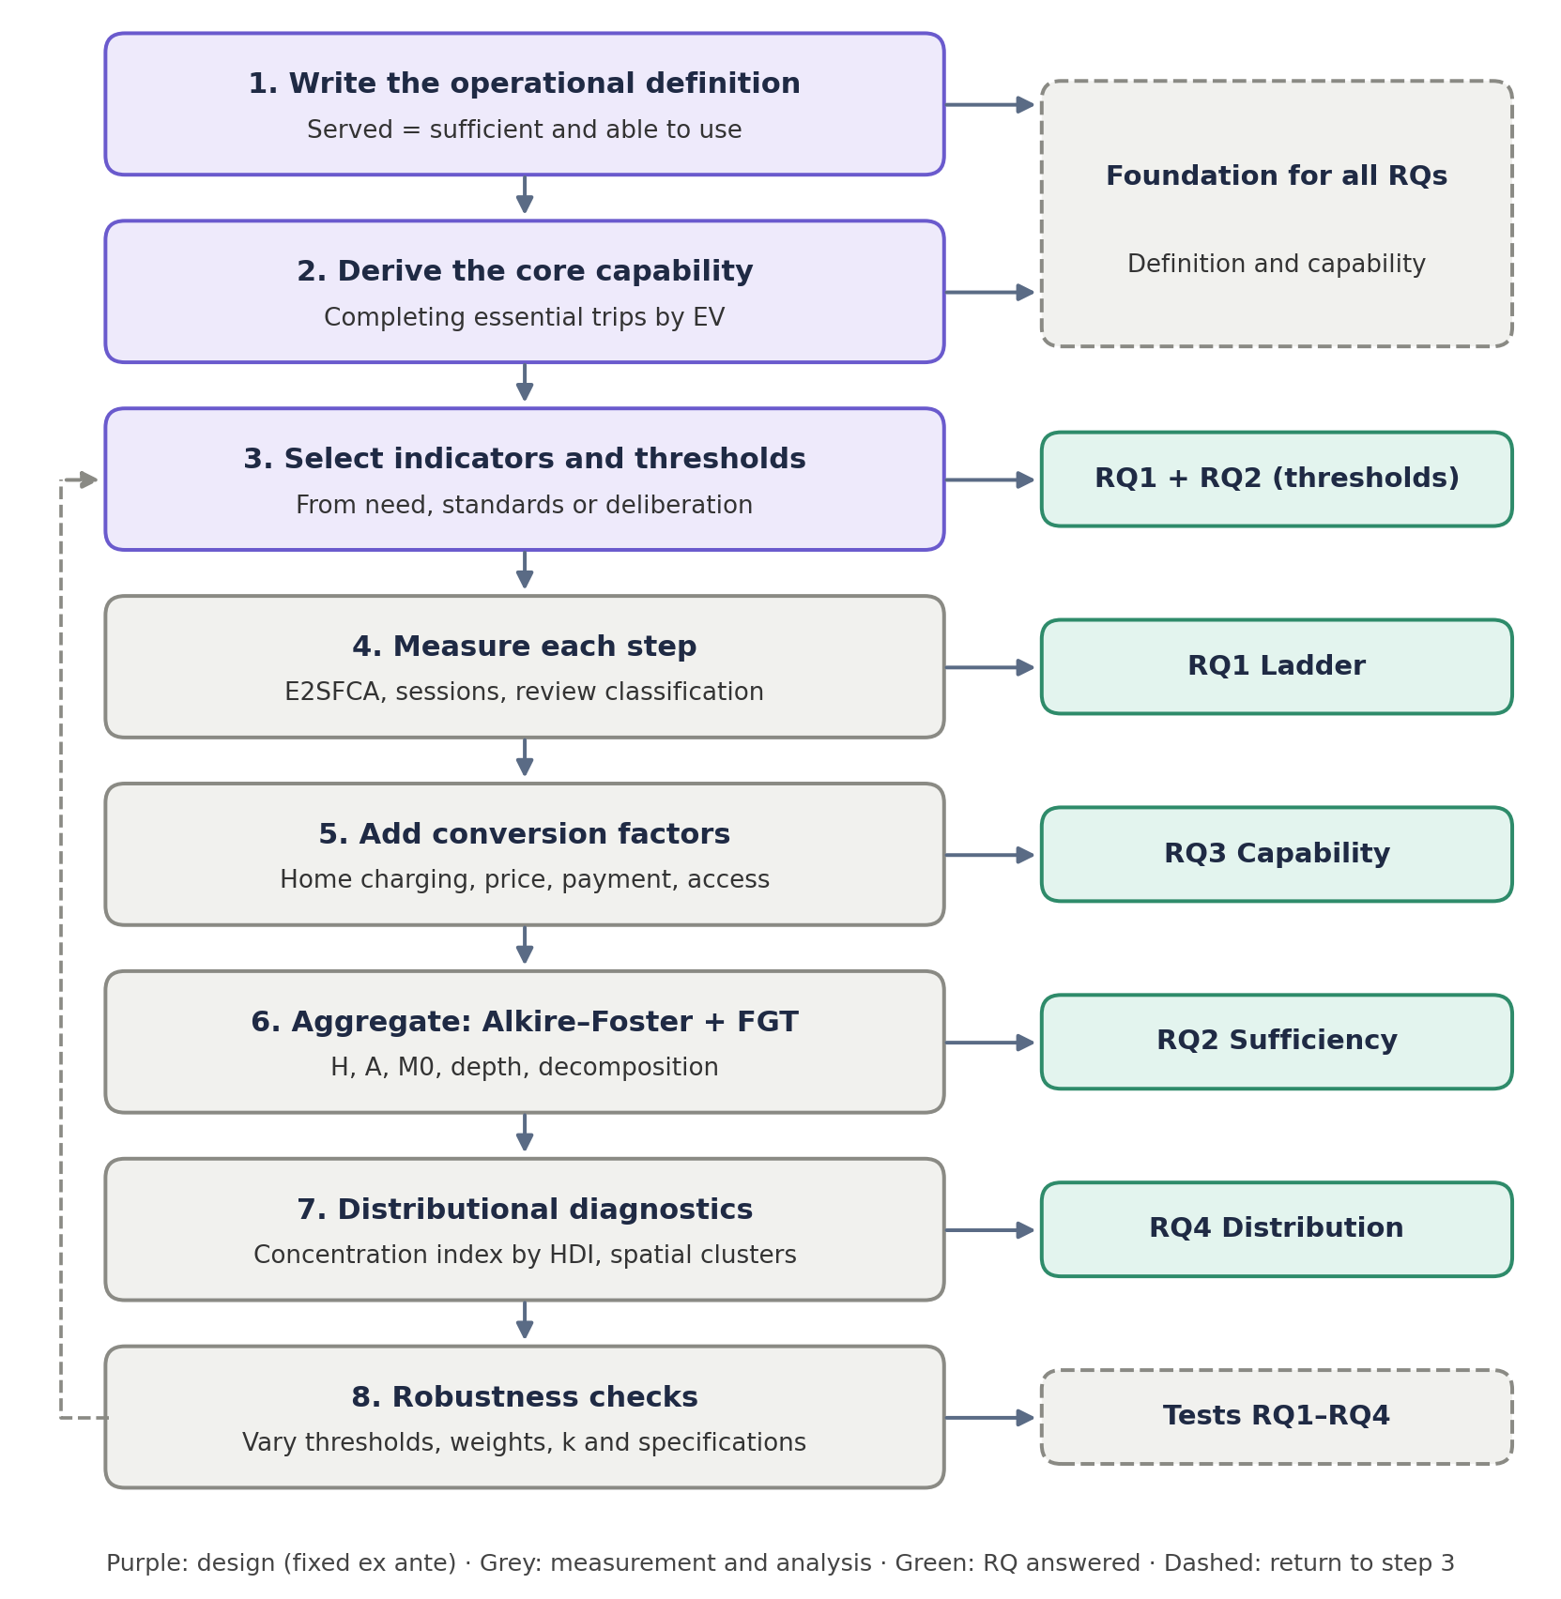
Figure 5. Eight-step workflow and the research question answered at each step.

5.2 Data
Data | Content | Used for | Status
National SPKLU master file | 3,233 units at 2,192 locations; coordinates, power class, capacity, status | RQ1, RQ2, RQ4 | Held
Charging transactions, West Java | 101,020 anonymised sessions at 636 chargers | Step 4, RQ3 | Held
User reviews | Reviews for 584 locations with service-quality scores; 1,000 to be labelled | Step 5, RQ3 | Held; labels to be produced
Socio-economic data | Statistics Indonesia (BPS) Population Census 2022; Village Potential (PODES); Economic Census; Klassen typology 2023; HDI | Need and ranking | Held
Road network | OpenStreetMap extracts (Geofabrik) per province or metropolitan area | Step 1, RQ4 | Public (West Java held)
Travel-time matrices | r5r/R5 village-to-village car travel times (p50) for all village pairs within 60 minutes; one matrix per metropolitan area | Step 1, RQ4 | Held for West Java, Jakarta and mainland Banten; to be built for other areas
Gridded population | Kontur Population 2023 (H3 resolution 8, ~0.7 km²), aggregated to villages | Need (N1), population weighting | Public
Village boundaries | GADM 4.1 level 4 / BPS–HDX 2020 desa/kelurahan polygons, 10-digit BPS codes | Origins and need | Public
Distribution transformer survey | 53,797 transformers with location and loading | Conversion factors | Held
Home-charging connections | 3,694 applications | Population of need (N2) | Held
PLN customer load by sub-district | Connection capacity and dwelling type | N2 at finer resolution | Requested
Charger uptime logs | Operational availability | Step 3 | Requested
EV registrations by district and month | Samsat, Korlantas, Dishub | RQ3 | Not yet obtained
Charger commissioning dates | Monthly precision | Optional extension | Requested
Where data cannot be obtained, pre-specified fallbacks apply: the PODES share of owner-occupied landed housing replaces PLN customer data for N2; a service-quality proxy replaces uptime logs for the subset of the network with reviews; and RQ3 is restricted to utilisation and reviews if registrations are unavailable. Each fallback weakens a specific claim, which is then stated explicitly.

5.3 Units of analysis and population of need
Every verdict is computed nationally for 514 districts and cities; for villages (desa/kelurahan) within each of the ten metropolitan areas, the unit at which travel time is measured and metropolitan areas are compared; and for 1,292 grid cells of approximately 5 km in West Java. Villages are used rather than a grid for the metropolitan comparison because they are the finest unit that carries official codes, can be joined to census and village-potential data, and are small enough in urban areas (typically 1–5 km²) for a single origin point to represent them. The difference between scales is reported as a result, since aggregation can conceal inequality. Chargers at toll-road rest areas, at fuel stations on inter-city national roads, or more than 2 km from the nearest settlement are classified as corridor chargers and excluded from local service; the rule is validated manually on a random sample of 200 chargers and revised if accuracy falls below 90 per cent.
The population of need is the set of households that depend on public charging, not the whole population and not EV owners alone. Three denominators are reported. N1 uses all households (Census 2022) and is non-circular but overly broad. N2, the primary denominator, subtracts households likely to be able to charge at home, proxied by PLN residential connections of at least 2,200 VA in landed housing, because the ability to charge at home depends on access to off-street residential parking, which is unevenly distributed across dwelling types (Taylor, 2020). N3 uses registered EVs and is circular; it is reported only for comparison with the literature.

5.4 Measuring the ladder (RQ1)
Road-network travel times are computed with the R5 routing engine through the r5r package (Pereira et al., 2021), following the workflow established by the main supervisor for West Java. For each metropolitan area, a routable network is built from the OpenStreetMap extract; one origin point is placed inside every village polygon (a point guaranteed to lie on the surface, not the centroid, which can fall outside irregular villages); and a village-to-village travel-time matrix is computed by car for a fixed weekday departure time, with a 60-minute cut-off. Stations are assigned to villages by exact coordinates, so the travel time from a village to its nearest charger, and the number of chargers reachable within 15 and 30 minutes, follow directly from the matrix. This workflow has been implemented and tested end to end for West Java, Jakarta and mainland Banten (Section 5.10). Capacity is measured with E2SFCA on the same travel-time matrix:
$$R_{j}=\frac{S_{j}}{\sum_{k}{N_{k}w\left(t_{kj}\right)}}$$
$$A_{i}=\sum_{j}{R_{j}w\left(t_{ij}\right)}$$
where S_{j} is the capacity of charger j (kW), N_{k} the population of need in area k, t the travel time, and w a stepwise distance-decay weight. The conservation property, Σ_{i} A_{i} N_{i} = Σ_{j} S_{j}, is checked numerically in every run, and the implementation is first validated on synthetic cases. Utilisation for step 4 is the sum of overlapping session durations divided by (plugs × 60 minutes), averaged over weekday evening peaks. Because transaction records were collected for billing, queues and failed sessions are not recorded; these are inferred from patterns and labelled as inferences.

5.5 Measuring sufficiency (RQ2)
For area i and dimension j, g_{ij} = 1 if the area is below the threshold on that dimension. With weights w_{j} summing to one:
$$c_{i}=\sum_{j}{w_{j}g_{ij}}$$
$$H=\frac{households in areas with c_{i}≥k}{all dependent households}$$
$$A=mean of c_{i} among areas with c_{i}≥k, M_{0}=H×A$$
$${FGT}_{α}=\frac{1}{n}\sum_{x_{i}<z}{{\left(\frac{z-x_{i}}{z}\right)}^{α}}, α=1 (depth), 2 (severity)$$
Equal weights are the baseline, and k is reported across its full range, from the union approach (deprived in at least one dimension) to the intersection approach (deprived in all). Contributions by dimension and region are reported. Uncertainty is estimated by bootstrap clustered by district or city with 2,000 replications; no index is reported without an interval.

5.6 Measuring capability (RQ3)
Spearman’s rank correlation between access and use is computed for West Java, and areas are classified into the four quadrants of Section 4.4 using medians. Because transactions are anonymised, with no persistent customer identifier, new and returning users are distinguished through sessions per registered vehicle, which requires registration data. User reviews are analysed with TF-IDF features and topic modelling. A stratified random sample of 1,000 reviews (by province and charger class) is coded by two coders using a binary five-label codebook, with Cohen’s kappa computed and the codebook revised if kappa falls below 0.6, after a pilot of 100 to 200 reviews. Classifiers progress from a TF-IDF and support-vector-machine baseline to a fine-tuned Indonesian transformer, evaluated by macro-F1 with five-fold cross-validation stratified by location so that reviews of the same charger do not appear in both training and test sets. SHAP attributions identify the drivers of positive and negative perceptions, and classification is paired with qualitative reading of a sample, since frequencies of words do not establish their meaning.

5.7 Measuring distribution (RQ4)
For the comparison between metropolitan areas, each area receives the same set of measures computed on its villages, weighted by resident population: the share of residents within 15 and 30 minutes of a charger; the population-weighted Lorenz curve and Gini coefficient of chargers reachable within the threshold (equality); the concentration index of reachable chargers with villages ranked by the socio-economic position of their district (expenditure per capita or HDI from Statistics Indonesia; a village-level wealth proxy where one is available), with the Erreygers correction for the bounded share measure (equity); and the gap between the poorest and richest population quintiles. Theil decomposition separates inequality within metropolitan areas from inequality between them. The comparison is reported as paired rankings, one on equality and one on equity, so that a city that is unequal but not inequitable can be told apart from one that is both.
Nationally, the concentration index of the deprivation score, with areas ranked by HDI, is computed with the Erreygers correction because the score is bounded. Interpretation is tied to the ranking variable: HDI, rather than household income, is used because EV owners tend to be wealthier, so income-based rankings could mislead. Global Moran’s I and LISA identify clusters, with low–low clusters forming the priority map. MGWR allows each covariate its own bandwidth and tests whether the association between development and service is specific to Java. Theil decomposition reports horizontal equity within and between groups.

5.8 Robustness and pre-specification
Five analytical choices can each be defended in more than one way: the denominator (N1, N2, N3), the catchment (10, 15, 30 minutes), the threshold (0.5, 1.0, 1.5 times baseline), the spatial unit (district or grid), and the treatment of corridor chargers (excluded, weighted 0.5, included). Together these yield 3 × 3 × 3 × 2 × 3 = 162 specifications, all of which are run and reported as a specification curve (Simonsohn et al., 2020). For RQ2, k and the weights are varied as additional sensitivity dimensions.
Principle | Pass rule (candidate, fixed ex ante) | Meaning of failure
Sufficiency (primary) | H ≤ 0.10, with the confidence interval not crossing 0.10 | Some households lack minimum service; the most serious failure
Multidimensional sufficiency | M0 reported across k; pass rule agreed with supervisors before analysis | Multidimensional insufficiency is widespread
Vertical equity | Erreygers concentration index of access ≤ 0, interval not crossing zero | Access favours more-developed areas
Horizontal equity | Conditional on need, the HDI coefficient on access is not different from zero (α = 0.05) and H differs by ≤ 10 percentage points across Klassen classes | Equal need receives unequal access
The following practices are prohibited and recorded in the decision log: moving a threshold after observing H or M0; selecting k or a denominator for the most striking result; reporting only the Gini coefficient; and treating a statistically insignificant difference as evidence of no difference.

5.9 Validity, limitations and boundaries of claims
Threat | Consequence | Mitigation
N2 cannot be constructed | H and M0 lose their non-circular basis | Three ordered proxies; PODES fallback; weaker claim stated
Uptime logs unavailable | Step 3 covers only reviewed chargers | Proxy with coverage reported; test whether review presence correlates with access
Review authors are self-selected | Step 5 describes reviewers, not all users | Areas without reviews recorded as unknown
Transactions recorded for billing | Queues and failed sessions unobserved | Inferred from patterns and labelled as inference
Nameplate capacity exceeds delivered power | Access overstated | Comparisons across places remain informative; threshold comparisons are conservative
Modifiable areal unit problem | Inequality muted at district scale | Two scales; difference reported
Capabilities are unobservable | RQ3 relies on proxies | Stated as a boundary of the claim
Correlated dimensions (reach and power) | Double counting | Redundancy checks; results re-estimated without each dimension

No causal claims are made for RQ1 to RQ4. Spatial association between service and development does not show that development causes allocation. The relationship between EV adoption and infrastructure is bidirectional, so registrations serve only as context. West Java findings test, rather than represent, the national pattern. If the 162 specifications produce the same map, half of the methodological contribution becomes a reported negative result, while the sufficiency verdicts remain.

5.10 Pilot workflow and the outputs it will produce
The travel-time workflow of Section 5.4 has been implemented end to end for a pilot area comprising West Java, Jakarta and the mainland districts of Banten (the area covered by the supervisor’s r5r script), with 6,669 villages as origins and 1,556 station locations from the national master file assigned to 634 of them by exact coordinates. Resident population from the Kontur 2023 grid is aggregated to each village so that every measure is weighted by people rather than by places. The pilot is a test of the method, not a result of the thesis; its purpose is to confirm that the chain from station coordinates to village polygons, travel-time matrix, population of need, and equality/equity measures runs without manual steps and produces readable output. The outputs it generates, which the thesis will produce for every metropolitan area, are:
- a village-level map of travel time to the nearest charger, and of the number of chargers and villages reachable within 15 and 30 minutes;
- the distribution of residents by travel-time band, and the share of residents beyond the 60-minute cut-off;
- Lorenz curves and Gini coefficients of reachable chargers, contrasted with the Gini of chargers located within the village itself, to show how much counting reach rather than possession changes the verdict;
- concentration indices of reachable chargers against population density and against district socio-economic position, and the poorest-to-richest quintile gap;
- a comparison of metropolitan areas against each other and against non-metropolitan districts on the same measures.
The pilot results are maintained in the project’s research dashboard, where they are recomputed from the raw inputs by script, and will be reported in the thesis only once the same pipeline has been run for all metropolitan areas and the robustness procedure of Section 5.8 has been applied. The pilot has also fixed two practical decisions: villages are identified by their 10-digit BPS code so that routing outputs, boundary files and census data join without name matching, and stations are attached to villages by point-in-polygon rather than by the address fields of the master file, which are inconsistent.

Chapter 6. Ethics and Data Governance

6.1 Ethics approval and data governance
- Ethics approval. An application to the Monash University Human Research Ethics Committee (MUHREC) is planned for November 2026, covering secondary data and, if adopted, deliberative threshold-setting with stakeholders.
- Operational data. Transaction records contain no persistent customer, card, or plate identifiers. A data-use agreement with PLN will specify scope, confidentiality, and freedom to publish. Small cells will be suppressed or aggregated.
- Reviews. Reviews are public, but author names and identifying attributes are removed from analytical data and figures, and the terms of service of source platforms are checked before any text is shared.
- Storage. Public repositories contain only code, aggregated data, and synthetic data; raw data are held in controlled storage.
- Researcher position. The researcher is a PLN employee on study leave, and PLN operates the network being assessed. This is disclosed. Findings will be reported as they are, including unfavourable ones, and the research role is kept separate from any corporate role.

Chapter 7. Expected Contributions and Thesis Structure

7.1 Expected contributions
Type | Contribution | Condition for the claim
Theoretical | An explicit normative standard, combining sufficiency and capability, for assessing charging equity | The systematic search confirms the absence of such operationalisation for EV charging
Methodological | A multidimensional sufficiency measure for charging services, with incidence, intensity, depth, and decomposition | The integration is the author’s proposal and is checked against the literature
Methodological | Quantification of how far equity verdicts depend on the definition of need and access | All specifications are run and reported
Empirical | National evidence from a developing archipelago with an integrated state utility | Data quality and coverage are sufficient; claims of being “first” are avoided without audit
Empirical | A like-for-like comparison of equality and equity of charging access across Indonesia’s metropolitan areas on road-network travel time | Travel-time matrices are built for every metropolitan area on the same specification
Policy | A distinction between failures requiring new sites and failures requiring repair, capacity, or service improvements; staged targets | Thresholds are derived transparently

7.2 Proposed thesis structure
Component | Content | Status
Introduction and framework | Problem, normative standard, conceptual framework (Chapters 1 to 3 of this proposal) | Drafted
Paper A | Measurement: ladder profile and multidimensional sufficiency (RQ1 and RQ2) | New
Paper B | Capability and distribution (RQ3 and RQ4), including the metropolitan comparison of equality and equity of access | New
Supporting papers | Ex-ante prediction of station-level energy sales; access and use in West Java | New
Synthesis chapter | Capability-sufficiency map and policy implications | New
Optional extension | Network change, 2023 to 2026 | Conditional on data

7.3 Concluding remarks
This research begins from a simple observation: an indicator that ranks Aceh above Jakarta in charging provision is misleading. It replaces the counting of chargers with a question that can be answered and tested: who is really served, sufficiently and with a real ability to use the service? The answer is pursued through an explicit standard stated in advance, a five-step ladder that fails in identifiable places, thresholds fixed before the data are examined, and verdicts tested across 162 specifications. The outcome will be an answer that is defensible rather than merely available, and that distinguishes where Indonesia needs new chargers from where it needs chargers that work.

References
Albana, A. S., Muzakki, A. R., & Fauzi, M. D. (2022). The optimal location of EV charging stations at Surabaya using the location set covering problem. In 2022 International Conference on Technology and Policy in Energy and Electric Power (ICT-PEP) (pp. 95–99). IEEE.
Alkire, S., & Foster, J. (2011). Counting and multidimensional poverty measurement. Journal of Public Economics, 95(7–8), 476–487.
Amilia, N., Palinrungi, Z., Vanany, I., & Arief, M. (2022). Designing an optimized electric vehicle charging station infrastructure for urban area: A case study from Indonesia. In 2022 IEEE 25th International Conference on Intelligent Transportation Systems (ITSC) (pp. 2812–2817). IEEE.
Anselin, L. (1995). Local indicators of spatial association—LISA. Geographical Analysis, 27(2), 93–115.
Asensio, O. I., Alvarez, K., Dror, A., Wenzel, E., Hollauer, C., & Ha, S. (2020). Real-time data from mobile platforms to evaluate sustainable transportation infrastructure. Nature Sustainability, 3(6), 463–471.
Casal, P. (2007). Why sufficiency is not enough. Ethics, 117(2), 296–326.
Center for Law, Energy & the Environment. (2024, December). Equitable EV action plan framework: A roadmap for local leadership. UC Berkeley School of Law. https://www.law.berkeley.edu/wp-content/uploads/archive/2024/12/Equitable-EV-Action-Plan-Framework_CLEE.pdf
Chen, B., Moore, A., Jia, B., Zhang, K., & Cao, M. (2025). Equity considerations in public electric vehicle charging: A review. World Electric Vehicle Journal, 16(10), 553. https://doi.org/10.3390/wevj16100553
Conway, M. W., Byrd, A., & van der Linden, M. (2017). Evidence-based transit and land use sketch planning using interactive accessibility methods on combined schedule and headway-based networks. Transportation Research Record, 2653(1), 45–53. https://doi.org/10.3141/2653-06
Crisp, R. (2003). Equality, priority, and compassion. Ethics, 113(4), 745–763.
Erreygers, G. (2009). Correcting the concentration index. Journal of Health Economics, 28(2), 504–515.
Foster, J., Greer, J., & Thorbecke, E. (1984). A class of decomposable poverty measures. Econometrica, 52(3), 761–766.
Fotheringham, A. S., Yang, W., & Kang, W. (2017). Multiscale geographically weighted regression (MGWR). Annals of the American Association of Geographers, 107(6), 1247–1265.
Frankfurt, H. (1987). Equality as a moral ideal. Ethics, 98(1), 21–43.
Fraser, N. (2008). Scales of justice: Reimagining political space in a globalizing world. Columbia University Press.
A geocoded dataset of public EV charging stations in Indonesia with provider, venue, and provincial coverage information (Version 1) [Data set]. (2026). Mendeley Data. https://doi.org/10.17632/z2bvd5r574.1
Geurs, K. T., & van Wee, B. (2004). Accessibility evaluation of land-use and transport strategies: Review and research directions. Journal of Transport Geography, 12(2), 127–140.
Hsu, C.-W., & Fingerman, K. (2021). Public electric vehicle charger access disparities across race and income in California. Transport Policy, 100, 59–67.
Jasso Chávez, J. A., Kelly, N., Pereira, R. H. M., Boisjoly, G., & Manaugh, K. (2026). Revisiting sufficientarianism in accessibility research: A review of accessibility poverty. Transport Reviews. Advance online publication. https://doi.org/10.1080/01441647.2026.2720413
Jiao, J., Choi, S. J., & Nguyen, C. (2024). Toward an equitable transportation electrification plan: Measuring public electric vehicle charging station access disparities in Austin, Texas. PLoS ONE, 19(9), e0309302. https://doi.org/10.1371/journal.pone.0309302
Karner, A., Pereira, R. H. M., & Farber, S. (2025). Advances and pitfalls in measuring transportation equity. Transportation, 52(4), 1399–1427. https://doi.org/10.1007/s11116-023-10460-7
Lucas, K., van Wee, B., & Maat, K. (2016). A method to evaluate equitable accessibility: Combining ethical theories and accessibility-based approaches. Transportation, 43(3), 473–490.
Lundberg, S. M., & Lee, S.-I. (2017). A unified approach to interpreting model predictions. Advances in Neural Information Processing Systems, 30.
Luo, W., & Qi, Y. (2009). An enhanced two-step floating catchment area (E2SFCA) method for measuring spatial accessibility to primary care physicians. Health & Place, 15(4), 1100–1107.
Luo, W., & Wang, F. (2003). Measures of spatial accessibility to health care in a GIS environment: Synthesis and a case study in the Chicago region. Environment and Planning B, 30(6), 865–884.
Metais, M. O., Jouini, O., Perez, Y., Berrada, J., & Suomalainen, E. (2022). Too much or not enough? Planning electric vehicle charging infrastructure: A review of modeling options. Renewable and Sustainable Energy Reviews, 153, 111719.
Nussbaum, M. C. (2011). Creating capabilities: The human development approach. Harvard University Press.
Peng, Z., Wang, M. W. H., Yang, X., Chen, A., & Zhuge, C. (2024). An analytical framework for assessing equitable access to public electric vehicle chargers. Transportation Research Part D: Transport and Environment, 126, 103990. https://doi.org/10.1016/j.trd.2023.103990
Pereira, R. H. M., Saraiva, M., Herszenhut, D., Braga, C. K. V., & Conway, M. W. (2021). r5r: Rapid realistic routing on multimodal transport networks with R5 in R. Findings. https://doi.org/10.32866/001c.21262
Pereira, R. H. M., Schwanen, T., & Banister, D. (2017). Distributive justice and equity in transportation. Transport Reviews, 37(2), 170–191.
Rawls, J. (1971). A theory of justice. Harvard University Press.
Robeyns, I. (2005). The capability approach: A theoretical survey. Journal of Human Development, 6(1), 93–117.
Sen, A. (1999). Development as freedom. Oxford University Press.
Sheldon, T. L. (2022). Evaluating electric vehicle policy effectiveness and equity. Annual Review of Resource Economics, 14, 669–688.
Simonsohn, U., Simmons, J. P., & Nelson, L. D. (2020). Specification curve analysis. Nature Human Behaviour, 4(11), 1208–1214.
Soltani Mandolakani, F., & Singleton, P. A. (2024). Electric vehicle charging infrastructure deployment: A discussion of equity and justice theories and accessibility measurement. Transportation Research Interdisciplinary Perspectives, 24, 101072. https://doi.org/10.1016/j.trip.2024.101072
Taylor, E. J. (2020). Parking policy: The politics and uneven use of residential parking space in Melbourne. Land Use Policy, 91, 103706. https://doi.org/10.1016/j.landusepol.2018.11.011
van Wee, B., & Geurs, K. (2011). Discussing equity and social exclusion in accessibility evaluations. European Journal of Transport and Infrastructure Research, 11(4), 350–367. https://doi.org/10.18757/ejtir.2011.11.4.2940
Widita, A., & Diwangkari, A. (2022). How disruptive is a disruption? The association between TNCs and vehicle ownership in urbanizing Indonesia. Case Studies on Transport Policy, 10(1), 572–580. https://doi.org/10.1016/j.cstp.2022.01.017
Widita, A., Ikaputra, & Widyastuti, D. T. (2025). TOD-related features and station-level ridership: Insights from the Jakarta Metropolitan Area, Indonesia. Public Transport, 17, 505–527. https://doi.org/10.1007/s12469-024-00369-4
Young, I. M. (1990). Justice and the politics of difference. Princeton University Press.
Yu, Q., Que, T., Cushing, L. J., Pierce, G., Shen, K., Kejriwal, M., Yao, Y., & Zhu, Y. (2025). Equity and reliability of public electric vehicle charging stations in the United States. Nature Communications, 16, 5291. https://doi.org/10.1038/s41467-025-60091-y

