NAME : QASEH MARSYA QAIYSARA BINTI MOHD ZULFIKAR

CLASS : 1K5

screenshot of result (database created)

1. Database ( library_system )



1. Table ( book_data )

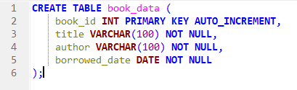

1. Add 5 books into the table created

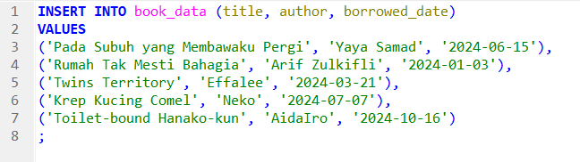

* **List all book**

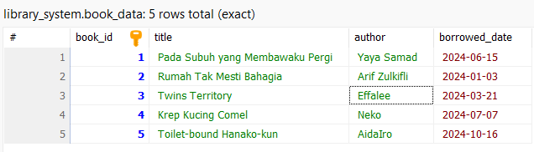

* **Find books by author**



Result :

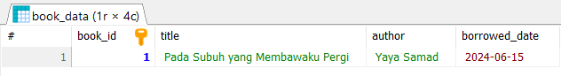

* **Find books borrowed on a specific date**

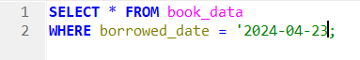

Result :

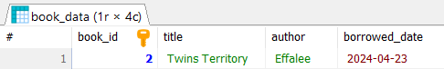

* **Find books borrowed after a certain date**

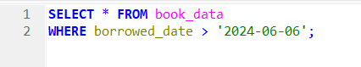

Result :

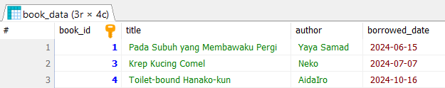

* **Data Manipulation**

Borrowed Date

Before Update borrowed_date



Update borrowed_date



After Update borrowed_date

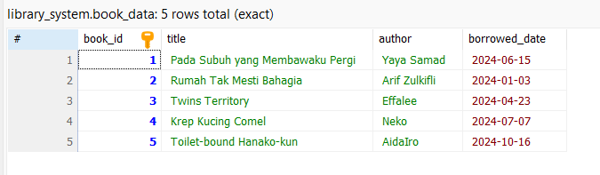

Delete a book

Before Delete a book



Delete a book

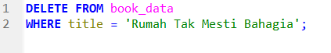

After delete a book

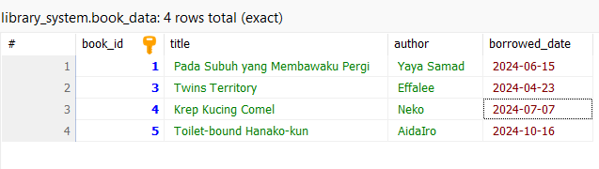

Re-add a deleted book

Before re-add a deleted book



Re-add a deleted book

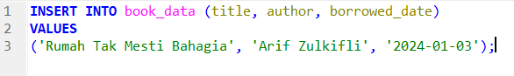

After re-add a deleted book

