**Note: Step no 1 to 7 are required only once on any laptop**

1. Download & extract allure cli utility from this url. Better to copy extracted folder to some location which would never change

<https://repo.maven.apache.org/maven2/io/qameta/allure/allure-commandline/2.13.5/allure-commandline-2.13.5.zip>

1. Open control panel > change view to “Small Icons” > Click User Accounts

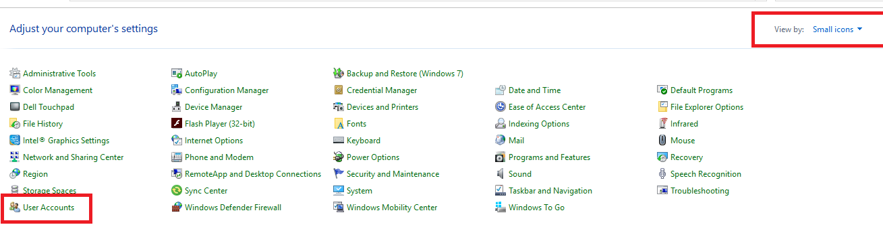

1. Click “Change my environment variables”

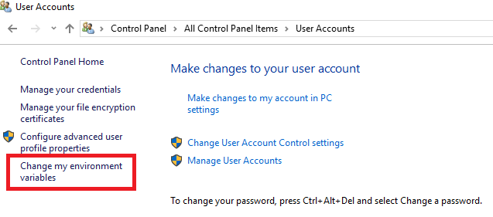

1. Click on Path and then click edit

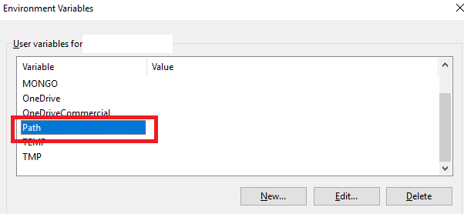

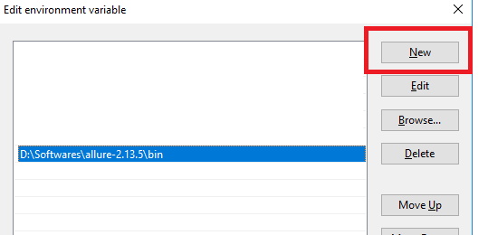

1. Add path of allure bin folder there



1. Check your allure version by opening CMD and running this command

Allure –version

1. Allure version should be shown as 2.13.5
2. To open allure report in browser, go to directory where you have allure-report

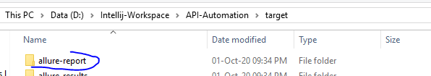

1. Open cmd in above directory by typing cmd in address bar and then hitting enter



1. After cmd is opened type allure open

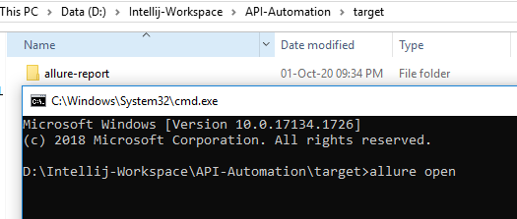

1. CMD will look like this and will open report in your default browser

