**QatHome***The Internet Queue*

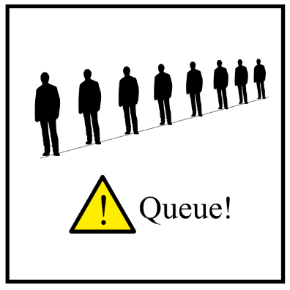

***Abstract***

*It is estimated that each person spends more than 100 hours per year waiting in line. This time is wasted and may be employed in more productive or pleasant activities.*

*QatHome is a website that allows people to stand in-line online finally allowing them to do whatever they like the most during their waiting time. The only thing people have to do is to open the QatHome website, find the place to go, immediately see how long the queue is and get the ticket online. The system will warn them when it is time to go.*

**OMG another queue!**

When you go to a crowded place, such as an office, a public service, a bank, a hospital, whatever, you already known what is going to happen. Yes, you are going to stand in line for a long time, you will not work, nor you will enjoy yourself. At least you might enjoy sharing your frustration with other people next to you.

Have you ever thought to do your queue online? Why not standing in-line online?  
There are some places around the world that already offer their customers the possibility to start queuing online and people love this service.

This project is an internet-based solution that will allow people to stop wasting their time in line, everywhere and soon.

**Normal queue vs QatHome**

Well, we all know how a normal queue works. You go somewhere, push a button, get your ticket (in case there are tickets), take a seat (lucky you if you have one) and wait.

Imagine if instead of first going somewhere, you open QatHome, click three times, get your ticket online and wait for your turn while keeping doing whatever you like. Fifteen minutes before your turn, you get an SMS that tells you “it’s time to go to that place =)”. Only at that moment you go there and wait only a few minutes.

**In-advance reservation**

QatHome can start queuing instead of you. You only have to tell that you want to be at the post office at 11.00. The computer running our statistical model will issue the ticket at the right time instead of you, so that you can go there at 11.00 (and not before that time) and get your service in a few minutes. You will get a reminder 15 minutes before your turn just to be sure that you do not miss it.

**Advantages for the consumer**

Save time.   
Get your service whenever you want.  
Queue wherever you like, at work, at home, or in the bus.   
Get your service in a relaxed environment with only two or three people before you.  
QatHome is free of charge.

**Additional features for consumers**

Skip the queue: if you are really in a rush and you want to skip the queue, you can pay a fee and get your service when you need it. It is the same idea of the airport priority line. With QatHome you can have a priority service at your local public service, post office or your favorite take-away.

**QatHome for business**

If you manage a crowded business, in order to properly manage your customers in line, you need an expensive touch-screen printer, wires everywhere in your office so that your queue system can communicate with your employees and your customers and finally you need a place for people waiting in line, if possible with air-conditioning and chairs.

With QatHome there is no more need for any of those. You can replace your expensive system with standard cheap computers and a web browser. Your employees will use standard computers to ask QatHome for the next customer. If some of your customers still want to start queuing at your office, they will still be able to do it. But instead of your expensive machines they will find a standard public computer where they will start queuing in the same way they can start queuing with their own computers. Setting up these computers is easy and requires no infrastructure. There will be no more need for the maintenance of printers. Moreover the room that is now full of people will be suddenly empty and available for your business needs.

Many of your costumers will enjoy the special “in-advance” reservation service that will allow them to come to your desks whenever they want without you having to do anything. QatHome will seamlessly put them in line at the right moment. This means more satisfied customers and relaxed employees for a successful business.

The basic service is totally free.

**Additional features for business**

The free basic service allows to manage one office with one queue. Premium service will allow you to manage multiple offices with unlimited parallel services and queues. With premium service you will be able to monitor the performance of your employees, to receive feedbacks from your customers and you will have many other features.

The low cost license fee of our premium service is only a small fraction of what you pay right now. The first year is free.