

QATIP Intermediate

Azure Lab07

Managing Azure Storage using Terraform

Contents
Lab Objectives 1
Teaching Points 2
Before you begin 2
Solution 2
Task 1. Create a Resource Group 3
Task 2. Add a Blob Storage Account and Container 4
Task 3. Examine the Files Upload code 6
Task 4. Create an Azure Storage management policy 10
Task 5. Create an Azure Storage Access Signature token 12
Task 6. Using the SAS token 13
Task 7. Lab Clean-Up 14

Lab Objectives
- In this lab, you will use terraform to create the following resources...
- Resource Group
- Storage Account
- Container
- Storage Management Policy
- Shared Access Signature (SAS) token

Teaching Points
This lab focusses on using terraform to create and manage Azure storage accounts, including creating containers, uploading data, storage management policies and SAS tokens.

Before you begin
- Ensure you have completed Lab0 before attempting this lab
- In the IDE terminal pane, enter the following command…
cd c:\azure-tf-int\labs\07
- This shifts your current working directory to c:\azure-tf-int\labs\07. Ensure all commands are executed in this directory
- Close any open files and use the Explorer pane to navigate to and open the bonuslab

Solution
The solution to this lab is in folder c:\azure-tf-int\labs\solutions\07. Try to use this only as a last resort if you are struggling to complete the step-by-step processes.

Task 1. Create a Resource Group

Try it yourself
- Populate the Task1 section of main.tf with an Azure provider block, using version 4.16.0, and a resource block creating a resource group called “RG1” in “Denmark East”
- Save, plan, and apply the deployment.
- Switch to the Azure portal to verify the deployment

Step-by-Step
Using the Registry resource url above for guidance….
- Using this link, copy the terraform and provider blocks into the Task1 section of main.tf
- Using this link, copy the azurerm_resource_group example block and paste below the provider block in main.tf
- Change the resource name to "RG1"
- Change the location to "Denmark East"
- Save changes
- Run terraform init
- Run terraform plan
- An error is returned because the azurerm provider block is missing a features section
- The features section allows you to configure the way terraform behaves when configuring certain resources. See Features Block for more details.
- To accept the default behaviour, enter a blank block; features {} within the provider block..
provider "azurerm" {
features{}
# Configuration options
}
- Beneath the features section; add the following, replacing <your subscription id here> with your subscription id…
subscription_id = "<your subscription id here>"
- Save the file changes
- Run terraform plan
- The planning stage should complete successfully.
- Run terraform apply followed by yes
- Switch to the Azure portal and verify the new Resource group RG1 exists.

Task 2. Add a Blob Storage Account and Container

Try it yourself
Using this link for guidance, update the Task2 section of main.tf with the following…
- An azurerm_storage_account resource block with the following parameter/values…
name: "storageacct<add a unique-identifier>"
- An azurerm_storage_container resource block with the following parameter/values…
name: "examplecontainer"
- Save, plan, and apply the deployment.
- Switch to the Azure portal to verify the deployment of the storage account and container.

Step-by-Step
- Using this link, copy the azurerm_storage_account resource block example code into the Task2 section of main.tf
- Update the code as follows..
name: "storageacct<add a unique-identifier>"
- Copy the azurerm_storage_container resource block example code into the Task2 section of main.tf
- Update the code as follows
name: "example-container"
- Save, plan, and apply the deployment.
- Switch to the Azure portal to verify the deployment of the storage account and container.

Task 3. Examine the Files Upload code
- The Registry resource gives an simple example of copying a local file into a storage container…
DO NOT USE THIS CODE
resource "azurerm_storage_blob" "example" {
name = "my-awesome-content.zip"
storage_account_name = azurerm_storage_account.example.name
storage_container_name = azurerm_storage_container.example.name
type = "Block"
source = "some-local-file.zip"
}
- Whilst this code would work as shown, it has very limited use. A more realistic example would be to upload several files and identify the mime type of the files to ensure its metadata is correctly stored.
- To achieve this requires code of more complexity. Your main.tf is pre-populated with a Task3 section that contains an example of such code, but all lines are currently commented out.
- Uncomment all code lines in the Task3 section of your main.tf

Code breakdown.

Mime types
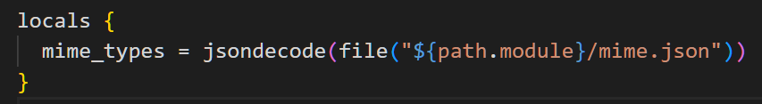
mime_types: This variable is a map (key-value pairs) of MIME types, loaded from the mime.json file in the root directory
This map will be used to nominate the content-type of a file based upon its file extension….
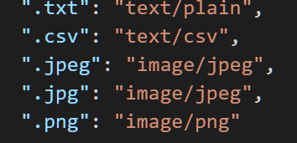

for_each in the Resource Block..
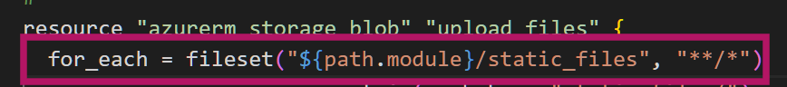
for_each: This lets you create multiple instances of the resource, one for each file.
fileset(): Scans the folder static_files for all files that match the pattern **/* (all files and subdirectories recursively).

Blob Name
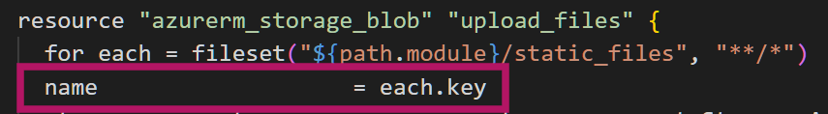
each.key: Refers to the relative path of the current file found by fileset().
Example Output: "Teide.jpeg"

Blob Source
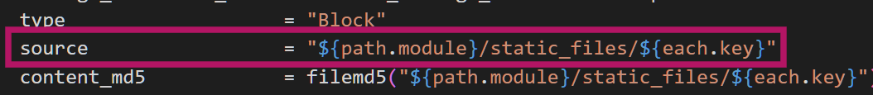
source: Specifies the full local path to the file being uploaded.
${path.module}: Refers to the current working directory of the Terraform module.
Example Source: "c:\azure-tf-int\labs\08\static_files\Teide.jpeg"

File Integrity
filemd5(): Computes the MD5 checksum of the file. This ensures file integrity during the upload process.
Azure uses the checksum to verify that the file has not been corrupted during upload.

MIME Type
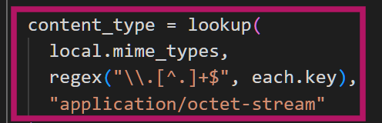
Purpose: Assigns a content type (like image/jpeg or text/plain) based on the file extension.
Extract File Extension:
regex("\\.[^.]+$", each.key):
Finds the file extension (e.g., .jpeg, .png).
Example Input: "Teide.jpeg" → Output: ".jpeg".
The regex \\.[^.]+$ is used to extract the file extension from a file name by matching a dot (.) followed by one or more characters that are not dots, located at the end of the string. This helps identify the file type (e.g., .txt, .jpeg) for mapping to its corresponding MIME type in the local.mime_types map. If no match is found, it defaults to "application/octet-stream".

Code Summary
This Terraform code defines a process for uploading files as blobs to our Azure Storage container with appropriate metadata:
Local MIME Type Mapping: The locals block reads a JSON file (mime.json) from the module path. This file contains mappings of file extensions to their respective MIME types, and the jsondecode() function converts it into a usable map in Terraform.
Iterating Over Files: The azurerm_storage_blob resource uses the fileset() function to iterate over all files in the static_files directory (including subdirectories). Each file is identified by its relative path.
Blob Name Assignment: The name attribute of each blob is set.
Storage Container Details: The storage account and container names are set using existing resources, azurerm_storage_account.storage_acct_1 and azurerm_storage_container.storage_cont_1.
Blob Type: The type of blob is specified as Block, which is commonly used for uploading large files.
File as Blob Source: The source attribute specifies the absolute file path from which the blob content will be uploaded.
MD5 Checksum for Verification: The content_md5 attribute computes the MD5 hash of the file to ensure data integrity during the upload process.
MIME Type Assignment: The content_type attribute determines the appropriate MIME type for the file. It uses regex("\\.[^.]+$", each.key) to extract the file extension from the file name, then looks up the corresponding MIME type in the local.mime_types map. If no match is found, it defaults to "application/octet-stream".
So, this configuration automates the process of iterating through local files, mapping them to their MIME types, and uploading them as blobs into the Azure Storage container while preserving metadata and ensuring integrity.
- Save the file changes
- Run terraform plan
- The planning stage should complete successfully.
- Run terraform apply followed by yes
- Switch to the Azure portal and verify the uploading of the 3 files to the storage container that the correct content-type has been attributed…
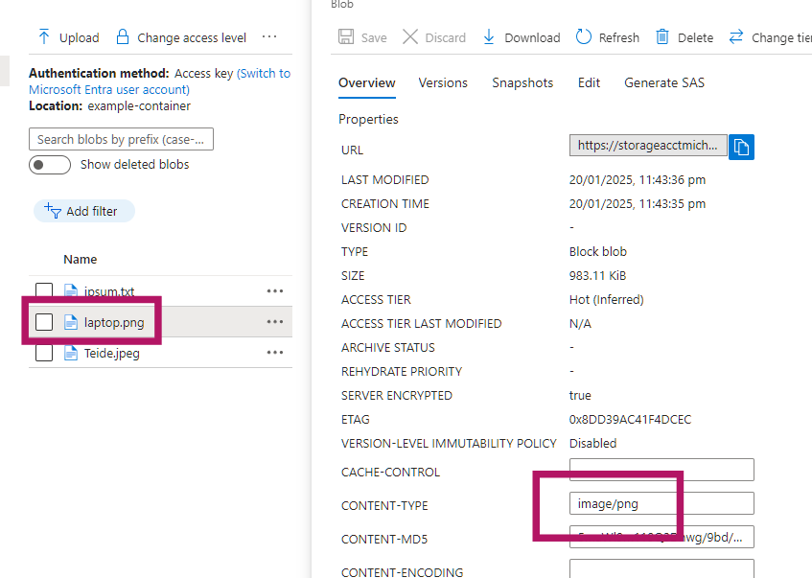

Task 4. Create an Azure Storage management policy

Try it yourself
- Review the sample code using this link to familiarize yourself with storage management policy.
- Using the example code for reference, in the Task 4 section of main.tf, create a policy that has a single rule focussing on the base_blob storage tier for all blob changes over time.
- Associate the policy with your storage account.
- Save, plan, and apply the deployment.
- Switch to the portal and verify the policy creation.

Step-by-Step
- Using this link, copy the sample code for an azurerm_storage_management_policy resource block into the Task4 section of main.tf
- The example code contains 2 rules. Remove all of rule2.
- For filtering, we want the policy to apply to all blobs, so remove the prefix_match and match_blob_index_tag portions of the filters block.
- We are focussing on the blobs themselves here so remove the snapshot block
- Save, plan, and apply the deployment.
- Switch to the portal and verify the policy creation. (your storage account name will differ)..
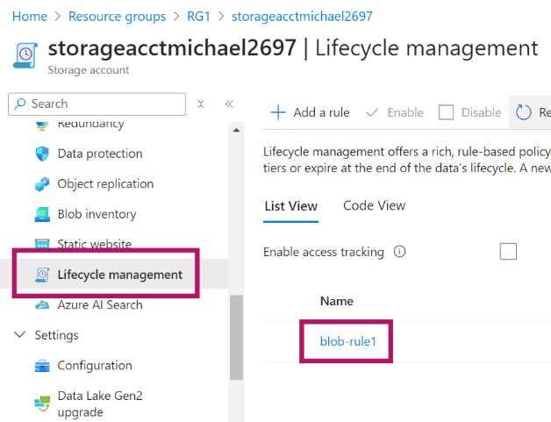
- Click into the rule to view the parameters..
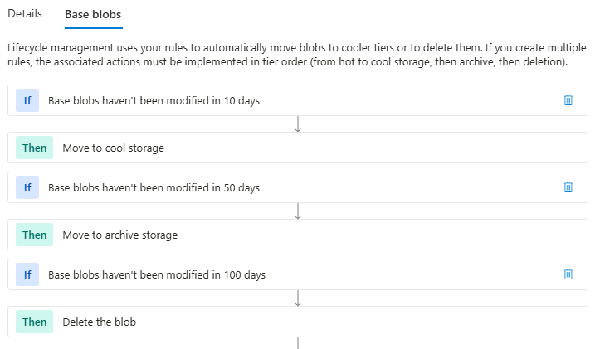

Task 5. Create an Azure Storage Access Signature token

Try it yourself
- Review the sample code using this above link to familiarize yourself with Storage Access Signature token creation.
- Create a data resource block to generate a SAS token with the following parameters:
Permissions to apply to container resource types and blob services only
SAS should be valid for all of year 2026
SAS should grant read/write/list permissions
- Link the SAS to your storage account
- Mark the output as sensitive
- Save, plan, and apply your changes

Step-by-Step
- Using this link, copy the azurerm_storage_account_sas example data block into the Task5 section of main.tf
- Change the connection_string value to link this SAS with our storage account..
azurerm_storage_account.example.primary_connection_string
- Remove the signed_version_attribute
- Set the resource types to containers only (set as ‘true’, set others as ‘false’)
- Leave blob as the only service
- Change the date portion of the start date to 2026-01-01
- Change the date portion of the expiry date to 2027-01-01
- Set read/write/list permissions to true, all others to false.
- Save your file changes and then run terraform plan
- An error should be displayed regarding the output code block…
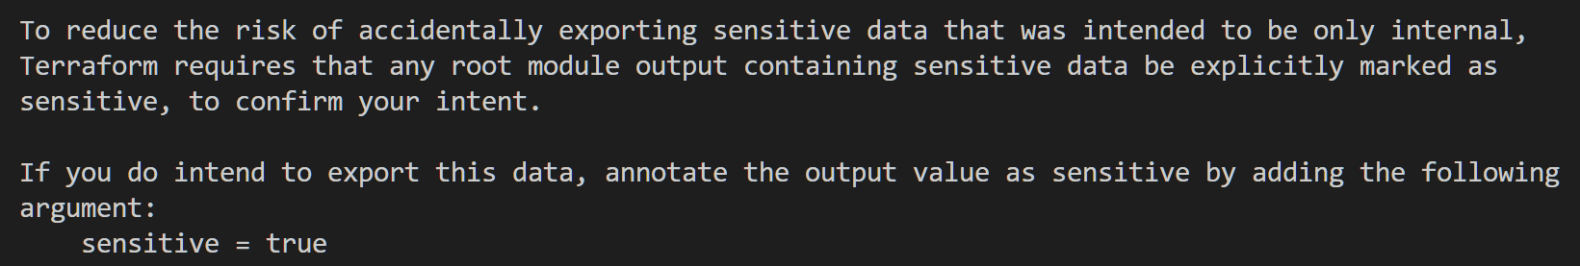

- The SAS token is security sensitive and terraform will not display it directly as part of an output block. To fix this issue we and mark this value as being ‘sensitive’ which means it will not be displayed but can be explicitly requested. To mark a value as sensitive, enter a line under the value..
output "sas_url_query_string" {
value = data.azurerm_storage_account_sas.example.sas
sensitive = true
}
- Save your file changes and then run terraform plan
- Planning should complete
- Run terraform apply followed by yes
- Note. The Shared Access Signature (SAS) token generated via Terraform using the azurerm_storage_account_sas data block is not stored or visible directly in the Azure Portal. This is because SAS tokens created through APIs, SDKs, or Terraform are generated on the client-side and not stored by Azure for security reasons.

Task 6. Using the SAS token
- Output the SAS token using terraform output sas_url_query_string
- Reconstruct the following URL, substituting values as appropriate to your resources (ensure there are no spaces)..
https://<storage account name>.blob.core.windows.net/<container name>?restype=container&comp=list&<your sas token (minus leading ?)>

- Paste the re-constructed URL into a web browser to view the container object details using the SAS token..

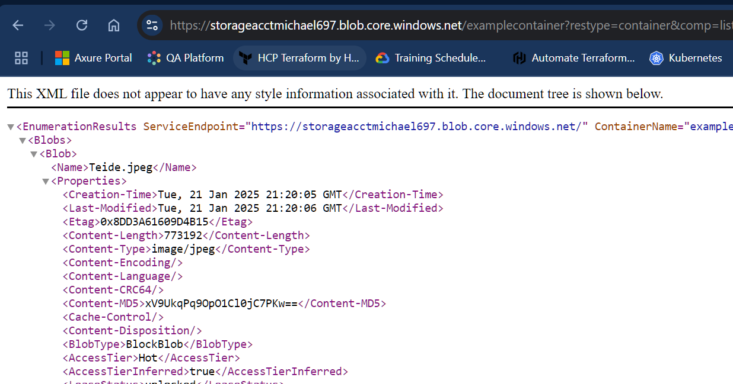

Task 7. Lab Clean-Up
- Run terraform destroy and confirm with yes when prompted.

**** Congratulations, you have completed this lab ****

Copyright
© 2026 QA Michael Coulling-Green. All rights reserved. These lab materials are provided as part of an authorised training course. Course attendees may reuse these materials for their own personal learning and reference outside of the training session. Unauthorised copying, redistribution, publication, or use of these materials to deliver training is prohibited without prior written permission from the author.

