O Topics :

* Decision tree -> information gain

<https://medium.com/@ODSC/the-complete-guide-to-decision-trees-part-1-aa68b34f476d>

<https://medium.com/deep-math-machine-learning-ai/chapter-4-decision-trees-algorithms-b93975f7a1f1>

ID3

<https://medium.com/@lope.ai/decision-trees-from-scratch-using-id3-python-coding-it-up-6b79e3458de4>

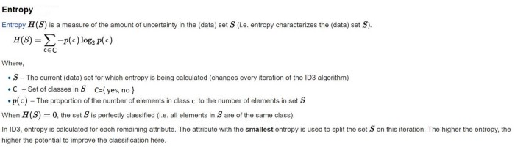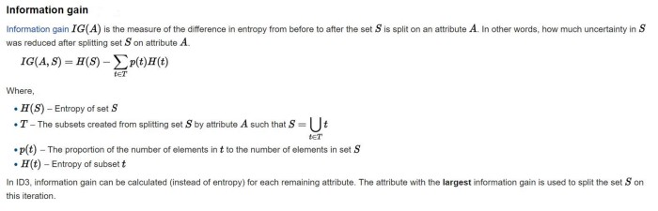1.compute the entropy for data-set2.for every attribute/feature:

1.calculate entropy for all categorical values

2.take average information entropy for the current attribute

3.calculate gain for the current attribute3. pick the highest gain attribute.

4. Repeat until we get the tree we desired.

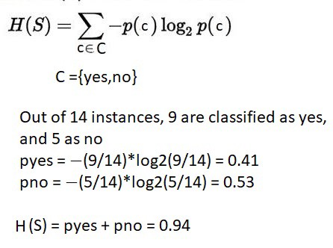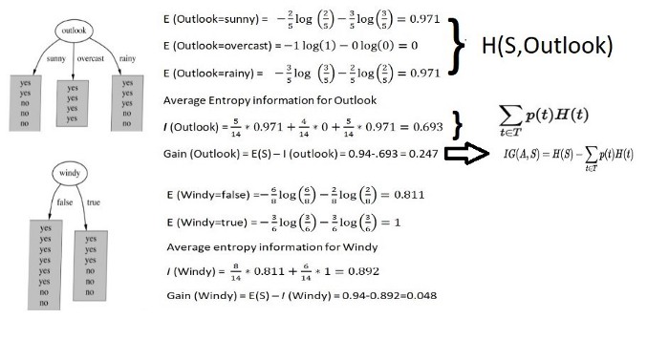

Pick the highest

This one is better i think

* Random forest

<https://medium.com/@harshdeepsingh_35448/understanding-random-forests-aa0ccecdbbbb>

<https://williamkoehrsen.medium.com/random-forest-simple-explanation-377895a60d2d>

* KNN
* ‫‪Large‬‬ ‫‪Margin‬‬ ‫‪Nearest‬‬ ‫‪Neighbor‬‬ ‫

<https://en.wikipedia.org/wiki/Large_margin_nearest_neighbor>

http://contrib.scikit-learn.org/metric-learn/_modules/metric_learn/lmnn.html

* Metric learning

<http://contrib.scikit-learn.org/metric-learn/generated/metric_learn.LMNN.html>