PRACTICAL ASSESSMENT TASK 1: SUBTASK 1: WORKSHEET 1
Create GitHub Account
Student’s surname and First name/s | MOKGOTHO KATISO EDWARD
Student’s ID number | 03071258640881
Class group | IT L3 (ROBOTICS)
Assessment date
Your GitHub username.
qavaake-gif
GitHub profile page screenshot.
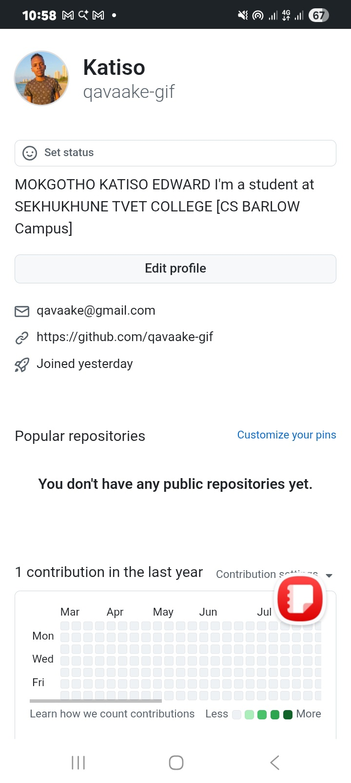
GitHub profile link.
https://github.com/qavaake-gif

