PRACTICAL ASSESSMENT TASK 1: SUBTASK2: WORKSHEET 2
Create GitHub Account
Student’s surname and First name/s | MOKGOTHO KATISO EDWARD
Student’s ID number | 03071258640881
Class group | IT L3 (ROBOTICS)
Assessment date
IPO chart
INPUT | PROCESSING | OUTPUT
First Temperature | Store first Temperature value | Prompt user for second Temperature
Second Temperature | Find difference between second & first Temperature | Display warning if temperature increases too much
Third Temperature | Check if oil Temperature is correct for frying | Display message if oil is ready
 | Compare difference with limits(10 and 50 degrees) | Display instruction to increase or reduce heat

Flowchart
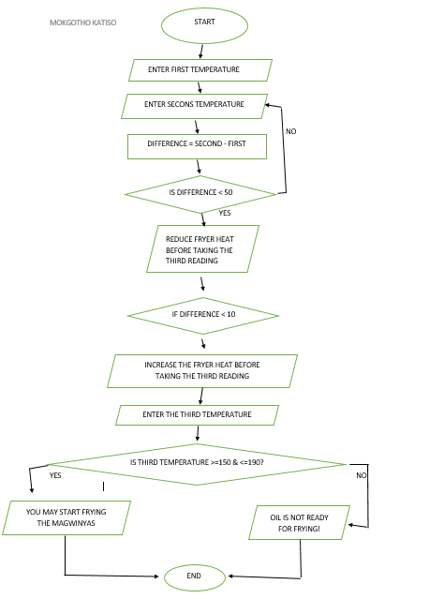
C++ program source code.
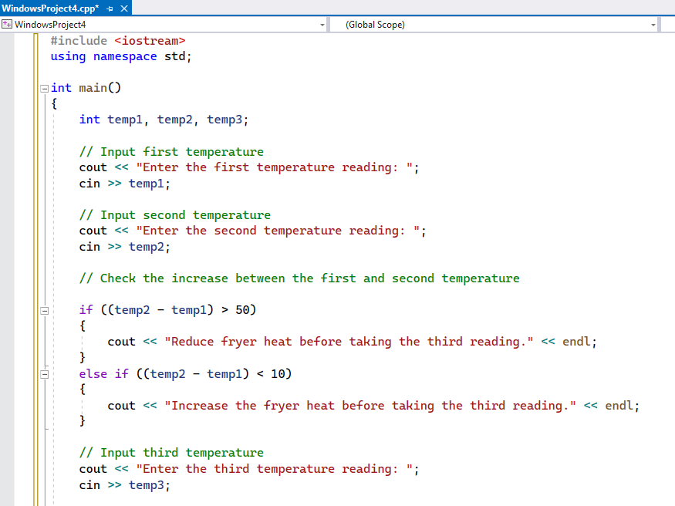
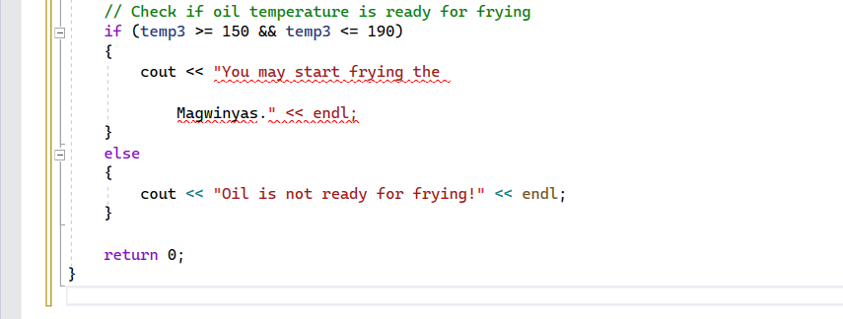
GitHub link.
https://github.com/qavaake-gif/pat1-subtask2

