PRACTICAL ASSESSMENT TASK: SUBTASK3: WORKSHEET 3
Create GitHub Account
Student’s surname and First name/s | MOKGOTHO KATISO EDWARD
Student’s ID number | 03071258640881
Class group | IT L3 (ROBOTICS)
Assessment date
C++ program source code.
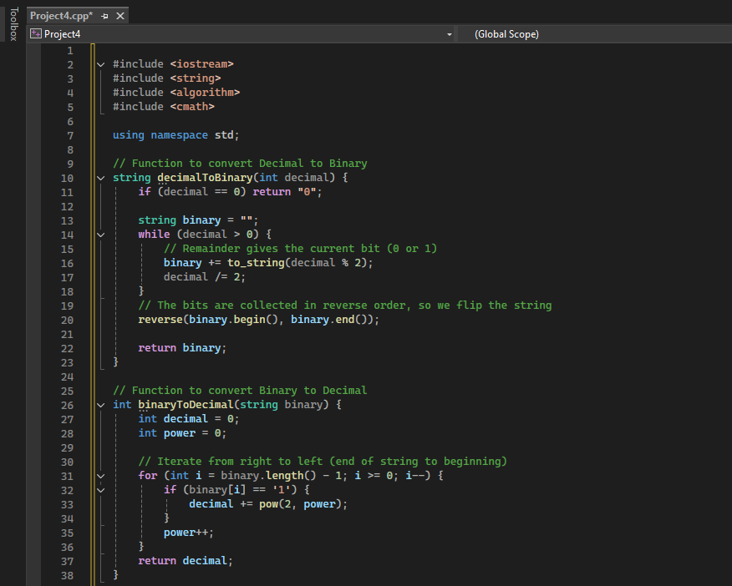
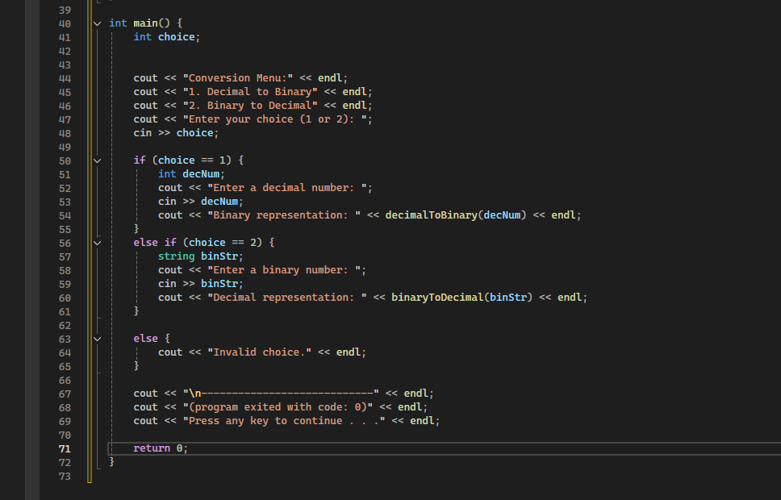

Algorithms designed
Decimal → Binary
- Start
- Input decimal number
- Divide number by 2
- Store remainder
- Repeat until number = 0
- Display binary result
- End
Binary → Decimal
- Start
- Input binary number
- Multiply digits by powers of 2
- Add results together
- Display decimal result
- End

