PRACTICAL ASSESSMENT TASK 2: SUBTASK 1: WORKSHEET 1
Creating Github repo and research on Morse code
Student’s surname and First name/s | MOKGOTHO KATISO EDWARD
Student’s ID number | 0307125864081
Class group | IT & ROBOTICS
Assessment date
GitHub repo link.
https://github.com/qavaake-gif/pat2-subtask1
GitHub README.md screenshot.
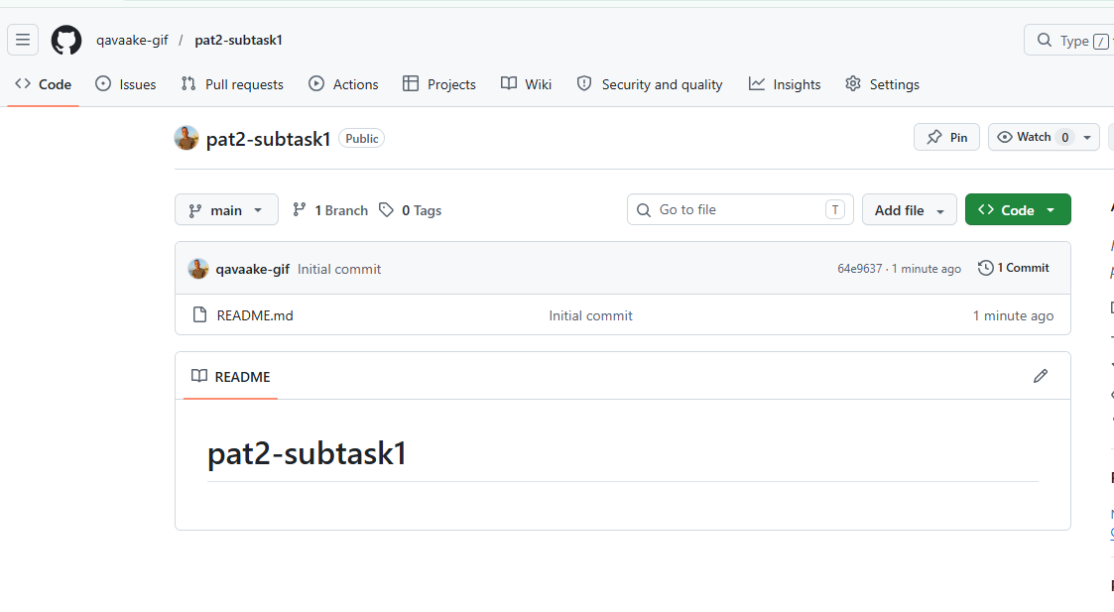

README.md copy
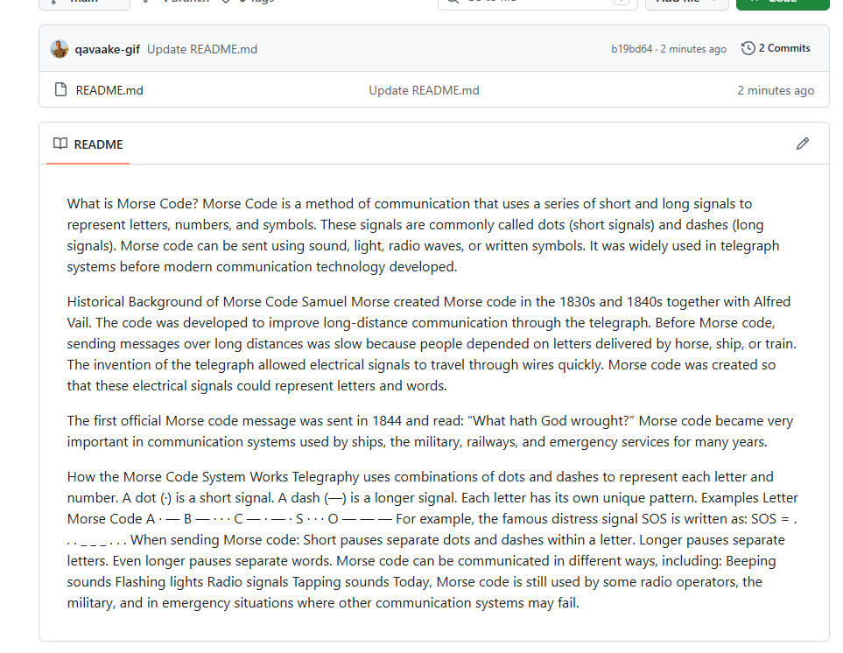

PRACTICAL ASSESSMENT TASK 2: SUBTASK 2: WORKSHEET 2
C++ program for Morse code translation
Student’s surname and First name/s | MOKGOTHO KATISO EDWARD
Student’s ID number | 0307125864081
Class group | IT & ROBOTICS
Assessment date
GitHub repo link.
https://github.com/qavaake-gif/pat2-subtask1
GitHub commit screenshot.
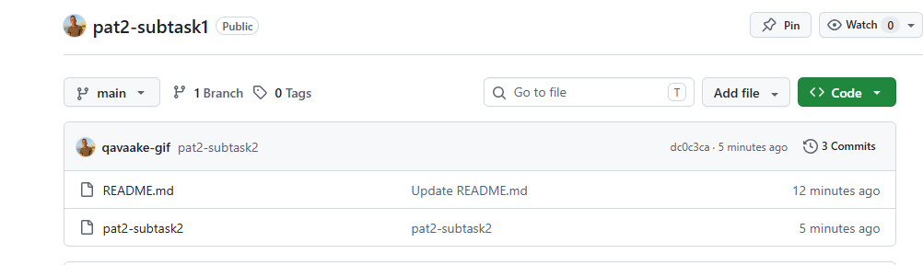
C++ Program source code
#0408066049086
#include <iostream>
#include <string>
#include <cctype>

using namespace std;

// Function to return Morse code for each letter
string getMorseCode(char letter)
{
switch (toupper(letter))
{
case 'A': return ".-";
case 'B': return "-...";
case 'C': return "-.-.";
case 'D': return "-..";
case 'E': return ".";
case 'F': return "..-.";
case 'G': return "--.";
case 'H': return "....";
case 'I': return "..";
case 'J': return ".---";
case 'K': return "-.-";
case 'L': return ".-..";
case 'M': return "--";
case 'N': return "-.";
case 'O': return "---";
case 'P': return ".--.";
case 'Q': return "--.-";
case 'R': return ".-.";
case 'S': return "...";
case 'T': return "-";
case 'U': return "..-";
case 'V': return "...-";
case 'W': return ".--";
case 'X': return "-..-";
case 'Y': return "-.--";
case 'Z': return "--..";
default: return "";
}
}

int main()
{
string message;
string fullMorse = "";

// Ask user for input
cout << "Enter a short message: ";
getline(cin, message);

cout << "\nMorse Code Translation:\n";

// Loop through each character
for (int i = 0; i < message.length(); i++)
{
char ch = message[i];

// Check for spaces between words
if (ch == ' ')
{
fullMorse += " "; // 7 spaces between words
}
else
{
string morse = getMorseCode(ch);

// Display letter and Morse code
cout << toupper(ch) << ": " << morse << endl;

// Add to full Morse message
fullMorse += morse + " "; // 3 spaces between letters
}
}

// Display full Morse code message
cout << "\nFull Morse code with spaces:\n";
cout << fullMorse << endl;

return 0;

PRACTICAL ASSESSMENT TASK 2: SUBTASK 3: WORKSHEET 3
C++ Error correction
Student’s surname and First name/s |  |  | MOKGOTHO KATISO EDWARD
Student’s ID number |  |  | 0307125864081
Class group |  |  | IT & ROBOTICS
Assessment date
Corrected C++ source code.
// FIXED: Added # before include statement
#include <iostream>

// FIXED: Added iomanip library for setprecision()
#include <iomanip>

using namespace std;

// Constants
const int NUM_EXPERIMENTS = 3;
const int NUM_READINGS = 3;

// FIXED: Changed float main() to int main()
int main()
{
// FIXED: Changed char variables to int variables
int i, j;

// Variables to store values
double readingValue;
double total;
double average;

// Loop through experiments
for (i = 1; i <= NUM_EXPERIMENTS; i++)
{
// FIXED: Added missing semicolon
total = 0;

cout << "\nEXPERIMENT " << i << endl;
cout << "====================\n";

// Loop through readings
for (j = 1; j <= NUM_READINGS; j++)
{
// FIXED: Added missing semicolon
cout << "Enter reading " << j << " value: ";

cin >> readingValue;

// FIXED: Changed subtraction to addition
total = total + readingValue;
}

// FIXED: Corrected average formula
average = total / NUM_READINGS;

// Determine range of average
// FIXED: Corrected logical condition
if (average < 100)
{
cout << "Experiment " << i << " average: "
<< fixed << setprecision(2)
<< average
<< " is Below acceptable range\n";
}

// FIXED: Replaced OR with &&
// FIXED: Corrected acceptable range logic
else if (average >= 100 && average <= 300)
{
cout << "Experiment " << i << " average: "
<< fixed << setprecision(2)
<< average
<< " is Within acceptable range\n";
}

// Above acceptable range
else
{
cout << "Experiment " << i << " average: "
<< fixed << setprecision(2)
<< average
<< " is Above acceptable range\n";
}
}

return 0;
}

Error correction list.
For each error you corrected, provide the following additional information:

Error Description Syntax or How was the error corrected
Logical

 | Include <iostream> missing # | Syntax Error | Changed to #include <iostream>
 | using namespace stt; | Syntax Error | Changed stt to std
 | float main() | Logic Error | Changed to int main()
 | char i, j; | Logic Error | Changed char to int
 | Missing semicolon after total = 0 | Syntax Error | Added ;
 | cout << "Enter reading..." missing semicolon | Syntax Error | Added ;
 | total = total - readingValue | Logic Error | Changed - to +
 | Missing semicolon after total calculation | Syntax Error | Added ;
 | average = total / NUM_READINGS + total; | Logic Error | Changed to average = total / NUM_READINGS;
 | if (average > 100) | Logic Error | Changed to average < 100
 | OR used in condition | Syntax Error | Changed to average >= 100 && average <= 300
 | average <= 100 OR average <= 300 | Logic Error | Added #include <iomanip>
 | fixed << setprecision(2) without <iomanip> | Syntax Error | C++ uses && and `
 | “Below acceptable range” message in wrong condition | Logic Error | Corrected condition structure
 | Within acceptable range” spelling | Syntax Error | Corrected spelling

Student’s Pledge
**Anti-Plagiarism Pledge for Introduction to Technical Programming**

I, ________________________, as a dedicated student of Introduction to Technical Programming, hereby solemnly pledge to uphold the principles of academic integrity, honesty, and originality throughout the duration of the conduct of the PAT and ISAT. I understand the importance of maintaining the highest ethical standards in my academic work, and I commit to the following:

- **Original Work:** I pledge that all work I submit for this course, including assignments, reports, and projects, will be entirely my own original work, created specifically for this class.

- **No Plagiarism:** I will not engage in any form of plagiarism, including but not limited to copying content from the internet, fellow students, or any other external sources without proper citation. I understand that plagiarism is a serious academic offense and will not be tolerated.

- **Proper Citation:** If I use external sources or reference materials in my work, I will cite them appropriately using the citation style specified by the instructor. I will give credit to the original authors and sources to acknowledge their contributions to my work.

- **Respect for Intellectual Property:** I will respect the intellectual property rights of others and adhere to all copyright laws when using external sources in my assignments or projects.

- **No Unauthorized Sharing:** I will not share my work with other students who might use it inappropriately, nor will I seek or accept work from others to submit as my own.

- **Academic Honesty:** I will report any suspected instances of academic dishonesty to the instructor or appropriate authority and support the maintenance of academic integrity within the class.

By taking this pledge, I am committed to maintaining the highest standards of academic integrity, and I understand that any violation of this pledge may result in academic consequences, including but not limited to failing grades or disciplinary action. I pledge to do my best to uphold these principles and promote a culture of academic honesty and excellence within our community.

Student details: __________________________
Signature: ______________________________
Date: __________________________________

Student’s Declaration of Authenticity
Student surname and  initials |  | ID  Number
Subject | Introduction to Technical Programming
Select 1  - Practical Assessment Task One (PAT 1)  - Practical Assessment Task Two (PAT 2)  - Integrated Summative Assessment Task (ISAT) |  | Lecturer
I hereby declare that the contents of this assessment task are my own original work (except where there is clear acknowledgement and appropriate reference to the work of others) and have not been plagiarised, copied from someone else or previously submitted for assessment by anyone.

_________________________ ___ / ___ /
SIGNATURE OF STUDENT DATE



NATIONAL CERTIFICATE (VOCATIONAL)
NQF LEVEL 3

INTEGRATED SUMMATIVE ASSESSMENT TASK

INSTRUCTIONS TO STUDENTS

SUBJECT: Introduction to Technical Programming LEVEL 3 SUBJECT CODE: 10041063

DATE OF IMPLEMENTATION: 01 JANUARY 2024

This document consists of 21 pages.

This is a practical application task that tests your ability to apply the knowledge and skills acquired in the vocational subject. The work required from you is an important and compulsory component of your studies.
- General information
  - Study the task carefully.
  - Note the mark and time allocations per Subtask and for the task as a whole.
  - Your lecturer will inform you of the assessment date(s), time(s) and access to resources.
  - Study the resources required carefully.
  - Use the assessment tool as guidance on how your work will be marked.
  - You are required to provide proof that you submitted work done by yourself.
  - Reference all information sources, i.e., internet, books, magazine articles, etc. correctly.
  - Beware of plagiarism, do not copy and paste information from information sources unless it is a direct quote which is correctly referenced

- Description of the task
The different Integrated Summative Assessment subtasks bridge theoretical knowledge with practical application, nurturing essential skills and proficiencies crucial for success in professional software development. Learners gain insights into industry-standard tools, refine coding skills, enhance problem-solving abilities, and develop an understanding of user-centric design and efficient data management, aligning with the demands and expectations of modern workplace environments.
Subtask 1 requires students to analyse GitHub and GitLab, two prominent software development platforms, exploring their features and differences. They're tasked with compiling their findings into a structured document, highlighting similarities and distinctions between the platforms to offer a concise analysis of their functionalities.

Subtask 2 extends the prior project, directing students to modify an existing decimal-tobinary and binary-to-decimal converter program. They need to create a new GitHub repository for version control and enhance the program by adding conversion functions, a user-friendly menu, and a demo option. The submission entails the modified program, an explanatory PDF, and GitHub commit screenshots.

Subtask 3 involves students in improving order management for Magwinya Magic using a C++ program employing one-dimensional arrays. They're tasked with implementing functionalities like adding orders, displaying all orders, searching orders by Order ID, and calculating total revenue. The program should feature a menu-based user interface and structured arrays for managing order data. The submission includes the functional C++ program and a detailed PDF explaining its functionality and the structure of parallel arrays for order data management.

These subtasks provide practical scenarios, including platform comparison, program enhancement, and structured data management, aimed at enhancing students' comprehension and proficiency in software development and programming concepts.

- Instructions for the task
3.1 Sub-task 1: Investigating GitHub and GitLab (15)

Background:
In the first PAT, you created a GitHub account, a widely used web-based platform for version control and collaboration in software development. Now, let's explore another popular service called GitLab. GitLab offers similar functionalities, making it an alternative choice for developers. In this subtask, you will investigate and compare GitHub and GitLab, highlighting their similarities and differences, as well as identifying key features of each.

Instructions:
GitHub:
  - Visit the GitHub website at https://github.com/about.
  - Explore the features and services offered by GitHub.
  - Identify at least three key features of GitHub.

GitLab:
  - Visit the GitLab website at https://about.gitlab.com/.
  - Explore the features and services offered by GitLab.
  - Identify at least three key features of GitLab.

Licensing:
  - Identify the core distinction in licensing approaches between GitLab and GitHub.

Feature Comparison:
  - Identify and list at least five features that are common to both GitHub and GitLab.
  - Identify and list at least two features that are unique to GitHub. • Identify and list at least two features that are unique to GitLab.

Submission:
Complete INTEGRATED SUMMATIVE ASSESSMENT TASK: SUBTASK1: WORKSHEET 1
This document should clearly present your research on the similarities and differences between GitHub and GitLab, along with the identified common and unique features of each platform.

Important Note:
Ensure that your document is concise and focuses on the most relevant aspects of each platform. You may use online resources to gather information, but make sure to cite any sources you consult.

By completing this subtask, you will gain insights into the core features of both GitHub and GitLab and understand how they compare in terms of their functionalities. Enjoy your exploration and be sure to submit a well-organized report!

3.2 Sub-task 2: Adding Conversion functions and menu (25)

Background:

In Practical Assessment Task 1 (PAT 1), you worked on creating a decimal-to-binary and binaryto-decimal converter program. This task builds upon that foundation by enhancing the program to include two additional functions. This reflects real-world software development scenarios where you often need to modify and extend existing code.

Create GitHub Repository:
Create a new GitHub repository named "isat-subtask2" to manage and version control your project. Make sure to use the GitHub account you created in PAT 1.

Enhancement Requirements:
In this subtask, your goal is to modify and extend the existing converter program by adding four new functions:
- Function 1: Decimal to Binary o Create a function that receives an integer value as a parameter and returns the binary equivalent as a string.
- Function 2: Binary to Decimal o Develop a function that receives a string of binary digits and returns the integer equivalent.
- Function 3: Decimal to Hexadecimal o Create a function that receives an integer value as a parameter and returns the hexadecimal equivalent as a string.
- Function 4: Hexadecimal to Decimal o Develop a function that receives a string of hexadecimal digits and returns the integer equivalent.

Menu Driven Command Line Interface:
- Implement a user-friendly menu system that allows the user to select one of the following options calling the applicable function for each.
  - Convert Decimal to Binary ▪ Convert Binary to Decimal
  - Convert Decimal to Hexadecimal
  - Convert Hexadecimal to Decimal
  - Demo (Generate and convert random integers to binary)
  - Exit (To exit the program)

Additional Menu Option Descriptions
- Demo:
- When this option is selected, the program should generate a random number between 0 and 99.
- It should then convert this random number to binary and display the results.
- Exit: o When this option is selected, the program should exit.

Example Output:

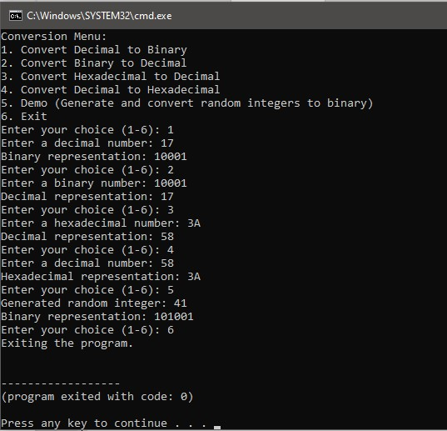

Submission:
Complete INTEGRATED SUMMATIVE ASSESSMENT TASK: SUBTASK 2: WORKSHEET 2
Include the following:
- The modified converter program that includes the new functions and the user-friendly menu system.
- Explanations and examples of how the new functions and menu system work, along with any challenges you encountered during the modification.
- A screenshot showing your GitHub repository, specifically the "isat-subtask2" repository, and your commits to it. Ensure you have at least 5 commits to reflect your progress and changes.

This task represents real-world software development practices, including extending code to add new features and creating user-friendly interfaces for applications.

3.3 Sub-task 3: Magwinya Magic Orders (35)

Background:
In Subtask 3, you will work on a task that involves using basic one-dimensional arrays (parallel arrays) in C++ for efficient order management. This task will help you further enhance your programming skills.

Scenario:
You are a part of the Magwinya Magic team, and they have a requirement to improve their order tracking system. Currently, they maintain a simple Excell document where each order is added as they are placed. Each line in the document represents one order, and each order is described in the following format:

Order ID: <OrderID>, Customer: <CustomerName>, Number of Magwinyas: <How many ordered>, Total: <TotalAmount>
- <OrderID> is a unique numerical identifier for the order.
- <CustomerName> is the name of the customer who placed the order.
- <Number of Magwinyas> is how many Magwinyas the customer ordered.
- <TotalAmount> is the total cost of the order.

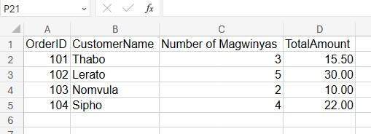

In the sample Excell sheet above:
- Order 101 was placed by Thabo, who ordered 3 Magwinyas, totaling R15.50.
- Order 102 was placed by Lerato, who ordered 5 Magwinyas, totalling R30.00.
- Order 103 was placed by Nomvula, who ordered 2 Magwinyas, totalling R10.00. • Order 104 was placed by Sipho, who ordered 4 Magwinyas, totalling R22.00.

The Magwinya Magic team wants to improve their order processing system by using basic onedimensional arrays (parallel arrays) in C++ to more efficiently store and manage order data. By adopting one-dimensional arrays, Magwinya Magic can streamline their order processing system. For example, they can easily add new orders by updating the arrays, retrieve information about specific orders, or perform calculations based on the stored data. This transition not only improves the efficiency of order management but also sets the foundation for potential future enhancements and functionalities.

Here's how the transition to one-dimensional arrays could benefit Magwinya Magic:

Order ID Array: The team can use a dedicated array to store unique numerical identifiers for each order. This makes it easier to reference and identify specific orders within the system.

Customer Names Array: Another array can be designated for storing customer names. This allows for quick access to the names of customers who have placed orders, facilitating better customer tracking.

Number of Magwinyas Array: A separate array can be used to store the quantity of Magwinyas ordered for each transaction. This provides a clear record of the product quantities associated with each order.

Total Amounts Array: The team can employ an array specifically for storing the total cost of each order. This ensures that financial information is well-organized and easily accessible.

C++ Program Instructions

Order Data Management:
- Create a C++ program that uses basic one-dimensional arrays (parallel arrays) to store order data efficiently.
- You should have the following arrays each being able to store 50 elements:
  - An array for Order IDs (string) o An array of Customer Names (string)
  - An array for the Number of Magwinyas Ordered by each customer (integer) o An array for the Total Cost of Orders (float)
- Initialize each array with the following sample data for the first 10 elements. Take note for future orders the Order ID should increment accordingly. The remaining 40 empty Order IDs should be initialized with a 0 as an element value.

Order IDs (string) | 101 | 102 | 103 | 104 | 105 | 106 | 107 | 108 | 109 | 110
Customer  Name  (string) | Thabo | Lerato | Nomvula | Sipho | Bongani | Lindiwe | Jabulani | Ayanda | Kgosi | Refilwe
Number of  Magwinyas  Ordered  (integer) | 3 | 5 | 2 | 4 | 6 | 1 | 3 | 2 | 6 | 4
Total Cost of Order  (float) | 15.75 | 30.50 | 10.00 | 22.00 | 40.25 | 5.50 | 18.00 | 12.75 | 28.00 | 24.50

- You may assume the system will not handle more than 50 orders at one time.

User Interface:
Develop a menu-based user interface that allows the user to perform the following actions:
- Add a new order.
  - When adding a new order, the user should input the order details, and the program should create new entries in the parallel arrays to store the order data efficiently. An appropriate order number should be generated based on the last valid order number in the array.
  - Make sure that the application will only accept at most 50 orders. If the number of orders added exceeds 50 display an appropriate error message.
- Display all orders.
  - When displaying all orders, the program should list all orders stored in the parallel arrays with valid Order ID’s (0’s excluded).
- Find an order by Order ID.
  - When finding an order by Order ID, the user should input an Order ID, and the program should display the order details for that specific order.
  - If an order was not found, display an appropriate message.
- Calculate and display the total revenue generated from all orders.
  - When calculating the total revenue, the program should sum up the Total Cost values from the parallel array and display the result.
- Exit the program.

Example Output:
The sample output is only given as a guide. The student may design their own Command Line Interface interactions. You may decide how they want to display all order and include some elements of formatting. The sample output for option 2 of the menu could be improved.
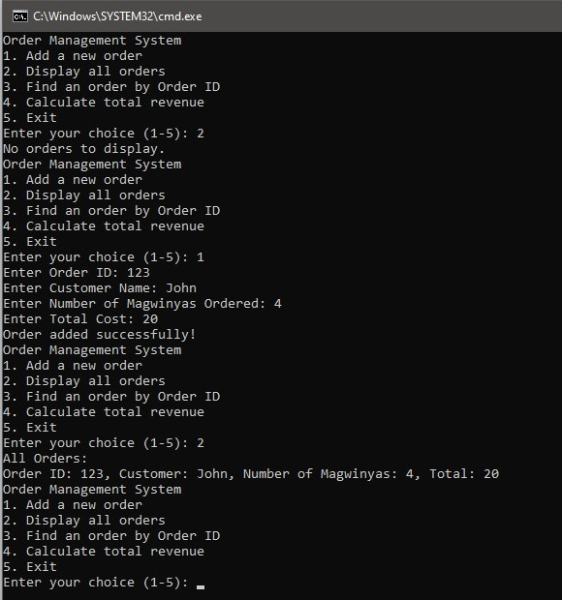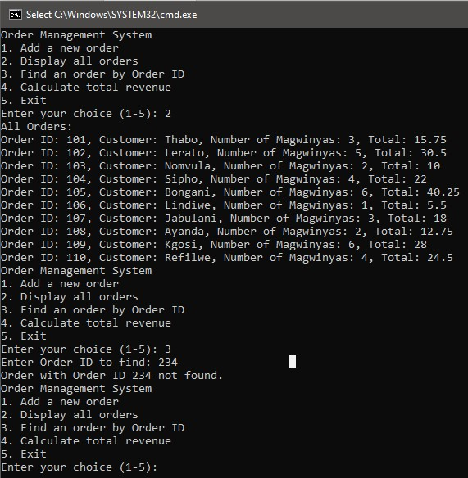
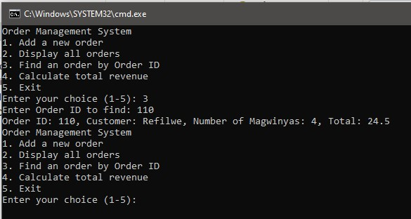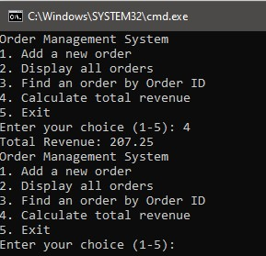

Submission:
Complete INTEGRATED SUMMATIVE ASSESSMENT TASK: SUBTASK 3: WORKSHEET 3

Include the following:
- The C++ program that implements the order data management system using basic onedimensional arrays (parallel arrays) and meets the specified requirements.
- An explanation of the program's functionality, the structure of your parallel arrays, and how to use the program.

This task will provide you with practical experience in working with parallel arrays to manage structured data. You will be creating an efficient order management system for Magwinya Magic, which can help improve their business operations.

VERY important relating to all submissions to Git/GitHub
- When creating your GitHub repo ensure to set the visibility as "Private" to safeguard your code and project details. Only your lecturer when evaluating the project can request to be added as a collaborator in order to view the repository.
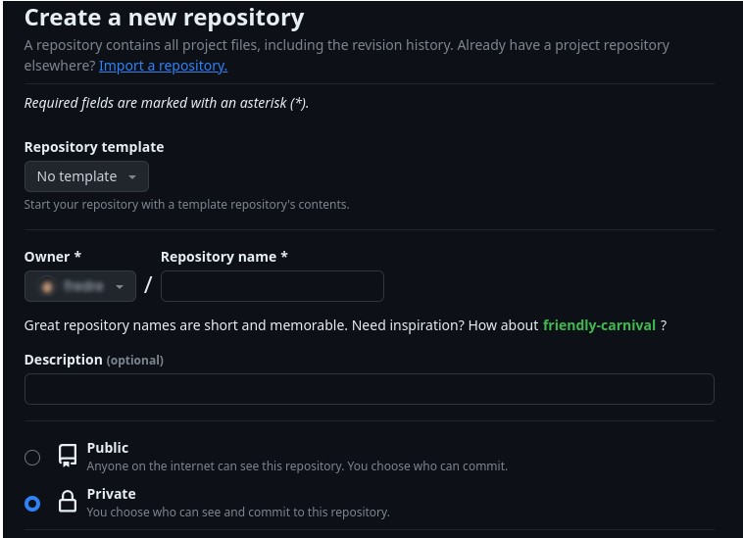

Sharing your code or any part of any project with anyone except your lecturer is a SERIOUS violation of the code of conduct!

- Time and mark allocation

Subtask | Activity | Time allocation | Mark allocation | Assessment tools
1 | Investigating GitHub and GitLab | 90 | 15 | Marking checklist
2 | Adding conversion functions and  menu | 120 | 25 | Marking checklist
3 | Magwinya Magic Orders | 240 | 35 | Marking checklist
 | TOTAL | 450 | 75

- Assessment tools

STUDENTS’S CHECKLIST: INTEGRATED SUMMATIVE ASSESSMENT TASK
Student’s Surname and First Name/s
Student’s ID Number
Lecturer’s Surname and Initials
Assessment date
Task description |  | SECTION MARK | STUDENT’S MARK
Subtask 1: Investigating GitHub and GitLab |  | [15 ]
GitHub and GitLab core distinction. (2 marks) |  | 2
GitHub and GitLab common features. (5 marks max) |  | 5
GitHub unique features (4 marks max) |  | 4
GitLab unique features (4 marks max) |  | 4

Subtask 2: Adding conversion functions and menu | [25 ]
C++ application implementation with functions and menu (17 marks)  The code incorporates all of the following functions and they are correctly placed inside of the program with functionality as described in the problem statement.  - Function to convert Decimal to Binary  - Function to convert Binary to Decimal  - Function to convert Decimal to Hexadecimal  - Function to convert Hexadecimal to Decimal  The rest of the application responds as per the requirements. | 17
Reflection on changes needed and challenges encountered. (4 marks) Use the grading criteria to evaluate the reflection for accuracy and completements. (Max 4 marks)  - 4 marks: Comprehensive Reflection  - The student provided a comprehensive reflection on the necessary changes and encountered challenges. The reflection is detailed, addressing various aspects, including specific changes, reasons for modifications, and a clear articulation of the encountered challenges, offering insight into the resolution process.  - 3 marks: Informative Reflection  - The reflection covers a good amount of information about the changes required and faced challenges. Although not exhaustive, the student offers substantial insights into potential improvements and the challenges faced during the project.  - 2 marks: Limited Reflection  - The reflection is brief and offers limited information regarding the changes needed and encountered challenges. It lacks depth and detail, providing only basic insights into some of the changes required and challenges faced.  - 1 mark: Minimal Reflection  - The reflection is very brief and lacks meaningful content regarding changes needed or challenges encountered. There is minimal insight provided, failing to address the necessary modifications or challenges faced.  - 0 marks: Absence of Reflection  - No reflection was provided regarding changes needed or challenges faced. There is no information or insight offered into the modifications required or any encountered challenges during the project. | 4

GitHub commit screenshot and repo link (4 marks) Award 1 mark if all below criteria is met:  - GitHub repo link submitted.  - The provided GitHub repository link was functional, valid, and accessible at the time of evaluation.  - The GitHub repository submitted by the student matched their own repository. The contents, commits, and ownership of the repository aligned with the student is undergoing evaluation.  Use the grading criteria to evaluate the submitted commits for accuracy and completeness (Max 3 marks).  - 3 marks: 5 or more meaningful commits with descriptive messages. - 1 marks: Few commits with minimal or missing descriptions.  0 marks: Single or no commits with inadequate description. | 4
Subtask 3: Magwinya Magic Orders | [35 ]
Functionality explanation (5 marks)  Use the grading criteria to evaluate the submitted commits for accuracy and completeness (Max 5 marks)  - 5 marks: Comprehensive Explanation  - The student provided a comprehensive and detailed explanation of the program's functionality, clearly describing how the program operates. The explanation of the structure of  parallel arrays is thorough, detailing their purpose, relationship, and how they are utilized within the program. Additionally, clear and concise instructions on how to use the program were provided, covering all essential aspects, steps, and possible functionalities.  - 4 marks: Detailed Explanation  - The explanation of the program's functionality is sufficiently detailed, covering most aspects effectively. The structure of parallel arrays is adequately explained, highlighting their relevance to the program. Instructions on how to use the program are clear but may lack detail in certain areas, potentially requiring further clarification for complete understanding.  - 3 marks: Adequate Explanation  - The explanation of the program's functionality and the structure of parallel arrays is provided but lacks depth or detail. Instructions on how to use the program are present but might be vague or missing some crucial steps, causing potential confusion for users.  - 2 marks: Limited Explanation  - The explanation of the program's functionality and the structure of parallel arrays is minimal and lacks substantial detail. Instructions on how to use the program are unclear or | 5
significantly incomplete, making it challenging for users to understand its functionalities.
- 1 mark: Minimal Explanation
  - The explanation of the program's functionality, the structure of parallel arrays, and instructions for usage is very brief and provides minimal insight. The information given is insufficient to understand how the program functions or how to utilize it effectively.
- 0 marks: Absence of Explanation
  - No explanation was provided regarding the program's functionality, structure of parallel arrays, or instructions on how to use the program. There is a complete absence of information on these essential aspects.

C++ application implementation (30 marks total)  - Initialization and use of Parallel Arrays (5 marks total)  - Menu system (5 marks total)  - Adding a new order (5 marks total)  - Display all orders (5 marks total)  - Find order by order id (5 marks total)  - Calculate total revenue (5 marks total) | 30
TOTAL MARKS | 75/100
 | %

INTEGRATED SUMMATIVE ASSESSMENT TASK: SUBTASK 1: WORKSHEET 1
Investigating GitHub and GitLab
Student’s surname and First name/s
Student’s ID number
Class group
Assessment date
GitHub and GitLab core distinction
Identify the core distinction in licensing approaches between GitLab and GitHub.

GitHub and GitLab common features.
Identify and list at least five features that are common to both GitHub and GitLab.

GitHub unique features
Identify and list at least two features that are unique to GitHub

GitLab unique features
Identify and list at least two features that are unique to GitLab.

INTEGRATED SUMMATIVE ASSESSMENT TASK: SUBTASK 2: WORKSHEET 2
Adding conversion functions and menu
Student’s surname and First name/s
Student’s ID number
Class group
Assessment date
C++ application source code.
Add your full C++ program here

Reflection on changes needed and challenges.
Explanations and examples of how the new functions and menu system work, along with any challenges you encountered during the modification.

GitHub commit screenshot and repo link
Link to GitHub repo.
A screenshot showing your GitHub repository, specifically the "isat-subtask2" repository, and your commits to it. Ensure you have at least 5 commits to reflect your progress and changes.

INTEGRATED SUMMATIVE ASSESSMENT TASK: SUBTASK 3: WORKSHEET 3
Magwinya Magic Orders
Student’s surname and First name/s
Student’s ID number
Class group
Assessment date
Functionality explanation.
An explanation of the program's functionality, the structure of your parallel arrays, and how to use the program.

C++ program source code
The C++ program that implements the order data management system using basic onedimensional arrays (parallel arrays) and meets the specified requirements.

6. RECORD OF PERFORMANCE IN INTEGRATED SUMMATIVE ASSESSMENT TASK
College
Campus
Student’s Surname and First Name/s
Student’s ID Number
Lecturer’s Surname and Initials
Date of conclusion of assessment
ASSESSMENT GRID
SUBTASKS |  | MARK ALLOCATION | STUDENT’S MARK | MODERATED MARK
Subtask 1: Investigating GitHub and GitLab |  | 15
Subtask 2: Adding conversion functions and menu |  | 25
Subtask 3: Magwinya Magic Orders |  | 35
Total |  | 75/100
Converted to % |  | 100%

COMPETENCE LEVEL INDICATORS
Outstanding | Highly competent |  | Competent | Not yet competent | Not achieved
80-100% | 70-79% |  | 50-69% | 40-49% | 0-39%
5 | 4 |  | 3 | 2 | 1
Student’s Competence Level
Student’s Signature
Lecturer’s Signature and Date
Moderator’s Signature and Date
Feedback to student

Student’s Declaration of Authenticity
Student surname and  initials |  | ID  Number
Subject | Introduction to Technical Programming
Select 1  - Practical Assessment Task One (PAT 1)  - Practical Assessment Task Two (PAT 2)  - Integrated Summative Assessment Task (ISAT) |  | Lecturer
I hereby declare that the contents of this assessment task are my own original work (except where there is clear acknowledgement and appropriate reference to the work of others) and have not been plagiarised, copied from someone else or previously submitted for assessment by anyone.

_________________________ ___ / ___ /
SIGNATURE OF STUDENT DATE

Student’s Pledge
**Anti-Plagiarism Pledge for Introduction to Technical Programming**

I, ________________________, as a dedicated student of Introduction to Technical Programming, hereby solemnly pledge to uphold the principles of academic integrity, honesty, and originality throughout the duration of the conduct of the PAT and ISAT. I understand the importance of maintaining the highest ethical standards in my academic work, and I commit to the following:

- **Original Work:** I pledge that all work I submit for this course, including assignments, reports, and projects, will be entirely my own original work, created specifically for this class.

- **No Plagiarism:** I will not engage in any form of plagiarism, including but not limited to copying content from the internet, fellow students, or any other external sources without proper citation. I understand that plagiarism is a serious academic offense and will not be tolerated.

- **Proper Citation:** If I use external sources or reference materials in my work, I will cite them appropriately using the citation style specified by the instructor. I will give credit to the original authors and sources to acknowledge their contributions to my work.

- **Respect for Intellectual Property:** I will respect the intellectual property rights of others and adhere to all copyright laws when using external sources in my assignments or projects.

- **No Unauthorized Sharing:** I will not share my work with other students who might use it inappropriately, nor will I seek or accept work from others to submit as my own.

- **Academic Honesty:** I will report any suspected instances of academic dishonesty to the instructor or appropriate authority and support the maintenance of academic integrity within the class.
By taking this pledge, I am committed to maintaining the highest standards of academic integrity, and I understand that any violation of this pledge may result in academic consequences, including but not limited to failing grades or disciplinary action. I pledge to do my best to uphold these principles and promote a culture of academic honesty and excellence within our community.

Student details: __________________________
Signature: ______________________________
Date: __________________________________

