Supplemental Materials

Media Literacy Interventions: Meta-Analytic Review of 40 Years of Research

HyunYi Cho*
School of Communication, the Ohio State University, 154 N. Oval Mall, Columbus, OH, USA; cho.919@osu.edu

Christopher J. Carpenter
Department of Communication, Western Illinois University, Macomb, IL, USA

Wenbo Li
School of Communication and Journalism, Stony Brook University, Stony Brook, NY, USA

Table of Contents

Table S1 | Effects of Moderators on Efficacy | Page 2
Table S2 | Effects of Moderators on Social Norms | Page 3
Figure S1 | Forest Plot of the Effects of Interventions on Attitudes | Page 4
Figure S2 | Forest Plot of the Effects of Interventions on Behavior | Page 5

Table S1
Effects of Moderators on Efficacy

Table S2
Effects of Moderators on Social Norms

Figure S1
Forest Plot of the Effects of Interventions on Attitudes
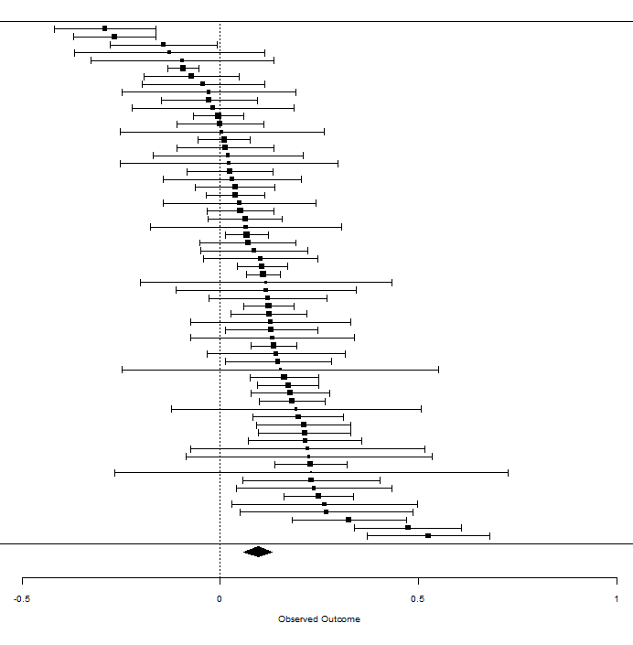

Figure S2
Forest Plot of the Effects of Interventions on Behavior

