Appendix A
Sample lesson plan

Intro to Lateral Reading Lesson Plan - Caffeine
COR Question: Who is behind the information?
Strategy Focus: Lateral Reading

The Problem: Evaluating the authorship or sponsorship of a source is a critical part of deciding whether it is trustworthy. Websites often present information about themselves and their authors, but this information may not provide the full story or be completely truthful. A better way to learn about who is behind a website is to read laterally—to go outside the site to see what other sites say about it. | This lesson will introduce students to lateral reading, a strategy for investigating a website or post by going outside the site. Students watch the teacher model the strategy and then have a chance to practice it in order to determine who is behind a website and, ultimately, whether that site is a trustworthy source of information.

Materials:
- Link to “Article Evaluation” task: https://forms.gle/QVcEWW3W5nKDjhR1A
- Modeling script
- Projector to display computer screen while modeling
- Computers for students (groups may share, if necessary)
- Link to or copies of Guiding Questions for students

Lesson Summary:
- Students complete task
- Teacher models lateral reading to evaluate the same website
- Students practice evaluating another website using lateral reading
- Students discuss lateral reading and what they learned as a class

Lesson Plan:
- Students complete a version of the “Article Evaluation” task.
  - This task asks students to evaluate an article about the health benefits of caffeine. Students must determine whether the article is a reliable source of information about caffeine. To successfully evaluate the article, students must investigate the International Food Information Council by going outside the site itself. However, our experience piloting similar tasks in real classrooms has shown us that many students will not spontaneously do this.
- Class Vote:
  - After students complete the task, ask them to raise their hands (or use any other mechanism for sharing out) to vote on their conclusions about the site’s reliability. Possible responses include: “Definitely reliable,” “Somewhat reliable,” “Not at all reliable,” and “I’m not sure.”
- You may ask students to share the reasoning behind their evaluations of the website. It’s okay if students share incorrect evaluations or surface misconceptions about online information at this stage. Later, in the next part of the lesson, you will model an effective approach to evaluating the website, so there’s no need to correct students at this point.
- Modeling:
  - Show students screencast of website evaluation.
  - Note: This will be most effective if you are online and project your computer screen for students to watch you as you model.
- Debrief Modeling:
  - Ask students:
- What did you notice the researcher doing?
- Why was it important to look beyond the “About” page to find out about the organization?
- Why should we adopt a skeptical attitude about what an unknown organization writes on its “About” page?
- How did the evaluation of the article compare to the one you wrote at the beginning of class? What was similar? What was different?
- Why is lateral reading necessary to find out more about the sponsors of a website?
  - Ask students: What information do we need about an organization or author to help us decide if they are trustworthy as sources of information on a particular topic? Help students consider multiple aspects of a source:
- The sponsoring organization or author’s perspective and why they might be motivated to present the information.
- How much expertise or authority they have on the topic and how committed they are to providing trustworthy information. Aspects to consider when deciding whether an organization has authority include:
- Whether its authors are trained as journalists (e.g., professional news outlets or fact checking organizations) or have backgrounds in the specific subjects they’re covering.
- Whether the organization has processes in place to ensure the information they produce is factual and trustworthy (like editors, fact checkers, and review processes like peer review).
- Whether the organization has systems in place to catch, correct, and admit mistakes when they are made (like corrections sections).
- Whether there are obvious conflicts of interest (e.g., a fossil fuel company providing information that downplays global warming).
- Guided Practice:
  - Pass out “Lateral Reading Guiding Questions”.
  - Have students work in pairs to evaluate the website https://www.theodysseyonline.com/coffee-benefits-and-harms and answer the guiding questions. Pairs may share a device if necessary.
- Share Out and Discuss:
  - Pairs of students share what they learned about Odyssey Online as they read laterally.
  - Points to consider about the source:
- Odyssey Online is an online platform that crowdsources articles: writers submit articles to be published on the site. According to a CNBC article in 2017, Odyssey is “an expansive platform with 15,000 creators, most of them college students across US campuses.”
- Because Odyssey does not follow standards of more traditional journalism outlets (e.g., editors, fact checkers, corrections, etc.) and does not have procedures in place to ensure the quality of its articles, we cannot necessarily trust that this is a reliable source of information on caffeine
- Instead, this article may be seen as a single college student’s views on caffeine. Students could read the other linked articles and studies to check if those are more reliable sources.
  - Final discussion question: Could you have learned this information about Odyssey Online if you stayed on the site itself?
    - If students do not address it directly, make sure they understand how much information they would have missed had they stayed on the site itself.
    - Remind students why prioritizing the question “Who is behind this information?” is so important and why lateral reading is a powerful method of investigating online sources.

Appendix B
Sample Task
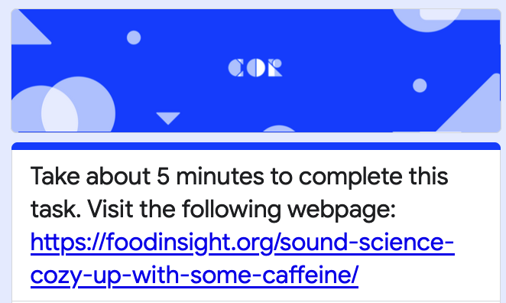

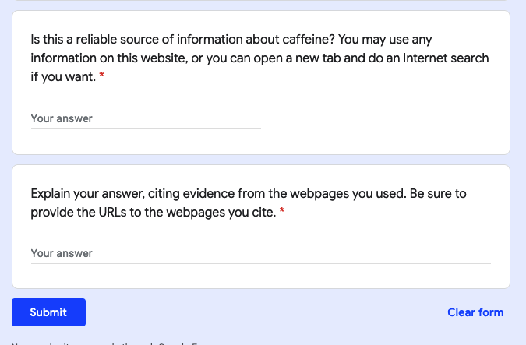
Appendix C
Descriptions of Civic Online Reasoning Lessons
Topic | Description
Caffeine: Intro to lateral reading | As part of an introductory biology unit about caffeine, students learned to read laterally by watching a screencast demonstrating lateral reading about an article regarding the benefits of caffeine from a website funded by beverage industry groups. Students then practiced reading laterally about another article about caffeine from a crowd-sourced website that lacks editorial review.
Ecology: Lateral reading continued | Students practiced the skill of lateral reading by evaluating sites of varying quality during an ecology unit project that asked them to find information about a particular animal.
India: Lateral reading review | Students reviewed lateral reading during a lesson about sanitation in India. Students compared what they could learn about a site just by staying on it with what they learned by reading laterally. Students evaluated a site for World Toilet Day that initially might not have seemed as credible, but was actually a project of the United Nations.
Nutrition: Lateral reading on social media part 1 | Students practiced reading laterally on social media. The whole class read laterally about a TikTok video from a registered dietician. Students then individually created screencasts of themselves reading laterally about a source they found on social media.
China: Lateral vs. vertical reading practice | Students watched a video criticizing the response of the United States to the pandemic. Students initially considered how they might evaluate the site based on surface-level features. They then read laterally to discover that it came from China’s largest state-run news agency.
GMOs: Lateral reading on social media part 2 | Students practiced reading laterally on social media. During a unit on genetically modified organisms, they evaluated a post from an Instagram account called “GMO answers.” By reading laterally, they learned that the website is run by agrochemical companies with a vested interest in public policy about GMOs.
Saudi Arabia: Credible sources for lateral reading | Students evaluated a series of social media posts about Saudi Arabia’s ban on women driving. One post came from a journalist, one from the government of Saudi Arabia, and one from an advocacy organization working to overturn the ban.
Forensics: Authority of sources for lateral reading | Students were introduced to the skill of click restraint. They were shown a search engine results page (SERP) and asked to consider which result they would select first. They then read laterally to investigate the sources.

