

COMSATS University Islamabad, Vehari Campus

Project Proposal
(SCOPE DOCUMENT)
for

Quantum Virtual Machine (QVM)
Version 1.0

By
Ahmad Faraz CIIT/SP23-BCS-007/VHR
Muhammad Abdul Qayyoum CIIT/SP23-BCS-033/VHR

Supervisor
Assistant Prof. Mr. Farhad Mubashir

Bachelor of Science in Computer Science (2023-2027)

SCOPE DOCUMENT REVSION HISTORY

No. | Comment | Action

Supervisor Signature:__________________
Date:_____________

Contents

Abstract 4
Introduction 5
Problem Statement 5
Problem Solution for Proposed System 5
Related System Analysis/Literature Review 6
Advantages/Benefits of Proposed System 7
Scope 8
Modules 8
System Limitations/Constraints 9
Software Process Methodology 9
Tools and Technologies 9
Project Stakeholders and Roles 10
Team Members Individual Tasks/Work Division 11
Data Gathering Approach 11
Concepts 11
Gantt Chart 12
Mockups 12
Conclusion 14
References 15

Project Category: Quantum Computing, System Software, Compiler Design

Abstract
Quantum computing software development is currently hindered by hardware fragmentation, where different vendors utilize incompatible gate sets and topologies. Current approaches, such as Qiskit or Rigetti Forest, rely on vendor-specific SDKs that tightly couple algorithms to specific hardware backends. This creates a lack of portability, forcing developers to rewrite code for different architectures and leading to significant vendor lock-in. This project proposes a "Write Once, Run Anywhere" (WORA) Quantum Virtual Machine (QVM) that acts as an abstraction layer, automatically transpiling a single high-level circuit for multiple target topologies. The proposed system will enable seamless algorithm execution across diverse simulated backends, significantly reducing development overhead and promoting interoperability.

Introduction
Quantum computing is transitioning from theoretical physics to engineering, necessitating robust software stacks to manage Noisy Intermediate-Scale Quantum (NISQ) devices. The core challenge lies in the "compilation stack," which must translate abstract mathematical algorithms into physical machine instructions (pulses) while respecting device-specific constraints like qubit connectivity and coherence times. The current ecosystem lacks a unified, hardware-agnostic runtime environment. A quantum program written for a linear-topology machine often fails to execute on a lattice-topology machine without manual refactoring of the circuit logic, creating a significant barrier to entry. Existing frameworks are powerful but heavyweight and vendor-centric. They prioritize their own hardware ecosystems, making it difficult for students and researchers to experiment with cross-platform compilation logic without navigating complex, monolithic codebases. The motivation for this study stems from the need to democratize quantum software development. By decoupling the algorithm from the hardware, developers can focus on logic rather than physical constraints, similar to how the Java Virtual Machine (JVM) revolutionized classical computing. The primary objective of this study is to design and implement a lightweight Quantum Virtual Machine (QVM) capable of transpiling high-level quantum circuits into hardware-compatible Intermediate Representations (IR) for at least two distinct simulated architectures.

Problem Statement
The primary problem this project addresses is hardware fragmentation and vendor lock-in in the quantum computing domain⁵. Currently, quantum hardware providers use different underlying technologies (e.g., Superconducting Qubits vs. Trapped Ions), which result in incompatible instruction sets and connectivity graphs. A developer writing code for one platform often cannot run it on another without significant manual refactoring. Furthermore, optimizing a circuit for a specific device’s topology is a complex, error-prone task that requires deep knowledge of the hardware. There is a lack of lightweight, educational, and open-source runtimes that demonstrate how to abstract these complexities effectively⁶. This project aims to solve these interoperability challenges by automating the translation process.

Problem Solution for Proposed System
The proposed system solves these problems by introducing a middleware layer—the Quantum Virtual Machine. Instead of targeting a specific device, the developer writes code for the QVM. The system solves the fragmentation issue through a three-stage pipeline:

- Ingestion: The system accepts a high-level circuit and converts it into a standardized Intermediate Representation (IR).
- Transpilation: The core engine analyzes the target backend’s constraints (native gates and topology). It inserts SWAP gates where necessary and decomposes complex gates into the target's primitive basis gates.
- Execution: The system either executes the circuit on its own internal statevector simulator for verification or outputs the compiled circuit for a specific hardware target.
This approach ensures that the logic of the algorithm remains preserved while the implementation details are automatically handled by the software.

Related System Analysis/Literature Review
The domain of quantum software development kits (SDKs) is dominated by major hardware vendors.

- Qiskit (IBM): The industry standard, offering a comprehensive suite for programming IBM's superconducting quantum processors. It focuses heavily on pulse-level control and extensive libraries but is tightly coupled with the Python ecosystem and IBM's cloud architecture.
- ProjectQ: An open-source framework developed at ETH Zurich. It features a robust compiler engine that can target various backends. It pioneered many concepts in quantum emulation but has a steep learning curve for beginners.
- Rigetti Forest (pyQuil): Focuses on the Quantum Abstract Machine (QAM) and uses the Quil instruction set. It emphasizes hybrid quantum-classical computing but is primarily designed for Rigetti's specific chip architectures.
The proposed project differs by offering a lightweight, educational-focused implementation of the "Write Once, Run Anywhere" philosophy without the overhead of enterprise cloud dependencies.

Table 1: Related System Analysis
System Name | Features | Limitations | Comparison with Proposed
Qiskit | Industry standard, huge library | Steep learning curve, heavy install | Proposed system is lightweight and educational.
ProjectQ | Advanced Compiler Engine | Complex architecture | Proposed system focuses on visual topology mapping.
Quil (Rigetti) | Hybrid Classical/Quantum support | Vendor specific (Rigetti chips) | Proposed system is hardware agnostic.

Advantages/Benefits of Proposed System
The advantages of the proposed QVM include:

- Hardware Agnosticism: Developers can write algorithms once and transpile them for different qubit topologies (Linear, Grid) without rewriting code.
- Educational Value: The system provides transparency into the transpilation process, showing users how logical qubits are mapped to physical ones.
- Lightweight Runtime: Unlike massive SDKs (like Qiskit), this QVM is designed to be a minimal, standalone package suitable for local testing.
- Cost-Effective: Eliminates the need for paid cloud subscriptions for testing small-scale algorithms (up to 10 qubits).
- Interoperability: The system can export circuits to the OpenQASM 2.0 standard, making the code compatible with IBM quantum processors.
- Visualization: Provides visual feedback on circuit depth and gate composition before and after transpilation.

Scope
The scope of this project is to develop a desktop-based Quantum Virtual Machine (QVM) using Python. The system will support the creation, compilation, and simulation of quantum circuits with a maximum capacity of 10 qubits. The core functionality centers on a "Transpiler Pipeline" that accepts a high-level circuit definition and adapts it to specific architectural constraints (e.g., restricted connectivity). The system will strictly use Statevector simulation (exact linear algebra) rather than shot-based sampling to ensure mathematical accuracy for small circuits. The output will include the final state vector, measurement probabilities, and a visualized circuit diagram. The project will not include pulse-level control, quantum error correction (QEC), or integration with real hardware APIs beyond OpenQASM string generation.

Modules
The proposed project consists of the following modules:

Module 1: Quantum Program Parser
This module serves as the entry point. It accepts the user's high-level quantum code (written in a Python-based DSL) and validates the syntax. It checks for valid gate names, qubit indices, and parameter values.
Module 2: Intermediate Representation (IR) Engine
This module converts the parsed code into a hardware-agnostic Directed Acyclic Graph (DAG) or linear instruction list. This IR is the central structure that decouples the algorithm logic from the execution backend.
Module 3: The Transpiler (Topology Mapper)
The core intelligence of the system. It takes the IR and a "Target Architecture" (e.g., Linear Line) as input. It utilizes algorithms (such as SWAP insertion) to map logical qubits to physical qubits, ensuring that two-qubit gates only occur between connected neighbors.
Module 4: Gate Decomposer
This module translates complex/arbitrary gates into the "Native Gate Set" of the target backend. For example, decomposing a Toffoli gate into a sequence of CNOT and single-qubit rotations.
Module 5: Statevector Simulator Engine
The mathematical engine responsible for execution. It utilizes NumPy to perform tensor products and matrix multiplications, evolving the system's state vector step-by-step according to the transpiled circuit.
Module 6: Visualization and Export Interface
This module renders the final quantum state as a probability histogram. It also handles the export functionality, converting the internal IR into an OpenQASM 2.0 string for external usage.

System Limitations/Constraints
The limitations of the proposed project are as follows:

- Qubit Count Limit: Due to the exponential memory requirements of statevector simulation (2^n complex numbers), the system is limited to simulating a maximum of 10-12 qubits on standard hardware.
- No Error Noise Model: The simulator is "ideal," meaning it does not simulate decoherence, thermal relaxation, or gate errors.
- Classical Overhead: The transpilation process (finding the optimal SWAP path) is an NP-hard problem; the system will use heuristic approaches which may not always find the absolute optimal circuit depth.

Software Process Methodology
The project will follow the Waterfall Methodology. This approach is chosen because the complex mathematical nature of quantum simulation requires a structured, disciplined lifecycle where requirements and mathematical specifications are fully defined before implementation begins.
We will execute the project in strictly sequential phases: starting with Requirement Analysis, followed by the development of the Core Simulator Engine, then the Compiler/Transpiler Logic, and finally the Visualization tools. Each phase must be completed and verified before the next begins. This ensures that the system architecture is robust and stable, with the complete, fully integrated system delivered and tested in the final stage of the lifecycle.

Tools and Technologies
The following tools and technologies will be used:

Table 2: Tools and Technologies
Tool/Technology | Version/Description
Python | v3.10+ (Core Programming Language)
NumPy | Linear Algebra Library for Matrix Operations
NetworkX | Graph Theory Library (for Topology Mapping)
Matplotlib | Data Visualization (Histograms/Plots)
VS Code | Integrated Development Environment
Git/GitHub | Version Control System

Project Stakeholders and Roles

Table 3: Project Stakeholders
Stakeholder | Role
Ahmad Faraz SP23-BCS-007  Abdul Qayyoum SP23-BCS-033 | System Architecture, Implementation, Testing
Supervisor | Guidance, Code Review, Academic Requirements
Quantum Learners | End-users utilizing the tool for education

Team Members Individual Tasks/Work Division
Table 4: Work Division
Student Name | Registration Number | Tasks
Ahmad Faraz  Abdul Qayyoum | SP23-BCS-007  SP23-BCS-033 | Documentation, Visualization  Simulator Engine, Transpiler Logic

Data Gathering Approach
Since this is a system development project rather than a data science project, "Data Gathering" refers to the acquisition of technical specifications¹⁶.

- Literature Review: Analyzing whitepapers from IBM and Rigetti to understand their native gate sets and topology constraints.
- Algorithm Benchmarking: Collecting standard quantum algorithms (Bernstein-Vazirani, Grover's) to use as test cases for the transpiler.

Concepts
The following concepts will be learned during the project¹⁷:

- Concept-1: Quantum Superposition
The fundamental principle where a qubit exists in a linear combination of |0⟩ and |1⟩ states simultaneously. The simulator must mathematically represent this using complex vectors.
- Concept-2: Qubit Topology & Mapping
Real quantum chips have limited connectivity (not all qubits are connected). This concept involves using Graph Theory to map abstract program variables to physical nodes on a chip.
- Concept-3: Transpilation
The process of source-to-source compiling. In this project, it specifically refers to transforming a high-level circuit into a lower-level equivalent that respects hardware constraints (inserting SWAP gates).
- Concept-4: Unitary Transformations
Quantum gates are unitary matrices that preserve the norm of the probability amplitude. The project involves implementing these linear algebra operations efficiently.

Gantt Chart
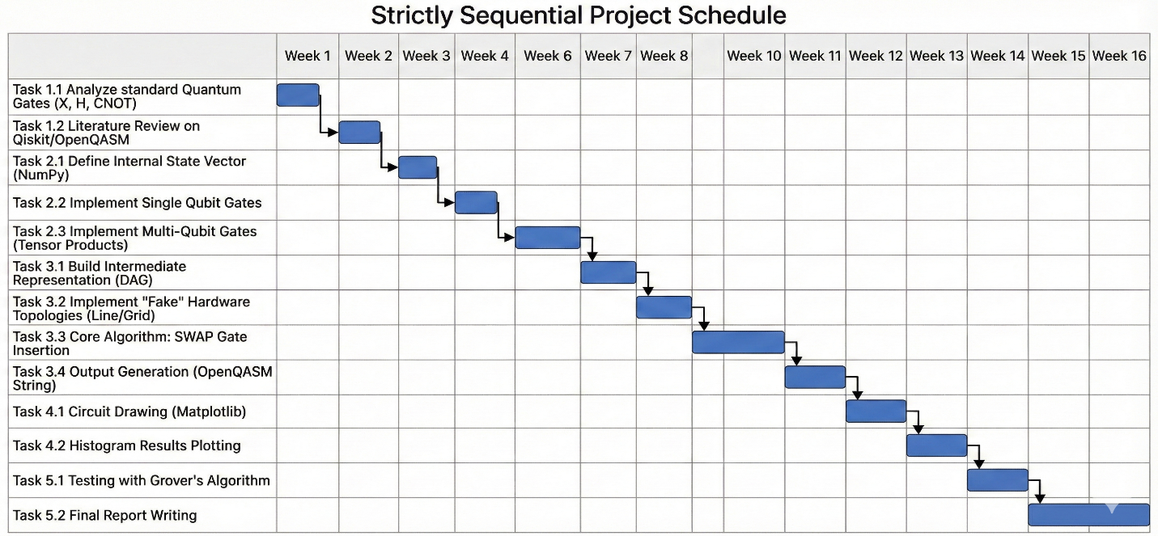
Figure 1: Gantt Chart

Mockups
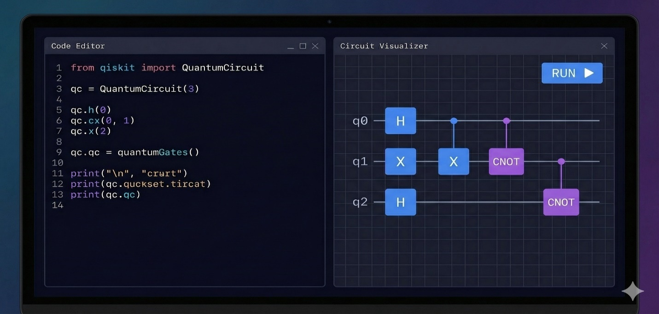
Figure 2: Main Dashboard
Description: A split-screen interface. The left panel is a code editor where the user writes python-like quantum code. The right panel displays a live-updated circuit diagram showing the gates placed on the qubits.
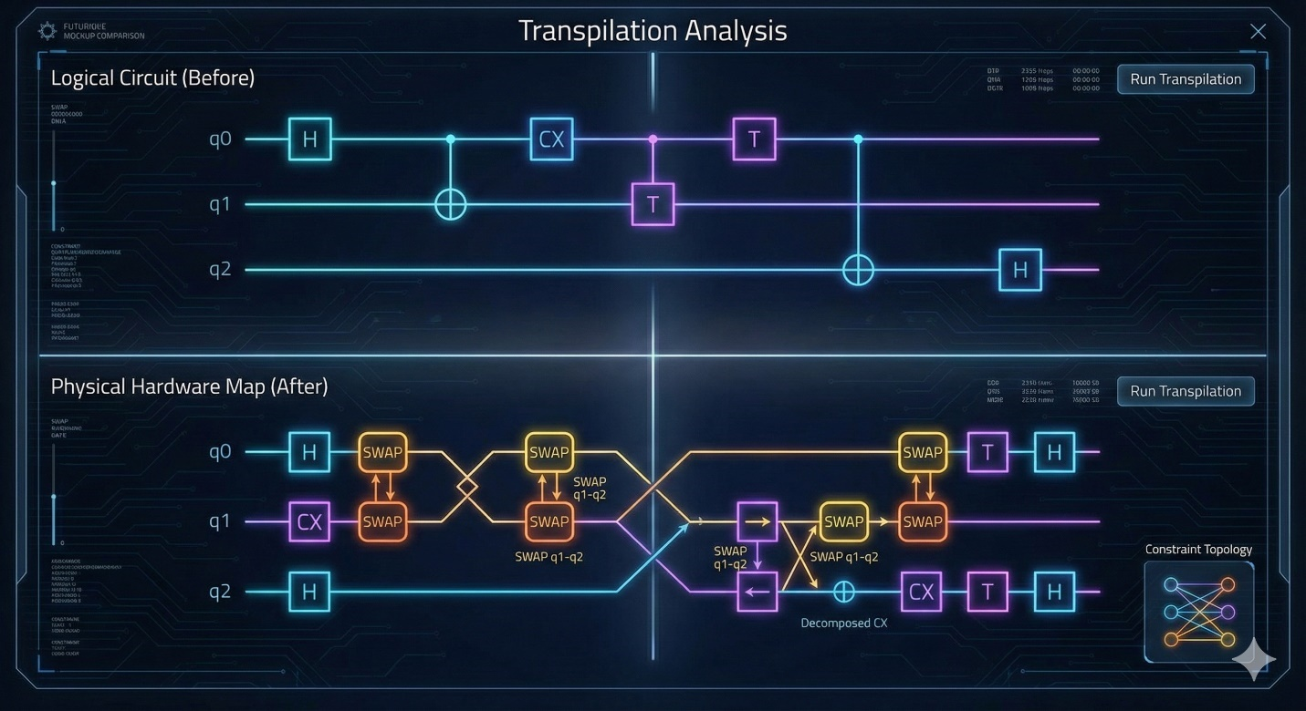
Figure 3: Transpilation View
Description: A comparison view. The top shows the "Logical Circuit" (clean, ideal). The bottom shows the "Physical Circuit" (after transpilation), highlighting where SWAP gates were inserted to respect the device's connectivity constraints.
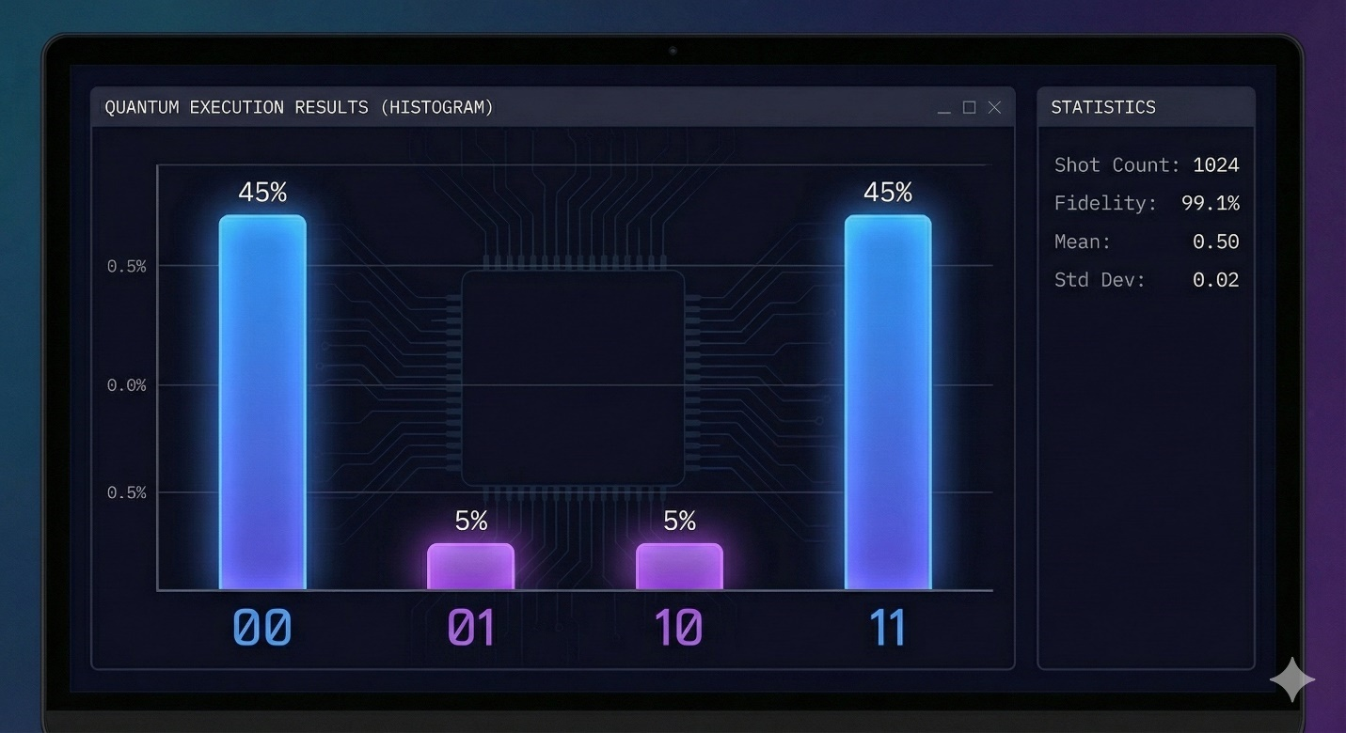
Figure 4: Execution Results
Description: A probability histogram (bar chart). The X-axis represents the measurement states (00, 01, 10, 11) and the Y-axis represents the probability percentage, verifying the algorithm's correctness.

Conclusion
Hardware fragmentation in quantum computing prevents code portability, and current tools are often vendor-locked. Current tools are too complex for lightweight educational use and do not transparently demonstrate the mapping process. A hardware-agnostic Quantum Virtual Machine (QVM) with automated transpilation to solve interoperability issues. The project uses Agile methodology to build a Python-based compiler pipeline that maps logical circuits to physical topologies using graph theory. A functioning runtime that can execute a single Grover’s Algorithm instance on both "Linear" and "Grid" simulated topologies without code changes. This project demonstrates advanced compiler design principles and linear algebra applications, serving as a foundational tool for understanding quantum computer architecture.

References
¹⁹

- M. A. Nielsen and I. L. Chuang, Quantum Computation and Quantum Information, Cambridge University Press, 2010.
- IBM Quantum, "Qiskit Documentation," [Online]. Available: https://qiskit.org/.
- A. W. Cross, et al., "OpenQASM 3: A broader and deeper quantum assembly language," arXiv preprint arXiv:2104.01472, 2021.
- Steiger, D. S., Häner, T., & Troyer, M. (2018). "ProjectQ: An open source software framework for quantum computing." Quantum, 2, 49.

