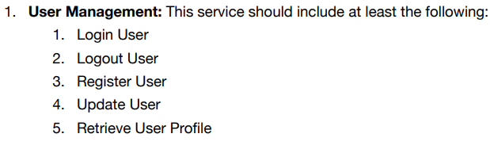

1.User Management

Api:<https://1d5qsjoz4c.execute-api.us-east-2.amazonaws.com/default/UserManagement>

DBTableName: Account

User accounts are stored in table ’Account’ in DynamoDB

**Important: All the upper case in spelling really matters!!!**

Headers must contain ‘Operation’. 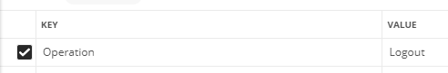

1.1&1.2 Login&Logout

The value of Operation must be Login or Logout in this case.

httpMethod must be PUT.

UserName and UserPassword need to be sent in this format in body.

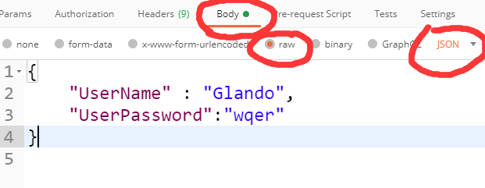

e.g.

{

"UserName" : "Glando",

"UserPassword":"wqer"

}

1.3 Register

To register new user, httpMethod needs to be POST.

Also, you need to send UserName and UserPassword in the same format as above. (1.1&1.2)

1.4 Update

You can update your password by using the following method:

httpMethod: PUT

Operation: Update

Body:

{

"UserName" : "Glando",

"UserPassword":"wqer"

}

1.5 Retrieve

httpMethod: GET

Operation: Any(It does not matter here, but the key: ‘Operation’ still needs to be in headers)

Body:

{

"UserName" : "Glando"

}

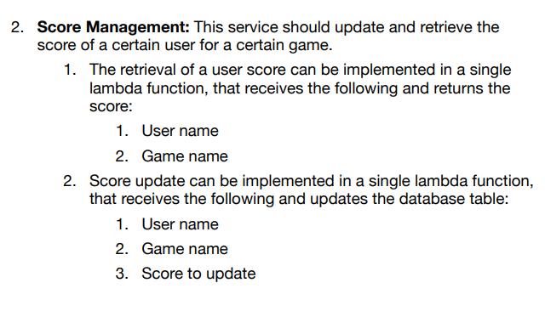

2.ScoreManagement

**Api:**<https://ezlqnb3ye0.execute-api.us-east-2.amazonaws.com/default/ScoreManagement>

DBTableName: AssignmentWar

* 1. To retrieve users, body must contain ‘UserName’, ’GameName’, and the GameName must be correct.

Only GET is supported.

e.g.

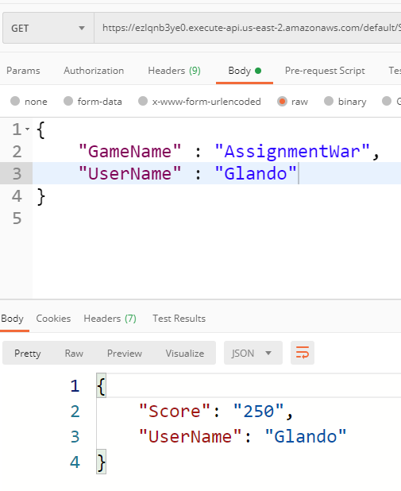

* 1. To update User Score, body must contain ‘UserName’, ’GameName’, ‘Score’, and the GameName must be correct.

Only PUT is supported.

e.g. 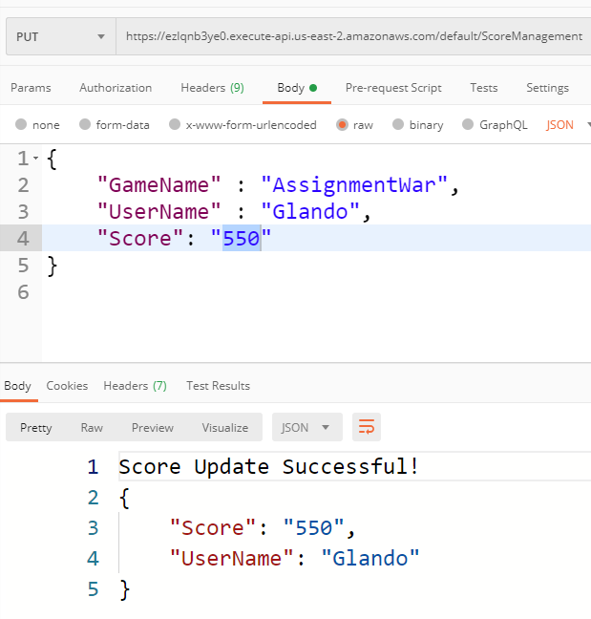

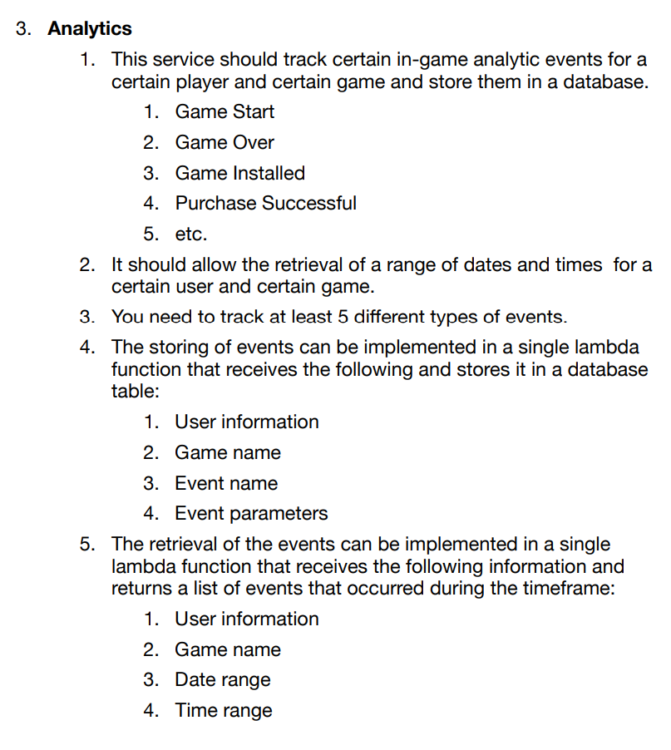

3.Analytics

3.1 To track events, body must contain ‘UserName’, ‘GameName’,’EventType’ and ‘EventDetail’.

TimeStamp will be created automatically by using server time.

Only POST is accepted.

e.g.

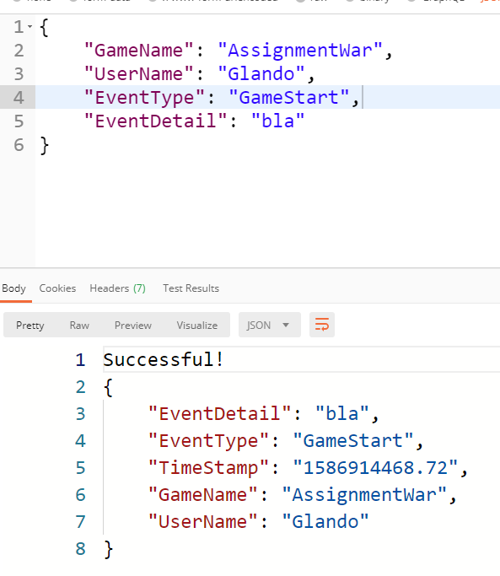

Supported EventType and EventDetail format list: (just for test, all data saved as string, so you can write whatever you want, but here are some recommends)

EventType EventDetail

------------------------------------------------

GameStart RoomNum

GameEnd Win/Loss

ItemPurchase Store,Price

PlayerDeath KilledBy

PlayerExpGain From

e.g

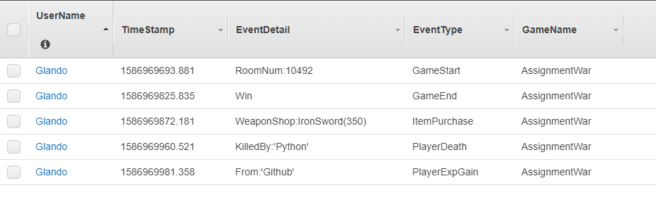

3.2 Retrieve Data

Only GET is supported!!

Supported filters:

GameName

UserName

TimeStart(%Y%m%d%H%M%S)

TimeEnd(%Y%m%d%H%M%S)

ExampleTimeformat:202004151305

The time you entered will be automatically fixed to server time

All filters are optional, but you must have one filter at least.

e.g.

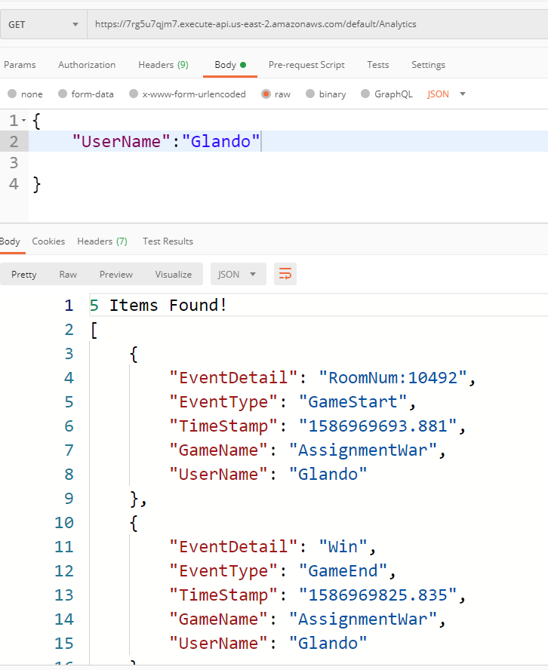

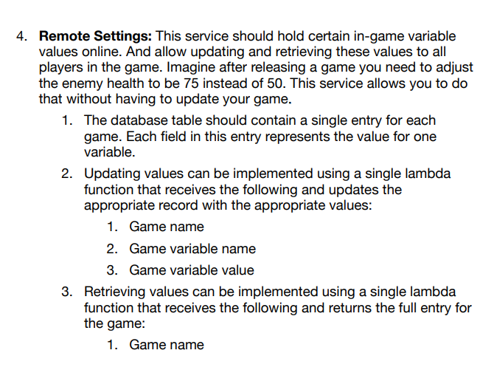

4.Remote Settings

Api:https://sgksfpe7bl.execute-api.us-east-2.amazonaws.com/default/RemoteSettings

4.2 data update

Only PUT is supported!

To submit changes or create new variable, all you need to do is send a json message with GameName, Key and Value in body.

e.g.

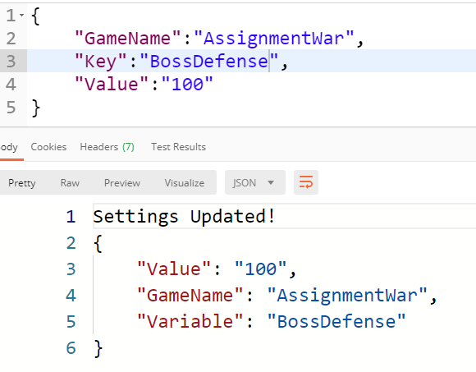

4.3 data retrieve

Only GET is supported!!

You can retrieve items by GameName, Key is optional, adding or not is up to you.

{

"GameName":"AssignmentWar",

"Key":"BossAttack"

}

Like this

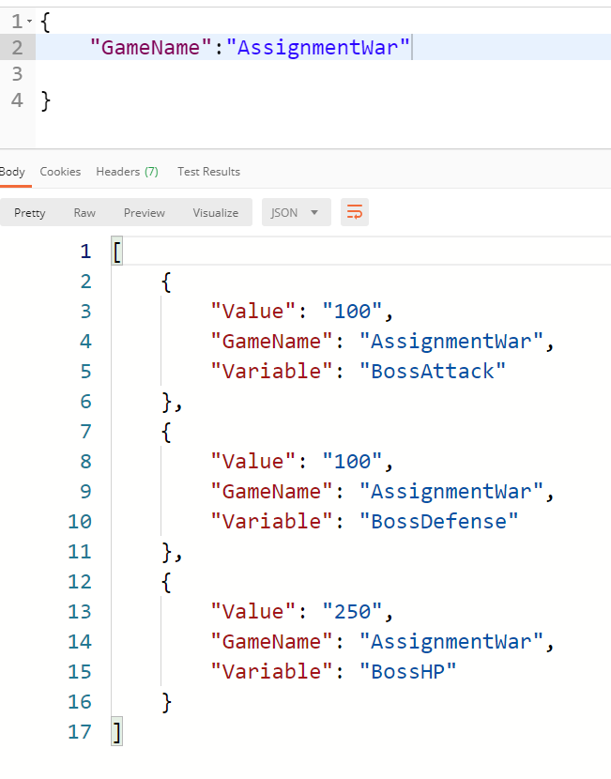

Or this

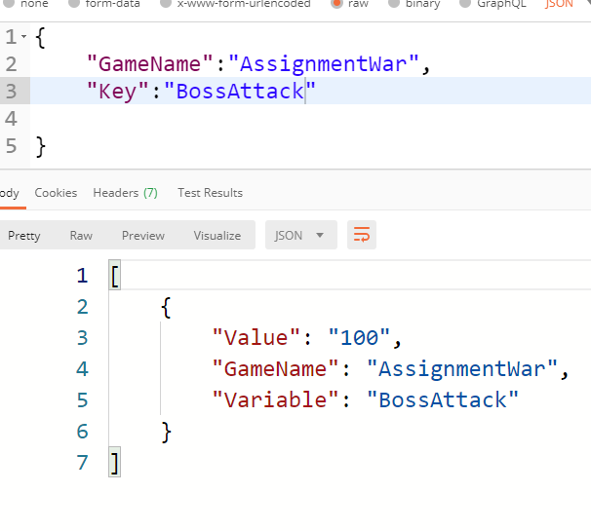

Link

https://www.getpostman.com/collections/a5ae70651f839ad16388