Group 7
Dedan Deus - 218338327
Emily Bendeck Garay - 221909833
Esha Malhi - 222552772
Qazi Fabia Hoq - 222109631
Het Pandya - 222541080
Noelia Cornejo -

MMAI 5040: Business Applications
Instructor: Divinus Oppong-Tawiah, Ph.D
Final Report: Dominick’s

Overview / Executive Summary
This project uses historical retail data from Dominick’s Finer Foods, a Chicago-based supermarket chain, collected over seven years. The datasets include store-level demographics from the 1990 U.S. Census, processed by Market Metrics, and daily store-level customer counts, sales, and promotional activity across product categories. These data provide insight into store traffic, shopper characteristics, and promotion responsiveness.
Dominick’s previously collaborated with the University of Chicago Booth School of Business to study shelf management, inventory, and pricing. Those studies focused on operational optimization, but this project takes a customer-focused approach, analyzing who shops at each store, how shoppers respond to promotions, and which stores display similar behavior patterns.
The analysis segments stores by demographics and promotion responsiveness to guide targeted marketing and engagement strategies, enhancing promotional effectiveness, customer interaction, and sales. Our analysis revealed some surprising outcomes, primarily that a customer’s ‘Education Level’ is a stronger predictor of their promotional responsiveness than ‘Income’, suggesting that segmented promotional strategies that account for this variable could be the optimal avenue to explore.
Problem Statement
This project aims to address the gap of customer-centric insights on this dataset by leveraging seven years’ worth of historical data including store-level demographics, customer counts, sales, and promotional activity. The core question that will be answered is: what customer features are most significant when evaluating their propensity to take advantage of promotions?
Methodology
The project’s methodology followed a structured approach, beginning with Exploratory Data Analysis and Preliminary Descriptive Analytics to establish baselines, examine the scope of the data, and analyze correlations between store demographics and promotional responsiveness. This initial phase revealed the finding that Education Level was a stronger predictor of promotional response than Income. This finding was then statistically validated using Chi-Square Tests of Independence, which proved there was no significant relationship between simple income categories and promotion response, validating the need for a more complex approach.
Then, the core of the analysis was Cluster Analysis as a means of inference from market basket data (Technique 4). Here, K-Means clustering was applied to a full set of standardized demographic and behavioral features (without PCA dimensionality reduction for the model itself) to segment the 107 stores into four distinct behavioral groups, such as “Promo Enthusiasts” and “Steady Shoppers”. Finally, we explored implementation issues (technique 6) by translating these four clusters into a strategic framework by developing cluster-specific Return on Investment (ROI) decision rules, for example, Minimum ROI being ≥ 15% for Promotion Enthusiasts. We also calculated promotion cost-benefit and ROI, and created a priority scoring system to rank stores for resource allocation based on financial, behavioral, and strategic factors.

Technique 1: Preliminary Descriptive Analytics

Data Overview & Scope
Our analysis of the Dominick’s Finer Foods dataset covers a comprehensive seven-year period, providing a robust foundation for customer segmentation. The final analytical dataset consists of 45,600 store-week observations across 107 unique stores.
The preliminary exploration establishes the scale of operations, with the average store generating $172,875 in weekly grocery sales and serving approximately 19,573 customers per week. These baselines allow us to measure the relative impact (“Lift”) of promotional activities.

Correlation Analysis: Identifying Drivers of Lift
To determine which store characteristics drive promotional success, we analyzed the correlation between store demographics and two key performance indicators: Customer Lift (incremental traffic during promotions) and Sales Lift (incremental revenue during promotions).
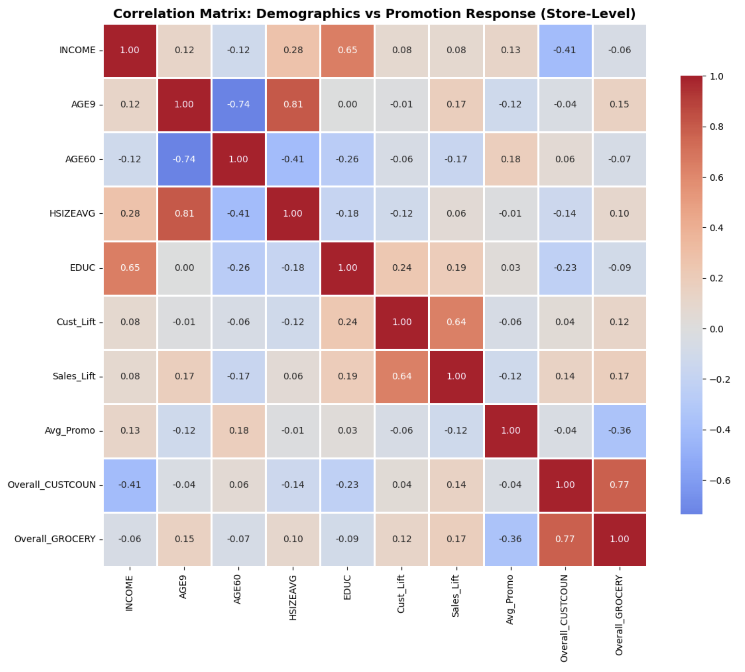
Figure 1 - Correlation Matrix: Demographics vs Promotion Response (Store-Level): This matrix identifies the direction and magnitude of the linear relationship between store demographic features and promotional lift metrics.
Key Findings from the Correlation Matrix include:
- Education is a Stronger Predictor than Income: Contrary to the traditional assumption that income is the primary driver of price sensitivity, our analysis shows that Education Level (EDUC) has a stronger positive correlation with Customer Lift (r=0.24) compared to Income (r=0.08). This suggests that informed/educated shoppers may be more strategic in utilizing promotions.
- Income is a Weak Predictor: The correlation between INCOME and Cust_Lift is surprisingly weak (0.08). This indicates that promotional responsiveness is not strictly a function of economic necessity. Affluent shoppers are nearly as likely to respond to promotions as lower-income shoppers.
- Household Size: There is a moderate positive correlation (r=0.28) between HSIZEAVG and INCOME, but Household Size itself has a weak relationship with lift (r=0.12).

Statistical Validation (Chi-Square Tests)
To validate these relationships, we performed Chi-Square tests of independence to determine if the observed associations were statistically significant.
Table 1 - Summary of Chi-Square Tests of Independence: This table provides statistical validation for the observed differences in promotion activity across store zones.
Relationships Tested | Chi-Square (χ2) | P-Value | Statistical Significance
Income Level vs. Promo Response | 7.90 | 0.095 | Not Significant  (p > 0.05)
Store Zone vs. Promo Activity | 27.63 | 0.002 | Significant  (p < 0.05)
Age Profile vs. Traffic Level | 2.58 | 0.630 | Not Significant  (p > 0.05)

Test 1: Income Level vs. Promotion Response
- Result: P-value of 0.0953 (Fail to Reject Null Hypothesis).
- Finding: We found no statistically significant relationship between simple income categories (Low/Med/High) and promotion response.
- Implication: This is a critical finding for our business proposal. It proves that a simple strategy of “targeting low-income stores with coupons” is flawed. Responsiveness is nuanced, validating the need for the multi-dimensional clustering approach (Technique 4) utilized later in this report.
Test 2: Store Zone vs. Promotion Activity
- Result: P-value of 0.0021 (Reject Null Hypothesis).
- Finding: There is a statistically significant association between Store Zone and Promotion Activity.
- Implication: Promotional intensity is currently unevenly distributed across geographic zones. This suggests operational inconsistency in how Dominick’s currently manages marketing, presenting an opportunity for optimization.
Test 3: Age Demographics vs. Traffic Level
- Result: P-value of 0.6297 (Fail to Reject Null Hypothesis).
- Finding: Shopping frequency (traffic) is independent of the age profile of the store (Family vs. Retiree).
- Implication: Baseline traffic is stable across demographics; therefore, any spikes in traffic can be reliably attributed to promotional activities rather than demographic habits.

Conclusion of Technique 1
The descriptive analytics reveal that demographics alone (like income) are poor predictors of promotion success. The data contradicts the assumption that only lower-income demographics respond to sales. This insight confirms that Dominick’s requires a more sophisticated segmentation model (Clustering) that combines education, household structure, and behavioral history to accurately target high-potential stores.

Technique 4: Cluster Analysis

Data Preparation and Analytical Scope
Technique 4 focused on segmenting Dominick’s stores based on customer demographics and responsiveness to promotions, directly supporting the project’s objective of identifying who shops at each store, how they respond to promotions, and which stores share similar behavioral patterns. Following the CRISP-DM framework, the process began with data understanding and preparation. The dataset combined demographic variables sourced from census-based trade areas with behavioral indicators derived from daily store performance. Demographic variables included age distributions, household composition, income levels, education, employment, retirement status, and indicators of poverty along with transportation access, capturing the characteristics of each store’s surrounding community. Behavioral features consisted of customer traffic, promotion counts, and promotional lift across product categories, capturing how these communities behaved in response to promotional incentives.
To prepare the data for clustering, all behavioral variables were standardized using z-scores to ensure equal weighting across features. Principal Component Analysis was used only for visualization, allowing a two-dimensional representation of stores for interpretation, while the K-Means clustering model itself was trained on the full set of standardized demographic and behavioral features without dimensionality reduction.

Model Development and Testing of K Values
The modelling stage began with evaluating multiple values of K. The two-cluster solution was tested first, as it produced the highest silhouette score among the options (0.26). The K=2 model revealed an interpretable separation based primarily on promotion responsiveness.
However, despite having the strongest silhouette score and the cleanest statistical separation, the K=2 solution was not selected. The resulting segments were too broad to generate meaningful managerial insights or support the project’s goal of developing store-specific promotional decision rules. The model essentially split the stores into high-promotion-lift and low-promotion-lift groups, which is directionally informative but not detailed enough to guide differentiated ROI thresholds, promotion rules, or tailored recommendations.
Because silhouette score alone should not determine the optimal number of clusters, K=4 was also evaluated. Although K=2 had the higher silhouette score, two clusters would not provide enough differentiation for actionable retail strategy. After reviewing the shape of the elbow curve, the PCA projections, and the business requirement for interpretable segments, four clusters were selected. The K=4 model provides balanced statistical validity and clear managerial meaning, producing four behavioral groups that align naturally with retail promotional strategy.
Taken together, stronger business interpretability, clear centroid separation across key variables, elbow-method evidence, and meaningful behavioral differences make K=4 the most defensible and action-oriented segmentation.
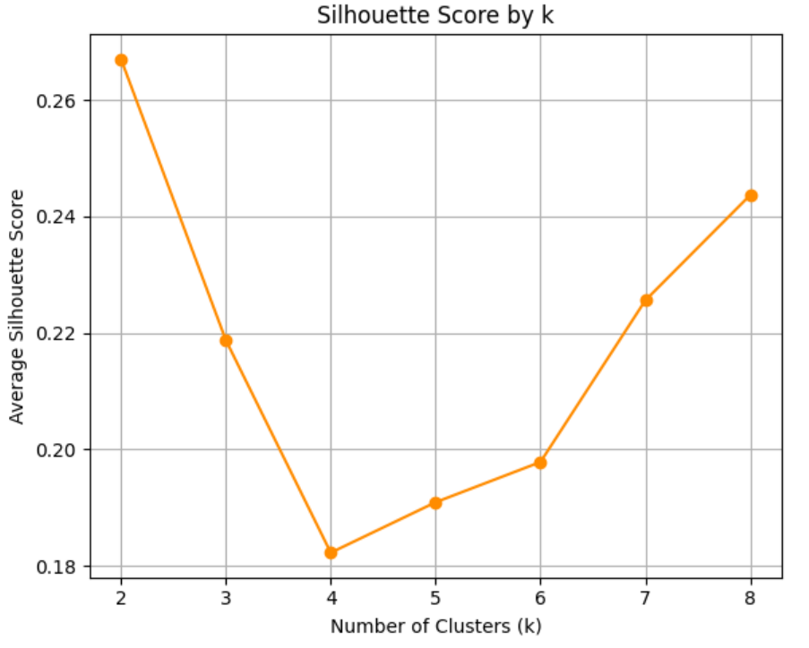

Figure 2 - Inertia and Silhouette Score Across K Values: This figure summarizes the model-selection diagnostics used to evaluate different numbers of clusters. The silhouette score plot evaluates how well-separated and cohesive the clusters are at each value of K. This metric guides the choice of a clustering solution that balances statistical fit with meaningful, interpretable segment structure.

Final Cluster Selection and Interpretation
Although the K=4 silhouette score was modest (0.1823), this was expected given the subtle demographic variation across stores. When considered alongside the Calinski-Harabasz score (27.93), the Davies-Bouldin score (1.5923), and the pattern observed in the elbow plot, the four-cluster solution offered the best balance between statistical evidence and managerial usefulness. For this reason, K=4 was selected as the final segmentation to support downstream decision making. Each cluster displayed meaningful and distinct behavioral patterns that align with how retailers typically differentiate store types for promotional planning:
“Promo Enthusiasts” showed the highest promotional lift and above-average promotion frequency. Their behavior reflects a strong sensitivity to price incentives, making them ideal candidates for frequent, discount-driven campaigns.
“Steady Shoppers” formed the largest cluster and exhibited stable customer volume, higher-income and well-educated demographics, and limited promotional lift. Their slightly negative lift suggests that discounts do not meaningfully change their purchasing behavior, making them better suited for loyalty-based or full-price strategies.
“Family-Focused Shoppers” served larger households with consistent week-to-week shopping patterns and modest positive lift. They respond well to moderate-frequency promotions that align with predictable household needs such as weekly replenishment trips.
“Mature Loyalists” represented older customer bases with steady non-promotional traffic and the lowest responsiveness to price incentives. Their negative lift suggests that traditional discounts are less effective, so they may benefit more from service-oriented initiatives or personalized loyalty rewards.

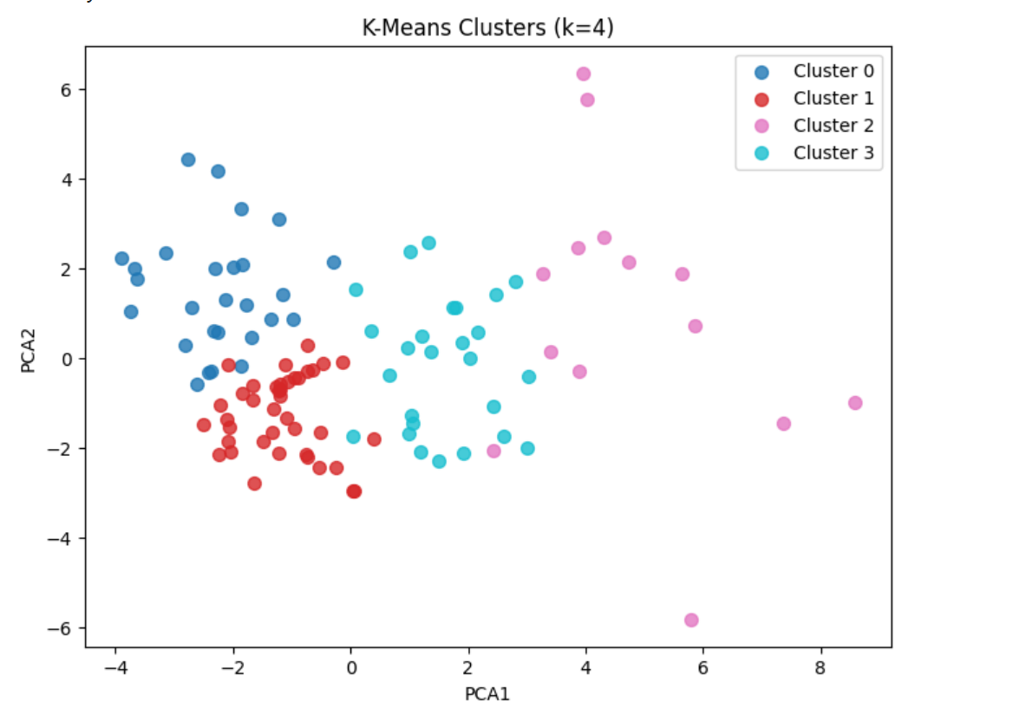

Figure 3 - K-Means Clustering Results: This visualization shows the four customer–store segments identified through the K-Means algorithm after combining demographic and promotional-response variables. Each point represents a Dominick’s store, and the color coding reflects its assigned segment: Cluster 0 (Promo Enthusiasts), Cluster 1 (Steady Shoppers), Cluster 2 (Family-Focused Shoppers), and Cluster 3 (Mature Loyalists). The distribution of points highlights how stores differ in their demographic composition and promotion sensitivity, illustrating the behavioral and structural distinctions that support the four-cluster solution used for downstream decision-rule development.

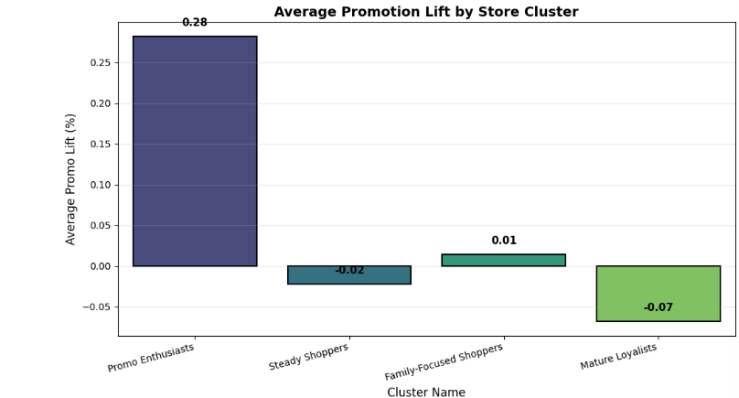

Figure 4 - Average Promotion Lift by Store Cluster: This visualization shows the average promotional lift observed within each of the four store clusters identified in the segmentation analysis. The chart highlights how Promo Enthusiasts generate strong positive lift during promotional periods, while Steady Shoppers and Mature Loyalists experience little to no incremental response. Family-Focused Shoppers display modest but positive lift. These differences provide clear evidence of distinct behavioural patterns across clusters and directly support the use of differentiated decision rules and ROI thresholds in later stages of the project.

Evaluation and Conclusion of Technique 4
Model evaluation followed CRISP-DM best practices. The PCA visualization showed approximate separation of stores in two-dimensional space, supporting the internal consistency of the four behavioral groups. These validation results confirmed that the segmentation was statistically grounded and practically interpretable for retail decision making.
The four-cluster framework directly addressed the project’s central questions: who shops at each store, how they respond to promotions, how customer bases differ across locations, and which stores share similar behavioral patterns. This segmentation provided the analytical foundation for Technique 6, enabling the development of ROI thresholds, promotion cost-benefit estimates, and a priority scoring system for allocating promotional resources. The clear behavioral differences between clusters ensured that the downstream decision rules were not only data-driven but also aligned with realistic retail strategy considerations.
Technique 6: Implementation, Decision Rules, Cost-Benefit Analysis, and Priority Scoring

Overview and CRISP-DM Alignment

Technique 6 operationalized the cluster insights from Technique 4 by translating analytical outcomes into a structured framework for store-level promotional decisions. Following the evaluation and deployment stages of CRISP-DM, this technique combined segmentation results with financial modelling, operational constraints, and ethical considerations to ensure that each promotional recommendation was economically justified, operationally feasible, and aligned with customer welfare.

Cluster-Based Decision Rules
The first component of Technique 6 involved developing decision rules that varied by cluster. Each store’s assigned cluster, estimated incremental sales, historical promotion frequency, and expected return on investment (ROI) determined whether a promotion would be recommended.
“Promo Enthusiasts” are the segment with the strongest and most reliable promotional lift. These stores consistently generate meaningful incremental sales whenever a discount or incentive is offered. Because of this dependable responsiveness, the minimum ROI threshold for this group is set at fifteen percent. This lower requirement allows the model to recommend more frequent and more tactical promotions since even modest campaigns tend to produce strong financial returns in these locations.
“Family-Focused Shoppers” demonstrate steady positive lift, but only when promotions align well with the needs of larger households. For this group the minimum ROI threshold is set at twenty percent. This ensures that only financially sound promotions are recommended while still allowing for moderate and well timed campaigns such as family packs or seasonal offers. The goal for this segment is to support promotions that generate clear incremental value without overspending on activity that would not meaningfully change customer behavior.
“Mature Loyalists” represent the segment with the lowest responsiveness to price based incentives. These stores maintain stable traffic patterns regardless of promotional activity, meaning that discounts rarely drive additional demand. To protect profitability, promotions are only recommended for this group when the expected return is exceptionally strong. This is enforced by setting a high minimum ROI threshold of thirty percent. Only promotions capable of generating very large incremental sales should be executed in these locations.
“Steady Shoppers” consistently attract high organic traffic and show almost no lift during promotional periods. For this reason the recommended decision rule for this group is to avoid running price promotions altogether. Instead of discounting, these stores benefit more from loyalty programs, premium assortments, or service enhancements because price reductions would not produce incremental sales and would only erode margins.
A final consistency rule is applied when cluster information is incomplete. If a store is missing key inputs such as lift values or demographic-derived measures, the model substitutes conservative median values drawn from either the store’s cluster or the full dataset. This ensures that ROI calculations remain stable and financially coherent even when data gaps occur. By grounding missing values in representative medians rather than assumptions, the system maintains fairness and avoids overstating or understating promotion potential. These rules reflected meaningful behavioral differences across clusters and ensured strategic, financially sound promotional deployment.

Cost-Benefit Analysis and ROI Estimation
The second component of Technique 6 assessed whether running a promotion at each store would truly create financial value for Dominick’s. This step combines the historical lift patterns uncovered earlier with realistic operational cost assumptions so the final recommendations reflect both customer behavior and business constraints.
Promotion cost included two parts. First, a fixed cost of five thousand dollars was applied uniformly to every store. This represents the predictable expenses that occur no matter where the promotion is launched, including staffing, signage, preparation work, and in-store execution. Second, the model added a variable cost equal to five percent of the store’s expected incremental sales. This reflects real retail practice where larger, more successful promotions typically require additional sampling, media spend, and fulfillment resources. These assumptions directly align with the cost structure implemented in the code, where each store receives the same fixed baseline and a variable portion tied to the size of the incremental sales lift.
Expected incremental sales were calculated using each store’s historical response to past promotions. The model combined the observed lift percentage with average customer traffic and average basket value to estimate how much additional revenue a new promotion is likely to produce. This choice follows the business requirement that insights must be grounded in real customer behavior, not hypothetical averages. Stores that historically showed stronger promotional response naturally project higher incremental revenue.
Return on investment (ROI) compared these incremental sales to the combined promotional cost. A positive ROI indicates that the promotion is expected to pay for itself and generate additional profit. This mirrors the budget decisions marketing managers make when deciding whether to activate a circular placement or price discount in a given week. To maintain analytical reliability, the model also calculated ROI per customer as a secondary check. This ensured results were not inflated by unusual traffic patterns or missing data. Cases with atypical customer counts were automatically corrected using conservative median values built earlier in the pipeline.
Only stores projected to generate a positive ROI after these adjustments qualify for consideration in the later cluster-based decision rules. This ensures that every final recommendation is financially justified and consistent with Dominick’s strategic objective of running promotions that grow profit rather than simply increase volume.

Priority Scoring System
The third component introduced a Priority Scoring System designed to rank stores when marketing budgets or operational capacity were limited. This ensured that, even among stores that met minimum ROI thresholds, resources would flow first to the opportunities with the strongest financial and strategic value. In a real retail environment where promotional calendars, staffing, and advertising bandwidth are finite, AI-driven ranking systems like this help managers decide not only whether to run a promotion, but where they will generate the highest return on constrained resources. The priority score combined three elements. First, each store’s ROI was scaled between zero and one so that extremely high or low values did not distort comparisons. Second, expected incremental sales were also scaled to capture the volume impact of a promotion, ensuring that stores generating large revenue gains were not overshadowed by stores with smaller but more efficient returns. Finally, a cluster-specific bonus was added to reflect the strategic importance of each segment.
The coding framework assigns the largest bonus to Promo Enthusiasts because they reliably convert promotional exposure into significant incremental sales. Family-Focused Shoppers and Steady Shoppers receive moderate bonuses, reflecting balanced opportunities where promotions can be beneficial but must be deployed selectively. Mature Loyalists receive the smallest bonus because promotions have limited ability to change their behavior and may erode margins without meaningful gains. These bonus values are intentionally small relative to ROI and sales scaling, which ensures that financial performance remains the primary driver while still incorporating segment-level strategic priorities. This blend of financial metrics and behavioral segmentation mirrors the way retail marketing teams prioritize stores for high-impact campaigns, allowing AI-driven scoring to complement managerial judgment instead of simply replacing it.
The final priority score provided a smooth and interpretable ranking that integrates profitability, revenue impact, and customer behavior patterns. This created a transparent system for allocating promotional resources when only a subset of eligible stores could be activated at a given time, allowing Dominick’s to deploy promotions in a way that maximizes return, supports regional merchandising strategies, and aligns with overall business objectives.

Conclusion of Technique 6
Customer experience was built into the modeling through the use of historical promotion frequency. Stores that already experience high promotional intensity were not automatically prioritized, preventing the risk of overwhelming customers with repeated messaging. In particular, clusters known for strong price responsiveness, such as Promo Enthusiasts, were handled carefully to avoid excessive solicitation that might diminish the perceived value of promotions over time. This reflects a core principle from retail marketing: the long-term health of customer relationships is just as important as short-term revenue spikes, and an AI system must support but not undermine customer trust and brand perception.
Technique 6 completed the CRISP-DM process by unifying the segmentation outputs, the financial modelling, the priority-based ranking method, and the operational and ethical safeguards into a comprehensive implementation plan. For each store, the model produced the cluster assignment, expected incremental sales, estimated promotion cost, calculated ROI, the decision generated by the rule-based engine, and the resulting priority score. This ranked output provides a clear foundation for determining which stores should receive promotions first when budgets or operational capacity are limited. By grounding each component in historical behavior and explicit cost assumptions, the model’s recommendations offer a transparent and defensible roadmap for managerial decision making.
Together, these elements ensure that the recommended promotional strategy is financially sound, operationally feasible, and aligned with fair and responsible marketing practices. The integration of conservative cost assumptions, cluster specific decision thresholds, and a robust scoring system ensures that promotional investments generate value while maintaining consistency with Dominick’s strategic objectives.

Insights and Recommendations
The analysis uncovered a critical insight: an individual’s Education Level is a stronger positive predictor of promotional responsiveness than Income. This suggests that informed shoppers employ strategic purchasing behaviors, and promotional response is not solely driven by economic necessity. Furthermore, statistical validation confirmed there is no significant relationship between simple income categories and promotional response. Based on the 4-cluster store segmentation, Dominick’s is recommended to implement cluster-specific promotional strategies to maximize ROI.
The first recommendation is to target the Promo Enthusiasts segment with frequent, discount-driven campaigns, enforcing a lower Min ROI due to their reliable and strong lift. Next, for the Steady Shoppers segment, we recommend implementing a “Do Not Promote” rule for price incentives, as they show virtually no lift. It is preferable to focus marketing on loyalty programs, premium assortments, or service enhancements instead. Also, for Family-Focused Shoppers, Dominick’s should use moderate-frequency promotions that align with household needs, setting a higher Min ROI to ensure financial soundness. And finally, for Mature Loyalists it is best to recommend promotions when the expected return is exceptionally strong, to protect profitability here.

Conclusion
This project successfully leveraged seven years of historical Dominick’s data to develop a customer-centric promotional strategy, addressing the core question of what features best predict a propensity to utilize promotions. The initial analysis revealed that traditional income-based targeting is flawed, as promotional responsiveness is nuanced and often driven by factors like education rather than economic necessity. The four-cluster K-Means segmentation identified groups like “Promo Enthusiasts”, “Steady Shoppers”, “Family-Focused Shoppers”, and “Mature Loyalists”. This provided the necessary analytical foundation by defining stores based on distinct behavioral and demographic patterns. Finally, these clusters were operationalized into a comprehensive implementation plan, featuring cluster-specific decision rules, a robust cost-benefit analysis, and a priority scoring system that integrates financial performance (ROI), revenue impact, and ethical considerations. Coupled with our final recommendations, this customer analysis ensured that Dominick’s promotional resources are allocated strategically and in a data-driven manner, maximizing profitability while maintaining operational feasibility and customer equity.

References
Solink. (n.d.). Retail store cost breakdown: Industry insights. Retrieved from https://solink.com/resources/industry-insights/retail-store-cost-breakdown/
Cliffedge Marketing. (n.d.). The cost and considerations of a multichannel shopper marketing campaign. Retrieved from https://cliffedgemarketing.com/the-cost-and-considerations-of-a-multichannel-shopper-marketing-campaign/
Himanshu. (n.d.). What are five marketing strategies that retailers spend half their budget on? Medium. Retrieved from https://medium.com/@imhimanshu/what-are-five-marketing-strategies-that-retailers-spend-half-their-budget-on-49a3adc288ae

