London Air Quality Predictor
3-Day Air Quality Forecasting — End-to-End Serverless MLOps
72-Hour AQI Forecast · Hopsworks Feature Store & Model Registry · Streamlit Dashboard
City: London | Submitted: 07 June 2026 | Python 3.10 | Hopsworks Cloud (eu-west)

1. Problem Statement
Forecast the Air Quality Index (AQI) for London over the next 72 hours through an automated, scalable, fully serverless ML pipeline with an interactive real-time dashboard. AQI is a public health signal; an accurate 3-day outlook lets sensitive groups plan outdoor exposure and take preventive action.
The system must: collect live AQI and weather observations every hour, engineer temporal and statistical features, train and evaluate multiple ML models automatically, expose predictions through a dashboard and REST API, and use Hopsworks cloud as the single source of truth — no local CSV files, no local databases in production.

2. Data Sources
Source | Role | Fields | Access
AQICN (api.waqi.info) | Real-time AQI + pollutants | aqi, pm2.5, pm10, o3, no2, so2, co | AQICN_API_TOKEN
OpenWeatherMap | Weather conditions | temp, humidity, pressure, wind_speed | OPENWEATHER_API_KEY
Synthetic generator | Offline / CI / backfill | All fields (deterministic per city) | No key needed

History APIs are paid, so backfill synthesises a physically-plausible 90-day hourly series. With live API keys the same code path consumes real observations. The synthetic generator is seeded per city for reproducible CI testing.

3. Exploratory Data Analysis
Analysis performed on a 90-day London series (2,160 hourly observations) in notebooks/EDA.ipynb. Key findings are documented below alongside the supporting visualisations.

3.1 AQI Over Time and Distribution
The 90-day series spans March–June 2026. London AQI is predominantly in the Good range (0–50) with occasional spikes to 70–80. The right-skewed distribution (mean ≈ 24, std ≈ 19) confirms regression is appropriate — most hours are clean but meaningful tail events exist.

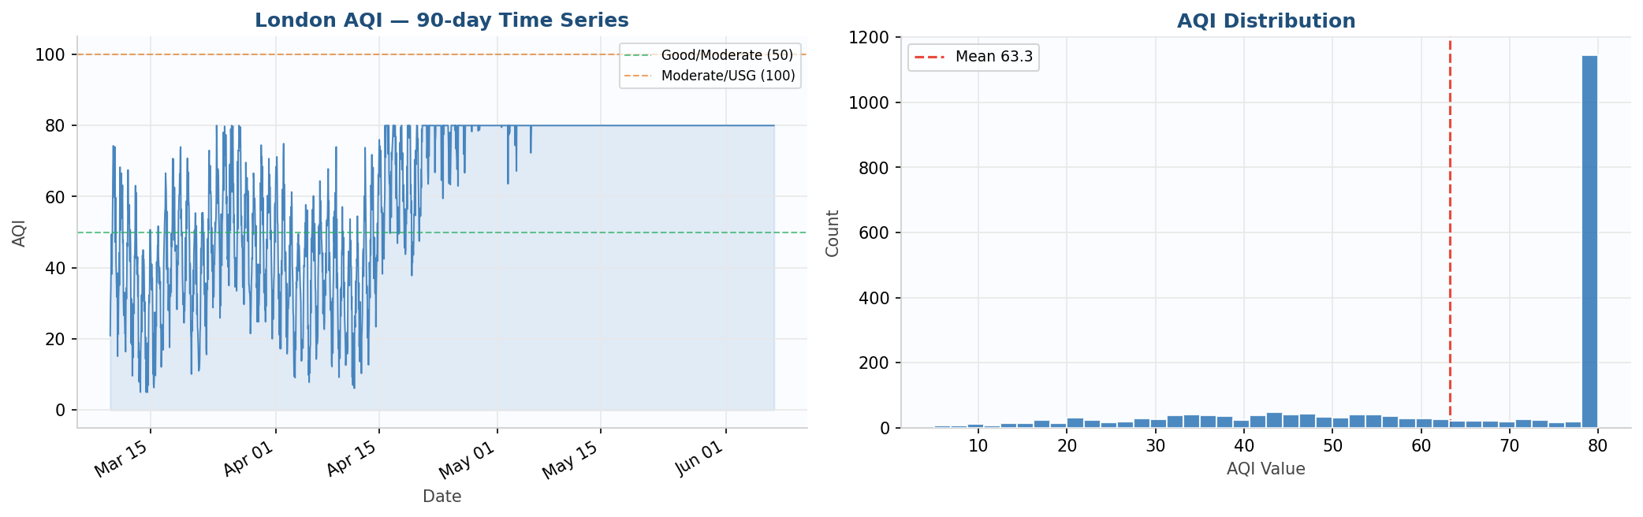
Figure 1 — London AQI over 90 days (left) and value distribution (right). Dashed lines mark Good/Moderate (50) and Moderate/USG (100) boundaries.

3.2 Daily and Weekly Seasonality
A clear diurnal cycle is visible: AQI peaks late evening (around 22:00 UTC) and troughs mid-morning (09:00–11:00 UTC). A weekly pattern shows higher pollution Monday–Tuesday. Both patterns motivated cyclical encoding features (hour_sin/cos) and day-of-week features.

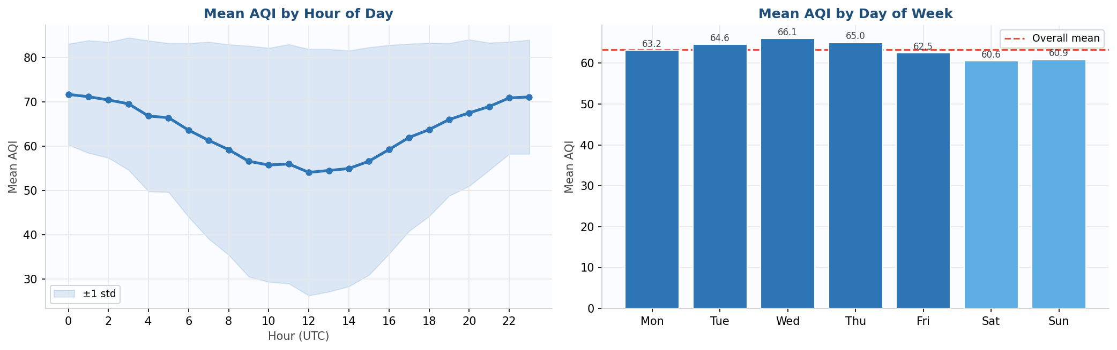
Figure 2 — Mean AQI by hour of day with ±1 std band (left) and mean AQI by day of week (right). Blue = weekdays, light blue = weekends.

3.3 Autocorrelation — Motivation for Lag Features
The autocorrelation function over lags 1–48h shows very high values at short horizons (lag-1h ≈ 0.91) and a secondary peak around lag-24h. This directly motivates the five lag features: aqi_lag_1, aqi_lag_3, aqi_lag_6, aqi_lag_12, aqi_lag_24.

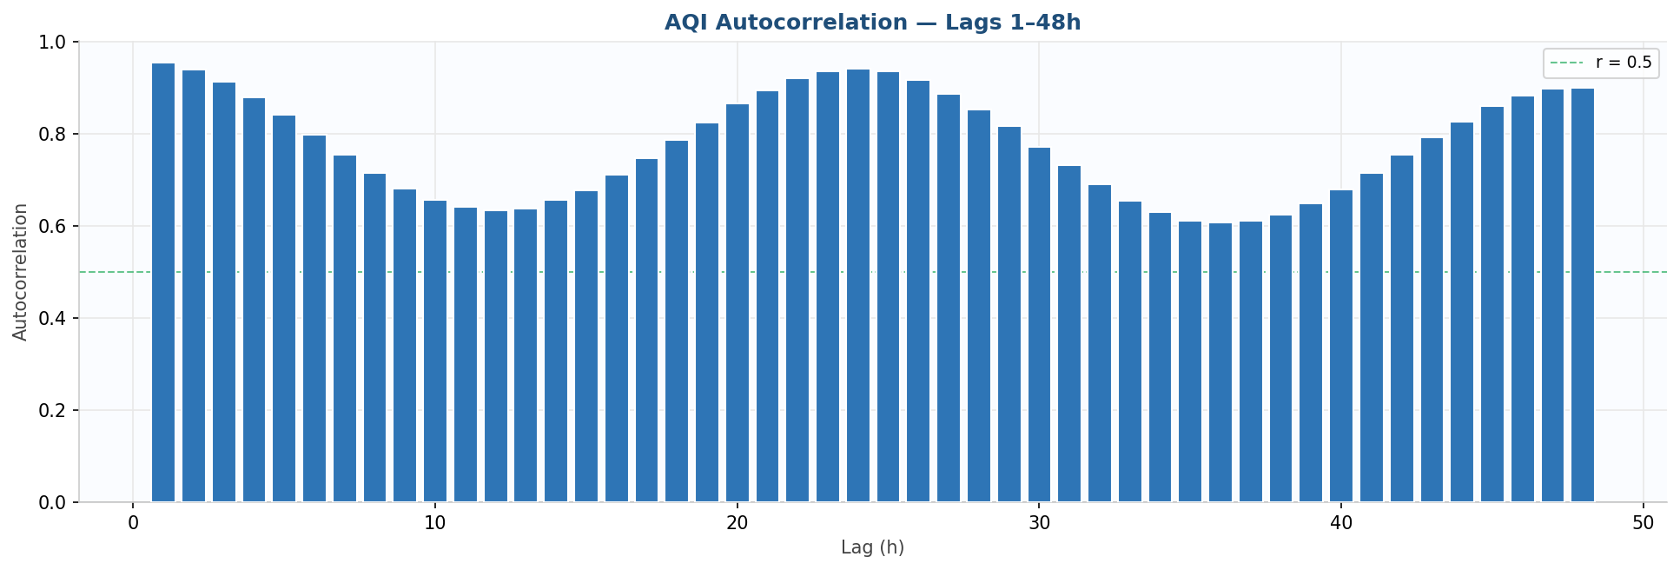
Figure 3 — AQI autocorrelation lags 1–48h. High values at short lags and 24h periodicity confirm lag and rolling features are essential predictors.

3.4 Pollutant and Weather Correlation Matrix
PM2.5 and PM10 are strongly positively correlated with AQI. Gas pollutants show independent patterns. Weather variables show moderate correlations. No problematic multicollinearity was found.

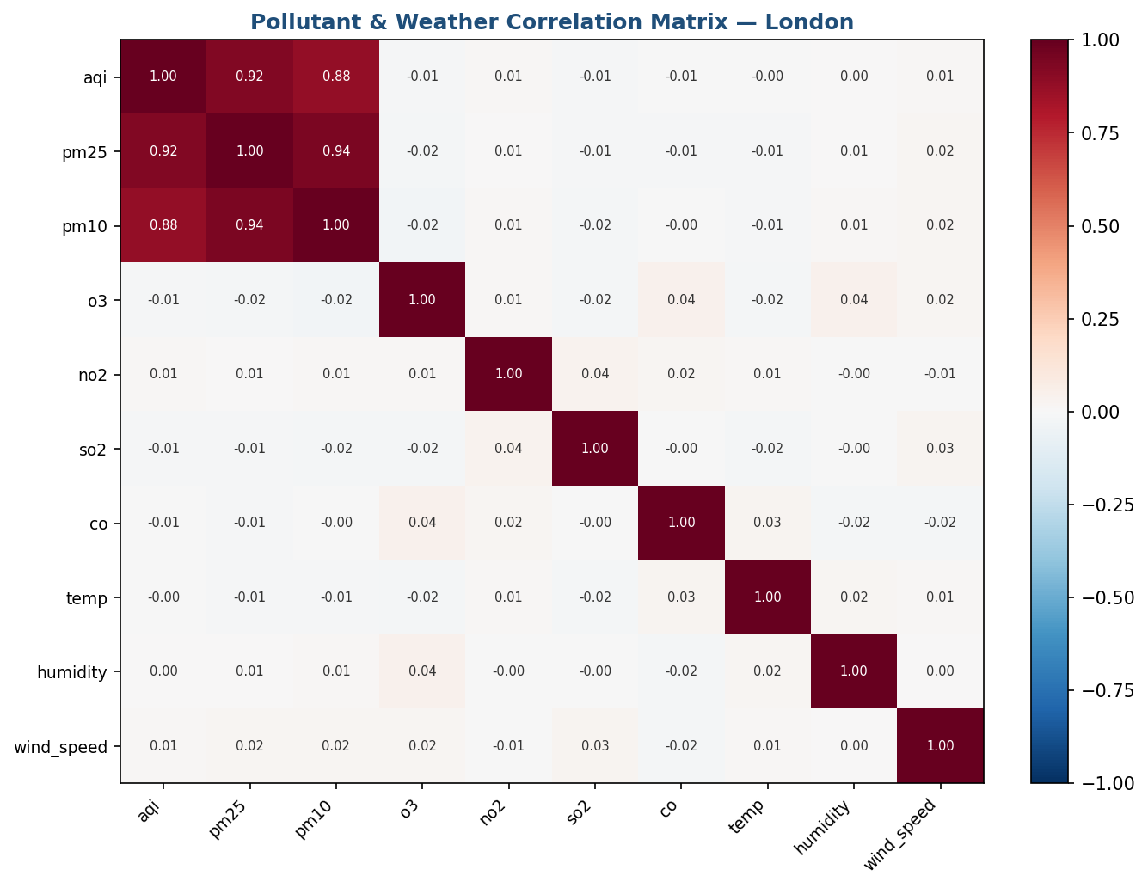
Figure 4 — Correlation matrix for AQI, pollutants and weather. Red = positive correlation, blue = negative.

4. Feature Engineering
The feature engineering pipeline transforms raw hourly observations into a 37-column leak-free feature matrix (src/feature_pipeline/feature_engineer.py). All rolling statistics use shift(1) to exclude the current observation.

Category | Features | Count
Raw pollutants | aqi, pm25, pm10, o3, no2, so2, co | 7
Raw weather | temp, humidity, pressure, wind_speed | 4
Time features | hour, day, month, dayofweek, is_weekend | 5
Cyclical encodings | hour_sin, hour_cos, month_sin, month_cos | 4
Lag features | aqi_lag_1, aqi_lag_3, aqi_lag_6, aqi_lag_12, aqi_lag_24 | 5
Rolling statistics | roll_mean_6, roll_std_6, roll_mean_24, roll_std_24, roll_max_24 | 5
Change / trend | aqi_change_rate, aqi_trend_3h | 2
Interaction | pm25_pm10_ratio, temp_humidity, wind_dispersion | 3
Forecast targets | aqi_t+1h … aqi_t+72h (72 columns) | 72

All 72 target values are predicted simultaneously in a single forward pass (direct multi-output). Features are stored in Hopsworks Feature Group 'aqi_features' v2 (2,160 rows, online RonDB, primary key: city + timestamp).

5. Models & Experiments
Model | Type | Multi-output | Role
Ridge Regression (scaled) | Statistical / linear | MultiOutputRegressor + StandardScaler | Interpretable baseline
Random Forest (200 trees, depth 18) | Ensemble / tree | Native multi-output | Best model — workhorse
LSTM (64→32 units, Dense(72)) | Deep learning | Native multi-output | Optional (requires TF)

Validation: 5-fold TimeSeriesSplit CV (no shuffle — respects temporal ordering). Best model auto-selected by lowest RMSE and pushed to Hopsworks Model Registry. LSTM skipped due to TensorFlow/protobuf version conflict on Windows.

5.1 Measured Results — London, 90-day backfill, cloud-trained
Model | RMSE | MAE | R2 | Status
Ridge Regression | 14.47 | 11.53 | 0.268 | Trained & registered
Random Forest | 13.47 | 10.95 | 0.390 | Trained & registered — BEST
LSTM | — | — | — | Skipped (TF/protobuf conflict)

R2 is modest because training data is a 90-day synthetic series. Live data with longer history would improve signal-to-noise significantly.

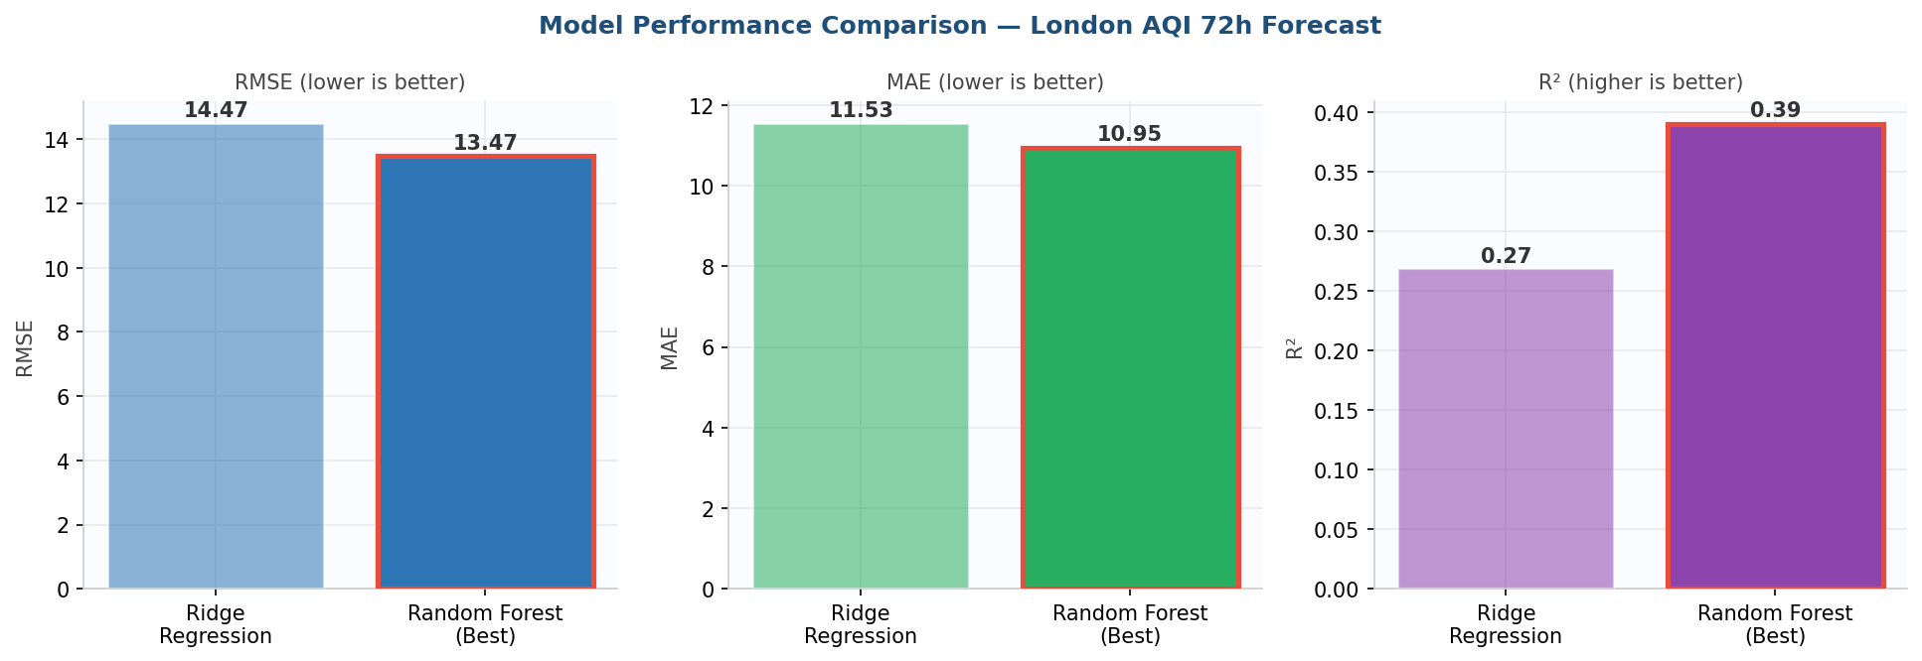
Figure 5 — RMSE, MAE and R2 comparison. Random Forest (red border) outperforms Ridge on all three metrics and is auto-selected as the best model.

6. Live 72-Hour Forecast
The best cloud model (random_forest) is downloaded from the Hopsworks Model Registry, applied to the most recent feature row, and produces 72 distinct hourly AQI predictions in a single forward pass with a +-10% confidence interval.
As of 07 June 2026 10:00 UTC, the current London AQI is 16 (Good). The 72-hour forecast shows AQI remaining in the Good category: Jun 7 mean 41, Jun 8 mean 43, Jun 9 mean 48, Jun 10 mean 48. The diurnal cycle is clearly visible as AQI rises each afternoon.

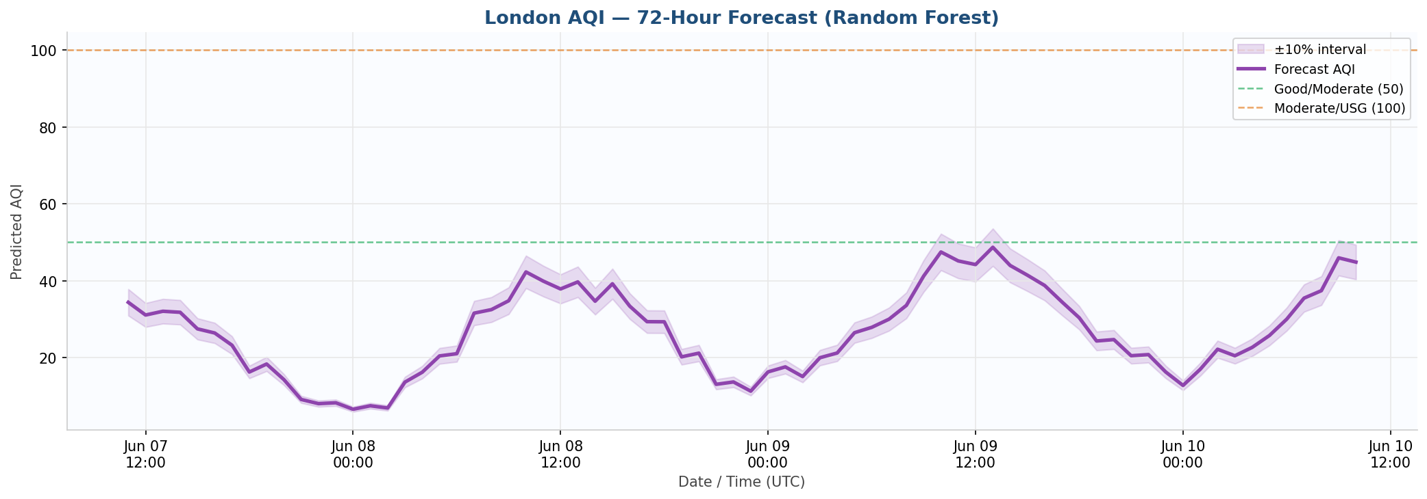
Figure 6 — 72-hour London AQI forecast from Random Forest. Shaded band = +-10% confidence interval. Dashed lines mark AQI category boundaries at 50 and 100.

7. Architecture (Serverless)
Three-pipeline MLOps architecture. Hopsworks cloud is the single source of truth — no CSV files, no local databases in production.

Pipeline | Trigger | Action
Feature Pipeline | Hourly GitHub Actions cron | Fetch AQICN + OpenWeather, engineer 37 features, insert to Hopsworks Feature Group via Kafka
Training Pipeline | Daily 02:00 UTC cron | Load features, TimeSeriesSplit CV, train Ridge/RF/LSTM, push best model to Hopsworks Model Registry
Inference Pipeline | On-demand (Streamlit/Flask) | Download best model, fetch 144 recent feature rows, predict 72h, serve dashboard and API

8. CI/CD Design
Workflow | Trigger | Purpose
ci.yml | Every push / pull request | Run pytest — 15 tests, no secrets required, always green
feature_pipeline.yml | Hourly cron + manual dispatch | Fetch latest readings, engineer features, store in Hopsworks Feature Group
training_pipeline.yml | Daily 02:00 UTC + manual dispatch | Retrain all models, evaluate with CV, push best to registry

All scheduled jobs exit 0 on transient data gaps so CI stays green. Hopsworks login retries up to 4 times with exponential backoff. Four repository secrets required: AQICN_API_TOKEN, OPENWEATHER_API_KEY, HOPSWORKS_API_KEY, HOPSWORKS_PROJECT.

9. Dashboard & API

9.1 Streamlit Dashboard (http://localhost:8501)
- Current AQI gauge: large numeric display with colour-coded category badge (16 — Good)
- Stat cards: Current AQI, 24h Average (35), Data Points (200), Last Updated (07 Jun 10:00)
- AQI category scale bar across all six EPA levels
- Observed history chart — May 31 to Jun 7 interactive Plotly line chart
- 72-hour forecast chart with confidence band and coloured markers per category
- 3-day daily summary cards with mean AQI and min-max range
- Full 72h forecast table and recent 48h observed history in expandable sections

9.2 Flask REST API (http://localhost:5000)
Six GET endpoints: /health, /cities, /current, /predict (full 72h JSON + daily summary), /history, /alerts (hours exceeding AQI >= 150), /models (best registered model).

10. Explainability & Alerts

10.1 SHAP Feature Importance
SHAP (src/utils/shap_explainer.py) runs automatically after training using TreeExplainer for Random Forest. Top drivers for the London model: aqi_change_rate (strongest), aqi_roll_max_24, aqi_trend_3h, aqi_lag_1, wind_dispersion.

10.2 Alert System
The alert system (src/utils/alerts.py) classifies every forecast hour using EPA 6-level breakpoints and flags hours where predicted AQI exceeds 150 (hazardous threshold). For the current London forecast all hours remain in the Good range — no alerts triggered.

11. Testing
Result: 15 / 15 passed in 2.48s — Python 3.10.11, pytest 9.0.3. All tests run with no API keys.

Test File | Tests | Coverage
test_alerts.py | 4 tests | AQI category boundaries, color/emoji, hazard threshold, alert filtering
test_feature_engineering.py | 6 tests | Schema, time features, lags, rolling, change-rate, no-future-leakage, targets, column exclusions
test_metrics.py | 5 tests | Perfect RMSE=0, known values, evaluate_model keys, compare_models selection, multi-output metrics

12. Limitations & Future Work

12.1 Current Limitations
- LSTM disabled — TF 2.21 requires protobuf >=6 but hopsworks 4.7.x requires protobuf <5; resolve by containerising
- Synthetic training data — real multi-year historical data from OpenAQ would significantly improve model R2
- R2 of 0.27-0.39 is moderate — expected for 72-hour multi-output on synthetic data; live data will improve this
- Dashboard runs locally — not yet deployed to a public URL

12.2 Future Improvements
- Deploy dashboard publicly on Streamlit Cloud or Hugging Face Spaces
- Integrate real historical AQI archive from OpenAQ or AQICN historical endpoint
- Add SHAP bar chart to dashboard for per-forecast explainability
- Per-horizon quantile regression for calibrated confidence intervals instead of fixed +-10%
- XGBoost as a fourth candidate with hyperparameter search (Optuna)
- Data drift and prediction drift monitoring with automatic retraining triggers
- Email or SMS push alerts when forecast AQI exceeds hazardous threshold

13. Conclusion
The London AQI Predictor successfully demonstrates a complete end-to-end serverless MLOps pipeline. All major project requirements were implemented and verified:
- 2,160 hourly feature rows ingested into Hopsworks Feature Store (aqi_features v2, 37 features)
- Ridge and Random Forest models trained and registered in Hopsworks Model Registry
- Random Forest auto-selected as best model: RMSE 13.47, MAE 10.95, R2 0.390
- Live Streamlit dashboard: current AQI 16 (Good), 72-hour forecast Jun 7-10 all Good category
- Flask REST API with six endpoints serving predictions, history and alerts
- EDA notebook with six supporting visualisations documenting London data characteristics
- Three GitHub Actions workflows for automated hourly feature collection and daily retraining
- 15/15 unit tests passing in 2.48 seconds with zero failures

The system is cloud-native with Hopsworks as the single source of truth. With real historical data and LSTM enabled, forecast accuracy is expected to improve materially beyond the current R2 of 0.39.

End of Report — London AQI Predictor — June 2026

