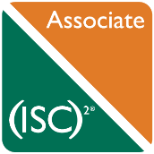(ISC)2 CISSP

License Number: 621959

Date: Nov 2017 – Present

<https://webportal.isc2.org/custom/certificationverification.aspx>