# Connectivity

First and foremost, we need to finalize a connectivity mechanism for our sensor deployments in the city. I’ve found a diagram that helps us understanding what type of connectivity exists and is best suited for what use cases.

Few points to consider here are what type of visibility is required in such solutions. Networks can be private (owned by user) or public (owned by enterprise and available to use as a service)

|  |  |  |
| --- | --- | --- |
|  | Network Type | |
| **Public** | **Private** |
|  | [Zigbee](https://zigbeealliance.org/solution/zigbee/) | NB-IoT |
|  | [Bluetooth](https://www.bluetooth.com/learn-about-bluetooth/tech-overview/) | Sigfox |
|  | [WiFi](https://en.wikipedia.org/wiki/IEEE_802.11) | LTE-M |
|  | LoraWan | |

Next chart will show how these network types are compared against bandwidth and range parameters across connectivity possibilities.

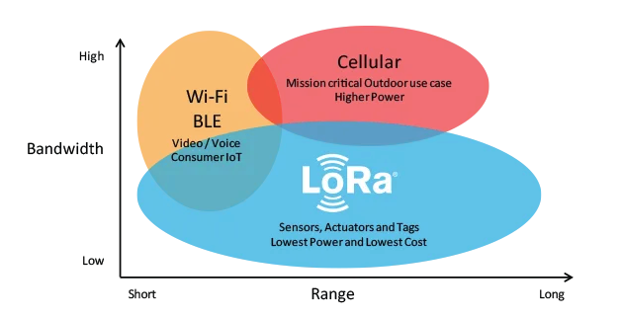

And I have gathered few more characteristics to compare our options here and have chosen **LORAWAN** as the preferred technology for such use cases based on latency and availability worldwide. Full reference is available at URL.

On next page, I will compare few more network types against wider parameters.

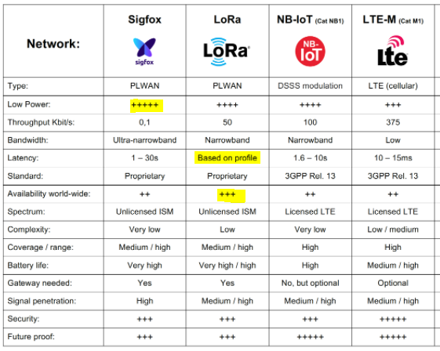

# Sensor

As by now we have figured out connectivity options, next stage in solutioning is to identify sensor type, I’ve short listed following sensors:

|  |  |  |  |  |
| --- | --- | --- | --- | --- |
|  | **Sensor Type** | **URL** | **Network** | **Comments** |
|  | Bosch | [URL](https://www.alliot.co.uk/products/sensors/parking-management-sensors/bosch-lorawan-parking-sensor/) | LoRaWAN |  |
|  | Nwave | [URL](https://www.nwave.io/smart-parking-sensor/) |  |
|  | Libelium | [URL](https://development.libelium.com/smart-parking-technical-guide/smartparkingnode) | Chosen as **preferred sensor**   * IP68 (more dust and water resistant) and IK10 (much more resilient) * Less maintenance headache * Planted in multiple ways under the road, half buried and on the road. * OTA management |

# Data Model

Parking data is maintained inside a NO-SQL database as per the following structure, our solution will transform the data into a structure so it can be retrieved

## Area

This could be either a street, restaurant parking, building basement or any logical group of location.

<https://github.com/qazimobeen/smartparking/blob/master/IoT.Smart.Parking/ParkingArea.json>

## Location

This is a parking spot available at an area defined above, and this structure maintains parking availability of a location within an area.

<https://github.com/qazimobeen/smartparking/blob/master/IoT.Smart.Parking/ParkingLocation.json>

# APIs

# Security