6-Lobaratoriya.PHP orqali CRUD (Create, Read, Update, Delete) amallarini bajarish

Ishdan maqsad
- PHP va MySQL yordamida ma’lumotlar bazasi bilan ishlashni o‘rganish
- CRUD (Create, Read, Update, Delete) amallarini amalda bajarish
- HTML forma orqali ma’lumotlarni kiritish va qayta ishlash
- Ma’lumotlar bazasidagi yozuvlarni chiqarish, tahrirlash va o‘chirish

Kerakli dasturiy vositalar
- XAMPP / OpenServer / Denwer
- PHP 7.x yoki yuqori
- MySQL
- Brauzer (Chrome, Edge va h.k.)
- Kod muharriri (VS Code, Sublime va boshqalar)

Nazariy qism
CRUD tushunchasi
CRUD – bu ma’lumotlar bazasida bajariladigan 4 asosiy amal:
Amal | Tavsif
Create | Yangi ma’lumot qo‘shish
Read | Ma’lumotlarni o‘qish (ko‘rish)
Update | Ma’lumotni tahrirlash
Delete | Ma’lumotni o‘chirish

1-qadam: Ma’lumotlar bazasini yaratish
phpMyAdmin orqali quyidagi SQL so‘rovni bajaring:
CREATE DATABASE talaba_db;
USE talaba_db;
CREATE TABLE talabalar (
id INT AUTO_INCREMENT PRIMARY KEY,
ism VARCHAR(50) NOT NULL,
familiya VARCHAR(50) NOT NULL,
yosh INT NOT NULL
);

2-qadam: Loyihaning fayl tuzilmasi
crud/
│
├── db.php
├── index.php
├── add.php
├── edit.php
├── delete.php

3-qadam: Ma’lumotlar bazasiga ulanish (db.php)
<?php
$conn = new mysqli("localhost", "root", "", "talaba_db");
if ($conn->connect_error) {
die("Ulanishda xatolik: " . $conn->connect_error);
}
?>

4-qadam: CREATE – Ma’lumot qo‘shish (add.php)
<?php
include 'db.php';
if(isset($_POST['submit'])){
$ism = $_POST['ism'];
$familiya = $_POST['familiya'];
$yosh = $_POST['yosh'];
$sql = "INSERT INTO talabalar (ism, familiya, yosh)
VALUES ('$ism', '$familiya', '$yosh')";
$conn->query($sql);
header("Location: index.php");
}
?>
<form method="POST">
Ism: <input type="text" name="ism"><br>
Familiya: <input type="text" name="familiya"><br>
Yosh: <input type="number" name="yosh"><br>
<button type="submit" name="submit">Saqlash</button>
</form>

5-qadam: READ – Ma’lumotlarni chiqarish (index.php)
<?php include 'db.php'; ?>
<a href="add.php">Yangi talaba qo‘shish</a>
<table border="1">
<tr>
<th>ID</th>
<th>Ism</th>
<th>Familiya</th>
<th>Yosh</th>
<th>Amallar</th>
</tr>
<?php
$result = $conn->query("SELECT * FROM talabalar");
while($row = $result->fetch_assoc()){
echo "<tr>
<td>{$row['id']}</td>
<td>{$row['ism']}</td>
<td>{$row['familiya']}</td>
<td>{$row['yosh']}</td>
<td>
<a href='edit.php?id={$row['id']}'>Tahrirlash</a>
<a href='delete.php?id={$row['id']}'>O‘chirish</a>
</td>
</tr>";
}
?>
</table>

6-qadam: UPDATE – Ma’lumotni tahrirlash (edit.php)
<?php
include 'db.php';
$id = $_GET['id'];
$result = $conn->query("SELECT * FROM talabalar WHERE id=$id");
$row = $result->fetch_assoc();
if(isset($_POST['update'])){
$ism = $_POST['ism'];
$familiya = $_POST['familiya'];
$yosh = $_POST['yosh'];
$conn->query("UPDATE talabalar
SET ism='$ism', familiya='$familiya', yosh='$yosh'
WHERE id=$id");
header("Location: index.php");
}
?>
<form method="POST">
Ism: <input type="text" name="ism" value="<?php echo $row['ism']; ?>"><br>
Familiya: <input type="text" name="familiya" value="<?php echo $row['familiya']; ?>"><br>
Yosh: <input type="number" name="yosh" value="<?php echo $row['yosh']; ?>"><br>
<button type="submit" name="update">Yangilash</button>
</form>

7-qadam: DELETE – Ma’lumotni o‘chirish (delete.php)
<?php
include 'db.php';
$id = $_GET['id'];
$conn->query("DELETE FROM talabalar WHERE id=$id");
header("Location: index.php");
?>

Topshiriqlar:
4. TOPSHIRIQ: “Shifoxona Bemorlar”
Database: hospital_patient_db
Jadval: medical_profiles
Ustunlar:
- profile_id
- patient_fullname
- diagnosis_type
- treatment_plan
- admission_date
- discharge_date
- attending_doctor
- ward_number

Topshiriq uchun kerakli bolgan kodlar.
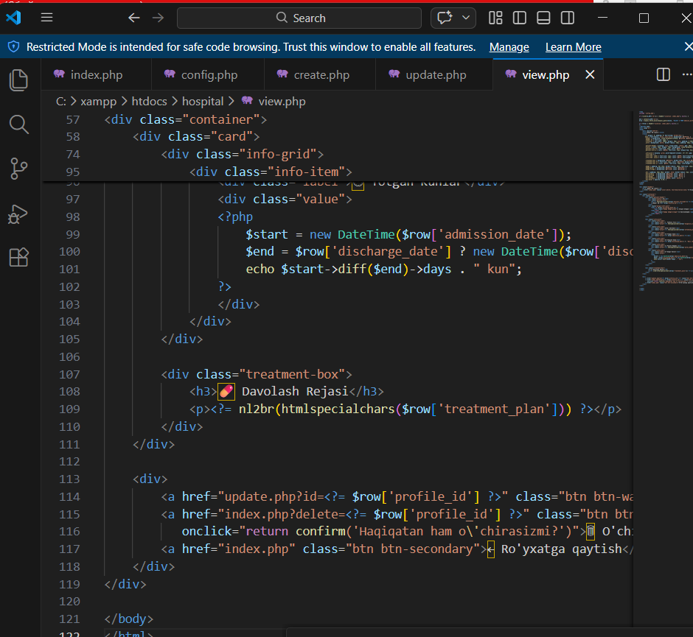

Xampda baza yaratildi
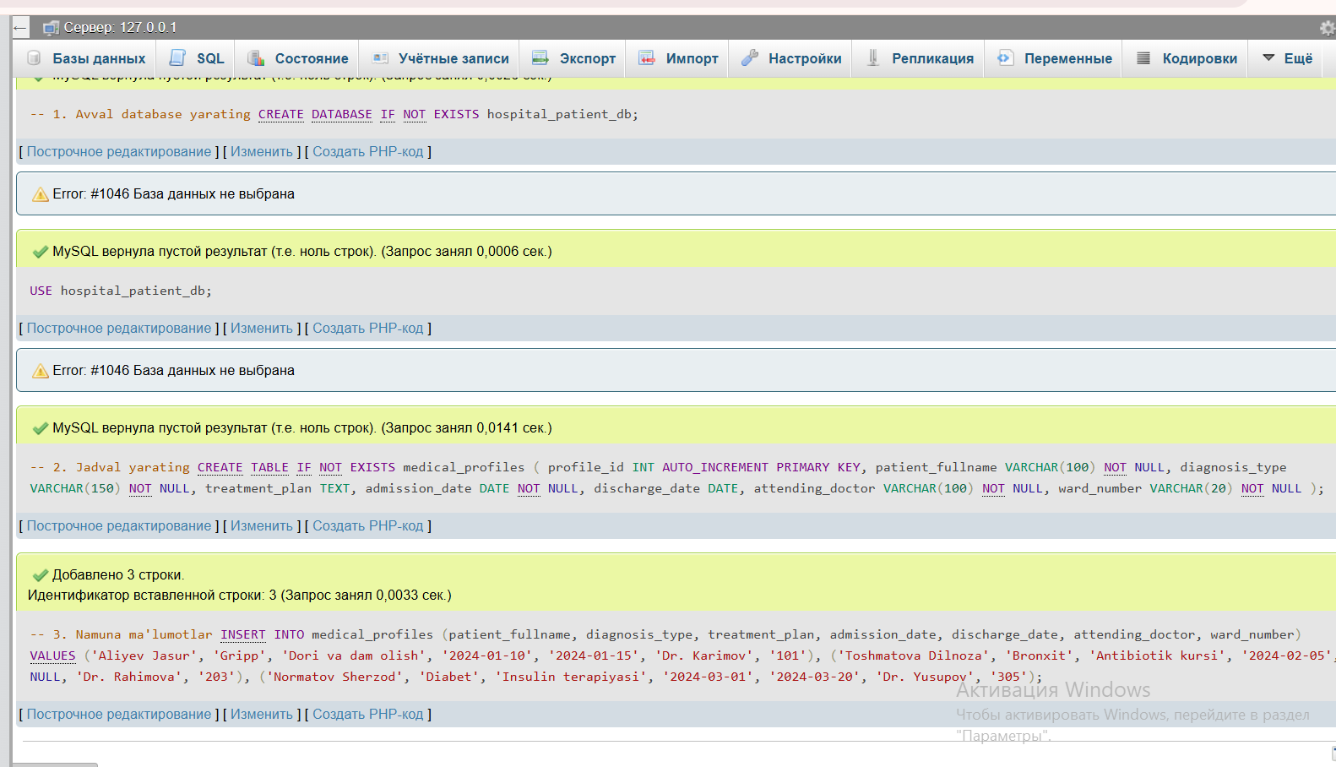

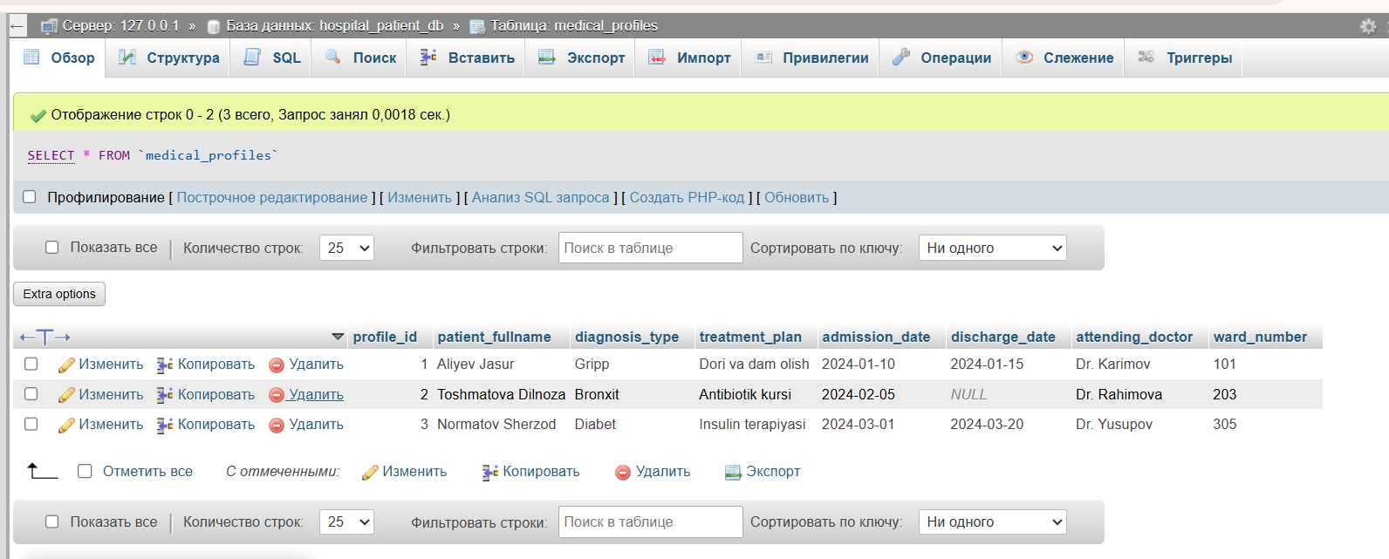

Amaliy loyiham
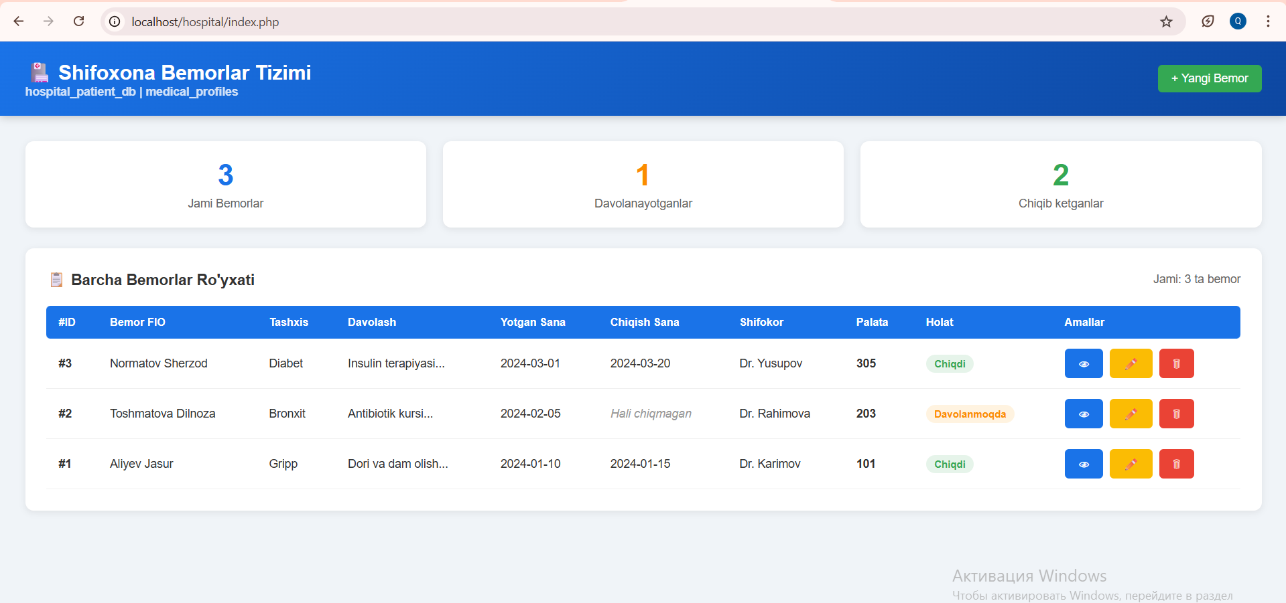
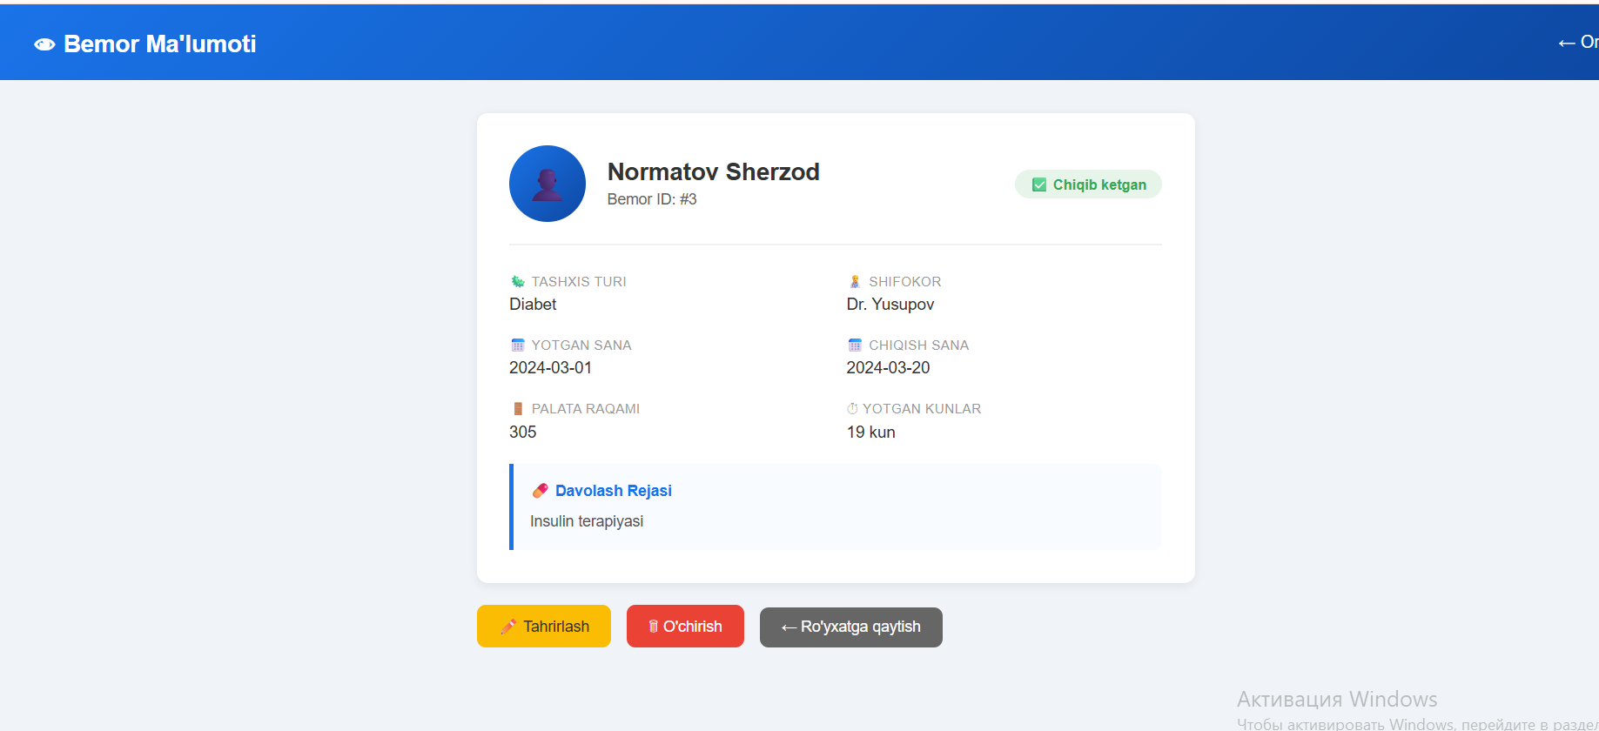

6-Laboratoriya davomi
MySQL da jadval yaratish va so'rov yuborish
Bizda avvalgi darsimizda jadval va baza yaratganmiz. Bugungi mavzuda esa shu yaratilgan bazamizga so’rov yuborishni korib chiqamiz.
-- ================================================
-- SHIFOXONA BEMORLAR TIZIMI - SQL SO'ROVLAR
-- Database: hospital_patient_db
-- Jadval: medical_profiles
-- ================================================

USE hospital_patient_db;

-- ================================================
-- 1. CREATE (INSERT) - MA'LUMOT QO'SHISH
-- ================================================

-- 1.1 Bitta bemor qo'shish
INSERT INTO medical_profiles
(patient_fullname, diagnosis_type, treatment_plan, admission_date, discharge_date, attending_doctor, ward_number)
VALUES
('Karimov Bobur', 'Yurak kasalligi', 'Dori va dam olish rejimi', '2024-03-01', NULL, 'Dr. Yusupov', '201');

-- 1.2 Bir vaqtda bir nechta bemor qo'shish
INSERT INTO medical_profiles
(patient_fullname, diagnosis_type, treatment_plan, admission_date, discharge_date, attending_doctor, ward_number)
VALUES
('Rahimova Malika', 'Gripp', 'Antibiotik va vitamin', '2024-03-05', '2024-03-12', 'Dr. Alimova', '102'),
('Toshev Sanjar', 'Diabet 2-tur', 'Insulin terapiyasi', '2024-03-08', NULL, 'Dr. Karimov', '305'),
('Nazarova Feruza', 'Bronxit', 'Nafas olish mashqlari', '2024-03-10', '2024-03-20', 'Dr. Yusupov', '104'),
('Holiqov Jasur', 'Suyak sinishi', 'Gips va reabilitatsiya', '2024-03-15', NULL, 'Dr. Rahimov', '406');

-- ================================================
-- 2. READ (SELECT) - MA'LUMOT O'QISH
-- ================================================

-- 2.1 Barcha bemorlarni ko'rish
SELECT * FROM medical_profiles;

-- 2.2 Faqat kerakli ustunlarni ko'rish
SELECT profile_id, patient_fullname, diagnosis_type, attending_doctor, ward_number
FROM medical_profiles;

-- 2.3 Hali chiqmagan (davolanayotgan) bemorlar
SELECT * FROM medical_profiles
WHERE discharge_date IS NULL;

-- 2.4 Chiqib ketgan bemorlar
SELECT * FROM medical_profiles
WHERE discharge_date IS NOT NULL;

-- 2.5 Muayyan shifokorning bemorlarini ko'rish
SELECT * FROM medical_profiles
WHERE attending_doctor = 'Dr. Yusupov';

-- 2.6 Muayyan palatadagi bemorlar
SELECT * FROM medical_profiles
WHERE ward_number = '201';

-- 2.7 Muayyan tashxis bo'yicha qidirish
SELECT * FROM medical_profiles
WHERE diagnosis_type LIKE '%Diabet%';

-- 2.8 Sanaga qarab qidirish (2024-yilda yotganlar)
SELECT * FROM medical_profiles
WHERE admission_date BETWEEN '2024-01-01' AND '2024-12-31';

-- 2.9 Bemorlarni FIO bo'yicha A-Z tartibda
SELECT * FROM medical_profiles
ORDER BY patient_fullname ASC;

-- 2.10 Eng so'nggi yotgan bemorlar (yangi → eski)
SELECT * FROM medical_profiles
ORDER BY admission_date DESC;

-- 2.11 Faqat birinchi 5 ta bemor
SELECT * FROM medical_profiles
LIMIT 5;

-- 2.12 Jami nechta bemor bor
SELECT COUNT(*) AS jami_bemorlar FROM medical_profiles;

-- 2.13 Har bir shifokorning nechta bemori bor
SELECT attending_doctor, COUNT(*) AS bemor_soni
FROM medical_profiles
GROUP BY attending_doctor
ORDER BY bemor_soni DESC;

-- 2.14 Har bir palatada nechta bemor bor
SELECT ward_number, COUNT(*) AS bemor_soni
FROM medical_profiles
GROUP BY ward_number
ORDER BY ward_number;

-- 2.15 ID bo'yicha bitta bemorni topish
SELECT * FROM medical_profiles
WHERE profile_id = 1;

-- 2.16 Bemorning necha kun yotganini hisoblash
SELECT
profile_id,
patient_fullname,
admission_date,
COALESCE(discharge_date, CURDATE()) AS chiqish_sana,
DATEDIFF(COALESCE(discharge_date, CURDATE()), admission_date) AS yotgan_kunlar
FROM medical_profiles;

-- ================================================
-- 3. UPDATE - MA'LUMOT YANGILASH
-- ================================================

-- 3.1 Bemorning chiqish sanasini yangilash (ID=1)
UPDATE medical_profiles
SET discharge_date = '2024-04-01'
WHERE profile_id = 1;

-- 3.2 Bemorning shifokorini almashtirish
UPDATE medical_profiles
SET attending_doctor = 'Dr. Alimova'
WHERE profile_id = 2;

-- 3.3 Palatani o'zgartirish
UPDATE medical_profiles
SET ward_number = '302'
WHERE profile_id = 3;

-- 3.4 Tashxis va davolash rejasini yangilash
UPDATE medical_profiles
SET
diagnosis_type = 'Gripp (og\'ir shakl)',
treatment_plan = 'Kuchaytirilgan antibiotik kursi va vitamilar'
WHERE profile_id = 4;

-- 3.5 Bir vaqtda bir nechta ustunni yangilash
UPDATE medical_profiles
SET
attending_doctor = 'Dr. Karimov',
ward_number = '205',
discharge_date = '2024-05-10'
WHERE profile_id = 5;

-- 3.6 Barcha "Gripp" tashxisli bemorlarning palatasini o'zgartirish
UPDATE medical_profiles
SET ward_number = '110'
WHERE diagnosis_type LIKE '%Gripp%';

-- ================================================
-- 4. DELETE - MA'LUMOT O'CHIRISH
-- ================================================

-- 4.1 Bitta bemorni o'chirish (ID bo'yicha)
DELETE FROM medical_profiles
WHERE profile_id = 10;

-- 4.2 Chiqib ketgan bemorlarni o'chirish
DELETE FROM medical_profiles
WHERE discharge_date IS NOT NULL;

-- 4.3 Muayyan sanadan oldin chiqib ketganlarni o'chirish
DELETE FROM medical_profiles
WHERE discharge_date < '2024-01-01';

-- 4.4 Barcha ma'lumotlarni o'chirish (EHTIYOT BO'LING!)
-- DELETE FROM medical_profiles;

-- 4.5 Jadvalni tozalab, ID ni qayta 1 dan boshlash
-- TRUNCATE TABLE medical_profiles;

-- ================================================
-- 5. QOSHIMCHA FOYDALI SO'ROVLAR
-- ================================================

-- 5.1 Eng ko'p bemorga xizmat qilgan shifokor
SELECT attending_doctor, COUNT(*) AS bemor_soni
FROM medical_profiles
GROUP BY attending_doctor
ORDER BY bemor_soni DESC
LIMIT 1;

-- 5.2 Hozir davolanayotgan bemorlar soni
SELECT COUNT(*) AS davolanayotganlar
FROM medical_profiles
WHERE discharge_date IS NULL;

-- 5.3 O'rtacha davolash muddati (kunlarda)
SELECT
ROUND(AVG(DATEDIFF(discharge_date, admission_date)), 1) AS ortacha_kun
FROM medical_profiles
WHERE discharge_date IS NOT NULL;

-- 5.4 Eng ko'p qo'llanilgan tashxis
SELECT diagnosis_type, COUNT(*) AS soni
FROM medical_profiles
GROUP BY diagnosis_type
ORDER BY soni DESC
LIMIT 1;
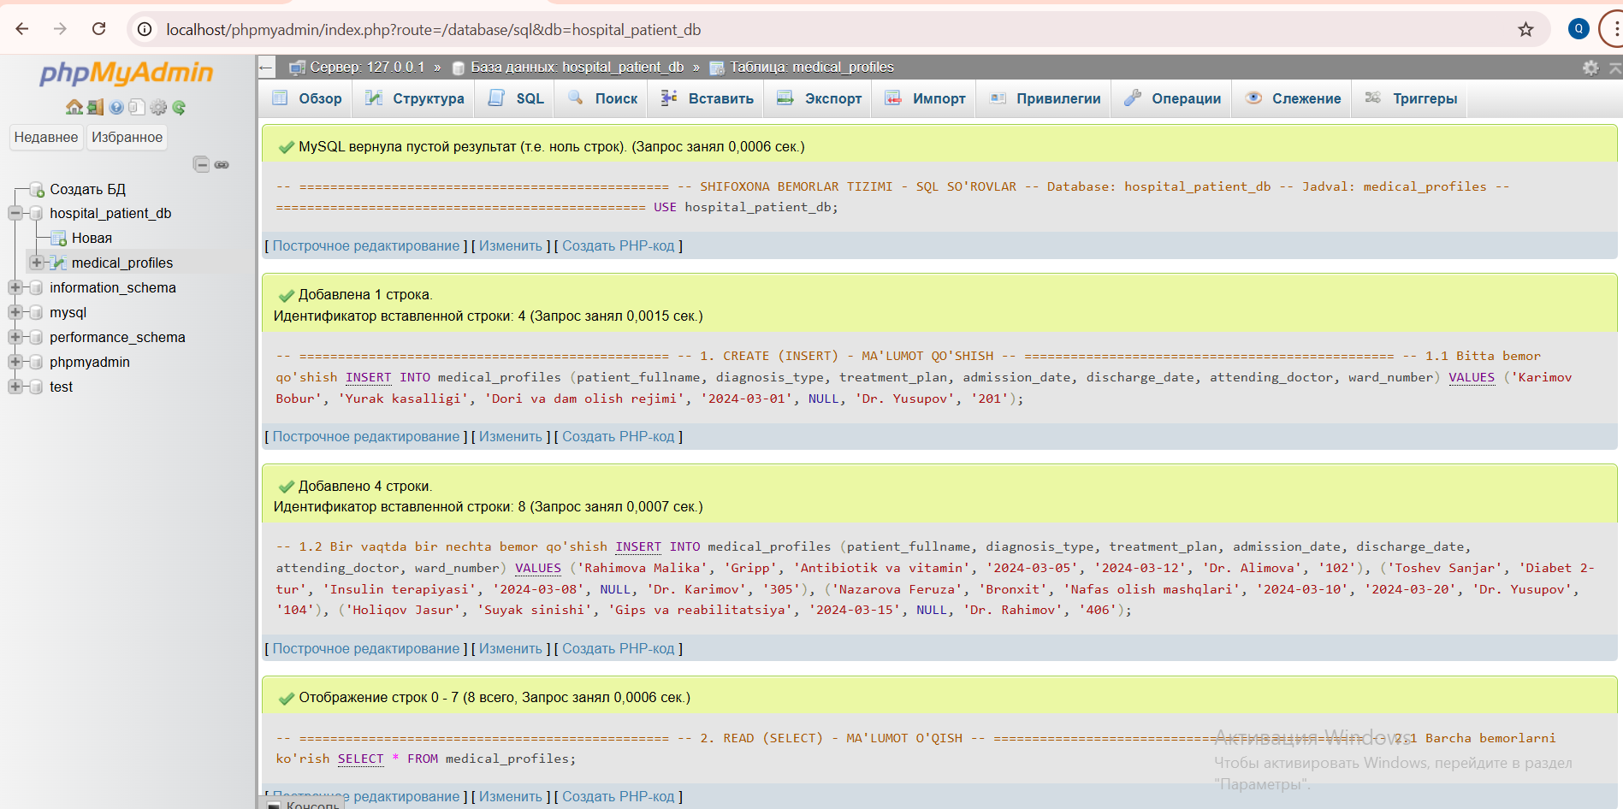

So’rov natijalaridan olingan javoblar
