LABORATORIYA ISHI №4
Mavzu: PHP orqali MySQL ma’lumotlar bazasiga ulanish

1. Ishning maqsadi
- Tayyor MySQL bazaga PHP orqali ulanish
- SELECT so‘rovlarini bajarish
- INNER JOIN orqali bir nechta jadval ma’lumotlarini chiqarish
- MySQLi (procedural, OOP) va PDO usullarini taqqoslash
- Ular orasidagi farqlarni amaliy ko‘rsatish

2. Nazariy qism
PHP orqali MySQL bilan ishlashning 3 asosiy usuli mavjud:
- MySQLi (Procedural)
- MySQLi (Object-Oriented)
- PDO (PHP Data Objects)


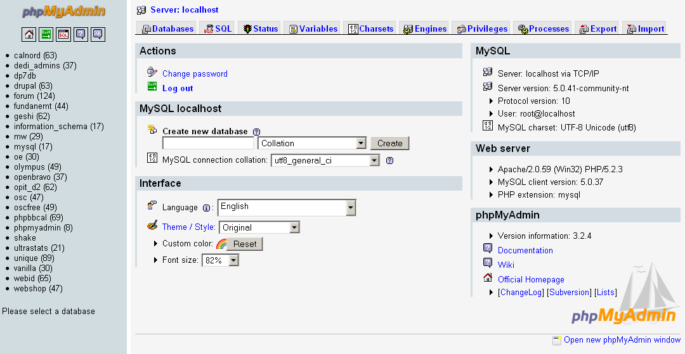

3. Amaliy baza (tayyor database)
Database: db_universitet
3 ta jadval:
fakultetlar
- id (PK)
- nomi
talabalar
- id (PK)
- ism
- kurs
- fakultet_id (FK)
fanlar
- id (PK)
- fan_nomi
- kredit
- talaba_id (FK)

4. Oddiy SELECT so‘rovi
SELECT * FROM talabalar;

5. JOIN so‘rovi
SELECT
talabalar.ism,
talabalar.kurs,
fakultetlar.nomi AS fakultet,
fanlar.fan_nomi
FROM talabalar
INNER JOIN fakultetlar ON talabalar.fakultet_id = fakultetlar.id
INNER JOIN fanlar ON talabalar.id = fanlar.talaba_id;

6. PHP orqali ulanish usullari
6.1 MySQLi – Procedural usul
<?php
$conn = mysqli_connect("localhost", "root", "", "db_universitet");
if (!$conn) {
die("Ulanish xatoligi: " . mysqli_connect_error());
}
$sql = "SELECT * FROM talabalar";
$result = mysqli_query($conn, $sql);
while ($row = mysqli_fetch_assoc($result)) {
echo $row['ism'] . " - " . $row['kurs'] . "<br>";
}
mysqli_close($conn);
?>
Xususiyatlari:
- Oddiy
- Faqat MySQL bilan ishlaydi
- Xavfsizlik PDO ga qaraganda pastroq
6.2 MySQLi – Object Oriented usul
<?php
$conn = new mysqli("localhost", "root", "", "db_universitet");
if ($conn->connect_error) {
die("Xatolik: " . $conn->connect_error);
}
$sql = "SELECT * FROM talabalar";
$result = $conn->query($sql);
while ($row = $result->fetch_assoc()) {
echo $row['ism'] . "<br>";
}
$conn->close();
?>
Xususiyatlari:
- OOP yondashuv
- Professionalroq
- Katta loyihalar uchun qulay
6.3 PDO usuli (Tavsiya etiladi)
<?php
try {
$conn = new PDO("mysql:host=localhost;dbname=db_universitet", "root", "");
$conn->setAttribute(PDO::ATTR_ERRMODE, PDO::ERRMODE_EXCEPTION);
$sql = "SELECT * FROM talabalar";
$stmt = $conn->query($sql);
while ($row = $stmt->fetch(PDO::FETCH_ASSOC)) {
echo $row['ism'] . "<br>";
}
} catch(PDOException $e) {
echo "Xatolik: " . $e->getMessage();
}
?>
Xususiyatlari:
- Turli DB lar bilan ishlaydi (MySQL, PostgreSQL, Oracle)
- Eng xavfsiz
- Prepared Statement kuchli
- try-catch bilan ishlaydi

7. PDO orqali JOIN misoli
<?php
try {
$conn = new PDO("mysql:host=localhost;dbname=db_universitet", "root", "");
$conn->setAttribute(PDO::ATTR_ERRMODE, PDO::ERRMODE_EXCEPTION);
$sql = "SELECT
talabalar.ism,
talabalar.kurs,
fakultetlar.nomi AS fakultet,
fanlar.fan_nomi
FROM talabalar
INNER JOIN fakultetlar
ON talabalar.fakultet_id = fakultetlar.id
INNER JOIN fanlar
ON talabalar.id = fanlar.talaba_id";
$stmt = $conn->query($sql);
echo "<table border='1'>";
echo "<tr><th>Ism</th><th>Kurs</th><th>Fakultet</th><th>Fan</th></tr>";
while ($row = $stmt->fetch(PDO::FETCH_ASSOC)) {
echo "<tr>
<td>{$row['ism']}</td>
<td>{$row['kurs']}</td>
<td>{$row['fakultet']}</td>
<td>{$row['fan_nomi']}</td>
</tr>";
}
echo "</table>";
} catch(PDOException $e) {
echo "Xatolik: " . $e->getMessage();
}
?>

8. Usullarni taqqoslash
Xususiyat | MySQLi Procedural | MySQLi OOP | PDO
DB turi | Faqat MySQL | Faqat MySQL | Ko‘p DB
Xavfsizlik | O‘rtacha | Yaxshi | Eng yaxshi
try-catch | Yo‘q | Yo‘q | Bor
Prepared | Bor | Bor | Juda kuchli
Professional | O‘rtacha | Yaxshi | Eng yaxshi

9. Natija
Laboratoriya ishida:
- Tayyor MySQL bazaga ulanish amalga oshirildi
- SELECT so‘rovi bajarildi
- INNER JOIN ishlatildi
- 3 xil PHP usuli taqqoslandi
- PDO eng tavsiya etiladigan usul ekanligi ko‘rsatildi
Topshiriqlar:

4- Online do‘kon
Database: db_shop

Jadvallar:
kategoriyalar
- id
- nomi
mahsulotlar
- id
- nomi
- narx
- kategoriya_id (FK)
buyurtmalar
- id
- mahsulot_id (FK)
- sana

Bog‘lanish:
- mahsulotlar.kategoriya_id → kategoriyalar.id
- buyurtmalar.mahsulot_id → mahsulotlar.id

JOIN vazifa:
Mahsulot + Narx + Kategoriya + Buyurtma sanasi chiqarish.

Talaba nima qiladi?
- PDO ulanish
- 3 jadvalni bog‘laydi
- SELECT + INNER JOIN
- HTML table chiqaradi
Amaliy topshiriq uchun loyiha kodim.
Inddex.html

<!DOCTYPE html>
<html lang="uz">
<head>
<meta charset="UTF-8">
<meta name="viewport" content="width=device-width, initial-scale=1.0">
<title>Online Do'kon - Buyurtmalar</title>
<style>
* {
margin: 0;
padding: 0;
box-sizing: border-box;
}

body {
font-family: 'Segoe UI', Tahoma, Geneva, Verdana, sans-serif;
background: #f0f2f5;
padding: 30px;
}

.container {
max-width: 1000px;
margin: 0 auto;
background: white;
border-radius: 12px;
box-shadow: 0 4px 20px rgba(0,0,0,0.1);
overflow: hidden;
}

.header {
background: linear-gradient(135deg, #667eea, #764ba2);
color: white;
padding: 25px 30px;
}

.header h1 {
font-size: 24px;
margin-bottom: 5px;
}

.header p {
opacity: 0.85;
font-size: 14px;
}

.table-wrapper {
padding: 25px;
overflow-x: auto;
}

table {
width: 100%;
border-collapse: collapse;
}

thead tr {
background: #667eea;
color: white;
}

thead th {
padding: 14px 18px;
text-align: left;
font-weight: 600;
font-size: 14px;
letter-spacing: 0.5px;
}

tbody tr {
border-bottom: 1px solid #eee;
transition: background 0.2s;
}

tbody tr:hover {
background: #f5f3ff;
}

tbody tr:last-child {
border-bottom: none;
}

tbody td {
padding: 13px 18px;
font-size: 14px;
color: #333;
}

.badge {
background: #ede9fe;
color: #6d28d9;
padding: 4px 10px;
border-radius: 20px;
font-size: 12px;
font-weight: 600;
}

.narx {
color: #059669;
font-weight: 700;
font-size: 15px;
}

.sana {
color: #6b7280;
font-size: 13px;
}

.error {
background: #fee2e2;
color: #dc2626;
padding: 15px 20px;
border-radius: 8px;
margin: 20px;
border-left: 4px solid #dc2626;
}

.empty {
text-align: center;
padding: 40px;
color: #9ca3af;
font-size: 16px;
}

.footer {
padding: 15px 25px;
background: #f9fafb;
border-top: 1px solid #eee;
font-size: 13px;
color: #6b7280;
}
</style>
</head>
<body>

<div class="container">
<div class="header">
<h1>🛒 Online Do'kon</h1>
<p>Buyurtmalar ro'yxati — mahsulot, narx, kategoriya va sana</p>
</div>

<?php
// ==========================================
// 1. PDO orqali MySQL ga ulanish
// ==========================================
$host = 'localhost';
$dbname = 'db_shop';
$username = 'root';
$password = '';
$charset = 'utf8';

$dsn = "mysql:host=$host;dbname=$dbname;charset=$charset";

$options = [
PDO::ATTR_ERRMODE => PDO::ERRMODE_EXCEPTION,
PDO::ATTR_DEFAULT_FETCH_MODE => PDO::FETCH_ASSOC,
PDO::ATTR_EMULATE_PREPARES => false,
];

try {
$pdo = new PDO($dsn, $username, $password, $options);

// ==========================================
// 2. SQL: 3 jadvalni INNER JOIN bilan bog'lash
// ==========================================
$sql = "
SELECT
mahsulotlar.nomi AS mahsulot_nomi,
mahsulotlar.narx AS narx,
kategoriyalar.nomi AS kategoriya,
buyurtmalar.sana AS sana
FROM buyurtmalar
INNER JOIN mahsulotlar ON buyurtmalar.mahsulot_id = mahsulotlar.id
INNER JOIN kategoriyalar ON mahsulotlar.kategoriya_id = kategoriyalar.id
ORDER BY buyurtmalar.sana DESC
";

$stmt = $pdo->query($sql);
$buyurtmalar = $stmt->fetchAll();

// ==========================================
// 3. HTML Table chiqarish
// ==========================================
if (count($buyurtmalar) > 0):
?>

<div class="table-wrapper">
<table>
<thead>
<tr>
<th>#</th>
<th>Mahsulot nomi</th>
<th>Narx (so'm)</th>
<th>Kategoriya</th>
<th>Buyurtma sanasi</th>
</tr>
</thead>
<tbody>
<?php foreach ($buyurtmalar as $index => $qator): ?>
<tr>
<td><?= $index + 1 ?></td>
<td><?= htmlspecialchars($qator['mahsulot_nomi']) ?></td>
<td class="narx"><?= number_format($qator['narx'], 0, '.', ' ') ?> so'm</td>
<td><span class="badge"><?= htmlspecialchars($qator['kategoriya']) ?></span></td>
<td class="sana"><?= htmlspecialchars($qator['sana']) ?></td>
</tr>
<?php endforeach; ?>
</tbody>
</table>
</div>

<div class="footer">
Jami: <strong><?= count($buyurtmalar) ?> ta</strong> buyurtma topildi.
</div>

<?php
else:
echo '<div class="empty">📭 Hech qanday buyurtma topilmadi.</div>';
endif;

} catch (PDOException $e) {
echo '<div class="error">
❌ <strong>Xatolik:</strong> ' . htmlspecialchars($e->getMessage()) . '
</div>';
}
?>

</div>

</body>
</html>

Bu esa phpmyadminda yaratgan db_shop baza.
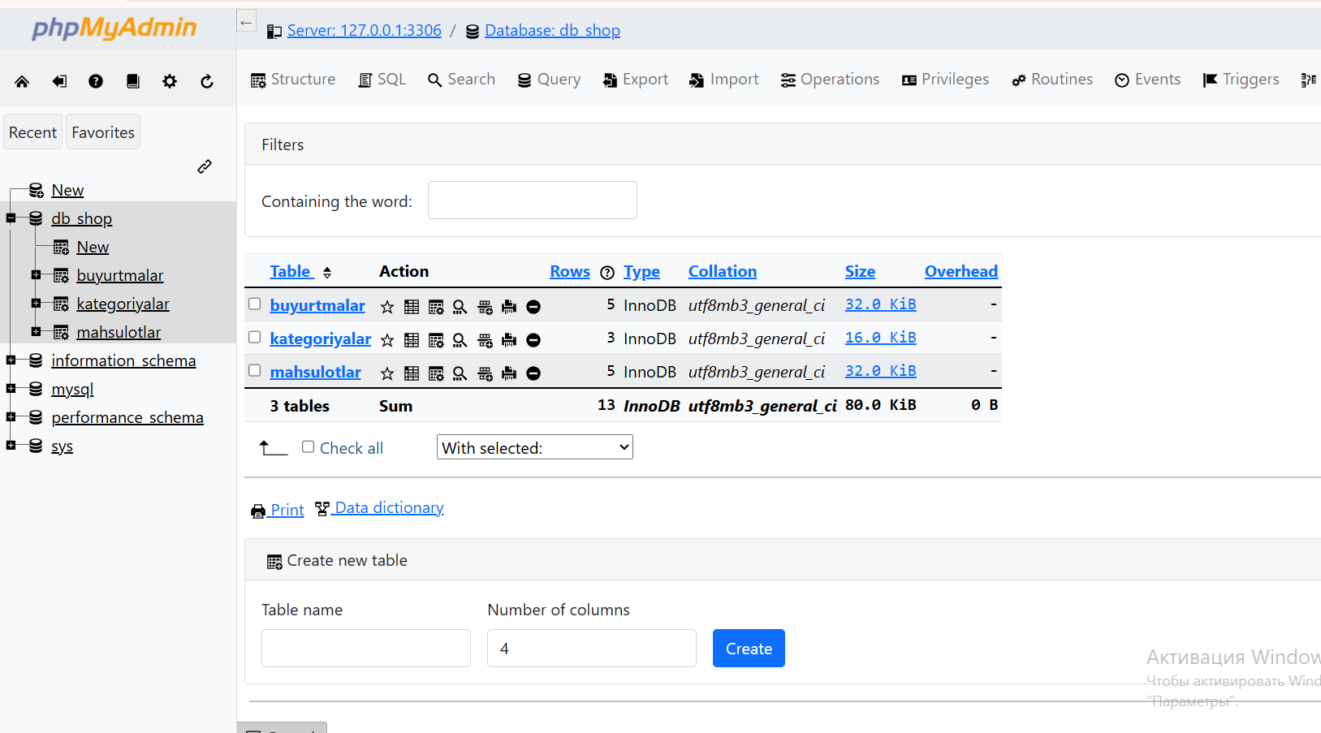

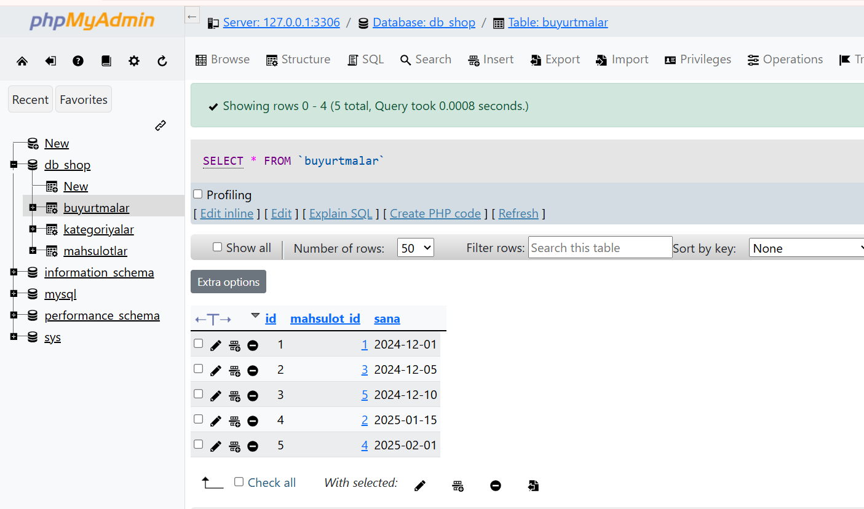

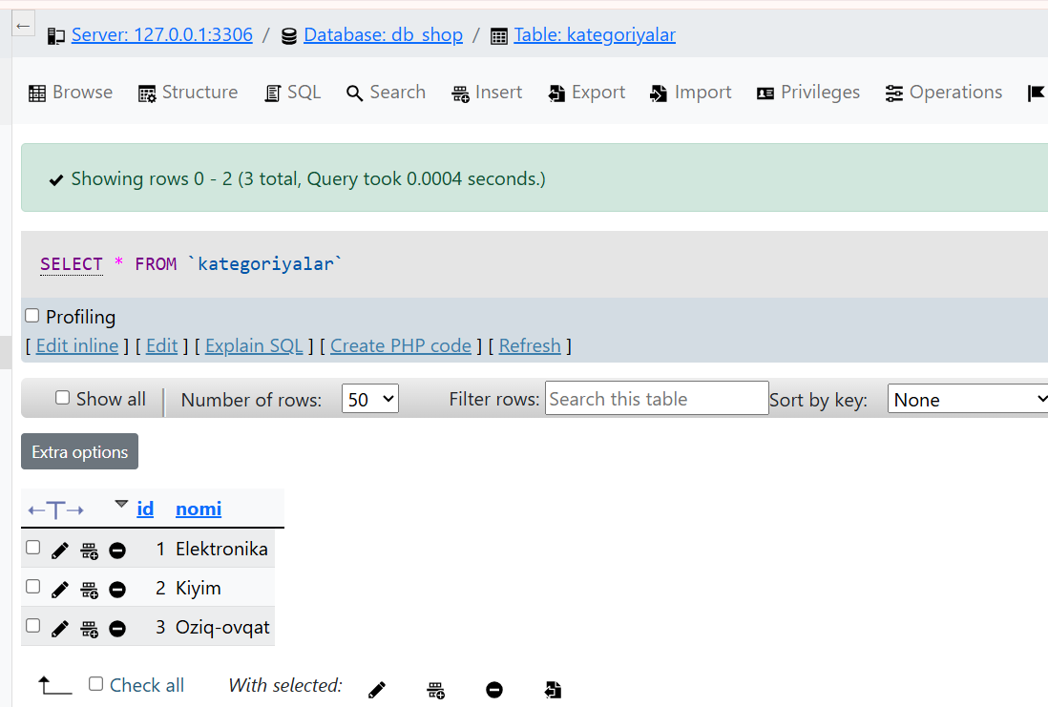

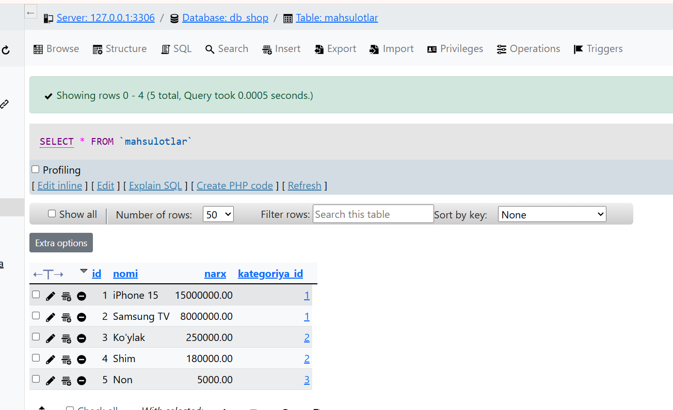

Bu esa bugungi laboratoriya topshirig’I natijasi. Topshiriqda “JOIN vazifa:
Mahsulot + Narx + Kategoriya + Buyurtma sanasi chiqarish”- edi va mening loyihamda quyidagi vazifa bajarildi.

