Arithmetic in a Near-Pixel SIMD Architecture for 3D Stacked Chips
Kenny Nagy

(805) 410-2430
kenny_nagy@ucsb.edu

Research Paper for ECE252B
Computer Arithmetic

Winter 2020

ABSTRACT
An implementation suitable for signal processing in 3D chips using Trough-Silicon-Via (TSV) is presented here. A Digit-Serial architecture for arithmetic modeled on the work of Richard Hartley and Keshab Parhi is explored and tailored for use in 3D stacks.

Lincoln Laboratory has developed a digital-pixel focal plane array with per-pixel, 16-bit full dynamic range, analog-to-digital conversion, but with limited real-time digital image processing capability. Their orthogonal-transfer circuit serially shifts the pixels from one cell to the next. Adding power and area efficient DSP capabilities with a Digit-Serial architecture would be very advantageous and not effect the transfer speed.

A digit-serial implementation style is explored for where bit-serial systems are too slow and bit-parallel systems are too large. The digit-size is the number of bits processed in a clock cycle. The complexity and the clock frequency increase with the digit-size. A digit-serial system can be reduced to bit-serial or bit-parallel in the extreme ends. The family of implementations can be compared and contrasted to discover the optimal trade-off between throughput and size. The structured architecture of digit-serial designs also lend themselves to automatic algorithmic construction.

INTRODUCTION
Another much-sought-after demand is the ability to integrate real-time, high pixel-count, image-based sensor systems into low size, weight, and power (SWaP) packages to enable the integration of the systems into a wide range of platforms. However, the development of such low-SWaP, high-performance sensor systems poses significant challenges for conventional focal plane array (FPA) technologies, which have limited data rate, dynamic range, and on-chip processing capabilities. While conventional technologies perform well in limited circumstances, scaling the technologies to meet these emerging demands is difficult and results in large, complex, expensive systems. The digital-pixel focal plane array (DFPA) was developed to address the shortfalls of conventional FPAs.

Electronic On-Chip Image Stabilization
High-speed orthogonal transfer (i.e., the ability to perform
on-chip image translation) enables efficient signal
integration in the presence of line-of-sight motion. Specifically,
knowledge of the line-of-sight angle movement
(e.g., using an inertial measurement unit) can be used to
stabilize the image on chip for continuous signal integration
without the need for high-speed readout. This capability
is demonstrated in Figure 6, which shows a resolved
image that has been stabilized.

The ability of the DFPA to shift pixel values synchronously
with a scanning mirror (this process is referred
to as time delay and integrate [TDI]) can significantly
improve the sensitivity of scanning systems relative to
those using conventional analog FPA technology. With
N stages (e.g., N columns assuming a row-wise scan)
of TDI, the total integration time increases by a factor
of N relative to a single TDI stage, resulting in an SNR
improvement of √N .

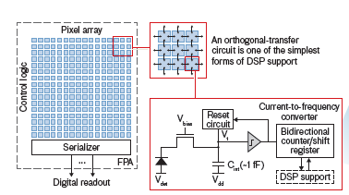

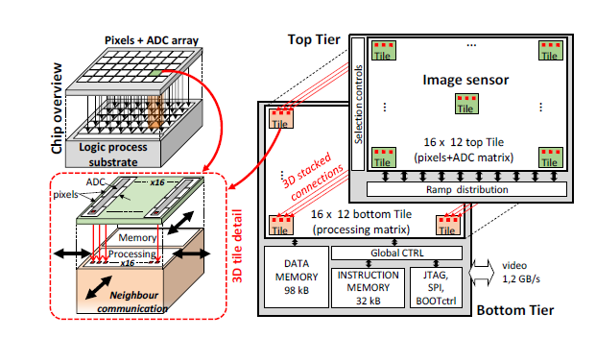

Full Adder
In this paper, we introduce a novel low-power
multiplexer-based 1-bit full adder that uses 6 identical
multiplexers with 12 transistors in total (this adder
will be called MBA-12T thereafter). This new adder
has low short-circuit current and reduced transition
activity than previously proposed low-power adders.

The testing result shows that the MBA-
12T consumes 26% less power than 28-transistor
CMOS adder. Meanwhile, MBA-12T exhibits at least
23% in power-savings over the least powerconsuming
10-transistor adder and a minimum of
64% in speed improvement over the fastest of all
other tested adders.

In this part a 1-bit full adder that utilizes a novel
multiplexer-based architecture, built upon 6 identical
multiplexer gates, is shown in Fig. 2. Substituting each
of the multiplexer gates with a 2-transistor circuit
(Fig. 2.b) gives us the new MBA-12T adder, which
requires a total of 12 transistors to realize the
function of a full adder (Fig. 3).

In this paper, a novel low-power multiplexer-based
1-bit full adder (MBA-12T) is presented, which is
constructed using 6 identical multiplexers and a total
of 12 transistors. MBA-12T adder exhibits charge
recycling capabilities and has very low short-circuit
current. HSPICE simulations have been performed to
evaluate MBA-12T and five other adders, including
28-transistor complementary CMOS, SERF and 10T
adders. Simulation results show that MBA-12T
consumes 26% less power than conventional 28-
transistor CMOS adder. In addition, MBA-12T
consumes 23% less power than the most power
efficient 10-transistor adders and is 64% speedier
than the fastest of all other tested adders. MBA-12T
therefore, is suitable to be applied to build larger low
power high performance VLSI systems.

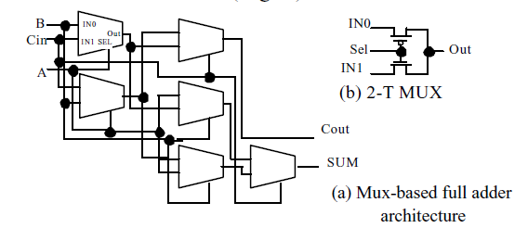

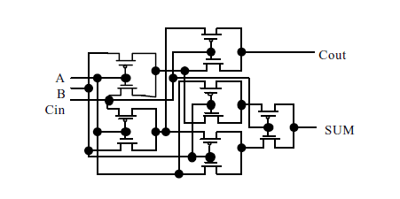

(5;3) Counter

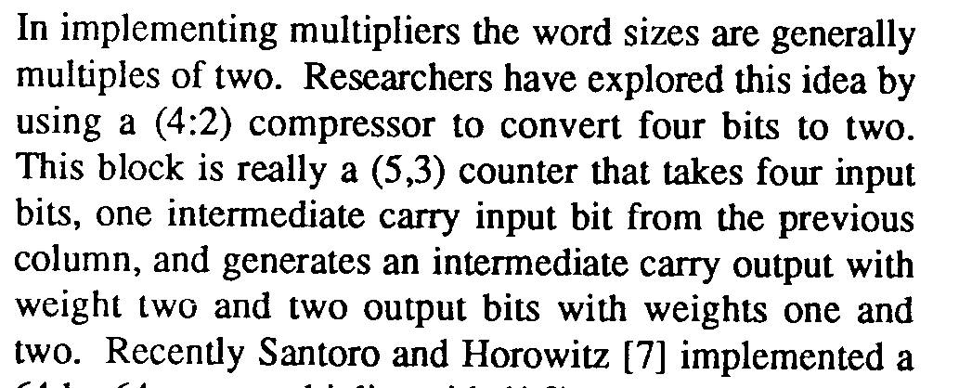

A compressor is a device which is mostly used in multipliers to reduce the operands while adding terms of partial products. A typical M-N compressor takes M equally weighted input bits and produces N-bit binary number. The simplest and the most widely used compressor is the 3-2 compressor which is also known as a full adder. It has Three inputs to be summed up and provides two outputs. Similarly, a 4-2 compressor can also be built from two Cascaded 3-2 compressor circuits. The conventional implementation of a 4-2 compressor is composed of two serially connected full adders, as shown in figure. Different structures of 4-2 compressors are reported in literature and these are governing by the basic equation as Follows:

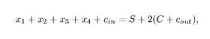

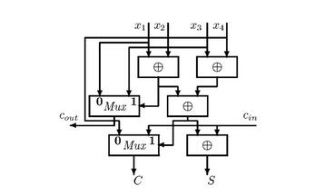

Serial Adder
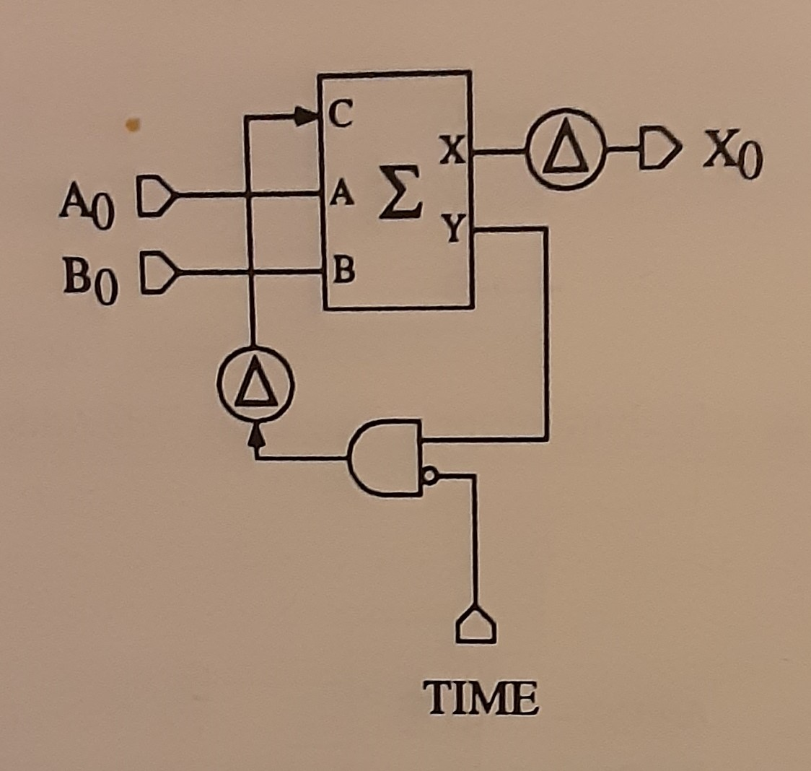

Serial Multiplier

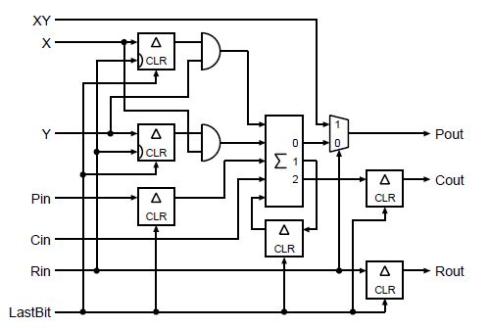

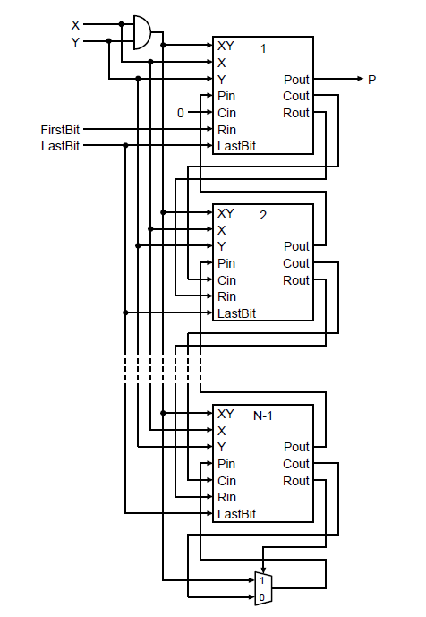

Digit-Serial Computation

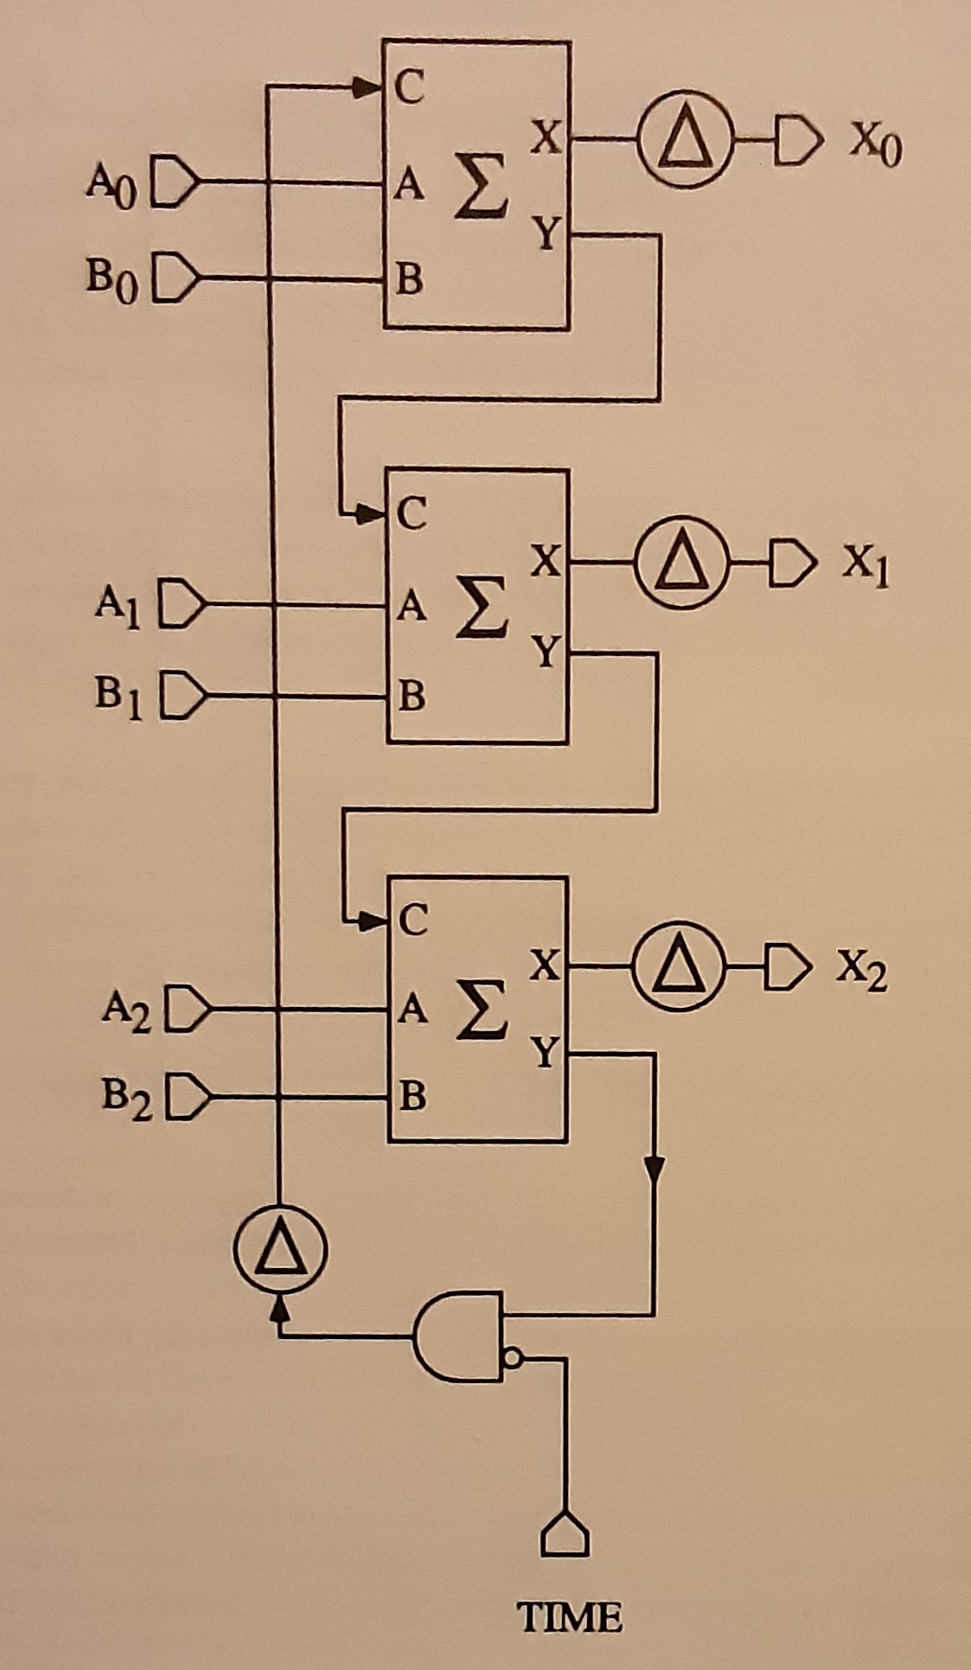

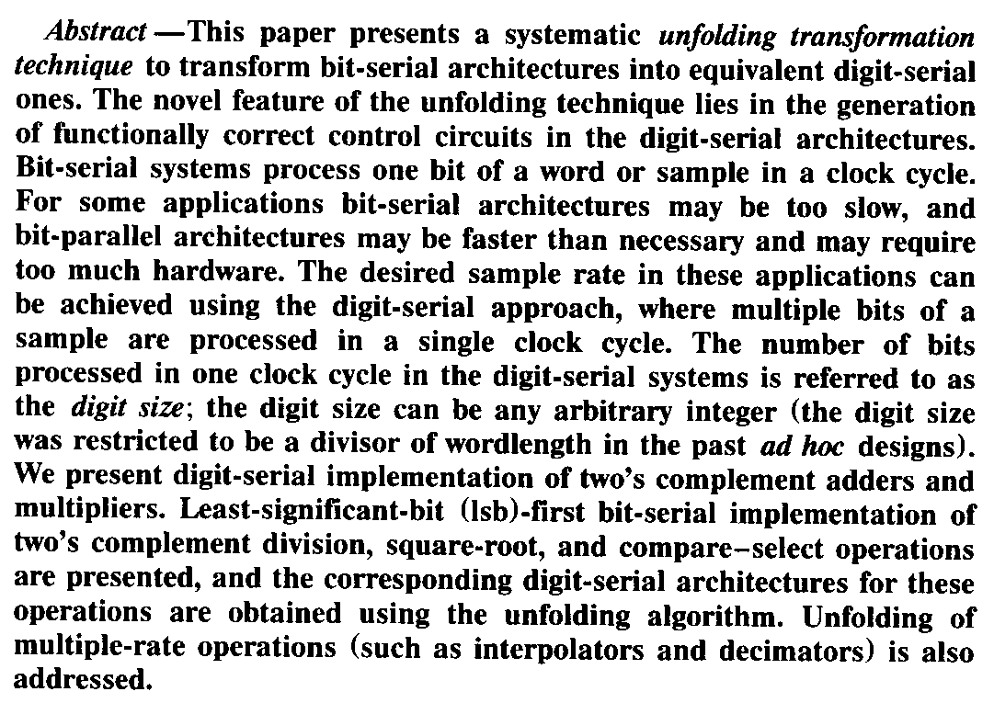

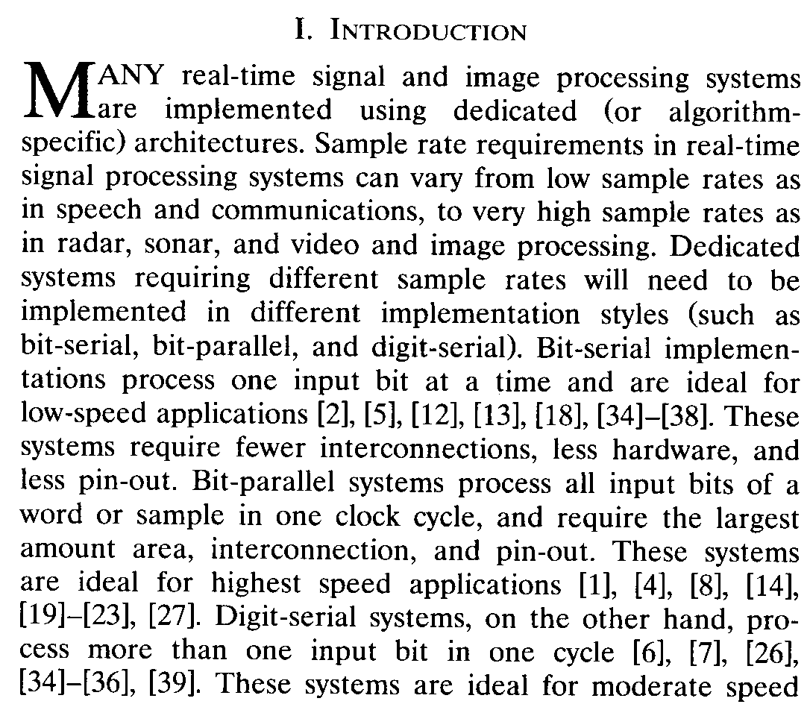

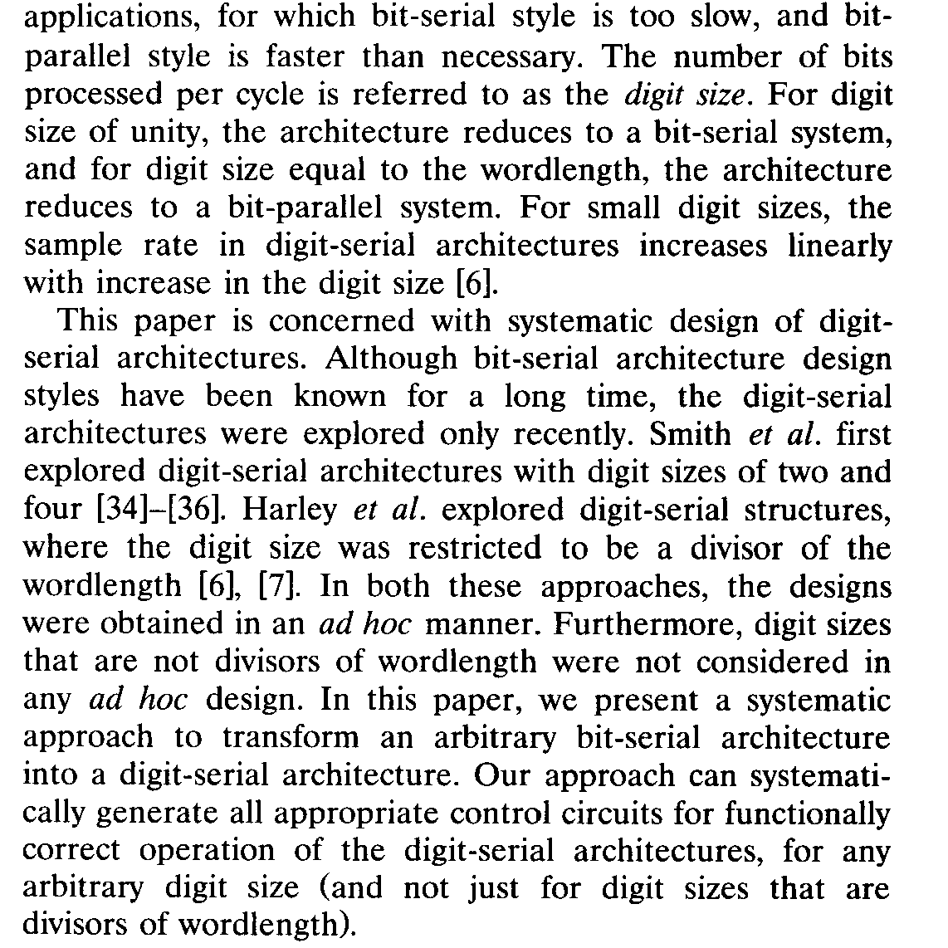

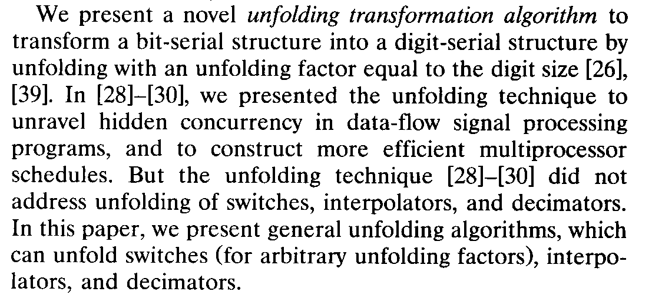

Pixel Array

CONCLUSION

REFERENCES
[AlSh04] Abdulkarim Al-Sheraidah, Yingtao Jiang, Yuke Wang, and Edwin Sha,“A Novel Low Power Multiplexer-Based Full Adder”
[Bogh19] B. M. Boghosian, P. V. Coveney, and H. Wang, "A New Pathology in the Simulation of Chaotic Dynamical Systems on Digital Computers," Advanced Theory and Simulations, 2019; 1900125 DOI: 10.1002/adts.201900125
[Chev19] S. Chevobbe, M. Lepecq, K. Benchehida, M. Darouich, T. Dombek, F. Guellec, and L. Millet, "A Versatile 3D Stacked Vision Chip with Massively Parallel Processing Enabling Low Latency Image Analysis," Proc. Int'l Image Sensor Workshop, June 2019.
[Hart95] Richard Hartley; Keshab Parhi “Digit-Serial Computation”
[Ienn94] Paolo Ienne, Marc Viredaz,“Bit-Serial Multipliers and Squarers”
[Kore02] Israel Koren, “Computer Arithmetic Algorithms,” Second edition.

