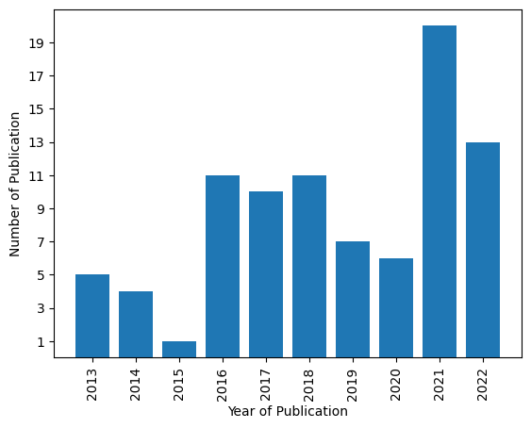

|  |  |
| --- | --- |
| Year of Publication | Number of Publication |
| 2013 | 5 |
| 2014 | 4 |
| 2015 | 1 |
| 2016 | 11 |
| 2017 | 10 |
| 2018 | 11 |
| 2019 | 7 |
| 2020 | 6 |
| 2021 | 20 |
| 2022 | 13 |

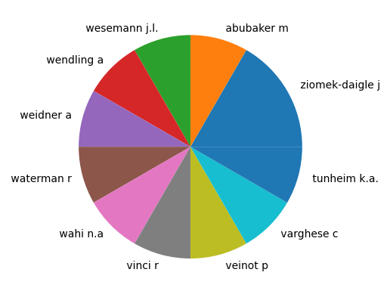

|  |  |
| --- | --- |
| Author | Number of publications |
| ziomek-daigle j | 2 |
| abubaker m | 1 |
| wesemann j.l. | 1 |
| wendling a | 1 |
| weidner a | 1 |
| waterman r | 1 |
| wahi n.a | 1 |
| vinci r | 1 |
| veinot p | 1 |
| varghese c | 1 |
| tunheim k.a. | 1 |

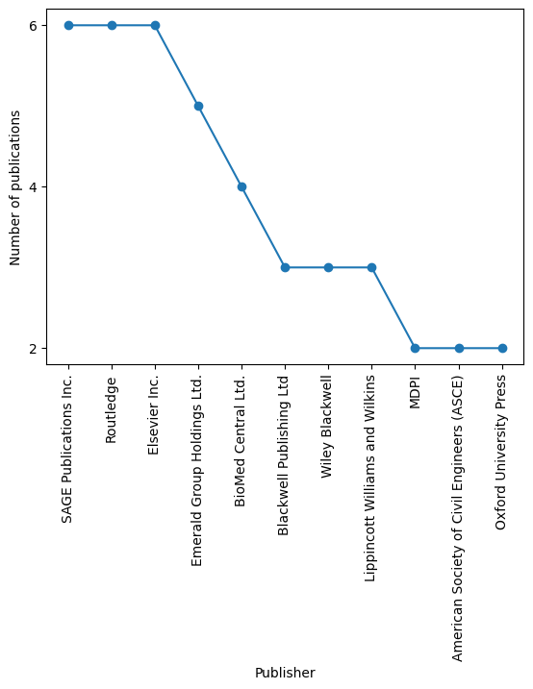

|  |  |
| --- | --- |
| Publisher | Number of publications |
| SAGE Publications Inc. | 6 |
| Routledge | 6 |
| Elsevier Inc. | 6 |
| Emerald Group Holdings Ltd. | 5 |
| BioMed Central Ltd. | 4 |
| Blackwell Publishing Ltd | 3 |
| Wiley Blackwell | 3 |
| Lippincott Williams and Wilkins | 3 |
| MDPI | 2 |
| American Society of Civil Engineers (ASCE) | 2 |
| Oxford University Press | 2 |

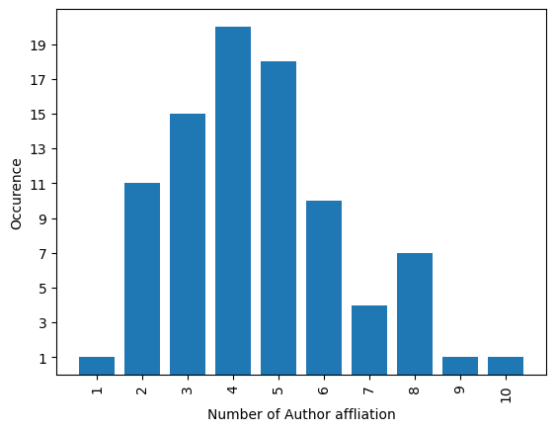

|  |  |
| --- | --- |
| Number of Author affliation | Occurence |
| 1 | 1 |
| 2 | 11 |
| 3 | 15 |
| 4 | 20 |
| 5 | 18 |
| 6 | 10 |
| 7 | 4 |
| 8 | 7 |
| 9 | 1 |
| 10 | 1 |

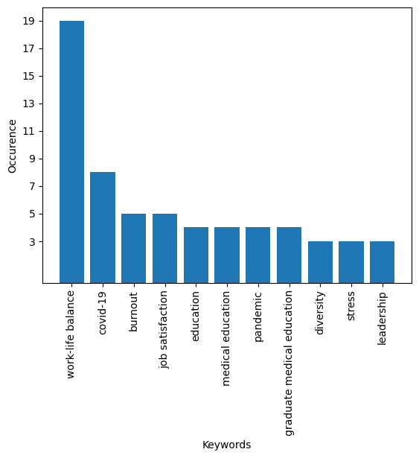

|  |  |
| --- | --- |
| Keywords | Occurence |
| work-life balance | 19 |
| covid-19 | 8 |
| burnout | 5 |
| job satisfaction | 5 |
| education | 4 |
| medical education | 4 |
| pandemic | 4 |
| graduate medical education | 4 |
| diversity | 3 |
| stress | 3 |
| leadership | 3 |

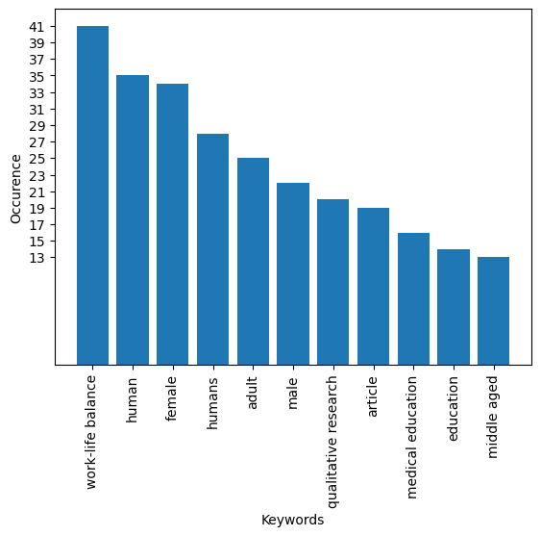

|  |  |
| --- | --- |
| Keywords | Occurence |
| work-life balance | 41 |
| human | 35 |
| female | 34 |
| humans | 28 |
| adult | 25 |
| male | 22 |
| qualitative research | 20 |
| article | 19 |
| medical education | 16 |
| education | 14 |
| middle aged | 13 |