YubiKey
Security Key C NFC


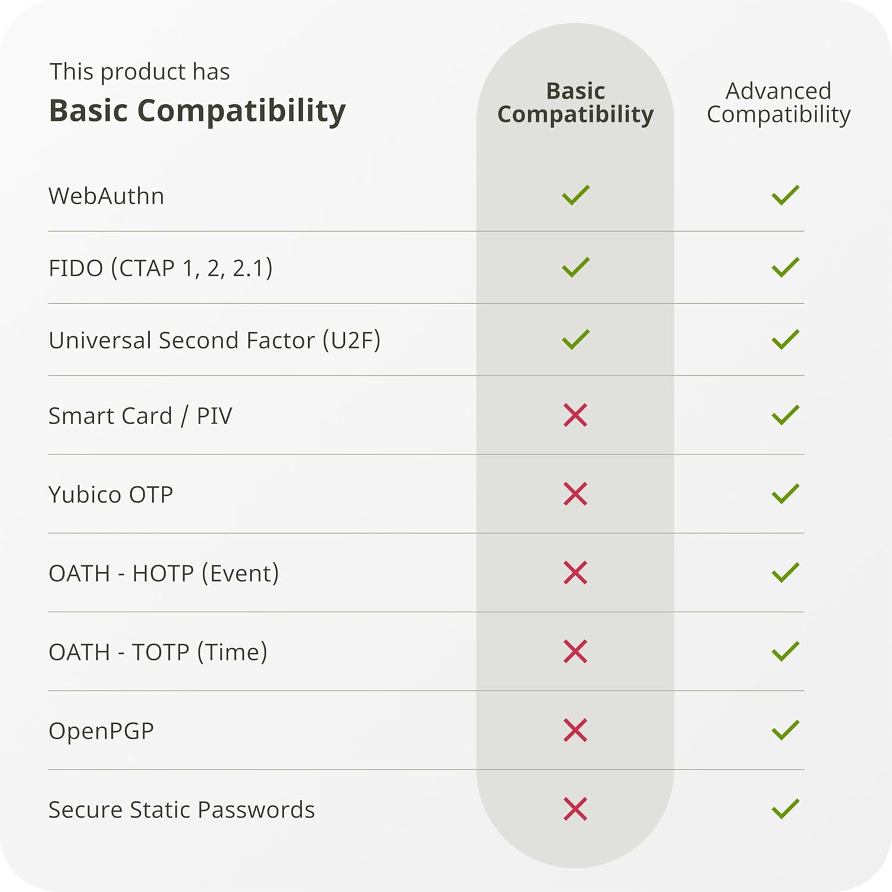
$29
YubiKey
5C NFC

$58
YubiKey
5C Nano

$68
YubiKey Legend:
“5”: Device has “Advanced Compatibility”
“C”: Device has a USB-C interface
“NFC”: Device will work wirelessly with most newer phones

“Bio” devices come with fingerprint readers
YubiKey
Bio C (FIDO Edition)

$98
Thetis
FIDO2 BioFP
$49

