Jordan Dunlap

Algorithms

BFS and DFS Project

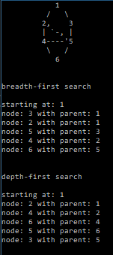

The sample graph is shown. I was caught by some forgotten CSC101 material when I noticed my \’s were not showing. I had to use an escape character.

The struct, node, has a pointer for each cardinal and ordinal direction, as well as one for the parent of the node for the purposes of testing.

The Breadth-First search uses a queue to hold the nodes. As nodes are discovered, they are scrutinized to see if they are already in the map. If so, they are not updated, and the first parent of the node in the map is used.

The Depth-First search uses a stack to hold the nodes. As a node is discovered, it updates the parent pointer, because we want to use the latest one found. Then, the node is scrutinized and is only added to the map and stack if it is a unique state.