STEP 1:

Create: “ZCL_REST_RESOURCE_005” by SupperClass “CL_REST_RESOURCE”

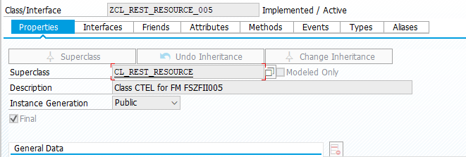

Click Methods and changing “IF_REST_RESOURCE~POST”

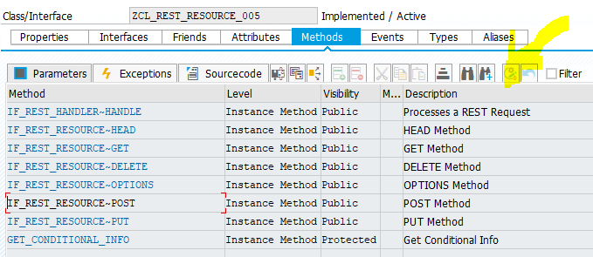

Create code: get Json by url to internal table in sap abap.

STEP 2:

Create class: “ZCL_REST_HANDLER_005” by SupperClass “CL_REST_HTTP_HANDLER”

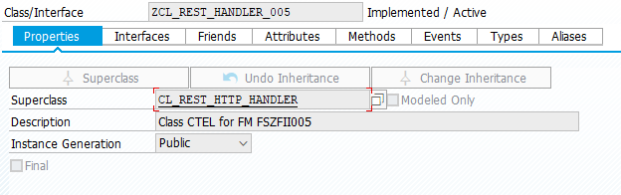

Changing method: “IF_REST_APPLICATION~GET_ROOT_HANDLER” with code:

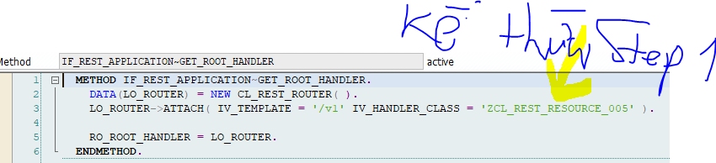

Changing method “HANDLE_CSRF_TOKEN” with add code:

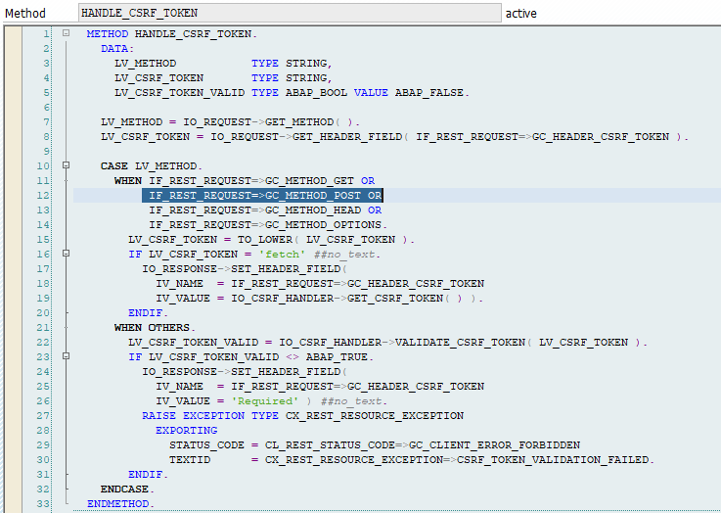

STEP 3: GO to Tcode: SICF -> F8

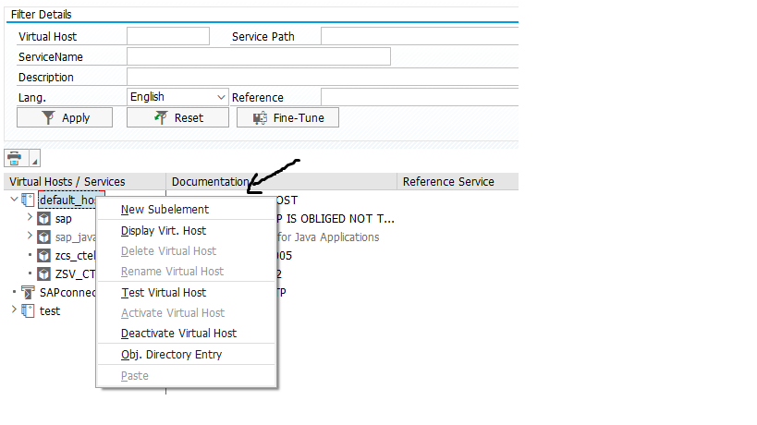

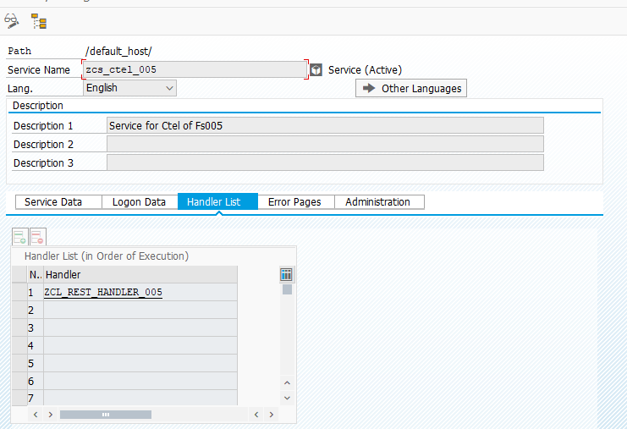

With handler create at STEP 2

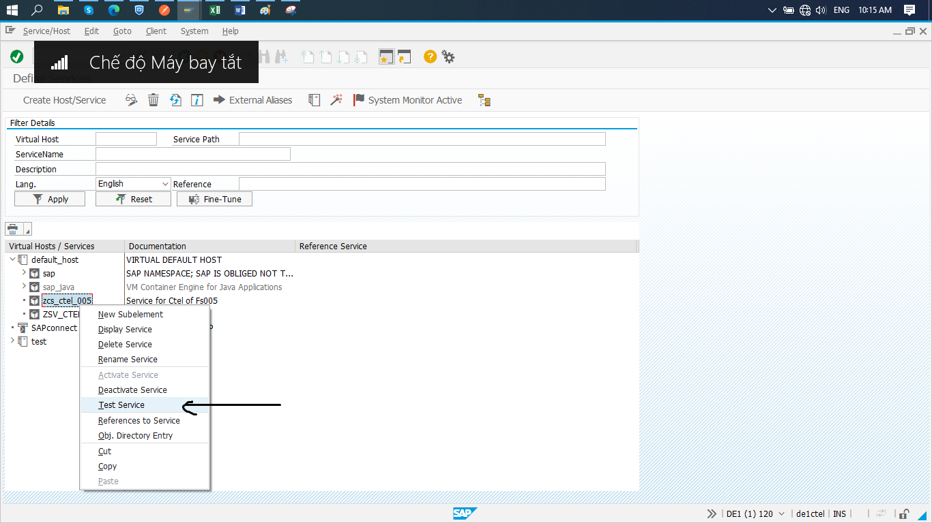

End you can Url to Post data from Json to Sap Abap.

http://de1ctel.cmctelecom.vn:8001/zcs_ctel_005/v1?sap-client=120

http://de1ctel.cmctelecom.vn:8001/zcs_ctel_005/?sap-client=120: url created by Sap

/v1: add in methods: “IF_REST_APPLICATION~GET_ROOT_HANDLER” in class “ZCL_REST_HANDLER_005”