|  |  |  |
| --- | --- | --- |
| F:\PWARC\gif\sun3.gif | F:\PWARC\pics\pichold\Bill Fortune Jr FD 2010.jpg | **2 Stations, 5 watts each** **No directional antennas** **237 contacts in 41 states** **We worked well as a team!**  **Was it a success? You bet!** |

**Pueblo West Metropolitan District Board Proclaims Amateur Radio Week**  
**June 8, 2010**

|  |  |
| --- | --- |
| Amateur Radio received a boost in the community on June 8 when the Pueblo West Metropolitan District Board of Directors (left) presented a Proclamation to President Jim McConnell (right) of the Pueblo West Amateur Radio Club. Board Chairman Mike French made the presentation proclaiming the week of June 21-27 as Amateur Radio Week in Pueblo West. | F:\PWARC\pics\pichold\proclamation.jpg |

The Proclamation reads:

**WHEREAS,** the Community of Pueblo West has more than 60 licensed Amateur Radio operators who have demonstrated their value in public assistance by providing emergency radio communications, and

**WHEREAS,** these Amateur Radio operators donate these services free of charge to the Community, in the interest of the citizens of our Community and our Nation; and

**WHEREAS,** these Amateur Radio operators are on alert for any emergency, local or world-wide, and practice their skills during the American Radio Relay League's Field Day exercise, and

**WHEREAS,** this year's national Amateur Radio Field Day will take place on June 26-27, 2010

**NOW, THEREFORE, WE, the Pueblo West Metropolitan District Board of Directors** by virtue of authority vested by us, do hereby proclaim the week of June 21-27, 2010 as Amateur Radio Week in recognition of this important emergency preparedness exercise, and call upon all citizens to pay tribute to the Amateur Radio operators of our Community.

**IN WITNESS WHEREOF,** I have hereunto set my hand and caused the Great Seal of the Pueblo West Metropolitan District to be affixed, on this the 8th Day of June, in the Year Two Thousand and Ten.

**MIKE FRENCH, Chairman**

**Cheers Plaza, 334 S. McCulloch Blvd.**

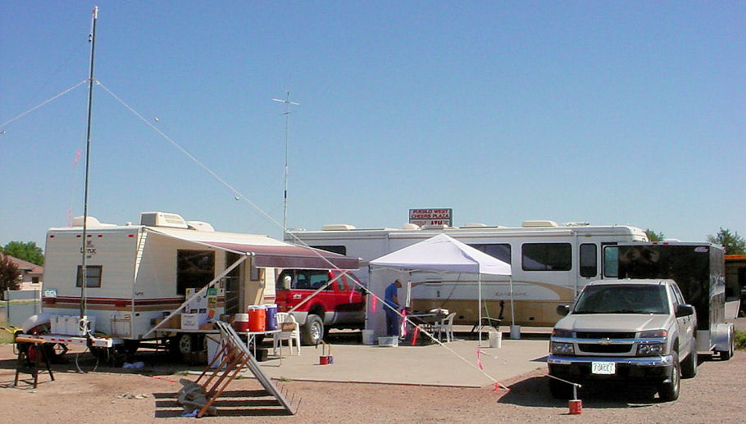

|  |  |
| --- | --- |
| Pueblo West Amateur Radio Club successfully presented its first Field Day exercise on June 26 & 27 in Pueblo West. Twelve licensed club members, one non-licensed member, and two licensed guests contributed to the successful event.  Those who attended were Bill Ewing (WA0KAQ), Jane Ewing (KA0USA), Andy Lloyd (ND0P), David Ewing (KC0RNI - guest operator), Ralph Schuster (KA0RER), David Yeater (unlicensed member), Bill Fortune Jr. (W0NHF), Bill Fortune III (KB0RPD), Ed Force (NI5R), Kirk Kelley (KD0LDH), Neal Tew (KD0MBL), Ty Luck (KG6WSI), Dennis Watson (KB0YLK - guest operator), Jim McConnell (NE0DA), and Dan Broadbooks (NG0T).  Two stations were set up with both using batteries charged by solar panels. A propane generator running an air conditioner was used to keep cool.  Station 1, owned by NE0DA, was used for the SSB and CW modes. The rig was an IC-706 hooked to a vertical for 40-10 meters. | F:\PWARC\pics\pichold\FD map.jpg |

This station made 119 CW and 26 SSB contacts. Dan (NG0T), who enjoys and is very proficient in CW contesting, was responsible for all of this station's CW contacts. He showed why CW is a preferred mode for low power FD contesting, bringing in 1,190 points for his effort. The 26 SSB contacts supplied another 130 points for a total of 1,320 points.

Solar powered Station 2, owned by WA0KAQ and KA0USA set up in their trailer, used a generator donated by Pueblo West Rental Center to run the air conditioner. The station was used primarily more for teaching members how to operate PSK31 than as a contest station. It consisted of a Yaesu FT-897D transceiver, and MFJ-1279M Deluxe Sound Card Interface, an MFJ-945E mobile antenna turner, and a homebrew jumpered Inverted "V" antenna cut for 40, 20, and 10 meters. At least 9 different operators used this station, the majority of them never having used the mode before. All of them made at least one contact, and the rest had several contacts each.

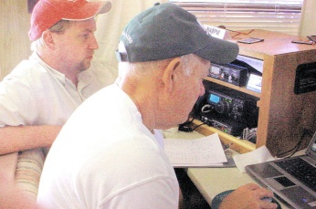

David Ewing (left), KC0RNI, son of WA0KAQ & KA0USA, upgraded his license to General last month in anticipation of our Field Day. He came from Westminster to join us, and operated PSK31 for the first time. In short order, he was soon instructing others on how to use the mode and the FLdigi software. Ed (right), NI5R, was one of the operators who will soon be using the mode from their homes.

Station 2 accounted for 78 PSK31 contacts by a variety of members as they learned the new mode, and 14 CW contacts made in the early morning hours by WA0KAQ, for a total of 920 points.

Through no fault of our own, we were unable to check into the Central Colorado Traffic Net on Saturday evening to send a radiogram to the Colorado Section Communications Manager or to send additional messages for bonus points. The net meets on the Colorado Connection repeater system, and the transmit link from Colorado Springs to Denver is unusable.

The unofficial results show our claimed score to be 2,240 points, plus 950 bonus points, for a total of 3,190 points.

The breakdown by band is as follows

|  |  |  |  |
| --- | --- | --- | --- |
| **Band** | **CW** | **Digital** | **SSB** |
| **40 meters** | **14** | **65** | **0** |
| **20 meters** | **76** | **9** | **22** |
| **15 meters** | **37** | **2** | **1** |
| **10 meters** | **6** | **2** | **3** |

Field Day also has an educational aspect as well as the contesting side. KA0USA put together a nice information table where visitors could learn about amateur radio and about our club. A dozen companies supplied catalogs, flyers and other information about their products, and information from the ARRL was also available. Visitors also found free iced tea, ice water, lemonade and cookies to take their minds off the hot weather on Saturday.

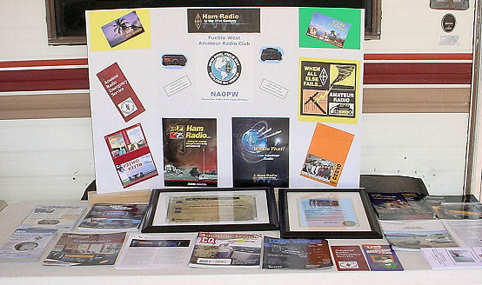

Information Table for Public Education

Member David Yeater framed the Pueblo West Metropolitan District Board's proclamation that proclaimed the last week in June as Amateur Radio Week in Pueblo West, and the club's new charter as an ARRL Affiliated Club. Both were interesting display pieces on the table.

Our local newspaper's lack of publication for publicity for the event hurt us, but we did have some visitors. This was due mainly to being located near S. McCulloch Blvd. and them seeing our signs as they drove by. Of note, one ham who had lived here for two years and didn't know there was a club in Pueblo West stopped to get information. He noted he was ready to sell his equipment on eBay, but now he may be joining our club.

|  |  |
| --- | --- |
| Though no longer a requirement for a ham license, Morse code still holds the fascination of many newcomers. Even young children find it to be a fun challenge to learn it. At right, Paul, KB0JIT, shows 6-year-old Benji Lloyd how to spell B-E-N-J-I using a keyer.  Due to sunless conditions on Saturday afternoon following a brief period of lightning, the three 60-watt solar panels did not produce enough current to run Station 2 through the entire night. About 5:00 a.m. the battery voltage was dropping to about 11.3 volts on transmit, so it was decided to change the radio's power source to a bank of four 18 Ah batteries. The batteries powered the laptop computer and radio for the remaining 7 hours. | F:\PWARC\pics\pichold\Paul & Benji.jpg |

|  |  |
| --- | --- |
| F:\PWARC\pics\pichold\Bill Fortune Jr FD 2010.jpg | No Field Day or other ham event would be complete without a ham to man the talk in station. Bill, W0NHF, our oldest and longest licensed member, was there to handle that task this year. He set up his station in the motor home using battery power in case anyone needed information or directions to get to the event.  Was the event a success? Did it meet the organizer's expectations? Definitely! Everyone seems to have had a good experience at Field Day, the first such event for the majority of the members. The members worked together as a team in everything they did, and whatever was needed they unselfishly supplied. They were ready for new experiences, and no one seemed to leave disappointed.  With one event under its belt, so to speak, next years' Field Day Committee will have something to build on and a chance to make it even more of a success than this year's exercise was. |