MEETINGS & WEEKLY LOGS

07-01 Week 1 | Monday weekly meeting : internship goals

GUI / Dashboard for the grid-agent
1. Should allow user to start / stop the grid-agent
2. Should provide a GUI for the user to change parameters
3. Should visualize relevant metrics
4. Should allow user to change parameters on the run

Implementation ideas / remarks :
- Split functionalities : parameters, start/stop in a web dashboard, visualization in a web dashboard
- The visualization will need information from the resource-agents at some point, the grid-agent could send a list of followers + addresses so that the dashboard can contact them easily

Extensions :
1. GUI for the resource-agents as well
2. point 4. from above can be considered an extension for now
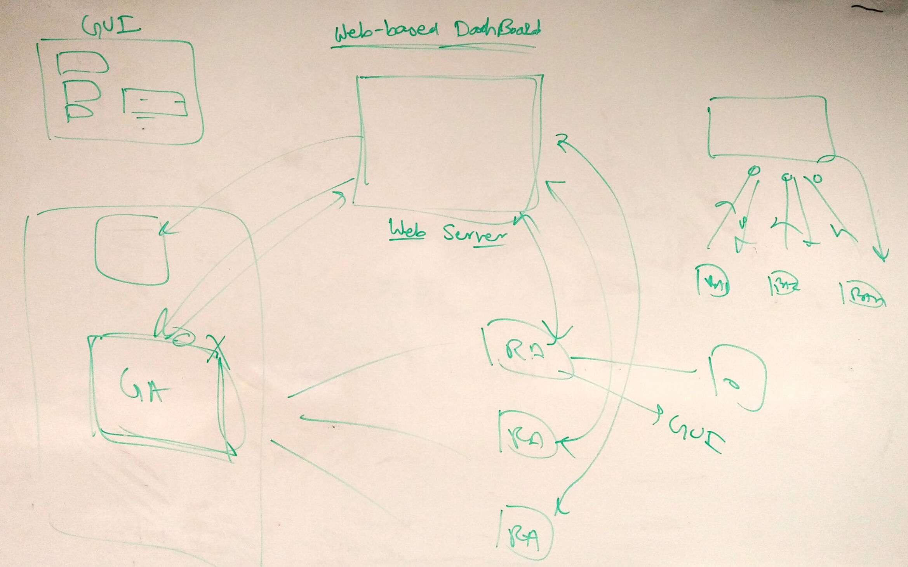
Figure : Architecture idea

Invention assignment witness

Acted as witness for the assignment of invention of PCT/IB2019/054963 to EPFL.
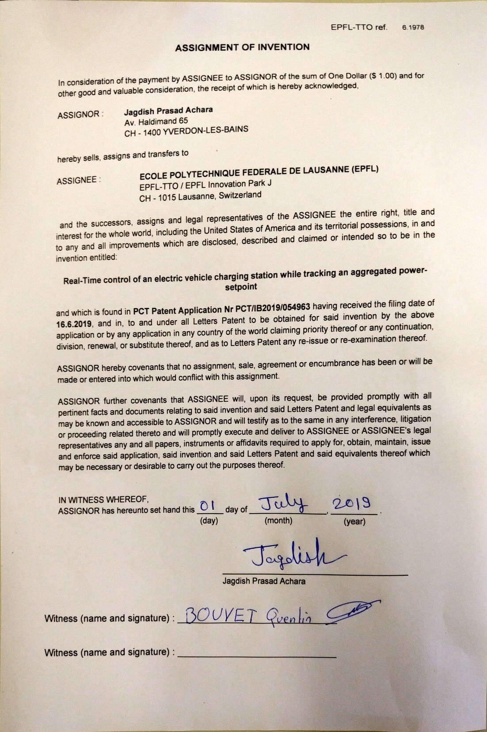

07-05 Week 1 | Friday weekly log

Recap :

Grid-agent GUI progress :
1. Wrote and tested a set of IPC functions
2. Found GUI library with suitable license
3. Designed a mock interface
4. Started animating the mock interface

Grid-agent GUI todo :
1. use rapidjson to autofill mock interface
2. Use proper data structure to link keys and values and hide them accordingly
3. Integrate IPC library to GUI buttons and produce functional PoC GUI
4. Implement {pause, resume} functionalities and ‘--gui’ toggle in the grid-agent
5. Produce a functional grid-agent GUI

Libraries licensing :

wxWidgets is under wxWindows licence, which is essentially L-GPL + authorisation to distribute derivative work in binary form :
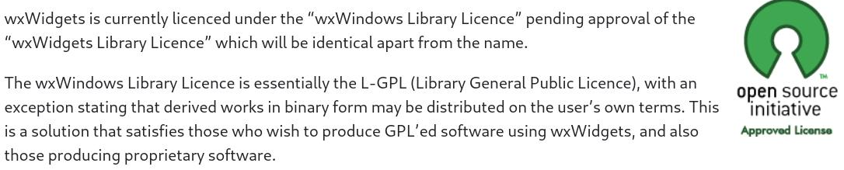
L-GPL allows both static and dynamic linking anyway, so it should not be a problem
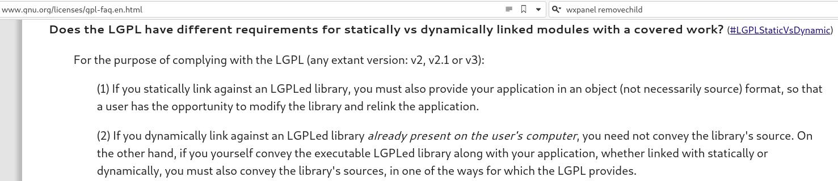
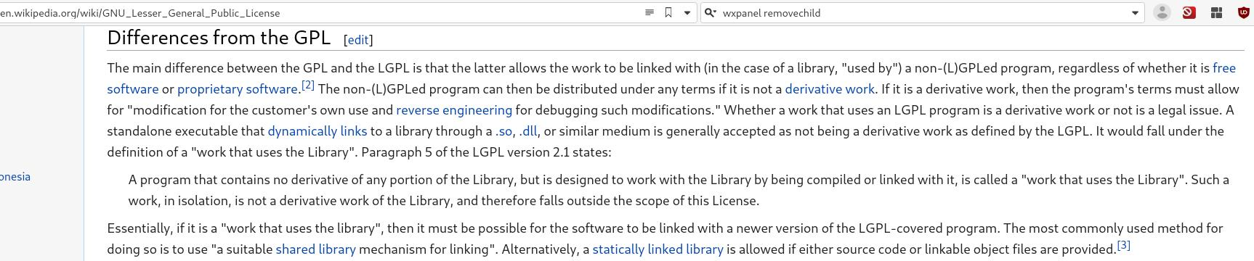
Proof-of-Concept GUI :

The goal is to : (1) modify the grid-agent as little as possible, and (2) still be able to run the grid-agent entirely in command line, without dependancies on GUI libraries (for embedded systems, etc). Therefore, I aim for the following architecture :
1. The grid-agent binary and the GUI binary are entirely separate, and run as separate processes
2. The GUI binary will start the grid-agent binary with a ‘--gui’ toggle, that indicates that the grid-agent should expect commands from a gui process
3. The grid-agent then needs to implement (1) stuff for inter-process communication (ie. include that in its main loop) and (2) stuff to execute commands from the GUI
4. Specifically, the grid-agent will implement pause(), resume(), quit() functions. The reload-parameters will be implemented by quit()’ing, then restarting from the GUI process, exploiting the fact that the grid-agent is stateless.

As for functionality, the grid-agent GUI is essentially a json editor, which can start, stop, and reload the grid-agent with values edited by the user. It provides a default configuration and can also load and dump json files. Ideally, I would like to implement tooltip comments (parsing comments from the json file).

IPC “library” :

The IPC (Inter Process Communication) “library” provides a way for processes to communicate over hasline(), writeline(), readline() non-blocking primitives.

It is implemented on top of named unix pipes (pipes backed by a file) and handles data buffering.
Buffering is necessary in order to delimit lines (= parse ‘\n’ characters), and unix pipes are a good choice because they offer (1) non-blocking IO with the read(fd) and write(fd) primitives and (2) can poll for data using the poll(fd) system call.

IPC could have been implemented over unix-domain sockets with non-blocking configuration (and the code could probably easily be modified to switch pipes and sockets). It was however not possible to use buffered inputs (FILE*, ifstream, …), because these don’t allow checking if data is present or for non-blocking operations, which is why I had to implement buffering.

07-08 Week 2 | Monday Weekly Meeting

Feedback on GUI :

JSON editor is ugly, do a simple GUI with categories : ”Network configuration”, “Slack configuration”, …

07-12 Week 2 | Friday weekly log

Recap :

Grid-agent GUI progress :
1. Drafted a new tile-based layout
2. Tiles are json-parametrizable, informations about settings are also parametrizbale
3. Controls type is adapted to match parameter type
4. Drafted interdependance annotation system for parameters

Grid-agent GUI todo :
1. Extend wxWidgets classes to have nicer controls (i.e. sliders should display the value)
2. Extend wxWidgets classes to implement GUI logic and interdependance system
3. Integrate IPC library to GUI buttons and produce functional PoC GUI
4. Implement {pause, resume} functionalities and ‘--gui’ toggle in the grid-agent
5. Produce a functional grid-agent GUI

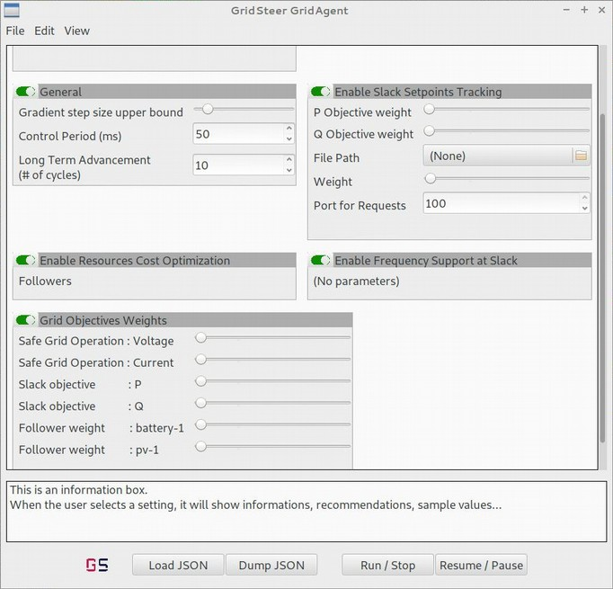
Challenges faced this week :

Not all wxWidgets layout tools work the same, although they have the same interface : for example wxFlexGridSizer doesn’t respect children max sizer. This problem was worked-around using a more complex Sizer hierarchy.

Also, working with rapidjson template types.
07-15 Week 3 | Monday meeting log

Feedback on GUI :

New Layout is good, need to implement functionality now
Need a nice set of vertical sliders to configure the weigths of the agents of the grid.

07-19 Week 3 | Friday weekly log

New features :

Can ‘dump-json’

New technical stuff :

GUI elements now update the backing json document in memory
json_utils can now write to file

07-22 Week 4 | Monday meeting log

Feedback on GUI :

Almost no progress has been made, “lot of complaining, no new features”
Line-to-line voltage should be displayed in a textbox
→ need to prioritize _features_, time is running

Features prioritization

Features :
1. Start / Stop the grid-agent binary
→ start the binary
→ modify grid-agent to add a ipc-listen loop
→ implement stop command in the grid-agent
2. Load JSON
→ read json file
→ replace global pointers
→ loop over all controls to refresh them
→ implement a “json key → [controls]” map & loop over it
3. Display information in the InfoBox
→ Gui objects read their “hint” field in the guiconfig.json
→ Gui objects have a onClick / onModified handler that show the input
4. Range for inputs is user configurable
→ Gui objects read their “option/range” field in the guiconfig.json
5. Pause / resume the grid-agent binary
→ Implement pause command in the grid-agent
6. Textinput at the top shows the ga binary path
7. “Save grid-agent output to file” button

Enhancements :
6. Line-to-line voltage should be a float in a Number Box
→ implement floatbox / intslider
7. Make a complete / though-out GUI
→ display relevant stats
8. User should be able to input lists
→ implement list inputs
→ this is going to be a big one
9. Improve/extend start/stop/pause/resume backend
→ what about code quality ?
→ Which additional features do we want ? Reload what ? How to do it ?
→ Define proper protocol
→ Unix domain sockets may allow to put the IPC loop in the cmomunicationManager
10. Import / Export JSON with drag and drop
11. Setting inputs greys-out some other, user-configurable inputs
Setting inputs for a key modifies the value displayed by all values for that key
→ Controls read their “sets / freezes / unfreezes” list from
→ As part of set(), controls query the “key → [controls]” map and run necessary functions

Other / Fixes :
1. Bug with generic number boxes / sliders : If the same key is declared “float” and “int”, setting it to a float value, then to an int value will cause a crash
2. Re-layout when window geometry changes
3. Line break markers in guiconfig for nicer design
4. Disable scroll input on control
5. Rewrite IPC library with unix domain sockets
6. Float box should enforce granularity when user types number in
07-29 Week 5 | Weekly log of the past week

Implemented Features :

- All Controls / Inputs new get their range from the “options” annotation, including strings (ip addresses) and filenames who have regex ranges
- Fixed sliders design
- Export to JSON implemented with a file-selection dialog
- Pressing ‘start’ starts the grid-agent binary with the setting shown in the GUI
- Can now start / stop
- Can now pause / resume
- Using a Control shows relevant information in the infobox
- Clicking a label now shows relevant information in the infobox
- load_json now works

Implemented technical stuff :

- Finally fixed the “inheritance problem” with a “minimal-override” virtual interface and a generic JsonKey behaviour interface implemented on top of that. Children only need to reimplement the minimal-override to inherit the whole behaviour interface
- Changed ‘granularity’ behaviour to better reflex the name, implemented FloatSlider label sizing based on range.
- Implemented granularity within range object
- fork_ga_binary() : dump current settings to temp file, open IPC channel, fork the binary
- Added optional ‘hint’ field into JsonKey

07-29 Week 5 | Monday meeting log

Feedback on GUI :

Good, GUI features are almost done
Need to work on grid-agent features

Features to implement :

- Show feedback when the grid-agent is running
- change start/stop, pause/resume buttons
- Show some stuff in the infobox (“grid-agent started successfully, etc”)
- Implement parameters live reload
- make a list of all parameters that could be changed
- Implement those that can be changed easily
- implement top bar for the grid-agent
- implement freeze inputs
- try to detect if grid-agent already running

07-29 Week 5 | Another Meeting log

Discussed GUI finalization :

Implemented :
- some parameters live reload
- feedback when starting / pausing the grid agent

Now, to move forward, last “vital” features that should be done within 1day, 2 max :
- Fix pause/resume bug
- Implement “disable” for parameters that are not allowed to live-reload
- Implement “pausing reload” if possible

Also : LISTS LISTS LISTS

Discussed dashboard starting ideas :

Start simple : implement the infrastructure :
- modify grid-agent to send advertisements (setpoints) to viz server
- python backend managing a influxdb
- grafana frontend

Do this for next week.
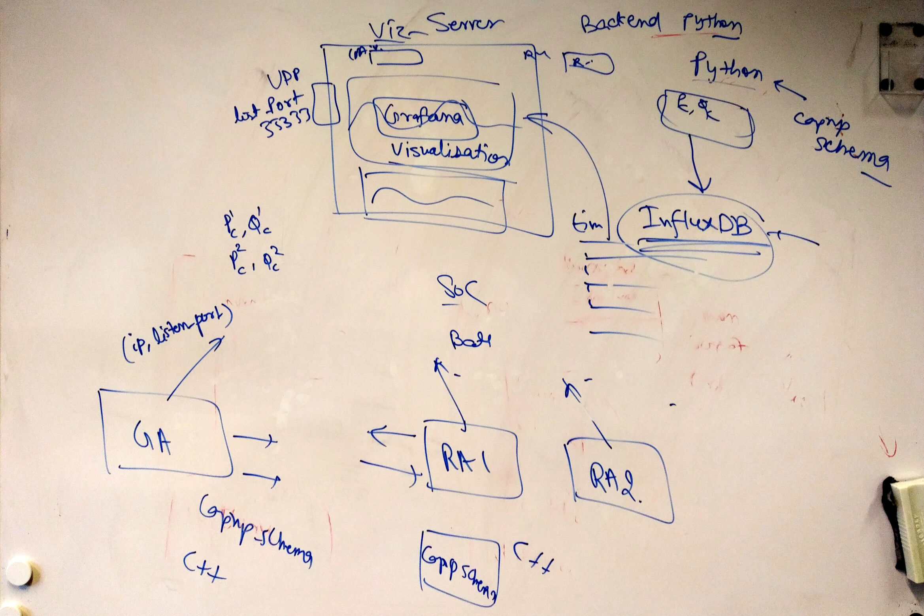
07-29 Week 6 | Past-week review

Implemented Features :

- pause / resume bug
- disable parameters that aren’t live-reloadable when GA runs

Dashboard :

- Setup infrastructure : TimescaleDB database, grafana server
- Modified grid-agent to upload slackP, slackQ to the database

07-29 Week 6 | Monday meeting log

TODO : Dashboard :

- GridAgent view : Plot requested slack tracking v. achieved slack, active and reactive power
--> Modify existing database to receive necessary data
--> Modify grid-agent to send necessary data
--> Add Graphs to the grafana server
- Grid view : Plot a graph of the grid state
--> New database for the grid state
--> Grid-agent should upload necessary data to this database
--> Draw the graph in javascript ? Find good library ? Tricky !
- Ressource view : per-resource, show P, Q, + resource-dependant metrics (SoC, ...)
--> New database, one per resource type, that holds the resource-dependant metrics + id
--> How to generate one view per resource ? Is rgafana suited for this ? Tricky !

07-29 Week 7 | Past-week review

Grafana Features :

- Templated graphs (variable/templated number of curves on a single graph)
- Stacked graph (Positive stacked on top, Negative stacked on bottom, mixed split in two series)

Grafana Plugins :

- Rudimentary PQplot [Battery only]:
- Dynamic PQ region with complex svg intersection
- Dynamic Implemented PQ,
- Dynamic Requested PQ

Other :

- Better simulation
- Grafana “Smoothing interval” variable :
- Implemented smoothing in “Grid Overview” section SQL queries

07-29 Week 7 | Monday meeting log

TODO | Dashboard | PQplot:

-Fixes
- Invert P and Q Axis
- Fix the Stroke of the
- Generalize PQplot to all agents
--> Adapt PQ region plotting on a per-agent case
- Update “Agent View” template to use PQplot
- Legends
--> Axes legends (P, Q)
--> Explain Colors: PQ region, implementedSetpoint, requestedSetpoint
--> Show Immediate P, Immediate Q ?

TODO | Dashboard | TOPOplot:

- Implement it !!
--> Read on topology libraries documentation
--> ???
--> Profit

TODO | Other :

- Implement lists in GUI
- Implement “override refresh rate” setting for live visualizations
- Some beautifying
07-29 Week 8 | Past-week review

Dashboard | PQplot :

- Inverted PQ axes
- Fixes stroke

TODO | Dashboard | TOPOplot :

-

Other :

-

07-29 Week 8 | Monday meeting log

