Drawing 1: Early concept of event heat map over time, no involvement of sources and mentions at that time.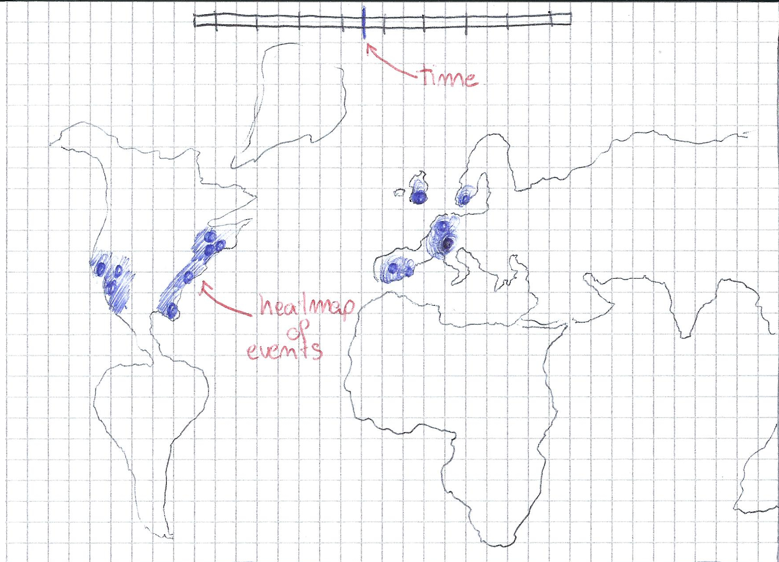
Drawing 2: Idea of sources artifacts below map that grow depending on number of mentions. Idea of edges connecting sources to events at the time of article.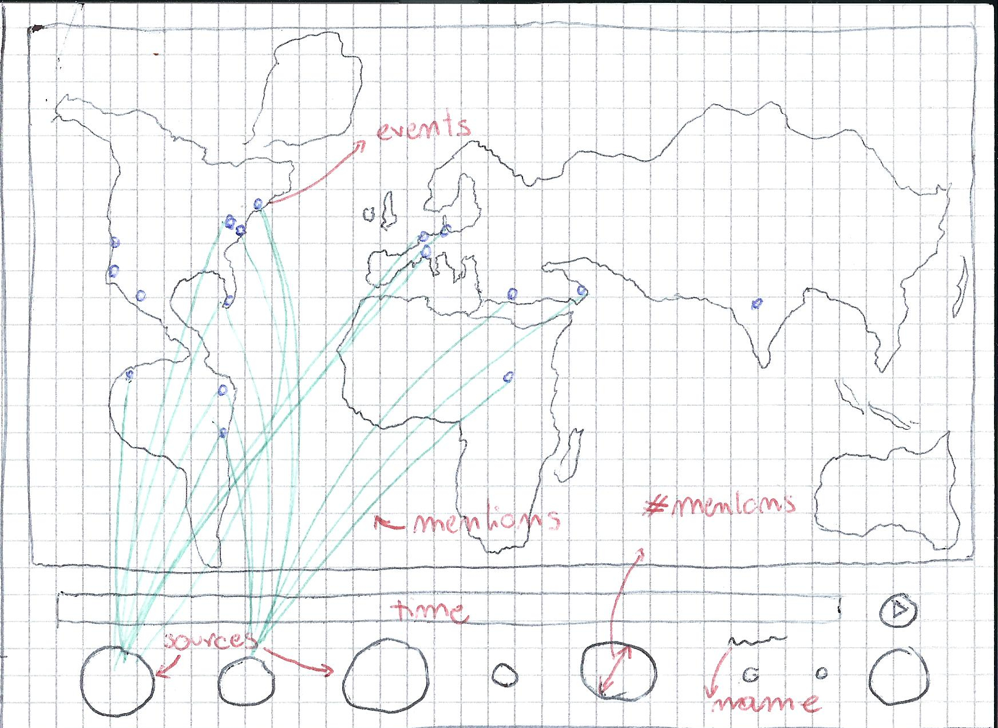
Drawing 3: Evolution of source artifacts. In this stage the idea was to have them float around the map and gravitate towards their zones of influence.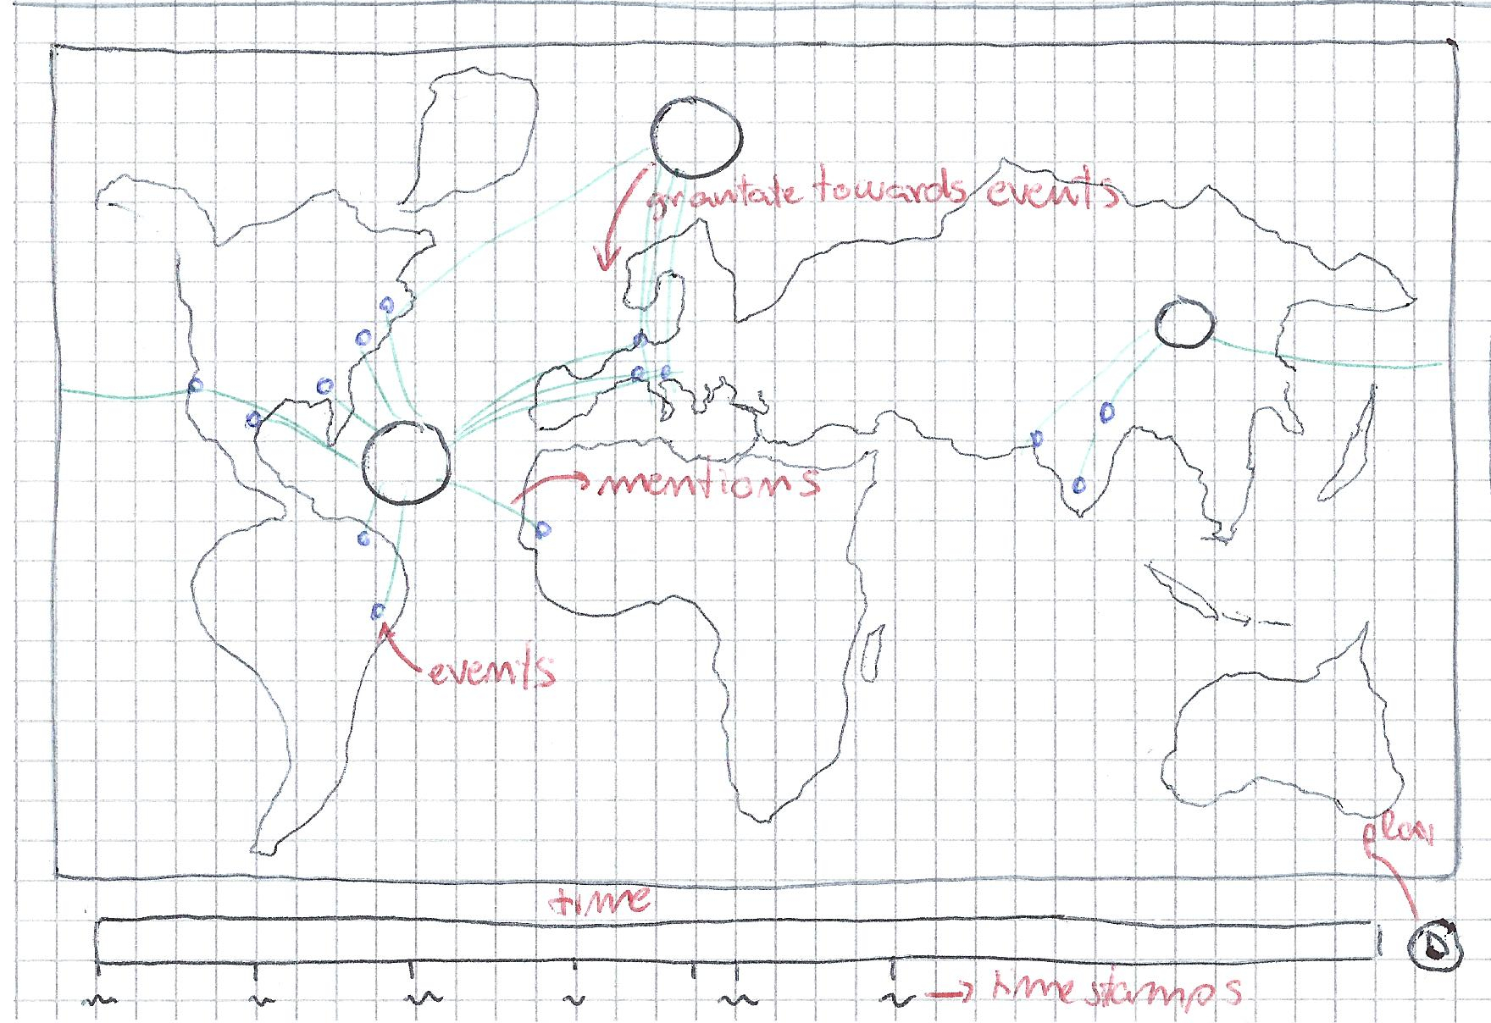
Drawing 4: First step of final idea. Empty map with starting time and play button, empty sources panel.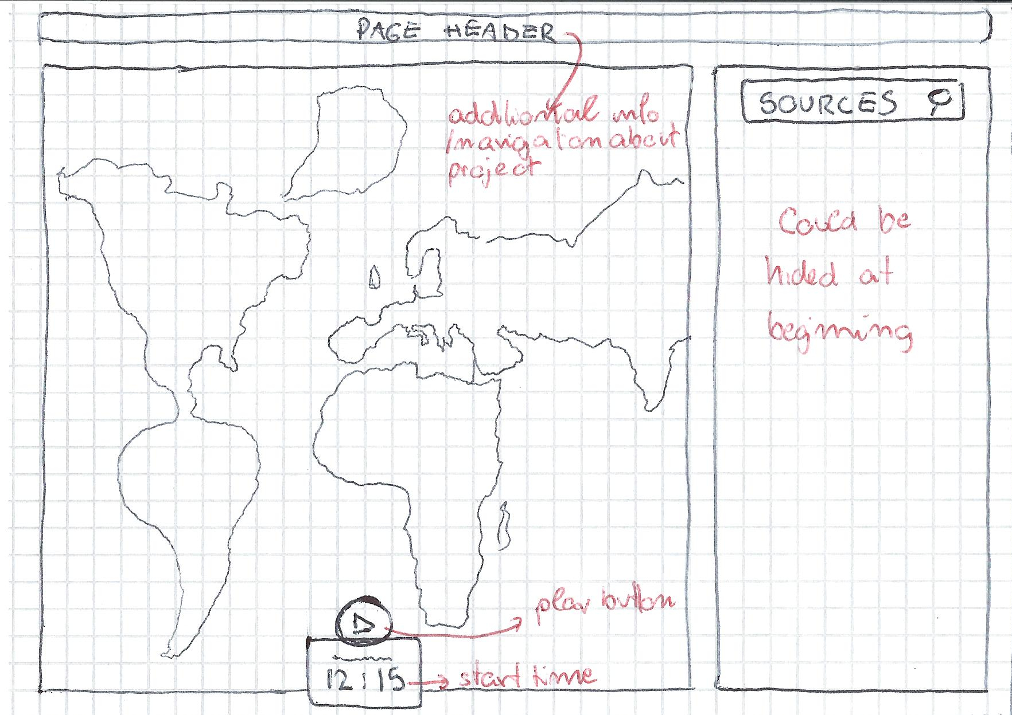

Drawing 5: Second step of final idea. On pressing play, time flows and events appear on map according to GDELT timestamps. They can be individually inspected.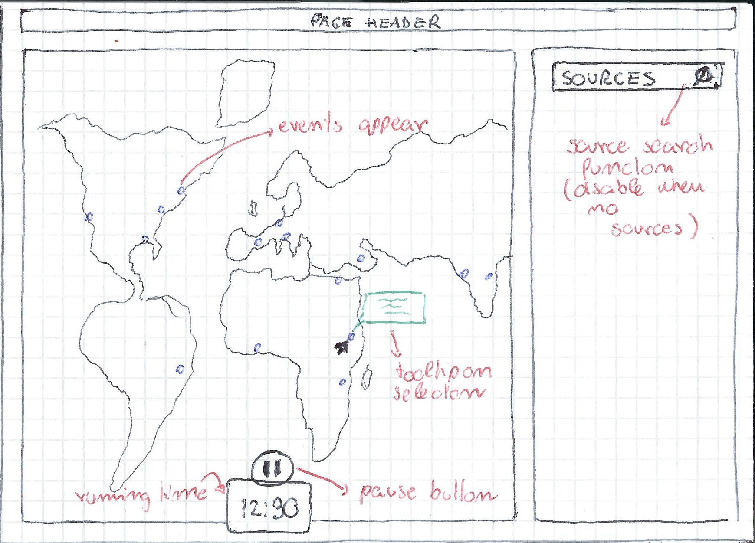
Drawing 6: Third step of final idea. Source entries appear ordered by mentions in the side panel, showing articles eveolution for that source over time. Some visualization technique shows when a source mentions an event present on the map (still to decide how).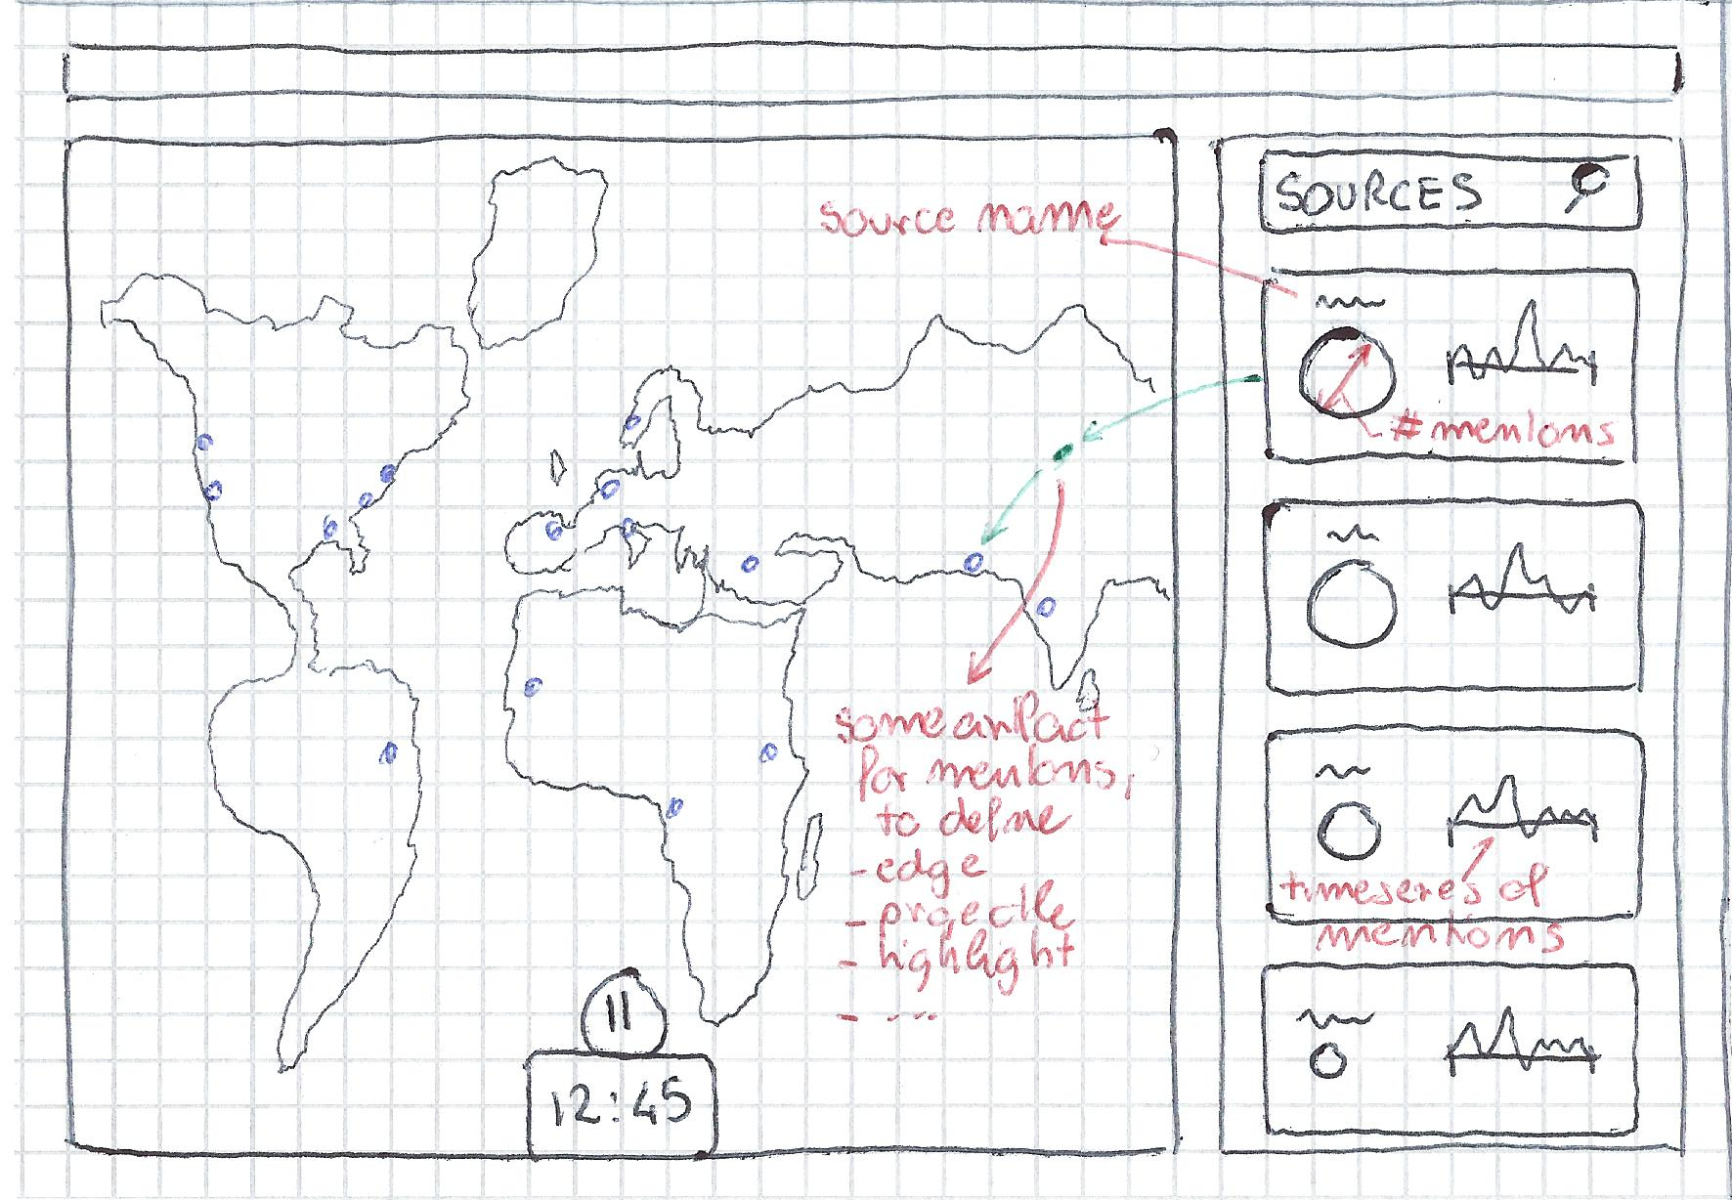
Drawing 7: Last drawing of final idea. Complex interaction with the viz: users can select a source and even a timeframe, and the map shows the relevant events to the selection, allowing to gather per-source insight.

