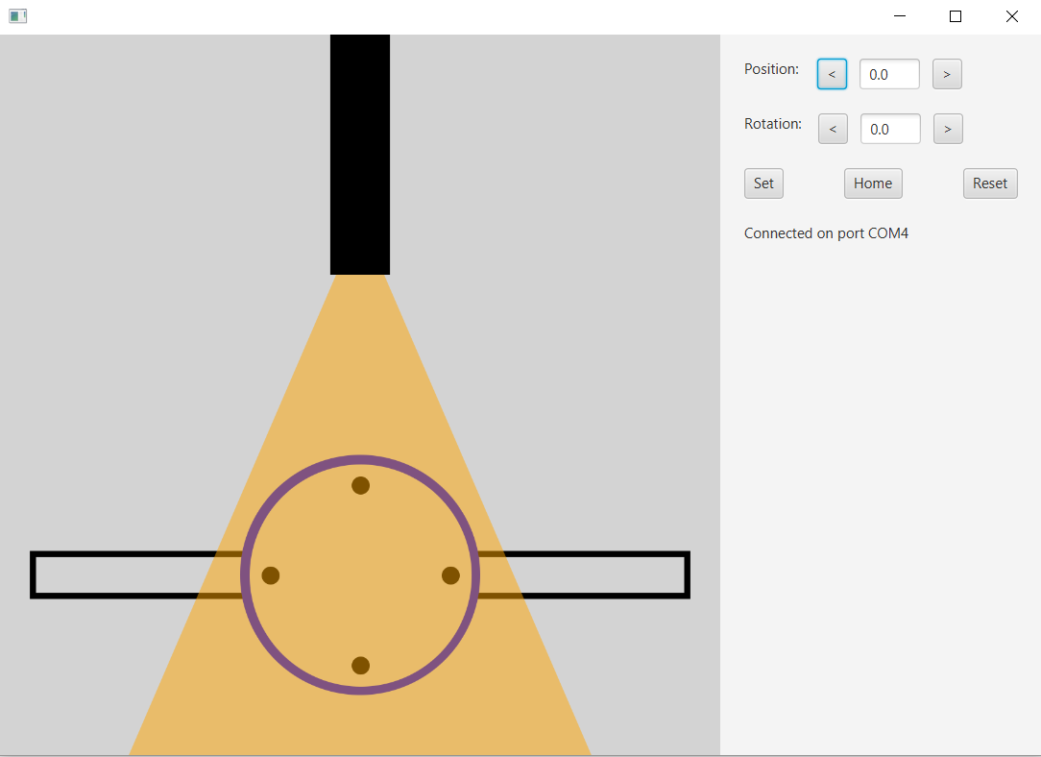

E

D

C

B

A

A: This part is purely aesthetic. A vague representation of the DBD, plasma plume, and Langmuir probes. Wildly inaccurate, but it looks pretty and moves around n such.

B: Use these text fields to enter in where you want the steppers to go, in millimeters and degrees respectively

C: These four small buttons move the respective steppers by one step at a time. Helpful for small adjustments. It also turns on “precision mode” in the firmware, which essentially keeps the stepper driver powered to help it be more accurate. Always click set when you are done playing with the fine adjustments, or the boards will stay powered and heat up

Set: Tells the Arduino to go to whatever position and rotation you wrote down in the text fields (B)

Home: Sets position and rotation to 0

Reset: Reboots the Arduino, essentially setting the current position to be the new home

D: Shows connection status. The software should automatically reconnect with the Arduino, though it may take a few seconds to update. If the Arduino disconnects though, it will have the same effect as rebooting in that its current position will be the new home.

E: Closing the program will automatically tell the Arduino to Home ( go to 0,0 )

Opportunities for improvement:

* The big one is to make use of the non-volatile storage on the sd shield everything is soldered to. Using the sd card would require moving the stepper control wires over, because I mistakenly soldered into the required pins. This could be used to store the position/rotation, so reboots and disconnects don’t scramble everything. Also, I forsee that extra storage being helpful when taking Langmuir data.