Open Your Account
- Click your profile icon at the top right corner of the screen, next to the search bar.

Screenshot

Open the Account Settings
- In the dropdown menu, click on Account.

Screenshot
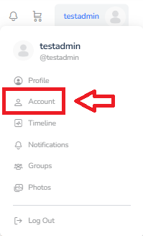

Go to Login Information
- Once on the Account Settings page, click on Login Information in the left sidebar.

Screenshot
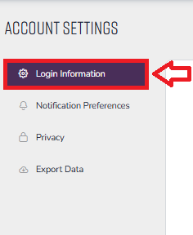

Enter Your New Password
- In the Add Your New Password field, type your desired password.
- In the Repeat Your New Password field, type the same password again.
- Optional: Click the eyeball icon next to each field to see the password you’ve typed.

Screenshot
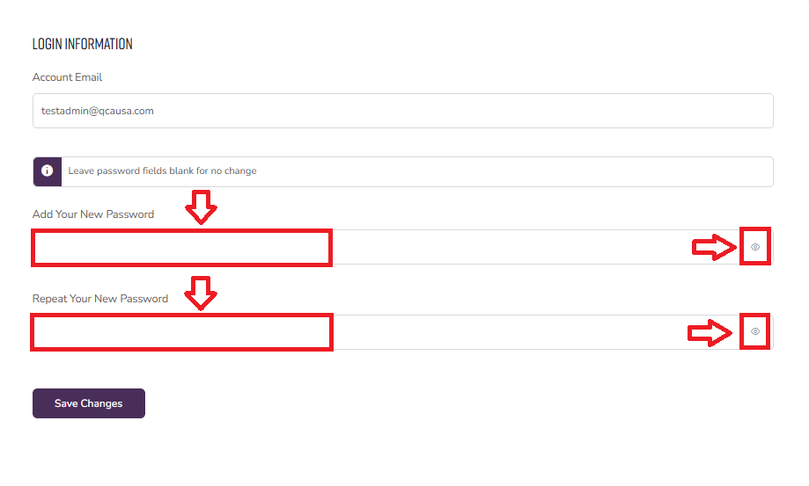

Check Your Password Strength
- Make sure your password has at least a Medium strength rating for better security.

Screenshot
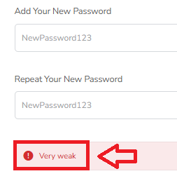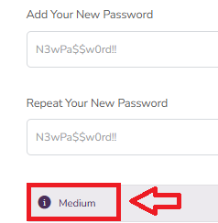

Save Your New Password
- Click the Save Changes button to update your password.

Screenshot
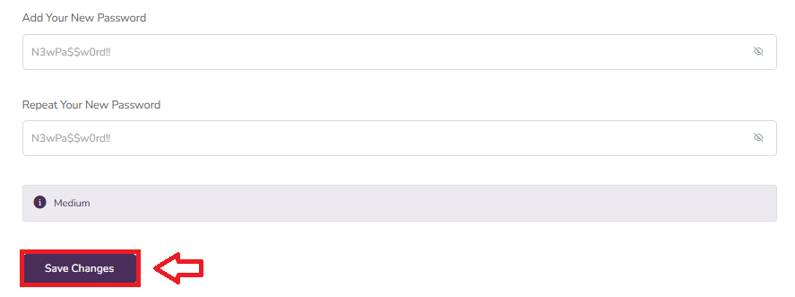

Confirm Password Reset
- If your password reset was successful, a message will appear at the top of the screen that says: "Your settings have been saved."

Screenshot
