##### Supplementary

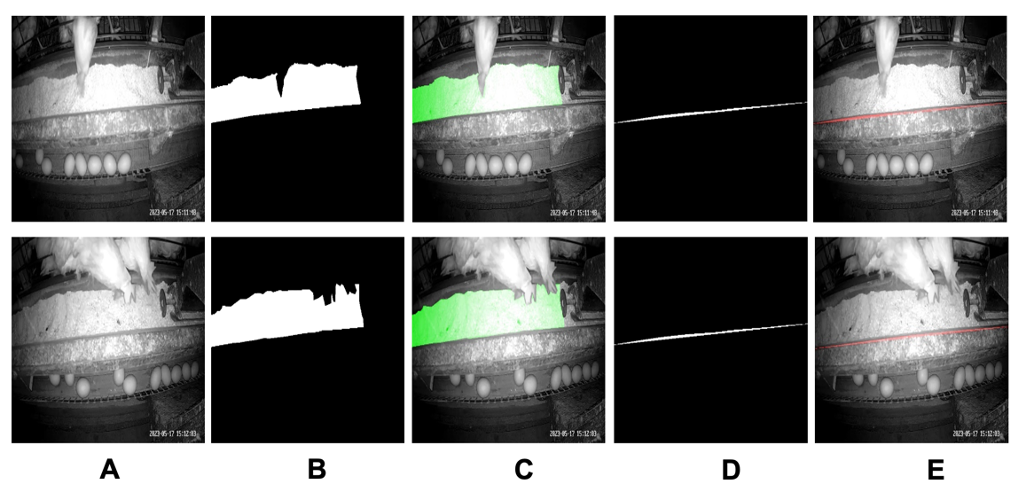

1. Feed area and feed line. A shows the original image,And B, D shows that the mask of feed area and feed line. and C, E shows that the visualization of feed are and feed line.
2. Algorithm of Health analysis Module

|  |
| --- |
| **Input:** Detection sequence $D=\left\{d_{1},d_{2}…{,d}_{m}\right\}$*,* Track sequence: |
| $$T=\{t_{1},t_{2},…,t_{m}\}Acquisition of Localization$$ =\{t_1,t_2,\ldots,\t_m\} |
| Unmatched number threshold: $max_age$; |
| Compute matching: $Hungarian(D,T)$ using Eq. 10-12 |
| Compute prediction $predict()$ using Eq. 13 |
| Compute update $update(T_{i})$ using Eq. 14-17 |
| 1: **While** video in progress |
| 2: **if $T$** is $None$ |
| 3: Compute $OpticalTracks$ using Eq. 7-9  4: $T=predict(OpticalTracks)$ |
| 4: $T=predict(OpticalTracks)$ |
| 5: **else** |
| 6: $Hungarian\left(D,T\right)$ |
| $$→Matched_{Tracks},Unmathed_{tracks},Unmatched_{detections}$$ |
| 7: **for ${mt}_{i}∈ Matched_{Tracks}$** **do** |
| 8: $OpticalTracks←update(T_{i})$ |
| 9: $for {ud}_{i}∈Unmatched_{detections}$ |
| 10: Compute $OpticalTracks$ using Eq. 7-9 |
| 11: $for {ut}_{i}∈Unmatched_{tracks}$ |
| 12: **Select ${ut}_{i}$**  by $max_age$ into $OpticalTracks$ |
| 13: $T=predict(OpticalTracks)$ |
| 14: **until** video finish |

1. Algorithm OF Moving normal vector method

|  |
| --- |
| **Input:** Sequence of mask area in video sequence: |
| $Seq(m)=\left\{m_{1},m_{2}m_{3}…m_{n}\right\}$; |
| Current frame mask $m_{i}$; |
| Moving threshold: $ths$ |
| Moving Detection Function $D\left(m_{i}, m_{i-1}\right)$ |
| Cage object horizontal ordinate: $c_{x}$ |
| Feed fixed horizontal ordinate: $f_{x}$ |
| Initialed Vertical line: $VerticalLine$ |
| **Output:** Well estimate feed area of each cage: $F\left(S;cage\right)$ |
| 1: **Procedure $m_{i}→Seq(m)$** |
| 2: **repeat** |
| 3: **if $ths$** < $D\left(m_{i}, m_{i-1}\right)$ 4: $T=predict(OpticalTracks)$ |
| 4: $VerticalLine+=m_{i}(f_{x},:)$ |
| 5: **if $c_{x}=f_{x}$** : |
| 6: $S=VerticalLine$ |
| 7: $VerticalLine:=0$ |
| 8: **until $m_{n}→Seq(m)$** |
| 9: **end Procedure** |
| 10: **Return $Each cages result F\left(S;cage\right)$** |

1. Statistical testing of CKTrack and classical methods

|  |  |  |  |  |  |
| --- | --- | --- | --- | --- | --- |
| **Model** |  | **Matric** | **Shapiro** | **P-value**  **(T-test)** | **P-value**  **(Nonparametric)** |
| ResNext |  | Sensitivity | 0.636470318 | - | 0.00390625 |
| **CKTrack** |  | **0.022059433** |
| ResNext |  | Specificity | 0.678435385 | - | 0.835156615 |
| **CKTrack** |  | 0.401722282 |
| ResNext |  | Precision | 0.685249746 | 0.654788 | - |
| **CKTrack** |  | 0.736854434 |
| ResNext |  | Accuracy | 0.310656816 | 0.267413 | - |
| **CKTrack** |  | 0.064519487 |
| ResNext |  | Speed | 0.328451842 | - | 0.000976563 |
| **CKTrack** |  | 0.037564632 |  |
| MobileNetV2 |  | Sensitivity | 0.307281286 | - | 0.00390625 |
| **CKTrack** |  | 0.022059433 |
| MobileNetV2 |  | Specificity | 0.136877924 | 0.55002 | - |
| **CKTrack** |  | 0.401722282 |
| MobileNetV2 |  | Precision | 0.498032033 | 0.990822 | - |
| **CKTrack** |  | 0.736854434 |
| MobileNetV2 |  | Accuracy | 0.117012478 | 0.599761 | - |
| **CKTrack** |  | 0.064519487 |
| MobileNetV2 |  | Speed | 0.043124001 | - | 0.000976563 |
| **CKTrack** |  | 0.037564632 |  |
| EfficientNet-b7 |  | Sensitivity | 0.01387128 | - | 0.00390625 |
| **CKTrack** |  | 0.022059433 |
| EfficientNet-b7 |  | Specificity | 0.279030621 | 0.55002 | - |
| **CKTrack** |  | 0.401722282 |
| EfficientNet-b7 |  | Precision | 0.055184528 | 0.852747 | - |
| **CKTrack** |  | 0.736854434 |
| EfficientNet-b7 |  | Accuracy | 0.123130299 | 0.599761 | - |
| **CKTrack** |  | 0.064519487 |
| EfficientNet-b7 |  | Speed | 0.610497773 | - | 0.000976563 |
| **CKTrack** |  | 0.037564632 |
| Deepsort |  | Sensitivity | 0.040498711 | - | 0.009765625 |
| CKTrack |  | 0.022059433 |
| Deepsort |  | Specificity | 0.892798603 | 0.983184 | - |
| **CKTrack** |  | 0.401722282 |
| Deepsort |  | Precision | 0.458195865 | 0.980987 | - |
| **CKTrack** |  | 0.736854434 |
| Deepsort |  | Accuracy | 0.095873207 | 0.822335 | - |
| **CKTrack** |  | 0.064519487 |
| Deepsort |  | Speed | 0.254999846 | - | 0.000976563 |
| **CKTrack** |  | 0.037564632 |

1. Four measurement definition

|  |  |  |
| --- | --- | --- |
| **Measure** | **Definition** | **Formula** |
| IOU_1 | IOU for  continuous regions | $$\frac{(\frac{{gt}^{bg}∩{pt}^{bg}}{{gt}^{bg}∪{pt}^{bg}}+\frac{{gt}^{fa}∩{pt}^{fa}}{{gt}^{fa}∪{pt}^{fa}})}{2}$$ |
| ${gt}^{bg}$: the ground truth of back-ground |
| ${gt}^{fa}$: the ground truth of feed area |
| ${pt}^{bg}$: the prediction of back-ground |
| ${pt}^{fa}$: the prediction of feed area |
| IOU_2 | IOU for  discrete instances | $$\frac{(\frac{{gt}^{bg}∩{pt}^{bg}}{{gt}^{bg}∪{pt}^{bg}}+\frac{{gt}^{fl}∩{pt}^{fl}}{{gt}^{fl}∪{pt}^{fl}})}{2}$$ |
| ${gt}^{fl}$: the ground truth of feed line |
| ${pt}^{fl}$: the prediction of feed line |
| IOU_3 | IOU for  both continuous regions and discrete instances | $$\frac{(IOU_1+IOU_2)}{2}$$ |
| IOU_1: the IOU (Eq. 11) of feed area |
| IOU_2: the IOU of feed line |
| $$Mape$$ | Mean absolute percentage error,  which is often used to compare the accuracy of model prediction. The smaller the value,  the higher the prediction accuracy of the model. | $$\frac{1}{n}∙\sum_{i=1}^{n}{\frac{({pt}^{re}-{gt}^{re})}{{gt}^{re}}}$$ |
| ${gt}^{re}$: the real number of  residuals for each cage |
| ${pt}^{re}$: the prediction of  residuals for each cage |
| $n$: the number of cages |