PROJECT 1

Note: Can complete the project using 2 environments
- Winform
- WebApp

1. Use SQL Server, create a database, named MyOrder:
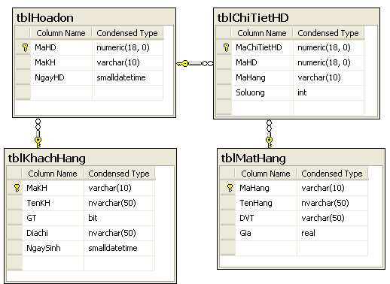
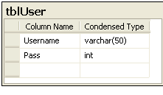
2. Design the Purchase Management program includes the following forms:
a. Form Login:
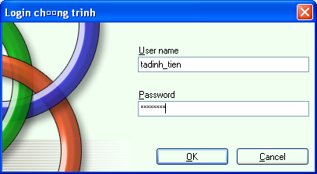
Requirement: The user enters the account and password, and then click OK. If the login is successful, the dialog box will be displayed and go to the main Form (Item b).
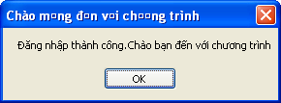
Logging in to the wrong information will notify:
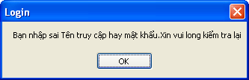

b. Form main:
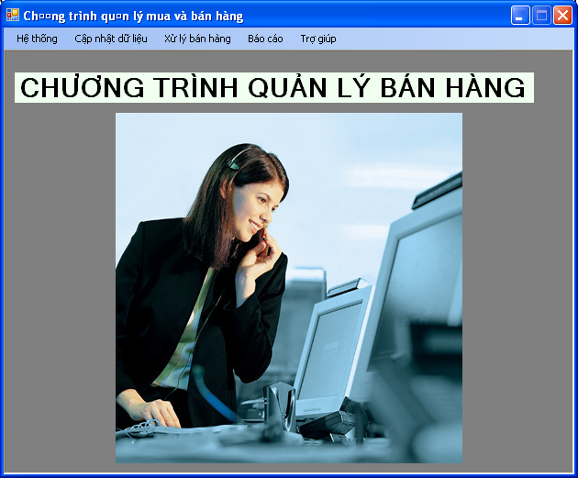
Requirement:
- Select the “Cập nhật khách hàng” Menu, then you will go to the Item c.
- Select the “Cập nhật hàng hóa” Menu, then you will go to the Item d.
- Select the “Xử lý bán hàng” Menu, then you will go to the item e.
- Select the “Báo cáo bán hàng” Menu,then you will go to the item f.
c. Form update Customer:
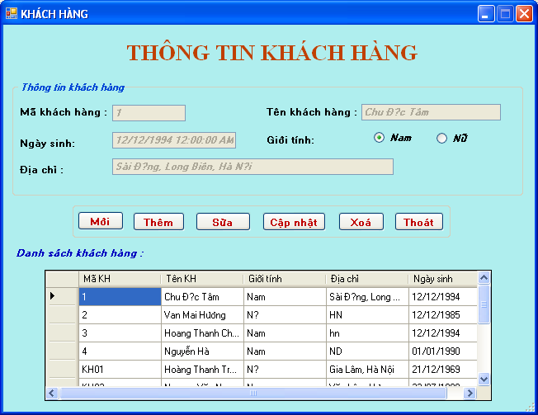
Requirement:
- When the form is loaded for the first time:
+ The TextBox is disabled.
+ DataGrid will display customer information from the database.
+ The TextBox will display by default the information of any customer.
- When clicking on a customer in datagrid, the corresponding information of that customer will be displayed in the corresponding TextBoxes.
- Click on the “Mới” button and the TextBox will be invalidated and whitewashed.
- After filling in the customer information (and checking that the input is correct) and pressing the “Thêm” button, the customer will be added to the database.
- After selecting a customer in DataGrid and clicking the “Sửa” button, the TextBox is valid and we can edit or delete that customer from the database.
- After editing certain customer information and clicking the “Cập nhật” button, that customer information will be updated into the database.
- Clicking the “Xóa” button will destroy the customer information selected from the database.
- Clicking the “Thoát” button will exit the program. (asked before exiting)
d. Form update product:
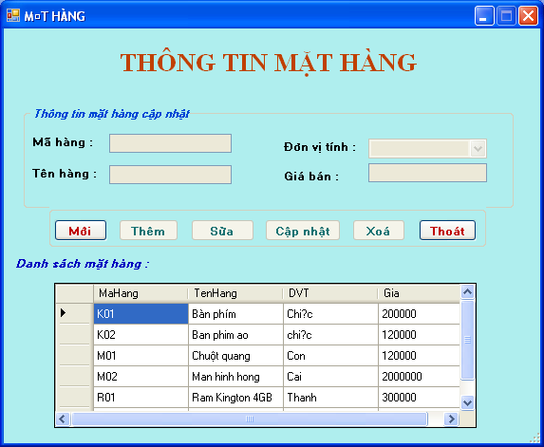
Requirement:
- When the form is loaded for the first time:
+ The TextBox is disabled.
+ DataGrid will display item information from the database.
+ The TextBox will display the default information of any item.
- When clicking on an item in the DataGrid, the corresponding information of that item will be displayed on the corresponding TextBoxes.
- Click on the “Mới” button and the TextBox will be invalidated and whitewashed.
- After filling in the item information (and checking that the price entry information is correct) and pressing the “Thêm” button, the item will be added to the database.
- After selecting an item in DataGrid and clicking the “Sửa” button, the TextBox is valid and we can edit or delete the item from the database.
- After editing certain item information and clicking the “Cập nhật” button, that item information will be updated into the database.
- Clicking the “Xóa” button will destroy the selected item information from the database.
- Clicking the “Thoát” button will exit the program. (asked before exiting)

e. Form Sale:
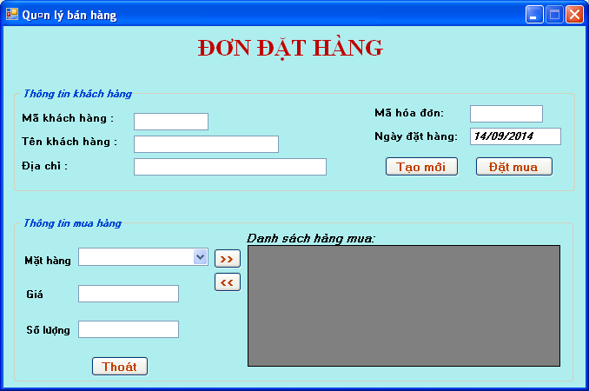
Requirement:
- When Load Form then
+ The “Đặt mua”, >>, << buttons will be disabled.
+ Information of items in the database will be displayed in combobox items.
+ Select Which Item, the corresponding Price will be displayed in the Price TextBox.
- Clicking the “Tạo mới” button will whitewash all TextBoxes.
- Clicking the “Thoát” button will exit the program (with questions before exiting)
- When typing a “Mã khách hàng”/ “Tên khách hàng” that exists in the database, the remaining information of that customer will be displayed in the corresponding TextBoxes.
- When typing any invoice code, will we check if the invoice code is in the database?
+ If not available, let the “Đặt mua” button take effect.
+ If it already exists, the information of the ordered items of that invoice in the Purchase DataGrid, >> and << button be valid again.
- The >> button will act corresponding to the Invoice Code being processed:
+ Add a new invoice detail to the tblChitietHD table if the Item has not been ordered.
+ Update quantity if this item is already placed in the tblChitietHD table.
- The << button will cancel a new invoice detail from the tblChitietHD table corresponding to the currently processing Invoice Code. (item I select on the DataGrid side)
f. Form report:
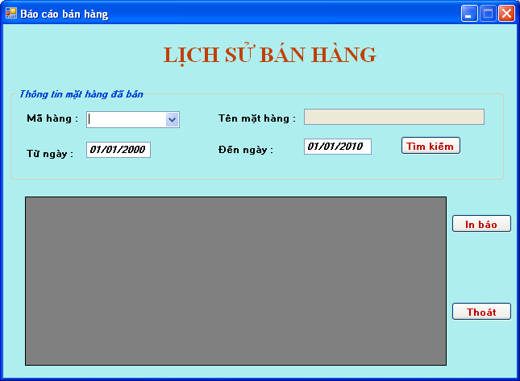
Requirement:
- Clicking the “Thoát” button will exit the program (with questions before exiting)
- Click the “In báo cáo” report button, you will print the content to report (Will do with Crystal Report)
- Select which item in ComboBox The item code will be removed from the database and filled in the DataGrid (If any).
- Type the name of the item, the information will be removed from the database and filled in the DataGrid (If any).
- Type the search date and press the Search button, the information will be retrieved from the database and filled in the DataGrid (If any).

PROJECT 2

Note: Can complete the project using 2 environments
- Winform
- WebApp

1. Create a database, named MyTest:
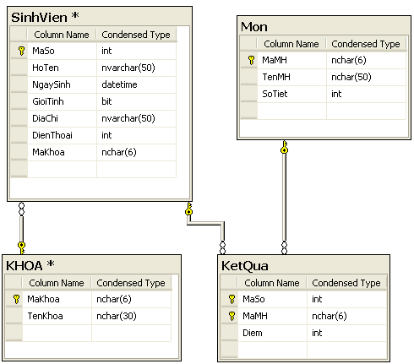

2. Building a Windows Form application that illustrates basic student information management, the information to manage includes:
- Student information: MASo, HoTen, NgaySinh, GioiTinh, DiaChi, DienThoai, Faculty
- Course information: MaMH, TenMH, SoTiet
- Faculty information: MaKhoa, TenKhoa
- Look up the scores of the student's subjects: each student will have points with the corresponding subjects.
- Look up the list of students by faculty

Requirement: Write an MDI-style Windows Application program with functions
- Function input:
  - Student information
  - List of faculties
  - List of subjects
  - Mark of student
- Function report
  - View a list of students with corresponding scores
  - View students in each respective faculty

The main screen of the program illustrates as follows:
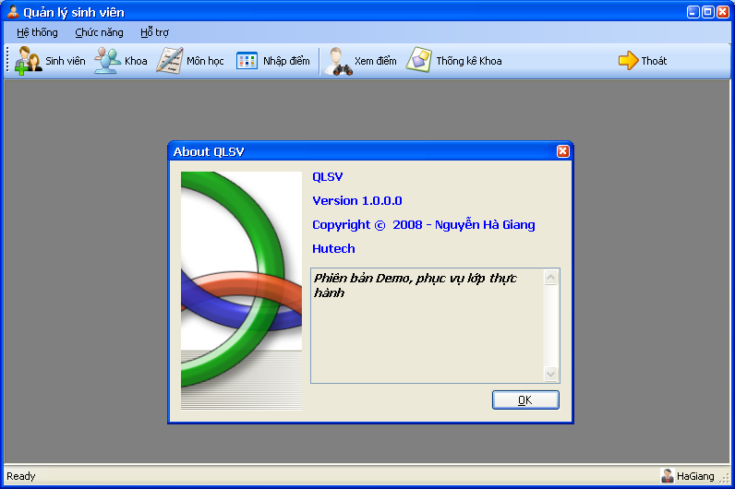

Form input function:
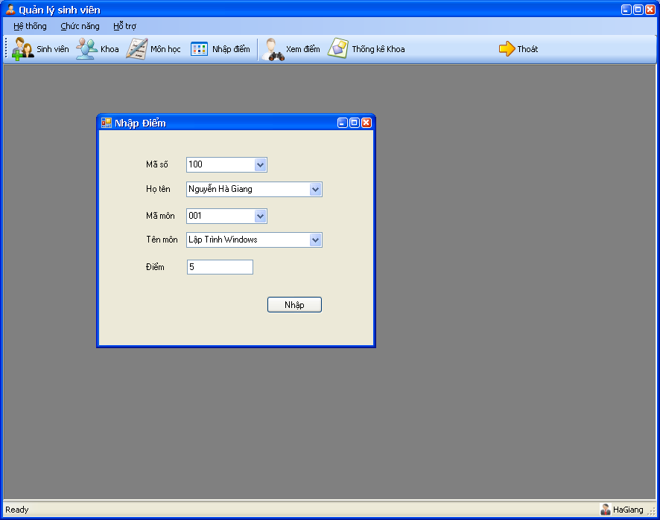
Input mark
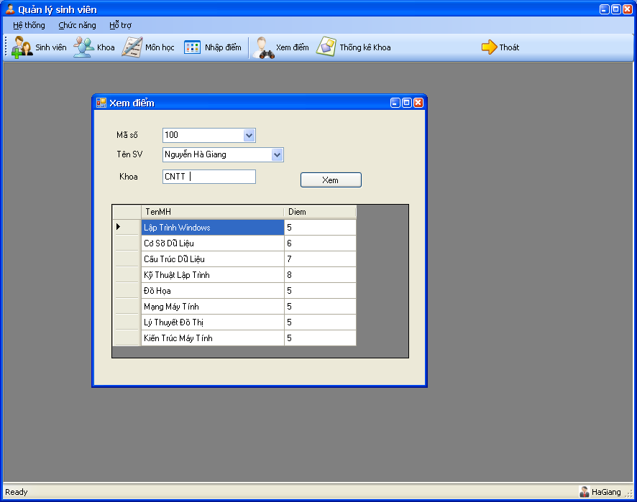
Search by mark

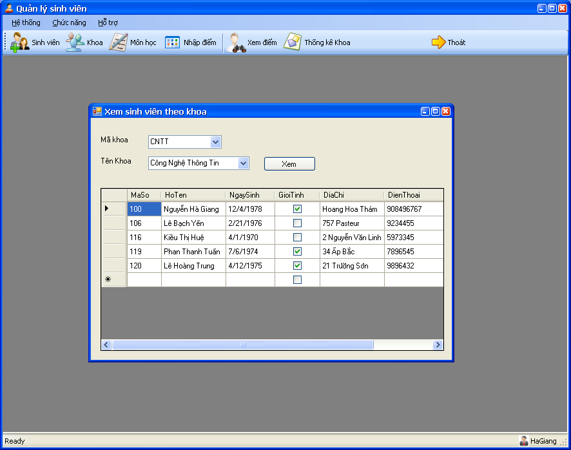
View student information

