VIETNAM GENERAL CONFEDERATION OF LABOUR

**TON DUC THANG UNIVERSITY**

**FACULTY OF INFORMATION TECHNOLOGY**

**SOFTWARE ENGINEERING**

**COMPUTER STORE MANAGEMENT**

*Instructor:* **Mr. DANG MINH THANG**

*Executor*: **NGUYEN LE QUOC CUONG – 518H0478**

**CAO MINH BAO – 518H0473**

**TRAN NGUYEN HOANG THAI - 518H0272**

Class**: 18H50202**

Course**: 22**

**HO CHI MINH CITY, 2020**

VIETNAM GENERAL CONFEDERATION OF LABOUR

**TON DUC THANG UNIVERSITY**

**FACULTY OF INFORMATION TECHNOLOGY**

**SOFTWARE ENGINEERING**

**COMPUTER STORE MANAGEMENT**

*Instructor:* **Mr. DANG MINH THANG**

*Executor*: **NGUYEN LE QUOC CUONG – 518H0478**

**CAO MINH BAO – 518H0473**

**TRAN NGUYEN HOANG THAI - 518H0272**

Class**: 18H50202**

Course**: 22**

**HO CHI MINH CITY, 2020**

THANKS

- We would like to sincerely thank Mr.Thang for his help and support throughout the learning process. He answered questions and guided us to successfully complete this project.

- Besides, we are thoroughly grateful to all teachers of the Faculty of Information Technology in TĐT University for giving me a chance to study and contact with my major.

**THIS PROJECT WAS ACCOMPISHED AT TON DUC THANG**

**UNIVERSITY**

I commit that this product belong to us with the guardian of Mr. Dang Minh Thang. The content of research, result of this project is honest and has not been published in any form before. The data in the tables for analysis, comment and evaluation were collected by the author from various sources in the reference section.

Besides, our project used many kinds of comments, assessments as well as data from another authors, organizations. This project has original quotes and annotations.

If any fraud is detected, I will take full responsibility for the contents of my project. Ton Duc Thang University is not involved to any violations of copyright and copyright caused by me during implementation (if any).

*Ho Chi Minh City, November 20th 2020*

*Author*

*(Sign and write full name)*

*Nguyễn Lê Quốc Cường*

*Cao Minh Bảo*

*Trần Nguyễn Hoàng Thái*

**CONFIRMATION AND EVALUATION OF LECTURERS**

**Confirmation of lecturers**

_______________________________________________________________________________________________________________________________________________________________________________________________________________________________________________________________________________________________________________________________________________________________________________________________________________

Tp. Hồ Chí Minh, ngày tháng năm

(kí và ghi họ tên)

**Evaluation of lecturers**

_______________________________________________________________________________________________________________________________________________________________________________________________________________________________________________________________________________________________________________________________________________________________________________________________________________

Tp. Hồ Chí Minh, ngày tháng năm

(kí và ghi họ tên)

**INTELLECTUAL PROPERTY**

The following documentation, the content therein, and/or the presentation of its information is proprietary to and embodies the confidential processes, designs, technologies, and otherwise of the team. All copyright, trademarks, trade names, patents, industrial designs, and other intellectual property rights contained therein are, unless otherwise specified, the exclusive property of the team.

CATALOGUE

THANKS 3

**CONFIRMATION AND EVALUATION OF LECTURERS** 5

**CHAPTER 1 : EXECUTIVE SUMMARY** 9

**1.1 Introduction** 9

**1.2 Organization chart** 9

1.3 The scope of the system. 10

1.4 Problem of sell computer: 10

**1.5 Introduction computer store management System.** 10

**CHAPTER 2 : SRS DOCUMENT.** 11

**2.1** **Actor:** 11

**2.2** **Flow chart** 11

**2.3** **Question of author and customer answer.** 13

2.4 Functional requirement. 14

2.5 Non-functional requirement. 14

**2.6** **List of use cases.** 14

2.7 Use Case Diagram and Specification 15

**2.7.1** **The process of customers buying product** 15

**2.7.2** **Use case diagram** 15

**2.7.3** **Use case specification** 16

**III.** **DESIGN DOCUMENT** 19

**3.1** **Class diagram** 19

**3.2** **Activity and sequence diagram** 20

**3.2.1** **Activity Diagram about manager login to system** 21

**3.2.2** **Activity Diagram for process buying product for customer** 21

**3.2.3** **Sequence Diagram about computer store system** 22

**3.2.4** **Sequence Diagram seller with system** 23

**3.3** **Entity relationsjip diagram** 24

**IV.** **REALIZE SOFTWARE – TESTCASE – UNIT TEST – SVN/GIT** 24

**1.** **Database** 24

**2.** **Interface design and manipulation** 25

**3.** **SVN/GIT** 39

**V.** **REFERENCES** 39

# **CHAPTER 1 : EXECUTIVE SUMMARY**

**1.1 Introduction**

This is the store that sells the best quality computers as well as computer components at a reasonable price. The store will surely make customers trust and love with 4 characteristics:

* Enthusiastic staff
* Top experts
* 24/7 dedicated service
* Selling price = The cheapest market price - 1000 VND

## **1.2 Organization chart**

 Store Management



Assistant Management





Accountant Sales department



Cashier Shipping department

1.3 The scope of the system.

Provide the software with the following system:

* + - Add and update customer information.
    - Add and update Product
    - Payment.
    - Storage.
    - Search.

1.4 Problem of sell computer:

* + - Check defective products
    - Payment problems, cannot check the change of the quantity of products
    - Difficult to update customer information.
    - Hotel management is not complete.
* Store management require a software that helps them manage the store easier and more effective.

## **1.5 Introduction computer store management System.**

Computer store management software is created to help the Store manager easier to model the process of management. It is a database system to create a selective retrieval of information, for subsequent analysis, manipulation and application. System design will be released under the "Computer Store Management System" name and will be updated if the Store Management requested.

Computer Store Management System:

* Product information storage system: Computer ID, brand name, main name, ram, storage, display, battery, cpu, vga, weight, price.
* Customer purchase information storage system: Customer ID, name, gender, phone, email, address, brand name, model.

# **CHAPTER 2 : SRS DOCUMENT.**

1. **Actor:**

*Customer:* do not interact directly into the system, provide information, choose product, payment.

*Management*: can interact directly with the system, can see all information of employees, product and customers. Have the right to update customer’s information, update product.

Accountant: can interact with the system, dominate shelf profits and monthly spending

Cashier: can interact with the system and customers, can create bill and make payment.

Seller: a person who directly interacts with the software, provides a detailed table of expenditures for accounting  
 Shipper: Not a person who directly interacts with the software, ship product to customer.

1. **Flow chart**
2. **Customers who buy product**

1. **The manager performs operations that interact with the system**

1. **Question of author and customer answer.**

|  |  |  |
| --- | --- | --- |
| Section/Screen | Comment/Question | Answer |
| **Login** | Question: Regarding the login entered the system, here I don't see mention of decentralization for  user when logged in at all. Here covers which positions and rights?  Offer: Only admin can log in to the system to check the information of customers as well as products. | We totally agree. |
| Payment | Offer: The staff selects the customer ID to make payment and report pay will be sent to the admin | We totally agree. |
| Helps | Offer: If the staff have any problem, they can contact the author by phone | We totally agree |

1. Functional requirement.

- The system will record the customer’s information.

- The system will show status product

- The system records the income and expenditure of the store.

1. Non-functional requirement.

- Easy to use interface.

- The needs in terms of performance, logical database requirements, design constraints, standards compliance, reliability, availability, security, maintainability and portability.

- Only the manager has the right to login to the system.

- Manager can add, edit, and delete operation in the software.

- The log in information shall be verified within five seconds.

1. **List of use cases.**

Login: this function allows the admin to log in to software with username and password

Log Out: This function allows admin to exit the software

Customer Manage: This function allows admin to access all information of customers, admin can add, delete and update information.

Product Manage: This function allows admin to access all information of products, admin can update the quantity, change information and delete product.

Employee Manage: This function allows manipulate information about employees working in the store

Payment: This function allows customer request payment. The actor chooses the customer ID and press Pay.

1. Use Case Diagram and Specification
2. **The process of customers buying product**

1. **Use case diagram**

1. **Use case specification**
2. **Sign in**

|  |  |
| --- | --- |
| Actor | Manager |
| Describe | Manager enter credentials include: username and password enter the login form of the system  The system checks login information and reports successful login |
| Illegal | Username and password incorrect |
| Script | Manager enter the correct username and password in the store management system  Manager enter the incorrect username or password will display the wrong message and request to re-enter |

1. **Log out**

|  |  |
| --- | --- |
| Actor | Manager |
| Describe | Managers have logged into the system  The manager chooses the logout function on the system  The system ends the session |
| Illegal | Dropouts |
| Script | Manager exit the system |

1. **Use case Payment**

|  |  |
| --- | --- |
| Actor | Cashier  Customer |
| Describe | Cashier chooses bill  The system displays information of payment invoices  The employee presses the payment button invoice printing system |
| Illegal | If the invoice is not paid by the buyer, the cashier will cancel the invoice |
| Script | After the customer finish buy product, the cashier will proceed with billing and payment  The customer will pay the cost of the purchase |

1. **Use case Employee Manage**

|  |  |
| --- | --- |
| Actor | Manager |
| Describe | Manager choose the function of employee management, the system displays all of the employee’s information in the store  The manager chooses the action corresponding to the employee who wants to operate: add,edit and delete  The system will display a form corresponding to the operation selected by the manager: add-display a new employee form,edit-display employee information, delete-request confirmation to delete an employee |
| Illegal | Manager cant delete employees that don’t exist in the system |
| Script | Manager perform operations with employees in the store’s system |

1. **Use case Product Manage**

|  |  |
| --- | --- |
| Actor | Manager |
| Describe | The manager chooses the function of product information management. The system display a list of product categories  The manager selects which products want to view, edit or delete  If the manager chooses to view-display product information, edit-display an edit information form, delete- request confirmation from the administrator  Finish working with the products |
| Illegal |  |
| Script | The manager manipulates information that a product is provided |

1. **Use case Customer Manage**

|  |  |
| --- | --- |
| Actor | Manager |
| Describe | The manager selects Customer, then the system displays a list of customer information that has been stored in the system  The administrator can add, edit or delete the information |
| Script | Management staff interact with customer provided information |

1. **DESIGN DOCUMENT**
2. **Class diagram**

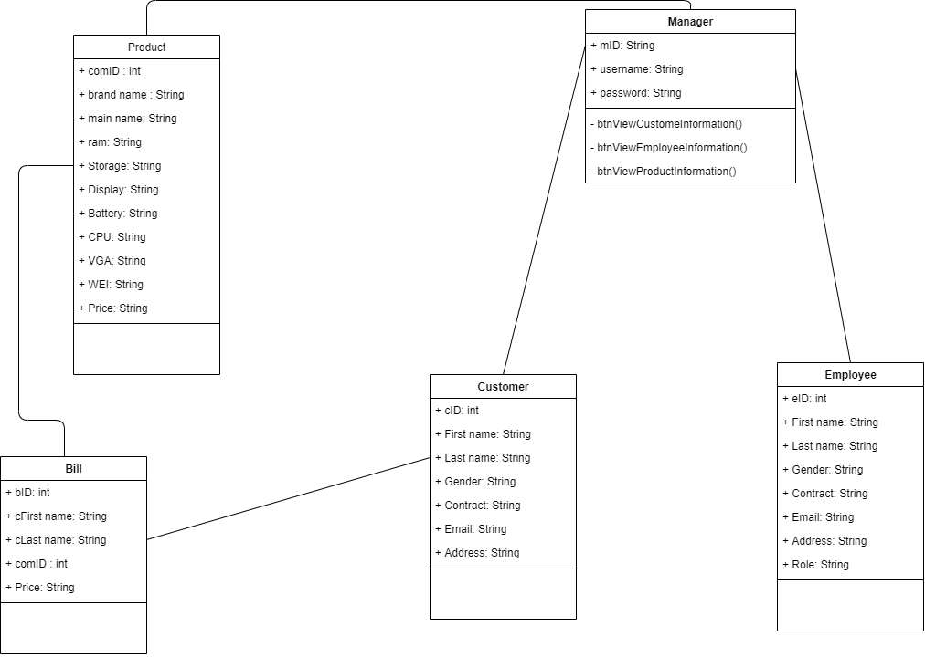

With class CUSTOMER: with customer table, this is place to save customer information such as customer ID, name, gender, phone number, email, address.

With class MANAGER: with manager table, this is place save manager ID, username, password.

With class BILL: with bill table, place to save information payment, customer id, customer name, product ID and total cost.

With class PRODUCT: with product table, this is place save product information such as product id, brand name, main name, RAM, storage, display, battery, CPU, VGA, WEI, price.

With class EMPLOYEE: with employee table, this is place save employee information such as employee id, name, gender, phone number, email, address and role of employee

1. **Activity and sequence diagram**
2. **Activity Diagram about manager login to system**

1. **Activity Diagram for process buying product for customer**

1. **Sequence Diagram about computer store system**

1. **Sequence Diagram seller with system**

1. **Entity relationship diagram**

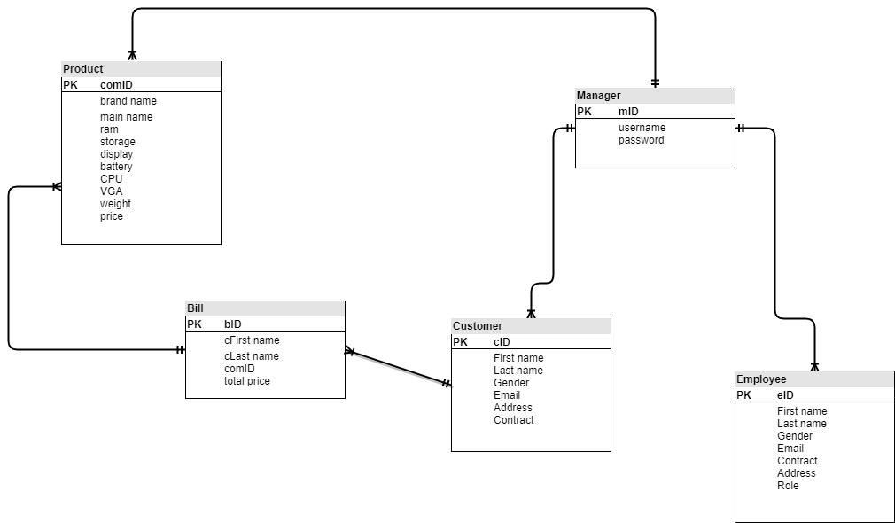

1. **REALIZE SOFTWARE – TESTCASE – UNIT TEST – SVN/GIT**
2. **Database**

* **Table newComputer**

|  |  |  |  |
| --- | --- | --- | --- |
| Num | Variable name | Data type and size | Binding |
| 1 | cid | int | primary key |
| 2 | bname | varchar(250) | not null |
| 3 | mname | varchar(250) | not null |
| 4 | ram | varchar(250) | not null |
| 5 | storage | varchar(250) | not null |
| 6 | display | varchar(250) | not null |
| 7 | battery | varchar(250) | not null |
| 8 | cpu | varchar(250) | not null |
| 9 | vga | varchar(250) | not null |
| 10 | wei | varchar(250) | not null |
| 11 | price | varchar(250) | not null |

* **Table customerPurchase**

|  |  |  |  |
| --- | --- | --- | --- |
| Num | Variable name | Data type and size | Binding |
| 1 | pid | int | primary key |
| 2 | cname | varchar(250) | not null |
| 3 | gender | varchar(250) | not null |
| 4 | contact | varchar(250) | not null |
| 5 | email | varchar(250) | not null |
| 6 | addr | varchar(250) | not null |
| 7 | idcard | varchar(250) | not null |
| 8 | brand | varchar(250) | not null |
| 9 | model | varchar(250) | not null |

1. **Interface design and manipulation**
2. Form “Sign In”: This is the main login interface of the application and users required to log in to get into the system

Username: admin

Password: 1

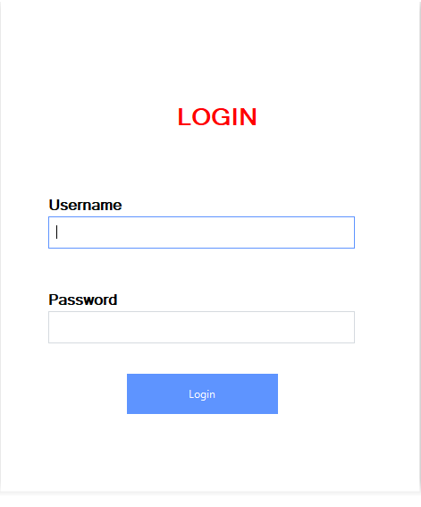

1. **Form: “ComputerShop Management”: This is a main form after log in**

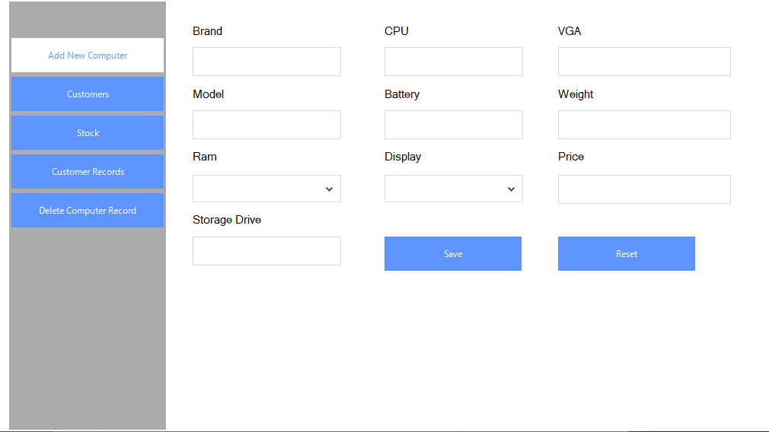

After loggin in, staff can manipulate functions is: Add New Computer, Customer Purchase, Stock, Customer Records, Delete Computer Record.

* Case 1: Add New Computer

This is a form to add a new computer

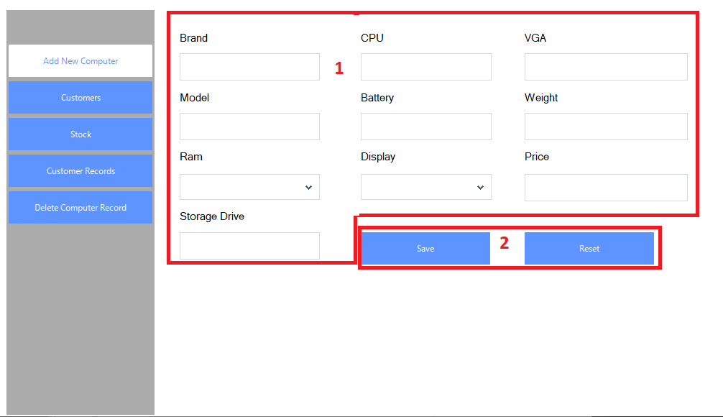

* With:

(1): New computer information

(2): The function can manipulate with computer information

* Detail:

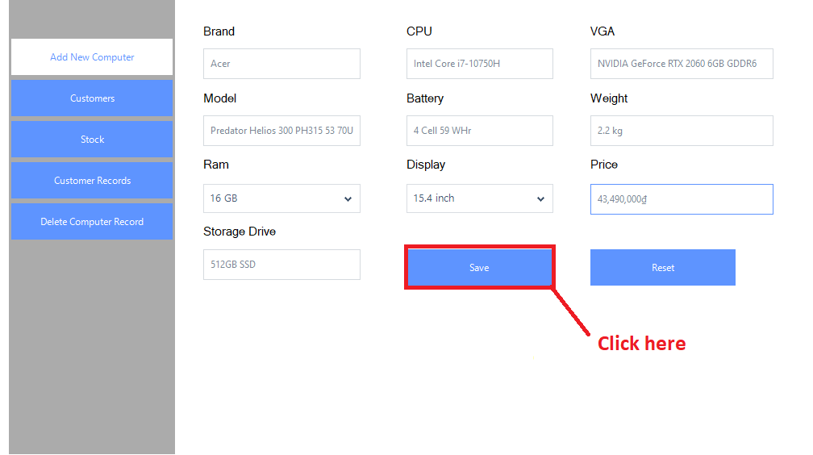

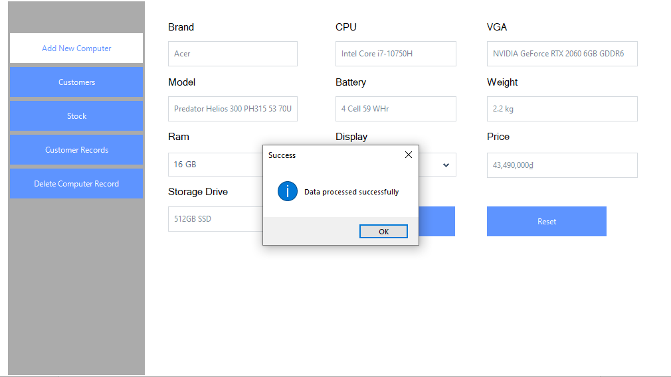

* Case 2: Customer Purchase

This is a form to create new customer purchase record

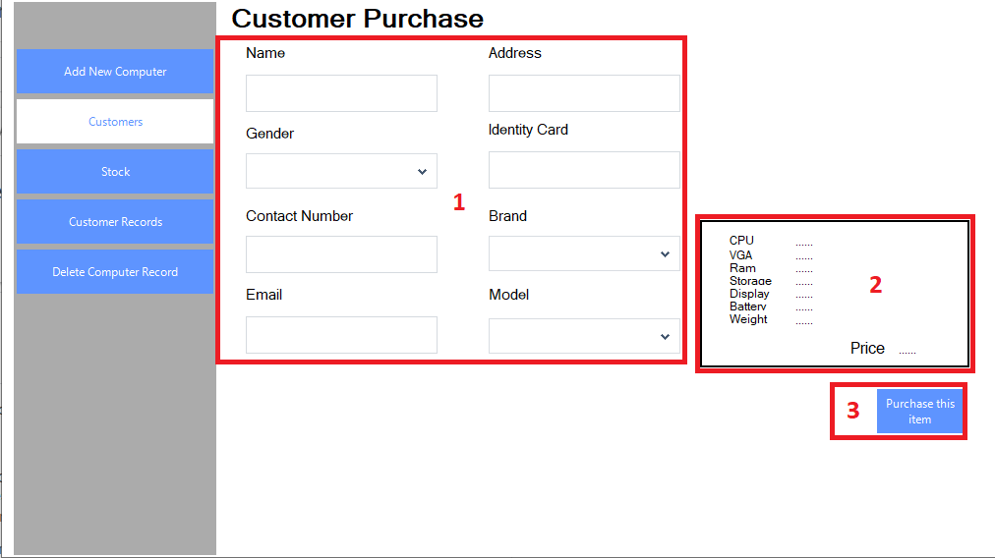

* With:

(1): Customer Information and brand, model of computer that customer want to buy

(2): Computer Information after select brand, model in (1)

(3): CHOT DON!

* Detail:

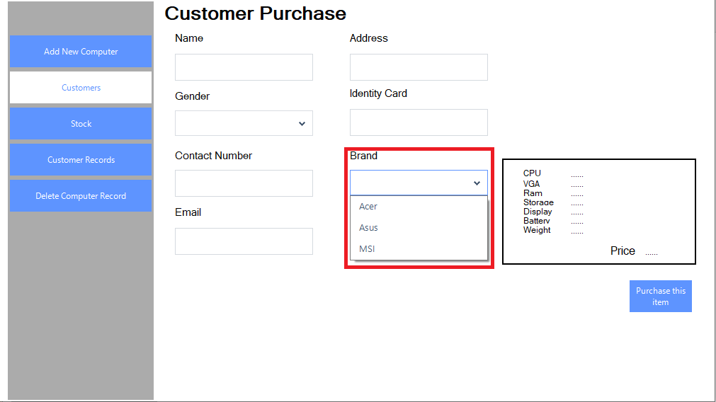

When we click at the Brand combobox, it will show all the computer brands have existed in the database

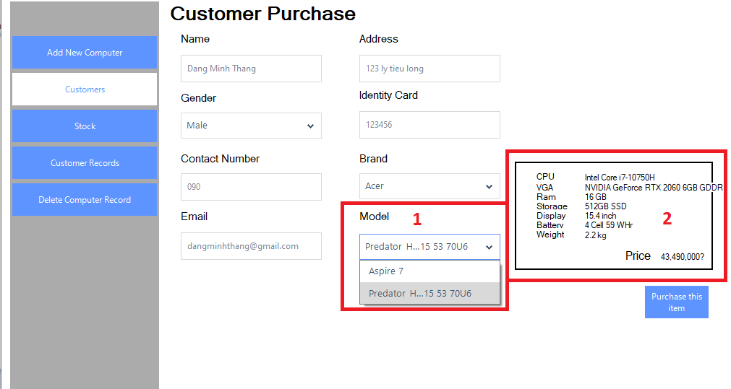

(1): All computer models for the brand we have selected that have existed in the database

(2): The computer information for the model we have selected

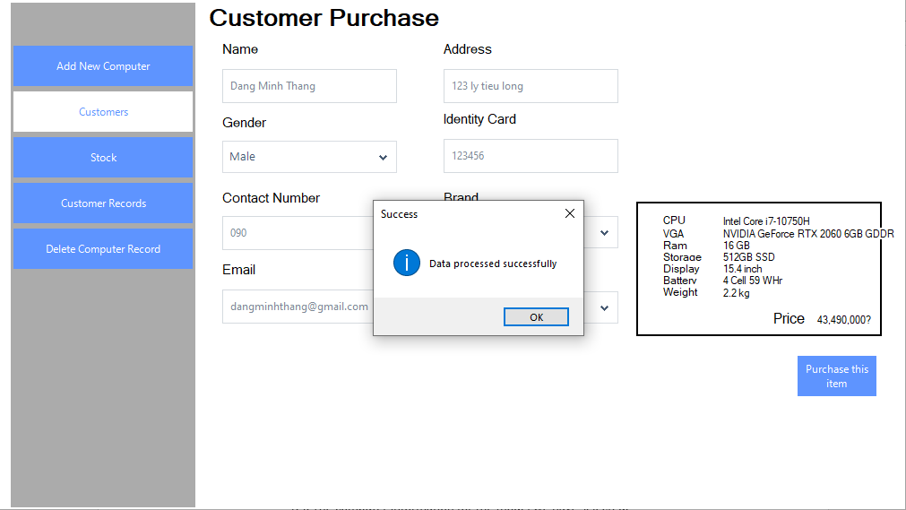

* Case 3: Stock

This is the form show all the computer that we have in the database

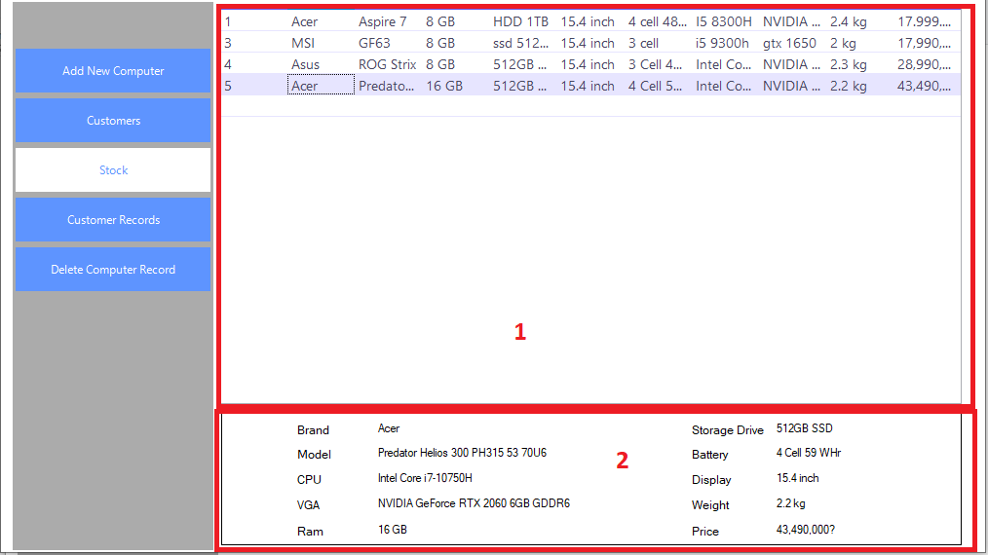

* With:

(1): The table shows the current computer information at the shop

(2): Detail of the computer when click on a row in (1)

* Case 4: Customer Records

This is a form show all the customer records

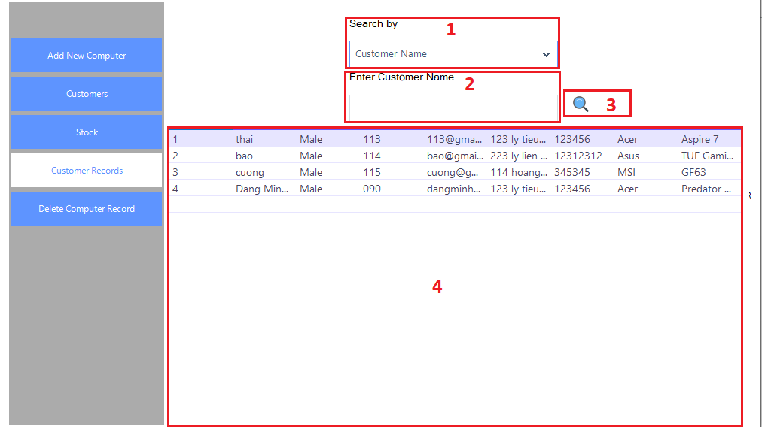

* With:

(1): Choose option to search. There are 2 options: Search by Customer Name or Contact Number

(2): Textbox to enter the information for searching.

(3): Button to search

(4): The table to show all the customer record or result after searching

* Detail:

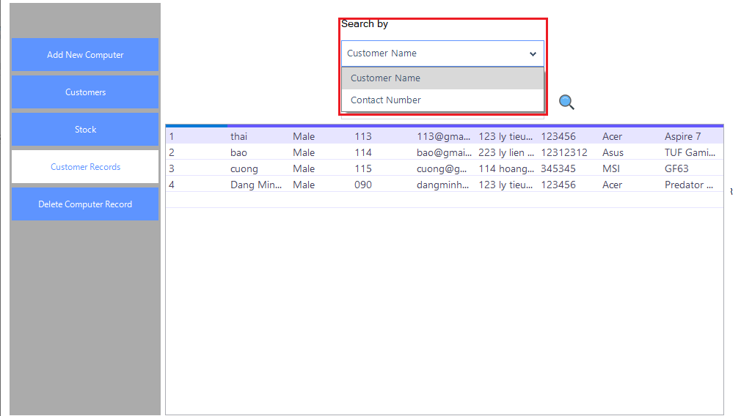

When we click on the Search by combobox, it will show 2 options for searching: Customer Name or Contact Number

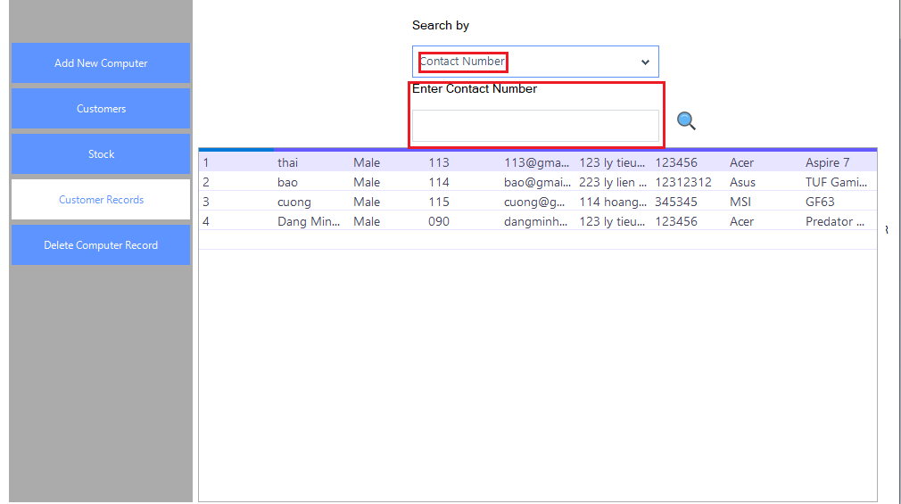

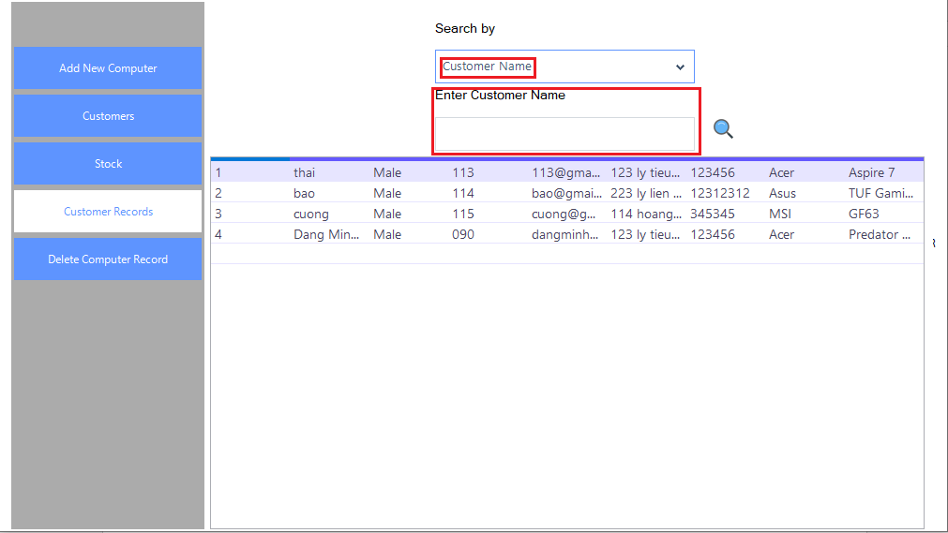

After choose the option to search, the label of the textbox will change

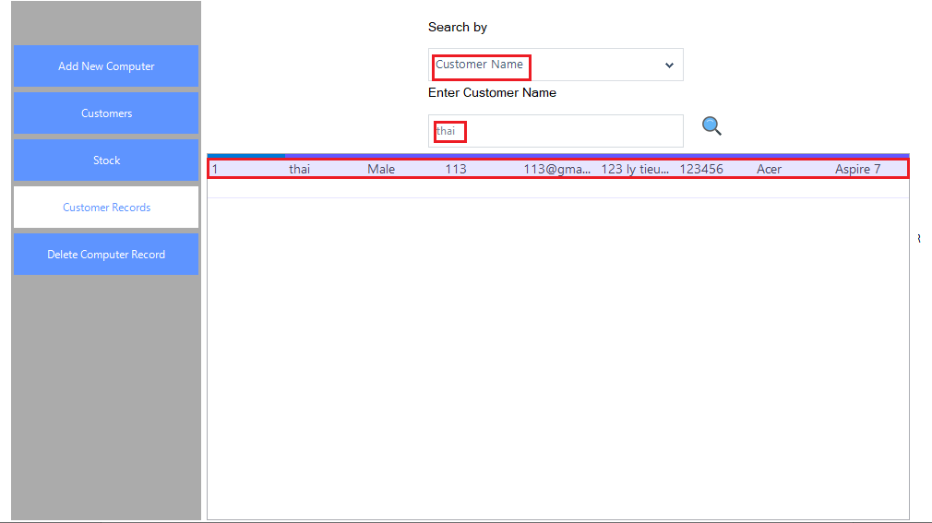

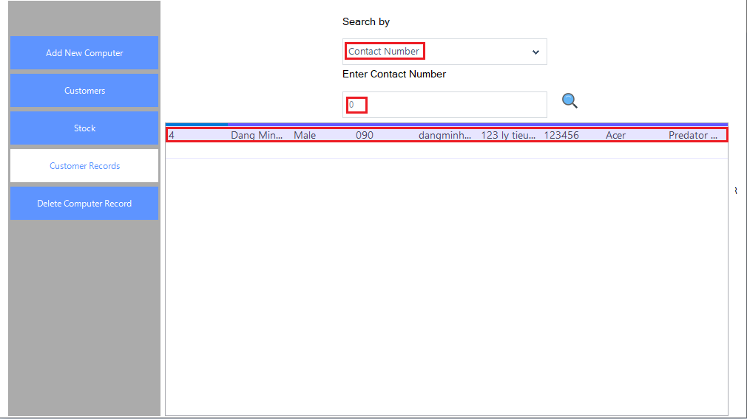

* Case 5: Delete Computer Record

This is a form to delete Computer Record from the database.

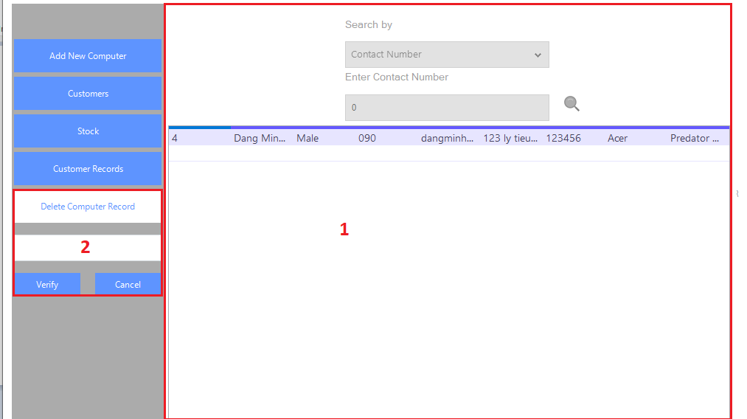

* With:

1. : This panel will be disabled when the user click on Delete Computer Record button and the user have to enter password to enable the panel of Delete Computer Record function
2. : Textbox to enter password, Verify button to enable the panel of Delete Computer Record function, Cancel button to enable (1) panel but cannot get into the panel of Delete Computer Reord function

* Detail:

The password to get into the panel of Delete Computer Reord function is: **thaideptrai**

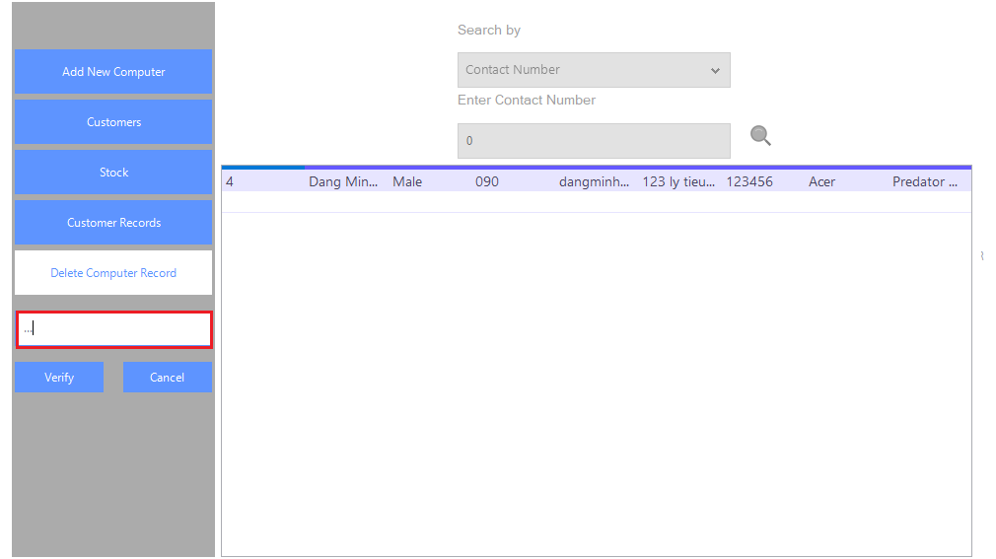

When we enter the wrong password the textbox will be reset. (I am entering 123)

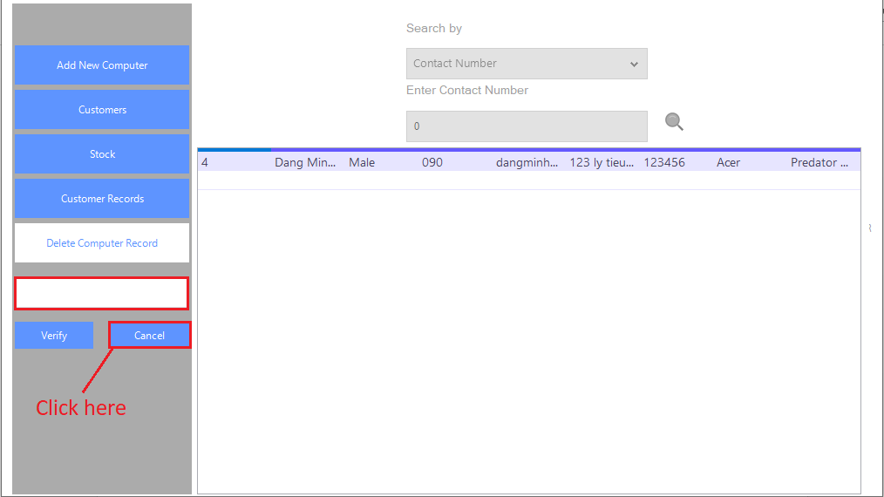

When we click on the Cancel button, the textbox and 2 button under it will disapper and the right panel will be enabled

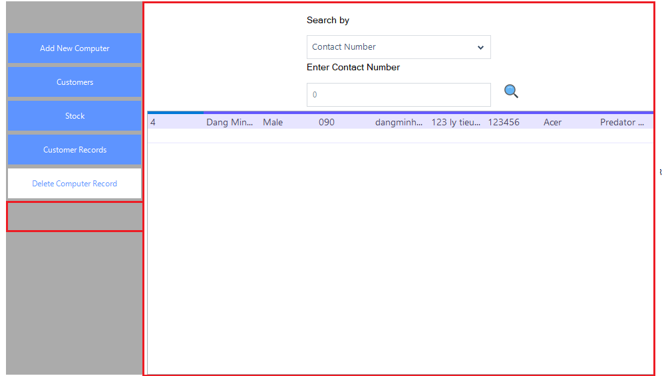

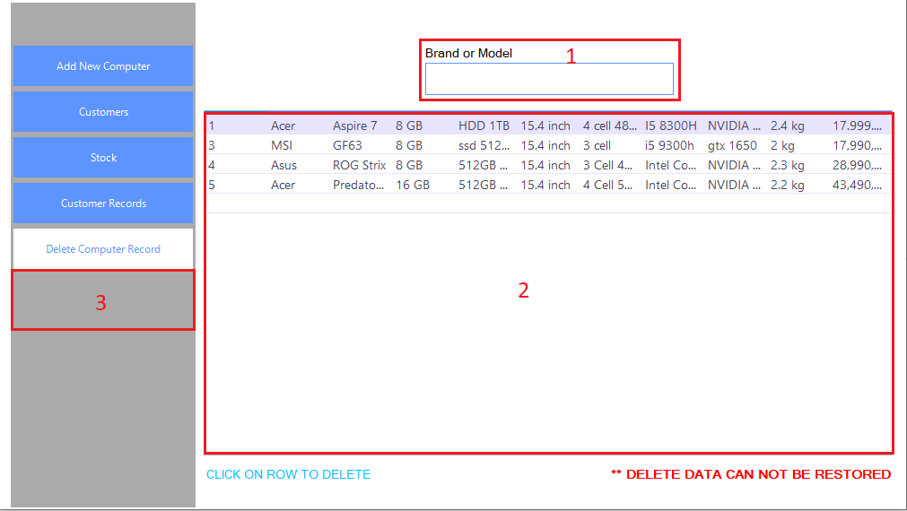

When we enter the correct password (**thaideptrai**) (3) will disappear and the panel of Delete Computer Record function will be enabled with (1) to enter Brand or Model that user want to delete and (2) is the table show all Computer Record or result for searching

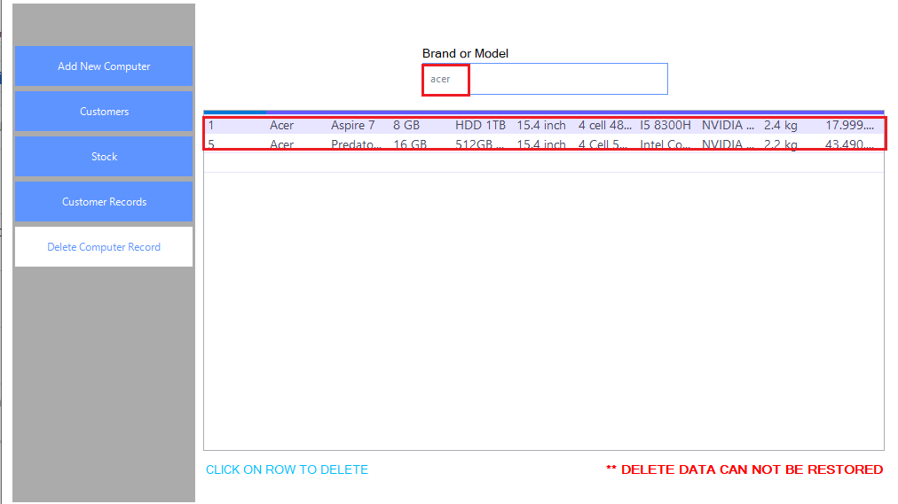

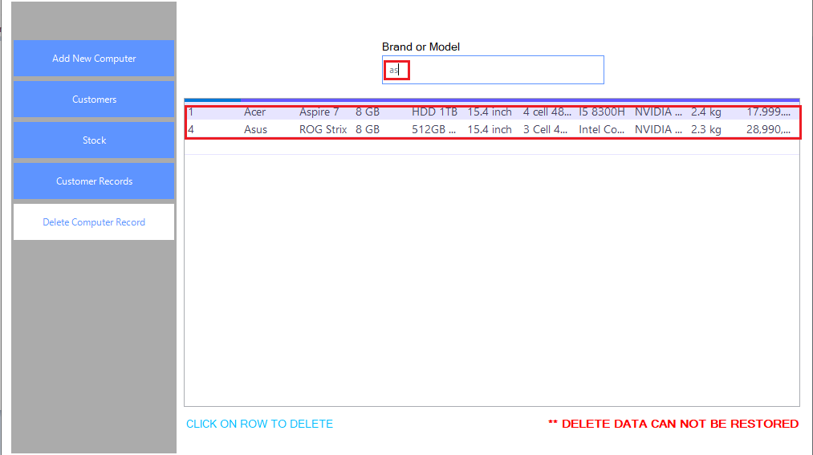

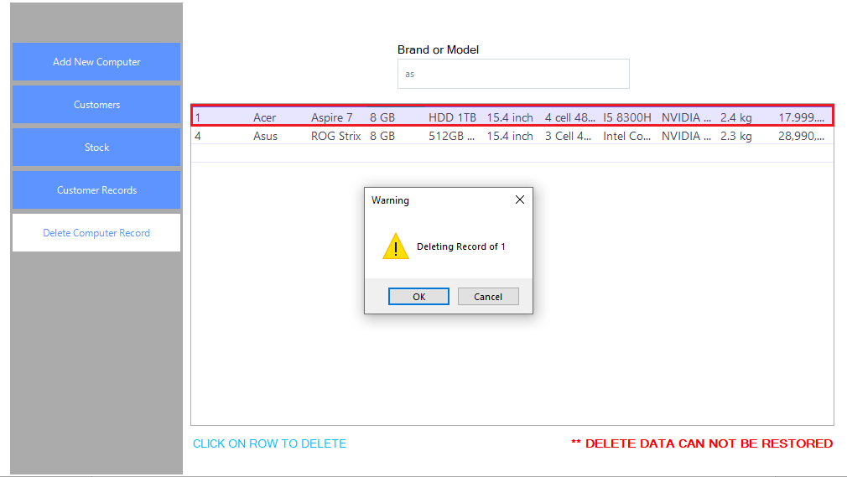

When we click on the row, it will show a message box like this.

Case 1: When click on Cancel button

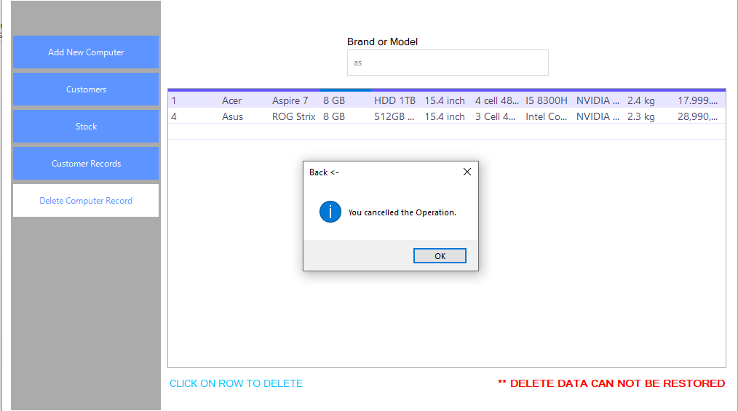

Case 2: When click on OK button

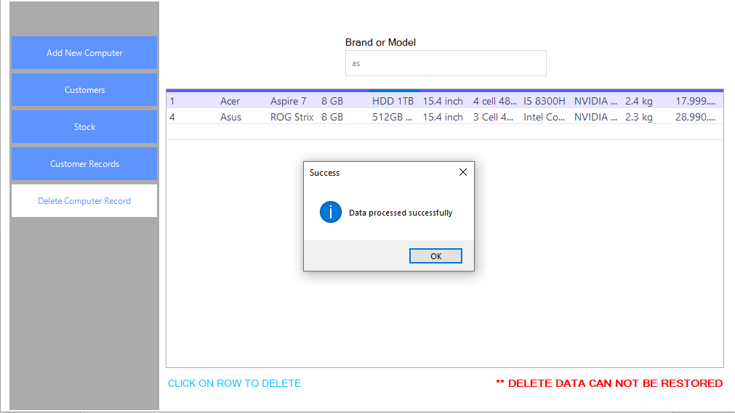

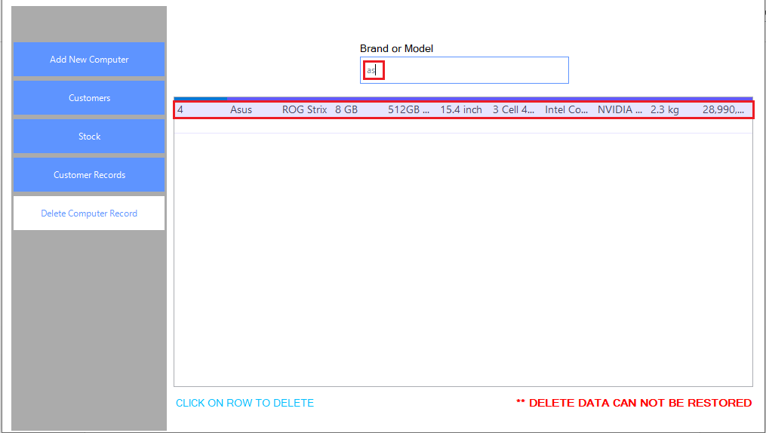

1. **SVN/GIT**
2. **REFERENCES**

<https://www.slideshare.net/banthe1704/n-phn-tch-thit-k-h-thng-qun-l-bn-hng-siu-th>

<https://www.stdio.vn/article/thao-tac-voi-du-lieu-trong-sql-select-insert-update-delete-M6ru1>